Section: 13 / 3
Dive Right In!
- 1. Introduction - Course Roadmap2:08
- 2. Roadmap to the First App2:08
- 3. Official Course Github Repo0:00
Section: 20 / 3
Got OSX? Go Here.
- 4. OSX Installation6:02
- 5. More on OSX Installation5:25
- 6. Running in the Simulator2:12
Section: 30 / 3
Got Windows? Go Here.
- 7. Windows Setup of React Native6:31
$ react-native run-android
→ error : Skipping device 'emulator-5554' (emulator-5554): Device is UNAUTHORIZED,
Android emulators have by default "Usb Debugging" in settings. You just need to wipe the data of the emulator. Do the following steps. It will work :---
- Close the emulator and run the command adb kill-server in the command prompt. If adb is not set in you path then you might run this command from directory where adb is present.
- Click on Wipe Data option from avd Actions men. 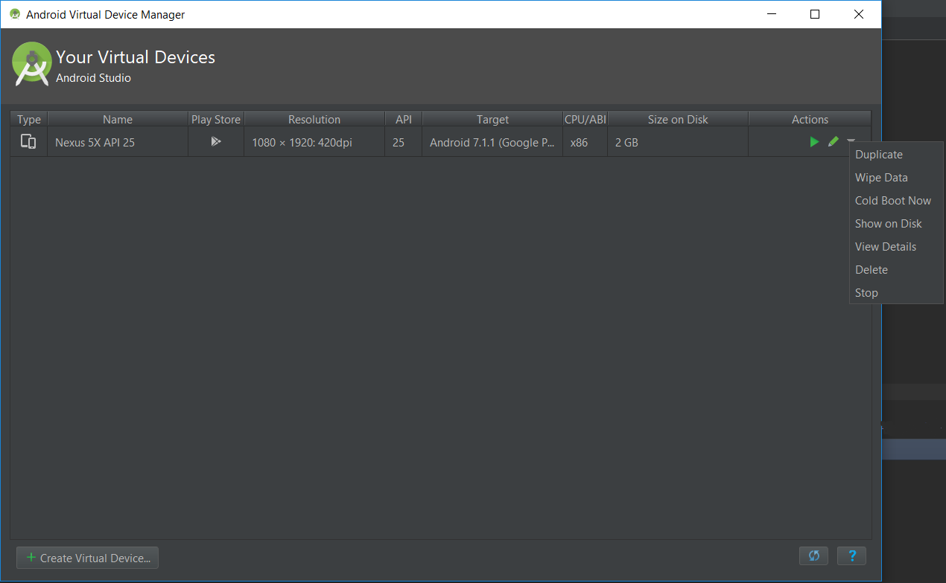
- Now run the emulator. It should work.
* error smartphone simulator : unable to load script from assets index.android.bundle :

This issue helped me resolve the problem in following steps.
- (in project directory) mkdir android/app/src/main/assets
************* always do following in case of error : emulator **********
- react-native bundle --platform android --dev false --entry-file index.js --bundle-output android/app/src/main/assets/index.android.bundle --assets-dest android/app/src/main/res
- react-native run-android
You can automate the above steps by placing them in scripts part of package.json like this
"android-linux": "react-native bundle --platform android --dev false --entry-file index.js --bundle-output android/app/src/main/assets/index.android.bundle --assets-dest android/app/src/main/res && react-native run-android"
change the port in dev setting in emulator/ localhost:8083… → works!!-I think previous port is assigned already , so this port is not working → new port works!

- 1) jdk, node , python installed
- 2) command line as administrator C:\WINDOWS\system32>npm install -g react-native-cli
- C:\WINDOWS\system32>cd C:\react_native\myDev
- C:\react_native\myDev>react-native init albums
- 3)To run your app on iOS:
- cd C:\react_native\myDev\albums
- react-native run-ios
- - or -
- Open ios\albums.xcodeproj in Xcode
- Hit the Run button
- To run your app on Android:
- cd C:\react_native\myDev\albums
- Have an Android emulator running (quickest way to get started), or a device connected
- react-native run-android
- 4) open android devtool by
- open existing/ C:\react_native\myDev\albums\android → Error msg shown(Installing missing platform) : then click link and install .
- → Tools/AVD Manager/nexus5/Oreo(android 8.1)/Select Oreo and then Next/ Finish : this is my virtual device(emulator)/ in the rightmost Actions/ play button click.
- 5) window + R / type control panel/ system / advanced System setting/Environment Variables/
- JAVA_HOME : already setup
- in PATH new path added asf → C:\Users\Gloria\AppData\Local\Android\Sdk\platform-tools
- (as admin privilege ) C:\react_native\myDev\albums>react-native run-android
- * ubuntu : $ sudo gedit ~/.bashrc
- export PATH=”${PATH}:/home/ys/Android/Sdk/platform-tools”
- export PATH=”${PATH}:/home/ys/Android/Sdk/tools”
- $ source ~/.bashrc
- ~reactNativeRedux/myDev/albums$ react-native run-android
- 6) whenever restart pc/
- - start android dev tool ( ~/android-studio/bin$ ./studio.sh)
- - Tool/ ADM(Android Develop Manager) / Actions / click play button
- $ cd ~/reactNativeRedux/myDev/albums
- ~/reactNativeRedux/myDev/albums$react-native run-android
- 8. Android Studio and React Native CLI Installation5:12
- 9. Emulator Creation and System Variables14:56
Section: 40 / 4
[Optional] ESLint Setup
- 10. ESLint Setup and Overview8:56
- 11. ESLint Setup with Atom6:18
- atom/settings/ type in linter-eslint / choose linter-eslint, linter
- ~/reactNativeRedux/myDev/albums$> npm install --save-dev eslint-config-rallycoding
- - eslint rule setting :
- - make new file named .eslintrc in atom albums root dir (.eslintrc is project specific file- need to make on every project)
- 12. ESLint Setup with Sublime Text 38:22
- 13. ESLint Setup with VSCode3:37
Section: 50 / 10
Onwards!
- 14. Troubleshooting React Native Installs0:00
- 15. Project Directory Walkthrough2:16
- 16. Getting Content on the Screen3:17
- 17. React vs React Native3:11
- * react
- 1)know how a component should behave 2)knows how to take a bunch of components & make them work together.
- * react-native (Portal to the mobile device)
- 1) knows how to take the output from a component and place it on the secreen.
- 2) Provides default core components(image, text)

- 18. Creating a Component with JSX6:16
- babeljs.io → Try it out / We can see all JSX(dialect to javascript) code(left) is compiled javascript code(RIGHT) actually excuted on mobile device.
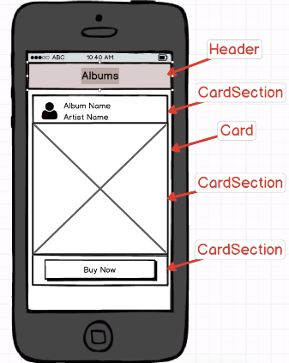
- 19. Registering a Component3:45
- 20. Destructuring Imports5:25
- ~/reactNativeRedux/myDev/albums$react-native run-android → some text shows in phone.
- 21. Application Outline4:47

- 22. The Header Component8:29o
- one component per file RULE
- 23. Consuming File Exports6:50
- importing header, then nesting inside App component
- , Tab_key + RR for refresh smartphone.
Section: 60 / 5
Making Great Looking Apps
- 24. Styling with React Native4:33
- 25. More on Styling Components4:51
- 26. Introduction to Flexbox5:24
- 27. Header Styling4:23
- 28. Making the Header Reusable7:18
Section: 70 / 14
HTTP Requests with React Native
- 29. Sourcing Album Data4:51
- 30. List Component Boilerplate6:07
- 31. Class Based Components7:26
- 32. Lifecycle Methods6:40
- class AlbumList extends Component { componentWillMount() { console.log(“,,”); debugger; }
- then, flip over to simulator, refresch(tab + RR), Dev Mode (Ctrl+M), then click remote debugging / error show but goto asf.
- http://localhost:8081/debugger-ui/ (Go to http://localhost:8081/debugger-ui/ . Then stop remote js debugging and run your react native app again(~/reactNativeRedux/myDev/albums$react-native run-android). Finally debug js remotely. Has worked for me.
- * try killing the process of your browser and emulator. Run adb kill-server to remove your attached devices. Restart your emulator and rerun the remote debugger. The remote debugger should be pointing to your localhost:8081/debugger-ui
* cd ~/reactNativeRedux/platform-tools
* ~/reactNativeRedux/platform-tools$ adb kill-server
** In my case the issue was that the emulator was making a request to:
http://10.0.2.2:8081/debugger-ui
instead of:
http://localhost:8081/debugger-ui and the request was failing.
To solve the issue: Before enabling remote debugging on your emulator, open http://localhost:8081/debugger-ui in chrome. Then enable remote debugging and go back to the chrome page where you should see your console logs
--------------
- → componentWillMount() { console.log(‘...’); debugger; }
- //debugging mode enter point and In source, check ...
- ) ,in this screen, mouse right button click/ choose “Inspect”/Console
- in localhost:8080/dibugger-ui / Console → chrome automatically stop in break point/ click sources/
*in chrome debug console: uncaughed error: ..→type “ chrome:extentions “ in browser
then disable all extentions shown in Extention page, then restart webbrowser → Error removed !
- 33. Quick Note On Axios0:00
- $ npm install axios
- 34. Network Requests8:11
- 35. Component Level State8:57
- two possible states of album list component.The event that seperate two diff states is fetching a data.
- When state changed, React just fetch list of albums then you need to re-render with new list of data.
- (three step: 1. Set default state(intial) for our component , state={albums:[]} 2. fetch a data, tell about state update using .then(response => this.setState({albums:response.data}) 3. make sure component make use of this state.)
- (1) state={albums: []} // no album data shown, //no data state
(2) state = { albums: [{name: ‘sse’}, {name:’pdk}] }; //having a data state
- 36. More on Component Level State6:53
- we use props to communicate from parent component to child comp/ State is for component internal record keeping
- 37. Rendering a List of Components5:55
- 38. Displaying Individual Albums9:30
- (1) AlbumList.js
- 1)state = {albums: []};
- componentWillMount() { axios.get(‘http://rallycoding...’)
- then(response => this.setState({ablums:response.data})); }
- renderAlbums() { return
- this.state.albums.map(album => <Text key={album.title}>{album.title}</Text> ); }
→ replace <Text> with <AlbumDetail>
- render(){return (<View>{this.renderAlbums()}</View>);}
- 2)this.state.albums.map(album=> <AlbumDetail key = {album.title}>{album.title}</AlbumDetail>);
- → communication from parent to child using props system in React: (passing album down to AlbumDetail as a props).
- 3) this.state.albums.map(album => <AlbumDetail key={album.title} album={album} />);
- // Inside AlbumDetail, I will have props of props.album (property name is album, variable is album)
- (2) AlbumDetail.js
- const AlbumDetail = (props) => { return (<View> <Text>{props.album.title}</Text></View>);};
- → replace <View> with <Card> below.
const AlbumDetail = (props) => { return (<Card> <Text>{props.album.title}</Text></Card>);};
- → in card.js, communication from parent,AlbumDetail to child,Card using props.children
const Card = () => { return ( <View style={styles.containerStyle}>props.children</View> ); }
- 39. Fantastic Reusable Components - The Card5:25
- (3) Card.js
- const Card = () => { return ( <View style={styles.containerStyle}>props.children</View> ); }
- const styles= { containerStyle: { borderWidth: 1, border Radius: 2, borderColor: ‘#ddd’, borderBottomWidth: 0, shadowColor: ‘#000’, shadowOpacity: 0.1, shadowRadius:2, elevatioin: 1,
- marginLeft: 5, marginRight: 5, marginTop: 10 }};
- 40. Styling a Card6:05
- 41. Passing Components as Props4:12
- props.children
- 42. Dividing Cards into Sections8:23
- (1) Card.js
- const CardSection = () => { return (<View></View>); } →
- const CardSection = (props) => { return (<View style={styles.containerStyle}>
- props.children</View>); }
- const styles -= { containerStyle: {borderBottomWidth: 1, padding: 5, backgroundColor:’#fff’, justifyContent: ‘flex-start’, flexDirection:’row’, borderColor:’#ddd’, position: ‘relative’ }};
- (2) AlbumDetail.js
- const AlbumDetail = (props) => { return (
- <Card>
- <CardSection>
- <Text>{props.album.title}</Text>
        - </CardSection>
- <CardSection>
- <Text>{props.album.title}</Text>
        - </CardSection>
- </Card>);}; //same title twice shown.
- →

Section: 80 / 12
Handling Component Layout
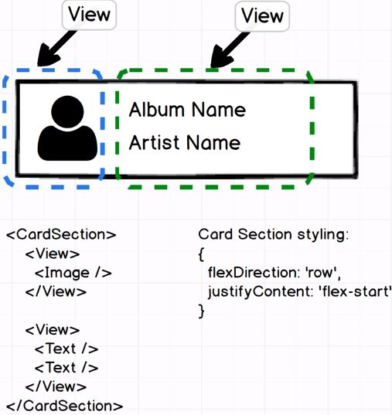
- 43. Mastering Layout with Flexbox5:12
- 44. Positioning of Elements on Mobile5:20

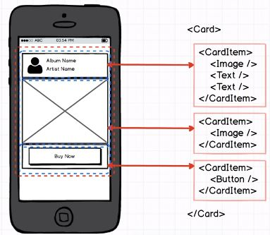

- in CardSection.js, const styles = {justifyContent: 1) default : upper left 2)‘flex-end’ 3) ‘center’ 4)’space-between’ 5) ‘space-around’ 6)’flex-start’ (to get both item(View) push upto the lefthand side of container as shown below ! But default direction is up & down direction(vertical), so need to flexDirection: ‘row’ for left & right direction.)
- flexDirection(default is column) : ‘row’ ..}
- 45. More on Styling4:27
- (1)AlbumList,
- (2)AlbumDetail,
- const AlbumDetail = (porps) => { return ( <Card> <CardSection><View></View>
- <View style={styles.headerContentStyle}><Text>{porps.album.title}</Text> <Text>{props.album.artist}</Text></View></Cardsection></Card>);};
- const styles = { headerContentStyle: { headerContentStyle: {flexDirection: 'column',
- justifyContent: 'space-around'}};
- 46. Images with React Native7:35
- 47. Displaying Album Artwork8:40
- * rallycoding.herokuapp.com/api/music_albums → [{ title: “..”, artist: “..”, url: “https://..”, image: “https://..”, thumbnail_image:”https://..”}, {..}..]
- (1)const AlbumDetail = (porps) => { return (<Card> <CardSection><View>
- <Image source={{uri: props.album.thumbnail_image}}/></View>..
- (2) destructuring (props)
- 1) option 1 : destructuring directly props as argument itself, like {album : {title, artist}}
- 2) option 2 : destucturing inside function body
- const AlbumDetail = ({ album }) => {
- const {title, artis, thumbnail_image} = album;
- return (<Card> <CardSection><View> <Image source={{thumbnail_image}}/></View>
- <View style={styles.headerContentStyle}><Text>{title}</Text>
- <Text>{artist}</Text></View></Cardsection></Card>);};
- (3)thumbnail_image not shown since thumbnailStyle with height, width not defined !
- 1)const AlbumDetail = ({ album }) => {
- const {title, artist, thumbnail_image} = album;
- return (<Card> <CardSection><View> <Image style={style.humbnailStyle} source={{humbnail_image}}/></View>
- <View style={styles.headerContentStyle}><Text>{title}</Text>
- <Text>{artist}</Text></View></Cardsection></Card>);};
- const styles = {headerContentStyle:{..}, thumbnailStyle:{height: 50, width: 50}}
- 2)const AlbumDetail = ({ album }) => {
- const {title, artis, thumbnail_image, image} = album;
- const {thumbnailStyle, headerContentStyle, thumbnailContainerStyle, headerTextStyle,imageStyle} = styles;
- return (<Card> <CardSection><View> <Image style={humbnailStyle} source={{thumbnail_image}}/></View>
- <View style={headerContentStyle}><Text style={headerTextStyle}>{title}</Text>
- <Text>{artist}</Text></View></Cardsection>
- <CardSection><Image style={imageStyle} source={{uri: image}/> </CardSection></Card>);};
- const styles = {headerContentStyle:{..}, headerTextStyle :{fontSize: 18},thumbnailStyle:{height: 50, width: 50}, thumbnailContainerStyle : {justifyContent: ‘center’, alignItems: ‘center’, marginLeft: 10, marginRight: 10},imageStyle:{}}
- 48. Making Content Scrollable4:30
- in AlbumList,
- state = {albums: []};
- componentWillMount() { axios.get(‘https://rallycoding..’).then(response => this.setState({albums: response.data}));
- renderAlbums(){ return this.state.albums.map(album => <AlbumDetail key{album.title} album={album}/>);}
- render(){return( <ScrollView> {this.renderAlbums()}</ScrollView>);}//<View> → <ScrollView>
- * but still bouncing back after scroll down. → Whenever you have scrollView, you must add style property of flex : 1 to your root view element. (expand this component to fill the entire content area of device) → In index.ios.js
- const App =() => (<View style={{flex : 1}}><Header headerText={‘Albums’} /><AlbumList /></View>);
- 49. Handling User Input with Buttons7:50
* https://facebook.github.io/react-native/docs/getting-started.html (react-native doc,guide) / left panel
/Components /Button component→ touchableHighlight, touchableNativeFeedback, touchableOpacity, touchableWithoutFeedback
- (1)Button.js
- const Button = ( ) { return (<Text>Button Click!!</Text> ); } → Insert ToucahbleOpacity Button :
- import {Text, TouchableOpacity } from ‘react-native’;
- const Button = () => {return (<TouchableOpacity><Text>Click!!</Text></TouchableOpacity);};

- (2)AlbumDetail.js,
- 1) <Card>...<CardSection><Button /></CardSection></Card>
- → import {... Linking} from ‘react-native’;
- 2) <Card>...<CardSection><Button onPress={() => Linking.openURL(url)}>Buy Now</Button> </CardSection></Card>
- 50. Styling of Buttons with UX Considerations5:28
- *alignItems – tell all child component shd follow this align but alignSelf- just take effect for only this component.
- const Button() => {const {buttonStyle, textStyle} = styles;
- return ( <TouchableOpacity style={buttonStyle}><Text style={textStyle}> Click!!
- </Text></TouchableOpacity>); };
- const styles = { textStyle: {alignSelf: ‘center’, color:’’#007aff’, fontSize: 16, fontWeight: ‘600’, paddingTop: 10, paddingBottom: 10},
- buttonStyle: {flex: 1, alignSelf: ‘stretch’, backgroundColor:’#fff’, borderRadius:5, borderWidth:1, borderColor:’#007aff’, marginLeft: 5, marginRight:5 }};

- 51. Responding to User Input7:18
- 52. Linking Between Mobile Apps4:20
- 53. Setting Button Text by Props2:29
- 54. App Wrapup3:07
Section: 90 / 14
Authentication with Firebase
- 55. Auth App Introduction4:45
- 56. A Common Root Component4:27
- 57. Copying Reusable Components11:21
- 58. What is Firebase?5:17
- 59. Firebase Client Setup4:47
- 60. Login Form Scaffolding6:10
- 61. Handling User Inputs3:20
- 62. More on Handling User Inputs3:18
- 63. How to Create Controlled Components4:30
- 64. Making Text Inputs From Scratch4:14
- 65. A Focus on Passing Props5:01
- 66. Making the Input Pretty6:00
- 67. Wrapping up Inputs7:15
- 68. Password Inputs8:35
Section: 100 / 9
Processing Authentication Credentials
- 69. Logging a User In5:35
- 70. Error Handling7:18
- 71. More on Authentication Flow7:30
- 72. Creating an Activity Spinner4:59
- 73. Conditional Rendering of JSX6:40
- 74. Clearing the Form Spinner8:28
- 75. Handling Authentication Events6:09
- 76. More on Conditional Rendering7:19
- 77. Logging a User Out and Wrapup5:30
Section: 110 / 6
Digging Deeper with Redux
- 78. App Mockup and Approach3:55
- 79. The Basics of Redux8:30
- 80. More on Redux7:37
- 81. Redux is Hard!11:39
- 82. Application Boilerplate2:35
- 83. More on Redux Boilerplate8:14
Section: 120 / 7
Back to React
- 84. Rendering the Header5:31
- 85. Reducer and State Design6:45
- 86. Library List of Data7:31
- 87. JSON CopyPaste0:00
- 88. The Connect Function10:06
- 89. MapStateToProps with Connect7:31
- 90. A Quick Review and Breather5:34
Section: 130 / 13
Rendering Lists the Right Way
- 91. The Theory of ListView7:11
- 92. ListView in Practice6:03
- 93. Rendering a Single Row5:13
- 94. Styling the List6:31
- 95. Creating the Selection Reducer4:42
- 96. Introducing Action Creators5:47
- 97. Calling Action Creators8:56
- 98. Adding a Touchable6:56
- 99. Rules of Reducers5:16
- 100. Expanding a Row5:12
- 101. Moving Logic Out of Components6:23
- 102. Animations7:02
- 103. Wrapup5:06
Section: 140 / 5
Not Done Yet...
- 104. Overview of Our Next App4:40
- 105. App Challenges5:08
- 106. Quick Note0:00
- 107. Just a Touch More Setup6:22
- 108. More on Boilerplate Setup7:02
Section: 150 / 5
Handling Data in React vs Redux
- 109. Login Form in a Redux World7:00
- 110. Rebuilding the Login Form6:19
- 111. Handling Form Updates with Action Creators8:42
- 112. Wiring up Action Creators8:01
- 113. Typed Actions8:47
Section: 160 / 12
Don't Mutate that State
- 114. Immutable State8:39
- 115. Creating Immutable State7:08
- 116. More on Creating Immutable State7:45
- 117. Synchronous vs Asynchronous Action Creators8:01
- 118. Introduction to Redux Thunk6:29
- 119. Redux Thunk in Practice5:38
- 120. Redux Thunk in Practice Continued7:49
- 121. Making LoginUser More Robust3:27
- 122. Creating User Accounts7:23
- 123. Showing Error Messages6:45
- 124. A Firebase Gotcha6:45
- 125. Showing a Spinner on Loading11:57
Section: 170 / 13
Navigating Users Around
- 126. Dealing with Navigation8:19
- 127. Navigation in the Router4:53
- 128. Displaying Multiple Scenes5:41
- 129. Navigating Between Routes3:40
- 130. Grouping Scenes with Buckets7:19
- 131. Navigation Bar Buttons3:17
- 132. Navigating to the Employee Creation Form6:01
- 133. Building the Employee Creation Form5:14
- 134. Employee Form Actions7:00
- 135. Handling Form Updates at the Reducer Level6:14
- 136. Dynamic Property Updates8:48
- 137. The Picker Component7:42
- 138. Pickers and Style Overrides7:00
Section: 180 / 11
Firebase as a Data Store
- 139. Firebase JSON Schema6:36
- 140. Data Security in Firebase5:54
- 141. Creating Records with Firebase5:43
- 142. Default Form Values5:48
- 143. Successful Data Save to Firebase7:49
- 144. Resetting Form Properties9:48
- 145. Fetching Data from Firebase8:16
- 146. Storing Data by ID8:58
- 147. Dynamic DataSource Building8:01
- 148. Transforming Objects to Arrays7:07
- 149. List Building in Employee List6:25
Section: 190 / 13
Code Reuse - Edit vs Create
- 150. Reusing the Employee Form6:56
- 151. Create vs Edit Forms6:53
- 152. Reusable Forms9:06
- 153. A Standalone Employee Edit Form3:27
- 154. Initializing Forms from State9:13
- 155. Updating Firebase Records7:15
- 156. Clearing Form Attributes5:17
- 157. Texting Employees4:42
- 158. Modals as a Reusable Component7:14
- 159. The Modal Component Continued8:11
- 160. Styling the Modal9:26
- 161. Employee Delete Action Creator8:30
- 162. Wiring up Employee Delete4:19
Section: 200 / 1
Bonus!
- 163. Bonus? Bonus!0:00

