Applying for a new job can be hard. Applying for a job in an industry you’re specifically targeting is harder. If you’re looking to steer your development career towards Blockchain but don’t know how or where to apply for jobs, this article walks through what Blockchain companies look for and how to find them.

What Companies Look For
Blockchain companies work on the cutting edge of technology. They’re looking for developers who are comfortable with a wide range of tech and thrive in being uncomfortable. Having a few years of experience as a developer using several tech stacks is a big help. It shows that you’ve professionally looked outside your comfort zone a few times and that you’re able to operate in different environments.
This is the first thing companies look for. Experience.
Since blockchain is a small niche right now, hiring managers want to see an aptitude towards blockchain development. The most effective way of showing that you have the skills they need is by having a public portfolio.
This sounds a bit scary, but don’t panic. You don’t need to have created blockchain DApps for clients. A portfolio can be made up of a bunch of side projects that you made for yourself, tinkering with the technology. This can sometimes be even more impressive. It shows that you’re so interested in the technology that you spend your spare time learning it.
Write a list of some DApp ideas, and commit to creating one of them from start to finish. You can even deploy your DApp for free using Testnets and free web hosting services like Github Pages and Heroku.
Therefore, the next thing companies look for is blockchain aptitude.
This is my least favourite part, but it has to be done. It is the first impression you give to a hiring manager when applying for a job: update your CV/resume.
If you have a few years of experience as a software developer, you’ll likely have an old CV sitting in a folder somewhere on your computer. You need to update it so that it’s Blockchain specific, while also referencing your experience as a developer in other fields.
This often depends on the job ad itself, but make sure you’ve updated it to include all of your current experience, your interest in blockchain, a reference to your portfolio, and all of the buzzwords and tech you want to get involved with being in crypto. “Solidity”, “Smart Contracts”, “Web3”, “Hyperledger”, etc.
Make it short and visually nice to look at. Mine is just one page, and it even has my photo on it. From one glance, any employer should get a complete sense of what you can do.

Where to Find the Jobs
I’m not going to tell you that finding a blockchain job is as easy as finding any other development job — it’s not. As I said, the industry is niche and small right now. Although technology is progressing and big players are getting interested, it’s still a long way off from going mainstream. You have to go out and find opportunities for yourself.
Fortunately, Blockchain is a forward-thinking industry, so finding a company far away from where you live is not as much of an issue because most of them have good remote working options. Many are 100% remote, meaning they don’t have a physical office. This makes it easier if you don’t live near a huge tech hub like Silicon Valley.

Blockchain-specific ad boards
Your first port of call when searching for jobs should be blockchain-specific ad boards. Blocktribe.com, cryptojobslist.com and cryptocurrencyjobs.co are good examples of boards that focus on blockchain-only roles. Start here, and apply for every recently posted job that fits you.

Mainstream ad boards
The next stop is more mainstream boards. These will likely be more heavily populated with noise, so spend a little more time sifting through and finding the roles that attract you the most.
Believe it or not, Google is a very good accumulator of job ads. A search for “Blockchain Jobs” will return a widget showing the top jobs near you in the blockchain industry.
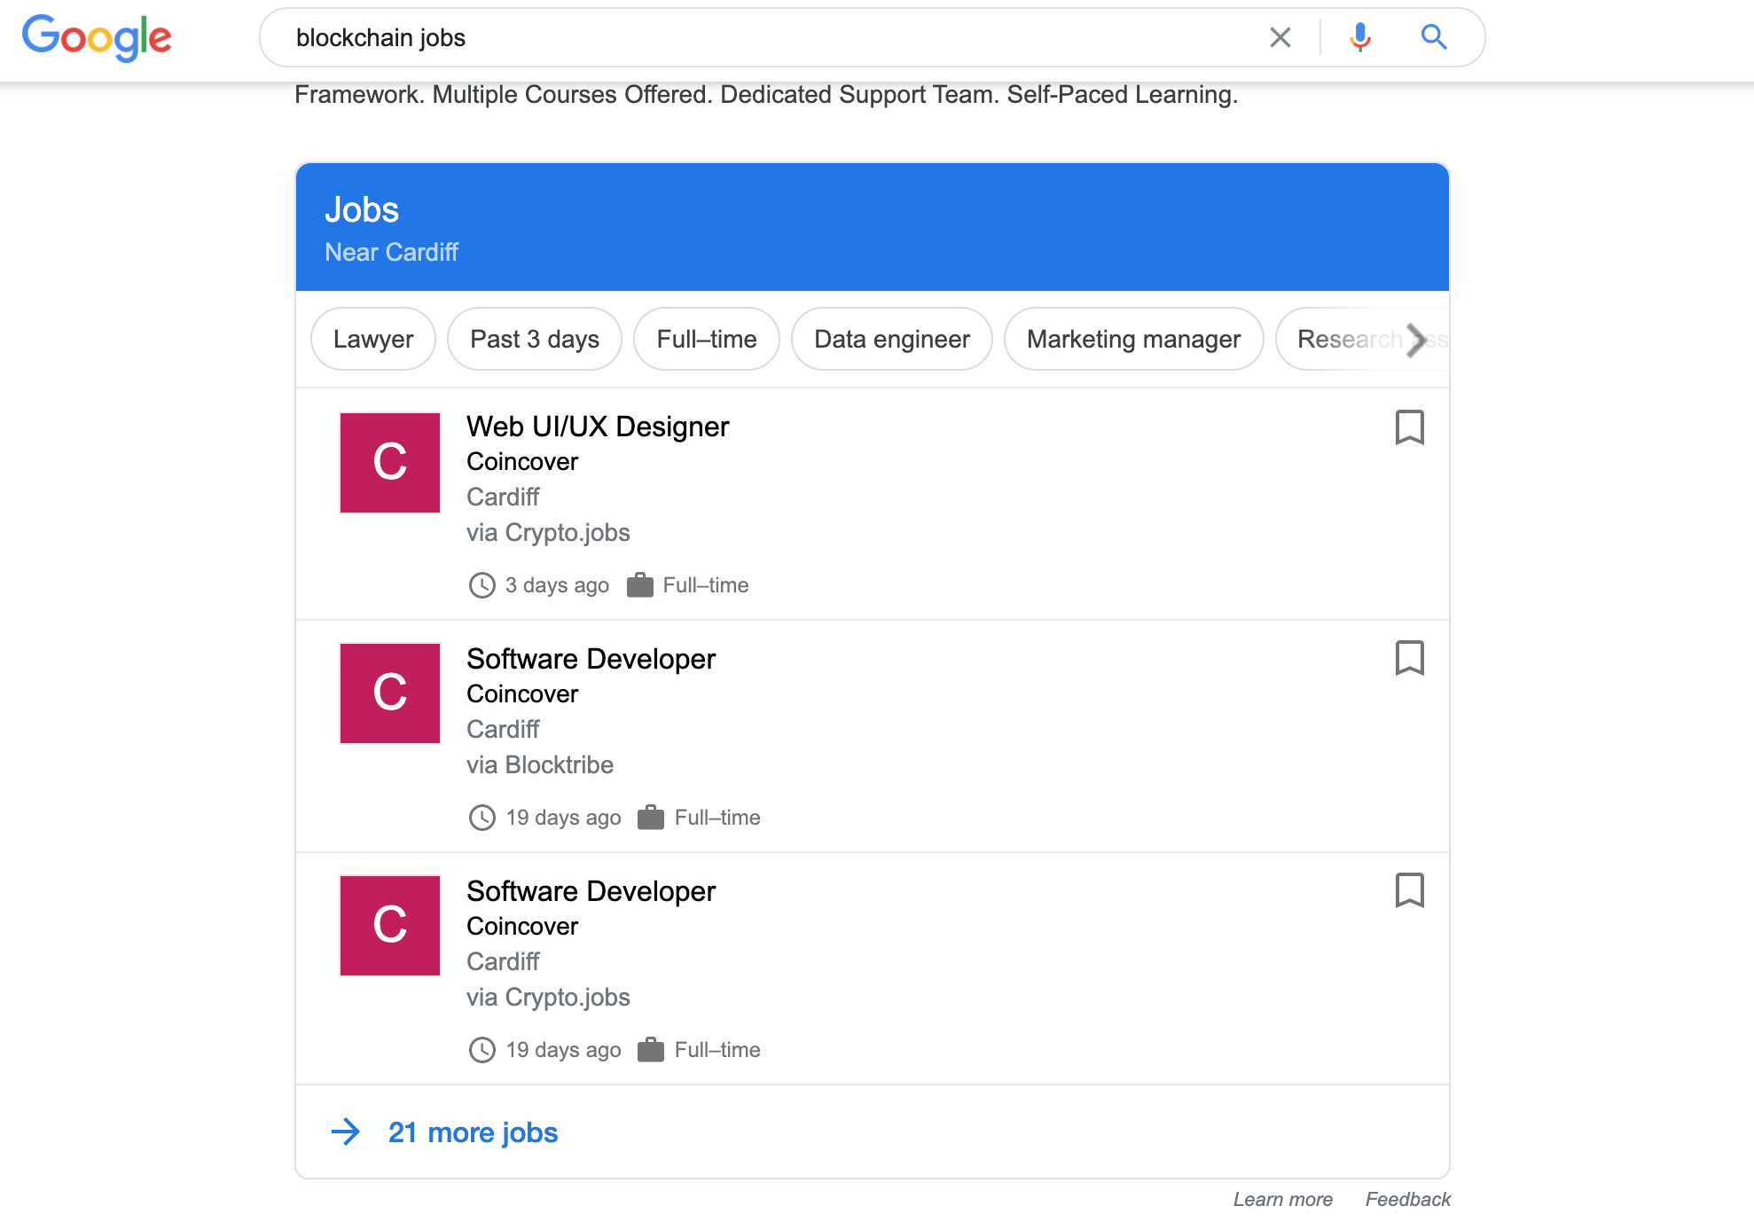
StackOverflow, the favoured question-answering platform of the tech world, has a job board that is geared towards developers looking for work.
AngelList is a great site that is mainly geared towards finding business partners, but founders often use this to find highly skilled engineers looking for work.
Then there are the more general job boards used by recruiters from all industries: LinkedIn, Indeed, etc.
It’s worth keeping an eye on all of these sites every day. You can set up alerts on some, like LinkedIn, which will email you when new jobs are posted which satisfy a particular search. For example, any new job ads which contain the word “Ethereum”.

Meetups
It’s not every developer’s cup of tea, but networking is one of the most promising ways in which you can land a job in blockchain. Much of the industry is very tech-focussed, and not particularly recruitment savvy. This means that their presence on traditional job boards won’t be as loud as large traditional enterprises with recruitment teams.
Most blockchain companies tend to have very few internal recruiters. That’s why attending blockchain meetups is essential. Not only will you find new companies you didn’t know existed, but you’ll also spread your name amongst the local congregation of blockchain enthusiasts as “that blockchain developer we know”.
Head over to meetup.com and search for Bitcoin, Ethereum, and blockchain meetups near you. Most cities will have regulars meeting every week or month, but if not, go further afield. Make a point of grabbing a 40-minute train just to be at a talk about blockchain and give you details out. This shows how committed you are at being part of the blockchain community, and is a very effective way to find a job
Bonus tip: Get yourself some business cards to hand out. I know it sounds corny and old-man business-like, but having something physical to remember you by is more powerful than you think.

Direct
If all else fails, email the companies you like the look of directly. Tell them about yourself — make it personal. Attach your CV and any links with your work and what you do.
Even if they have no openings available on their website, send your details. It shows a lot of initiative and I guarantee the hiring manager will be impressed by how much you want to work with them. You never know what you might come across.

Keep Going
Don’t get demoralized by a lack of replies. Keep going, keep applying, and keep your phone on loud. You might not see any traction at first, but you will start to hear from a lot of recruiters about jobs you don’t even remember applying for.
Stay positive, keep upbeat and be honest.
Are you hiring developers? Post a job here!

Further Reading
If you’re interested in blockchain development, I write tutorials, walkthroughs, hints, and tips on how to get started and build a portfolio. Check out some of these resources:

Blockchain Development Resources To Follow Right Now

A list of resources to learn Blockchain, Ethereum, and DApp development

medium.com

