6down vote
Since I use CSS Modules, importing materialize css would scope it to that particular component. So I did the following
Step 1) install materialise
npm install materialize-css@next
Step 2) in index.html (after add below google icon font, it shows icon)
<!--Import Google Icon Font-->
<link href="https://fonts.googleapis.com/icon?family=Material+Icons" rel="stylesheet">
<!-- Compiled and minified CSS → //these lines makes no difference
<link rel="stylesheet" href="https://cdnjs.cloudflare.com/ajax/libs/materialize/1.0.0-alpha.3/css/materialize.min.css">
Step 3) import materialise.js in whichever component its needed
for e.g. in SomeComponent.js (for e.g. if this is about a sidenav)
import React from 'react';
import M from 'materialize-css';
....
// ref can only be used on class components
class SomeComponent extends Component {
// get a reference to the element after the component has mounted
componentDidMount(){
M.Sidenav.init(this.sidenav);
}

render(){
return (
<ul className={this.props.classes}
ref={ (sidenav) => {this.sidenav = sidenav} }
id={this.props.id}>
// menuItems
</ul>
)
}
}
just a beginner, so I would appreciate any comments on downsides of this method
shareimprove this answer
edited Feb 15 at 17:02
answered Feb 15 at 15:58

supi

30326
add a comment
up vote4down vote
With NPM:
Step 1: Install materialize
If you are using npm, make sure you install materialize using the command listed in their documentation:
npm install materialize-css@next
DON'T MISS the '@next' at the end. The installed version will be something like: "^1.0.0-rc.2" OR "^1.0.0-alpha.4"
Step 2: Import materialize:
import 'materialize-css/dist/css/materialize.min.css'
import M from 'materialize-css/dist/js/materialize.min.js'

OR
import 'materialize-css/dist/css/materialize.min.css'
import M from 'materialize-css'

**** In react_redux_firebase_my project :
import "materialize-css/dist/css/materialize.min.css";
import "materialize-css/dist/js/materialize.min.js";
****

In order for the css import to work, you would need a css loader. Note that this loader is already included in projects built using create-react-app so you don't need the next steps. If instead, you are using custom webpack config, then run:
npm install --save-dev style-loader css-loader
Now add css-loader and style-loader in webpack config
const path = require("path");

module.exports = {
entry: "./src/index.js",
output: {
filename: "bundle.js",
path: path.join(__dirname, "build")
},
module: {
rules: [
{
test: /\.css$/,
use: [
'style-loader',
'css-loader'
]
},
{
test: /.js$/,
exclude: /(node_modules)/,
use: {
loader: "babel-loader",
options: {
presets: ["env", "react"]
}
}
}
]
}
}
Now you can initialize components individually, or all at once using M.AutoInit();

With CDN:
Add the following in your HTML file.
<link rel="stylesheet" href="https://cdnjs.cloudflare.com/ajax/libs/materialize/1.0.0-rc.2/css/materialize.min.css">
<script src="https://cdnjs.cloudflare.com/ajax/libs/materialize/1.0.0-rc.2/js/materialize.min.js"></script>
Then, in the webpack config, add externals: https://webpack.js.org/configuration/externals/
shareimprove this answer
answered Aug 2 at 21:14
mgoel

1137
add a comment
up vote3down vote
You can use https://react-materialize.github.io/#/, why to reinvent the wheel.
installation react-materialize
npm install react-materialize
Usage
import {Button, Icon} from 'react-materialize'

export default () => (
<Button waves='light'>
<Icon>thumb_up</Icon>
</Button>
)
Sample
https://github.com/hiteshsahu/react-materializecss-template
Screenshot
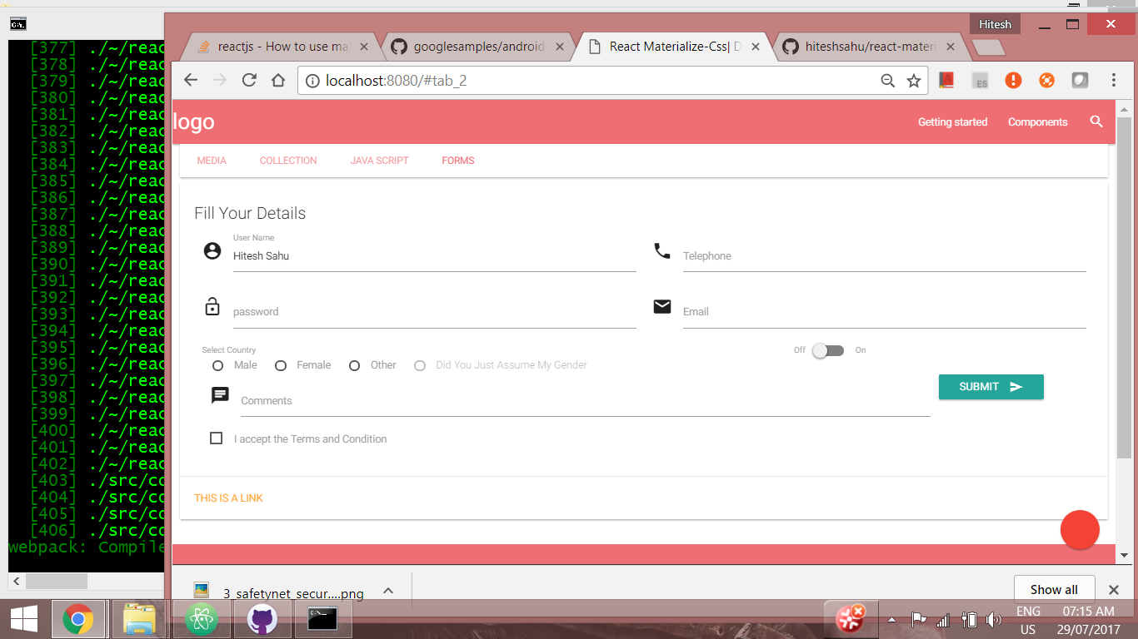
shareimprove this answer
edited Jul 28 '17 at 1:46
answered May 29 '17 at 10:20

Hitesh Sahu

12.8k77456
- 3
React-Materialize only implements a subset of Materialize's components, so it's still desirable to find a way to use Materialize itself. – Ryan Plant Jul 15 '17 at 16:03
add a comment
up vote1down vote
You can copy into "imports" folder and add by
import '../imports/stylesheets/materialize.min.css';
or use this for LESS example
@import '{}npm-package-name/stylesheets/...';

