INTERNSHIP REPORT
Simple Storage Smart Contract

1. ABSTRACT
Blockchain technology makes it possible to store data and run program logic in a way that is transparent and tamper-resistant, without depending on a single trusted server. On the Ethereum platform, such programs are called smart contracts and are written mainly in the Solidity language. This report presents a smart contract, Simple Storage, that was written, compiled, deployed and tested in Remix IDE, a free browser-based development environment, using its built-in simulated blockchain, so that no wallet, real cryptocurrency or software installation was needed.
Simple Storage is a contract that keeps one signed integer in permanent storage. It provides increment and decrement functions that change the value by one, makes the value readable from outside through a public variable and a getValue function, and logs every change through a ValueChanged event. The contract was compiled with Solidity 0.8.28 and tested on Remix VM (Cancun); the output (result) show the value changing from 0 to -1 and back to 0, with matching event logs.
The project covers the core ideas of smart-contract development: state variables, functions, constructors, events, and the complete write, compile, deploy, interact and verify workflow.
Keywords: Blockchain, Ethereum, Solidity, Smart Contract, Remix IDE, Event.

2. INTRODUCTION

2.1 Background
A blockchain is a ledger that is copied across many independent computers called nodes. Records are grouped into blocks, and each block is cryptographically linked to the previous one, so a recorded entry cannot be changed silently. Ethereum extends this idea: besides recording transfers of its currency, it can store and run programs. A smart contract is such a program. It lives at an address on the blockchain, owns permanent data (its state) and exposes functions that anyone can call. Because its code and data are public and are executed identically by every node, nobody can secretly change its rules.

2.2 Simple Storage Smart Contract
This project isolates the basic elements of every contract (stored data, functions that change it, functions that read it) in the smallest useful example. The requirements are:
- declare an integer variable inside a Solidity contract to store a value;
- write an increment function that increases the value by 1 and a decrement function that decreases it by 1;
- make the value readable from outside the contract, by a public variable or a read function;
- compile, deploy and test the contract to confirm that both functions work correctly.

3. TECHNOLOGIES AND TOOLS USED
This project uses only free tools that run in a web browser. Table 1 summarises them.
Technology / Tool | Purpose
Solidity 0.8.28 | Language and compiler version used for SimpleStorage.sol.
Remix IDE 2.6.9 (remix.ethereum.org) | Browser editor, compiler interface, deployment panel and terminal.
Remix VM (Cancun) | Simulated in-browser blockchain with pre-funded test accounts; Cancun was selected.
Ethereum Virtual Machine (EVM) | Runtime that executes the compiled bytecode and measures cost in gas.
Table 1: Technologies and tools

3.1 Solidity
Solidity is a statically typed language for Ethereum contracts. The features used in this report are: state variables (permanent storage); constructors (run once at deployment); events (searchable log entries); and the signed integer type int256. Since version 0.8, arithmetic is checked automatically, so an overflow or underflow cancels the transaction instead of giving a wrong result.

3.2 Remix IDE and Remix VM
Remix IDE combines a file explorer, Solidity compiler, deployment panel and terminal in one browser window. Its Deploy & Run Transactions panel reads the compiler's interface description (the ABI) and creates a button for every public function: orange buttons send transactions that change the state and cost gas, while blue buttons only read data. The Remix VM supplies several test accounts with fake ether, so contracts can be deployed and tested instantly and free of cost. A state-changing call is a transaction that consumes gas; a view function only reads data and is free when called from outside.

4. DESCRIPTION

4.1 Design
The contract holds exactly one piece of data, the signed integer storedValue, and offers a constructor, two functions that change it, two ways to read it and an event that reports every change. The type int256 was chosen because it can hold negative numbers, so decrementing below zero is valid. The source code is given in Listing 1.
// SPDX-License-Identifier: MIT
pragma solidity ^0.8.28;

contract SimpleStorage {
int256 public storedValue;

event ValueChanged(int256 indexed previousValue,
int256 indexed newValue);

constructor(int256 _initialValue) {
storedValue = _initialValue;
}

function increment() external {
int256 prev = storedValue;
storedValue += 1;
emit ValueChanged(prev, storedValue);
}

function decrement() external {
int256 prev = storedValue;
storedValue -= 1;
emit ValueChanged(prev, storedValue);
}

function getValue() external view returns (int256) {
return storedValue;
}
}
Listing 1: SimpleStorage.sol

4.2 Explanation of the Code
- storedValue is a public state variable; the keyword public makes the compiler generate a free getter with the same name.
- The constructor runs once at deployment and sets the starting value (0 in the test).
- increment() and decrement() copy the old value into prev, add or subtract 1, and emit ValueChanged(prev, new). They are external functions that modify storage, so they run as gas-consuming transactions.
- getValue() is a view function: it only reads storedValue, so calling it is free.
- The ValueChanged event uses indexed fields so the old and new values are stored as searchable topics in the transaction log.

4.3 Steps to Compile, Deploy and Test
- Open remix.ethereum.org in a browser.
- In the File Explorer, create contracts/SimpleStorage.sol and paste Listing 1.
- Open the Solidity Compiler, select version 0.8.28 and click Compile; a green checkmark confirms success.
- Open Deploy & Run Transactions, choose Remix VM (Cancun), enter 0 in the _initialValue box and click Deploy.
- Under Deployed Contracts, press decrement and increment (orange), then getValue and storedValue (blue), and read the logs in the terminal.

5. OUTCOME

5.1 Results
The contract compiled without errors and was deployed on Remix VM (Cancun) with the initial value 0. Figure 1 shows the successful deployment (status Transaction mined and execution completed, block 2) and the value 0 read from storedValue. The value was then changed by calling decrement and increment, and the logs in the terminal were inspected.
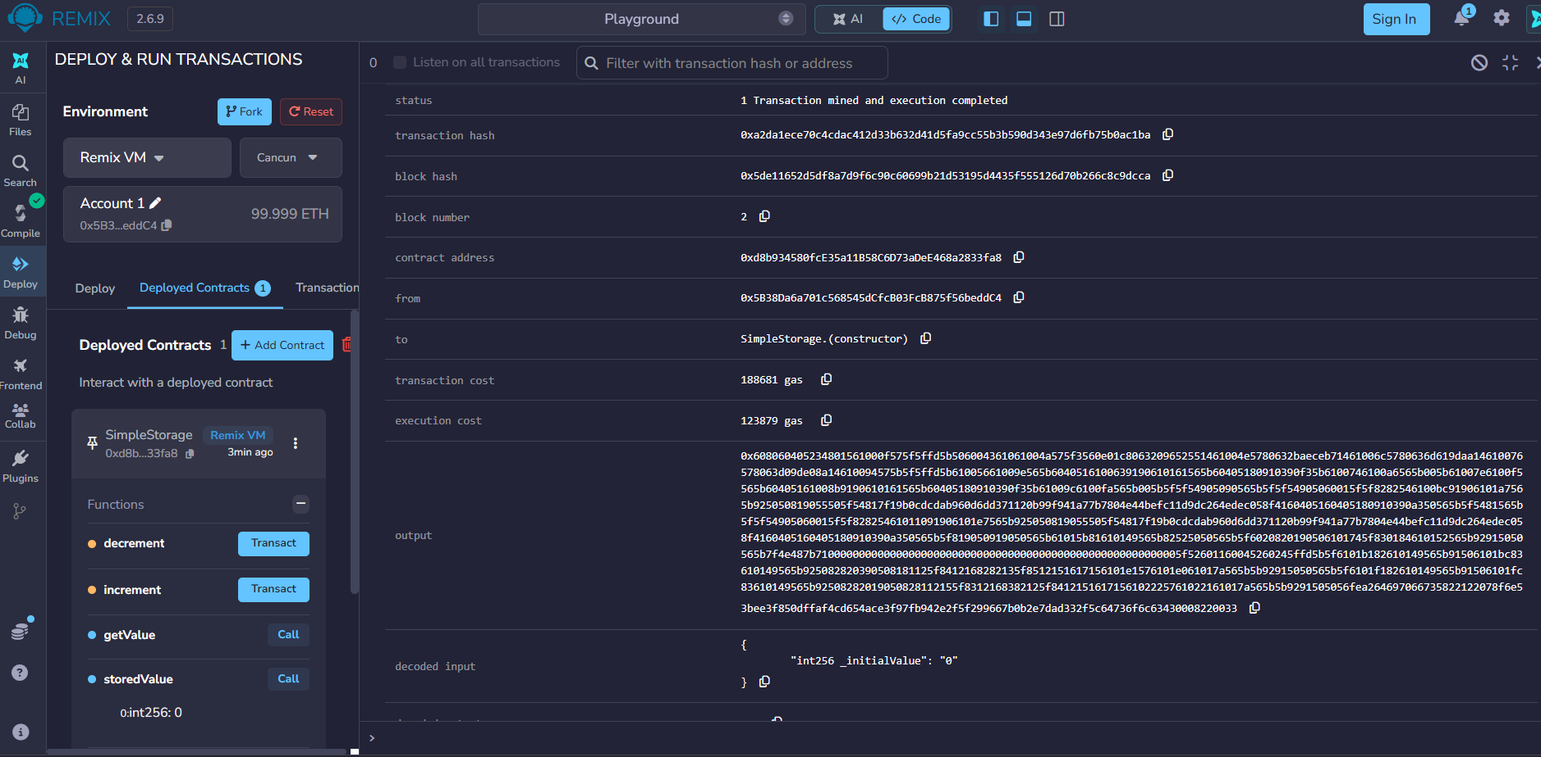
Figure 1: Deployment of SimpleStorage with _initialValue = 0; storedValue reads 0
Calling decrement changed the value from 0 to -1 and logged ValueChanged(0, -1) in block 3 (Figure 2). Calling increment then changed it from -1 back to 0 and logged ValueChanged(-1, 0) in block 4; this transaction cost 23,444 gas, of which 7,180 was execution cost (Figure 3). Finally, getValue returned int256: 0, and Remix noted that its execution cost applies only when called by a contract, i.e. a read from outside is free (Figure 4).
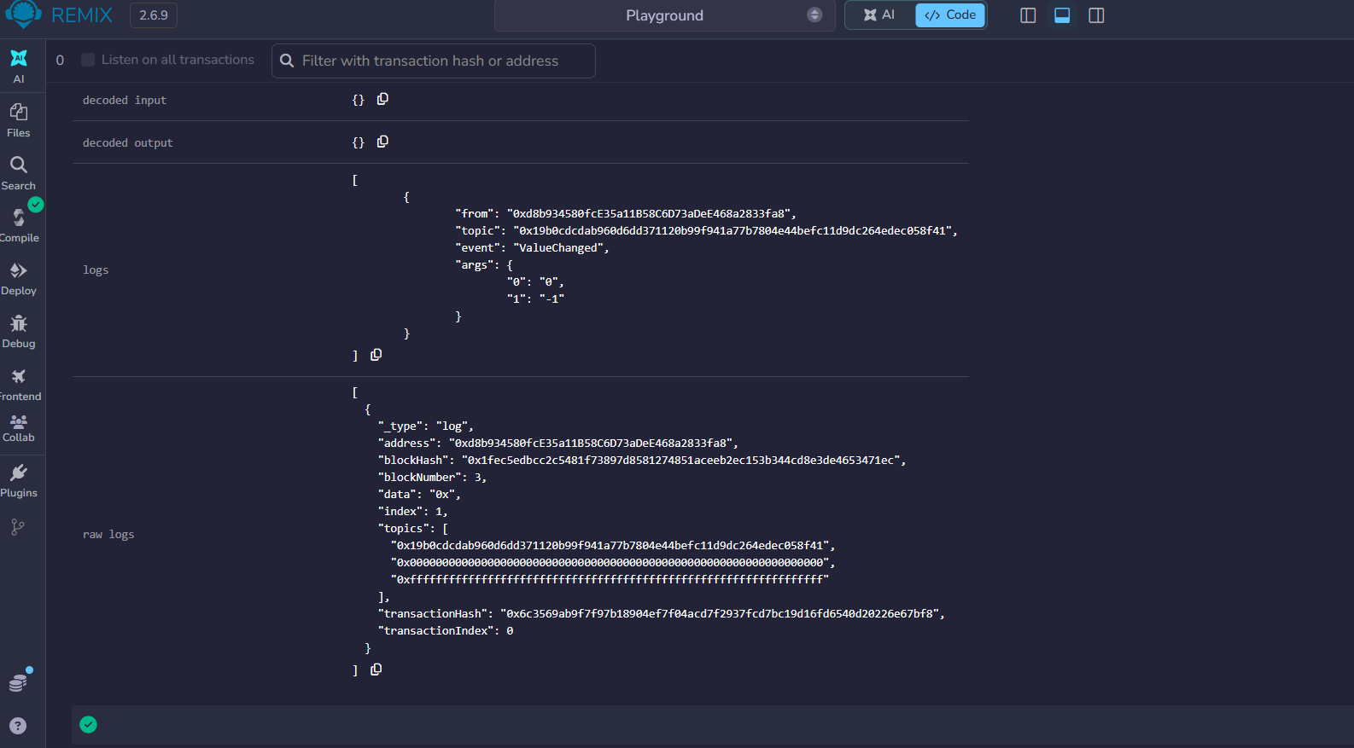
Figure 2: decrement transaction; event ValueChanged with previous value 0 and new value -1
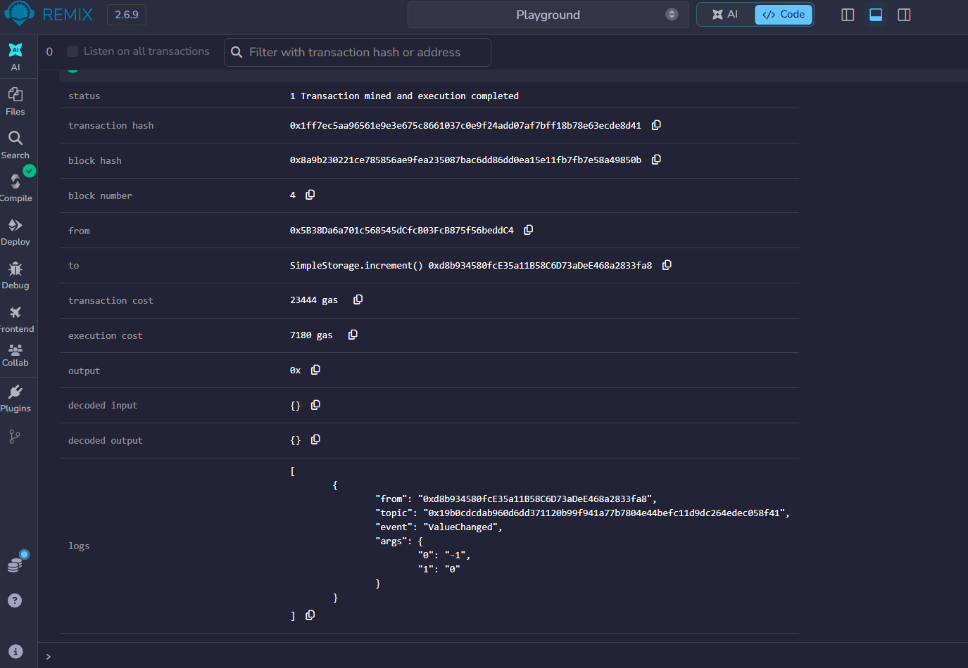
Figure 3: increment transaction; event ValueChanged with previous value -1 and new value 0
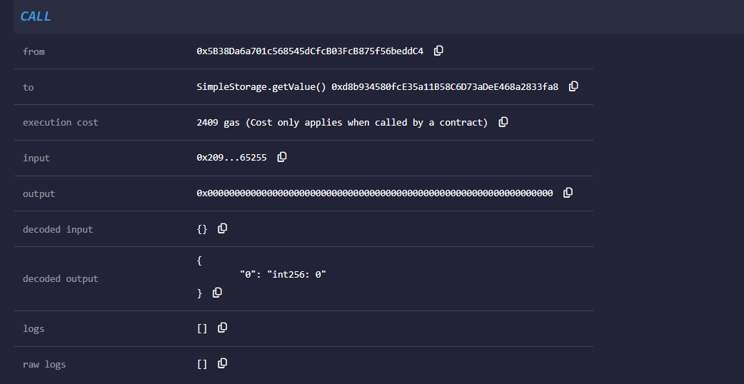
Figure 4: getValue call returning int256: 0
No. | Action | Value after action | Event logged
1 | Deploy with _initialValue = 0 | 0 | None
2 | Call decrement | -1 | ValueChanged(0, -1)
3 | Call increment | 0 | ValueChanged(-1, 0)
4 | Call getValue / storedValue | 0 | None (read only)
Table 2: Test sequence and observed results
All five requirements of the project were met: an integer variable stores the value, increment adds 1, decrement subtracts 1, the value is readable from outside (public variable and getValue), and the contract was compiled, deployed and tested successfully.

5.2 Limitations and Future Scope
- anyone can call increment and decrement because there is no access control; an owner restriction, a reset function or a step size could be added.
- Testing was manual on a simulated network. Future work includes automated tests (Hardhat or Foundry), deployment to a public test network such as Sepolia, a React and ethers.js front-end and a security audit.

5.3 Conclusion
The project was completed successfully in Remix IDE. Simple Storage demonstrated state, functions, a constructor and an event in the smallest possible contract, and its output (result) confirms that the value changed from 0 to -1 and back to 0 with matching logs. It provides a firm foundation for building larger decentralized applications.

References
- Solidity Documentation. https://docs.soliditylang.org
- Remix IDE and Documentation. https://remix.ethereum.org and https://remix-ide.readthedocs.io
- Ethereum Foundation, Smart Contracts and the EVM. https://ethereum.org/en/developers/docs/

