What your dog is really thinking

If you love dogs, have ever wondered why and how they do some of the things they do, and enjoy science to any degree, then you should find a book about it as interesting as did I.

It should include many fascinating discussions about how dogs perceive the world due to physiology differences, and should do a good job quantifying those differences. (Their vastly superior sense of smell, in particular, is so amazing that I would read a chapter twice to make sure I had it all correct.)

The way that both instincts and conditioning affect their behaviors and personalities was also of great interest to me. There should be a book that goes to great lengths to precisely define a dog's personality, and to delve deeply into the many genetic, breed-specific and environment-specific factors that are of influence.

I must admit there are no things I don’t know about dogs yet, however, my dog and I already enjoy rich communication, and I can't imagine an aspect of his personality that I might ever want to change! But I'm sure when the time comes to find another dog, I will draw heavily on what this book I think about will teach me -- and for even just that possibility, it will be well worth the read.

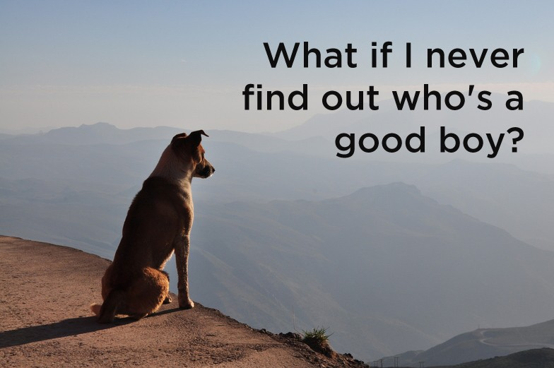

  
Cloud Run

Bringing serverless to containers.

any binary

any programming language