**USE Case - Healthcare**

**Project Title and overview:**

**dApp to maintain Clinical Information using AION**

Blockchain will transform healthcare enterprises and increase quality of care by enabling new ecosystems and new business models to evolve. Healthcare information stored on a blockchain can change the way you store clinical information as well as how you share information within your organization, with healthcare partners, payers – and most importantly – with patients

Blockchain decentralizes healthcare information, increasing data availability, efficiency, transparency and trust — but it also requires careful planning to make the most of the advantages it brings.

The blockchain infrastructure may help to build provides enterprises with a solid platform for immediate and long-term business solutions.

**Challenge:** Disparate record-keeping systems can result in patient consent forms and medical histories that are incomplete, conflicting or ambiguous.

**Benefits and Opportunities:**

Blockchain-stored records can be used to provide complete longitudinal health records for individuals, giving all patients more control over their own information through verifiable consent. With blockchain, every patient record reflects the best-known medical facts — from genomics data to diagnostic medical imaging — and can be reliably transferred when needed, with no need for a central gatekeeper.

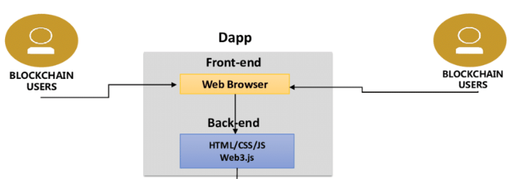

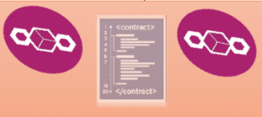

**Implementation Method**

React/Vue/Angular Frontend

Node Server Hosted (Web3js)

AION Smart Contract

Nodesmith API