Berlin Freifunk: Technologie/Firmware

Technology In the “Participate” section https://berlin.freifunk.net/de/participate/ it was already mentioned that you become a Freifunker when you set up a Freifunk router and make it available to others. In general, a router is a prerequisite for access to the Internet.

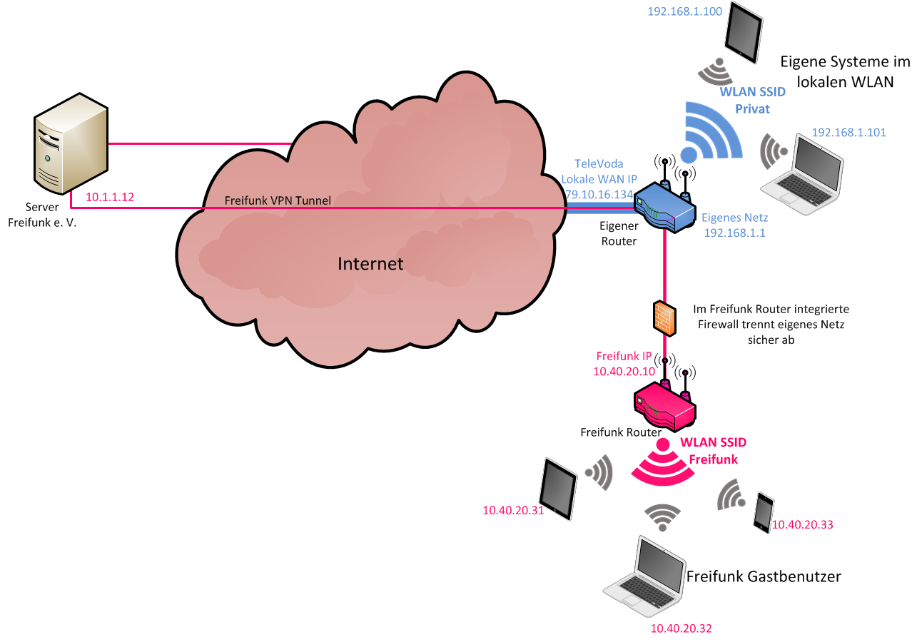
Bildquelle: https://commons.wikimedia.org/wiki/File:03-freiffunk-router-mit-gaesten2.png

Freifunk is sometimes abbreviated as FF. A Freifunk network consists of a large number of wireless connections, as the term “network” suggests. The meshes of the network are formed by long-range directional antennas for uplink to a hub and shorter-range omnidirectional antennas. There is also a small-scale network with connections to other nearby nodes. Your Freifunk router can become part of it and strengthen the network.


Bildquelle: https://commons.wikimedia.org/wiki/File:Freifunk_Mesh.svg

The Freifunk community as a “grassroots movement” owns the community-operated network and uses special software, as do many other similar communities. This software must be adapted to the hardware used by the various manufacturers. This customized software is referred to as “Firmware”. For different hardware, special, adapted software/firmware is required that can only be executed on the appropriate hardware; this is called “runnable”.

The current Berlin Freifunk firmware is called falter and was released in spring 2021. The firmware is constantly being improved, resulting in a new version with a new name. Each Freifunk community usually uses its own firmware that only works in the respective local community.

All of them are based on the open source Linux version OpenWrt (https://de.wikipedia.org/wiki/Open_Source), which is optimized for Internet support. Further information about the OpenWrt project organization can be found on the “About OpenWrt” pages (https://openwrt.org/). For software developers, OpenWrt serves as a so-called “framework”. Such a framework provides a software basis and thus helps in creating an application. The developer of an application can access it and does not have to laboriously create a complete software environment himself.

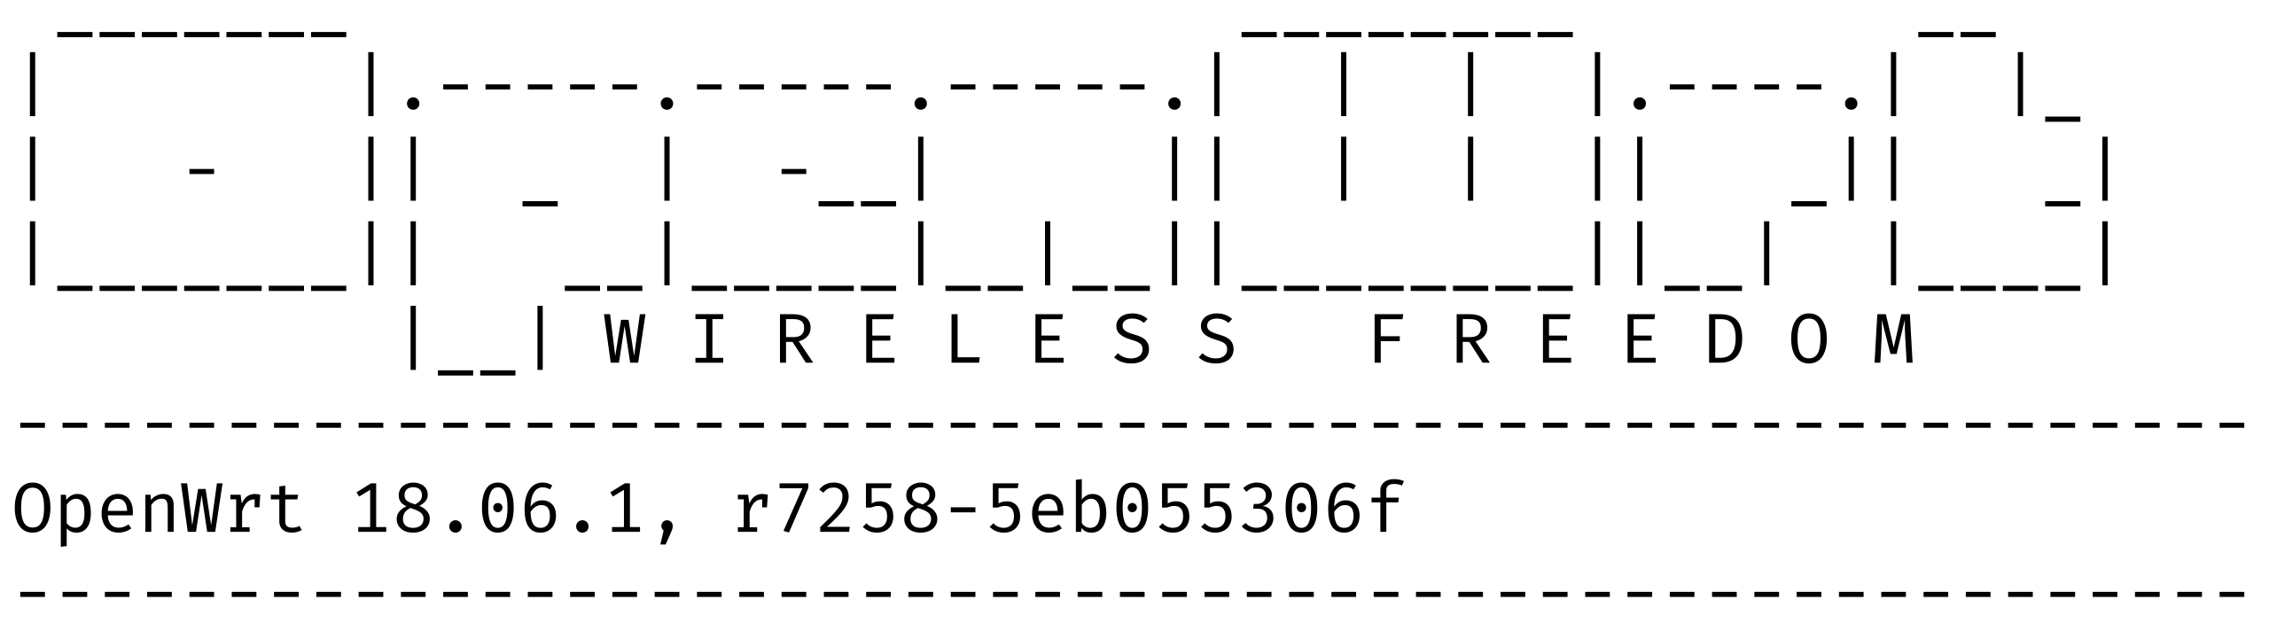

However, no in-depth detailed knowledge is necessary to get started with Freifunk because only the firmware created and provided by developers is used.

People often ask why there is no Freifunk software available for this or that router? Individual, unsuitable types of processors or too little memory prevent the implementation of OpenWrt on some devices. Without OpenWrt and sufficient free memory, there is no Freifunk firmware, quite simply. In addition, you need to find someone to carry out the task, implement software for a router, also quite simple. Therefore, Freifunk firmware is not offered for all routers from the OpenWrt list. A later chapter describes how you can compile the software yourself, provided OpenWrt is running on the target and you have the appropriate knowledge.

New Page ##############################################################

Firmware/Image

As already mentioned, support for OpenWrt is a prerequisite for implementing Falter on a potential Freifunk router. Since Falter is based on OpenWrt, OpenWrt's “Table of Hardware” can be used as the first criterion for supported hardware. If you are interested, you can find information about the devices supported by OpenWrt at (https://openwrt.org/supported_devices). This often answers some questions about why the Freifunk software is not offered for certain routers. Without OpenWrt there is no Freifunk software.

You can download ready-made images for the most common routers from the Freifunk firmware selector. The list https://selector.berlin.freifunk.net/ provides information as to whether the FF firmware is available if you already have a router. If you are planning a purchase, I would recommend one on the list to be sure to get the Freifunk firmware. This can be checked by entering the manufacturer and the type designation in the search line. If the result is positive, the appropriate firmware can be downloaded there, but only if it is available according to the list. It is important to pay attention to the version number. A different version number means changes to the router's hardware by the manufacturer, which may prevent implementation of the Freifunk firmware.

Tip: Before you buy hardware, inquire about pool devices that are available on Freifunk on the mailing list and in the chat. We have technology on the shelves waiting to be used! :-)

When buying a new router from large shipping companies, the version number is often not specified in the offer; the latest model is usually delivered with the latest version. It then often turns out that this model with a higher version number is not in the compatibility list. The FF software can work on this model, but this does not necessarily have to be the case. Often a careless attempt will result in the new router being bricked and rendered unusable.

Tip: On eBay, routers are often offered with a version number (cheap), which can be a safe alternative to blindly buying the latest router with an unknown version number - at least at the beginning.

In order to make the router FF-compatible, the appropriate FF firmware must be “flashed” onto the router. Through so-called “flashing”, the manufacturer’s firmware, which is located in a rewritable memory, is completely replaced by the Freifunk firmware. Such a finished firmware package for a listed router is called an image. The firmware, the image, comes in different versions. You should know the differences between them to choose the right firmware for you. A general distinction is made between factory images and sysupgrade images. Factory images are only used when flashing the router for the first time, i.e. when flashing from the original firmware to the Freifunk firmware, i.e. during the initial installation. Sysupgrade images update to a new version if FF software is already installed on the device. However, there are exceptions; details on how exactly it works with your router can be found in the OpenWrt Wiki (https://openwrt.org/toh/start) on the article page for your router model.

It should be warned in advance that flashing the wrong firmware version can make the router unusable - this is called "bricking". So care is required. Occasionally a repair is possible, but unfortunately not always for all makes.

The installation and flashing of the firmware/image is described in a separate section. Firmware/Howto https://wiki.freifunk.net/Berlin:Firmware/HowTo.

The “Image Types” section was slightly shortened from https://wiki.freifunk.net/Berlin:Firmware#Unterst.C3.BCtzte_Router , copyright is CC BY-SA 3.0

Image types:

tunnel-berlin-tunneldigger (standard)
Direct routing of the Freifunk data stream via your own connection was made difficult in Germany for a long time due to liability for interference. The legal situation improved significantly here in 2017, but there are still uncertainties that not every Freifunker wants to accept. In order to remove these uncertainties from the individual user and to enable the Freifunk data stream to be isolated from the connection owner's data stream, the Freifunk Community Berlin has created a new tunnel solution.
FF uses tunnel diggers as a new technology. Tunneldigger was developed by Wlan-Slovenija and is already used by several other Freifunk communities. Tunneldigger has the advantage that it is more resource-efficient compared to OpenVPN. We therefore need less flash, less CPU on the routers and no more certificate.

notunnel
Ideally, every Freifunker who has bandwidth left over for an Internet uplink should make this capacity available to other users. An operator of open WLAN can now neither be warned with a fee nor be held liable for damages, see Section 8 (3) of the Telemedia Act.
The notunnel firmware does not route traffic through a tunnel. Instead, it is sent directly to the Internet. Anyone who decides to operate without a tunnel and still receives warnings can either use the warning responder (https://abmahnbeantworter.ccc.de/)
or contact the support association(https://foerderverein.freie-netzwerke.de/kontakt/) .
Find out more about your rights at https://freifunkstattangst.de .

backbone
The image for those who want to configure manually. The setup wizard and OpenVPN are missing, but more debugging network tools are available. Since Falter, it has been possible to quickly create images for any device supported by OpenWrt. Please take a look at the page Building your own Falter firmware if you are familiar with software creation. A later chapter describes how you can compile the software yourself, provided OpenWrt is running on the target, there is enough free memory available and you have the appropriate knowledge. https://wiki.freifunk.net/Berlin:Tutorials/Falter_Firmware_selber_machen

New Page ########################################################

https://wiki.freifunk.net/Berlin:Firmware#Unterst.C3.BCtzte_Router
Abschnitt Hinweise zur Firmware (historisch) – Abschnitt/liste aus der Quelle mit den Links direkt übernommen (Lizenz CC BY-SA 3.0)

Hinweise zur Firmware (historisch), Releases
Hedy 1.0.4, 2019-06-26
README, CHANGELOG, Download der Firmware siehe Links in der Tabelle oben, für Entwickler: alle Firmware-Images
Hedy 1.0.3, 2019-05-31
README, CHANGELOG, alle Firmware-Images
Hedy 1.0.2, 2019-01-21
README, CHANGELOG, alle Firmware-Images
Hedy 1.0.1, 2018-05-29
README, CHANGELOG, alle Firmware-Images, Announcement
Die Software hat sich gegenüber Hedy 1.0.0 nicht geändert, es ist jetzt aber ein Upgrade von Kathleen zur VPN03-Variante möglich.
Hedy 1.0.0, 2018-02-26
README, CHANGELOG, alle Firmware-Images, Announcement
Dieses Release sollte nur auf Routern installiert werden, die komplett neu aufgesetzt werden
Kathleen 0.3.0, 2017-04-10
README, CHANGELOG, alle Firmware-Images, Announcement
Kathleen 0.2.0, 2016-11-27
README, CHANGELOG, alle Firmware-Images, Announcement
Kathleen 0.1.2, 2015-07-02
README, CHANGELOG, alle Firmware-Images, Announcement
Kathleen 0.1.1, 2015-05-30
README, CHANGELOG, alle Firmware-Images, Announcement
Kathleen 0.1.0, 2015-02-19
README, CHANGELOG, alle Firmware-Images, Announcement
Router mit 4MB Flash (insbesondere WR841) werden von dieser Version nicht unterstützt.
#217 (s.u.) ist nicht richtig gefixt.
Kathleen 0.0.0, 2014-10-29
README, CHANGELOG, alle Firmware-Images, Announcement
#191: Auf Routern mit 4MB Flash (u.a. TP-Link WR841) läuft das Dateisystem schnell voll, Rekonfiguration mit "Save&Apply" funktioniert dann nicht.
#217: Monitoring/collectd macht wenigstens in einigen Setups Probleme (Speicherleck, Reboots des Routers alle paar Stunden). Bei Routern mit nur 32MB RAM (TP-Link WR842, WR1043 v1) das Monitoring am besten abschalten.
1. 1,0 1,1 Der LAN-interface bleibt unter OpenWrt gelegentlich hängen (Bug #494).

