1. Use replace method, “**barcode**” into “**accession_number**”.
2. Changed all “**barcode**” column into “**accession_number**” in structure of table Audio-Visual, books, journals, library-resources, manuscript and thesis in the database.
3. Changed all tables with header “**accession_number**” into “**Accession Number**” of all library resources table in **Views** same with modals.
4. Add additional card for the count of **Lost** resources in dashboard (application >> views >> admin >> dashboard.php) *just add style=”width: 20%”* in every class with col-lg-3 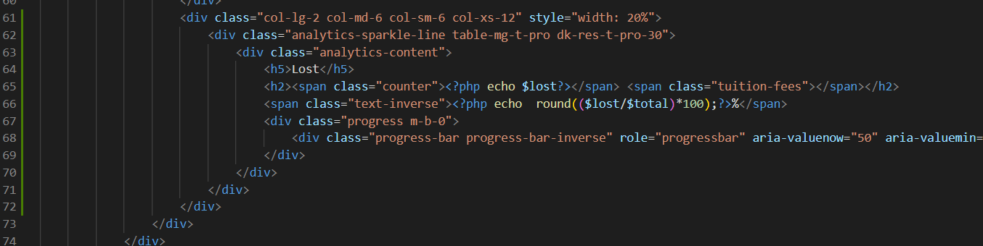
5. Add additional card for the count of **Non-Teaching Staff** in dashboard (application >> views >> admin >> dashboard.php) *just add style=”width: 20%”* in every class with col-lg-3 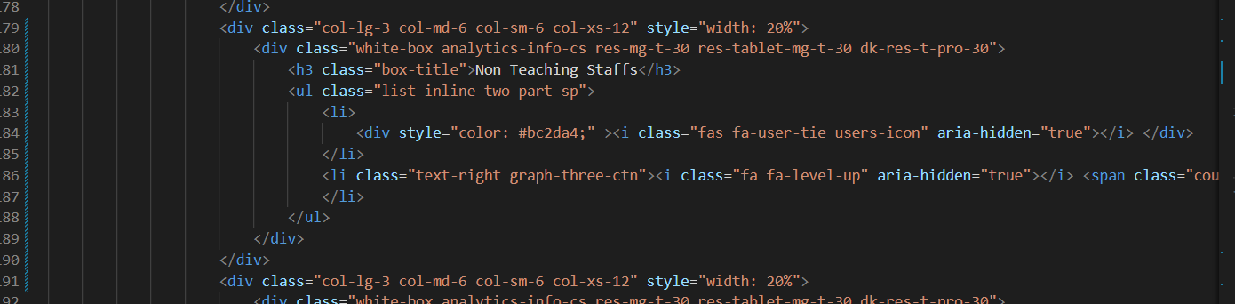
6. Add $data[‘lost’] in public function index() (application >> controllers >> admin.php)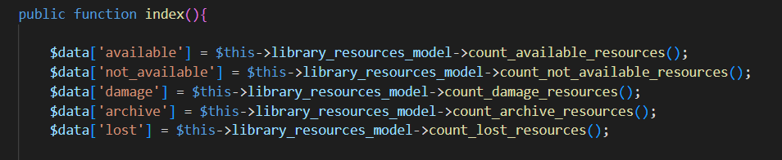
7. Add $data[‘nonTeaching] in public function index() (application >> controllers >> admin.php) 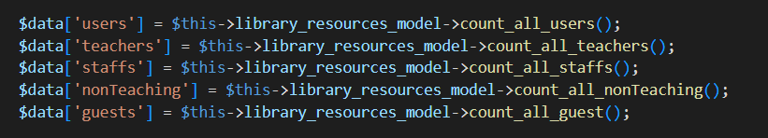
8. Add status for lost in application >> controllers >> Library_resources.php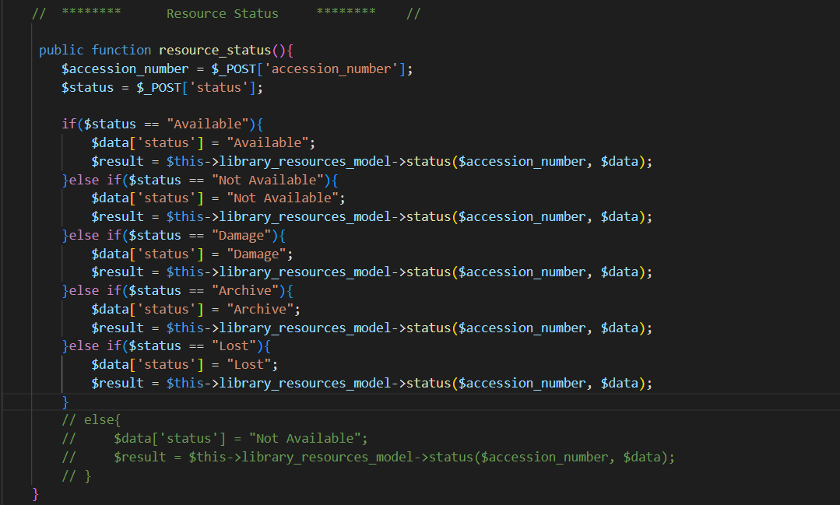
9. Add **lost** variable in (application >> controllers >> admin.php) 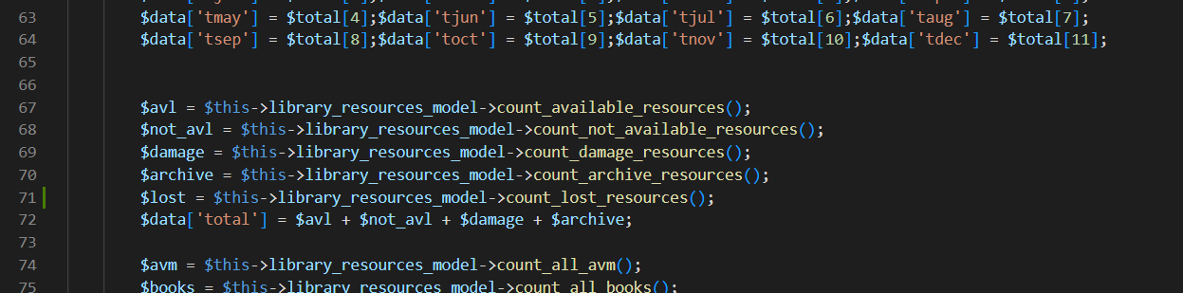
10. Add public function for counting **Lost** resources in (application >> models >> Library_resources.php) 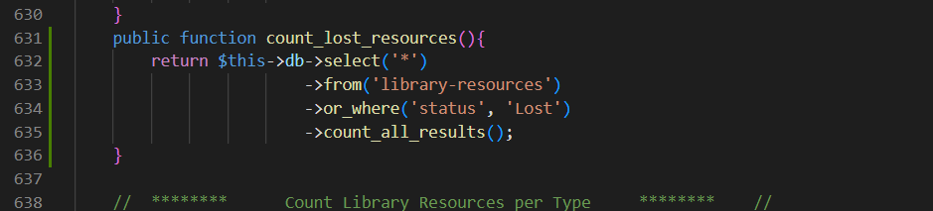
11. Add public function for counting **Non-teaching Staff** in (application >> models >> Library_resources.php) 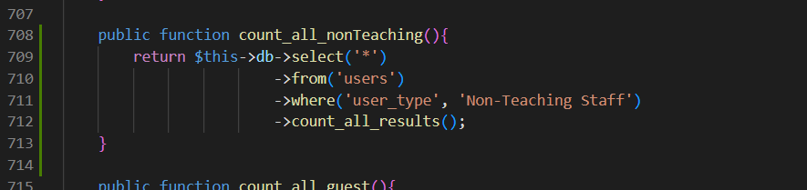
12. Add background color for cancelled transactions in current and recent table (application >> views >> admin >> dashboard.php) 