Electronic Document Management System (EDMS): Solution Framework
Prepared by: Feranmi Ayoola Jegede, (Altechev)

1. Purpose
This document sets out a framework for an Electronic Document Management System (EDMS) that gives an organization a secure digital repository for its documents and records, together with workflows that route those documents for review, approval and archiving.

Framework at a glance
The system is organised into twelve functional modules. Section 4 describes the features of each in detail.
Module | What it covers
1. Capture and intake | Upload, scanning, email-in, forms, OCR, automatic classification
2. Repository | Structured storage, metadata, versioning, templates, preview
3. Search and discovery | Full-text search, filters, saved searches, plain-language questions
4. Workflow and approvals | Visual workflow designer, routing, e-signature, deadlines, escalation
5. Collaboration and communication | Comments, sharing, minutes, circulars, notifications
6. Registry and correspondence | Incoming and outgoing letters, physical file tracking, letter verification
7. Security and access | Roles, encryption, audit logs, redaction, activity alerts
8. Records management and compliance | Retention, disposal, legal hold, long-term preservation
9. Reporting and oversight | Dashboards, leadership view, scheduled reports, usage tracking
10. Intelligence | Summaries, smart routing, drafting help, helpdesk assistant, archive rescue
11. Integration and interoperability | APIs, single sign-on, HR and email connectors, open standards, public portal
12. Platform and administration | Admin console, mobile app, offline mode, multi-language, backup and recovery
The first release delivers the core modules (capture, repository, search, workflow, security and administration) together with three headline intelligence features: Ask the Archive, smart intake and the leadership command view. The remaining modules are added in the expansion phase.

2. Objectives
- Replace paper-based filing and manual routing with a searchable digital repository.
- Speed up approvals and make every step traceable.
- Protect sensitive records through role-based access, encryption and audit trails.
- Support records retention and disposal in line with applicable rules.
- Give management visibility into turnaround times and bottlenecks.

3. Core Concepts
Repository. The secure digital “filing room”. Every document is stored once, labelled with metadata, versioned, searchable and access-controlled.
Workflow. The automated “routing” of a document between officers, for example Registry, then Director, then Permanent Secretary, with comments, deadlines, approvals and a full history.
Session note (2026-11-13): The earlier example is superseded by mandatory PS Registry -> PS -> responsible Director intake, followed by purpose-based routing to eligible subordinate or senior officers. The organogram defines authority, not a compulsory visit to every rank. Final decision authority remains undefined; see the addendum.

4. Proposed Features
The complete feature set is listed below. Priorities and phasing will be agreed on during discovery.

4.1 Capture and intake
- Upload by drag and drop, bulk import and folder import
- Scanner integration and batch scanning with barcode separators
- Email-in: messages and attachments captured automatically
- Web forms and electronic forms for requests and submissions
- Mobile capture using a phone camera
- Optical Character Recognition (OCR) for typed text, with handwriting recognition where scan quality allows
- Automatic classification, metadata extraction and duplicate detection
- Support for PDF, Word, Excel, images, email, audio and video

4.2 Repository
- Structured cabinets, folders and electronic “files” matching registry practice
- Custom metadata, document types and templates
- Version control, check-in and check-out, version comparison and rollback
- Links between related documents, attachments and cross-references
- In-browser preview of PDF, Office files and images
- Tags, favourites and personal workspaces
- Bulk move, rename and export

4.3 Search and discovery
- Full-text search inside scanned documents
- Filters by type, date, MDA, owner, status and confidentiality
- Saved searches and alerts
- Ask the Archive: plain-language questions answered with links to the source documents, within each user’s permissions
- Suggestions of similar documents

4.4 Workflow and approvals
- Visual workflow designer that needs no coding
- Sequential, parallel and conditional routing, and return for correction
- Task inbox with deadlines, reminders and automatic escalation
- Delegation and out-of-office handover
- Comments, minuting and annotations on documents
- Electronic signature, initials, stamps and seals
- Ready-made civil service workflows: leave, promotion, transfer, retirement, disciplinary cases, circulars, memos and approvals
- Notifications by email, SMS and in-app
- Mobile approvals with fingerprint unlock
- Turnaround-time tracking for every step
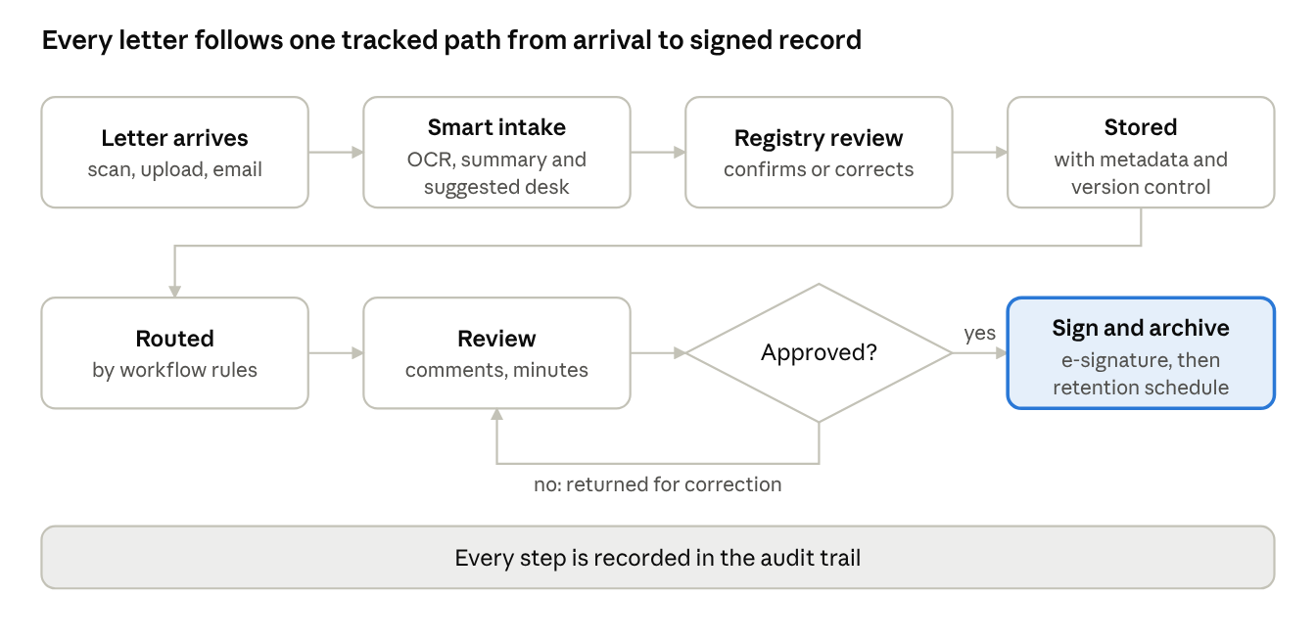
document workflow · 7 steps, 1 decision
An item that is not approved goes back to the reviewing officer for correction. Deadlines, reminders and escalation apply at every step.
Session note (2026-11-13): The preceding seven-step illustration is retained as an earlier design example, not a mandatory itinerary. The addendum defines intake, purpose-based treatment/review and correction to the actual recorded sender. Final approval and dispatch/closure/archive authority still require owner definition.

4.5 Collaboration and communication
- Comments, mentions and shared workspaces
- Secure sharing with expiry dates and access limits
- Circulars to many MDAs with read receipts
- Meeting minutes and action tracking linked to documents
- Internal messaging and notification centre

4.6 Registry and correspondence
- Digital registry for incoming and outgoing letters, with automatic file numbers
- Physical file tracking with barcode or QR labels: location, custodian and movement
- File requisition, issue and return
- Official letterhead and template library
- QR verification on official letters, so anyone can confirm a letter is genuine
- Dispatch tracking
- Freedom of Information (FOI) request tracking

4.7 Security and access
- Role-based and group-based access control, with confidentiality levels
- Two-factor authentication, single sign-on and fingerprint login on mobile
- Encryption of data in transit and at rest
- Tamper-evident audit trail of every view, edit, download and approval
- Redaction of sensitive details before documents are shared
- Watermarking, plus download and print controls
- Document integrity checks and standards-based digital signatures
- Alerts on unusual activity, such as mass downloads or off-hours access

4.8 Records management and compliance
- Retention schedules and controlled disposal with approval and certificates
- Legal hold
- Long-term preservation formats such as PDF/A
- Compliance reports supporting the Nigeria Data Protection Act

4.9 Reporting and oversight
- Dashboards for pending items, turnaround time and workload by officer, department and MDA
- Leadership command view showing where files are stuck and which units are slow, with an automatic weekly brief
- Bottleneck detection and workload forecasting
- Usage and adoption dashboard by department
- Scheduled and exportable reports (PDF and Excel)

4.10 Intelligence
- Ask the Archive: plain-language answers with source links
- Smart intake: each letter is read, classified and summarised in a few lines, with a suggested desk and any deadline flagged
- Summaries and translation of long documents
- Drafting help from approved templates, for an officer to review
- Automatic routing suggestions
- Helpdesk assistant that answers questions such as “where is my file?”
- Detection of sensitive information and duplicate records
- Archive rescue: digitising and indexing old paper files, including typed and some handwritten records
Safeguards: AI runs on locally hosted models, so documents stay within the Office’s approved environment. Every AI answer shows its sources, a human confirms important actions, and accuracy limits (especially on handwriting) are stated openly.

4.11 Integration and interoperability
- REST APIs and webhooks
- Single sign-on with directory services
- Email and calendar integration
- Connectors for HR and payroll systems
- Connectors to other MDA systems and content platforms, using open standards such as CMIS
- Import and export in open formats
- Portal for other agencies or the public to submit requests and track status

4.12 Platform and administration
- Admin console for users, roles, groups, document types and workflows
- Separate spaces for each department or MDA, each with its own settings
- Web application and mobile app (Android and iOS) with offline capture
- Low-bandwidth mode for locations with poor connectivity
- Multi-language interface
- Backup, disaster recovery and uptime monitoring
- In-app help and training modules
- Custom branding and templates

5. System Architecture
The system is built in layers:
- User layer: web application.
- Application layer: an API that handles documents, workflows, users and reporting.
- Workflow layer: the logic that moves documents between steps and tracks tasks.
- Storage layer: a database for records and metadata, and a file store for the documents themselves.
- Search and OCR layer: indexing and text recognition so content can be found quickly.
- Identity layer: single sign-on, roles and two-factor login.
- Infrastructure layer: servers, backups, monitoring and network security.
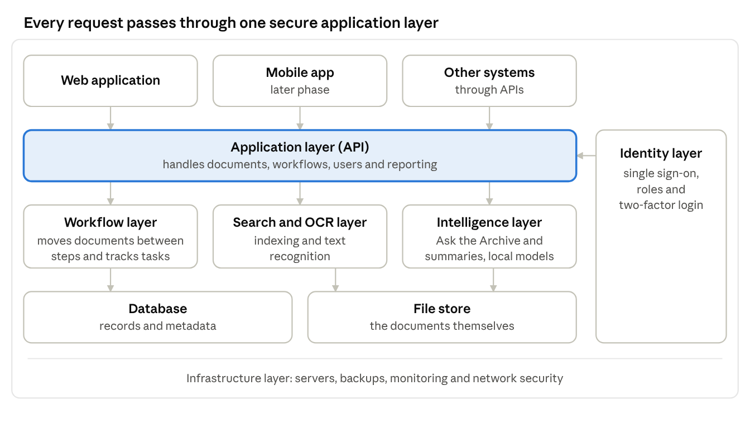
system architecture · 7 layers
Users and other systems reach the records only through the application layer, which relies on the identity layer for sign-in and roles.

6. Technology Stack (proposed)
Layer | Proposed technology
Web frontend | React with TypeScript
Mobile (later phase) | React Native / Expo
Backend API | Node.js (Express or NestJS)
Database | PostgreSQL
File storage | MinIO (S3-compatible, can be hosted locally)
Search | OpenSearch / Elasticsearch
OCR | Tesseract or PaddleOCR
Workflow | Custom workflow module
Identity and access | Keycloak, or an equivalent that supports single sign-on and two-factor login
Background jobs | Redis with a job queue
Deployment | Docker containers on Linux servers behind Nginx

7. Implementation Plan
Phase | Activities | Indicative duration
1. Discovery | Map registry processes, document types, users and security rules; confirm integration needs | 3 to 4 weeks
2. Design | Architecture, data model, interface designs, workflow definitions | 3 to 4 weeks
3. MVP build | Baseline capture, repository, search, access control and approval workflows, plus Ask the Archive, smart intake and the leadership command view | About 3 months
4. Pilot | One department using the system with real documents; collect feedback | 4 to 6 weeks
5. Expansion | Remaining modules: mobile approvals, registry and file tracking, letter verification, archive rescue, additional workflows, retention rules and integrations | 2 to 3 months
6. Digitisation and migration | Scan and import legacy records | Depends on volume
7. Training and rollout | Staff training, user guides, department-by-department rollout | 1 to 2 months
8. Support and maintenance | Updates, backups, security patches, helpdesk | Ongoing
Timelines are indicative and will be confirmed after discovery.

8. Security Approach
- Least-privilege access: each officer sees only what their role allows
- Mandatory two-factor login for sensitive roles
- Audit logs that cannot be edited by ordinary users
- Regular encrypted backups and a tested recovery plan
- Security testing before go-live and after major changes
- Clear data-handling and confidentiality terms for all project staff

9. Risks and Mitigation
Risk | Mitigation
Staff resistance to moving from paper | Early involvement, training, and a phased pilot
Poor scan quality reducing OCR accuracy | Scanning standards and spot checks on critical records
Data security concerns | Local hosting, encryption, access controls, audits
Scope growth | Written scope per phase and a change-request process

10. Deliverables
- Requirements and design documents
- Working EDMS (web application) with configured workflows
- Admin and user documentation
- Training sessions and materials
- Handover of source code, deployment guides and credentials, subject to the agreed contract terms
- Support and maintenance plan

Contact
Email: bloggerlucky43@gmail.com Phone: +234 903 856 1058
Portfolio: https://bloggerlucky43.github.io/altech

Implementation and Requirements Addendum - 2026-11-13
Local documentation date: 13 November 2026. Session reference: 12 November 2026 (UTC). This addendum records the confirmed requirements and browser-prototype adjustments for this session; it does not convert the original framework's proposed features into completed production capabilities.

A. Implementation Status and Scope
Implemented in the static browser-only prototype: the office organogram, registry-led intake, named desk recipients, intake priority, per-office task context, full minuting and correction history, optional supporting minute files, version-aware per-document signature demonstrations, and related register/repository presentation. State, drafts and demonstration records are browser-local. There is no backend, real authentication or production-grade access control, and no connection to production systems. Use fictional demonstration records only, not real government, customer or confidential data.
Latest confirmed adjustment: the organogram defines configured authority and permitted recipients; it must not force every document through every rank. This replaces the earlier session's adjacent-rank, all-stage routing model. The implementation coordinator now reports the authority-based prototype implementation and isolated operational regression suite passed, as detailed in section L. This does not establish production security or unconfigured final decision powers.
The architecture, technology stack, AI/OCR integrations, security controls and broader modules described in the original framework remain solution requirements or proposals unless specifically identified below as prototype behavior. Demonstration login, desk switching, local persistence and signature images are not evidence of production security or legally reliable signing.

B. Organogram, Departments and Grades
The Permanent Secretary (PS) is the reporting root. PS Registry is a separate intake desk, not the PS's supervisor. The four reporting branches are PRS, HRM, Finance & Accounts, and General Administration. PRS retains the existing storage key Policy & Planning; HRM retains Human Resources. Display labels change without renaming the existing department storage keys or discarding saved records.
Each department shows Director, Deputy Director (DD), Assistant Director (AD), Chief, Assistant Chief, Principal, Senior, Officer I and Officer II. User-confirmed configured grade reference: Director GL17; DD GL16; AD GL15; Chief GL14; Assistant Chief GL13; Principal GL12; Senior GL10; Officer I GL09; Officer II GL08. There is no GL11 in this mapping. These ranks define the configured authority relationship, not a mandatory document itinerary or independently verified nationwide grade/workflow policy. No grade is assumed for the PS, and no registry grade or final approval authority is invented.

C. Confirmed Intake and Authority-Based Routing
Initial incoming correspondence must follow PS Registry -> PS -> the responsible department's Director. The mail subject may produce a keyword-based department suggestion, but the PS selects and confirms the responsible department and a named Director. The suggestion is not an autonomous routing decision.
After mandatory intake, the organogram determines which officers are eligible for the chosen purpose, not which desks every record must visit. A record may legitimately skip irrelevant intermediate ranks when assigned to a permitted subordinate for treatment, or go upward to a permitted senior officer for review. This is an authorized selected path, not a rank-bypass violation. The directory/rank indexes remain reference data; Archive is a records destination, not a rank or an automatic next action.

D. Receipt, Register and Priority
Soft copy is the usual receipt channel. Scanned hard copy additionally requires a physical paper reference and confirmation that the scan is readable. Intake captures fictional file name, size and metadata only: no real scanner, OCR engine, document upload pipeline or email ingestion is wired. Incoming capture uses the same intake route and creates linked correspondence/register information rather than a disconnected operational entry.
Normal and Urgent are selectable at intake. Legacy or unknown priority defaults non-destructively to Normal. Each assigned desk's queue places Urgent records first, then orders by deadline. Priority is retained across drafts, persisted records, handoffs, history, linked register information and export. Priority does not bypass mandatory intake, broaden the permitted purpose-based recipient choices, grant access or imply approval.

E. Office Identity and Assignment Permissions
Per-office user IDs identify the current demonstration officer and record assignee. The inbox is assigned-only; starting treatment, forwarding, minuting and signing require the currently assigned office context. Central officers may browse department folders, while departmental officers browse their own department only. Folder visibility is not permission to act on another officer's task.
Switch desk is a fictional context selector, not authentication, identity verification or a real security boundary. Browser-side guards illustrate the intended assignment and department rules; a production system must enforce identity and permissions independently on the server.

F. Named Handoffs and Routing Purpose
After the initial Director assignment, For treatment permits any subordinate rank within the same responsible department; an officer need not select the numerically adjacent rank. For review / approval permits any senior rank in that department. A Director may escalate for review to the PS. These choices do not authorize arbitrary cross-department routing, and the initial PS assignment still selects the responsible department's Director.
The named-recipient dropdown follows the selected purpose and the sender's configured authority relationship. Multiple staff entries at an eligible rank may be selected individually. Recipient ID/name, sending and receiving officer/desk, department and purpose are recorded for the actual chosen handoff. Selection of a valid non-adjacent recipient is authorized routing, not a missing-stage error.
Every handoff requires a full-text minute. Routing-purpose choices are limited and validated: For treatment, or For review / approval. The latter records a request for review or approval, not an approval already granted. The named recipient, office assignment and purpose are explicit rather than inferred from rank alone.

G. Instructions, Minutes and Evidence
Task Details shows the latest instruction. A dedicated Minutes tab retains the full sequence of handoffs, comments, correction responses and treatment outcomes with author, desk/rank, document version and time. History and journey markers show the actual chosen officers and recorded actions, including authorized non-adjacent or upward handoffs. Unvisited ranks must not receive fabricated actions, signatures or passed-stage markers merely because of their position in the organogram. The current desk and a review request do not imply PS approval.
The demonstration source preview retains the original addressee, or Permanent Secretary where that original value is absent; moving a file to a treatment desk does not rewrite the letter's addressee. Priority, receipt channel, physical reference when supplied, and assigned officer are reflected in the related metadata presentation.

H. Corrections, Treatment and Final Authority
Return for correction uses the actual recorded sending officer for the selected handoff, not the numerical preceding rank. That officer may be higher or lower because the authorized route may have been downward treatment or upward review. The correction requester is recorded, and resubmission returns to that fixed original requester rather than an arbitrary substitute. Correction metadata is retained and the document version increments; previous signatures remain historical evidence for their earlier versions. Archived records cannot be reopened arbitrarily.
Any departmental rank may Record treatment separately. The record remains Treated and assigned to the treating officer, awaiting review; the officer must explicitly route the completed work upward for review using the permitted senior-recipient choices. An explicit review handoff sets the record to Pending, not Approved. Completion is not limited to Officer II, and recording treatment must not automatically forward, approve, archive or dispatch the record.
The owner must still configure the final decision-maker, approval limits and authorized decision/dispatch/closure/archive policy. An upward review request is not a final approval. The PS's reporting position and a Director's ability to request PS review do not establish unconfirmed final approval powers. Earlier framework examples remain historical illustrations; the prior session's all-stage operational model is superseded by this confirmed authority-based routing requirement.

I. Preservation of Existing Demonstration State
Legacy Approved and Archived records remain retained. Existing steps, histories, users, drafts and priorities are mapped non-destructively into the confirmed office context; unknown priority becomes Normal. Existing history is not rewritten to invent prior officers' acts, approvals or signatures.
Workflow Designer/Studio remains an illustration and configuration canvas. Saved canvas edits are preserved, but the canvas cannot override mandatory intake or the configured purpose-based authority/recipient rules. A saved linear drawing is not a requirement to visit every depicted rank. Unsupported standalone imports, bulk/template/offline/archive-rescue simulations are explicitly configuration-only rather than creating fake operational workflow records. Unlinked legacy Incoming examples remain labelled illustrations; operational incoming capture is linked to the register.

J. Signature Capability and Reusable-Signature Proposal
Current prototype capability: a per-document typed or drawn signature, subject to assignment checks and recorded with the current officer/version context. There is no saved reusable signature profile, signature-profile upload, certificate-based signing or cryptographic tamper detection. A signature image or typed name alone is not cryptographic proof, verified identity, or automatic approval.
Proposal only, not implemented: allow a person to upload or draw one signature and save it privately for later use. Each use must be explicitly authorized on a preview of the particular document/version, with clear consent and reauthentication for sensitive documents. Production storage should be owner-only and encrypted. Revocation should prevent future use without deleting or changing historical evidence.
Each proposed endorsement should bind an immutable document version to signer ID, name, designation, timestamp and purpose, and prevent a stale signature from being reused on a changed version. Certificate-based or equivalent cryptographic endorsement is recommended for production assurance. Benefits include speed, visual consistency and accessibility; risks include account takeover, image theft, accidental signing and false confidence in an image. These safeguards and reusable-profile behavior remain proposals, not delivered prototype features.

K. Get Support: Unresolved Scope
Get Support remains a proposal awaiting scope confirmation. It could mean technical helpdesk assistance or consultation with another officer; the clarification was dismissed, so neither option, nor both together, has been selected or implemented in this session.
Recommended distinction, not an approved implementation: separate helpdesk navigation for usage, access and technical issues with tracked tickets, from a task consultation/support request. In a consultation, ownership stays with the current assignee and no additional approval authority is granted. The owner must define the intended service, recipients, visibility and escalation rules before implementation.

L. Preview and Verification Snapshot
Local preview reference: http://127.0.0.1:5500, served as static files by a local Python preview server, without production connections. Earlier implementation-coordinator checks passed confirmed grades and 38 office contexts, priority persistence/order, scanned-paper reference, PS department selection, named recipients, review requests without false approval, attributed minutes, the original letter addressee, central/department navigation guards and legacy record/user/note migration. Earlier adjacent-route tests are not evidence that every rank is required under the revised model.
The coordinator reports passed supporting-file attachment and byte-identical download, oversize rejection before minute saving, standalone-minute attachment, HTML-file refusal, and attachment persistence checks. Earlier responsive checks at widths 320, 375, 768 and 1440 found no overflow or browser exceptions; syntax checks for four JavaScript modules and a diff check passed. These results are prototype checks, not production database, backend, security, malware-scanning or legal-signature acceptance.
Final coordinator-reported isolated Playwright/Edge operational regression passed: a Director assigned Officer II directly with no fabricated skipped-rank history; Officer II returned correction to that actual Director and the Director resubmitted to the exact Officer II requester; Officer II recorded treatment and explicitly requested Director review with Pending, not Approved, status; a Director also recorded treatment and escalated a report to the PS without approval being implied. A full-rank path remains possible, not compulsory. Related priority, intake, named-recipient, full-minute, supporting-file, department-access, responsive and legacy-state cases also passed. These results validate prototype behavior only; final authority, dispatch/closure and production controls remain unconfigured.

M. Supporting Files and Presentation
Presentation adjustment reported for this session: the visible coat-of-arms credit footer was removed, while the SVG's existing license metadata was retained unchanged. This records a display change only and makes no claim about licensing or legal compliance.
Optional supporting files are implemented for standalone minutes, handoffs, correction requests and resubmissions using a shared minute form. FileReader reads selected file bytes locally, and download retrieves the supporting payload; files remain separate supporting documents, not replacement intake files. Files are associated with the minute's author, document version and time, and their access follows the record's prototype permissions. There is no backend upload or malware scanning.
Supporting-file limits: at most three files, at most 1 MB per file and 2 MB per submission, with an aggregate browser-storage budget of 3.5 million serialized characters. Allowed types are PDF, DOC/DOCX, XLS/XLSX, TXT, PNG and JPEG; scripts, HTML and SVG are excluded. Confirmation that selected files are fictional and user-consented is required when files are selected. Supporting-file selection/download is distinct from main receipt/intake, which remains file-name/size/metadata-only. Coordinator-reported checks passed handoff/standalone minute attachments, download, oversize rejection, HTML refusal and persistence.

N. 1Gov Comparison and Proposed Improvements
This is a requirements benchmark, not a claim of newly implemented features, exact interface resemblance or equivalence to an operational government platform. Public 1Gov/Gov ECMS descriptions support configurable processes and team assignments; they do not establish the exact grade ladder, mandatory visit to all ranks, this ministry's approval powers, saved personal signature profiles, cryptographic architecture or legal-signature guarantees.
Official product source: 1Gov, Workflow Management / Gov ECMS, undated, https://www.1gov.ng/products/ecms . The page describes process/activity definition, team assignment, customizable forms, configured automatic approvals, overdue escalation, task IDs and status, KPI reporting, multi-signer e-signing and inter-MDA requests. Product descriptions are not proof that every deployment uses every feature, and automatic-approval configuration is not permission to invent an approval policy here.
Official implementation context: OHCSF, 11 November 2025, https://ohcsf.gov.ng/2025/11/11/6835/ , confirms migration to 1Gov and standard-operating-procedure development. It does not establish the exact configured grades or document route. FMINO, 18 December 2025, https://fmino.gov.ng/federal-ministry-of-water-resources-and-sanitation-launches-1gov-enterprise-content-management-system-for-digital-service-delivery/ , confirms a ministry deployment with electronic approvals and correspondence through approved digital registries; it does not define this prototype's final decision authority.
Conceptual alignment: registry-led intake, department/named-recipient assignment, priority, full minutes, supporting files and traceable handoffs. The revised authority-based treatment/review requirement supports case-appropriate routing rather than an all-rank itinerary. This browser-local fictional prototype is not equivalent to shared, secured operational ECMS, and no untested superiority or exact UI comparison is claimed.
Proposed priority improvements, not implemented: owner-approved final decisions and approval limits, explicit dispatch/closure/archive outcomes, and approved delegation; durable backend identity, server-enforced permissions, shared document storage and tamper-resistant audit; real primary-document upload/OCR with quality checks and safe-file/malware controls; and records classification, retention, legal holds and controlled export/disposal. These remain requirements to resolve before real records or production use, not inferred powers or promised current capabilities.
Further proposals, not implemented: actual overdue escalation and workload/KPI reporting, low-bandwidth/resumable document access and adoption support, and approved inter-MDA integration. Reusable-signature privacy, version binding and explicit per-document confirmation remain proposals in section J, not cryptographic guarantees. Get Support remains unresolved as recorded in section K. Benchmark capability does not authorize implementation of an undefined local policy.

