**Probabilistic Approach to Casing Design using Monte Carlo Simulation**

**First Author*, Second Author**, Third Author\*\***

* Department, Institute Name

** Department, Institute Name, if any

DOI: 10.29322/IJSRP.X.X.2018.pXXXX

***Abstract*-**Casing Design plays an important role in the successful drilling of a well and accounts for a substantial percentage of well costs. The goal of casing design is to get an optimal design that will withstand the stress and other factors that affect the casing throughout the lifetime of the well. The conventional approach to casing design uses a deterministic working stress design (WSD), where minimum strength requirements of the casing are determined by comparing casing strength to the magnitude of severe accidental loads that may occur during the lifetime of the well. Uncertainties in the load and strength of the casing are accounted for by multipliers called safety factors (SFs) that are mostly based on experience and do not reflect the probability or consequence of the different casing failure modes. This approach may result in overly conservative casing designs, or design requirements for severe conditions that are expensive, leading to higher well costs.

In this paper, the Monte Carlo Simulation (MCS) method is applied to casing design, where uncertainties in loads are considered explicitly by assigning probability distributions to safety factors that affect design variables and parameters. As the MSC method predicts the failure probability, it gives a better view of the real risk involved in the design. Acceptable probabilities of failure can be selected based on the cost and consequence of an anticipated failure; thus, a probability approach to casing design is more flexible as it allows more risk-consistent designs compared to traditional working stress designs.

***Keywords*** – Casing Design, Probability Distribution Function, Monte Carlo Simulation, Cumulative Density Function, Statistical Analysis

* 1. INTRODUCTION

Casing is the major structural component of a well. Casing is needed to maintain borehole stability, prevent contamination of water sands, isolate water from producing formations, and control well pressures during drilling, production, and workover operations [1]. Designing of casing string requires knowledge of the operating conditions the casing will undergo as well as the concepts related to pipe properties [2]. While underdesigned casings are prone to failure at their early stage of operation, the overdesigned casing system adds higher cost to the total project expense [3]. Therefore, optimization of the casing design is essential to keep the casing cost minimal and the casing functioning properly.

The conventional approach to casing design uses a deterministic working stress design (WSD), which is based on multipliers called safety factors (SFs) [4]. The primary role of a safety factor is to account for uncertainties in the design variables and parameters. The magnitude of the SF is usually based on experience. Different companies use different acceptable SFs for their casing design presented in the relevant guidelines and recommendations, such as American Petroleum Institutes (API). Experience as shown that, SFs give little indication of the probability of failure of a given structure, as they do not explicitly consider the randomness of the design variables and parameters. Some other limitations of this approach are listed in [4].

Real world problems involve uncertainties [5]. In order to face engineering problems under uncertainty, it is necessary to prearrange proper probabilistic models capable of providing the quantification of such uncertainty, so that it can be taken into account in the process of decision making for engineering planning and design [6].

Several studies on the probability approach to casing design have been published. [7] found that material yield limit is the most inﬂuential random variable in failure probability, followed by the wall thickness. The casing grade was also found to provide signiﬁcantly impact in the serviceability limit state. Some high failure probability values are noticed in K55 steel grade. [8] examined the probabilistic forecast workflow for WSD key output "Minimum Absolute Safety Factor". Using Monte-Carlo random sampling method. [9] obtained a probability of casing failure with different pressure and a relationship between safety factor and probability of casing failure. It was shown that casings of different types and under the effect of different external loads have similar safety coefficient and different probabilities of failure.

The objective of this paper is to apply different probability distributions to determine the design load statistical values, with a Monte Carlo Simulation methodology applied for the selection of the most appropriate safety factor. Two probability distributions models are simulated using C# programming language. Distributions used in the analysis are Uniform and Triangular probability distribution models.

* 1. MONTE CARLO SIMULATION
* The random scenarios are deﬁned by generating naleatory values for each random variable
* assumed in the analysis, in accordance with the respective distribution model. Therefore, the
* statistical characterization of each variable and a random number generator are required. By its
* nature, Monte Carlo provides very accurate results, since an adequate number of simulations is

**Monte Carlo simulation** (also called the **Monte Carlo Method** or **Monte Carlo** sampling) is a way to account for risk in decision making and quantitative **analysis**. The **method** finds all possible outcomes of your decisions and assesses the impact of risk.

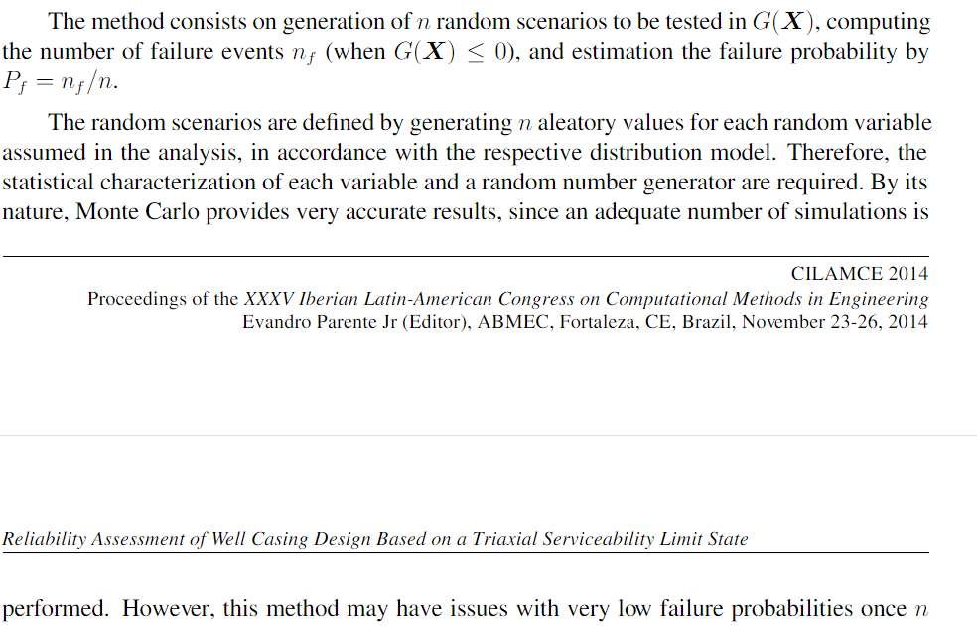

# Random Number Generation.

# Most algorithms are based on a [pseudorandom number generator](https://en.wikipedia.org/wiki/Pseudorandom_number_generator) that produces numbers *X* that are uniformly distributed in the [half-open interval](https://en.wikipedia.org/wiki/Half-open_interval) [0,1). These [random variates](https://en.wikipedia.org/wiki/Random_variate) *X* are then transformed via some algorithm to create a new random variate having the required probability distribution. With this source of uniform pseudo-randomness, realizations of any random variable can be generated.[[10]](https://en.wikipedia.org/wiki/Probability_distribution#cite_note-:0-10)

# 

# Selection SELECTION OF ADEQUATE PROBABILITY DENSITY FUNCTIONS

# With the aim of obtaining the more adequate representation of the actual probability distribution of the concrete compressive cubic strength, the three following distributions are selected and considered in the statistical analysis reported in this research work: (a) the Normal distribution, (b) the Shifted Lognormal distribution, (c) the Gumbel distribution.

# The Normal distribution has been selected because it is the most widely used for the representation of random variables, many building codes are based upon this distribution, it is one which arises frequently in practice as a limiting case of other probability distributions, it well represents random variables which are affected by different factors, which is the case of the concrete strength which is affected, for example, by the strengths and the dimensions of the aggregates, by the quality of the cement, by the mixing technologies, by the quantity and the chemical properties of the water in the mixture.

* 1. PROBABILITY DISTRIBUTIONS OF CASING DESIGN

Safety factors data can be obtained through experience or from relevant guidelines and recommendations, such as American Petroleum Institutes (API). Applying excessive Design Factors in casing design will increase the well cost, possibly dramatically if it causes unnecessary extra casing strings. Too low and failure is more likely. The tables in API 5C2 use formulae defined in API 5C3 (Supersededby ISO 10900). To understand the relevant safety factors to apply requires understanding of these formulae, as well as the manufacturing tolerances defined in API 5CT. In this study, two statistical probability distributions were applied to the casing deign safety factor data, with the distributions fitted using the Monte Carlo simulation (MCS) method. The formulations of various distributions presented in this section follow [10] and [11].

* 1. *Continuous Uniform Distribution*

The continuous uniform distribution, also referred to as the rectangular distribution, is commonly used to represent equal chance of occurrence. The distribution is a family of symmetric probability distributions and its PDF and CDF functions given in equation 1 and 2 below.

The uniform density function on the interval [a, b] is the constant function defined by

$f\left(x\right)=\frac{1}{b-a}$ 1.

Its graph is a horizontal line:

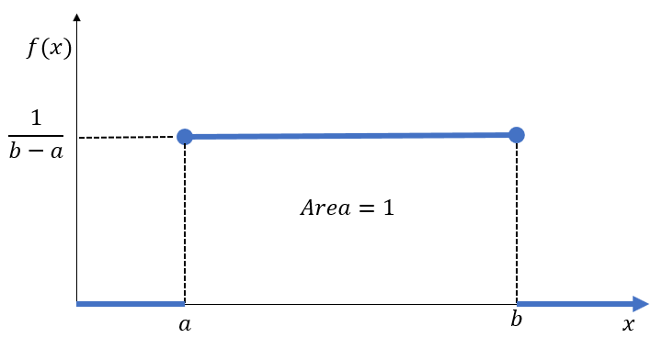

So,

$f\left(x\right)=\left\{\begin{aligned}\frac{1}{b-a}, &a≤x≤b , a>0 \\ 0, &otherwise\end{aligned}\right.$ 2

The cumulative distribution function on the support $a<x<b$ is defined by

$f\left(x\right)=\int_{a}^{x}{\frac{1}{b-a}dw=\left[\frac{w}{b-a}\right]}{x \atop a}=\frac{x-a}{b-a}$ 3

So,

$f(x)=\left\{\begin{aligned}0, x≤a \\ \frac{x-a}{b-a}, a<x<b \\ 1, x≥b \end{aligned}\right.$ 4

If a random variable X admits a uniform density function, we say that X is uniformly distributed, or that X has the uniform distribution.

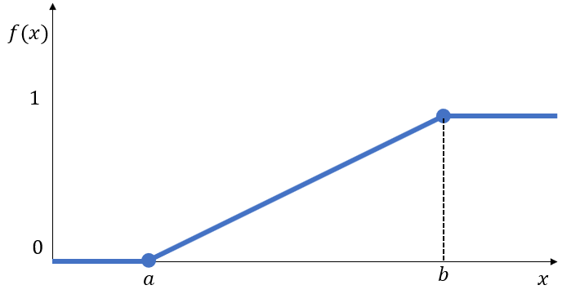

* 1. *Triangular Distribution*

As a drilling engineer you are required to

calculate the burst and collapse loads that would be used to select an appropriate weight and

grade of casing for the Surface, Intermediate and Production strings in this land well:

* 1. APPLICATION OF MONTE CARLO SIMULATION TO CASING DESIGN

The results of these method do not conclusively state that the probability distribution is representative of the API provided safety factor. However, the method can be used to conclude whether the safety factor is over or underestimated by a specific distribution at a required level of confidence (significance) based on the properties of the relevant statistic. The uniform and triangular distribution were applied to the safety factor of the casing design using C# programming language and Oxyplot [<https://oxyplot.readthedocs.io/en/latest/>]. An iterative process was employed by which the significance level was altered within the range: 0.01, 0.02, 0.05, and 0.10. The probability (p-value) obtained through these method indicates the probability of failure of a casing, as it explicitly consider the randomness of the design variables and parameters.. The p-value is crucial in the determination of the real uncertainty involved in the design, with a low value (below the significance level) suggesting that the theoretical distribution is not representative of the dataset. Selection of the best distribution can be made upon by a combination of the p-value, the confidence interval and visual inspection of the PDF and CDF fit in the simulation plots. This method is largely dependent on the number of iterations of the random variable. Large simulation data affects the performance of the tests as there are a large number of data points, especially at the tails of the distribution, which greatly affect the CDF.

* 1. CASE STUDY DATA

This study considered a real land well data set for casing design provided by [<https://www.studocu.com/in/document/itm-university/chemical-engineering/tutorial-work/270984243-casing-design-calculation/3308756/view>]. The well data are given in Table 1. These data are required to calculate the burst and collapse loads that would be used to select an appropriate weight and grade of casing for the surface, intermediate and production string of this land well.

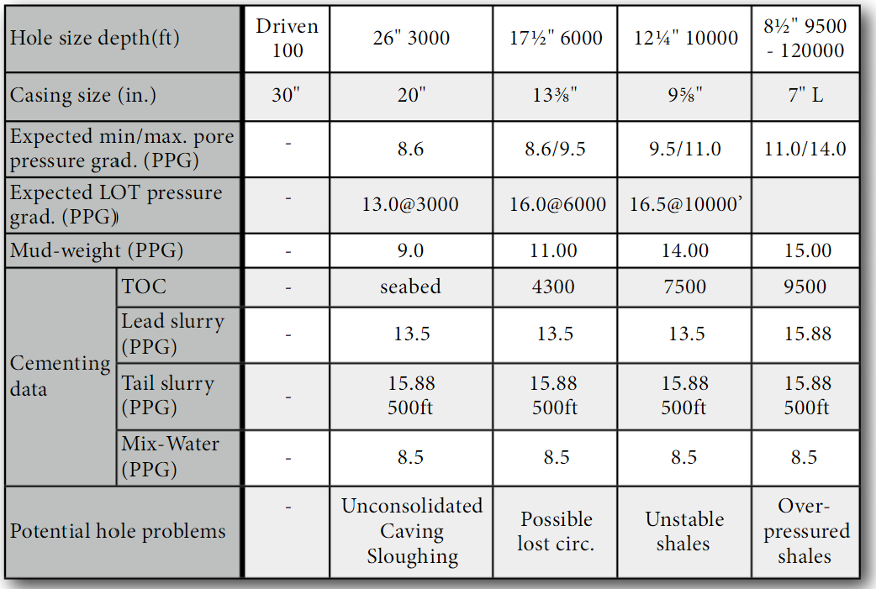

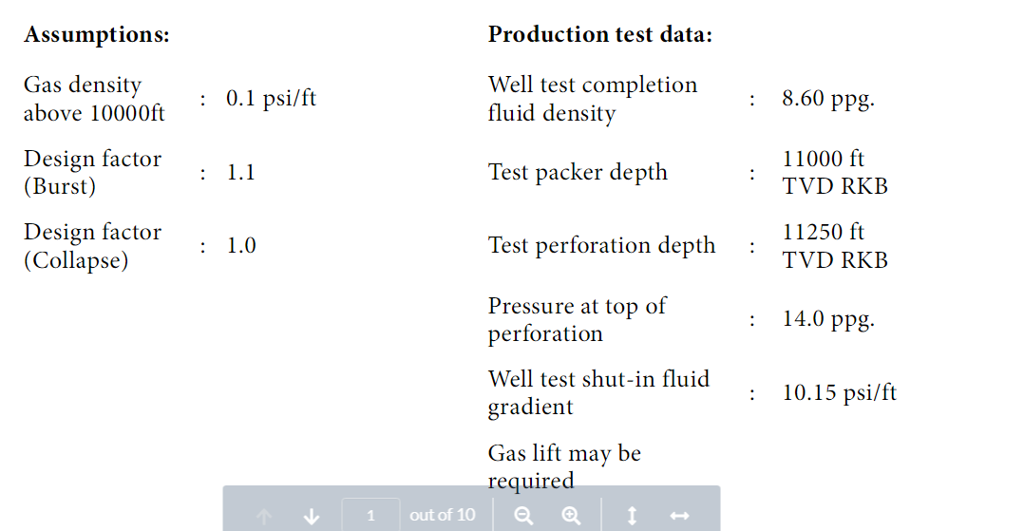

1. C# ALGORIM AND MODEL SET UP

The Microsoft C# (CSharp) programming language was used to model the casing design calculation; the pseudo code is presented in Figure 3. Both the uniform distribution and triangular distribution algorithm were implemented in C#. In order not to export the simulation results for visualization in Microsoft Excel, Windows Presentation Foundation (WPF) application was developed for data entry and visualization. The charts presented in the result section were generated by Oxyplot, a .Net chart library.

133

1. RESULTS AND DISCUSSION

Surface Casing (20" @ 3000 ft)

Burst Design – Drilling

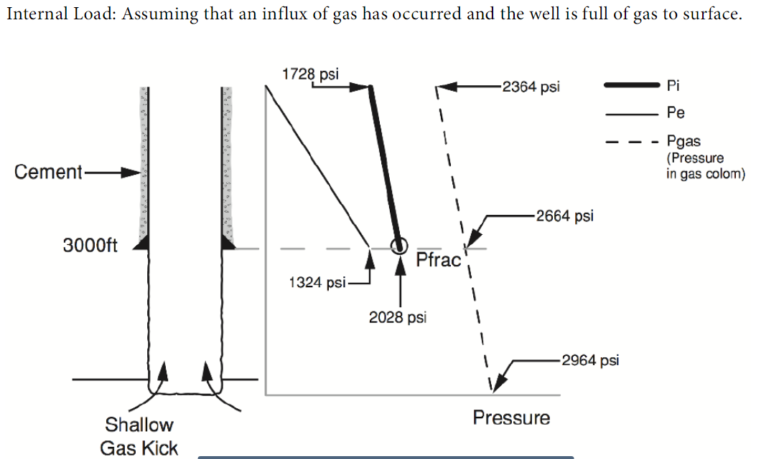 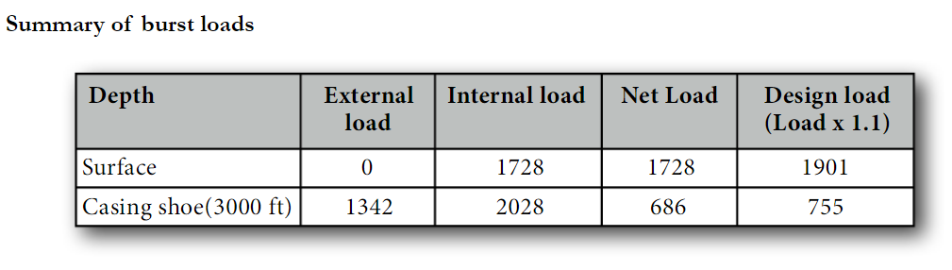 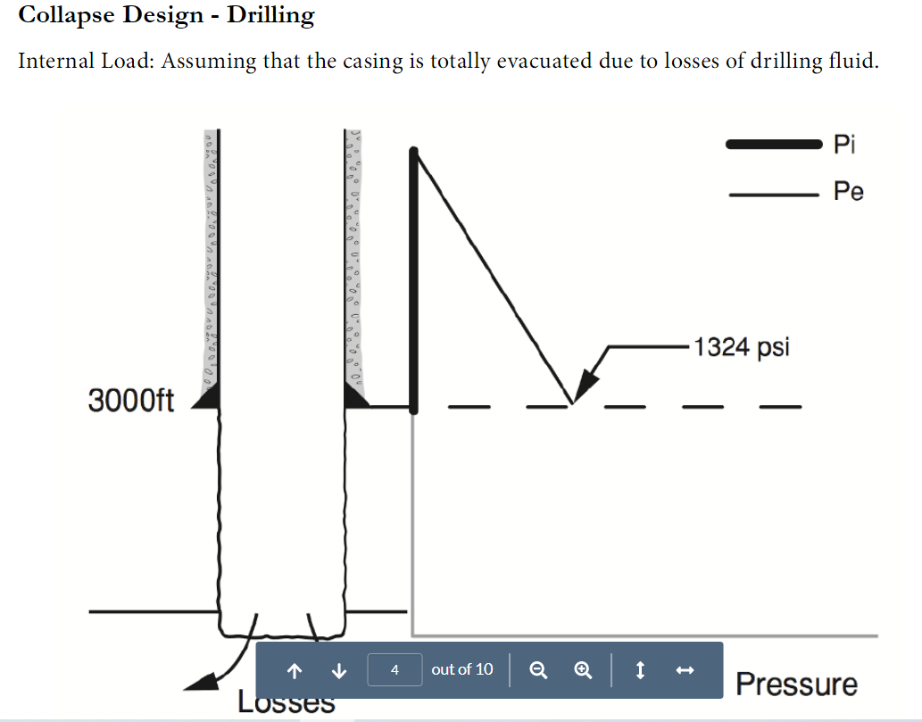 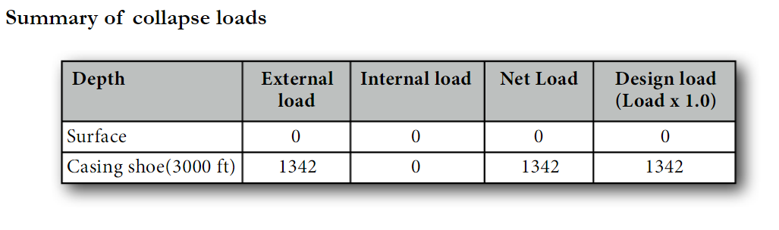

Intermediate Casing (13⅜" @ 6000 ft)

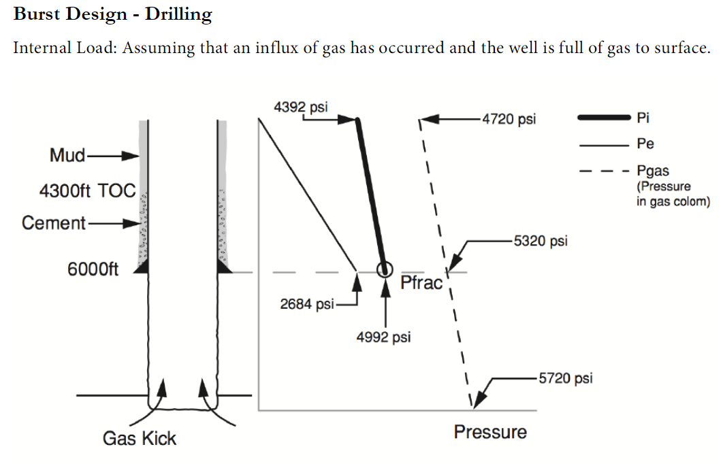 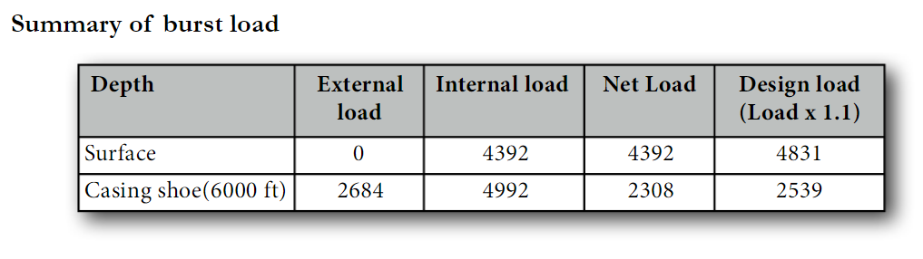 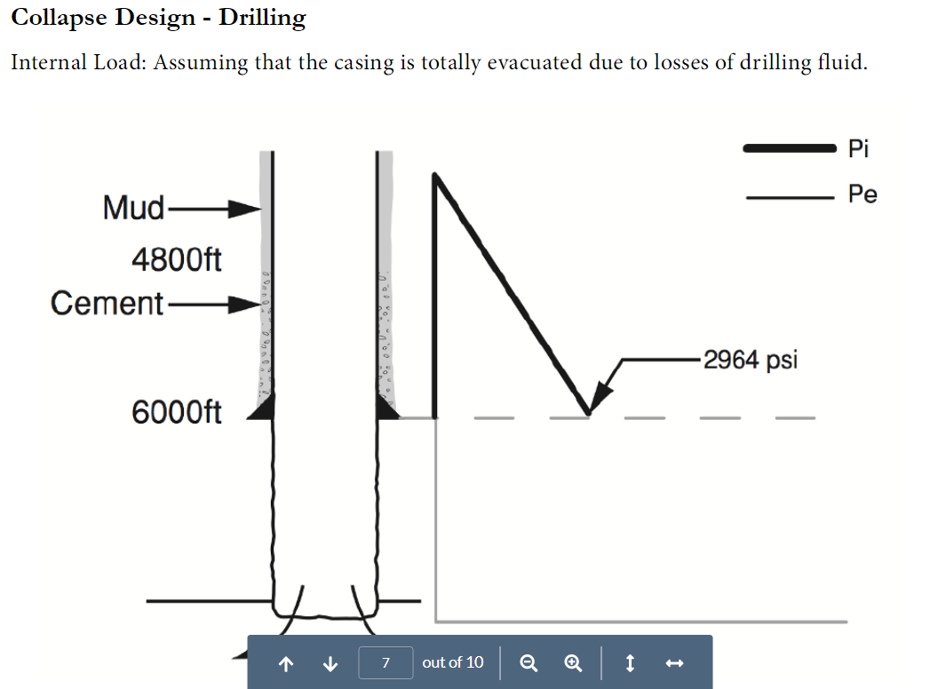 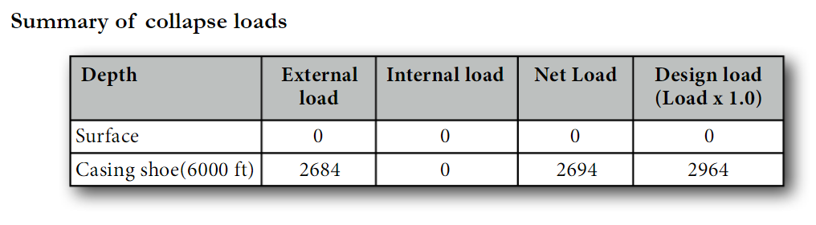

1. SUMMARY AND CONCLUSION

Some text goes here

ACKNOWLEDGMENT

The author acknowledges the support…

REFERENCES

1. <https://petrowiki.org/Casing_and_tubing>
2. <https://www.researchgate.net/publication/329360595_Relevant_Information_on_Oil_and_Gas_Casing_Design>
3. <http://oaktrust.library.tamu.edu/bitstream/handle/1969.1/ETD-TAMU-2011-12-10406/CHANTOSE-THESIS.pdf?sequence=2>
4. <https://petrowiki.org/Risk-based_casing_design>
5. <https://petrowiki.org/Risk-based_casing_design>
6. Conte, J.P., (2001). Statistics, Probability and Reliability. Course at the University of California at San Diego, fall 2001, 4.68-4.74.
7. <https://www.researchgate.net/publication/281852436_Reliability_Assessment_of_Well_Casing_Design_based_on_a_Triaxial_Serviceability_Limit_State>
8. <https://www.scribd.com/document/282985544/Casing-Design-using-PDF-Probabilistic-Distribution-Forecast>
9. <https://core.ac.uk/download/pdf/82297112.pdf>
10. Dekking, Frederik Michel; Kraaikamp, Cornelis; Lopuhaä, Hendrik Paul; Meester, Ludolf Erwin (2005), "Why probability and statistics?", *A Modern Introduction to Probability and Statistics*, Springer London, pp. 1–11, [doi](https://en.wikipedia.org/wiki/Digital_object_identifier):[10.1007/1-84628-168-7_1](https://doi.org/10.1007%2F1-84628-168-7_1), [ISBN](https://en.wikipedia.org/wiki/International_Standard_Book_Number) [978-1-85233-896-1](https://en.wikipedia.org/wiki/Special:BookSources/978-1-85233-896-1)

AUTHORS

**First Author** – Author name, qualifications, associated institute (if any) and email address. **Second Author** – Author name, qualifications, associated institute (if any) and email address. **Third Author** – Author name, qualifications, associated institute (if any) and email address.

**Correspondence Author** – Author name, email address, alternate email address (if any), contact number.