Test:

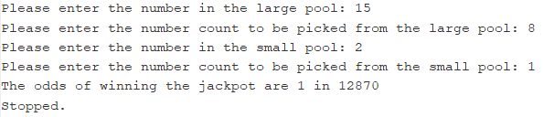

Euro Millions:

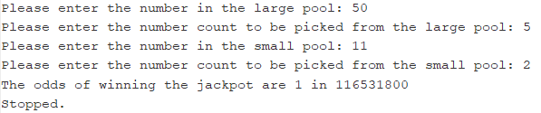

Mega Millions:

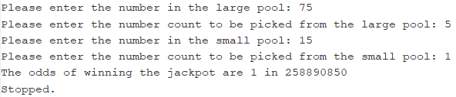

PowerBall:

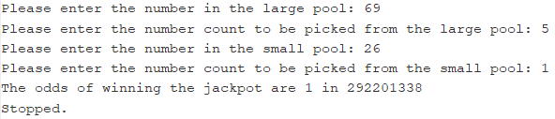

Thunderball:

