**Homework for Ch3:**

3.19. Consider the ER diagram of Figure 3.21, which shows a simplified schema for an airline reservations system. Extract from the ER diagram the requirements and constraints that resulted in this schema. Try to be as precise as possible in your requirements and constraints specification.

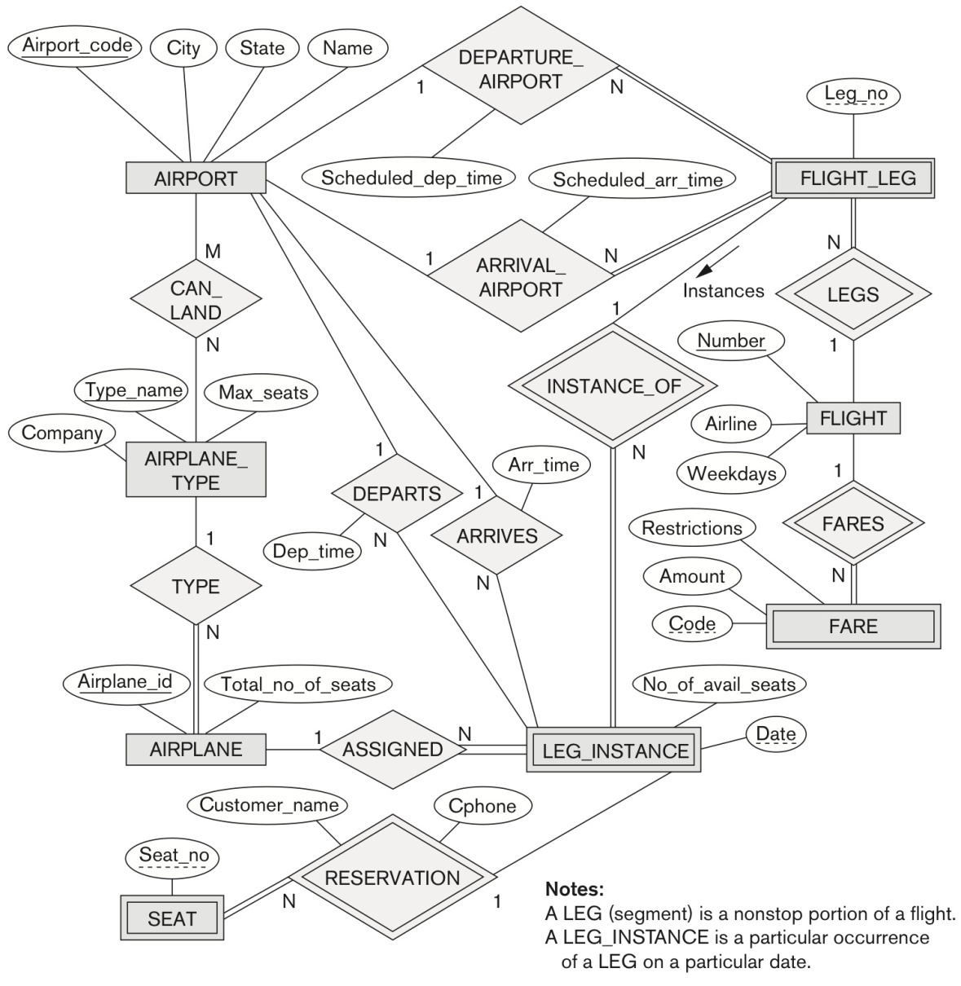

**Figure 3.21** An ER diagram for an AIRLINE database schema.

In addition, you need to convert Figure 3.21, 'An ER diagram for an AIRLINE database', on page 98 to IE notation. When you have your ERD in IE notation, you need to show foreign key migrations as well as create an intersection entity for a Many-to-Many (M:N) relationship.

Please submit your homework as a Word document or a PDF file with a screenshot of your ERD using IE notation via Module 3 Assignment: “Assignment Submission”. You need to send your homework in on time. Otherwise, you will lose **50%** of your points for the homework.

Solution:

The database will represent a simplified airline reservation database system. In the database, it is needed to store several key pieces of information and relationships. Those requirements are as follows:

1. The database will need to represent each airport, including its unique airport code, the airport name, and the city and state where the airport is located. Airport is a strong entity.
2. The database will also store each flight, including the unique flight number, the airline for the flight, and the weekdays on which the flight is scheduled. Flight is a strong entity.
3. Each flight also has an associated fare for the flight. Each flight fare contains a unique code, a monetary amount, and any restrictions associated with the fare. There may be many fairs associated with one flight. Fare is a strong entity.
4. Each flight will be composed of one or more flight legs (so a flight from JFK to Salt Lake City may have two legs, one from Newark to Denver, and another from Denver to Salt Lake City). Each flight leg will have its leg number as well as it’s departure airport, departure time, arrival airport and arrival time. Flight leg is a weak entity.
5. A leg instance is a particular instance of a flight leg. Each leg instance has an associated Date, as well as an associated number of available seats. After the conclusion of a flight, the actual arrival airport, arrival time, departure airport and departure time are recorded. Leg instance is a weak entity.
6. Each leg instance reservation can have one or more seats which include information like the customer name, customer phone number seat and seat number(s) for the reservation. Seat is a strong entity.
7. Each leg instance is also assigned an airplane. The information stored for the airplane includes its unique airplane id, the number of seats on the plane. Airplane is a strong entity.
8. For an associated airplane, there is then entity airplane type. Airplane type contains information on the airplane type name, company and maximum number of seats. Each airplane type has associated airports where it can land. Airplane type is a strong entity.

The above ERD in Chen’s notation is converted to IE notation according to the following diagram (using draw.io):

