Please share your comments on BCNF, 4NF and 5NF as well as Denormalization in practice:

* What is multivalued dependency(MVD)?  When does it arise?
* Does a relation with two or more columns always have an MVD? Show with an example.
* In your database project, please perform normalization on your ERD and comment whether your ERD is 1NF, 2NF, 3NF, BCNF, 4NF, and 5NF compliant.
* Do you see any needs to perform BCNF, 4NF, and 5NF in practice for database designproject(s)? Elaborate your reasons.
* Explain denormalization. Why you may need to consider denormalization.  Do you have any experience or observations on denormalization?  If yes, please share.
* Elaboratereasons that lead a relation becoming non-normalized and violating 1NF, 2NF, 3NF, BCNF, 4NF, and 5NF?

MVD, or multivalued dependency is a dependence between attributes in a relation such that for each value of A, there is a set of values for both B and C, where the set of values for B and C are independent of each other. This can often arise when a table is taken out of 1NF, which disallows attributes with multiple values. This happens often when two independent 1:M relationships are mixed in the same relation.

While MVD’s can occur in relations with two or more columns, this is not always the case. One example of a relation with 2+ columns and no MVD’s is shown below:

|  |  |  |  |
| --- | --- | --- | --- |
| emp_id | First | Last | Age |
| 0001 | Brian | Loughran | 25 |
| 0002 | Nico | Hischier | 21 |
| 0003 | Jack | Hughes | 19 |

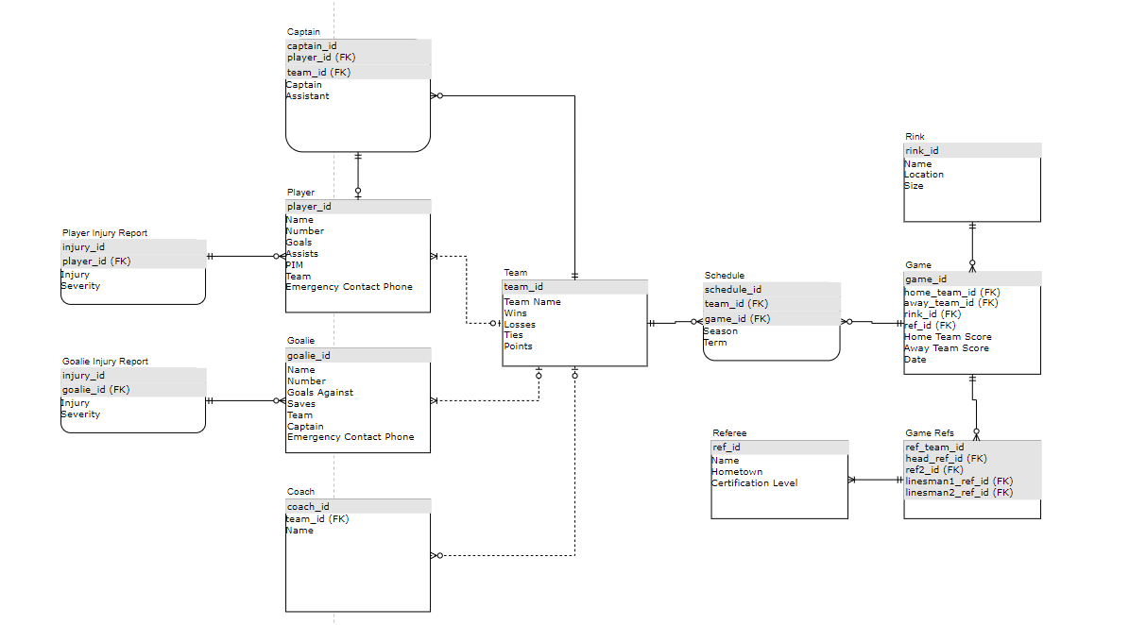

Some minor changes have been made to my original ERD for my database project to ensure normalization in 3NF. I believe that my database happens to be compliant with 5NF, however that was less of a conscious effort than it was a design choice. It seems that most databases are normalized to 3NF as is industry standard, so if my database was not compliant with 4NF or 5NF, I would not consider it to be too much of a worry.

Sometimes it is useful or necessary to add or change index structures to create a cluster for improved data access times. Indexes can provide a quick way to access specific rows and avoid a full scan of a table. This process is known as denormalization, however one should be wary of performing this process. Denormalization can cause data inconsistency and result in poor table design. It also may result in more redundant data and increase cost of tracking and handling duplicates and spurious data.

I do not have any personal experience with denormalization.

Some reasons a relation may not be in 1NF include the need to store multivalued attributes or resolve 1:M relationships in a single table. A table may not be in 2NF if an attribute does not depend on the full PK, a common issue with those new to database systems. A table may not be in 3NF if a primary key is not identified for a relation, such as the way that zip code can represent town, state, etc. A table may not be in 4NF if attributes within the table have an M:N relationship, and a table may not be in 5NF if a designer does not recognize a join dependency.