**Homework Assignment #4:**

All,

In HW4, you need to demonstrate your work using a RDBMS (e.g., MS Access, Oracle, MySQL, or others.)

Please use DDLs below to create the company database. The schema diagram for the company database is shown in Figure 5.5 (p. 161). You may encounter problems running the DDLs to create tables. Explain the reasons and how you fix them so that the table can be created

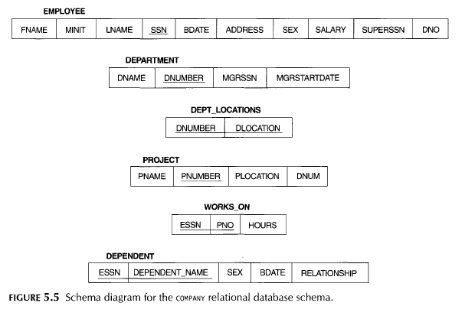

After you have created your database, please use DMLs below to populate all records shown in Figure 5.6 (p. 162) into your database. You may encounter problems running DMLs to insert data. Explain the reasons and fix them so that the data can be populated properly.

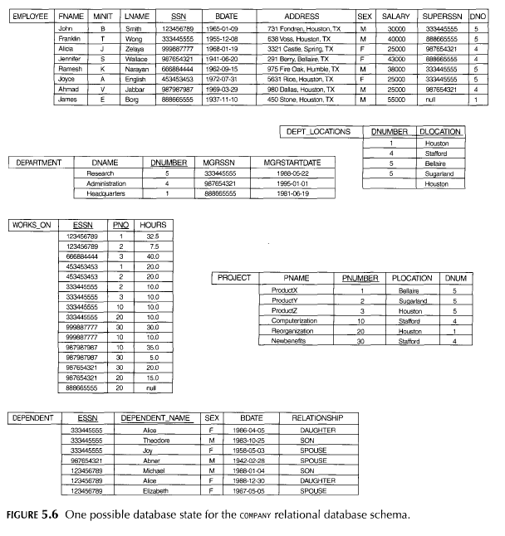

You can use screenshots to explain the problems and discuss how to fix them.

After you finish the first part above, demonstrate how the Division operation shown in Figure 8.8 (p. 256) works using the example: "Retrieve the SSNs of employees who work on all projects that John Smith works on" from the company database, using one SQL query statement that can retrieve the same results of the above example.

You may turn in your DDLs (create tables), DMLs (insert records) or your final SQL for the Division operation with your retrieved data. You may turn in your DBMS; you can have the log file, screenshots that include your DDLs and DMLs, and your findings in a Word document to prove your work is done properly.  
  
Dar-Ning

**Modified DDLs for the Company Database:**

-- Ref: Textbook Page 181

-- Figure 6.1 SQL CREATE TABLE data definition statements for defining the COMPANY schema from Figure 5.7.

-- Figure 6.2 Example illustrating how default attribute values and referential integrity triggered actions are specified in SQL.

CREATE TABLE EMPLOYEE (

Fname VARCHAR(15) NOT NULL,

Minit CHAR,

Lname VARCHAR(15) NOT NULL,

Ssn CHAR(9) NOT NULL,

Bdate DATE,

Address VARCHAR(30),

Sex CHAR,

Salary DECIMAL(10, 2),

Super_ssn CHAR(9),

Dno INT NOT NULL,

CONSTRAINT EMP_PK

PRIMARY KEY (Ssn),

CONSTRAINT EMP_SUPER_FK

FOREIGN KEY (Super_ssn) REFERENCES EMPLOYEE(Ssn)

ON DELETE SET NULL ON UPDATE CASCADE,

CONSTRAINT EMP_DEPT_FK

FOREIGN KEY(Dno) REFERENCES DEPARTMENT(Dnumber)

ON DELETE SET DEFAULT ON UPDATE CASCADE

);

CREATE TABLE DEPARTMENT (

Dname VARCHAR(15) NOT NULL,

Dnumber INT NOT NULL,

Mgr_ssn CHAR(9) NOT NULL DEFAULT '88866555',

Mgr_start_date DATE,

CONSTRAINT DEPT_PK

PRIMARY KEY (Dnumber),

CONSTRAINT DEPT_UK

UNIQUE (Dname),

CONSTRAINT DEPT_MGR_FK

FOREIGN KEY (Mgr_ssn) REFERENCES EMPLOYEE (Ssn)

ON DELETE SET DEFAULT ON UPDATE CASCADE

);

CREATE TABLE DEPT_LOCATIONS (

Dnumber INT NOT NULL,

Dlocation VARCHAR(15) NOT NULL,

CONSTRAINT DEPT_LOCATIONS_PK

PRIMARY KEY (Dnumber , Dlocation),

CONSTRAINT DEPT_LOCATIONS_DEPT_FK

FOREIGN KEY (Dnumber) REFERENCES DEPARTMENT (Dnumber)

ON DELETE CASCADE ON UPDATE CASCADE

);

CREATE TABLE PROJECT (

Pname VARCHAR(15) NOT NULL,

Pnumber INT NOT NULL,

Plocation VARCHAR(15),

Dnum INT NOT NULL,

CONSTRAINT PROJECT_PK

PRIMARY KEY (Pnumber),

UNIQUE (Pname),

CONSTRAINT PROJECT_DEPT_FK

FOREIGN KEY (Dnum) REFERENCES DEPARTMENT (Dnumber)

);

CREATE TABLE WORKS_ON (

Essn CHAR(9) NOT NULL,

Pno INT NOT NULL,

Hours DECIMAL(3, 1),

CONSTRAINT WORKS_ON_PK

PRIMARY KEY (Essn , Pno),

CONSTRAINT WORKS_ON_EMP_FK

FOREIGN KEY (Essn) REFERENCES EMPLOYEE (Ssn),

CONSTRAINT WORKS_ON_PROJ_FK

FOREIGN KEY (Pno) REFERENCES PROJECT (Pnumber)

);

CREATE TABLE DEPENDENT (

Essn CHAR(9) NOT NULL,

Dependent_name VARCHAR(15) NOT NULL,

Sex CHAR,

Bdate DATE,

Relationship VARCHAR(8),

CONSTRAINT DEPENDENT_PK

PRIMARY KEY (Essn , Dependent_name),

CONSTRAINT DEPENDENT_EMP_FK

FOREIGN KEY (Essn) REFERENCES EMPLOYEE (Ssn)

);

**DMLs for the Company Database:**

In order to save your time, I have included the DMLs for you.  However, you may need to modify them to properly import data with a DATE datatype of your RDBMS and a couple of minor typos.

INSERT INTO EMPLOYEE(FNAME, MINIT,LNAME,SSN,BDATE,ADDRESS,SEX,SALARY,SUPERSSN,DNO) VALUES

('John','B','Smith',123456789,'09-JAN-65','731 Fondren, Houston, TX','M',30000,333445555,5);

INSERT INTO EMPLOYEE(FNAME, MINIT,LNAME,SSN,BDATE,ADDRESS,SEX,SALARY,SUPERSSN,DNO) VALUES

('Franklin','T','Wong',333445555,'08-DEC-55','635 Voss, Houston, TX','M',40000,888665555,5);

INSERT INTO EMPLOYEE(FNAME, MINIT,LNAME,SSN,BDATE,ADDRESS,SEX,SALARY,SUPERSSN,DNO) VALUES

('Alicia','J','Zelaya',999887777,'19-JAN-68','3321 Castle, Spring','F',25000,987654321,4);

INSERT INTO EMPLOYEE(FNAME, MINIT,LNAME,SSN,BDATE,ADDRESS,SEX,SALARY,SUPERSSN,DNO) VALUES

('Jennifer','S','Wallace',987654321,'20-JUN-41','291 Berry, Bellaire, TX','F',43000,888665555,4);

INSERT INTO EMPLOYEE(FNAME, MINIT,LNAME,SSN,BDATE,ADDRESS,SEX,SALARY,SUPERSSN,DNO) VALUES

('Ramesh','K','Narayan',666884444,'15-SEP-62','975 Fire Oak, Humble, TX','M',38000, 333445555,5);

INSERT INTO EMPLOYEE(FNAME, MINIT,LNAME,SSN,BDATE,ADDRESS,SEX,SALARY,SUPERSSN,DNO) VALUES

('Joyce','A','English',453453453,'31-JUL-72','5631 Rice Houston','F',25000,333445555,5);

INSERT INTO EMPLOYEE(FNAME, MINIT,LNAME,SSN,BDATE,ADDRESS,SEX,SALARY,SUPERSSN,DNO) VALUES

('Ahmad','V','Jabbar',987987987,'29-MAR-69','980 Dallas, Houston','M',25000,987654321,4);

INSERT INTO EMPLOYEE(FNAME, MINIT,LNAME,SSN,BDATE,ADDRESS,SEX,SALARY,SUPERSSN,DNO) VALUES

('James','E','Borg',888665555,'10-NOV-37','450 Stone, Houston, TX','M',55000,NULL,1);

INSERT INTO DEPARTMENT(DNAME,DNUMBER,MGRSSN,MGRSTARTDATE) VALUES

('Research',5,333445555,'22-MAY-88');

INSERT INTO DEPARTMENT(DNAME,DNUMBER,MGRSSN,MGRSTARTDATE) VALUES

('Headquarters',1,888665555,'19-JUN-81');

INSERT INTO DEPARTMENT(DNAME,DNUMBER,MGRSSN,MGRSTARTDATE) VALUES

('Administration',4,987654321,'01-JAN-95');

INSERT INTO DEPT_LOCATIONS(DNUMBER,DLOCATION) VALUES

(1,'Houston');

INSERT INTO DEPT_LOCATIONS(DNUMBER,DLOCATION) VALUES

(4,'Stafford');

INSERT INTO DEPT_LOCATIONS(DNUMBER,DLOCATION) VALUES

(5,'Bellaire');

INSERT INTO DEPT_LOCATIONS(DNUMBER,DLOCATION) VALUES

(5,'Sugarland');

INSERT INTO DEPT_LOCATIONS(DNUMBER,DLOCATION) VALUES

( ,'Houston');

INSERT INTO PROJECT(PNAME,PNUMBER,PLOCATION,DNUM) VALUES

('ProductX',1,'Bellaire',5);

INSERT INTO PROJECT(PNAME,PNUMBER,PLOCATION,DNUM) VALUES

('ProductY',2,'Sugarland',5);

INSERT INTO PROJECT(PNAME,PNUMBER,PLOCATION,DNUM) VALUES

('ProductZ',3,'Houston',5);

INSERT INTO PROJECT(PNAME,PNUMBER,PLOCATION,DNUM) VALUES

('Computerization',10,'Stafford',4);

INSERT INTO PROJECT(PNAME,PNUMBER,PLOCATION,DNUM) VALUES

('Reorganization',20,'Houston',1);

INSERT INTO PROJECT(PNAME,PNUMBER,PLOCATION,DNUM) VALUES

('Newbenefits',30,'Stafford',4);

INSERT INTO WORKS_ON(ESSN,PNO,HOURS) VALUES

(123456789,1,32.5);

INSERT INTO WORKS_ON(ESSN,PNO,HOURS) VALUES

(123456789,2,7.5);

INSERT INTO WORKS_ON(ESSN,PNO,HOURS) VALUES

(666884444,3,40);

INSERT INTO WORKS_ON(ESSN,PNO,HOURS) VALUES

(453453453,1,20);

INSERT INTO WORKS_ON(ESSN,PNO,HOURS) VALUES

(453453453,2,20);

INSERT INTO WORKS_ON(ESSN,PNO,HOURS) VALUES

(333445555,2,10);

INSERT INTO WORKS_ON(ESSN,PNO,HOURS) VALUES

(333445555,3,10);

INSERT INTO WORKS_ON(ESSN,PNO,HOURS) VALUES

(333445555,10,10);

INSERT INTO WORKS_ON(ESSN,PNO,HOURS) VALUES

(333445555,20,10);

INSERT INTO WORKS_ON(ESSN,PNO,HOURS) VALUES

(999887777,30,30);

INSERT INTO WORKS_ON(ESSN,PNO,HOURS) VALUES

(999887777,10,10);

INSERT INTO WORKS_ON(ESSN,PNO,HOURS) VALUES

(987987987,10,35);

INSERT INTO WORKS_ON(ESSN,PNO,HOURS) VALUES

(987987987,30,5);

INSERT INTO WORKS_ON(ESSN,PNO,HOURS) VALUES

(987654321,30,20);

INSERT INTO WORKS_ON(ESSN,PNO,HOURS) VALUES

(987654321,20,15);

INSERT INTO WORKS_ON(ESSN,PNO,HOURS) VALUES

(888665555,20,NULL);

INSERT INTO DEPENDENT(ESSN,DEPENDENT_NAME,SEX,BDATE,RELATIONSHIP) VALUES

(123456789,'Alice','F','30-DEC-88','Daughter');

INSERT INTO DEPENDENT(ESSN,DEPENDENT_NAME,SEX,BDATE,RELATIONSHIP) VALUES

(123456789,'Elizabeth','F','05-MAY-67','Spouse');

INSERT INTO DEPENDENT(ESSN,DEPENDENT_NAME,SEX,BDATE,RELATIONSHIP) VALUES

(123456789,'Micheal','M','04-JAN-88','Son');

INSERT INTO DEPENDENT(ESSN,DEPENDENT_NAME,SEX,BDATE,RELATIONSHIP) VALUES

(333445555,'Alice','F','05-APR-86','Daughter');

INSERT INTO DEPENDENT(ESSN,DEPENDENT_NAME,SEX,BDATE,RELATIONSHIP) VALUES

(333445555,'Joy','F','03-MAY-58','Spouse');

INSERT INTO DEPENDENT(ESSN,DEPENDENT_NAME,SEX,BDATE,RELATIONSHIP) VALUES

(333445555,'Theodore','M','25-OCT-83','Son');

INSERT INTO DEPENDENT(ESSN,DEPENDENT_NAME,SEX,BDATE,RELATIONSHIP) VALUES

(987654321,'Abner','M','28-FEB-42','Spouse');

* The first issue that is encountered is that employee references department as a foreign key. The employee table should be created without that reference to the department, and once the department entity is created that foreign key relation can be added. The SQL code used to add the constraint after the employee relation was already created was:

ALTER TABLE employee

ADD CONSTRAINT EMP_DEPT_FK

FOREIGN KEY(Dno) REFERENCES DEPARTMENT(Dnumber)

ON DELETE SET DEFAULT ON UPDATE CASCADE

;

* For inserting into the employee relation, superssn is a typo, the column name is super_ssn. Renaming super_ssn to superssn was the easiest solution for this.
* Also for inserting an employee tuple, care should be taken to ensure that the manager is inserted before the employee. If not, you will violate the foreign key constraint emp_super_fk. For example, I inserted James Borg first, followed by Franklin Wong and Jennifer Wallace, etc.
* Again for inserting an employee tuple, the relationship between employee and department is problematic. Employee has a foreign key for department that they work in, and department has a foreign key for the employee manager. This makes it impossible to insert into either without violating the foreign key constraint. One solution for this is to remove the EMP_DEPT_FK constraint while inserting the employees and departments, then add the constraint after all the employees and departments are inserted.
* For inserting into department, two columns are misnamed, mgr_ssn and mgr_start_date. These were changed to mgrssn and mgrstartdate respectively to make the insertion operations easier.
* There was a typo in DEPT_LOCATIONS, according to figure 5.6 Sugarland is supposed to be assigned to department number 5, while Houston does not have a department number. I was not exactly sure what to do about the Houston entry which did not seem to have a department number. The department number cannot be null since it is a primary key. I did notice that ProjectZ was located in Houston and had a department number of 5, so I figured that the missing value was supposed to be a 5 and gave department 5 a location in Houston.

After making the changes specified, the data was successfully loaded to the postgresql database. The results for each of the relations is shown below:

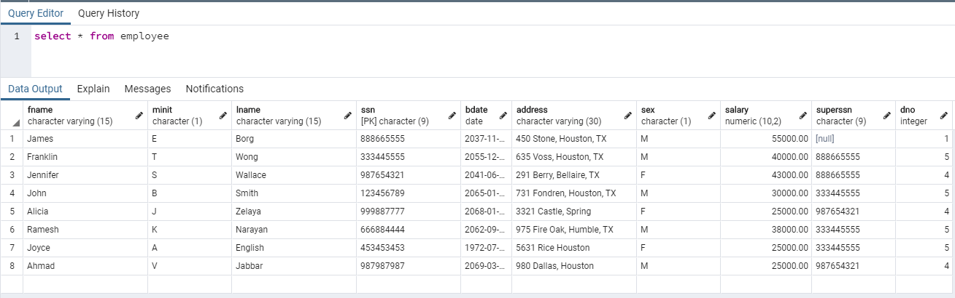

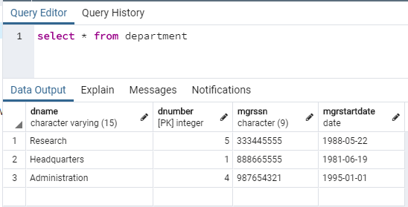

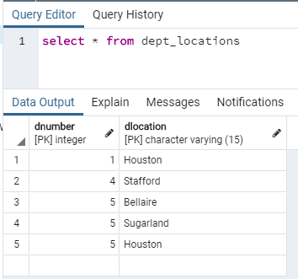

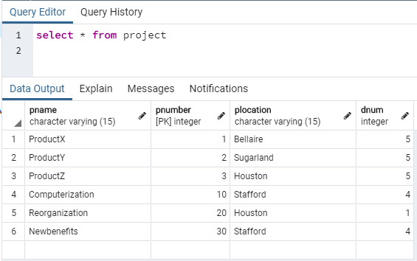

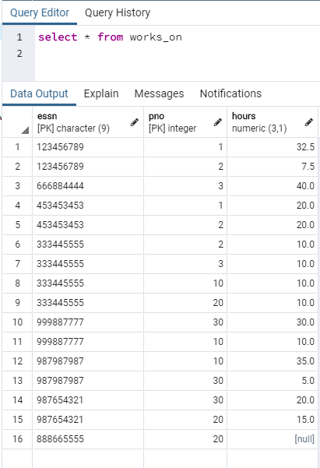

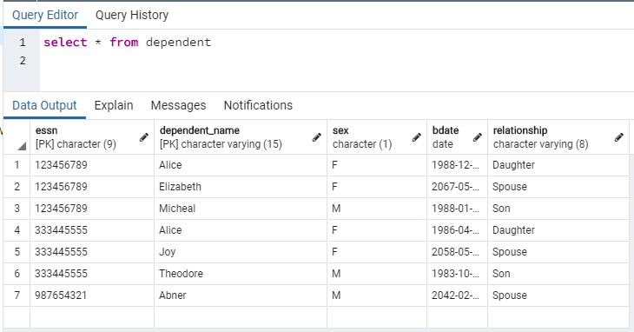

Division as relational algebra is not supported in SQL, however the same result can be represented using nested operations such as where not exists and except. One example of a DML which can accomplish this is:

SELECT ssn FROM employee as e

WHERE NOT EXISTS (

(select pno from works_on where essn=(

select ssn from employee where fname='John' and lname='Smith') )

EXCEPT(

SELECT pno FROM works_on WHERE essn = e.ssn) );

Running this query against the created database produces:

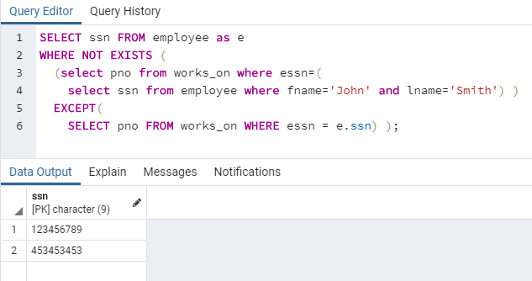

This matches what is expected. John Smith works on projects 1 and 2, and the only other employee who works on projects 1 and 2 is Joyce English, who has ssn=453453453.