**Top-Down**

Description:

The top-down estimation method is done by deriving a product estimate from global properties product and dividing those costs among components. This is in contrast to the bottom-up approach to estimation, where the estimate for each component is calculated and the sum of each of the components is added to produce the overall project estimate.

Advantages:

* The main advantage of the top-down estimation method is that focus at the system level will not leave out system level effort.

Disadvantages:

* Does not identify technical issues at lower levels
* Can miss details in complicated components
* Does not provide details like cost breakdown

**Bottom-Up**

Description:

The bottom-up estimation model is done by estimating the cost of each individual project component and adding the cost of each component to get an overall estimation for the project. This is in contrast to the top-down approach, which derives its estimate from the global properties divided among components.

Advantages:

* The estimate for each component is based on detailed understanding of the component
* Estimate is backed by personal commitments of individuals assigned to components
* Estimation errors between components should balance out

Disadvantages:

* Can provide underestimate by missing system level costs
* Detailed, thus requires more effort
* Some costs may be double-counted

**Price-To-Win**

Description:

This method of estimation is based off whatever the customer has to spend. This method takes into account what the customer wants to hear and provides an estimate based on that. While this may sound good, the price-to-win method of estimation is often overly optimistic, is rarely rooted in reality, and commitments made during contract decisions can be tough to meet.

Advantages:

* The main advantage is that this estimation method will often win the contract

Disadvantages:

* Schedule and budget often unrealistic
* Engineers can become demoralized by difficult schedule
* Not based off project specifications

**Gantt**

Summary:

The Gantt chart is the most common of the scheduling techniques. The characteristics of the Gantt chart include a list of tasks in hierarchal order along the vertical axis as well as relative time spans and durations for each task. Along the horizontal axis is a project timeline with dates in ascending order. Each task has a horizontal line with two triangles on either end indicating the estimated beginning and completion of each task. Plotted in this fashion, it is easy to identify any overlap in activities. A Gantt chart will also show active task status information. The triangles on either end of each task will indicate task status, so if neither triangle is shaded, the task has not been started. If the first triangle is shaded, and the second is not, the task is in progress. If both triangles are shaded, the task is complete. An example of a Gantt chats is shown below:

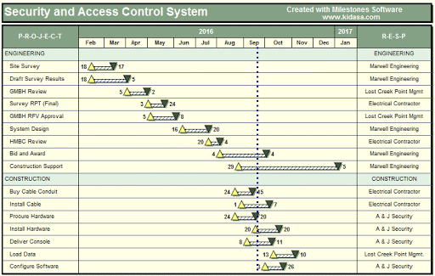

Advantages:

* Simple
* Easy to learn
* Simple to create/maintain
* High degree of appeal to client

Disadvantages:

* Poorly suited if you want to plot out many tasks
* Low degree of control
* Low degree of project scope