|  |
| --- |
| Johns Hopkins |
| Module 7 Assessment |
| Risk Management |
|  |
| **Brian Loughran** |
| **7/12/2020** |

|  |
| --- |
|  |

**Problem Statement**

Directions: Please complete the following problems. To turn in your assignment, please click on the “Module Seven Assignment” header in the Blackboard course site and upload a Microsoft Word or PDF document showing your work. As a member of the Risk Management Panel, you are attempting to assign quantitative value to a risk identified for your project. You have collected the following information:

• An existing design change is being used in a moderate increase in complexity design area of the system  
• A new vendor will handle the updates   
• A failure in the area under investigation could result in minimal or no consequences for technical goals and should not result in budget estimates exceeded   
• A failure in the area may result a small slip in schedule Note: Perform calculations to two decimal places.

1. What is the Risk Factor, Rf?
2. What would be the Risk Factor if there is a major design change which potentially resulted in some reduction in technical performance?
3. Did you help or hinder the situation with the changes in part b? Why?
4. Where should risk mitigation efforts be focused in part b? What might you suggest? Give at least 4 examples.

**Assumptions**

An assumption that we should be aware of is that the calculation of the risk factor has little meaning when either the probability or consequence of failure approach 1 or 0. The equation assumes that the probability and consequence of failure are between 0 and 1, thus a value of 0 or 1 muddies the consequence of the solution of the risk factor. Thus, we assume before we begin calculating the risk factor that the probability of failure and the consequence of failure will not fall very near 0 or 1.

In the computations section there are tables (Tables 1-2) which specify a value for probability of failure and consequence of failure to be applied to the overall risk factor. These values are generally arbitrary, and a change in these values would result in a change to the risk factor you would get in the computation stage. Thus, the values for the magnitude for probability of failure and consequence of failure should be noted as a part of the overall risk factor calculated. Another factor that should be noted is that the rows are very well suited to this problem statement, however in the real world some risks may exist between the rows, to give, for example a maturity factor in between values in the table. This does not need to be addressed for this specific problem, but for performing the risk factor computation in the real world this may be important to note.

**Computations**

**Part a):**

To compute the risk factor, we must first compute the probability of failure and the consequence of failure. The probability of failure (Pf) can be computed using Eq. 1, while the consequence of failure can be computed using Eq. 2, both of which are shown below:

$$P_{f}=\frac{(P_{m}+ P_{c}+ P_{d})}{3} (Eq.1)$$

$$C_{f}=\frac{(C_{t}+ C_{c}+ C_{s})}{3} (Eq.2)$$

Both of these equations reference other variables ( $P_{m}, P_{c}, etc.)$ which have not yet been discussed. To get the value of each of these values, we can consult Tables 1-2, which are lookup tables designed to produce the different factors used in computing probability of failure and consequence of failure in Eq. 1-2.

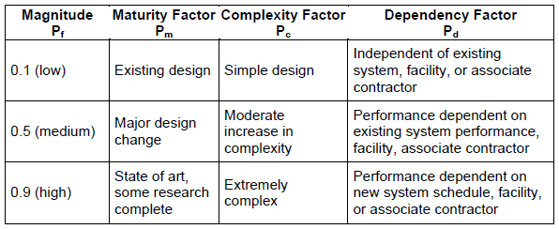  
*Table 1: Probability of Failure Factor Lookup Table*

*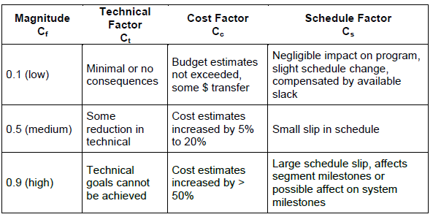  
Table 2: Consequence of Failure Factor Lookup Table*

By using the risk assessment in the problem statement we can find the value for each of the factors. The results of this lookup are as follows:

* Pm = 0.1: The problem statement specifies that we are changing an existing design, thus we get a value of 0.1.
* Pc = 0.5: The problem statement specifies that there is a moderate increase in complexity, thus the value is 0.5.
* Pd = 0.9: The problem statement specifies that a new vendor will handle the updates, matching with the high factor specifying that performance is dependent on a new associate contractor.
* Ct = 0.1: The problem statement specifies the area under investigation could result in minimal or no consequences for technical goals, thus the value is 0.1.
* Cc = 0.1: The problem statement specifies the area under investigation should not result in budget estimates exceeded, thus the value is 0.1.
* Cs = 0.5: The problem statement specifies a failure in the area may result a small slip in schedule, thus the value is 0.5.

With the values that we have obtained from the problem statement and Tables 1-2, we can compute the probability and consequence of failure. The computations are shown below:

$$P_{f}=\frac{(0.1+ 0.5+ 0.9)}{3}=0.5$$

$$C_{f}=\frac{(0.1+ 0.1+ 0.5)}{3}=0.23$$

We note that neither the probability of failure nor the consequence of failure is near 0 or 1, thus we meet our first assumption that would invalidate the results of computing the risk factor. Now that we have the consequence of failure and the probability of failure, we can use these two factors to compute the risk factor. This is done using the following equation (Eq. 3):

$$R_{f}=P_{f}+ C_{f}- \left(P_{f}*C_{f}\right) (Eq.3)$$

The result of this computation given the above probability of failure and consequence of failure is as follows:

$$R_{f}=0.5+ 0.23- \left(0.5*0.23\right)=0.62$$

Thus we have our risk factor for the given risks.

**Part b):**

This is again asking us to compute the risk factor but with slightly different risks. Thus, we can re-use Tables 1-2 and Eq. 1-3 in order to get the risk factor for the new risks associated with the problem statement. Similar to part a, we start by performing a table lookup in Tables 1-2 to get each of the parameters for the probability and consequence of failure. For factors that were not affected by the new information presented in part b, and in lieu of other information, we use the same factor from part a.

* Pm = 0.5: The problem statement specifies a major design change, thus we get a value of 0.5.
* Pc = 0.5: There is no change from part a to complexity factor, thus the value is 0.5.
* Pd = 0.9: There is no change from part a to dependency factor, thus the value is 0.9.
* Ct = 0.5: The problem statement specifies the area under investigation could result in some reduction in technical performance, thus the value is 0.5.
* Cc = 0.1: There is no change from part a to cost factor, thus the value is 0.1.
* Cs = 0.5: There is no change from part a to schedule factor, thus the value is 0.5.

Given the new values, we can recompute the probability and consequence of failure using Eq. 1-2:

$$P_{f}=\frac{(0.5+ 0.5+ 0.9)}{3}=0.63$$

$$C_{f}=\frac{(0.1+ 0.1+ 0.5)}{3}=0.37$$

And following computing the probability and consequence of failure, we can re-compute the associated risk factor:

$$R_{f}=0.63+ 0.37- \left(0.63*0.37\right)=0.77$$

**Discussion/Conclusions**

**Part c):**

Looking at the risk factor in part a and part b, we can make a conclusion about whether the changes to risk in part b helped or hindered the risk situation from part a. We note that the risk factor from part a was 0.62, and that the risk factor from part b was 0.77. A higher risk factor is associated with more risk, thus the changes introduced in part b hindered the risk situation existing in part a.

Further, the risk changes introduced in part b did not help risk according to any risk factor. Part b went from an existing design change to a major design change, which increased the maturity factor from 0.1 to 0.5. Part b also introduced a change from minimal or no consequences to technical goals to some reduction in technical performance, this time increasing the technical factor from 0.1 to 0.5. All other factors were kept at the same level in the absence of other information. Thus not only did the changes in part b hinder the risk situation, they did not decrease any of the associated risk factors.

**Part d):**

In part b, risk mitigation factors should be focused on the items which reduce the risk factor by the greatest amount. Each item included in this problem statement has only an effect on either the probability of failure or the consequence of failure, thus we can order each of the risks by their effect on the Rf/Cf value and prioritize mitigating the risks which are associated with the highest risk factor values. For each of the highest risk items, we can take mitigation actions on each. For each of the risks, those with low values are not included, those with medium risk will have a single mitigation suggestion, and those with high risk will have multiple suggestions for mitigation.

The greatest risk according to the risk factors is that a new vendor will handle the updates. This has a dependency factor of 0.9. Some possible mitigation efforts for this risk include the following:

* We can transfer the risk. This would involve either using the contractor used for the previous update, or if possible doing the update in-house (in some cases doing the update in-house may result in greater risk, if that is the case that is not recommended).
* We can control the risk. This could come in the form of buffing monetary and time budgets for the software update to give a little leeway in the case of slower than expected progress.
* We can publicize the risk. This would involve notifying upper management, marketing and customers about the risks of having a new contractor do the updates, and manage expectations appropriately.

Each of the next risks have equal risk factors, thus will be presented in the order they were presented previously. Each of the next four risks are tied in priority, thus mitigation efforts which have the greatest effect and least effort may be the most beneficial of the following.

The next greatest risk according to risk factors is that we are doing a major design change. This has a maturity factor of 0.5. One possible suggestion for mitigation is to “buy” information about the risk. Taking the time to have a detailed planning session and detailed review of the design change will reduce risks of failure modes and likely result in the update going smoother than if the sessions were not included.

In line with the previous risk according to risk factors is that we there is a moderate increase in complexity. This has a complexity factor of 0.5. One possible suggestion for mitigation is similar to the previous, to “buy” information about the risk. Increased planning and review often results in simple solutions to complex problems, so this may be a good mitigation effort here.

In line with the previous risk according to risk factors is that there may be some reduction in technical performance. This has a technical factor of 0.5. One possible suggestion for mitigation is to publicize the risk. If there may be bugs or reduced performance hits associated it is always best to let stakeholders such as upper management, marketing and customers know about the consequences of the risk, rather than have them find out for themselves with no warning.

In line with the previous risk according to risk factors is the possibility of small slip in schedule. This has a schedule factor of 0.5. One possible suggestion for mitigation is to assume the risk. If the slip in schedule is small, and the cost to avoid this is large, sometimes it is best to simply accept the consequences if the risk occurs.