|  |
| --- |
| Johns Hopkins |
| Module 8 Assessment |
| Metrics |
|  |
| **Brian Loughran** |
| **7/12/2020** |

|  |
| --- |
|  |

**Problem Statement**

Planned and actual data (metrics) for total staff, experienced staff, and unplanned personnel losses should be tracked and can be indicative of the state of the project. Use these milestones to answer parts a and b below:

• Software Requirements Specification is complete at end of month 1   
• Preliminary Design Review is at end of month 2   
• Critical Design Review is at end of month 4   
• Code & Unit Test is complete at end of month 7   
• Software Integration & Test is complete at end of month 9

1. What observations (good staff planning as well as those that need correction) can you make about the planned staffing given the milestones above?

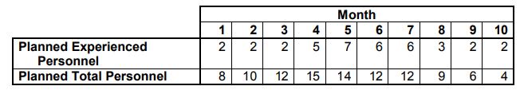

1. Given the same milestones and the planned versus actual staffing data below, explain why Critical Design Review might slip and how Software Integration & Test might still complete on schedule? Is there a cost implication? Explain why or why not?

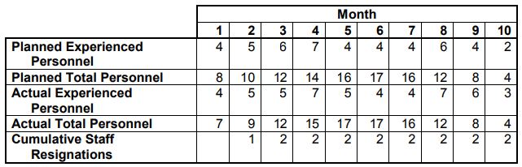

**Assumptions**

Throughout the course of this problem I am going to assume that adding personnel to a project will result in a linear increase in produced work. For example, the assumption follows that 4 people can do the work of 2 people in half the time. In reality, miscommunications between stakeholders will likely result in diminishing returns when adding members to a project, meaning that the 15th person added to a project will likely have less of an impact to schedule than the 2nd person added to the project. However we can ignore that situation for this problem.

The problem statement also has changing personnel for the project almost every month. Changing personnel with that frequency will likely lose a lot of time to bringing new members up to speed with the state of the project and thus reduce the amount of work that can be done in the short term. We will also ignore this effect and assume that each staff member is instantly brought up to speed with the project.

**Computations**

**Part a):**

One thing we can do with the staffing profile from part a is to compute the cumulative total personnel. Looking at the cumulative total personnel may give us some insight into comparing the total time spent working against proposed milestones to see if the schedule makes sense. A summary of the cumulative total personnel is shown below:

*Table 1: Cumulative Total Personnel Calculations*

Some conclusions can be made from the staffing profile in the Discussions/Conclusions section below.

**Part b):**

Similar to part a, we can plot the cumulative total personnel as well as the actual cumulative total personnel. This will again give us some insight as to the total amount of work performed for each of the milestones and give us an idea of how much work has been completed by each of the deadlines. The result of computing the total personnel is shown below:

 *Table 2: Cumulative Total Personnel Calculations*

Some conclusions can be made from the staffing profile in the Discussions/Conclusions section below.

**Discussion/Conclusions**

For both proposed schedules there are a few things we should be on the lookout for in terms of good software personnel metrics. Some basic items include:

* Total software staff profile should grow through the design phases, peak in coding and testing phases, and taper off as integration tests are completed
* Experienced staff profile should be high during initial phases, dip during code and unit test, then grow again for integration and test
* Ratio of total to experienced staff should be typically near 3:1, and should not exceed 6:1.
* Adding inexperienced staff late in the project will seldom improve schedule
* Adding experienced staff may improve schedule, but will also affect cost
* High personnel loss may indicate morale problems and will cause schedule and cost slips

We can compare these general rules of thumb for each of the proposed and actual schedules and compare and contrast how well the staffing profile matches with these guidelines. Suggestions for improvement can be made off that comparison.

**Part a):**

The first observation that can be made from Table 1 is that only 45 of 102 staff months will be worked by the time that the critical design review is due at the end of month 4. It will be very challenging to complete the critical design review with less than half of the budgeted staff months, so that will likely be the most difficult milestone to accomplish. If that milestone is reached however, the other milestones should be able to be met relatively easily for most projects.

Another observation is that the project does a good job having total staff profile grow during the design phases (months 1-4), peak in coding and test (months 4-7) and tapering off as the project moves into software integration and test. This matches well with the software personnel best practices. However, the delegation of experienced personnel leaves something to be desired. Experienced personnel should be at their peak during initial design and during integration and test, however it seems that experienced personnel are at their low points during these phases. Allocating more experienced personnel in months 1-3 and beyond month 7 than are already allocated would be preferred.

The ratio of experienced staff to inexperienced staff bounces around 1:3 and does not exceed 1:6 for this project, which is a sign of good personnel planning. The peak ratio for experienced to inexperienced is 1:5 in month 3, and is 1:1 in month 5 which represents the range of ratios for the project.

There is no peak in inexperienced staff at the end of the schedule, which is good. There is also no data for personnel loss, thus no conclusions can be drawn there.

Overall this is a good staffing profile, as I would make only minor changes if I was creating the schedule.

**Part b):**

We note for the staffing profile shown in Table 2 that the cumulative actual staffing profile lags the planned cumulative staffing profile for months 1-4 due to a pair of resignations. This lag could present a risk to the milestones in months 1-4, specifically the software requirements specification, the preliminary design review, and the critical design review. I would be worried about the preliminary design review, since just 16 of the planned 18 staff months will have been worked by that time, and the critical design review, since it is such a big milestone and the project was short a staff month of work, and one of the staff months worked was by a new, inexperienced employee since inexperienced employees added late in a schedule rarely have much impact to the schedule. Further, there was some turnover in staffing with two resignation with one in month 2 and one in month 3. High turnover has the potential to cause schedule slips, however it is debatable whether this is considered to be high turnover. Because there is added labor in months 4-5 to make up the deficit in work, we should be able to meet the following milestones including code and unit test in month 7 and the software integration and test in month 9.

This schedule does a good job of growing the staffing profile through the planning and design phase, peaking in the coding and test phases, then slowly tapering off staffing as integration tests are completed. This schedule also does a good job of scheduling experienced staff which peak right at the critical design review, dips during coding phases, and peaking again for integration and test. This schedule would be a good example for the way that staffing should be handled for the person who put together the schedule in part a.

The ratio of experienced staff to inexperienced staff is often at a perfect 1:1 ratio (in months 1-4 and 8-12) which is typically not a ratio that you want between experienced and inexperienced staff. Usually this should lie around 1:3, where it is very close for months 5-7. For projects that have a high degree of complexity sometimes this is ok, however the ratios could probably use some tweaking for the proposed project.

Similar to part a, there is no inexperienced personnel planned to be added near milestones which is good for schedule (save for where inexperienced personnel had to be added near milestone 4, but that was unplanned). This is good from a scheduling perspective. There is a high percentage of experienced staff as discussed previously which will likely have some affect on cost.

There is moderate personnel loss throughout the project, with two personnel resigning within the first two months of the project. This can be reflective of a chaotic work culture at the beginning of the project (or it can be a coincidence). If there was a chaotic environment with the project, it seemed to have been ironed out after the critical design review, with no further turnover after month 3.

Overall this is also a good schedule. Resignations were handled swiftly with little lag to the cumulative total personnel. If any changes were to be made to this schedule I would recommend they be minor.