|  |
| --- |
| Johns Hopkins |
| Module 11 Assessment |
| Merit Planning |
|  |
| **Brian Loughran** |
| **8/1/2020** |

|  |
| --- |
|  |

**Problem Statement**

Assume you are the manager for the team below. You have been given a budget merit increase of 5% for the department and the computer generated this report.

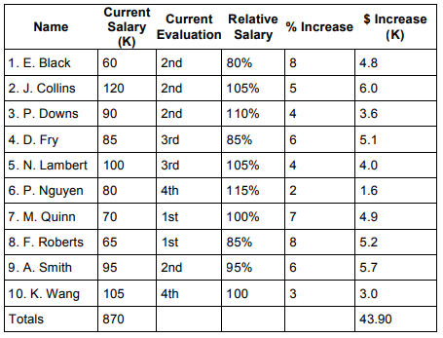

New Payroll: $870K * 5% = $913.5K

Consider the following changes to this computer prepared report.

• D. Fry's performance has increased to 2nd quartile.   
• M. Quinn's performance has decreased to 2nd quartile.

1. Develop a new proposed merit plan. Be sure to indicate if you have merit budget to return to the department manager or if you need additional merit budget; that is, how many dollars are you over or under the 5% given to your department.  
2. Outline to your supervisor how you justify the overage or underage.

**Assumptions**

Attached in the lecture is a table summarizing the % merit increase for employees with a relative performance and a relative salary. Depending on the organization and how much money is available for new payroll, the amounts for the payroll increase may be greater or smaller than what is shown in the table. An assumption that is used in this assessment is that the values for % merit increase in the lectures is appropriate for the amount of total merit increase spending. The computation section will prove that the % merit increase is mostly appropriate for the given increase in payroll, however for different total payroll budget values, the % merit increase values will also have to change. The table referenced from lecture is shown below:

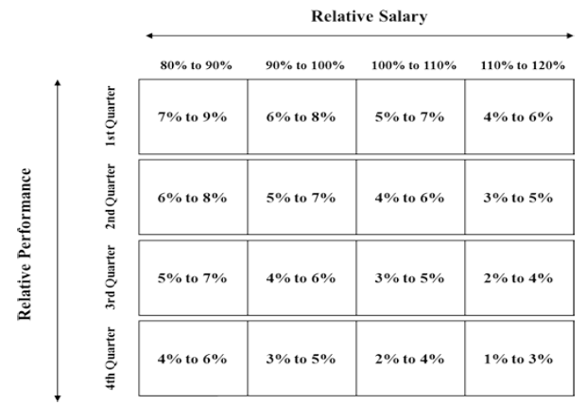  
*Table 1: % Merit Increase as a Function of Relative Salary and Relative Performance*

Noted is that in the problem statement each of the proposed % increase in salary for each employee is an integer percentage. A part of the computation will assume that the values can be decimal (ex. 5.5%). I do not foresee any non-bureaucratic reason that this could not be accomplished for a given employee.

**Computations**

One computation we can do is to confirm the first assumption from the assumptions section that each of the values in Expected % Increase for each employee falls in line with their relative performance and relative salary from Table 1. For employees where their relative salary falls on a margin (ex. 80%, 90%, 100%) we can assume the merit increase will fall between the min on the low side of the relative salary line and the max of the high side of the respective salary line. For example, an employee that has 100% relative salary and performs in the 2nd quarter will have an expected merit increase of 5%-6%. The summary of this table lookup is shown below:

|  |  |  |  |  |  |  |
| --- | --- | --- | --- | --- | --- | --- |
| Name | Current Salary (K) | Current Evaluation | Relative Salary | % Increase | Expected % Increase | $ Increase (K) |
| E. Black | 60 | 2 | 80% | 8.00% | 6%-8% | 4.8 |
| J. Collins | 120 | 2 | 105% | 5.00% | 4%-6% | 6 |
| P. Downs | 90 | 2 | 110% | 4.00% | 4%-5% | 3.6 |
| D. Fry | 85 | 3 | 85% | 6.00% | 5%-7% | 5.1 |
| N. Lambert | 100 | 3 | 105% | 4.00% | 3%-5% | 4 |
| P. Nguyen | 80 | 4 | 115% | 2.00% | 1%-3% | 1.6 |
| M. Quinn | 70 | 1 | 100% | 7.00% | 6%-7% | 4.9 |
| F. Roberts | 65 | 1 | 85% | 8.00% | 7%-9% | 5.2 |
| A. Smith | 95 | 2 | 95% | 6.00% | 5%-7% | 5.7 |
| K. Want | 105 | 4 | 100% | 2.86% | 3%-4% | 3 |
| Totals | 870 |  |  |  |  | 43.9 |

*Table 2: Expected % Merit Increase summary*

Comparing these results to the computer generated % increase is an exercise that can ensure that all the merit increases are fair and in line with Table 1. In general the computer generated % Increase falls nicely in line with the Expected % Increase. One instance where that is not necessarily the case is K. Want. K. Want may be the victim of a typo in the problem statement, which indicates that a 3K merit increase from his current salary of 105K is a 3% raise, when actually this is a 2.86% raise (this could also be a rounding error). Regardless, K. Want’s performance and relative salary likely deserves a slightly better raise than the one he is currently getting, so we can address that.

We can repeat this comparison exercise with updated evaluations for D. Fry and M. Quinn. Based on their current Relative Salary (which will not change) and their Current Evaluation, we can propose new Expected % Increase figures for each of the employees. This computation is summarized below:

|  |  |  |  |  |  |  |
| --- | --- | --- | --- | --- | --- | --- |
| Name | Current Salary (K) | Current Evaluation | Relative Salary | % Increase | Expected % Increase | $ Increase (K) |
| D. Fry | 85 | 2 | 85% | 6.00% | 6%-8% | 5.1 |
| M. Quinn | 70 | 2 | 100% | 7.00% | 5%-6% | 4.9 |

*Table 3: Reevaluations for D. Fry and M. Quinn*

We note that while D. Fry is still within the Expected % Increase range, M. Quinn has fallen out of their Expected % Increase range. It would not be fair to give a raise above the Expected % Increase to M. Quinn, nor would it be fair to K. Want to give him a raise below his Expected % Increase. Thus both will be adjusted, with M. Quinn being lowered to their maximum Expected % Increase, and K. Want getting bumped to their minimum Expected % Increase. We also note that we are currently overspending our allocated 43.5K merit increase for the year (we are currently spending 43.9K based on the computer generated report). Adjusting M. Quinn and K. Want to the proposed values will put everyone within their range, and still leave some money left over for the program.

While leaving some money for the program has some benefits, the money has already been allocated, and taking less money for merit increases for your employees may warrant the program giving less money for merit increases for the following year in some cases. Further, as a manager, I would not feel right giving as much merit as possible to employees of mine. Thus, I will choose to allocate freed up funds to D. Fry, who did well to outperform their last review. Doing so will produce the following values for each of the employees for the current merit cycle:

|  |  |  |  |  |  |  |
| --- | --- | --- | --- | --- | --- | --- |
| Name | Current Salary (K) | Current Evaluation | Relative Salary | % Increase | Expected % Increase | $ Increase (K) |
| E. Black | 60 | 2 | 80% | 8.00% | 6%-8% | 4.80 |
| J. Collins | 120 | 2 | 105% | 5.00% | 4%-6% | 6.00 |
| P. Downs | 90 | 2 | 110% | 4.00% | 4%-5% | 3.60 |
| D. Fry | 85 | 2 | 85% | 6.18% | 6%-8% | 5.25 |
| N. Lambert | 100 | 3 | 105% | 4.00% | 3%-5% | 4.00 |
| P. Nguyen | 80 | 4 | 115% | 2.00% | 1%-3% | 1.60 |
| M. Quinn | 70 | 2 | 100% | 6.00% | 5%-6% | 4.20 |
| F. Roberts | 65 | 1 | 85% | 8.00% | 7%-9% | 5.20 |
| A. Smith | 95 | 2 | 95% | 6.00% | 5%-7% | 5.70 |
| K. Want | 105 | 4 | 100% | 3.00% | 3%-4% | 3.15 |
| Totals | 870 |  |  |  |  | 43.50 |

*Table 4: Adjusted % Merit Increase summary*

**Discussion/Conclusions**

This proposed merit increase for each employee will put everyone within their Expected % Increase range for their current evaluation and current salary and manages to bring merit spending to exactly 5% of the current $870K payroll as requested by management.

This will also save the conversation between me and my supervisor for how to justify the overage or underage. In the case that there was a possible overage, a conversation would have to be had about how extraordinary the employees in the department are and why they deserve a raise greater than other departments. Helpful in this conversation would be specific examples of accomplishments, especially if those accomplishments can be tied to business operations and profits. Justifying an underage would have to come with assurances that each employee is happy with the merit bonus that they received and that there will be no negative side-effects for under spending on merit (like employees leaving due to low morale or higher paying positions). However, the conversation about spending exactly to the proposed merit budget will likely be brief, although I would lean more toward taking an overage than an underage in most situations.