Bit level manipulation | Zurabi Todua
The goal of this assignment was to make a C++ program that would be able to take a decimal number and return its fixed-width binary representation, one's complement and two's complement. The user could choose between 4, 8, 16, 32 and 64 bits, while the program kept running until they decided to exit.
The main requirement for this assignment was that every named variable had to be a pointer, meaning I couldn't use regular int variables for counters, regular arrays for saving the binary representations and things like that, while also making sure every dynamically allocated memory was deallocated when it was no longer needed.
Step 1: Print function
I divided the program into several smaller functions, so that I could manage every part of the problem separately and efficiently. Knowing I’d need to print a few arrays, I decided to make a printer() function, which would make this task easier.
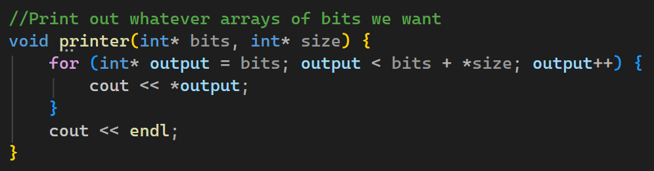
Step 2: Menu function (first half)
Next, I decided to focus on the Menu() function (it gets called immediately in main).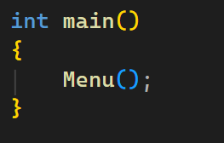
The menu manages the while loop, which shows the user the main layout of the program and gives them the choice between which bit system they want (4, 8, 16, 32, 64) or if they want to exit the program by inputting '0'. I also made sure to set up a system which would validate the user's input to make sure there weren't any letters or unsupported bit sizes used. Of course, I made sure to make the choice variable a pointer which gets deleted every time we are done using it.
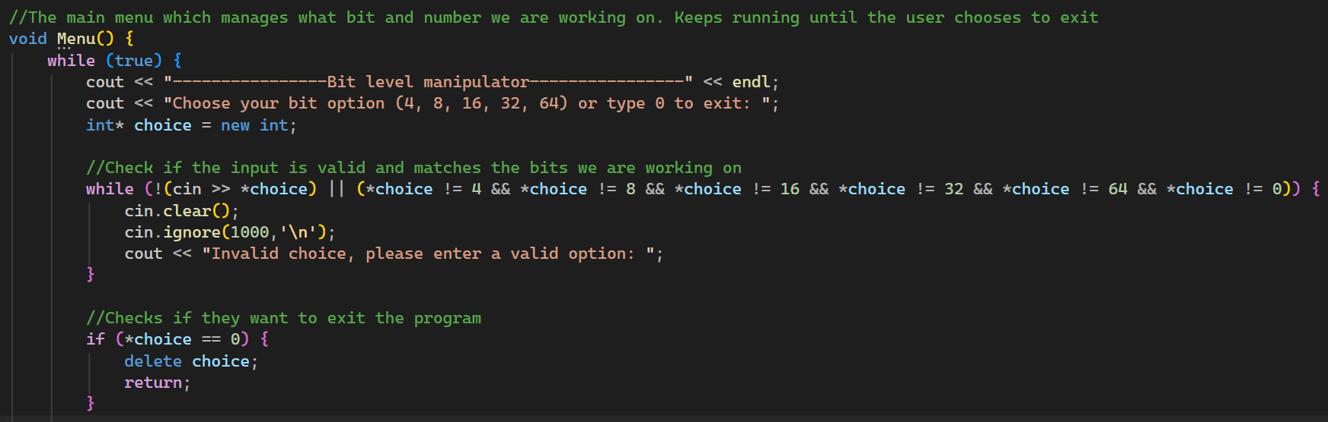
After this we can safely make the user input a long long type variable (int can't hold the full range of 64-bit signed numbers), which we also check for validity and then give it to the converter() function, along with the selected bit size. We also delete the earlier dynamically allocated variables.
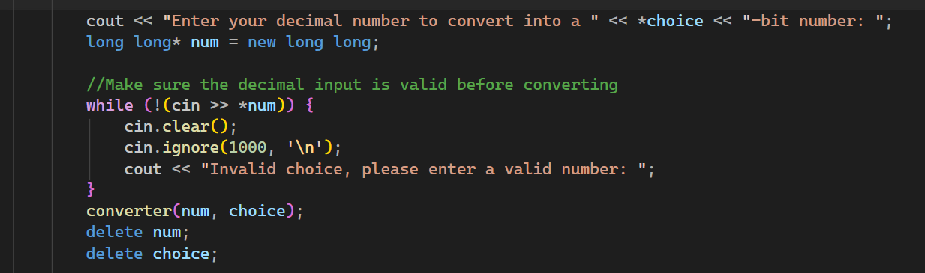
Step 3: Converter function
Now we can focus on the converter() function, which is mostly a packaging of all the functions which actually calculate the needed conversions. In here we first check if the given number actually fits into the given bit size (64 doesn't need a separate range check, because we're already using long long). If it can't fit, we print an error and return to Menu(), where the user can decide whether to perform another calculation.
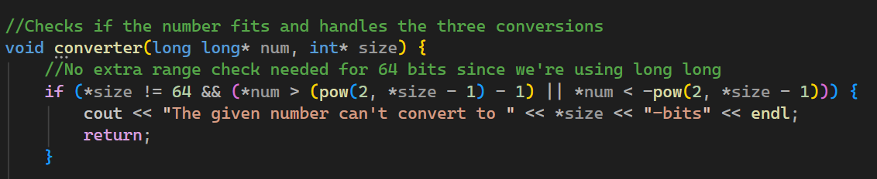
After this we can safely allocate three arrays (we delete each one at the end of the function) which will 1. Convert the decimal number into binary 2. Calculate the one's complement 3. Calculate the two's complement. We call the needed functions which do these calculations (I'll discuss each one later). I also initialize the arrays with zeros using (), so numbers that need fewer bits still have leading zeros and the output always has the selected number of bits.
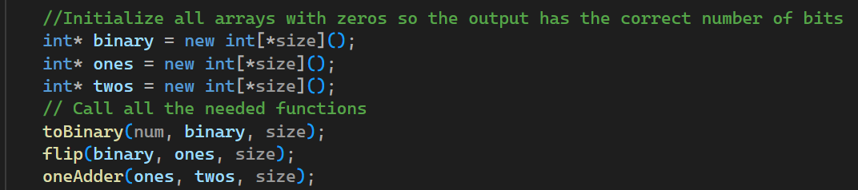
Step 4: To binary function
To convert a decimal into binary we first need to check if the number is negative or not. To turn a negative decimal number into binary, we first need to find its absolute value and then find its two's complement. Unfortunately, signed long long is lopsided and the absolute value of its lowest number would be one more than its maximum positive value. To make sure even the minimum case can be solved, we first add 1 to the negative number so we can safely negate it, then assign the result to an unsigned long long (which can hold a larger positive value, even though it has the same number of bits). After this we can safely add the 1 again to get the value we wanted. If it's not negative then we can work on the number without changing anything (I still assigned it to a temporary value so that we can maintain the original number without any changes to it).
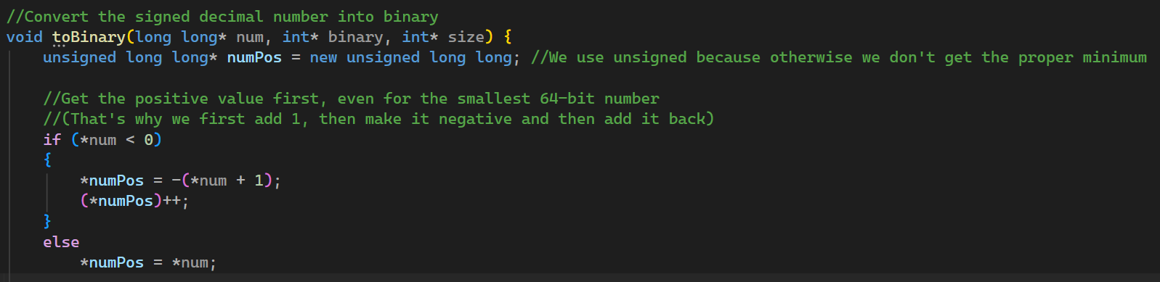
After this we can convert this number into its binary representation (if it's negative, we will also need to do other operations later). I dynamically allocate an integer which starts at the last index of the array (decrementing it until the saved number reaches 0). This way we can divide the number by 2 while storing the remainders from right to left.
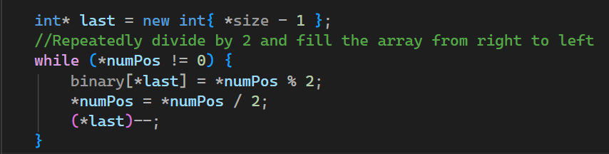
If the number was negative then we perform the flipping operation (find the one's complement) and then add one, both with separately written functions. Of course, I also deallocate the extra array and pointers afterward.
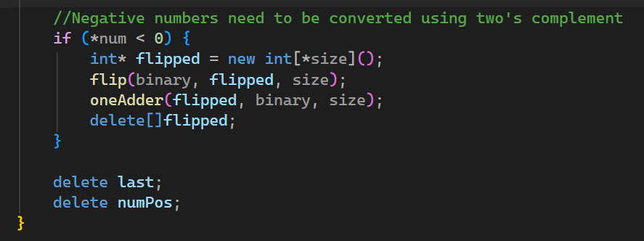

I also allocated another array which would store the flipped bits.

Step 5: flip function
To calculate the one's complement all we need to do is flip the ones and zeroes of the array. So, I go through the binary array using pointer arithmetic, while also incrementing the pointer which I assigned to the first value of the new array where we store the flipped numbers. If the number stored is 0 in the array, then we store 1 in the new one and vice versa.
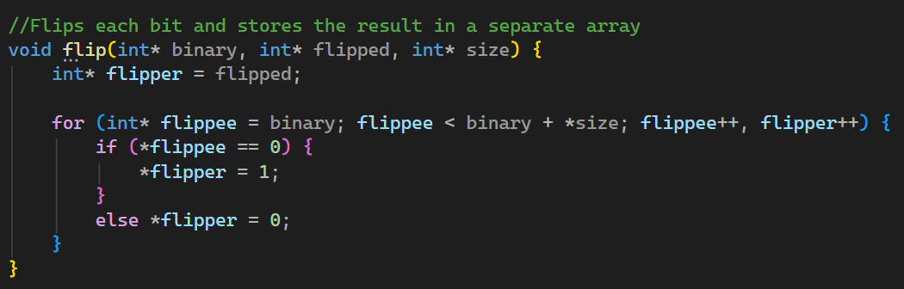
Step 6: Adding one
One final step we need to focus on is calculating the two's complement, which is just adding one to the one's complement. We allocate a temporary carry variable which saves what needs to be carried onto the next bit of the array and also two pointers which point to the end of the flipped and binary arrays. This way we can go through the arrays from right to left using a while loop, decrementing both pointers each time. Then we calculate the addition by adding the carry to the current bit and using mod 2 to store the remainder. For example, if the sum is 2, mod 2 gives us 0 while dividing the sum by 2 gives us a carry of 1 for the next bit. This way the carry can pass through multiple bits when needed. We delete the carry at the end of the calculation.
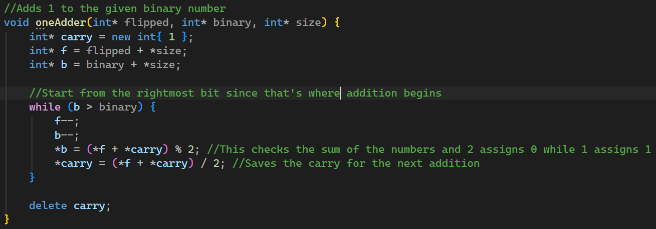

Step 7: Printing the results
After all of this, everything has been properly calculated and the converter () function prints everything and deallocates the arrays.
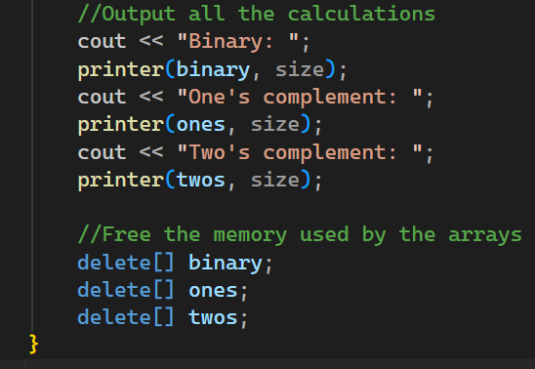

Step 8: The end
At last, the program goes back to the main loop of Menu() and asks the user if they want to continue. I also used another while loop which keeps asking until they type y, Y, n or N. The answer is stored in a dynamically allocated char pointer, which I made sure to delete afterward. If they type n or N, we exit Menu() and the program finishes. Otherwise, we just let the main while loop run again.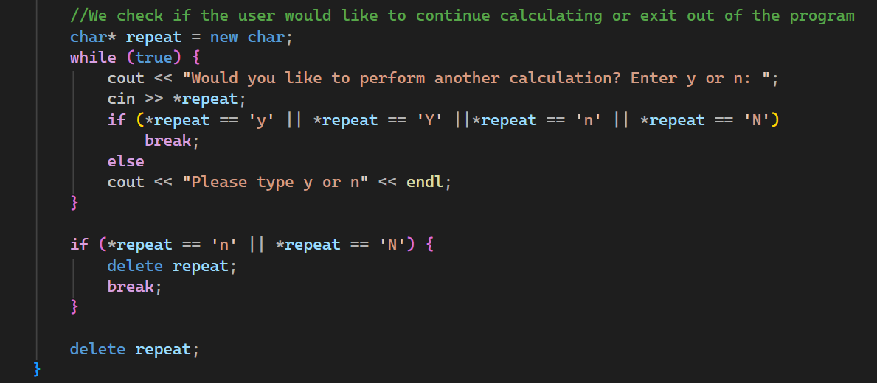

Challenges and how I dealt with them:
The main challenge was obviously using pointer variables for everything and not being able to make any ordinary variables. I kept losing track of where I had to delete and allocate memory, because of the variety of functions that used each one. I had to really make sure to understand where each variable stopped being useful and should’ve ended its lifetime without causing memory leaks or bugs.
I also had to figure out how to go through two arrays at the same time in the flip function, where I used pointer arithmetic’s with two increment operations in the for loop.
Another part that gave me trouble was handling the minimum 64-bit number, which caused overflowing because of long long’s lopsided nature. That’s when I decided to first get the negative number closer to 0 by adding one before negating it and then store it in an unsigned long long (which would be able to save the value). After that, I could add 1 back to get the original value without causing an overflow. This made me more wary of what the user could input and made me extra careful to check cases that might cause any trouble.
Test screenshots:
Test 1. Valid 4-bit input
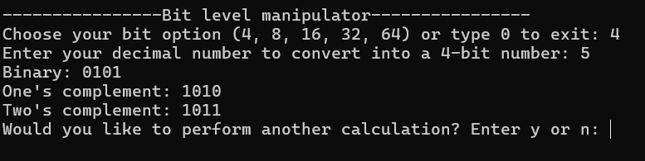
Test 2. Valid 8-bit input
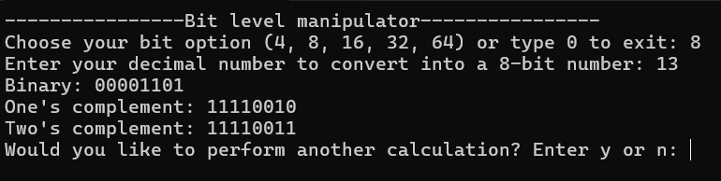
Test 3. Same number in different bit systems
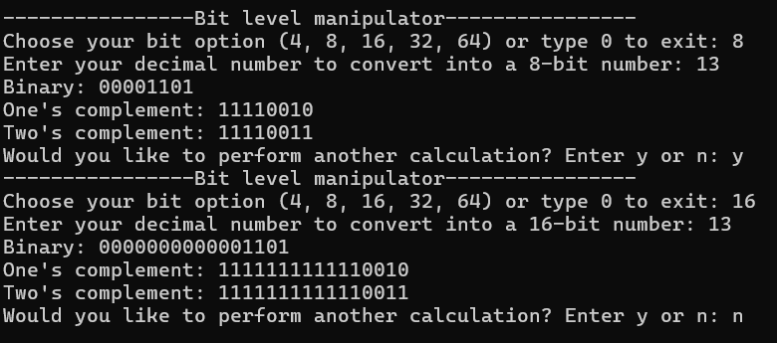

Test 4. One’s complement test
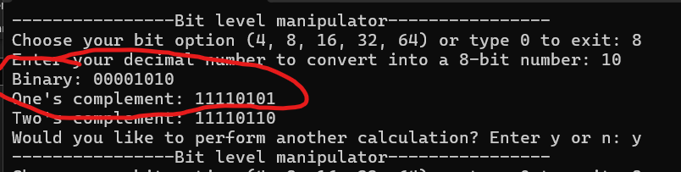
Test 5. Two’s complement and carry test
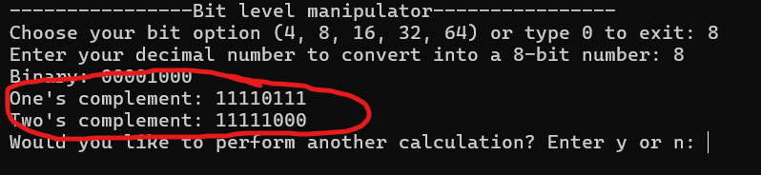
Test 6. Invalid bit-system choice
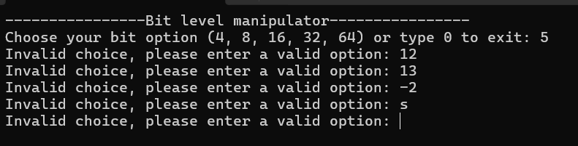
Test 7. Out-of-range number
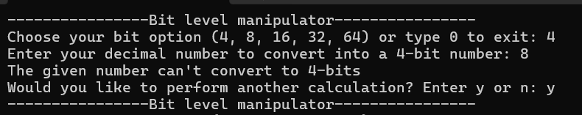

Test 8. Repeat calculations and exit
