Library management system in c++ Zurabi Todua

The goal of the program was to make a working library management system which would give the user ability to interact with its different types of items. Using object oriented programming is the perfect solution for such a task.
Class diagram:
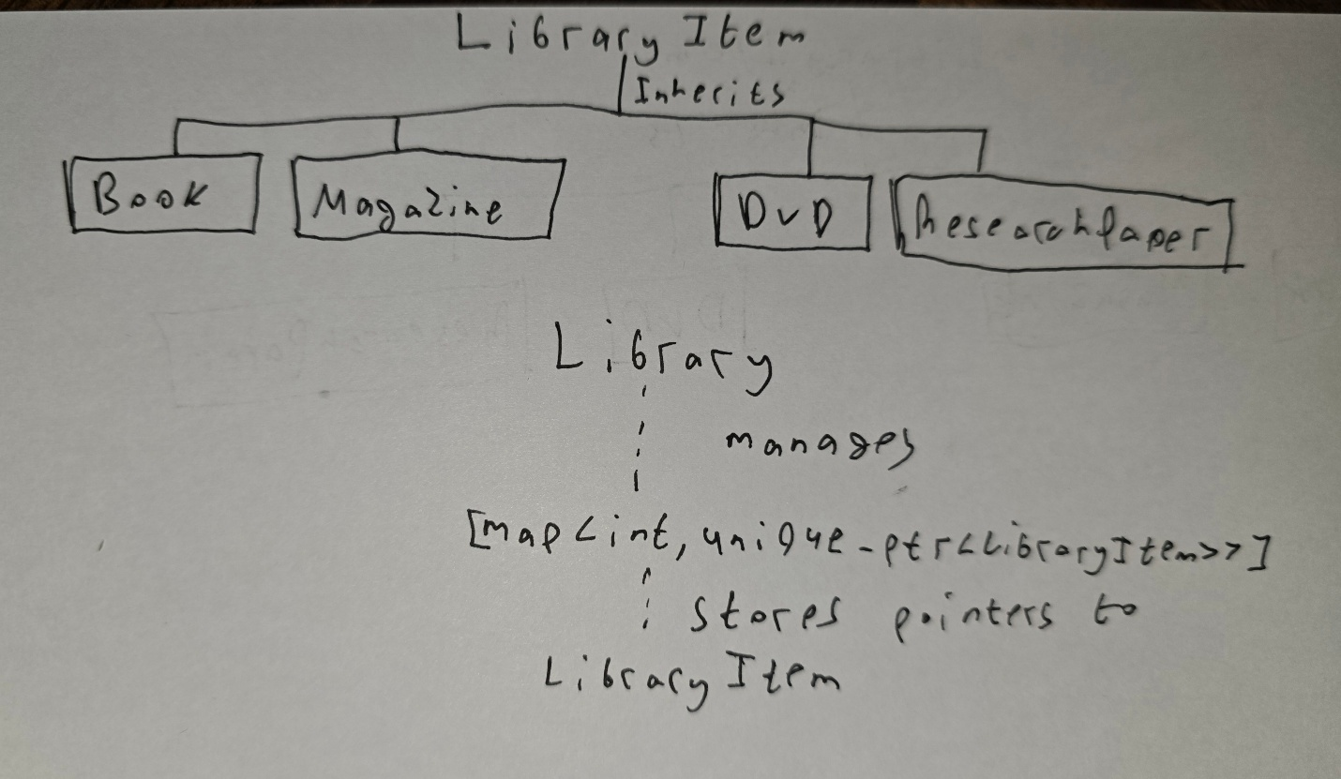
At first I made the main base class LibraryItem, which could store the common information that every library item has, such as ID, title, creator, publication year, availability status, borrower name, and borrow date. I of course made sure to follow the rules of encapsulation by privating all the main data types and using setters and getters so I could access them outside of the class.
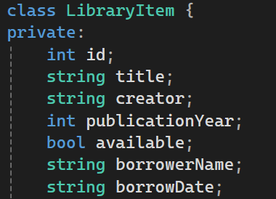
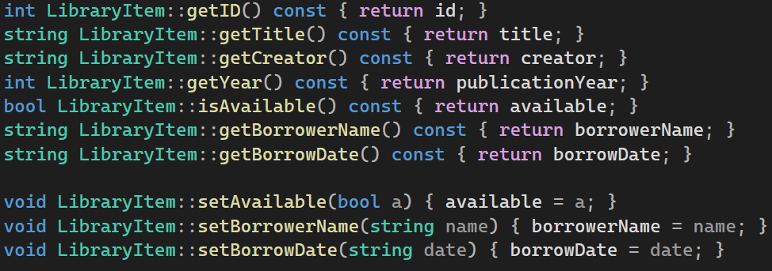
This way I could protect all my data in case of anything going wrong and corrupting the system. LibraryItem is used as the base class because books, magazines, DVDs, and research papers all share similar basic data and behavior. Instead of repeating the same fields in every class, the common fields are placed in LibraryItem. I used inheritance to acess all of the members and functions of the base class, while also keeping it cleaner and more organized for the derived classes: Book, Magazine, DVD, and ResearchPaper. Each one inherits from LibraryItem, but each one also has its own extra data. For example, Book has pages and genre, Magazine has issue number and month, DVD has duration and age rating, and ResearchPaper has conference and DOI.
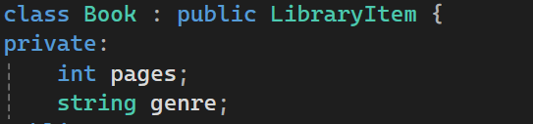
For constructing each class we would take the parameters and put the common fields into the LibraryItem constructor, while also setting their own unique data.
(These were almost identical for all derived classes)
I made the LibraryItem abstract with pure virtual functions (Virtual functions are used so that derived classes can override behavior from the base class) so that it could define what every library item must be able to do. It does not fully implement every behavior and forces the derived classes to make their own versions and override the function (Required for asbtract classes. This means a general LibraryItem object cannot be created directly) Functions like display(), getType(), saveToFile(), printToStream(), and calculateLateFee() are virtual. This allows the program to call functions through a base-class pointer and still run the correct derived-class version. Polymorphism is used through virtual functions. The program stores all item types as LibraryItem pointers. Even though the map stores base-class pointers, the actual objects can be books, magazines, DVDs, or research papers. When the program calls a function, the correct version of it is called depending on the real object type. For example, if the object is a DVD, the DVD::display() function runs.

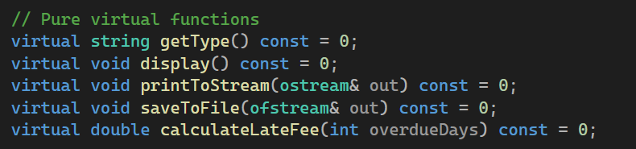
Also had do implement the virtual destructor, because derived objects are stored through base-class pointers. A virtual destructor makes sure objects are destroyed safely.

I also implemented operator overloading in LibraryItem class, allowing us to compare items by their year, check if their IDs are the same and also output them easily.
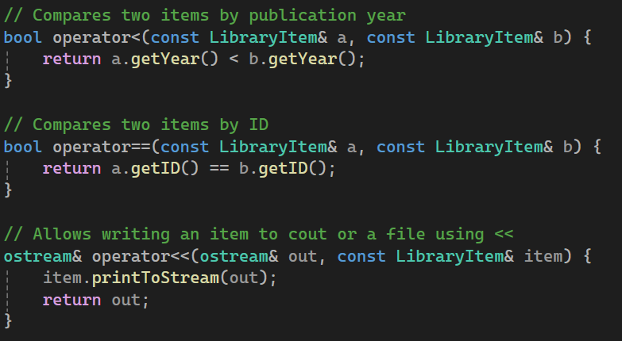
Next I had to actually override the functions in my derived class headers and implement them (I will only show the example of the class Book, because all 4 are basically the same).
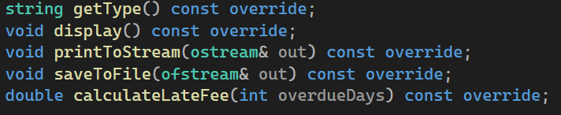
Each class having the abilty to return it’s type
Each class being able to be displayed with getter functions (While also checking if the book is avaliable or not, because it can change during the program)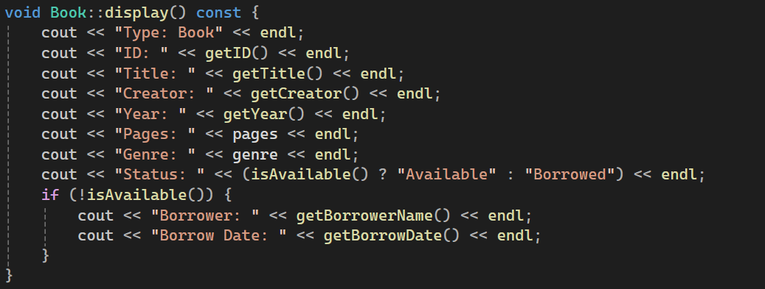
Each class being able to be printed into a stream (By using ostream& out, we can use this for either couting or files)
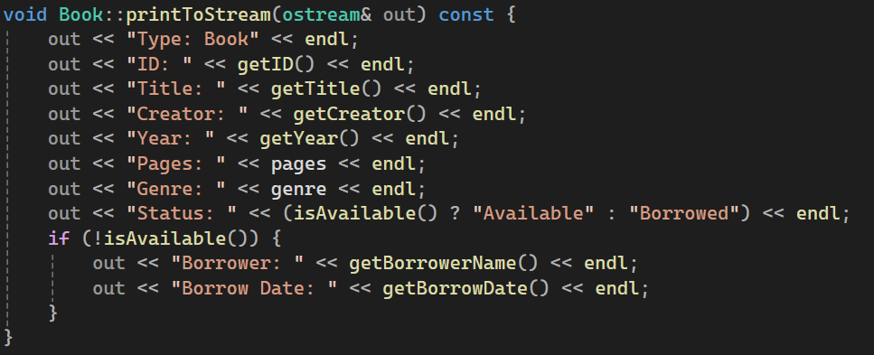
Each class being able to save the information into the file
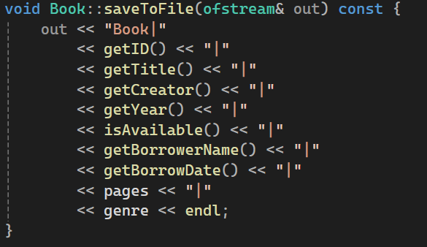
And also each class should be able to calculate the late fee according to each type’s late fee and how many days the borrower was late
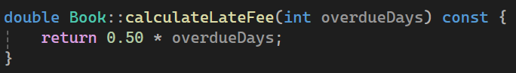

Before I moved onto the Library class which manages the most important functions, I also made a header file for certain utility functions that would help me save time and effort.
A function which would temporarily transfer strings into lower case so I could compare them without worrying about case-sensitivity
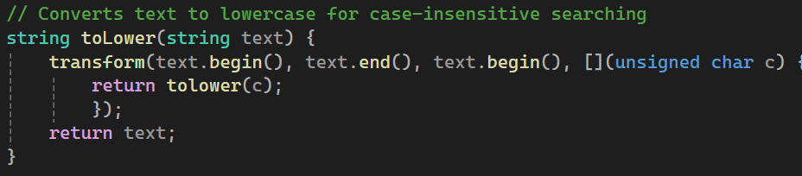
Functions which would help me handle real dates instead of manually typing them in (Get the current year, date using the ctime library, make single digit months/days more readable and convert dates to days approximetely)
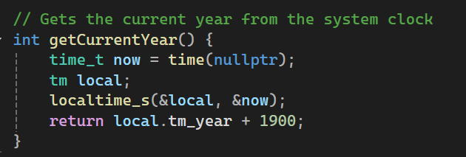
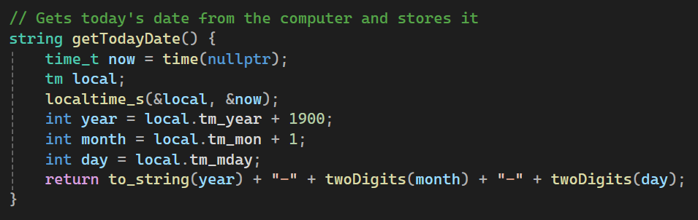
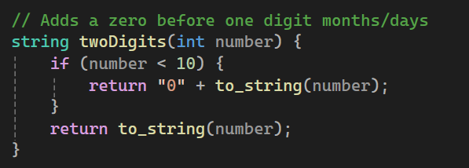
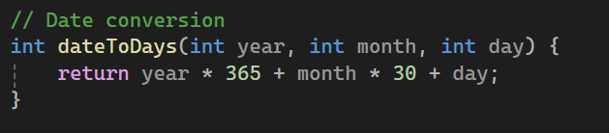
Functions for reading specific data such as dates, integers, doubles and strings (Made sure to have valid inputs otherwise throw an error at the user)
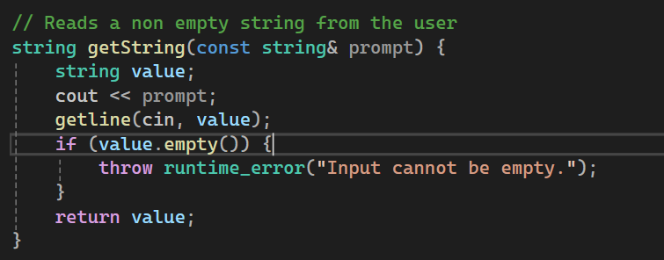
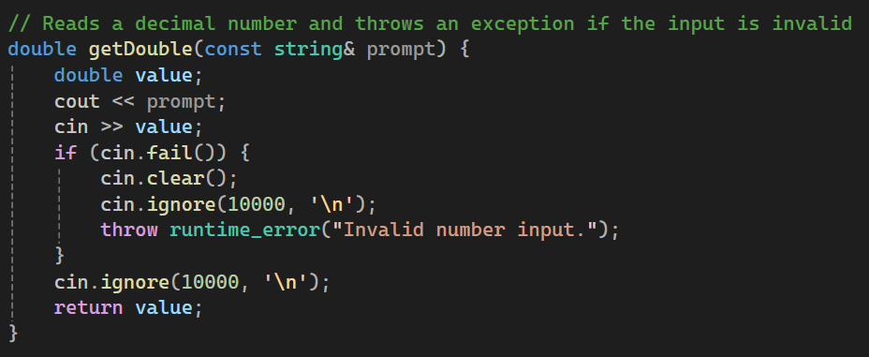
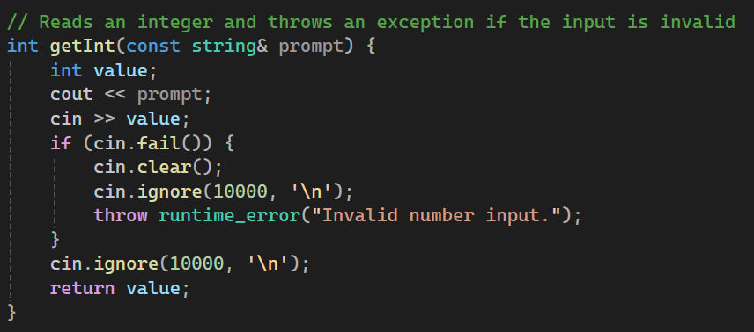
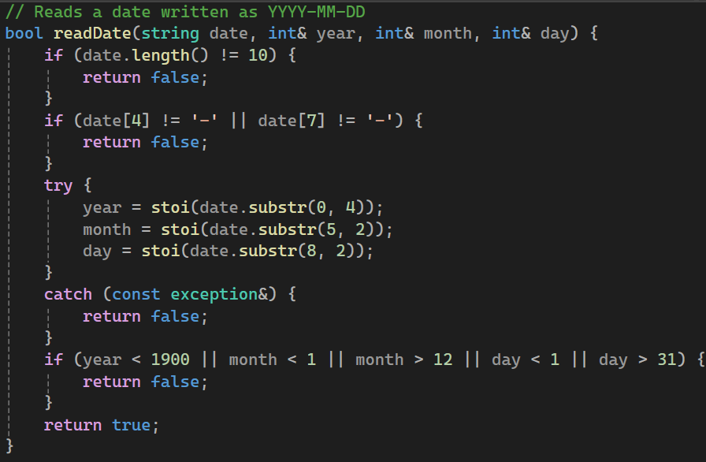
A function which calculated overdue dates by how late the item was returned after the loaning period
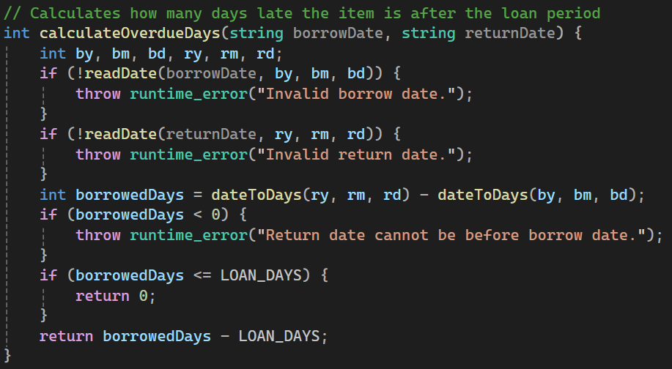
A function which would be able to validate if the given ID was positive, year was reasonable and title/creator had actual values
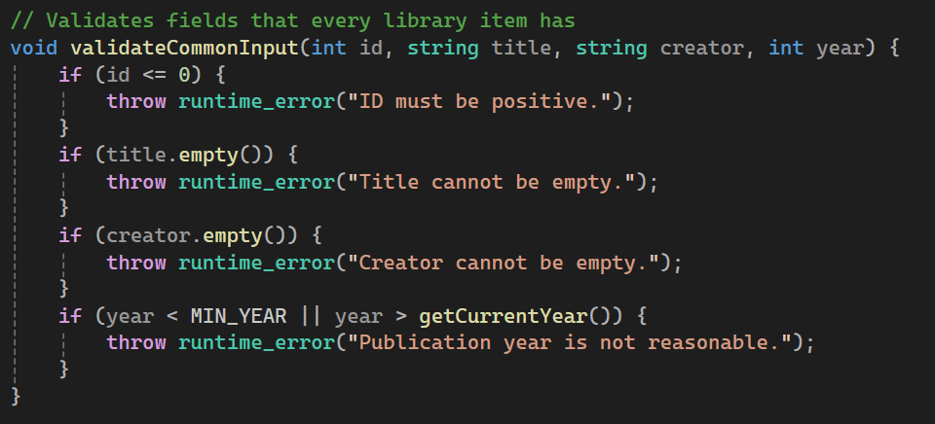
Now I moved onto the main part of the program, the Library class which managed the menu all the objects and all of its functions. It stored them in maps where, the key is the item ID, and the value is a smart pointer to a LibraryItem. (Being a smart pointer means the Library owns each item object. When an item is deleted from the map or when the program ends, memory is automatically cleaned up. This avoids manual delete and helps prevent memory leaks).This makes searching by ID easier and helps prevent duplicate IDs and allows the program to store different derived objects in one collection. The project also uses a temporary vector<LibraryItem*> in the sorting function. Since a map is always sorted by key, the vector is used to create a sorted display by title, year, type, or availability.

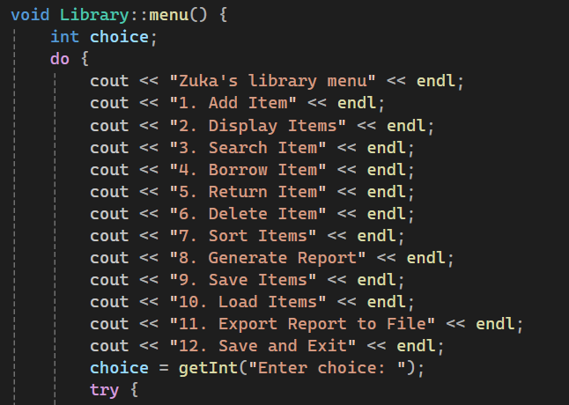
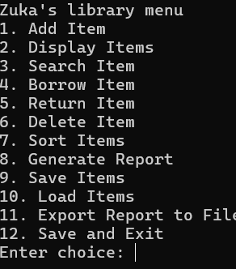
By running a do while function the menu would be displayed at least once and then the given choice was put into a switch, which then calls all the functions (Also makes sure to catch any errors that might occur during the cycle)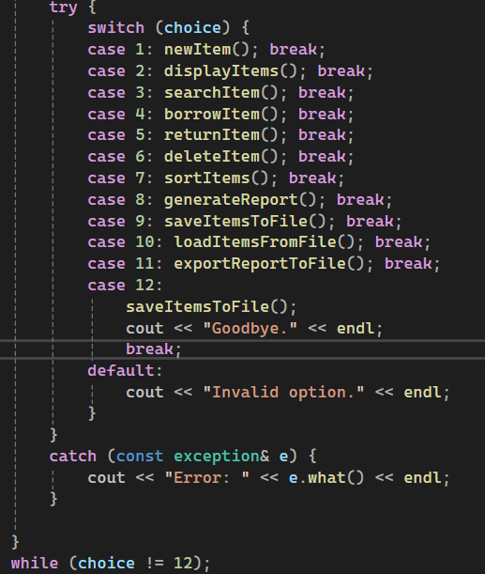
- newItem() function gives the user a choice to pick which type of item he is inserting, takes all the common field data and then adds the items to the map according to which type it corresponds to on the ifs (If it doesn’t correspond to any of them then it gives an error and goes back to the menu, otherwise it gives a successful message)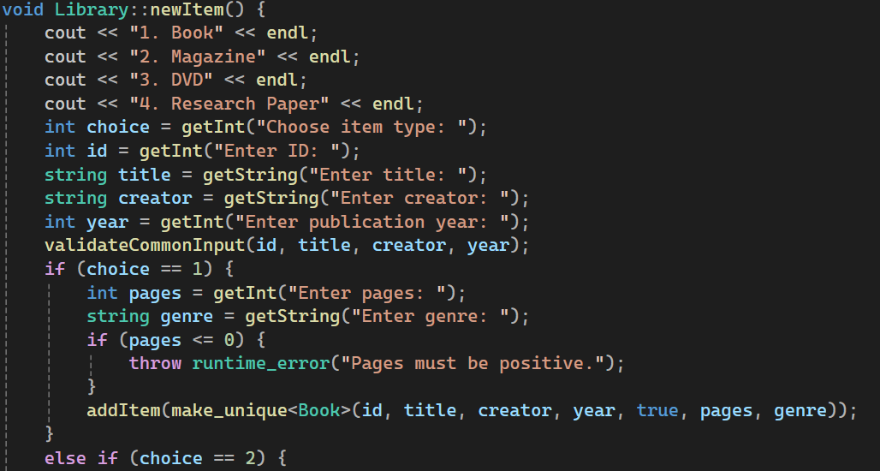
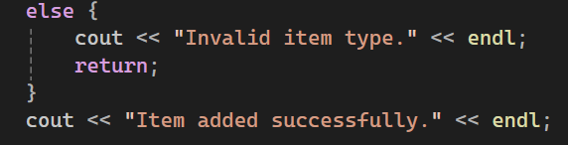
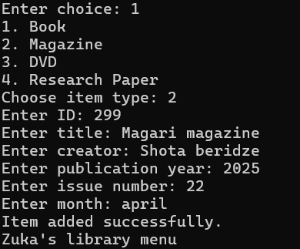
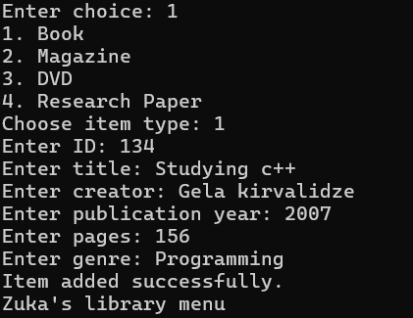
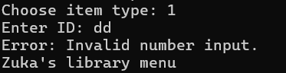
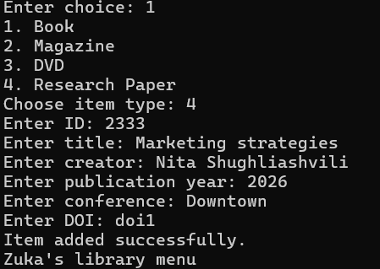
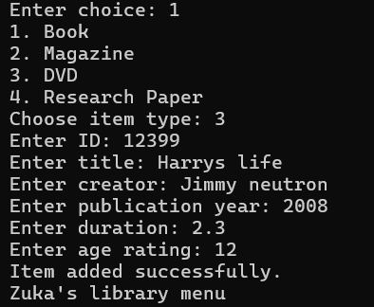
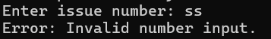
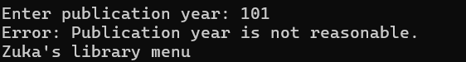
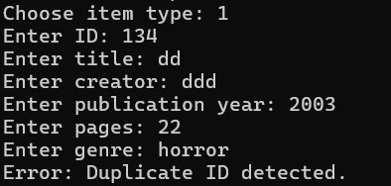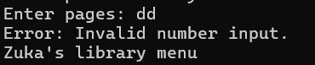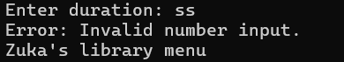
- displayItem() function goes over the container and just outputs the date with the already established display() function
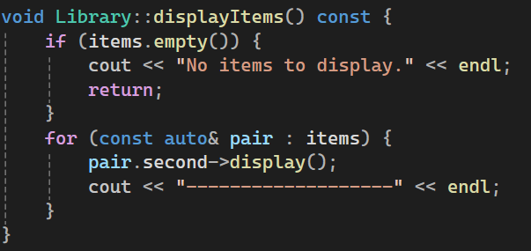
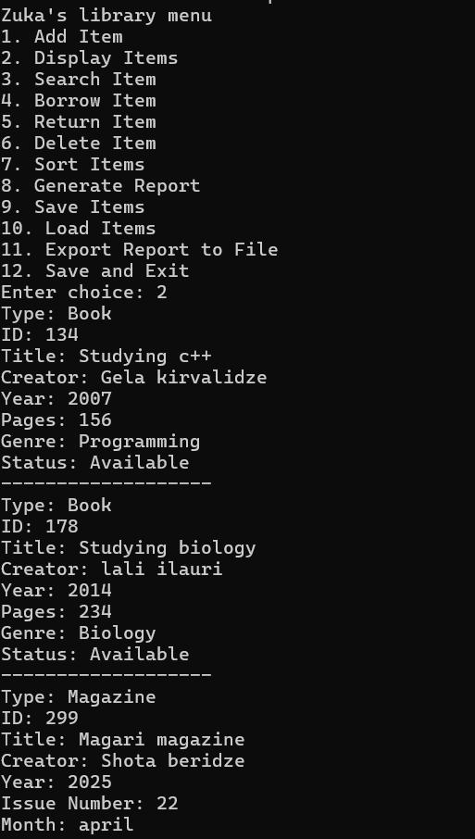

- searchItem() asks the user what criteria they want to search the item by and then goes over the container checking each one, printing the ones that match. (If it doesn’t find a match it either says so, or returns an error in the appropriate case)
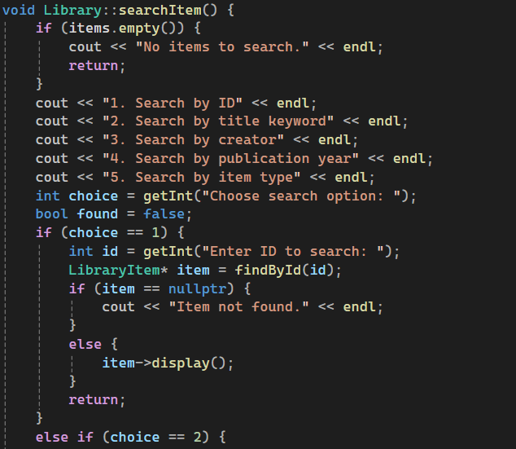
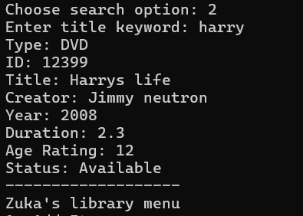
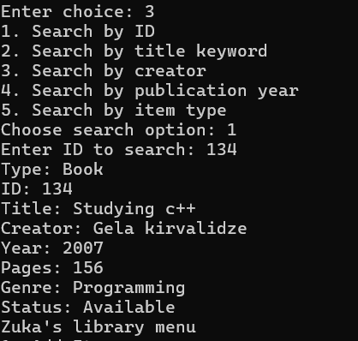
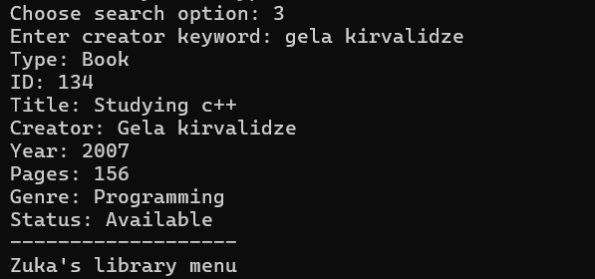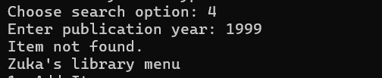
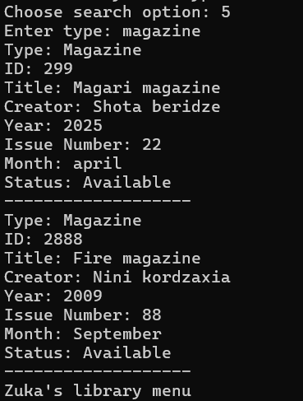
- borrowItem() asks the user which item they want to borrow with the ID, if the item is not found gives an error message, if the item is unavailable says so, otherwise it changes the avaliabality, asks the borrower’s name and sets the date. (I set a pre detirmined amount of loan days in the utility file)
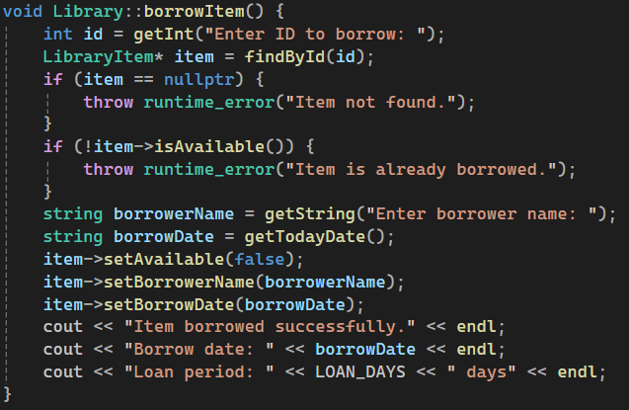
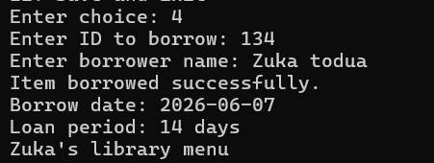
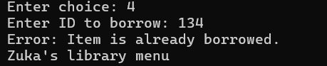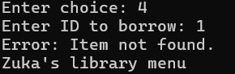
- returnItem() is the opposite function, which gets the ID of an item the user wants to find, goes over the container (makes sure the item was actually borrowed and the ID matches) and then changes the borrowerDate, borrowername and avaliabality back. Also prints out the fee the user has to pay, because of being overdue
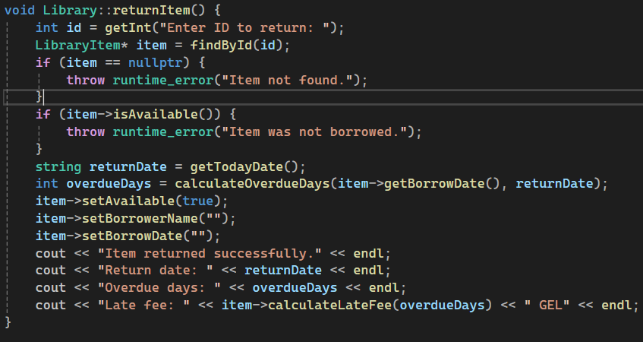
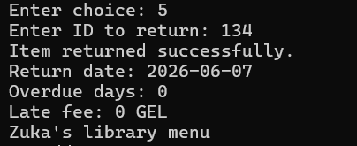
- deleteItem() makes sure the library isn’t empty and then asks the user if they want to delete by ID or displayed index. Based on that it goes over the container deletes the item from the container, which matches the ID/index. (outputs an error if it cant find the item)
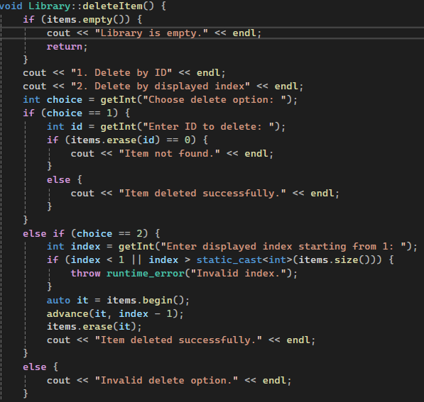
- sortItems() asks the user what they want to sort by and then uses the sort function to go over the items, sort it and display. (Inputs an error if needed)
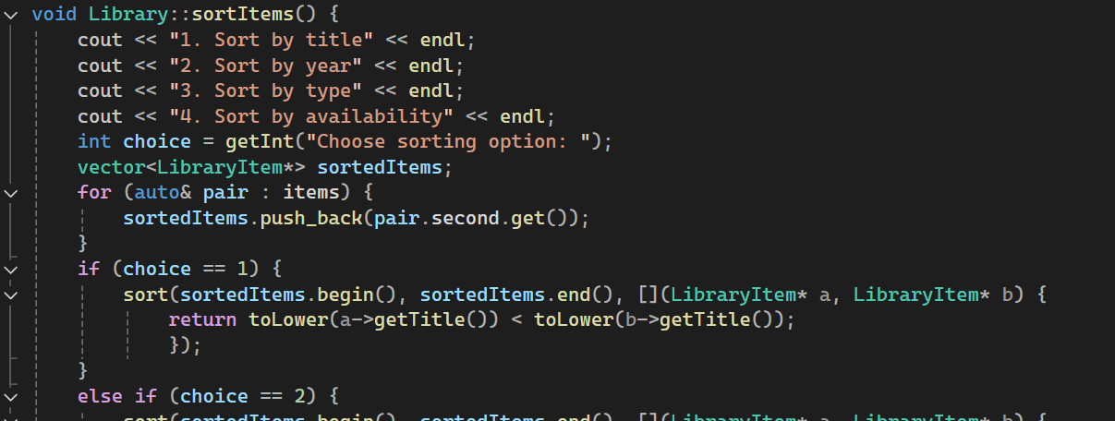
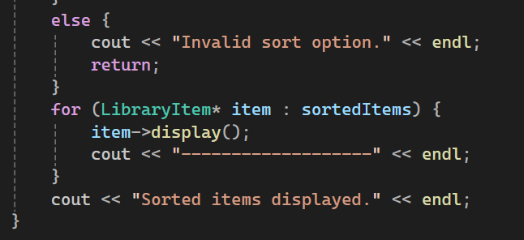
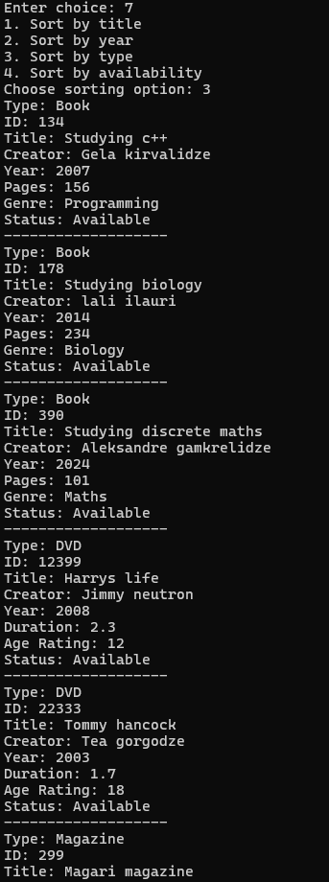
- generateReport() just goes over the container to find the amount of types and the function initializes oldest and newest with the first item, then loops through all items and compares publication years to find the real oldest and newest records.
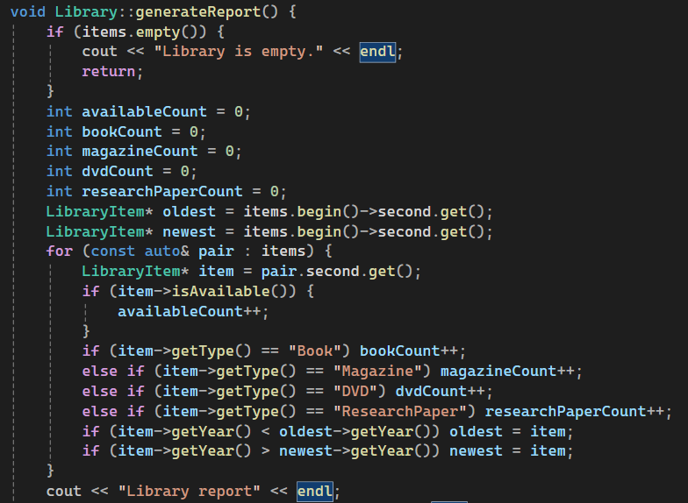
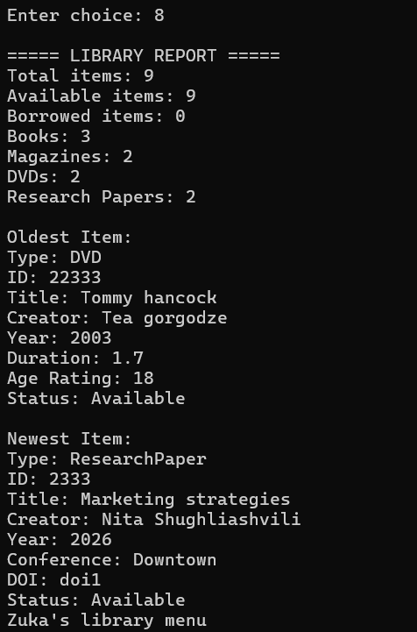
- exportReportFile() does basically the same as generateReport(), but it uses I/O files to export into a new LibraryReport.txt file. (Also checks if the file opened properly)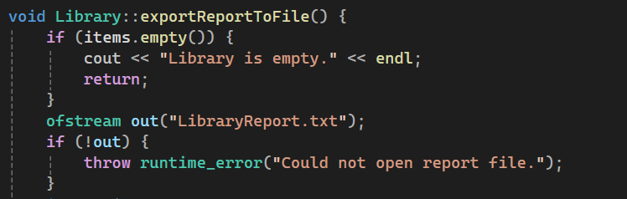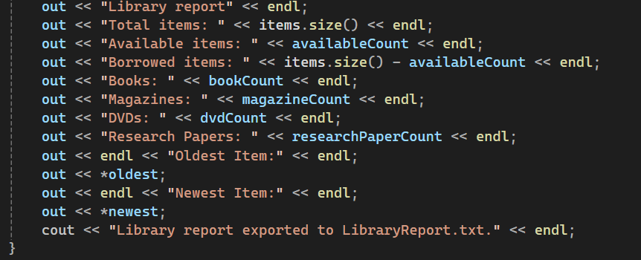
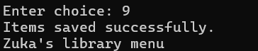
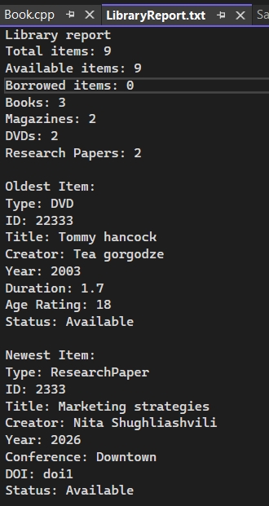
- saveItemsToFile() again uses I/O files to open a SavedItems.txt file and then goes over the container to output the items into it. (Also checks if the file was opened properly)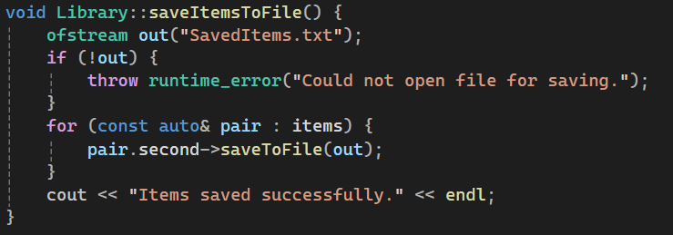
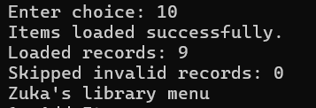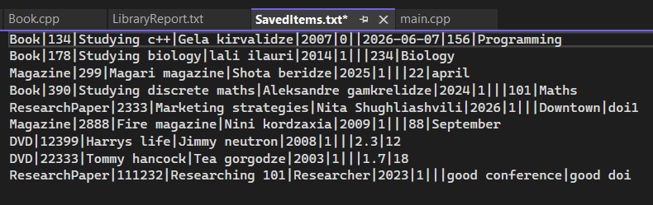
- loadItemsFromFile() opens the SavedItems.txt file to now read the information. Since we liked to display items with |, we have to make a string vector which saves the information by going over the lines from the text file and skipping |. The function then assigns those parts to appropriate data types and after checking the validations it checks which type the item is to properly store into the container. We also count how many items we loaded and how many items we skipped and output them. (Of course throw errors if something goes wrong) 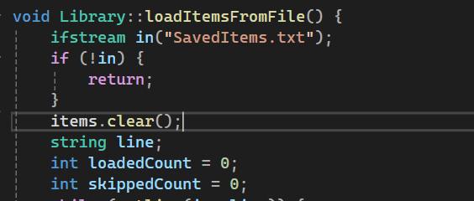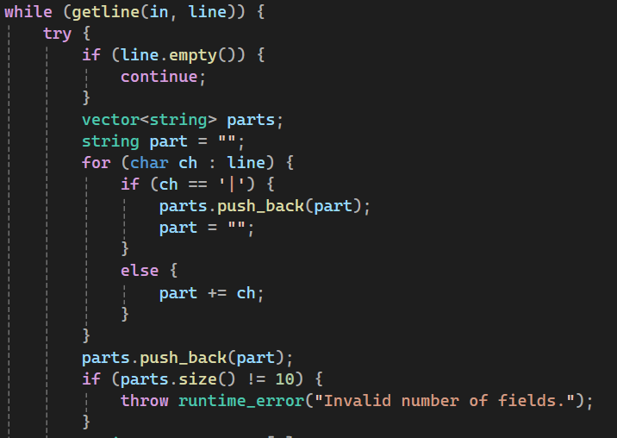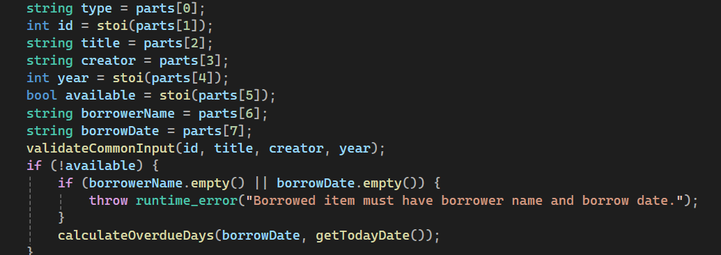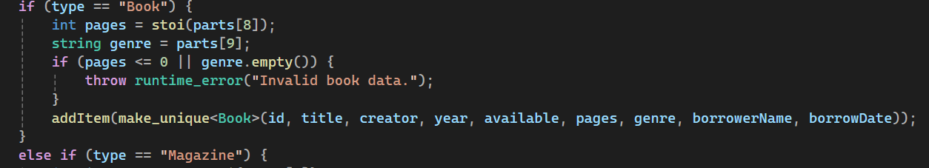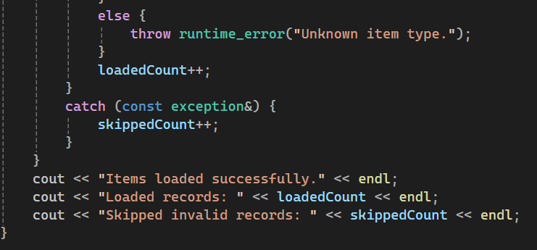
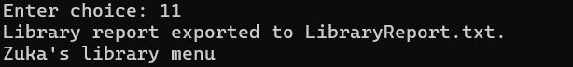
- Typing 12 just saves the items to file, types goodbe and breaks the while loop (exits the program).
In the end I just inclued the Library header into my main cpp file, made a Library class object, loaded items from file and ran the menu.
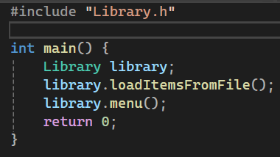
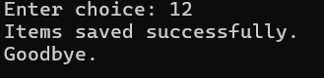

Reflection:
For me the hardest part of the project was loading the items back from the text file, because of how we had written them with | characters. Saving the data was muh easier, because I could just output each field with | between them. But here I had to read whole lines first and then go character by character to store the data members in one big string vector, only to then identify what data I was actually reading to make new objects.
In the start file structuring was also kind of a problem, because having hundreds of lines in one file made it hard to understand where I was making mistakes and everything got too messy. After I split the project into different header and cpp files everything felt more organizied and even though at first it felt kinda intimidating having to look through so many files, it definetly benefitted me in the long run.

