

Laborationsrapport
Projekt

MITTUNIVERSITETET
DSV Östersund

Examinator | Erik Ström | Erik.Strom@miun.se
Handledare | Robert Jonsson | Robert.Jonsson@miun.se
Författare | Bernard Che Longho | lobe1602@student.miun.se
Utbildningsprogram | Programvaruteknik, 180hp
Kurs | DT0146G, Webbprogrammering med HTML5, CSS3 och JavaScript
Huvudområde | Datateknik
Termin, år | HT, 2017

Innehållsförteckning
1 Inledning 4
1.1 Bakgrund 4
1.2 Syfte 4
2 Genomförande 5
2.1 Utrustning 5
2.2 Tillvägagångssätt 5
3 Resultats 8
4 Diskussion 12
Referenser 13

1 Inledning

1.1 Bakgrund
In our much interactive and busy world today, we often communicate remotely with our family, friends, work colleagues or business partners. One of the most common ways of effecting such communications is by using chat platforms like text sms, whatzapp, facebook messenger or other more complicated platforms like slack, ryver. There is nothing more annoying that waiting for too long expecting a response from the other person. It can even get worse when the other person types with lots of typos, making the communication unnecessarily long as one must spend time trying to figure our what has been sent. It is therefore important for everyone to know how fast and accurate they can type which will boost their moral and give them more confidence when text-chatting.
This project presents a tool (a web-based application) that one can use to measure his/her typing speed and accuracy. It contains ten(10) sample texts, half of which are in Swedish and the other half in English, giving users the possibility to choose which language to type with. The application also allows the user to decide whether or not, their accuracy should be calculated in a case-insensitive manner. The application ends when either the number of keystrokes has reached the text length or five(5) minutes has elapsed since the user clicks on the test input area.

1.2 Syfte
Varför utförs laborationen?
The purpose of this project is the application of HTML5, CSS3 and Javascript in developing a real world application.
Vad är dess målsättning?
The aims of this project are:
1. Using HTML5 tags to structure a webpage
2. Using CSS3 to style a webpage in accordance to some pre-defined specifications (see projektuppgift).
3. Using javascript to manipulate DOM(Document Object Module).
4. Downloading and importing other fonts from other sources and using in the project.
The project had main focus on the third objective where in one is required to update page contents, dynamically calculate a user’s typing speed and accuracy as they type.

2 Genomförande
In order to fullfil the aims of the project, this work contains an html file, a css file, and two javacript files, 2 audio files in the ”audio” folder, 2 webfonts in the ”fonts” folder and a couple of images in the img folder (see appendix for of file structure details).

2.1 Utrustning
Platform: Windows 10 Professional x64 bits
IDE: Webstorm v. 2017.2.5
Test browsers: The application was tested using chrome (Version 63.0.3239.132 (64bit)), firefox(version 57.0.4 (64-bit)), safari(version 5.1.7), opera(version 50.0.2762.58 (PGO)) and internet explorer (version 11.192.16299.0).
Text editor for this report: OpenOffice

2.2 Tillvägagångssätt
The file structure for this project is attached as an appendix.
In index.html, links to main.css, main.js and testStuff.js are attached. All styling is contained in main.css. Loading of test texts and changing them is handled in main.js while test measurements is done in testStuff.js. Test texts are stored in texts.xml. The audio files were downloaded from FreeSound(2017)[1] and converted to other formats (.mp3, .ogg) for cross browser compatibility using Online audio converter (2017) [2] while the fonts where downloaded from Webfonts (2017)[3].
Program initiation
When the program starts, texts are read from texts.xml and a test object is created. Each test object is made of the text title, author, text, and summary. English test objects are stored in an array (engTexts) and Swedish test objects are stored in another array (sweTexts). The aim of filling into different arrays is to improve performance when loading a new test as traversing an array of 5 elements will take less time than an array of 10.
After loading the texts in their respective arrays, a sample text and options for selecting different texts in the same language are displayed. Before displaying the sample text, all its characters are placed in a span element. Spanning the characters allows for styling as discussed below. In addition to displaying these texts, the statistics are set to zero waiting for the user to take action (click on the test input area).
Test timing starts when the user clicks on the test input area.
Test measurements
The program has a tracker that tracks the index of the currently typed text (typedIndex),the number of characters typed (typedEntries), the number of correctly typed entries(correctEntries), the number of wrongly typed entries(errorEntries) and the index of the next character(trackingIndex) in the test area (trackingIndex = typedIndex + 1)
As the user types, the character typed is compared to the character in the sample test text. If the two characters are the same, the sample text character is colored green and correctEntries is incremented by 1. If the two characters do not match, errorEntries is incremented by 1, the sample text character is colored red and a sound is played. Worthy of note is the fact that only non white space characters are colored so the number of red characters might differ from the number of errors displayed. However, the calculations take into consideration all errors.
Calculations
Errors = errorEntries
Accuracy = correctEntries/typedEntries * 100 (rounded to the nearest integer)
Gross words per minute (grossWPM) = (typedEntries / 5) / time*
Net words per minute = grossWPM - (errors/time)
* time is in minutes
After every keystroke, both typedIndex and trackingIndex are incremented by 1 and the time is measured and the statistics is updated and displayed. The text input area is cleared whenever the user presses the SPACEBAR. As mensioned above, trackingIndex keeps track of the next character to be typed. This character is highlighted as the user types. In order to avoid accessing a non-existent character, trackingIndex stops to increment when trackingIndex equals the number of characters in the test text.
Program end
The program ends when typedIndex equals the number of characters in the sample text or when 5 minutes has passed since the user clicked the text input area. When the program ends, the play/stop button changes to the play button, the text input area is disabled and its background changed from white to maroon and a text ”GAME ENDED” is displayed inside. Another way to stop the program is by pressing/clicking on the stop button. This button will only respond if the user has typed atleast a character. This also accompanies a sound and another text detailing why the program ends. Since the statistics are only updated after every keystroke, the last updated statistics remains in the display so the user can see their statistics alongside the duration of the test. At this point, clicking the play button resets the game.
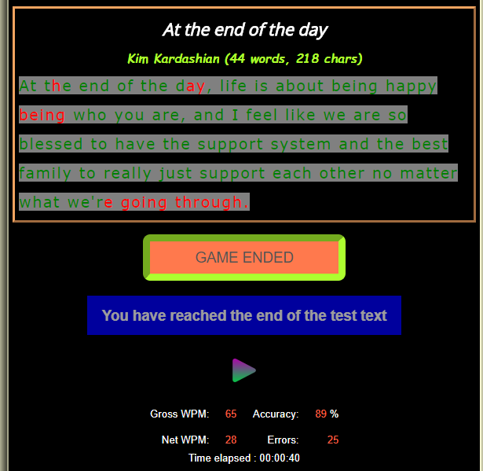
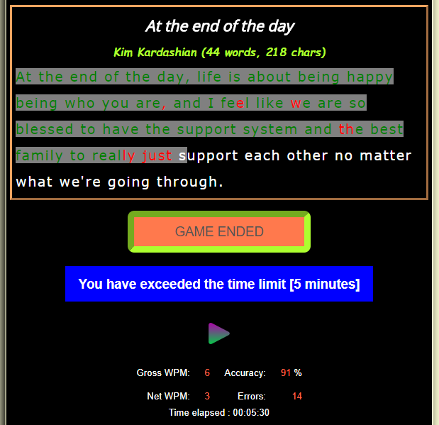
Figure 01a:. application view after typing all texts Figure 01b: application view after 5 minutes
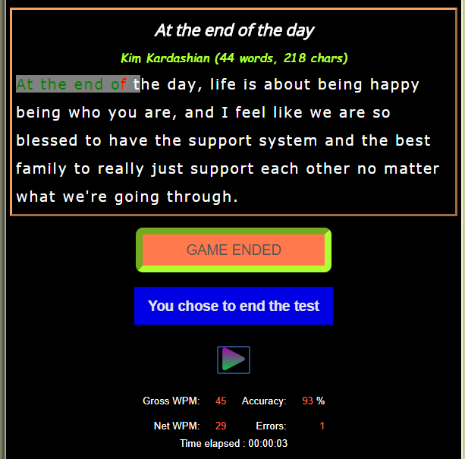
Figure 01b: application view when user ends the program

Program reset
The application resets if the user
- clicks on the play button after the program has ended,
- chooses another test,
- changes the display language
- clicks on the the page logo or
- reloads the page.

Version management
After every day of work, a copy of the project is backed-up in my student webspace at lobe1602/projekt[6] using FileZilla. Another copy is pushed to my a git repository project repo [7].

3 Resultats
The application is displays optimally with a screen witdth of 600px. However, if the screen with is smaller, a mobile friendly version is displayed as shown below.
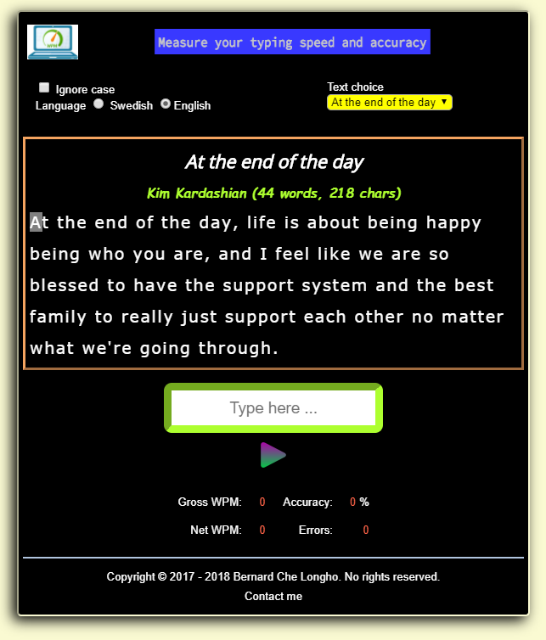
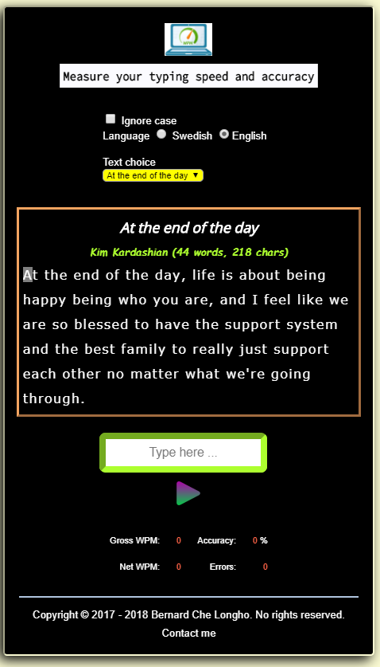
Figure 1a: App display on chrome width >= 600px Figure 1b: App display on chrome width = 500px
Tests
The application works best in chrome and opera. In both of these browsers, the application displays as defined in main.js and plays the error sound immediately when an error key is stroke. The figure below shows a test on Opera(fig. 2a) and chrome (fig. 2b).
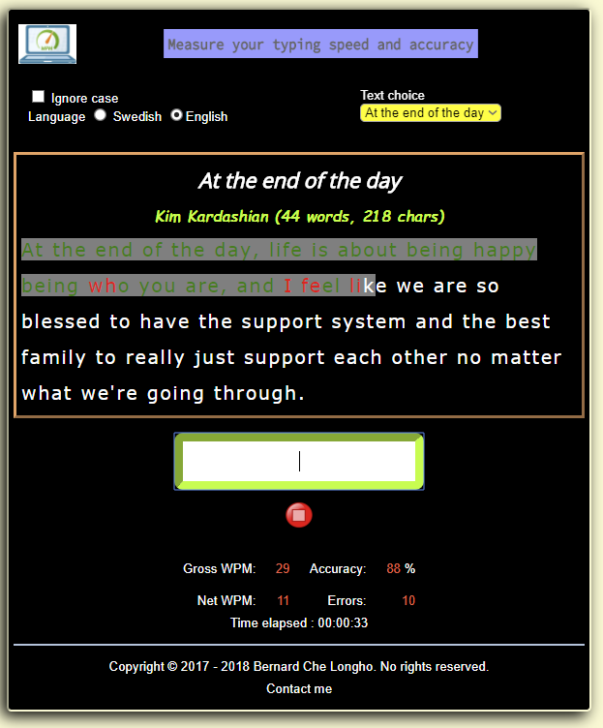
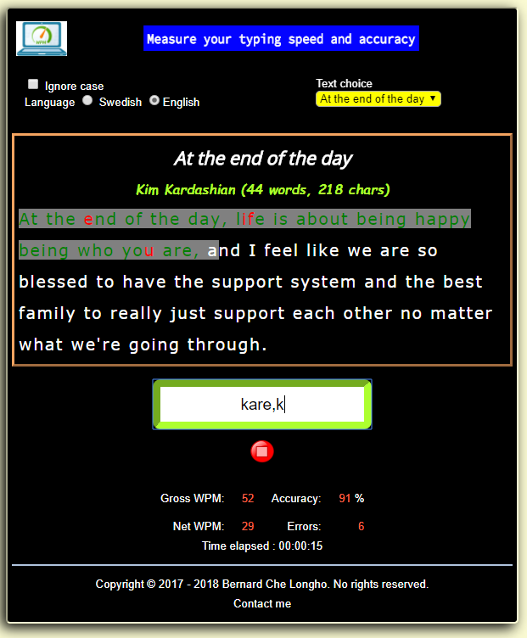

Figure 2a: Applicaiton display Opera 2b: Application display in Chrome
In firefox, a satisfactory results is obtained. Satisfactory here meaning it is possible to load new tests, type and get statistics. The problem encountered with firefox is that the rendering of the text choice selection box is pushed slightly to the right. Another problem with firefox is that the error sound has some latency which makes it seem as if no sound is played if one types too fast. The application interface as played with firefox is as shown in figure 3 below.
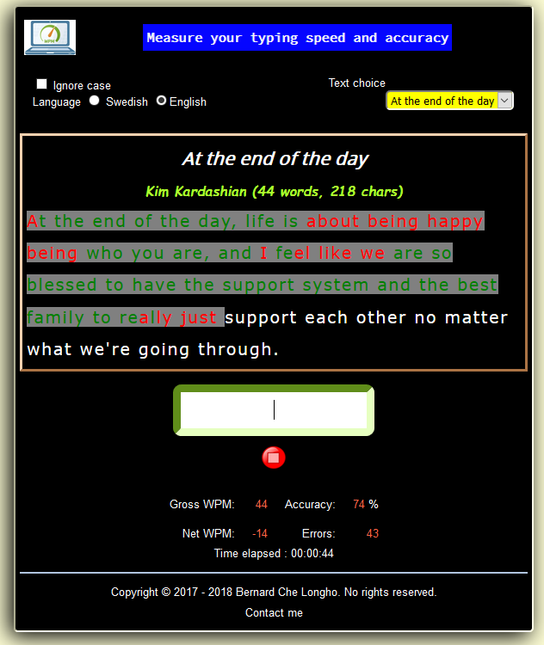

Figure 3: Application display on firefox
In safari, the application seem not to understand javascript. First and foremost, when the application loads, the test text to display is supposed to correspond to the current selected language. Safari ignores this and does the opposite. Secondly, when one chooses a text in the text choice area, the sample test text has to change accordingly. This too, does not happen with safari. Futhermore, the play/stop button that is supposed to be below the input area finds itself to the right of the input area and does not switch as required (play→ stop when user starts typing). In addition to the afore-mensioned, the statistics update is unpredictable and tracking seem not to work too. This application is therefore not supposed to be run with this browser.

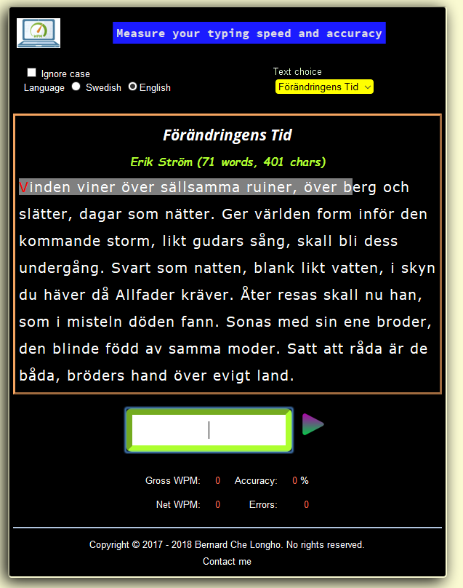

Figure 4: Application testing in safari browser
Internet explorer seem to ignore every aspect of this project. Like safari, it ignores the user’s language and displays a text in the opposite language in a completely weird manner. The displayed text spreads across the viewport, completely ignoring the width of the html page. In addition to this, it also does not respond to text choice and displays the textchoice selection box as does firefox. As if this is not enough, internet explorer ends the typing from once the user attempts to start (clicking the input text area, claiming that the maximum time, 5 minutes, has reached). This application is therefore not supposed to be run on this browser.
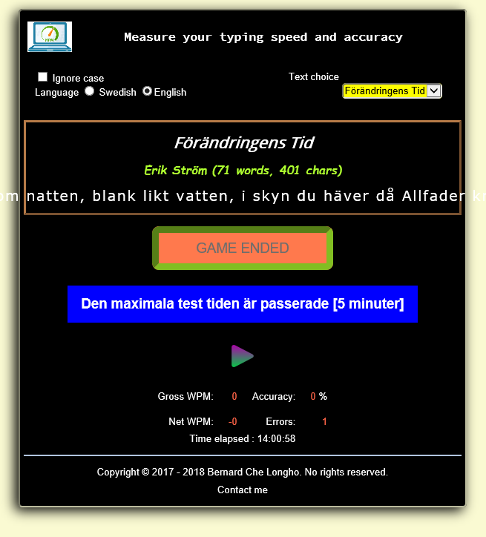
Figure 5: Application display in Internet explorer
Both the html5 and css files validates according to w3.org standats. Live demo of the application is at lobe1602/projekt[6] while the project source code is at project repo [7]

4 Diskussion
This project work has enabled me explore more that there is with html5, css3 and javascript. It was a real tasks that were required to accomplish enables one to dig deep into javascript and DOM of which was very enriching.
It really disturbing to know that the program could not run in both safari and internet explorer. I went an extra mile trying to hard-code the texts into an array but that didn’t work too. Then i thought maybe it is the vendor prefixes that were lacking then i went to autoprefixer CSS online [4] and pasted my css file. The cite then generated many prefixes in various parts of my css file. This did nothing to the rendering of the page contents. It instead results to 22 warnings when validating at css validator [5]. Since the file validates, i there ignored the warnings.
During this project i learned a lot about javascript and other stuff not covered during the lecture like attaching downloaded fonts. I am however disappointed with myself to not have been able to display the graph as the user types. I tried many ways but the best which i thought could work was as follows:
As the user types, the current time(seconds) alongside the netWPM are stored in an object called point which are then pushed into an array points. My idea was that once the array has more than 1 values, i will constantly take the last value (points[points.length-1]) and the last but one value (points[points.length-2]) as the values for my moveTo and lineTo in the canvas drawing. This however never showed up any value on the canvas. I therefore disabled the functionality but the logic is in the code drawProgress() (line 144 – 162 of testStuff.js).
I would appreciate feedback on why internet explorer and safari gave the weirdness and why firefox behaved the way it did.

Referenser
[1] Freesound https://freesound.org/people/GabrielAraujo/sounds/242503/, Accessed 2017-12-27.
[2] Online audio converter (2017) https://online-audio-converter.com/ accessed 2017-12-27.
[3] WebFonts(2017) http://fontsforweb.com/ Accessed 2017-12-24.
[4] Autoprefixer css online (2017) http://autoprefixer.github.io/ accessed 2017-12-26
[5] CSS validator https://jigsaw.w3.org/css-validator/validator
[6] lobe1602 web space http://studenter.miun.se/~lobe1602/projekt/
[7] project repo https://bitbucket.org/lobe1602/dt146g_project

Appendix
File structure
