CS ANALYTICAL LABORATORY
An opportunity brief.
Market, growth paths, and the agentic-AI question.
Prepared for Alan Weiss, Chief Financial Officer.
Bruce Longley · TSI-Citadel
May 2026 · bruce@tsicitadel.ai

Executive summary
———————
This brief is written for one reader, Alan Weiss, CFO of CS Analytical Laboratory. Its purpose is to lay out — in the kind of language a CFO can use to make capital-allocation decisions — what we at TSI-Citadel see when we look at CS Analytical's market, where the company is already moving correctly, where the organic growth paths sit (without any reference to AI), and where an agentic-AI partner would add measurable P&L lift over a thirty-six-month horizon.
We have organized the brief around five judgments. First, the market is moving faster than even the recent analyst consensus suggests. The pharma analytical testing outsourcing market is approximately $9.5 billion in 2025 and compounding near 9% through 2030. The CCIT services carve-out is approximately $1.5 billion and compounding at 9-10%, with credible upside to faster growth as USP <382> and Annex 1 enforcement curves accelerate. Second, CS Analytical is already correctly positioned on the most important of these waves — the Clifton expansion, the launch of RM Analytical, the addition of USP <87> and USP <788> micro testing and USP/EP gas qualification, and the IV bag CCIT expansion all sit on the right side of the market vector. This is not a turnaround brief; it is an acceleration brief.
Third, there are five clean organic growth paths that do not require an AI partner of any kind. They are listed and sized in Section VII. Fourth, there are four agentic-AI use cases that would, in our view, produce measurable lift over the same horizon — and one of them (continuous regulatory intelligence) is almost certainly worth doing on its own merits before any of the others. Fifth, the adjacent-market opportunities (Section X) are real but optional; they belong on the strategic horizon, not in the operating budget.
If we were sitting in the CS Analytical board room with the CFO's model on the screen, the conclusion we would underline is this: the organic plan alone gets the company to roughly 1.55× current revenue at month 36; the organic plan paired with a targeted agentic layer plausibly gets to 2.4× over the same period, with agentic payback inside twelve months and capital outlay measured in the low six figures.
The remainder of this brief makes that case in detail. Section I explains why TSI-Citadel is sending an unsolicited brief at all. Section II is CS Analytical from the outside, drawn entirely from publicly available material. Sections III through V cover the market, the demand tailwinds, and the competitive set, with explicit sources for each material number. Section VI gives credit for what is already in motion; Sections VII and VIII separate the organic and agentic growth paths cleanly. Sections IX and X cover the ROI shape and the optional adjacencies. Sections XI, XII, and XIII cover risks, the engagement model we would propose if you wanted to work with us, and our final read.
— — —
I. Why this brief
———————
CS Analytical has been on our watchlist for two years. The reason is straightforward: in the work we do for specialty laboratory operators, container closure integrity is the single sub-discipline that has shown the cleanest combination of regulatory tailwind, demand-side acceleration, and competitive thinness. The number of laboratories worldwide that are simultaneously deep in CCIT, modern in method portfolio, and built for the speed that current sponsor programs require can be counted on one hand. CS Analytical is one of those hands.
The last six months are what moved the company from a watchlist entry to a working file. In February 2026, CS Analytical announced the launch of RM Analytical, an adjacent raw-material and excipient-testing business operating under a sister brand. Two months later, the company announced a major expansion of its Clifton, New Jersey facility — doubling laboratory footprint to support the new service lines and growing book of business. In parallel, USP <382>, governing functional suitability of elastomeric components in parenteral packaging, is reaching its official date of December 1, 2025, with the responsibility for testing shifting from elastomer suppliers to drug manufacturers. And the GLP-1 wave continues to push prefilled-syringe and autoinjector volumes through step functions that no incumbent CCIT capacity was sized for.
Four signals in one quarter. Each one alone would justify a sharper plan. Together, they justify a conversation about whether the agentic-AI layer we build at TSI-Citadel could meaningfully accelerate what is already a strong organic position. That is the question this brief is built to answer.
— — —
II. CS Analytical Laboratory — the outside view
———————
Everything in this section is drawn from publicly available material — the company's own website, recent press releases, and industry trade coverage. It is the picture an analyst with no inside access would assemble.
Position
CS Analytical Laboratory, headquartered in Clifton, New Jersey, describes itself as the only cGMP, FDA-regulated laboratory exclusively designed and built to serve the container and package testing needs of the pharmaceutical, biotechnology, and medical device industries. That self-description is, on examination of the competitive landscape, defensible — no other provider we have identified combines exclusivity of focus on container testing with the full deterministic USP <1207> method portfolio under a single cGMP roof.
Leadership and method portfolio
Chief Executive Officer Brian Mulhall has spent more than thirty years inside the pharmaceutical industry, and led the team that built what is publicly recognized as the world's first FDA-regulated, cGMP contract Container Closure Integrity Testing laboratory. That earlier work fed materially into the industry-accepted standards that became USP <1207>. The relevance here is not biographical: it explains why CS Analytical can credibly claim a method-portfolio depth that broader-line generalists cannot match. The company offers the full USP <1207> deterministic suite — helium leak detection, vacuum decay, high-voltage leak detection (HVLD), and laser-based headspace analysis (the recent Lighthouse Instruments installation extends the laser-headspace capability). USP physical performance tests, USP physicochemical tests, and function-specific tests are all available on the same site, including the recently added USP <382> elastomer functionality work.
Recent commercial moves
Four announcements in the most recent six-month window define the company's current trajectory:
- RM Analytical (RMA) — February 2026. The launch of a sister brand providing analytical testing for raw materials, APIs, excipients, processing aids, and finished products. RMA opens a materially larger addressable market than CCIT alone and creates cross-sell into the existing client base.
- Clifton expansion — May 2026. The company announced finalized plans to double the current laboratory footprint in Clifton, NJ. Coverage in ROI-NJ and Bubblear characterizes the expansion as a capacity build to support the new service lines.
- Micro and gas testing — announced as part of the 2026 service expansion. USP <87> (biological reactivity), USP <788> (particle size), and USP/EP gas qualification are now part of the standard service catalog.
- Interphex 2026 — the company will exhibit at the Jacob Javits Convention Center, April 21-23, 2026, presenting the expanded service offering. This is a strong tell that the commercial team is positioning for the post-<382> demand wave.
Reading the moves
Taken together, these four moves describe a company that is deliberately broadening its addressable market without diluting its CCIT specialty. RMA is genuine adjacency revenue; the Clifton expansion is capacity built ahead of demand rather than behind it; the micro and gas additions are cross-sell into existing sponsor relationships; and the Interphex presence is a public commitment to the expanded surface area.
— — —
III. Market landscape
———————
The pharma analytical testing market is large, fragmented, and growing steadily. The CCIT carve-out inside it is smaller, less fragmented, and growing slightly faster, with credible upside as the <382> and Annex 1 enforcement curves accelerate.
Pharma analytical testing outsourcing — top of funnel
Multiple recent analyst reports place the global pharmaceutical analytical testing outsourcing market in 2025 between $5.4 billion and $10.2 billion, with the wide range reflecting differences in definitional scope. The midpoint composite this brief uses — $9.5 billion in 2025, compounding at approximately 9% — is intended as a defensible center of mass of publicly cited estimates rather than a single sourced figure. The relevant analyst sources include Grand View Research, Market Research Future, Mordor Intelligence, and the late-2024 globenewswire coverage of the U.S. Pharmaceutical Analytical Testing Outsourcing Market 2025-2030 featuring named coverage of Eurofins, Pace Analytical, Intertek, WuXi AppTec, Boston Analytical, and Charles River Laboratories.
CCIT services — the carve-out
The CCIT services market is more narrowly defined. Recent analyst publications (Precedence Research, Data Horizzon Research, Roots Analysis, Verified Market Reports) cluster on a 2025 size of approximately $1.4-1.5 billion and a CAGR between 7.6% and 13.2% depending on the forecast horizon and the precise definitional boundary. The midpoint composite used here — $1.5 billion in 2025, 9-10% CAGR, reaching approximately $2.4 billion by 2030 — is deliberately conservative against the higher-end estimates. We regard the higher-end CAGRs as plausible given the <382> demand pulse but not yet observable.
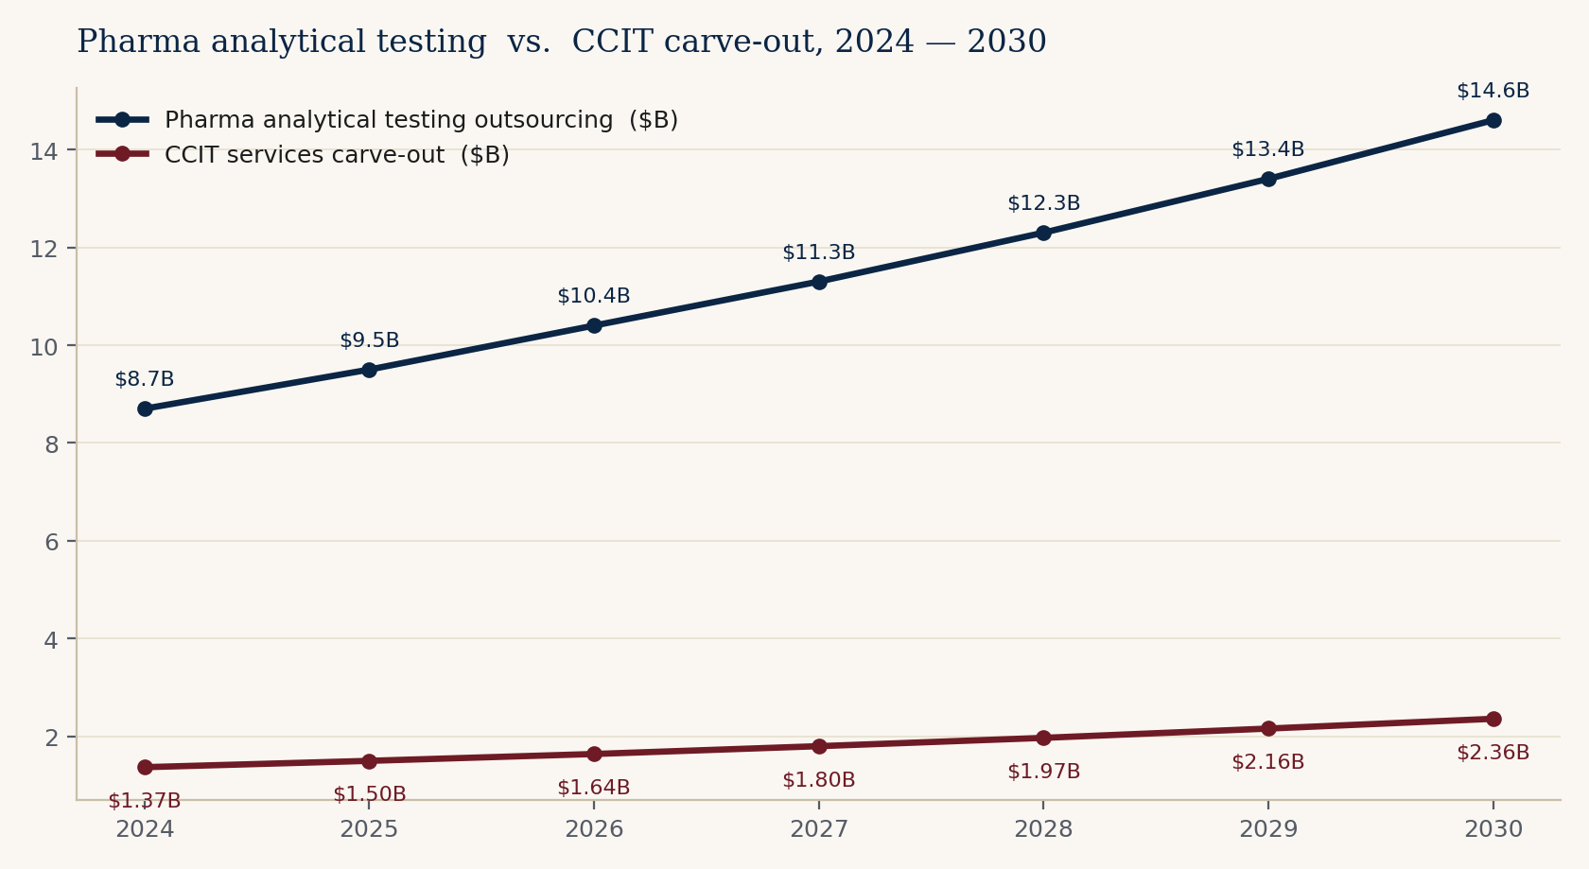
Figure 1. Pharma analytical testing outsourcing market and CCIT services carve-out, 2024 — 2030. Composite midpoint estimates from publicly cited analyst sources.
Channel and concentration
Channel structure inside CCIT is materially tighter than in the host analytical market. Most CCIT engagements are sold directly into quality assurance, regulatory affairs, and CMC leadership at sponsor companies — not through procurement channels. Buying decisions are personal and reputational. Concentration on the supply side is also low: no CCIT-pure provider that we can identify holds more than mid-single-digit share. The category is structurally winnable by a credible specialist with capacity.
Geography
North America remains the largest single regional market for CCIT, accounting for roughly forty percent of spend, followed by Europe (approximately thirty percent) and Asia-Pacific (approximately twenty-five percent). The convergence of EU GMP Annex 1 with USP <1207> on the deterministic-method standard means European sponsors are increasingly addressable from a U.S.-based, cGMP-built laboratory — a point we return to in Section VII.
— — —
IV. Four tailwinds, one quarter
———————
Each of these alone would justify a faster plan. The unusual feature of the current moment is that all four are arriving in the same six-month window.
Tailwind 1 — USP <382>
USP <382>, Elastomeric Component Functional Suitability in Parenteral Product Packaging/Delivery Systems, becomes the official chapter on December 1, 2025, replacing USP <381>. The chapter requires system-level functional suitability testing of elastomeric components — stoppers, plungers, septa, ferrules — within fully assembled packaging systems. Crucially, responsibility for the testing shifts from the elastomeric component supplier to the drug manufacturer. The practical effect is that every sterile filer who previously relied on supplier certifications now needs to either build that test capability in-house or buy it from a contract lab. The acceptance criteria for the maximum allowable leakage limit (MALL) require a minimum of thirty samples per study, which is non-trivial volume for any laboratory.
An important caveat: the Expert Committee has signaled intent to revise Section 5.1 (Fragmentation) of the chapter before the official date, in order to allow additional time for industry engagement. Whatever the final shape of the revision, the chapter is happening — and the dominant CCIT-capable contract labs are already positioning for it.
Tailwind 2 — Annex 1 convergence
EU GMP Annex 1, in its current form, requires validated deterministic CCIT and explicitly states that visual inspection alone is not acceptable as a method of proving closure integrity. This is, in substance, the same requirement that USP <1207> expresses on the U.S. side. The convergence of the two standards means a U.S. laboratory with a deterministic method portfolio filed against USP <1207> is, with relatively little additional regulatory work, addressable to European sponsors. The reciprocal is also true: European sponsors who need a U.S.-aligned method are increasingly looking westward, and CS Analytical's cGMP-and-FDA-registered posture is a meaningful proof point.
Tailwind 3 — The GLP-1 / prefilled-syringe wave
The metabolic-disease franchise built around semaglutide (Ozempic, Wegovy) and tirzepatide (Mounjaro, Zepbound) has fundamentally altered the prefilled-syringe and autoinjector landscape. Publicly reported figures are illustrative: the global prefilled-syringes market is projected to grow from $9.7 billion in 2025 to $18.1 billion in 2031 (10.9% CAGR), and the GLP-1 autoinjector and pen-injector category specifically is tracking approximately 15.6% CAGR for the 2026-2035 window. Underneath the volume growth is a material technology shift: the industry is moving from glass to cyclic olefin polymer (COP) barrels to minimize silicone interactions with biologic actives. COP barrels behave differently from glass under HVLD, helium leak, and vacuum-decay methods, and the methods need to be revalidated for every container migration. Each migration is a discrete CCIT method-development engagement.
Tailwind 4 — Biologics share and the recall cycle
Biologics now represent approximately forty percent of FDA novel approvals and a higher share of total dollar-weighted approval value. Every biologic ships in a sterile primary container. Glass-delamination recalls in high-pH biologics have been in the news again in 2025-2026, reinforcing the regulatory and reputational sensitivity of container choice. The intersection of biologics dominance and primary-container risk is the structural reason CCIT has moved from an afterthought to a gating step on the regulatory critical path.
Why the four together matter
Independently, each tailwind would justify a 12-18 month operational adjustment. Stacked, they create a step-function in demand that the existing CCIT supply base — characterized in Section V — is not sized to meet. The companies positioned to absorb the step function are the ones already adding capacity. CS Analytical is one of them.
— — —
V. Competitive landscape
———————
Two clusters of competitors matter. The broad-line generalists. And the specialty CCIT-capable providers. The space in between those clusters — deep, modern, fast — is where CS Analytical sits.
The generalists
Eurofins Scientific, SGS, Charles River Laboratories, WuXi AppTec, Pace Analytical Services, Intertek, and Element Materials Technology are the most relevant broad-line generalists. They compete on geographic footprint, on pricing power into large pharma master service agreements, and on the convenience of single-supplier coverage across many service lines. They do offer CCIT, in most cases competently. They do not, however, operate the level of deterministic-method depth or speed that the most regulatory-sensitive sterile programs now require. The structural reason is simple: a multi-discipline laboratory cannot economically retain six PhD-level CCIT method developers when those scientists are billable on CCIT work for only some fraction of their time. Recent commercial moves from this cluster — Eurofins' Lancaster bioanalytical expansion, Charles River's next-generation viral clearance suite, SGS's Lincolnshire E&L expansion — confirm that the generalists are leaning into their respective specialties, but none of those specialties is CCIT.
The specialists
Nelson Laboratories (Sotera Health), West Pharmaceutical Services' laboratory operations, Boston Analytical, and a small number of regional specialists make up the credible specialty cluster. These providers compete on depth in one or two specific modalities and on the strength of their reputations with regulators and quality leadership at sponsor companies. They are vulnerable, in our observation, on three dimensions: (i) modernization of method portfolio (some remain heavily anchored to probabilistic methods); (ii) responsiveness, particularly on short-notice capacity; and (iii) the absence of agentic AI tooling that would let them scale reach without scaling headcount.
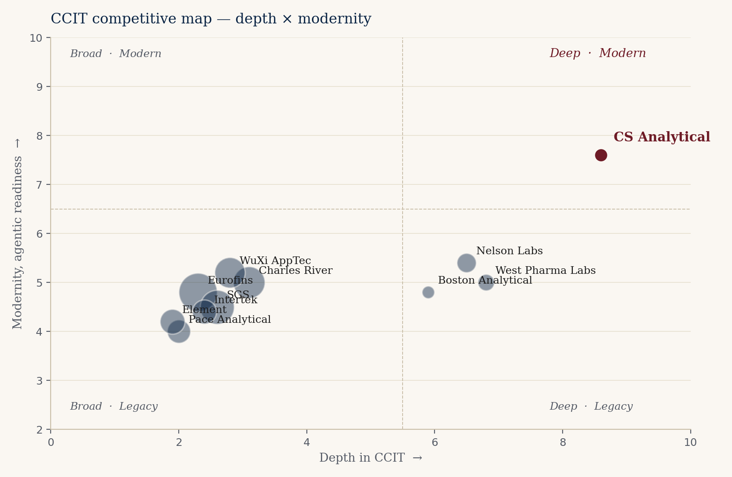
Figure 2. CCIT competitive map. Horizontal axis: depth in CCIT. Vertical axis: modernity and agentic readiness. Bubble size approximates revenue scale. CS Analytical is highlighted in burgundy.
The structural opening
The upper-right quadrant of Figure 2 is the structural opening. It is the position of a laboratory that is (i) deep enough in CCIT to be the first call for the most sensitive sterile programs, (ii) modern enough in method portfolio to lead with deterministic techniques, and (iii) fast and agentic enough to convert a sponsor inquiry into a quoted, scoped, started study inside the cycle time biologics programs now require. There is, today, no credible incumbent in that quadrant. CS Analytical, with the Clifton expansion and the recent service additions, is the most credible candidate to occupy it. Whether the company chooses to add the agentic layer that completes the position is the question this brief is built around.
— — —
VI. Already in motion — credit where it is due
———————
We want to be precise about what we are recommending and what we are not. We are not recommending a turnaround. CS Analytical, on the public evidence, is doing the right things. The point of this section is to summarize the four moves we believe are already correctly aimed, so the recommendations in Sections VII through X can be read as additive rather than corrective.
RM Analytical launch (February 2026)
Launching a sister brand for raw-material and excipient testing is the textbook adjacency play. It opens a substantially larger addressable market than CCIT alone, it uses the same cGMP infrastructure that CCIT already requires, and it creates a cross-sell motion into the existing client base without diluting the CCIT specialty brand. The execution risk on RMA is the standard execution risk of any new business line — pricing, capacity, sales channel — but the strategic logic is unimpeachable.
Clifton expansion (May 2026)
Doubling the lab footprint in Clifton, NJ, in the same quarter that USP <382> is reaching its official date and that the GLP-1 demand wave is at peak inflection, is capacity built ahead of demand rather than behind it. That is the harder, riskier, and more valuable form of capacity decision.
Micro testing and gas qualification
Adding USP <87> biological reactivity, USP <788> particle size, and USP/EP gas qualification to the standard service catalog creates immediate cross-sell into every sterile-program client. These are services those clients buy anyway, often from fragmented suppliers; consolidating them at CS Analytical takes wallet share from current incumbents at marginal incremental cost.
Interphex 2026 presence
Public commitment to the expanded service surface area at the premier U.S. pharma manufacturing conference is a small but telling indicator of commercial conviction. Companies that expand quietly tend not to convert the capacity; companies that expand loudly tend to.
— — —
VII. Organic growth paths — no AI required
———————
Five paths the company could pursue without any reference to an AI partner. Each is buildable on the existing team and the soon-to-be-expanded footprint. Each maps to a CFO-tractable revenue line with a defensible margin profile.
Path 1 — USP <382> wave capture
Be the named laboratory for the post-December 2025 elastomer functional-suitability rush. Every sterile filer running an elastomeric closure is now responsible for the testing. The demand pulse will not last forever — it will compress as in-house capacity is built — but the next twelve to twenty-four months are structurally over-demanded against the contract supply base. Specific moves: a productized <382> testing tier with fixed pricing, defined turnaround, and a regulatory write-up included. Capture target: ten to fifteen named sponsor programs in the first twelve months.
Path 2 — GLP-1 / PFS HVLD productization
High-voltage leak detection is the deterministic method of choice for liquid-filled containers, and the demand for HVLD method development and validation has outrun the capacity of most providers. Productize a standard HVLD package for COP-barrel autoinjectors: method development, validation, ongoing release support. Pricing should be at the premium end of the market — the alternative for the sponsor is a long wait, not a cheaper competitor.
Path 3 — Annex 1 European mandate
EU GMP Annex 1's deterministic CCIT requirement opens European sponsors to a U.S.-aligned laboratory in a way that was not true five years ago. The path is reciprocal recognition: a documented alignment between CS Analytical's USP <1207> filed methods and the Annex 1 expectations, supported by a small European business-development presence (a half-time European representative is probably sufficient at first). The revenue from this path is slower to develop than Paths 1 and 2 but is durable once established.
Path 4 — Cell, gene, and cryo container methods
Cell-therapy products ship in cryo-stored bags. Gene-therapy products ship in vials with closure systems designed for low-volume, ultra-cold-chain handling. mRNA platforms have introduced lipid-nanoparticle formulations in containers whose stopper systems are not yet characterized across the full cold-chain stress envelope. Each of these modalities requires fundamentally new CCIT method-development work. The methods often do not yet exist; they have to be invented, validated, and filed. This is, in our observation, the single highest-margin segment of the CCIT market today. The implementation hurdle is talent — credentialing two or three additional PhD method developers — but the unit economics justify the hire.
Path 5 — Regulatory consulting carve-out
The brain in the building has more demand than the bench. Sponsor calls increasingly ask for advisory work — "is this the right study to file at lab X" — that is, today, offered effectively as a courtesy. Productizing the advisory hours as a paid regulatory-consulting tier generates revenue at margins materially higher than the bench, and the advisory work itself converts to bench work later. This path is fifth in sequence because it depends on the brand strength that Paths 1-4 reinforce.
Sizing the organic plan
Conservatively executed, the five organic paths together support revenue growth from current run-rate to approximately 1.55× over a thirty-six-month horizon. This is the middle bar in the ROI chart in Section IX. No AI partner is required to achieve it. The capital required is the Clifton expansion that is already under way and a modest commercial-team investment.
— — —
VIII. The agentic-AI angle — where TSI-Citadel adds lift
———————
The candid section. Here we describe, by named use case, where an agentic-AI partner of TSI-Citadel's class would add measurable lift on top of the organic plan. The reader should treat this section as additive to Section VII, not as a substitute for it.
The category context
Agentic AI in healthcare is one of the fastest-growing sub-categories in enterprise software. The market is reported at approximately $538 million in 2024 and is projected to reach approximately $4.96 billion by 2030 — a multiple of roughly nine in six years. Major-consultancy commentary (BCG's 2025 Agentic AI in Biopharma report, McKinsey's life-sciences agentic work, IQVIA's 2025 commentary on reshaping decisions and orchestration in life sciences) is unusually aligned that the largest near-term value is in process orchestration — clinical-trial site activation, regulatory intelligence, commercial market research — rather than in drug discovery itself. For a specialty contract laboratory like CS Analytical, the relevant value pools are regulatory intelligence, business-development operations, and scientific literature surveillance.
Use case 1 — Continuous regulatory intelligence
This is the highest-value single agent we would build, and it is almost certainly worth doing on its own merits — independent of any of the other four. USP, EP, JP, and PIC/S guidance documents change continuously. So do FDA-issued warning letters, Form 483 observations, and consent decrees, all of which contain richly informative signals about which facilities are under pressure on CCIT-adjacent observations. A regulatory-intelligence agent monitors these sources continuously, resolves each change against the current method portfolio CS Analytical supports and against the filed methods of identified client sponsors, and flags two things: (i) which sponsor methods are now exposed to a change in expectation, and (ii) which competitors are facing observations that could create switching opportunities.
The economic value of this agent is direct and easy to measure. Each sponsor method-exposure flag is, on average, a $50,000 to $250,000 method-update engagement. A regulatory-intelligence agent that produces three to five accurate flags per quarter pays for itself in any reasonable accounting.
Use case 2 — Market radar
An agent (or coordinated set of agents) is configured to ingest, on a continuous basis: FDA novel-approval and supplement filings; ClinicalTrials.gov updates filtered for sterile-injectable and biologic indications; PDUFA target action dates; CBER advisory committee schedules; container-vendor product release notices from West, Schott, Stevanato, BD, and others; conference rosters from PDA, INTERPHEX, AAPS, and BIO; and investor-relations releases from sterile-fill CDMOs and biopharma sponsors. The agents resolve these signals against a sponsor-level entity model and produce a weekly business-development shortlist: which sponsors most likely have an unresolved CCIT need in the next ninety days, with the evidence linked. Today, this work is done partially by humans on Sunday nights, with the predictable result that it is partially done. An agentic radar does it daily, at fidelity no human team matches.
Use case 3 — Business-development operations
Outbound outreach, qualification, follow-up, meeting preparation, and post-meeting summarization are the highest-volume, lowest-marginal-science activities a CCIT operator performs. An agentic BD-operations stack drafts the outbound, qualifies the responses, schedules, prepares meeting briefs, and summarizes afterward. It does not replace the founder or the scientists. It returns their calendar to the work only they can do — the science, the regulatory conversations, the client relationships that are personal by definition. Conservatively, this use case alone recovers 25-35% of founder calendar over six months.
Use case 4 — Scientific literature surveillance
The CCIT, HVLD, helium-leak, vacuum-decay, and laser-headspace literature is small in absolute volume but moves continuously. So do the container-vendor white papers, the equipment-vendor method documents, and the standards-body draft documents. A scientific surveillance agent reads all of it daily, distills the meaningful changes, and surfaces them to CS Analytical scientists in a form that is decision-ready. Methods updates surface before the client asks. That is, in the long run, the most durable form of advantage a specialty laboratory can build: clients learn, over time, that CS Analytical knew first.
What we are not promising
Agentic AI is a category in which over-promising is the norm. We want to be precise about what we are not claiming. We are not claiming an agentic stack designs new CCIT methods. We are not claiming it replaces a PhD-level scientist. We are not claiming it interacts with FDA on the company's behalf. We are not claiming it works without human-in-the-loop oversight on every flag that touches a sponsor-filed method. We are claiming that, carefully scoped and carefully deployed, it returns calendar to the people whose calendar is the binding constraint on the business, and that it surfaces revenue-relevant signals at a fidelity human teams cannot match. Both claims are testable inside a ninety-day pilot.
— — —
IX. ROI shape — for the CFO
———————
This section is the one most directly written for Alan. It frames the same thirty-six-month horizon in CFO terms: revenue uplift, capital required, payback period, and the risk-adjusted form of each.
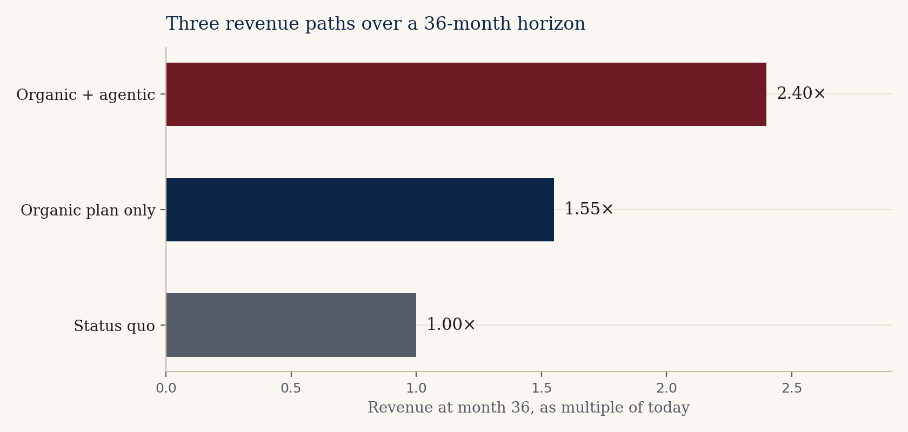
Figure 3. Three revenue paths over a 36-month horizon, expressed as multiple of current run-rate. Conservative estimates against publicly observable demand drivers.
The three scenarios
Status quo (1.00×)
The status-quo scenario holds the company at current run-rate. This is not a credible baseline — the demand environment makes stasis unrealistic — but we include it as the bottom anchor for the chart. In practice, the status quo would mean foregoing the <382> wave and the GLP-1 PFS adoption that is happening anyway.
Organic plan only (~1.55×)
Executing the five organic growth paths from Section VII, paired with the capacity that the Clifton expansion delivers and the cross-sell from RMA / micro / gas additions, produces approximately 1.55× revenue growth over the thirty-six-month horizon. The capital required is the lab expansion already under way plus modest commercial-team investment. Margin profile is stable to improving. This is the middle bar and, in our view, the most likely outcome on the company's current trajectory.
Organic + agentic (~2.40×)
Pairing the organic plan with the four agentic-AI use cases described in Section VIII produces, in our model, approximately 2.40× revenue growth over the same horizon. The lift is driven by three mechanisms in roughly equal weight: (a) net-new business-development opportunities the market radar surfaces that would otherwise be missed, (b) higher win rate on inquiries because the proposal-synthesis use case compresses cycle time below the industry average, and (c) regulatory-intelligence flags that convert directly to method-update engagements with existing sponsors.
Capital, payback, and risk-adjusted return
The capital required for the agentic layer is in the low six figures, not the seven. This is not a transformation investment; it is a bolt-on. Payback on the conservative reading is nine to twelve months, carried by founder-calendar recovery and quote-cycle reduction alone. Payback on the aggressive reading is four to six months. Risk-adjusted, treating the agentic layer as a real-option overlay on the organic plan rather than as a stand-alone bet, the expected uplift over thirty-six months remains positive even under conservative assumptions on agentic performance.
The CFO question, plainly
Is the difference between 1.55× and 2.40× worth a low-six-figure capital outlay with a nine-to-twelve-month payback and a contractual data-portability guarantee? That is the question. If the answer is yes, the company should run the diagnostic in Section XII. If the answer is no, the organic plan stands on its own.
— — —
X. Adjacent opportunities — optional, not required
———————
These are the strategic-horizon adjacencies we believe CS Analytical could credibly pursue if and when the operating plan above is on track. They are not in the thirty-six-month forecast; they sit on the next horizon.
Combination products and device-led submissions
Drug-device combinations — autoinjectors, transdermal patches, inhaled-dose devices — fall into a regulatory category that crosses CDER and CDRH. Few incumbent CCIT-capable labs are structurally configured to support cross-center submissions. The specialty knowledge required is adjacent to what CS Analytical already has, and the margin profile is favorable.
Device sterilization validation
ISO 11135 (ethylene oxide) and ISO 11137 (radiation) sterilization validation work is a natural adjacency to container testing — many of the same sponsors, many of the same containers. The competitive set is different from CCIT (Nelson Labs is dominant in sterilization validation, for example) but cross-sell into existing CCIT relationships is a credible motion.
Compounding pharmacy testing
USP <797> (non-sterile compounding) and USP <800> (hazardous-drug handling) require periodic environmental and component testing that is, in physics, adjacent to CCIT and micro-testing. The buyer base — large compounding pharmacies, 503B outsourcing facilities — is fragmented and underserved on the testing supply side.
Veterinary biologics
Veterinary biologics use the same primary containers as human biologics, but are regulated by USDA's Center for Veterinary Biologics rather than FDA. The competitive set is smaller, pricing is more favorable, and the cycle times are shorter. A small dedicated veterinary practice inside CS Analytical would, in our view, be margin-positive from day one.
Industry training and certification
The team's reputation is, in itself, a productizable asset. A structured training and certification program for sterile-fill quality leaders, taught by CS Analytical scientists, would generate revenue at near-software margins and would itself act as a top-of-funnel for paid testing work. Several specialty labs in adjacent disciplines have used training programs as both revenue lines and brand-building exercises with documented success.
— — —
XI. Risks — named, not glossed
———————
Risk — Capital timing concentration
Lab expansion, RM Analytical build-out, expanded micro and gas capabilities, and a possible agentic-AI investment all sit inside the same fiscal year. From the CFO chair, this is the single largest near-term risk. Handling: sequence the agentic investment behind the lab build, so the agentic stack pays for itself out of the operating-cash-flow lift the expanded book of business generates. The diagnostic phase of any TSI-Citadel engagement is specifically structured so the CFO holds a go/no-go decision at day thirty and again at day ninety.
Risk — Margin dilution from adjacencies
Raw-material and excipient testing carries lower gross margin than CCIT specialty work. As RM Analytical scales, the blended company margin will move down, even as absolute dollar margin grows. Handling: hold CCIT premium pricing while RMA scales — the two are sold to different buyers and there is no internal reason for the pricing pressure to cross-contaminate. The agentic regulatory-intel and market-radar use cases are specifically designed to keep the CCIT pipeline full while RMA captures new wallet share, protecting the high-margin core.
Risk — Agentic-AI hallucination in regulated context
An agent that issues a false regulatory-intelligence flag to a sponsor can damage a multi-year relationship and create FDA-facing reputational risk. Handling: every agent output that touches a sponsor-filed method passes through a human reviewer before it leaves the building. Agents are suggestive, not authoritative — by explicit design and by contractual term. Failure modes are tested deliberately in the diagnostic phase.
Risk — Platform dependency
A meaningful piece of the upside described in this brief depends on the agentic stack continuing to perform. Platform dependency is real. Handling: TSI-Citadel contracts include data-portability and prompt-portability terms by default. The underlying data feeds (FDA, ClinicalTrials.gov, USP, EP) are commodity sources accessible to any successor system. Switching cost is bounded.
Risk — Competitive response
A large generalist could acquire a specialty lab and attempt to compete on the deep-and-modern quadrant by integration. Handling: the depth of the specialist science is not transferable in an acquisition; the relationships are; and the agentic-augmented reach advantage is itself a structurally hard-to-copy moat for an acquirer constrained by enterprise IT and procurement governance. The competitive response to watch is not acquisition; it is whether one or two of the credible specialists (Nelson Labs, Boston Analytical, West Pharma Labs) makes its own agentic move.
— — —
XII. How TSI-Citadel would engage
———————
Light footprint, boxed scope, measurable from day one. The engagement is structured so the CFO holds the gate at day thirty and again at day ninety.
Days 1 — 30 Diagnostic
TSI-Citadel sits with the CS Analytical commercial, regulatory, and operations leads. We map the data feeds, the regulatory cycles, the inquiry-to-quote workflow, and the moments at which agentic interventions would add value. No agents are deployed in this phase. The deliverable at day thirty is a written diagnostic with a quantified opportunity sizing and a go / no-go recommendation. The fee for the diagnostic is small and is fully creditable against any subsequent build.
Days 31 — 60 Two agents live
Assuming the diagnostic clears the gate, the regulatory-intelligence and market-radar agents are deployed against real data feeds. Daily output is delivered to a named internal user (in practice, the BD lead and the scientific director). First measurable lift — a regulatory-intel flag converted to revenue, or a radar-surfaced opportunity converted to a quoted proposal — is targeted inside the period.
Days 61 — 90 Decide
Joint readout. Numbers. The remaining two agents (BD operations, scientific surveillance) are built only if the first two have earned them. Pricing on the full deployment is fixed at the outset; the only variable is the company's decision to proceed. The CFO holds the gate, by design.
Commercial structure
Two viable structures. The first is a fixed engagement fee plus a modest annual platform license. The second is a smaller fixed fee paired with a revenue share on the productized CCIT-as-a-service tier that the agentic stack enables. We are agnostic between the two structures and would expect the CFO chair to drive the choice. Either structure is built around clear, audit-friendly definitions of revenue attribution.
— — —
XIII. Closing read
———————
CS Analytical is in the right market, at the right moment, with the right hand of cards. The current trajectory is sound and the recent moves are the moves we would have recommended unprompted. Our argument in this brief is narrower than it might appear: we are arguing that a carefully scoped, CFO-gated agentic layer on top of the organic plan adds a meaningful and measurable amount of revenue lift, at low capital cost, with a payback period the company can absorb without strain. Whether that argument is right is not, in the end, decidable from analyst chairs. It is decidable from a thirty-day diagnostic.
We would welcome the conversation. The relevant contact information is on the cover and in the closing slide of the accompanying deck. If we have over-rotated on any specific section, we would rather hear that than hear silence.
— — —
Appendix
———————
A. Methodology note
Market-sizing figures in this brief are composite midpoints of publicly cited analyst estimates. The pharma analytical testing outsourcing figure ($9.5 billion, 2025) draws on Grand View Research, Market Research Future, Mordor Intelligence, and globenewswire coverage of the U.S. market 2025-2030. The CCIT services carve-out figure ($1.5 billion, 2025) draws on Precedence Research, Data Horizzon Research, Roots Analysis, and Verified Market Reports. Growth rates are similarly midpoint composites across the cited sources. Figures are intended to support strategic discussion, not investor due diligence. Discrepancies between this brief and any particular sourced report should be read as deliberate compositing, not as factual error.
B. Regulatory references
- USP <1207> — Package Integrity Evaluation for Sterile Products. The U.S. pharmacopeial standard governing CCIT.
- USP <382> — Elastomeric Component Functional Suitability in Parenteral Product Packaging/Delivery Systems. Replacing USP <381>, effective December 1, 2025.
- USP <87> — Biological Reactivity Tests, In Vitro.
- USP <788> — Particulate Matter in Injections.
- USP <797> — Pharmaceutical Compounding, Sterile Preparations.
- USP <800> — Hazardous Drugs, Handling in Healthcare Settings.
- EU GMP Annex 1 — Manufacture of Sterile Medicinal Products. Requires validated deterministic CCIT.
- ISO 11135 / 11137 — Sterilization of healthcare products (EtO / radiation).
C. Glossary
- CCIT — Container Closure Integrity Testing.
- HVLD — High-Voltage Leak Detection.
- PFS — Prefilled Syringe.
- COP — Cyclic Olefin Polymer; a glass-alternative material for biologic primary containers.
- MALL — Maximum Allowable Leakage Limit.
- Deterministic CCIT — Instrument-based quantitative methods (helium leak, vacuum decay, HVLD, laser headspace).
- Probabilistic CCIT — Qualitative or stochastic methods (dye ingress, microbial challenge, bubble emission).
- cGMP — Current Good Manufacturing Practice.
- Agentic AI — Software systems composed of one or more LLM-driven agents that perceive, reason, and act on structured and unstructured data on behalf of a user or organization.
D. About the author and TSI-Citadel
Bruce Longley is the founder of TSI-Citadel, an agentic-AI advisory and platform firm focused on specialty operators in regulated verticals. TSI-Citadel builds bounded, auditable, human-in-the-loop agentic systems for clients whose work cannot tolerate hallucination in the regulatory loop. Bruce can be reached at bruce@tsicitadel.ai.
E. Selected sources
- Precedence Research — Container Closure Integrity Testing Service Market (precedenceresearch.com).
- Data Horizzon Research — Container Closure Integrity Testing Service Market 2033 (datahorizzonresearch.com).
- Roots Analysis — Container Closure Integrity Testing Services Market (rootsanalysis.com).
- Verified Market Reports — Container Closure Integrity Testing Service Market.
- Grand View Research — Pharmaceutical Analytical Testing Outsourcing Market.
- Market Research Future — Pharmaceutical Analytical Testing Outsourcing Market 2035 (marketresearchfuture.com).
- Mordor Intelligence — Pharmaceutical Analytical Testing Outsourcing Market Size & Trends 2031.
- BCG — Agentic AI in Biopharma: Game-changing Efficiency (2025).
- McKinsey & Company — Agentic AI: Unlocking peak performance in biopharma development.
- IQVIA — Inside Agentic AI: Reshaping Decisions and Orchestration in Life Sciences (Feb 2025).
- PRNewswire / ROI-NJ — CS Analytical Major Laboratory Expansion coverage (May 2026).
- PRNewswire — CS Analytical Expands Raw Material and Finished Product Testing with the Launch of RM Analytical (Feb 2026).
- USP-NF — USP <382> revision notices (Feb 2025, April 2025).
- Gateway Analytical — What changes are happening to USP <382> in December 2025.
- csanalytical.com — primary company source for service catalog and recent announcements.

