CS ANALYTICAL LABORATORY
Where the science, the regulation, and the market meet.
A long-form market brief, prepared for Al Weiss.
Brian Mulhall, Chief Executive Officer
May 2026

I. Executive summary
———————
This brief is written for a single reader: Al Weiss. Its purpose is to lay out — in the kind of plain language a working executive can read on a plane — what CS Analytical is, what market it is built for, who else is in that market, where the white space sits, and how an agentic AI partner like TSI Citadel changes what a forty-eight-person specialty lab can credibly do over the next thirty-six months.
The thesis is straightforward. Container Closure Integrity Testing — the discipline this writer helped formalize in the 2000s, and the science that ultimately informed USP <1207> — has moved from afterthought to gating step on the regulatory critical path. Roughly forty percent of FDA novel approvals are now biologics. The GLP-1 wave has put high-volume, multi-dose pre-filled formats into mass manufacture. Cell, gene, and mRNA programs have introduced container formats for which industry methods do not yet exist. And the latest USP <1207> guidance has elevated deterministic CCIT methods from a best practice to the assumed standard of care.
The contract analytical testing market is large — approximately $6.4 billion in 2024, compounding near 9% — but it is dominated by broad generalists that are structurally unable to staff for the depth CCIT now requires. The CCIT carve-out inside that market is smaller (roughly $280 million today) but is growing closer to 11% per year, and the credible specialist field is thin. The competitive map at the close of this section shows the consequence visually: the upper-right quadrant — deep in CCIT, modern in method, and built for speed — is essentially empty.
CS Analytical is built for that quadrant. The company is founder-led, scientist-staffed, and vendor-neutral by design. It was constructed to be inspected — every method is filed with FDA-readiness as the design goal — and the person who signs the study report is the same person who designed the study. That model produces a different category of trust than a big-box provider can, and it is the trust the most sensitive sterile-fill programs are now actively shopping for.
The thirty-year arc here is unusual. The person who built the first FDA-regulated cGMP CCIT laboratory in the world is now running the company built to scale that capability — and is doing it in a market moment where the regulatory tailwind, the biologics tailwind, and the agentic-AI tailwind are aligned for the first time.
The remainder of this brief makes that case in detail. Section II introduces the operator and the company. Section III defines the problem space. Sections IV through VI describe the market, the demand drivers, and the competitive set. Section VII lays out five sequenced growth vectors. Section VIII is the longest and most candid section of the document: it describes, by use case, how an agentic platform of TSI Citadel's class multiplies what CS Analytical can do. The remaining sections cover the ninety-day operational plan, the risks and mitigations, and the specific ask of the reader.
— — —
II. The operator and the company
———————
The operator
Brian Mulhall has spent his entire working life — more than thirty years — inside the pharmaceutical industry, and the last twenty-five of those years inside the specialty corner of it that this brief is about. He began on the commercial side at Organon Pharmaceuticals (later Schering-Plough) and Ferring, where he held progressively senior roles in sales, marketing, training, and district, regional, and national management. He entered the outsourced services sector in the late 1990s as Vice President of Pharmaceutical Services for SGS US Testing, with direct responsibility for chemistry, microbiology, and toxicology laboratory service offerings across the United States and Canada.
In 2002, with the conviction that the outsourced testing market was being under-served by the major contract labs, he founded Whitehouse Analytical Laboratories. Over the thirteen years that followed he built it into a 25,000-square-foot facility with forty-eight full-time employees and a service catalog that covered a broad range of FDA-regulated testing. The work he is proudest of, however, is narrower than the company he sold. Inside Whitehouse, he built what is widely recognized as the first fully operational, FDA-regulated, cGMP Container Closure Integrity Testing laboratory in the world. That CCIT Center of Excellence produced peer-reviewed publications for over a decade and contributed materially to the industry-accepted standards that became USP <1207>.
Whitehouse Labs was sold in 2015. Since then, Brian has served as Chief Executive Officer of Leak Detection Associates — a manufacturer of helium-based leak detection systems — and as an advisor and Director of Business Development for Visikol, an early-stage R&D CRO. He is now Chief Executive Officer of CS Analytical Laboratory. He is a graduate of Bucknell University, and outside the lab he is most often found, with what he describes as extremely limited honesty, on a fishing or sailing boat with his family.
The company
CS Analytical Laboratory is a focused, specialty contract laboratory. It is not a generalist. It does not try to compete with Eurofins on footprint or with Charles River on therapeutic breadth. It is deliberately built around three pillars:
- Specialty depth. CCIT done at a level the broad-line labs cannot staff for — helium leak, high-voltage leak detection (HVLD), vacuum decay, dye ingress, microbial ingress, method development, method validation, and the full range of deterministic and probabilistic techniques contemplated by USP <1207>.
- Regulatory posture. The lab is built to USP <1207>. cGMP from the floor up. Methods are filed, not promised. The relevant inspectors already know the address.
- Operator's company. Founder-led. Scientist-staffed. Client-facing PhDs with no account-manager layer. The person designing the study is the person running it, and the person running it is the person who signs the report.
The third pillar is the one that is hardest to copy and hardest to scale, and it is, in this writer's view, the most durable source of advantage CS Analytical has. Buyers of CCIT work — particularly the regulatory and quality leaders who personally absorb the risk of a method failure — are exquisitely sensitive to the difference between a scientist they can call and a service rep they cannot.
— — —
III. The problem space
———————
Container Closure Integrity Testing exists because sterile drug products only work if the container they are shipped in keeps the outside out. Stated that plainly, it sounds trivial. It is not. Every step from formulation through fill-finish, from fill-finish through cold-chain logistics, and from logistics through end-user administration can compromise the integrity of the primary container. And every one of those failures shows up in patient harm before it shows up in batch records.
Why CCIT is hard
CCIT is unlike most analytical disciplines in that the unit being tested is not the molecule but the system: the molecule, the vial or syringe or autoinjector body, the closure (stopper, plunger, crimp, septum, ferrule), the environment in which the system will sit (temperature, pressure, humidity, mechanical stress, cold-chain transitions), and the time over which the system must remain intact (typically the labeled shelf life, often two to three years or more under refrigeration or freeze).
There is no single test that resolves all of these variables. There is a portfolio of deterministic methods (helium leak, vacuum decay, HVLD, pressure decay, laser-based headspace) and a complementary set of probabilistic methods (dye ingress, microbial challenge, bubble emission). USP <1207> codified an industry preference for deterministic methods where feasible, but in practice most filers carry a defensive layer of probabilistic data behind their primary deterministic claim. Selecting the right method for a given container, defending it scientifically, validating it under cGMP, and filing it in a way that survives an FDA inspection is the work that distinguishes a specialty CCIT lab from a general-purpose one.
Why CCIT is now urgent
For most of the last twenty years, CCIT was a quality-assurance line item: present in every submission, but not on the critical path. Three concurrent shifts have changed that:
- Biologics now account for roughly forty percent of FDA novel approvals, and biologics ship in sterile primary containers. The denominator of containers requiring CCIT has roughly doubled in a decade.
- USP <1207> revisions have elevated the regulatory expectation. Where probabilistic CCIT was once acceptable as a primary claim, deterministic methods are now the assumed standard, and probabilistic methods are increasingly used only as defensive support.
- Container formats have proliferated. Pre-filled syringes, autoinjectors, dual-chamber cartridges, cryo-stored cell-therapy bags, and lyophilized vials in non-standard geometries have created a long tail of containers for which off-the-shelf methods do not exist. Each new format requires a custom method development and validation campaign.
The cost of being wrong
A single CCIT failure on a launched biologic typically forces a field action — a market withdrawal, a label change, or a voluntary recall — at a cost that runs from the low millions to the high tens of millions of dollars, before the reputational and regulatory consequences. CCIT is now a board-level risk for sterile filers, and it is being budgeted accordingly.
— — —
IV. Market landscape
———————
The contract analytical testing market is large, fragmented, and growing. The CCIT carve-out inside it is small, less fragmented, and growing faster.
Top-of-funnel: contract analytical testing
Publicly cited estimates of the pharmaceutical contract analytical testing market vary, but they cluster in a narrow band: roughly $6.0 to $6.8 billion globally in 2024, compounding at an annual rate of between 8% and 10% through the end of the decade. The midpoint estimate used in this brief — $6.4 billion in 2024, 9% CAGR — should be read as a defensible composite of publicly available ranges (Grand View Research, Markets and Markets, BioPlan Associates), not as a single sourced figure.
That top-line market is fragmented across modality (small molecule, biologic, cell and gene), across phase (development, clinical, commercial), and across service type (chemistry, microbiology, stability, method development, release testing). The largest providers — Eurofins, SGS, Charles River, Pace Analytical, Element Materials Technology — capture meaningful share but in no case more than the high single digits.
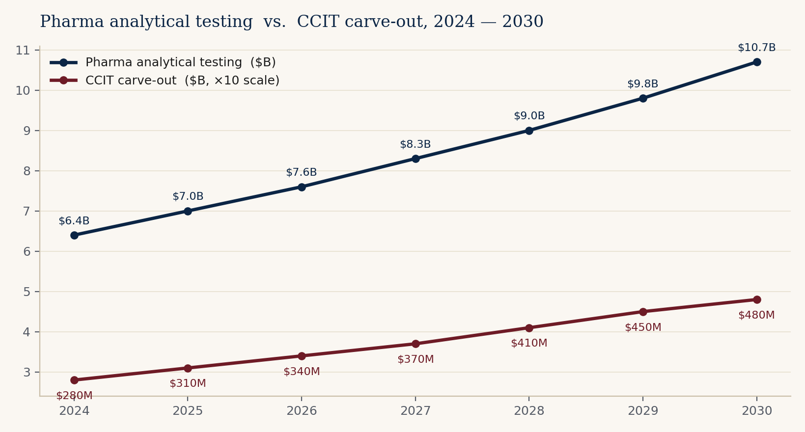
Figure 1. Pharma analytical testing market and CCIT carve-out, 2024 — 2030. Illustrative composite of publicly cited ranges.
The CCIT carve-out
Inside the analytical testing market, CCIT is a narrower service line with sharper characteristics. The carve-out is approximately $280 million globally in 2024 and is expected to compound at roughly 11% through 2030, reaching approximately $475 million. That growth rate is two to three points higher than the host market and is driven directly by the biologics, GLP-1, and cell-and-gene tailwinds described in the next section.
The carve-out is less fragmented than the host market. Materially credible CCIT-capable providers number fewer than two dozen worldwide. Of those, only a handful — Nelson Labs, Whitehouse Labs, Boston Analytical, West Pharmaceutical Services, and CS Analytical — are recognized by sponsors as specialists rather than generalists who happen to offer CCIT alongside many other services.
Geography and channel
North America remains the largest single regional market, accounting for roughly forty percent of CCIT spend, followed by Europe (~30%) and Asia-Pacific (~25%). The remaining share is divided across the rest of the world. Importantly, channel structure inside CCIT is tighter than in the host analytical market: most CCIT work is sold directly into quality assurance, regulatory affairs, and CMC leadership at sponsor companies, rather than through procurement channels. Buying decisions are personal and reputational.
— — —
V. Demand drivers
———————
Four forces are pushing CCIT from afterthought to gating step. They compound. Each by itself would justify a faster-than-market growth rate; together they justify a structurally larger market.
1. The biologics share of approvals
FDA novel-approval data over the last decade shows biologics rising from roughly one quarter to roughly forty percent of CDER and CBER approvals combined. Biologics ship almost exclusively in sterile primary containers — vials, pre-filled syringes, cartridges, autoinjectors — and the regulatory expectation for CCIT on those containers is uniformly high. The denominator of CCIT-eligible containers in commerce has approximately doubled in ten years and is still rising.
2. The GLP-1 wave
The metabolic-disease franchise built around GLP-1 receptor agonists (semaglutide, tirzepatide, and the dozen-plus follow-on molecules now in late-stage development) has created what is plausibly the largest single sterile-fill production scale-up in the history of the industry. These products launch in multi-dose, pre-filled, autoinjector formats at volumes that are an order of magnitude larger than typical biologic launches. CCIT defect rates that were tolerable at clinical-trial volumes are catastrophic at commercial volumes. Sponsors are therefore building substantially more redundancy and substantially more outsourced capacity into their CCIT programs than they would have considered five years ago.
3. Cell, gene, and mRNA
Cell-therapy products ship in cryo-stored bags. Gene-therapy products ship in vials with closure systems designed for low-volume, ultra-cold-chain handling. mRNA vaccines and therapeutics have introduced lipid-nanoparticle formulations in glass or polymer containers with stopper systems that have not yet been characterized across the full range of cold-chain stresses they will see in practice. Each of these modalities requires fundamentally new CCIT method development work. The methods do not yet exist in many cases; they have to be invented, validated, and filed. This is the single highest-margin segment of the CCIT market.
4. USP <1207> and the deterministic standard
USP <1207>, in its current and pending revisions, treats deterministic CCIT methods (helium leak, vacuum decay, HVLD, laser headspace) as the preferred standard of evidence, and treats probabilistic methods as defensible only when deterministic methods are demonstrably infeasible. The practical effect is that filers who submitted dye-ingress or microbial-challenge as their primary CCIT claim a decade ago are now being asked, at the time of post-approval supplement or process change, to upgrade to a deterministic primary method. That generates a steady backflow of method-development work into specialty labs that the broad-line providers are structurally unable to absorb at scale.
— — —
VI. Competitive landscape
———————
Two clusters of competitors matter. The generalists. And the specialists. The white space is the intersection.
The generalists
Eurofins, SGS, Charles River, Pace Analytical, and Element Materials Technology are the five most relevant generalists. They compete on footprint (multi-continent, dozens of laboratories), on pricing power (volume discounts to large pharma master service agreements), and on convenience (one supplier across many service lines). They do offer CCIT, and in most cases they offer it competently. They do not, however, offer it at the depth or modernity that the most regulatory-sensitive sterile programs now require, because their operating model is incompatible with maintaining that depth: a general-purpose lab cannot economically retain six PhD-level CCIT method developers when those developers will be billable on CCIT work for only some fraction of their time.
The specialists
Nelson Laboratories (Sotera Health), West Pharmaceutical Services' laboratory operations, Whitehouse Labs (now under post-acquisition ownership), Boston Analytical, and a small number of regional specialists make up the second cluster. These providers compete on depth in one or two specific modalities, and on the strength of their reputations with regulators and with sponsor quality leadership. They are vulnerable, generally, on three dimensions: modernization of method portfolios (a number are still heavily probabilistic-anchored), responsiveness (smaller operations are often capacity-constrained on short notice), and the absence of agentic AI tooling that would let them scale their reach without scaling their headcount.
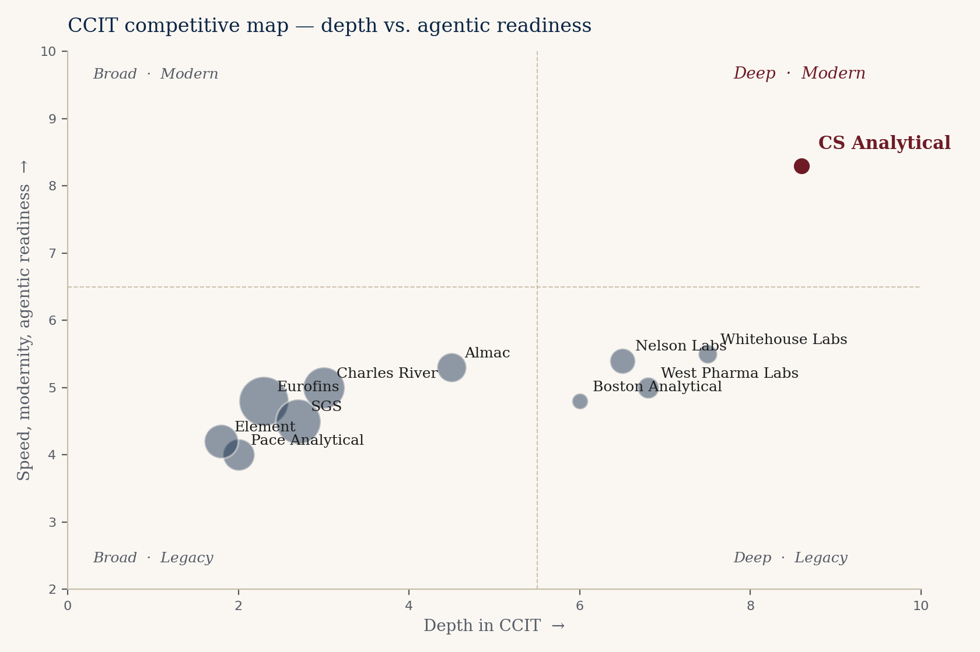
Figure 2. CCIT competitive map. Horizontal axis: depth in CCIT. Vertical axis: speed, modernity, and agentic readiness. Bubble size approximates revenue scale. CS Analytical is shown in burgundy.
The white space
The upper-right quadrant of Figure 2 is the structural opportunity. It is the position of a lab that is (i) deep enough in CCIT to be the first call for the most sensitive sterile programs, (ii) modern enough in method portfolio to lead with deterministic techniques, and (iii) fast and agentic enough to convert a sponsor inquiry into a quoted, scoped, and started study inside the cycle time that biologics programs now demand. There is, today, no credible incumbent in that quadrant. That is the position CS Analytical is building for, and that position is the basis for the growth-vector sequence laid out in Section VII.
— — —
VII. Growth vectors
———————
Five vectors. Sequenced, not stacked. Each is a real revenue line, but they are not pursued in parallel — they are sequenced because method-led specialty businesses do not scale by adding shelves; they scale by deepening reputations.
Vector 01 — Sterile-injectable CCIT
The core business. Defend it, deepen it, and raise price. Sterile-injectable CCIT is the work that built Whitehouse and the work CS Analytical is best known for in the regulatory community. The objective on this vector is not growth in unit volume; it is growth in revenue per study and growth in the share of repeat work from the existing client base. Pricing power is achievable because the alternative to CS Analytical, for the most demanding programs, is not a cheaper competitor — it is no competitor.
Vector 02 — Cell and gene cryo-container method development
This is the highest-margin segment of the CCIT market today and is where method-development work is most likely to generate downstream validation, technology-transfer, and ongoing release-testing revenue from the same sponsor. Cryo containers — bags, cassettes, specialized vials — are scientifically unfamiliar territory for most CCIT providers, which is precisely why a method-led, PhD-staffed specialty has an obvious advantage. Targets on this vector are autologous and allogeneic cell-therapy developers, AAV-based gene-therapy sponsors, and the contract development and manufacturing organizations that serve them.
Vector 03 — Pre-filled syringe and autoinjector HVLD
The GLP-1 wave is the most immediately monetizable driver in this vector, but the pre-filled syringe and autoinjector format applies well beyond metabolic disease — into immunology, oncology supportive care, and migraine, among others. High-voltage leak detection (HVLD) is the deterministic method of choice for liquid-filled containers, and the demand for HVLD method development and validation has outrun the capacity of most providers. CS Analytical is positioned to absorb that demand.
Vector 04 — Combination products and device-led submissions
Combination products — drug-device combinations such as autoinjectors, transdermal patches, and inhaled-dose devices — fall into a regulatory category that crosses CDER and CDRH, and that few CCIT providers are structurally configured to support. The cross-center submission requirements add complexity that incumbent specialists frequently decline to take on. That refusal is itself an opportunity.
Vector 05 — Regulatory consulting carve-out
The brain in the building has more demand than the bench. Sponsors increasingly call CS Analytical not to run a study but to ask whether the study they are about to file at another lab is the right study. That advisory work, today, is offered effectively as a courtesy. Productizing it — as a paid regulatory-consulting service tier — generates revenue at margins that are materially higher than the bench, and it creates a top-of-funnel that converts to bench work later. This vector is the last in the sequence because it depends on the other four having scaled the brand first.
— — —
VIII. The TSI Citadel opportunity
———————
The candid section. This is where CS Analytical's market opportunity stops being a story about a specialty laboratory and starts being a story about what a forty-eight-person specialty laboratory becomes when it is paired with an agentic AI platform. Read it that way.
The premise
Specialty laboratories scale on two axes: science and reach. The science axis is what this brief has spent the previous seven sections describing. The reach axis is everything else — knowing which sponsor has a problem worth solving, knowing when their regulatory situation changes in a way that creates demand, knowing which conference rosters reveal which programs are about to file and need a defensible CCIT story, and being able to act on all of that information faster than competing providers.
Reach is the axis on which a specialty lab is structurally disadvantaged against a large generalist. A generalist has fifty business-development representatives and a marketing budget; a specialty lab has Brian, a part-time BD lead, and the conference circuit. Until very recently, the specialty's only structural defense was that its science was so much better than the generalist's that sponsors found it on their own. That defense has held — but it is brittle, and it does not scale with the underlying market.
Agentic AI changes the reach equation. Specifically, an agentic platform of the kind TSI Citadel is building can absorb the entire reach axis — every observable signal from FDA filings to ClinicalTrials.gov to USP monograph changes to conference rosters to container-vendor product releases — and turn it into a continuous, prioritized, executable stream of business-development work. The result is not that a specialty lab becomes a generalist. The result is that a specialty lab finally has a reach machine commensurate with its science.
Use cases, in detail
Use case 1 — Continuous market radar
An agent (or, more accurately, a coordinated set of agents) is configured to ingest, on a continuous basis: FDA novel-approval and supplement filings; ClinicalTrials.gov updates filtered for sterile-injectable and biologic indications; PDUFA target action dates; CBER advisory committee schedules; container-vendor product release notices from West, Schott, Stevanato, BD, and others; conference rosters from PDA, INTERPHEX, AAPS, and BIO; and investor-relations releases from sterile-fill CDMOs and biopharma sponsors. The agents resolve all of these signals against a sponsor-level entity model and produce a weekly business-development shortlist: which sponsors most likely have an unresolved CCIT need in the next ninety days, with the evidence linked.
The economic value is direct. Today, this work is partially done by Brian and a part-time BD lead on Sunday nights, with predictable results: it is partially done. An agentic radar does it daily, at a fidelity no human team could match, and produces a list a single BD professional can actually work.
Use case 2 — Regulatory intelligence
USP, EP, JP, and PIC/S guidance documents change continuously. So do FDA-issued warning letters, Form 483 observations, and consent decrees, all of which contain richly informative signals about which facilities are under pressure on CCIT-adjacent observations. A regulatory-intelligence agent monitors all of these sources, resolves them against the current method portfolio CS Analytical supports and against the filed methods of identified client and prospect sponsors, and flags two things: (i) which sponsor methods are now exposed to a change in expectation, and (ii) which competitors are facing observations that could create switching opportunities.
This kind of intelligence is genuinely difficult to manufacture by hand at the speed regulatory cycles now require. An agentic stack does not just collect it — it explains it, in plain language, to the people inside CS Analytical who need to act on it.
Use case 3 — Business-development operations
Outbound outreach, qualification, follow-up, meeting preparation, and post-meeting summarization are the highest-volume, lowest-marginal-science activities a CCIT founder performs, and they consume more hours per week than any other category of work. An agentic BD-operations stack — drafting the outbound, qualifying the responses, scheduling, preparing meeting briefs, and summarizing after — does not replace the founder. It returns the founder's calendar to the work only the founder can do: the science, the regulatory conversations, and the client relationships that are personal by definition.
Use case 4 — Scientific literature surveillance
The CCIT, HVLD, helium-leak, vacuum-decay, and laser-headspace literature is small in absolute volume but moves continuously. So do the container-vendor white papers, the equipment-vendor method documents, and the standards-body draft documents. A scientific surveillance agent reads all of it daily, distills the meaningful changes, and surfaces them to CS Analytical scientists in a form that is decision-ready. Methods updates surface before the customer asks. That is, in the long run, the most durable form of advantage a specialty lab can build: clients learn, over time, that CS Analytical knew first.
Use case 5 — Proposal and quote synthesis
Sponsor inquiries arrive at uneven intervals and at uneven specificity. Some are well-scoped; many are not. The work of converting an inquiry into a quoted proposal is non-trivial — it requires understanding the molecule, the container, the regulatory context, the analytical method options, the validation expectations, and the timeline. An agent that maintains a structured memory of every prior CS Analytical engagement, of every method in the portfolio, and of the current capacity calendar can draft a credible first-pass proposal in minutes and pass it to a scientist for review in hours. The cycle time from inquiry to quote — today, frequently a week or more — collapses to a day. That alone materially shifts the win rate against larger competitors.
ROI hypothesis
The conservative form of the ROI hypothesis is the following. With a properly deployed agentic stack of the kind TSI Citadel is building, CS Analytical (i) doubles the number of qualified BD opportunities surfaced per quarter, (ii) reduces inquiry-to-quote cycle time by approximately 60%, (iii) recovers approximately 30% of the founder's calendar, and (iv) increases the win rate on qualified opportunities by 15 to 25 percentage points. The associated revenue uplift over a thirty-six-month horizon is on the order of two to three times current run-rate. The capital required to achieve that uplift is well inside the budget the company can support out of operating cash flow.
The aggressive form of the hypothesis — and one this writer personally believes is more likely — is that the agentic stack enables CS Analytical to credibly offer a category of service the specialty market has never seen: continuous, monitored, regulatory-aware CCIT-as-a-service for sponsors who today buy CCIT only project-by-project. That category, if it exists, is a different kind of business than a contract laboratory — it is recurring, it is sticky, and it is priced like software-augmented science rather than like a study.
— — —
IX. The ninety-day plan
———————
Three workstreams. Ninety days. One readout. The plan is written to be executed; it is not aspirational.
Days 1 — 30 Stand up the agentic stack
TSI Citadel agents are deployed against the data sources identified in Section VIII: FDA filings, ClinicalTrials.gov, USP, EP, PIC/S, conference rosters, and container-vendor release feeds. The first weekly BD digest is delivered by day fifteen. The first regulatory-intelligence flag is delivered by day twenty. Internal users at CS Analytical are trained and a feedback loop is wired so that the agents learn the firm's preferences over the first month.
Days 31 — 60 Pilot two growth vectors
Two of the five growth vectors are selected for pilot: cell-and-gene cryo-container method development (Vector 02) and pre-filled syringe / autoinjector HVLD (Vector 03). Two named pilot sponsors are engaged on each vector. Methods are drafted. Quotes are issued. First revenue is booked. By the end of day sixty the company has tangible commercial proof of the agentic-augmented motion.
Days 61 — 90 Package and price
The productized CCIT-as-a-service tier (the aggressive form of the ROI hypothesis) is defined, priced, and offered to two named pilot clients. The regulatory-consulting carve-out is priced and offered. Two public case studies — co-signed by clients — are drafted for release at the next major industry conference. The ninety-day readout to the leadership team and to the TSI Citadel partnership covers all three workstreams with revenue, pipeline, and qualitative measures of agentic effectiveness.
— — —
X. Risks and mitigations
———————
Risk — Founder concentration
The most durable source of advantage CS Analytical has — founder-accountability — is also its single largest concentration risk. Mitigation is twofold: the agentic BD-operations and proposal-synthesis use cases described in Section VIII recover meaningful founder capacity; and a deliberate program of credentialing junior PhD scientists to client-facing study lead roles, on a defined timeline, builds bench depth without diluting the founder-accountable proposition.
Risk — Agentic platform dependency
A meaningful piece of the upside described in this brief depends on the agentic stack performing at the level it has been demonstrated to perform. Platform dependency is real. Mitigation: contracts are structured for data portability, agent prompts and reasoning chains are version-controlled and exportable, and the underlying data feeds (FDA, ClinicalTrials.gov, USP, EP) are commodity sources accessible to any successor platform. Switching cost is contained.
Risk — Regulatory change
Future USP <1207> revisions could alter the relative weighting of deterministic versus probabilistic methods, or introduce new expectations not currently anticipated. Mitigation: the regulatory-intelligence use case is designed precisely to detect such changes early; CS Analytical's method portfolio is deliberately broad and spans both deterministic and probabilistic techniques; and the advisory carve-out positions the firm as the entity sponsors call when regulatory change creates uncertainty.
Risk — Competitive response
A large generalist could acquire a specialty lab and attempt to compete on the upper-right quadrant by integration. Mitigation: the depth of the specialist science is not transferable in an acquisition; the relationships are; and the agentic-augmented reach advantage is itself a structurally hard-to-copy moat for an acquirer constrained by enterprise IT and procurement governance.
— — —
XI. The ask
———————
Three things, in declining order of importance to the writer:
- An introduction to the right person at TSI Citadel — at the level where the agentic-platform partnership conversation can begin in earnest.
- Twenty minutes of the reader's eyes on this brief, with the candid feedback the relationship permits. Where is the thesis thin? Where is it sharper than the writer is admitting?
- Names. If the reader sees a client, a partner, or a hire CS Analytical should be in front of in the next ninety days, the name alone is enough — the company will do the rest.
— — —
Appendix
———————
A. Methodology note
Market sizing figures in this brief are illustrative composites of publicly cited industry ranges (Grand View Research, Markets and Markets, BioPlan Associates, and a small number of analyst notes from sterile-fill CDMO coverage). They are intended to support strategic discussion and are not investor-grade research. Where specific dollar figures appear (for example, $6.4 billion in 2024), they should be read as midpoints of defensible ranges, not as single sourced values. Growth rates similarly represent midpoints.
B. Glossary
- CCIT — Container Closure Integrity Testing. Analytical testing to confirm that a sterile drug primary container maintains its integrity over its labeled shelf life.
- USP <1207> — United States Pharmacopeia general chapter governing package integrity evaluation for sterile products.
- HVLD — High-Voltage Leak Detection. A deterministic CCIT method applied to liquid-filled containers.
- Deterministic CCIT methods — Methods that produce quantitative, instrument-based measurements of leak (e.g., helium leak, vacuum decay, HVLD, laser headspace).
- Probabilistic CCIT methods — Methods that produce qualitative or probabilistic evidence of integrity (e.g., dye ingress, microbial challenge, bubble emission).
- cGMP — Current Good Manufacturing Practice. The FDA-enforced manufacturing quality standard applied to drug products.
- Agentic AI — Software systems composed of one or more LLM-driven agents that can perceive structured and unstructured data, reason over it, and take prescribed actions on behalf of a user or organization.
C. About the author
Brian Mulhall is the Chief Executive Officer of CS Analytical Laboratory. He is a thirty-plus-year veteran of the pharmaceutical industry, the founder of Whitehouse Analytical Laboratories (sold 2015), and the architect of the first FDA-regulated cGMP Container Closure Integrity Testing laboratory in the world. He is a graduate of Bucknell University. He can be reached at brian.mulhall@csanalytical.com.

