CS ANALYTICAL LABORATORY
An opportunity brief.
Market, growth paths, and the agentic-AI question.
Prepared for Alan Weiss, Chief Financial Officer.
Bruce Longley · TSI-Citadel
May 2026 · bruce@tsicitadel.ai

Executive summary
———————
Three industry shifts compounded in the same six-month window of 2025-2026 — and CS Analytical Laboratory sits at the precise intersection of all three. USP <382> went official December 1, 2025, transferring elastomer functional-suitability testing responsibility from suppliers to drug manufacturers and putting every sterile-fill program in commerce on a method-update clock. The FDA, on the same day, deployed agentic AI to all of its employees — including inspectors. And in May 2026, Sotera Health's Q1 earnings call publicly committed Nelson Labs to acquisitive growth in pharmaceutical capability — with a 2018 precedent (Gibraltar Laboratories, NJ) that structurally resembles CS Analytical.
This brief is written for one reader, Alan Weiss, CFO of CS Analytical Laboratory. Its purpose is to lay out — in language a CFO can use to make capital-allocation decisions — what we at TSI-Citadel see when we look at CS Analytical's market, where the company is already moving correctly, where the organic growth paths sit (without any reference to AI), and where an agentic-AI partner would add measurable P&L lift over a thirty-six-month horizon.
We want to be explicit about one point at the start: the strength of CS Analytical's position is not only structural; it is personal. The leadership has built this market category before, the CSO is among the small set of contributors the industry actually cites when it writes its CCIT technical reports, and the commercial-and-financial leadership — CFO Alan Weiss — has configured the operating spine to make the science scalable.
Our five judgments are: First, the market is moving faster than even the recent analyst consensus suggests. Pharma analytical testing outsourcing is approximately $9.5 billion in 2025 and compounding near 9% through 2030; the CCIT services carve-out is approximately $1.5 billion and compounding at 9-10%. BioPlan Associates' 22nd Annual Report shows outsourcing budgets surged 11% in 2025, with the U.S. capturing 75% of outsourcing intentions and 82.6% of cell-and-gene-therapy facilities outsourcing. Second, CS Analytical is already correctly positioned on the most important of these waves. Third, there are five clean organic growth paths that do not require an AI partner of any kind. Fourth, there are five agentic-AI use cases that would produce measurable lift over the same horizon. Fifth, the strategic-optionality picture — Nelson Labs publicly acquisitive, the Gibraltar precedent on the record, life-sciences tools trading at 18-25× EBITDA on recurring revenue — materially changes the case for accelerating now rather than later.
Conservatively executed, the organic plan alone gets the company to roughly 1.55× current revenue at month 36; the organic plan paired with a targeted agentic layer plausibly gets to 2.4× over the same period, with agentic payback inside twelve months and capital outlay measured in the low six figures.
The remainder of this brief makes that case in detail. Section I explains why TSI-Citadel is sending an unsolicited brief at all. Section II is CS Analytical from the outside, including a public-record summary of the leadership team. Sections III through V cover the market, the demand tailwinds (now six rather than four), and the competitive set. Section VI gives credit for what is already in motion; Sections VII and VIII separate the organic and agentic growth paths cleanly. Sections IX and X cover the ROI shape — with strategic optionality — and the optional adjacencies. Sections XI, XII, and XIII cover risks, the engagement model we would propose, and our final read.
— — —
I. Why this brief
———————
CS Analytical has been on our watchlist for two years. The reason is straightforward: in the work we do for specialty laboratory operators, container closure integrity is the single sub-discipline that has shown the cleanest combination of regulatory tailwind, demand-side acceleration, and competitive thinness. The number of laboratories worldwide that are simultaneously deep in CCIT, modern in method portfolio, and built for the speed that current sponsor programs require can be counted on one hand. CS Analytical is one of those hands.
The last six months are what moved the company from a watchlist entry to a working file. In February 2026, CS Analytical announced the launch of RM Analytical, an adjacent raw-material and excipient-testing business operating under a sister brand. In May 2026, the company announced a doubling of its Clifton, New Jersey facility. In parallel, USP <382>, governing functional suitability of elastomeric components in parenteral packaging, became official on December 1, 2025 — the same day the FDA deployed agentic AI to all of its employees. Sotera Health's Q1 2026 earnings call (May 2026) explicitly named pharmaceutical-capability acquisitions as a Nelson Labs strategic priority. And the GLP-1 wave continues to push prefilled-syringe and autoinjector volumes through step functions that no incumbent CCIT capacity was sized for.
We are sending this brief because three things changed in one quarter that move CS Analytical from a watchlist entry to a working file: the regulatory bar moved (USP <382>, Annex 1 enforcement, FDA agentic deployment); the company moved (RM Analytical, Clifton expansion, USP <87>/<788> and gas testing); and the competitive set moved (Nelson Labs acquisitive, West Pharma vertical-integrating, Eurofins building 157,000 m²). Three vectors, one direction. We have a candid view of where the agentic layer plugs in, and we have written it down.
— — —
II. CS Analytical Laboratory — the outside view
———————
Everything in this section is drawn from publicly available material — the company's own website, recent press releases, and industry trade coverage. It is the picture an analyst with no inside access would assemble.
Position
CS Analytical Laboratory, headquartered in Clifton, New Jersey, describes itself as the only cGMP, FDA-regulated laboratory exclusively designed and built to serve the container and package testing needs of the pharmaceutical, biotechnology, and medical device industries. That self-description is, on examination of the competitive landscape, defensible — no other provider we have identified combines exclusivity of focus on container testing with the full deterministic USP <1207> method portfolio under a single cGMP roof.
Leadership and method portfolio
Chief Executive Officer Brian Mulhall has spent more than thirty years inside the pharmaceutical industry and led the team that built what is publicly recognized as the world's first FDA-regulated, cGMP contract Container Closure Integrity Testing laboratory. That earlier work fed materially into the industry-accepted standards that became USP <1207>.
Working alongside the CEO is Chief Scientific Officer Brandon Zurawlow, who joined the company in 2020 after a decade of CCIT-specific work that began at Whitehouse Laboratories in 2010. He is one of a small number of industry contributors formally recognized by the Parenteral Drug Association for his work on PDA Technical Report 86 — the industry's leading reference on pharmaceutical package integrity testing — and co-authored the container-closure-integrity chapter of Parenteral Medications, Fourth Edition. The relevance here is direct: when CS Analytical files a method against USP <1207>, the science is being signed off by a contributor to the technical report that USP <1207> implementers cite.
On the commercial and financial side, Chief Financial Officer Alan Weiss leads the company's finance, accounting, business-development, and human-resources functions — the operating spine that makes the science scalable.
The depth on the bench is real, not titular. Senior scientist Steven Klohr is a co-author on the 2011 PDA Journal paper that established vacuum-decay method development and validation for lyophilized product-package systems, and on the 2015 PDA white paper on integrity control versus integrity testing in routine manufacturing — both of which remain cited in current method-development practice.
The method portfolio reflects the credential structure of the team. CS Analytical offers the full USP <1207> deterministic suite — helium leak detection, vacuum decay, high-voltage leak detection (HVLD), and laser-based headspace analysis (a Lighthouse Instruments installation, June 2021, extends the laser-headspace capability). USP physical performance tests, USP physicochemical tests, and function-specific tests are all available on the same site, including the recently added USP <382> elastomer functionality work and the USP <87> / USP <788> microbial and particulate work.
Recent commercial moves
Four announcements in the most recent six-month window define the company's current trajectory:
- RM Analytical (RMA) — February 2026. The launch of a sister brand providing analytical testing for raw materials, APIs, excipients, processing aids, and finished products. RMA opens a materially larger addressable market than CCIT alone and creates cross-sell into the existing client base.
- Clifton expansion — May 2026. The company announced finalized plans to double the current laboratory footprint in Clifton, NJ. Coverage in ROI-NJ and Bubblear characterizes the expansion as a capacity build to support the new service lines.
- Micro and gas testing — announced as part of the 2026 service expansion. USP <87> (biological reactivity), USP <788> (particle size), and USP/EP gas qualification are now part of the standard service catalog.
- Interphex 2026 — the company exhibited at the Jacob Javits Convention Center, April 21-23, 2026, presenting the expanded service offering. The published Interphex messaging specifically names USP <1207> CCIT across the full container variety, IV bag package-system testing, ISTA/ASTM distribution testing for live cell-based therapy package systems, and the full USP <382> functional-performance program. The inclusion of live cell-therapy distribution testing is the company publicly committing to the cell-and-gene cryo vector before most of its competitive set is talking about it.
Reading the moves
Taken together, these four moves describe a company that is deliberately broadening its addressable market without diluting its CCIT specialty. RMA is genuine adjacency revenue; the Clifton expansion is capacity built ahead of demand rather than behind it; the micro and gas additions are cross-sell into existing sponsor relationships; and the Interphex 2026 surface area is a public commitment to the expanded scope. The CS Analytical team — including a CSO who literally co-wrote the cryogenic-CCIT chapter the industry now cites — has been moving on capacity, adjacencies, and conference visibility in exactly the right sequence.
— — —
III. Market landscape
———————
The pharma analytical testing market is large, fragmented, and growing steadily. The CCIT carve-out inside it is smaller, less fragmented, and growing slightly faster — with credible upside as the <382> and Annex 1 enforcement curves accelerate.
Pharma analytical testing outsourcing — top of funnel
Multiple recent analyst reports place the global pharmaceutical analytical testing outsourcing market in 2025 between $5.4 billion and $10.2 billion. Grand View Research's 2024 figure ($8.96B, projected to $14.56B by 2030 at 8.5% CAGR) and MarketsAndMarkets' healthcare analytical testing services figure ($7.48B in 2025, projected to $12.46B by 2030 at 10.8% CAGR) bracket the composite midpoint of $9.5B (2025) used in the body of this brief.
That top-line market is fragmented across modality, phase, and service type. The largest providers — Eurofins, SGS, Charles River, WuXi AppTec, Pace Analytical, Intertek, Element Materials Technology — capture meaningful share but in no case more than the high single digits. BioPlan Associates' 22nd Annual Report (released July 2025) characterizes the broader CDMO and contract-services landscape with four data points that bear directly on the CS Analytical thesis: outsourcing budgets surged 11% in 2025, 82.6% of cell and gene therapy facilities outsource, 87.3% of buyers prioritize quality and compliance over cost in CMO selection, and the U.S. captured 75% of outsourcing intentions — the highest level the survey has ever recorded. The top five CDMOs together cover only about 15% of the global market. The fragmentation is real and durable.
CCIT services — the carve-out
The CCIT services market is more narrowly defined. Recent analyst publications (Precedence Research, Data Horizzon Research, Roots Analysis, Verified Market Reports) cluster on a 2025 size of approximately $1.4-1.5 billion and a CAGR between 7.6% and 13.2% depending on the forecast horizon and the precise definitional boundary. The midpoint composite used here — $1.5 billion in 2025, 9-10% CAGR, reaching approximately $2.4 billion by 2030 — is deliberately conservative against the higher-end estimates. We regard the higher-end CAGRs as plausible given the <382> demand pulse but not yet observable.
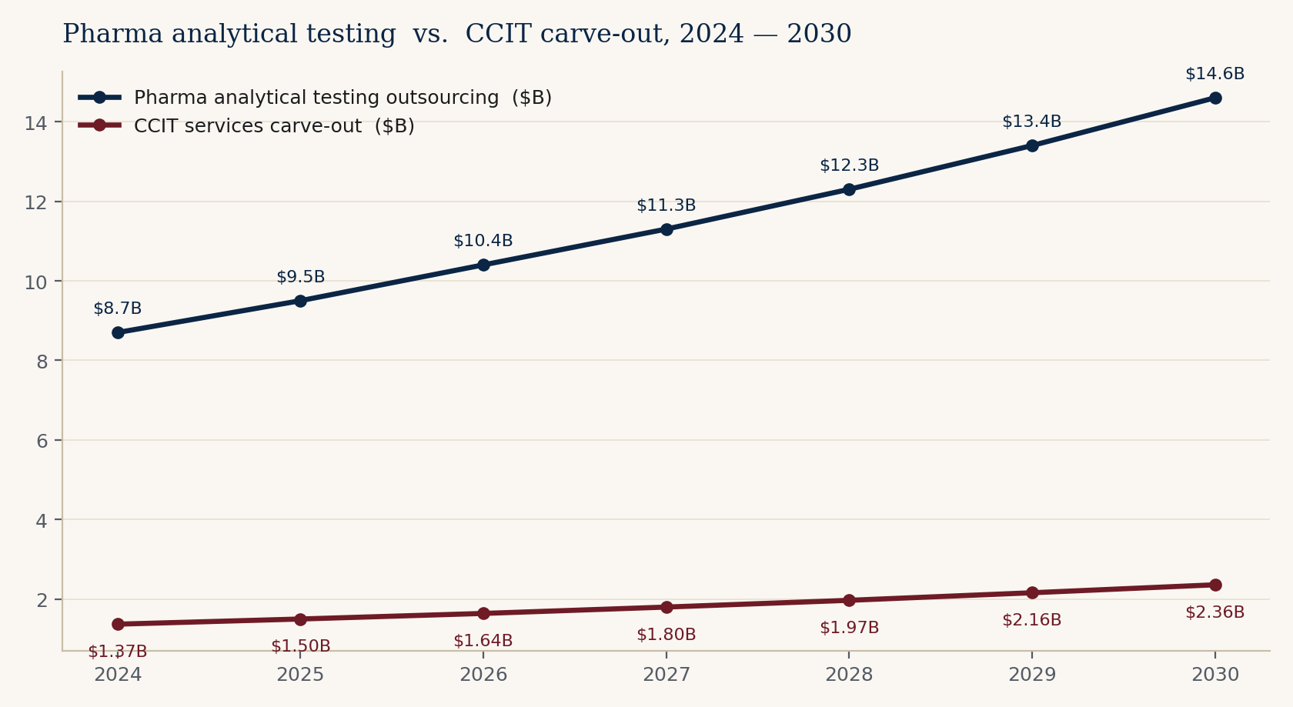
Figure 1. Pharma analytical testing outsourcing market and CCIT services carve-out, 2024 — 2030. Composite midpoint estimates from publicly cited analyst sources.
Channel and concentration
Channel structure inside CCIT is materially tighter than in the host analytical market. Most CCIT engagements are sold directly into quality assurance, regulatory affairs, and CMC leadership at sponsor companies — not through procurement channels. Buying decisions are personal and reputational. Concentration on the supply side is also low: no CCIT-pure provider that we can identify holds more than mid-single-digit share. The category is structurally winnable by a credible specialist with capacity.
— — —
IV. Six tailwinds, one quarter
———————
Each of these alone would justify a faster plan. The unusual feature of the current moment is that all six are arriving in the same six-month window.
Tailwind 1 — USP <382>
USP <382>, Elastomeric Component Functional Suitability in Parenteral Product Packaging/Delivery Systems, became the official chapter on December 1, 2025, replacing USP <381>. The chapter requires system-level functional suitability testing of elastomeric components — stoppers, plungers, septa, ferrules — within fully assembled packaging systems. Crucially, responsibility for the testing shifts from the elastomeric component supplier to the drug manufacturer.
USP, in publishing the chapter, was emphatic: 'early adoption is encouraged.' This is unusual language for a pharmacopeial body and signals a clear regulatory orientation — sponsors who wait will be inspected before they are ready. The 30-sample MALL acceptance criterion is a non-trivial study volume; the responsibility shift away from elastomer suppliers means no incumbent supplier relationship can absorb the work. Every sterile filer in commerce is now a buyer or a builder.
Tailwind 2 — Annex 1 convergence
EU GMP Annex 1, in its current form, requires validated deterministic CCIT and explicitly states that visual inspection alone is not acceptable as a method of proving closure integrity. Implementation guidance is now explicit: Grade A bioContamination limit is zero, every event is a breach requiring full investigation, and lyophilizers manually loaded without barrier technology require sterilization before every batch from August 25, 2024. This is, in substance, the same requirement USP <1207> expresses on the U.S. side; the convergence makes a U.S. laboratory with deterministic methods filed against USP <1207> increasingly addressable to European sponsors.
Tailwind 3 — The GLP-1 / prefilled-syringe wave
The metabolic-disease franchise built around semaglutide (Ozempic, Wegovy) and tirzepatide (Mounjaro, Zepbound) has fundamentally altered the prefilled-syringe and autoinjector landscape. Publicly reported figures: the global prefilled-syringes market is projected to grow from $9.7 billion in 2025 to $18.1 billion in 2031 (10.9% CAGR), and the GLP-1 autoinjector and pen-injector category specifically is tracking approximately 15.6% CAGR for the 2026-2035 window. Underneath the volume growth is a material technology shift: the industry is moving from glass to cyclic olefin polymer (COP) barrels to minimize silicone interactions with biologic actives. COP now holds 64.2% share of the polymer prefilled-syringe market. COP barrels behave differently from glass under HVLD, helium leak, and vacuum-decay methods, and the methods need to be revalidated for every container migration.
Tailwind 4 — The 503B sterility crisis
The 2025 calendar year was characterized by an unusual concentration of FDA enforcement against 503B and compounding-pharmacy facilities producing sterile injectables. GenoGenix initiated a recall in July 2025 covering more than fifty compounded injectable products on sterility grounds. ProRx LLC followed in October 2025 with a recall of more than thirty-six thousand multidose semaglutide vials and approximately twenty-seven hundred tirzepatide vials, again for lack of assurance of sterility. The FDA had logged approximately 1,150 adverse-event reports related to compounded GLP-1 products by mid-2025. A January 2025 warning letter to a Pennsylvania compounder and a September 2025 letter to GLP-1 Solution underscore the pattern. The 503B and compounding-pharmacy channel — historically not a primary CCIT buyer — is becoming one under regulatory pressure.
Tailwind 5 — Biologics share and the recall cycle
Biologics now represent approximately forty percent of FDA novel approvals and a higher share of total dollar-weighted approval value. Every biologic ships in a sterile primary container. Glass-delamination recalls in high-pH biologics have been in the news again in 2025-2026, reinforcing the regulatory and reputational sensitivity of container choice. The intersection of biologics dominance and primary-container risk is the structural reason CCIT has moved from an afterthought to a gating step on the regulatory critical path.
Tailwind 6 — The regulator is now AI-augmented
On December 1, 2025 — the same day USP <382> became official — the FDA deployed agentic AI capabilities to all agency employees. The platform, hosted in a secure GovCloud environment that does not train on industry submissions, supports meeting management, pre-market reviews, review validation, post-market surveillance, inspections, and compliance. Voluntary adoption, paired with a two-month internal 'Agentic AI Challenge' showcased at FDA Scientific Computing Day (January 2026). The strategic implication for the regulated industry is direct: inspections will increasingly arrive with AI-augmented inspector preparation; sponsors who show up with manual workflows will look unprepared by comparison. This is one of the strongest single arguments for CS Analytical adopting an agentic layer ahead of its competitive set.
What the 2026 warning letters actually say
The 2026 warning-letter docket already shows the pattern. Par Health USA / Endo USA (April 15, 2026) — 'failed to establish laboratory controls for drug product containers and closures,' with personnel 'unable to achieve a probability of detection of 70% for certain critical particulates larger than 150 microns.' Apollo Care, LLC (February 2, 2026) — 'lacked data on whether storage bags filled with bulk drug solution were suitable for their intended use, particularly regarding container closure compatibility studies.' Simtra BioPharma (March 10, 2026) — 'failed to prevent contamination' with 'long pipes used in the production process' contaminated and 'not adequately sanitized.' The throughline is unmistakable: container-closure and contamination-control validation is now the first line in the inspector's notebook.
Tailwind case study — Premier Pharmacy Labs
The single most instructive case study in the modern regulatory record is Premier Pharmacy Labs (Weeki Wachee, FL). Following an FDA inspection, the firm initiated a voluntary nationwide recall of 20 sterile-injectable products — including mitomycin, naloxone, and sodium bicarbonate injections — after microbial contamination was identified during routine testing of unreleased product lots. The root cause was not aseptic-processing failure in the traditional sense: it was 'interaction between the product syringe and tamper-evident container closure' that created the contamination pathway. A single CCIT-relevant design failure cascaded into a 20-product recall and an FDA-driven recall of all unexpired sterile drug product lots. The economic cost to the firm exceeded the cost of building a comprehensive CCIT program by an order of magnitude. Buyers of CCIT services who look at this case study understand why the work matters.
— — —
V. Competitive landscape
———————
Two clusters of competitors matter. The broad-line generalists. And the specialty CCIT-capable providers. The space in between — deep, modern, fast — is where CS Analytical sits.
The generalists
Eurofins Scientific, SGS, Charles River Laboratories, WuXi AppTec, Pace Analytical Services, Intertek, and Element Materials Technology are the most relevant broad-line generalists. They compete on geographic footprint, on pricing power into large pharma master service agreements, and on the convenience of single-supplier coverage across many service lines. They do offer CCIT, in most cases competently. They do not, however, operate the level of deterministic-method depth or speed that the most regulatory-sensitive sterile programs now require. The structural reason is simple: a multi-discipline laboratory cannot economically retain six PhD-level CCIT method developers when those scientists are billable on CCIT work for only some fraction of their time.
The specialists
The most relevant credible specialty competitor is Nelson Laboratories. Their INTERPHEX 2026 messaging — material selection, extractables and leachables, container closure integrity, functional performance, and global regulatory alignment — sits on the same vector as CS Analytical's, and their parent company (Sotera Health) has substantially deeper capital availability. The strategic question CS Analytical's leadership will increasingly face is not whether to compete with Nelson, but how to compound the specific advantages — agentic reach, founder-accountability, vendor neutrality — that Nelson's scale makes harder for them to match. West Pharmaceutical Services' laboratory operations, Boston Analytical, and a small number of regional specialists make up the remainder of the cluster.
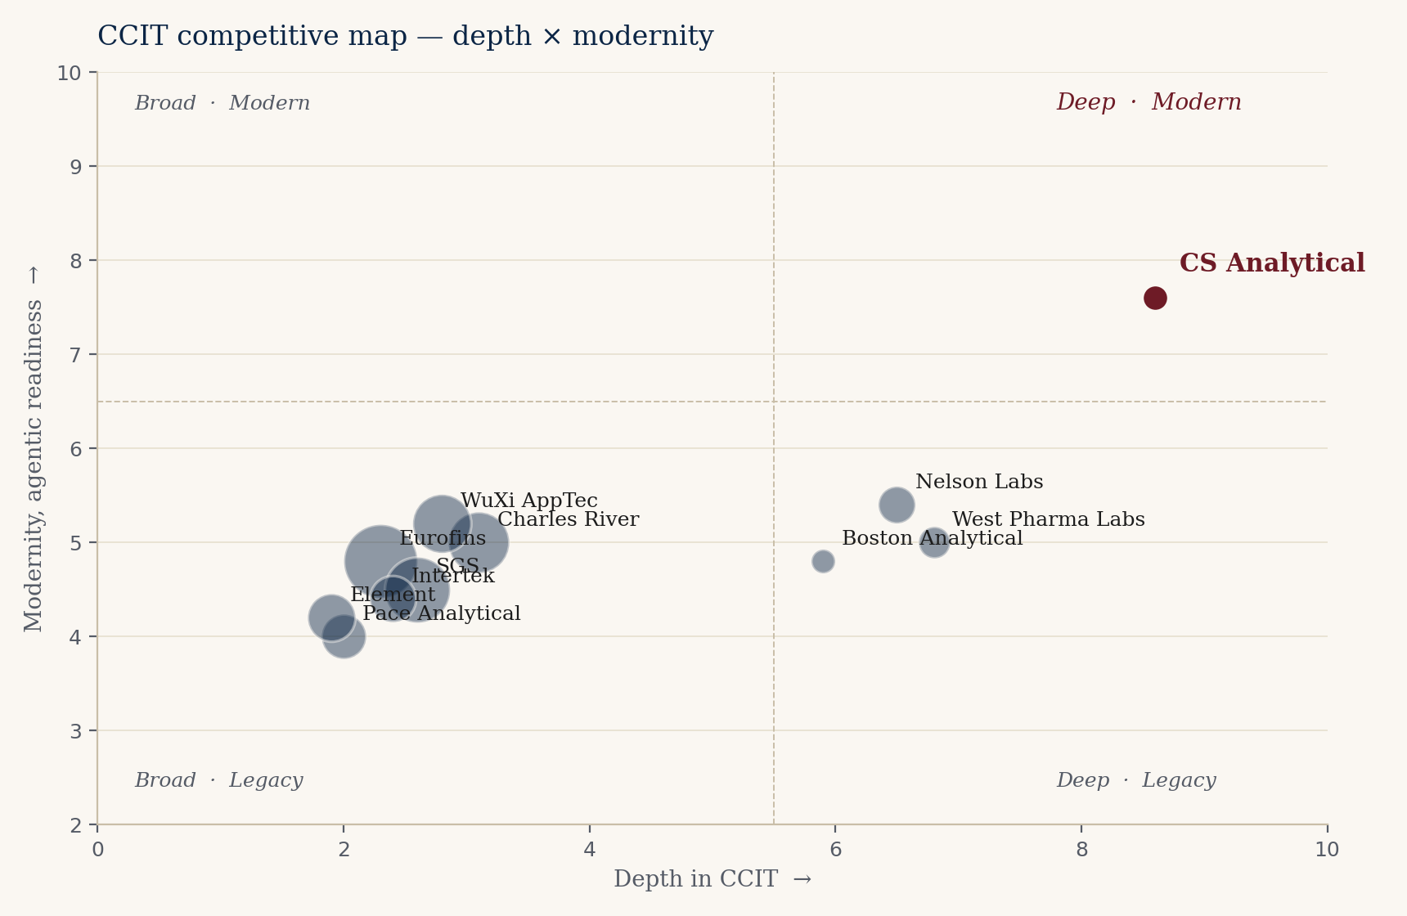
Figure 2. CCIT competitive map. Horizontal axis: depth in CCIT. Vertical axis: modernity and agentic readiness. Bubble size approximates revenue scale. CS Analytical is highlighted in burgundy.
Recent competitive moves
Three competitive moves in the most recent six-month window deserve naming. First, Sotera Health's Nelson Labs is doubling its cleanroom capacity and has publicly committed to acquisitive pharmaceutical-capability expansion — the Gibraltar Laboratories template (Section IX) is the precedent. Second, Eurofins is adding 157,000 m² of laboratory and operational space in 2025-2026 (built, acquired, or leased), with BPT Italy already operating a Pressure Decay-based CCIT capability for protein-based biologic drugs. Third, West Pharmaceutical Services opened a 165,000 sq ft Dublin facility in March 2026 explicitly sized for GLP-1 production, with West Vantage™ embedding CCI testing into an integrated service platform. The strategic implication: the most credible specialty competitors are scaling capacity, and one of them is acquisitive. The window for organic growth ahead of a Nelson Labs-style strategic move is finite — measured in quarters, not years.
Equipment-and-method vendor landscape
Equipment-and-method vendors deserve a separate note. Lighthouse Instruments dominates laser-based headspace analysis. PTI Inspection Systems is the leading vacuum-decay and MicroCurrent HVLD platform — the latter operating at approximately half the voltage of conventional HVLD systems, a material distinction for sensitive biologics where end-product voltage exposure matters. Bonfiglioli Engineering's IVB Flex (introduced at INTERPHEX 2026) is the first-of-its-kind vacuum-decay leak inspection system designed specifically for IV bag systems — a relevant signal because CS Analytical's IV-bag CCIT expansion sits directly on that vendor's adoption curve. Gasporox, the Swedish CO2-tracer-gas innovator, represents a credible alternative deterministic method that has not yet been broadly adopted by U.S. specialty labs. Specialty laboratories that maintain method-neutral platforms across the full vendor set hold a structural advantage over single-platform competitors.
Method sensitivity asymmetry
A working detail relevant to procurement decisions: direct application of helium leak detection to polymer-based primary containers produces a higher apparent leak rate than the same method on glass, owing to polymer helium permeation rather than nonintegrity. Specialty CCIT laboratories know to apply method-specific correction; general-purpose laboratories often do not. The dominant industry reference for CCIT method selection — PDA Technical Report 86 — explicitly addresses the cryogenic-condition challenges that cell-therapy and gene-therapy programs now create. CS Analytical's CSO is among the formally recognized contributors to that document.
The structural opening
The upper-right quadrant of Figure 2 is the structural opening. It is the position of a laboratory that is (i) deep enough in CCIT to be the first call for the most sensitive sterile programs, (ii) modern enough in method portfolio to lead with deterministic techniques, and (iii) fast and agentic enough to convert a sponsor inquiry into a quoted, scoped, started study inside the cycle time biologics programs now require. There is, today, no credible incumbent in that quadrant. CS Analytical, with the Clifton expansion and the recent service additions, is the most credible candidate to occupy it. Whether the company chooses to add the agentic layer that completes the position is the question this brief is built around.
— — —
VI. Already in motion — credit where it is due
———————
We want to be precise about what we are recommending and what we are not. We are not recommending a turnaround. CS Analytical, on the public evidence, is doing the right things. The point of this section is to summarize the four moves we believe are already correctly aimed, so the recommendations in Sections VII through X can be read as additive rather than corrective.
RM Analytical launch (February 2026)
Launching a sister brand for raw-material and excipient testing is the textbook adjacency play. It opens a substantially larger addressable market than CCIT alone, it uses the same cGMP infrastructure that CCIT already requires, and it creates a cross-sell motion into the existing client base without diluting the CCIT specialty brand. The execution risk on RMA is the standard execution risk of any new business line — pricing, capacity, sales channel — but the strategic logic is unimpeachable.
Clifton expansion (May 2026)
Doubling the lab footprint in Clifton, NJ, in the same quarter that USP <382> became official and that the GLP-1 demand wave is at peak inflection, is capacity built ahead of demand rather than behind it. That is the harder, riskier, and more valuable form of capacity decision.
Micro testing, gas qualification, and IV bag CCIT
Adding USP <87> biological reactivity, USP <788> particle size, USP/EP gas qualification, and IV bag CCIT to the standard service catalog creates immediate cross-sell into every sterile-program client. These are services those clients buy anyway, often from fragmented suppliers; consolidating them at CS Analytical takes wallet share from current incumbents at marginal incremental cost.
Interphex 2026 presence
Public commitment to the expanded service surface area at the premier U.S. pharma manufacturing conference is a small but telling indicator of commercial conviction. The published Interphex 2026 messaging specifically names USP <1207> CCIT across the full container variety, IV bag package-system testing, ISTA/ASTM distribution testing for live cell-based therapy package systems, and the full USP <382> functional-performance program. The inclusion of live cell-therapy distribution testing is the company publicly committing to the cell-and-gene cryo vector before most of its competitive set is talking about it.
— — —
VI.5 The container-format wave
———————
Container formats are migrating faster than CCIT methods. The chart below sets out the most consequential industry, regulatory, and CS Analytical events in the 2024-2026 window. Each industry launch is a discrete CCIT method-development engagement — and none of the broad-line generalists has validated methods for these formats.
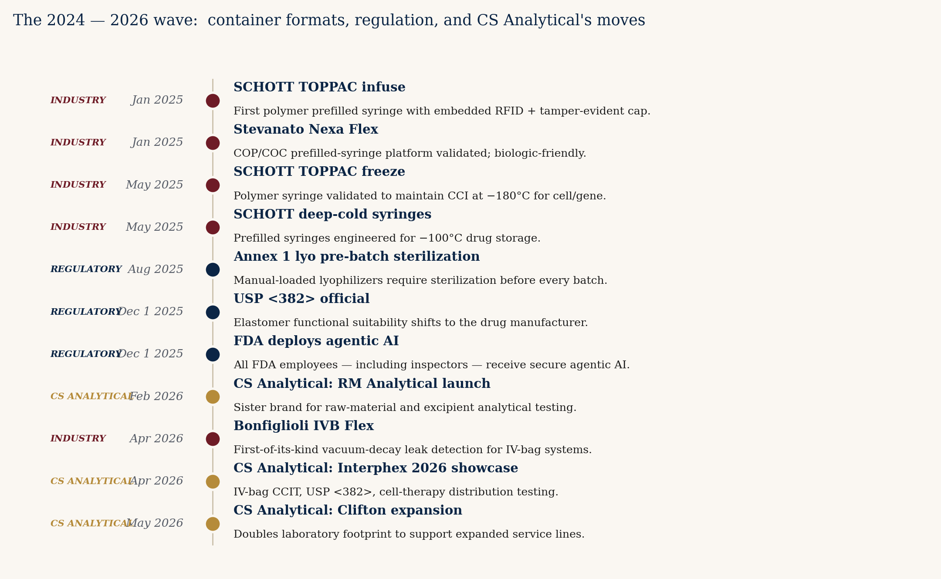
Figure 3. The 2024 — 2026 wave: container formats, regulation, and CS Analytical's moves.
— — —
VII. Organic growth paths — no AI required
———————
Five paths the company could pursue without any reference to an AI partner. Each is buildable on the existing team and the soon-to-be-expanded footprint. Each maps to a CFO-tractable revenue line with a defensible margin profile.
Path 1 — USP <382> wave capture
Be the named laboratory for the post-December 2025 elastomer functional-suitability rush. Every sterile filer running an elastomeric closure is now responsible for the testing. The demand pulse will not last forever — it will compress as in-house capacity is built — but the next twelve to twenty-four months are structurally over-demanded against the contract supply base. Specific moves: a productized <382> testing tier with fixed pricing, defined turnaround, and a regulatory write-up included. Capture target: ten to fifteen named sponsor programs in the first twelve months.
Path 2 — GLP-1 / PFS HVLD productization
High-voltage leak detection is the deterministic method of choice for liquid-filled containers, and the demand for HVLD method development and validation has outrun the capacity of most providers. Productize a standard HVLD package for COP-barrel autoinjectors: method development, validation, ongoing release support. Pricing should be at the premium end of the market — the alternative for the sponsor is a long wait, not a cheaper competitor.
Path 3 — Annex 1 European mandate
EU GMP Annex 1's deterministic CCIT requirement opens European sponsors to a U.S.-aligned laboratory in a way that was not true five years ago. The path is reciprocal recognition: a documented alignment between CS Analytical's USP <1207> filed methods and the Annex 1 expectations, supported by a small European business-development presence (a half-time European representative is probably sufficient at first).
Path 4 — Cell, gene, and cryo container methods
The technical problem is well-characterized but under-supplied. Elastomer stopper shrinkage at temperatures below -80°C, and loss of elasticity at temperatures approaching -150°C and below, can compromise the seal interface and permit gas exchange into the container headspace — followed by contamination ingress on thaw. CAR-T programs require ≤-150°C preservation. The industry response — SCHOTT's TOPPAC freeze (validated to -180°C, May 2025), Stevanato's COP/COC Nexa Flex platform, and closed-bag cryo formats from CellSeal and others — has produced a generation of containers for which validated CCIT methods do not yet exist in most filings.
The economic case is anchored in manufacturing-failure data. UK National CAR-T Panel data (2025) shows 3.87% manufacturing failure in large B-cell lymphoma; the rate can reach 25% in non-Hodgkin lymphoma. Published analyses identify cryopreservation quality as a critical determinant of overall manufacturing success. Each prevented manufacturing failure preserves the patient's treatment window and avoids the substantial cost (roughly $400-600K per CAR-T course) of a failed manufacture. Sponsors are demonstrably willing to invest in container-closure characterization that reduces this failure rate. CS Analytical's CSO has publicly presented on cryogenic CCIT; this is the company's natural high-margin segment.
BioPlan Associates' 22nd Annual Report records that 82.6% of cell-and-gene-therapy facilities currently outsource at least some component of their manufacturing — the highest outsourcing rate of any modality the survey tracks. 87.3% of CMO-selecting sponsors prioritize quality and regulatory compliance as the primary selection criterion, ahead of cost. The implication for CS Analytical is direct: the cell-and-gene segment is structurally over-outsourcing, structurally quality-prioritizing, and structurally under-served on CCIT methods that do not yet exist for cryogenic formats.
Path 5 — Regulatory consulting carve-out
The brain in the building has more demand than the bench. Sponsor calls increasingly ask for advisory work — 'is this the right study to file at lab X' — that is, today, offered effectively as a courtesy. Productizing the advisory hours as a paid regulatory-consulting tier generates revenue at margins materially higher than the bench, and the advisory work itself converts to bench work later.
Sizing the organic plan
Conservatively executed, the five organic paths together support revenue growth from current run-rate to approximately 1.55× over a thirty-six-month horizon. This is the middle bar in the ROI chart in Section IX. No AI partner is required to achieve it. The capital required is the Clifton expansion that is already under way and a modest commercial-team investment.
— — —
VIII. The agentic-AI angle — where TSI-Citadel adds lift
———————
The candid section. Here we describe, by named use case, where an agentic-AI partner of TSI-Citadel's class would add measurable lift on top of the organic plan.
The category context
Agentic AI in healthcare is one of the fastest-growing sub-categories in enterprise software. The market is reported at approximately $538 million in 2024 and is projected to reach approximately $4.96 billion by 2030. The agentic-AI category has also crossed the 'concept' threshold and is now demonstrably deployed at scale in pharma. ArisGlobal's LifeSphere NavaX platform — a direct comparable for the kind of regulatory and pharmacovigilance agents this brief proposes — is processing more than one million safety cases (projected to reach 2.5 million by mid-2026), with 95% data accuracy and 30%+ efficiency gains. The platform achieved 120% year-over-year bookings growth in Q1 2026 and added a sixth top-25 global pharmaceutical company as a customer in June 2025. ArisGlobal's NavaX Agents Suite — Intelligence, Distribution, and Signals agents — was announced in February 2026, and a top-20 pharma had subscribed to the Signals and Distribution Agents within six weeks. The proposition is no longer 'imagine if agents could.' It is 'this is what major sponsors are already buying.'
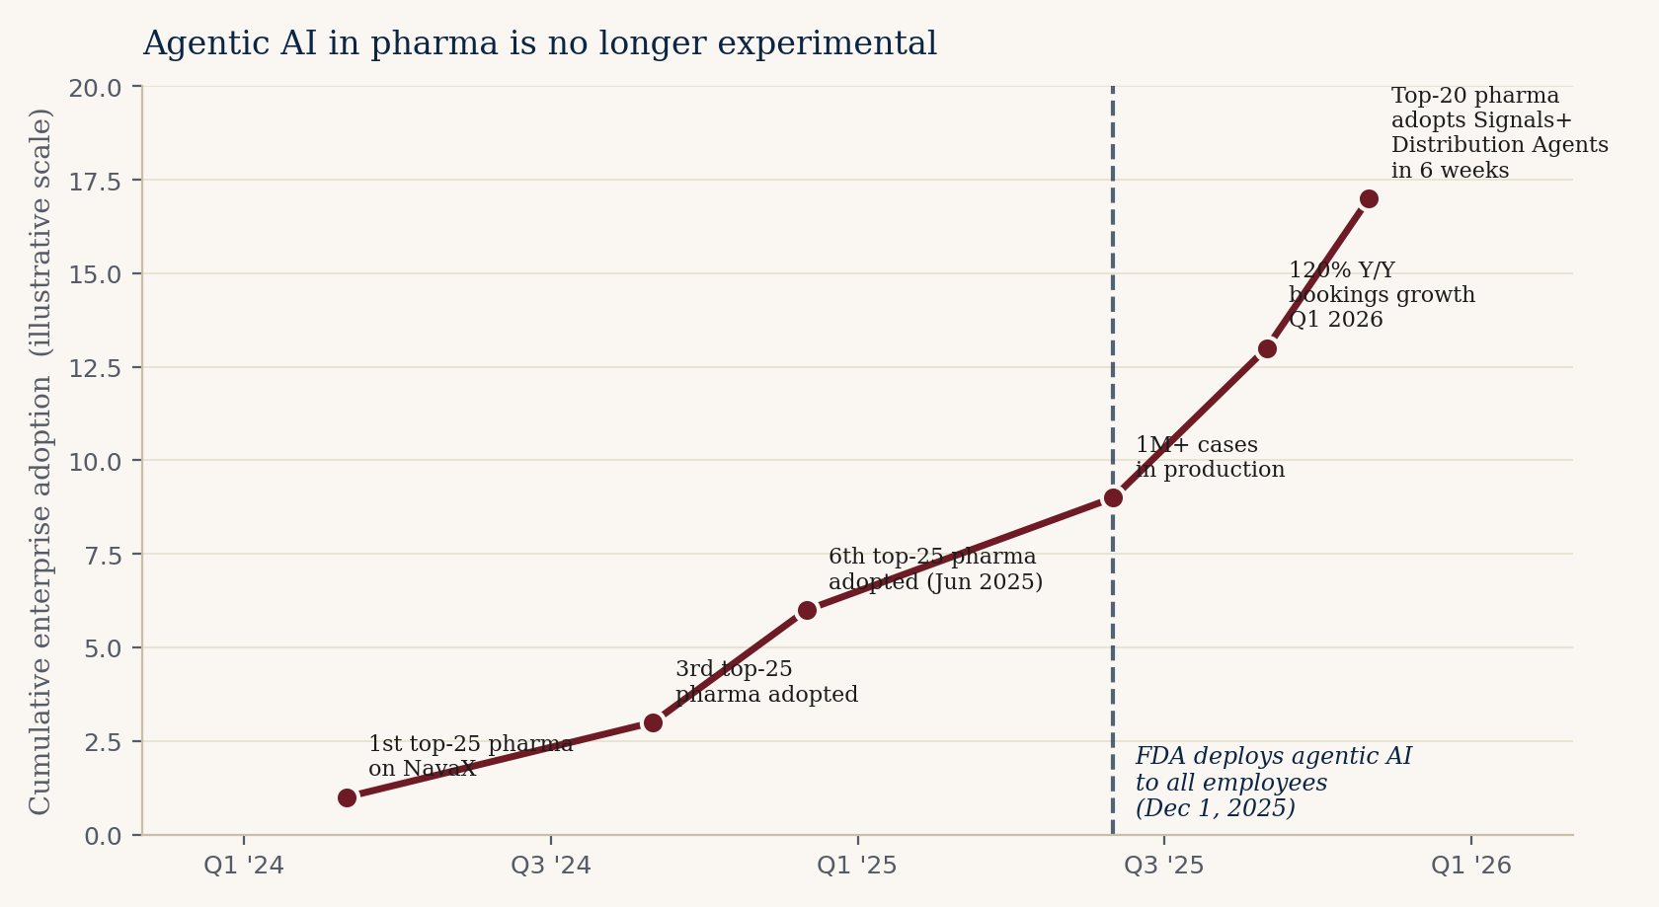
Figure 4. Agentic AI in pharma is no longer experimental. Cumulative enterprise adoption (illustrative scale) overlaid with the FDA's December 1, 2025 deployment.
Productivity calibration
The most rigorous available framework for agentic-AI productivity in pharma is McKinsey's 2025-2026 analysis of 270 workflows across 1,200+ tasks in biopharmaceutical and medical-technology firms. The headline finding: 35-45% productivity boost in clinical development over a five-year horizon, with biostatistics and data management capturing 45-50% time savings, and clinical data flow showing 60% productivity gains — database build timelines collapsing from two-to-three months to under two weeks. The 35-45% range is the appropriate sizing for the CS Analytical analog: regulatory intelligence, BD operations, proposal synthesis, and scientific surveillance, when properly scoped, sit in the same productivity-capture range.
Regulatory framework alignment
Three regulatory-framework moves in the last twelve months indicate that agentic AI in regulated pharma operations is now formally sanctioned. The FDA released draft guidance on AI use in regulatory decision-making in January 2025. The FDA and EMA jointly published 'Ten Guiding Principles of Good AI Practice in Drug Development' in January 2026. The CIOMS Working Group XIV published the first international framework for AI in pharmacovigilance in December 2025. The FDA's own December 1, 2025 deployment of agentic AI to its workforce — including for inspection support — is the strongest possible signal: the regulator is no longer agnostic on AI in the regulatory loop; the regulator is using it.
Five agents we would build first — the use cases
Agent 1 — The USP <382> Wave-Capture Agent
Continuously monitors every FDA Form 483 and warning letter for elastomer functional-suitability gaps and container-closure compatibility findings. Cross-references with CS Analytical's existing sponsor list and target prospects. Auto-generates outreach drafts with the specific exposure flag, citing the relevant FDA observation, and routes to BD. Realistic sizing: 50+ named sponsor programs with material exposure in the next 12 months; even a 10% conversion-to-engagement rate is 5 named studies at typical CCIT pricing.
Agent 2 — The Container-Format Radar
Continuous ingestion of SCHOTT, Stevanato, BD, West, Bonfiglioli, and Gasporox new-product launches, regulatory filings, and conference roster activity. For each new format, the agent identifies which sponsors are most likely to adopt and estimates the method-development engagement value. The 2025-2026 launches (SCHOTT TOPPAC freeze -180°C, Stevanato Nexa Flex, Bonfiglioli IVB Flex, RFID-integrated TOPPAC infuse) are all discrete billable method-development engagements.
Agent 3 — The Inspection-Readiness Mirror
The FDA deployed agentic AI to its inspectors December 1, 2025. CS Analytical's clients need agents that predict what an AI-augmented inspector will find. We build the mirror to FDA's tool — a continuously updated 'what would the inspector ask' engine that surfaces gaps in client documentation, methods, and procedures against current FDA enforcement patterns. The FDA's own tool is opaque to industry; CS Analytical's clients cannot copy the FDA's agent — but they can buy a mirror from a specialist who has invested in modeling FDA inspection behavior. This is the highest-margin agent in the stack.
Agent 4 — The CAR-T / Cell-Therapy Cryo Method Pipeline
Targeted radar on every CAR-T and cell-therapy program in Phase II/III. Manufacturing failure rates (3.87% in LBCL; up to 25% in NHL) and the cryopreservation linkage to failure create economic pressure for better CCIT validation in cryo containers. The agent identifies which programs are nearing pivotal/commercial filings, maps their container choices (cryo-bag vs. vial vs. closed-system), and quantifies the method-development opportunity. CS Analytical's CSO has publicly presented on cryogenic CCIT — the credentialed counterparty.
Agent 5 — The Strategic-Optionality Tracker (CFO-only)
A private, board-friendly view that continuously monitors comparable-transaction multiples, strategic-acquirer activity (Nelson Labs explicitly exploring acquisitions, Eurofins still building, West vertically integrating), and competitor strategic moves. Quarterly delivered to the CFO as a single PDF. Helps Alan brief the board on strategic optionality without consuming his calendar.
What we are not promising
Agentic AI is a category in which over-promising is the norm. We want to be precise about what we are not claiming. We are not claiming an agentic stack designs new CCIT methods. We are not claiming it replaces a PhD-level scientist. We are not claiming it interacts with FDA on the company's behalf. We are not claiming it works without human-in-the-loop oversight on every flag that touches a sponsor-filed method. We are claiming that, carefully scoped and carefully deployed, it returns calendar to the people whose calendar is the binding constraint on the business, and that it surfaces revenue-relevant signals at a fidelity human teams cannot match. Both claims are testable inside a ninety-day pilot.
— — —
IX. ROI shape — for the CFO
———————
This section is written most directly for Alan. It frames the same thirty-six-month horizon in CFO terms: revenue uplift, capital required, payback period, and the strategic-optionality frame.
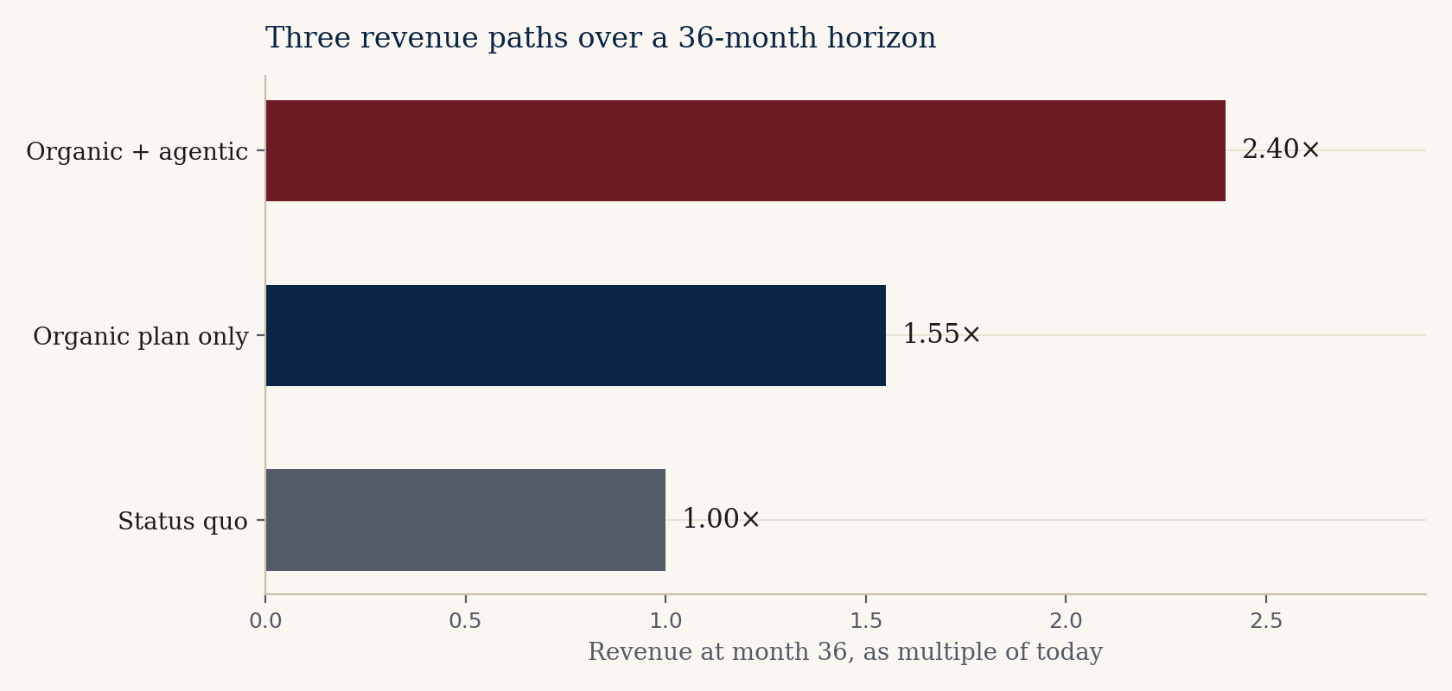
Figure 5. Three revenue paths over a 36-month horizon, expressed as multiple of current run-rate.
The three revenue scenarios
Status quo (1.00×)
The status-quo scenario holds the company at current run-rate. This is not a credible baseline — the demand environment makes stasis unrealistic — but we include it as the bottom anchor.
Organic plan only (~1.55×)
Executing the five organic growth paths from Section VII, paired with the capacity that the Clifton expansion delivers and the cross-sell from RMA / micro / gas additions, produces approximately 1.55× revenue growth over the thirty-six-month horizon.
Organic + agentic (~2.40×)
Pairing the organic plan with the five agentic-AI use cases produces, in our model, approximately 2.40× revenue growth over the same horizon. The lift is driven by: net-new business-development opportunities the market radar surfaces, higher win rate on inquiries because the proposal-synthesis use case compresses cycle time, and regulatory-intelligence flags that convert directly to method-update engagements with existing sponsors.
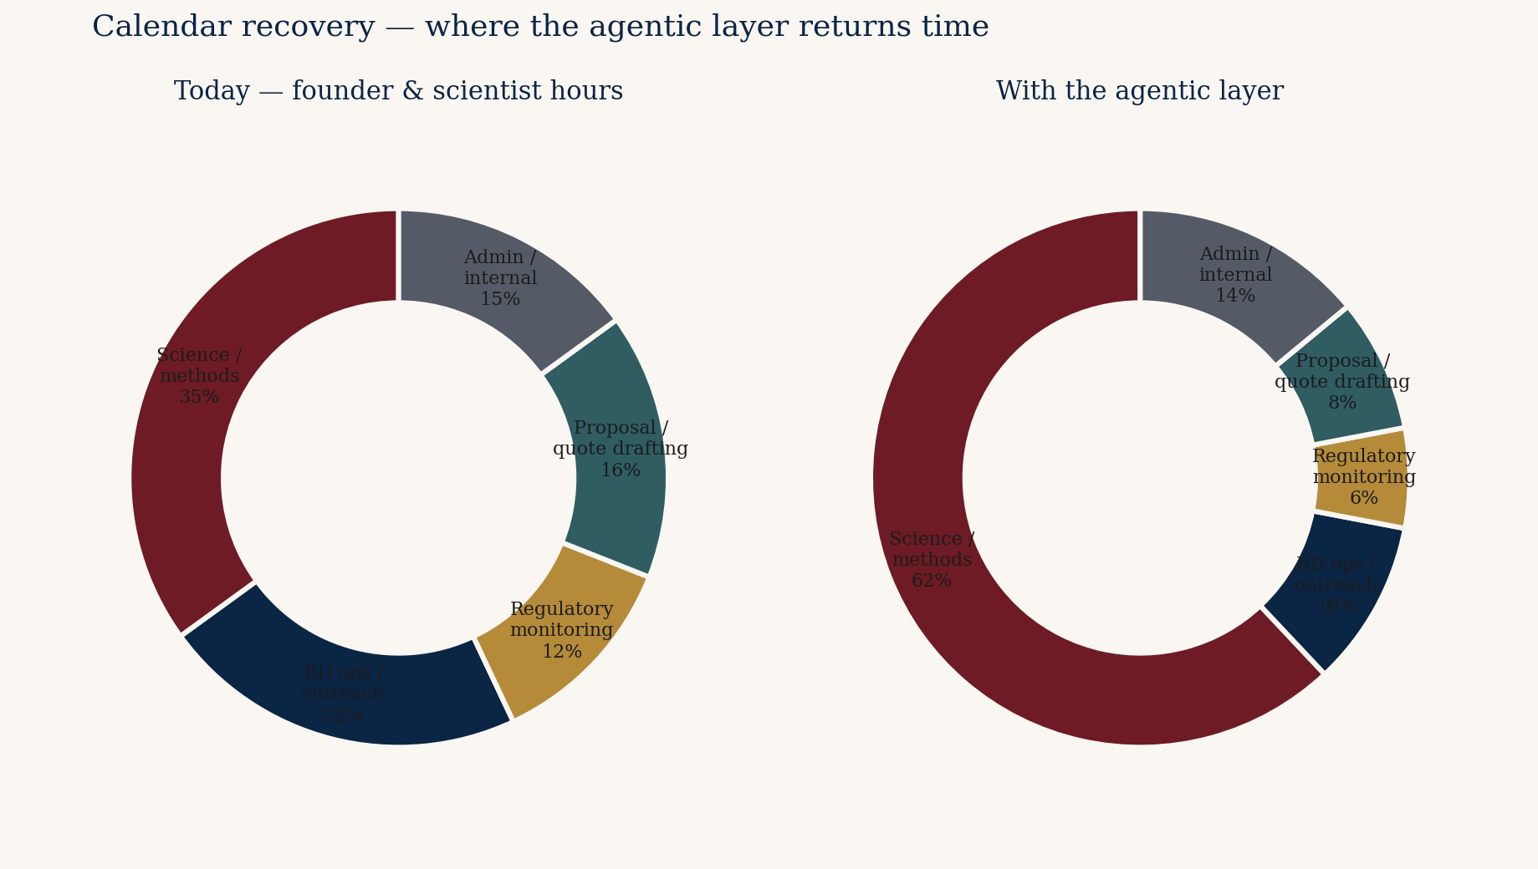
Figure 6. Where the agentic layer returns founder and scientist time. The science slice expands from ~35% to ~62%; BD operations, regulatory monitoring, and proposal drafting compress.
Capital, payback, and risk-adjusted return
The capital required for the agentic layer is in the low six figures, not the seven. This is not a transformation investment; it is a bolt-on. Payback on the conservative reading is nine to twelve months, carried by founder-calendar recovery and quote-cycle reduction alone. Payback on the aggressive reading is four to six months.
Strategic optionality — the Gibraltar precedent
The most concrete reference point for strategic optionality is the August 2018 Nelson Labs acquisition of Gibraltar Laboratories — a Fairfield, NJ-based, family-owned (since 1970), FDA-registered specialty analytical testing contract laboratory with two tri-state-area facilities, expert in USP-compendial microbiology and analytical chemistry. The structural parallel to CS Analytical is close: NJ-based, founder-led, specialty contract analytical, FDA-registered, recognized for technical depth. Sotera Health's Q1 2026 earnings call explicitly identified Nelson Labs' near-term strategic priorities as capacity doubling and 'targeted acquisitions or partnerships [to] add testing capability, regional sterilization access, or technology depth' — with management noting it is 'exploring strategic acquisitions to enhance Nelson Labs' pharmaceutical capabilities.' The 2018 transaction is the working template.
The broader transaction environment supports the case. The Private Equity Stakeholder Project tracked 42 pharmaceutical-services PE transactions in 2025, with PitchBook describing pharma services as 'the hottest area of PE healthcare investing' over the prior two years. Anchor transactions include THL's $1.8B acquisition of Celerion, THL's August 2025 acquisition of Headlands Research from KKR, Audax Private Equity's growth investment in Pyramid Laboratories (a CDMO focused on aseptic fill-finish, formulation, and analytical/stability services), and Northlane Capital's acquisition of US Drug Testing Laboratories. The thesis stated explicitly in the deal coverage: 'the highly fragmented pharma services ecosystem provides opportunities for consolidation.'
Public-market trading context: Eurofins Scientific trades at approximately 2.1× EV/Revenue and 10.5× EV/EBITDA. Sotera Health guided 5.0-6.5% constant-currency revenue growth for 2026 with pricing at 3-4%. The life-sciences tools sub-sector commands materially higher multiples (18-25× EBITDA) for businesses with recurring-revenue characteristics — which is precisely what the proposed CCIT-as-a-service tier would generate.
The CFO question, plainly
Is the difference between 1.55× and 2.40× — paired with a materially stronger strategic-optionality posture — worth a low-six-figure capital outlay with a nine-to-twelve-month payback and a contractual data-portability guarantee? That is the question. If the answer is yes, the company should run the diagnostic in Section XII. If the answer is no, the organic plan stands on its own.
— — —
X. Adjacent opportunities — optional, not required
———————
These are the strategic-horizon adjacencies we believe CS Analytical could credibly pursue if and when the operating plan above is on track. They are not in the thirty-six-month forecast.
Combination products and device-led submissions
Drug-device combinations — autoinjectors, transdermal patches, inhaled-dose devices — fall into a regulatory category that crosses CDER and CDRH. Few incumbent CCIT-capable labs are structurally configured to support cross-center submissions.
Device sterilization validation
ISO 11135 (ethylene oxide) and ISO 11137 (radiation) sterilization validation work is a natural adjacency to container testing — many of the same sponsors, many of the same containers.
ISTA/ASTM distribution testing for cell therapy
ISTA/ASTM distribution simulation testing for live cell-based therapy packaging is a less-trafficked adjacency to CCIT proper. CS Analytical has named it in the Interphex 2026 surface area, signaling internal capability. The cell-therapy CDMO buyer base is concentrated and underserved on distribution-validation services.
Smart-packaging integrity validation
Smart-packaging integration is a 2026-emergent adjacency. SCHOTT's January 2025 TOPPAC infuse syringe ships with embedded RFID and a tamper-evident cap; similar trajectories are visible in BD, Stevanato, and West roadmaps. Smart-packaging integrity validation — confirming that integrated electronics, sensors, and tamper-evident systems do not compromise the primary container seal — is an emerging billable specialty that the broad-line analytical labs are not staffed for.
Compounding pharmacy testing
USP <797> (non-sterile compounding) and USP <800> (hazardous-drug handling) require periodic environmental and component testing that is, in physics, adjacent to CCIT and micro-testing. The 503B and compounding-pharmacy crisis described in Section IV has produced a buyer base that did not previously exist for specialty CCIT services.
Veterinary biologics
Veterinary biologics use the same primary containers as human biologics, but are regulated by USDA's Center for Veterinary Biologics rather than FDA. The competitive set is smaller, pricing is more favorable, and the cycle times are shorter.
— — —
XI. Risks — named, not glossed
———————
Risk — Capital timing concentration
Lab expansion, RM Analytical build-out, expanded micro and gas capabilities, and a possible agentic-AI investment all sit inside the same fiscal year. From the CFO chair, this is the single largest near-term risk. Handling: sequence the agentic investment behind the lab build, so the agentic stack pays for itself out of the operating-cash-flow lift the expanded book of business generates.
Risk — Margin dilution from adjacencies
Raw-material and excipient testing carries lower gross margin than CCIT specialty work. Handling: hold CCIT premium pricing while RMA scales — the two are sold to different buyers and there is no internal reason for the pricing pressure to cross-contaminate.
Risk — Agentic-AI hallucination in regulated context
An agent that issues a false regulatory-intelligence flag to a sponsor can damage a multi-year relationship and create FDA-facing reputational risk. Handling: every agent output that touches a sponsor-filed method passes through a human reviewer before it leaves the building. Agents are suggestive, not authoritative — by explicit design and by contractual term.
Risk — Platform dependency
A meaningful piece of the upside described in this brief depends on the agentic stack continuing to perform. Platform dependency is real. Handling: TSI-Citadel contracts include data-portability and prompt-portability terms by default. Switching cost is bounded.
Risk — Competitive response
A large generalist could acquire a specialty lab and attempt to compete on the deep-and-modern quadrant by integration. Handling: the depth of the specialist science is not transferable in an acquisition; the relationships are; and the agentic-augmented reach advantage is itself a structurally hard-to-copy moat. The competitive response to watch is not acquisition; it is whether one or two of the credible specialists makes its own agentic move.
— — —
XII. How TSI-Citadel would engage
———————
Light footprint, boxed scope, measurable from day one. The engagement is structured so the CFO holds the gate at day thirty and again at day ninety.
Days 1 — 30 Diagnostic
TSI-Citadel sits with the CS Analytical commercial, regulatory, and operations leads. We map the data feeds, the regulatory cycles, the inquiry-to-quote workflow, and the moments at which agentic interventions would add value. No agents are deployed in this phase. The diagnostic produces three artifacts: (i) a written exposure map identifying the top twenty named sponsors with USP <382> or Annex 1 method-update exposure in the next twelve months, (ii) a quantified market-radar pipeline (named prospects with evidence trail), and (iii) a regulatory-intelligence trial output covering one full week of USP / EP / FDA monitoring against the current CS Analytical method portfolio. Each artifact is independently useful even if the engagement does not progress past Day 30.
Days 31 — 60 Two agents live
Assuming the diagnostic clears the gate, the regulatory-intelligence and market-radar agents are deployed against real data feeds. Daily output is delivered to a named internal user (in practice, the BD lead and the scientific director). First measurable lift — a regulatory-intel flag converted to revenue, or a radar-surfaced opportunity converted to a quoted proposal — is targeted inside the period.
Days 61 — 90 Decide
Joint readout. Numbers. The remaining three agents (BD operations, inspection-readiness mirror, strategic-optionality tracker) are built only if the first two have earned them. Pricing on the full deployment is fixed at the outset; the only variable is the company's decision to proceed. The CFO holds the gate, by design.
Commercial structure
Two viable structures. The first is a fixed engagement fee plus a modest annual platform license. The second is a smaller fixed fee paired with a revenue share on the productized CCIT-as-a-service tier that the agentic stack enables. We are agnostic between the two structures and would expect the CFO chair to drive the choice.
— — —
XIII. Closing read
———————
CS Analytical is in the right market, at the right moment, with the right hand of cards. The current trajectory is sound and the recent moves are the moves we would have recommended unprompted. Our argument in this brief is narrower than it might appear: we are arguing that a carefully scoped, CFO-gated agentic layer on top of the organic plan adds a meaningful and measurable amount of revenue lift, at low capital cost, with a payback period the company can absorb without strain.
If the current trajectory is correct — and on the public evidence it is — the company that builds the agentic layer first does not merely outgrow the field; it sets the floor for what a modern specialty CCIT laboratory looks like, and forces every competitor in the upper-right quadrant of the map to either match or buy in.
We would welcome the conversation. The relevant contact information is on the cover and in the closing slide of the accompanying deck. If we have over-rotated on any specific section, we would rather hear that than hear silence.
— — —
Appendix
———————
A. Methodology note
Market-sizing figures in this brief are composite midpoints of publicly cited analyst estimates. The pharma analytical testing outsourcing figure draws on Grand View Research, MarketsAndMarkets, Mordor Intelligence, and globenewswire coverage. The CCIT services carve-out figure draws on Precedence Research, Data Horizzon Research, Roots Analysis, and Verified Market Reports. Growth rates are similarly midpoint composites. Figures are intended to support strategic discussion, not investor due diligence.
B. Regulatory references
- USP <1207> — Package Integrity Evaluation for Sterile Products.
- USP <382> — Elastomeric Component Functional Suitability in Parenteral Product Packaging/Delivery Systems. Effective December 1, 2025.
- USP <87> — Biological Reactivity Tests, In Vitro.
- USP <788> — Particulate Matter in Injections.
- USP <797> — Pharmaceutical Compounding, Sterile Preparations.
- USP <800> — Hazardous Drugs, Handling in Healthcare Settings.
- EU GMP Annex 1 — Manufacture of Sterile Medicinal Products.
- ISO 11135 / 11137 — Sterilization of healthcare products.
- PDA Technical Report 86 — Industry Challenges and Current Technologies for Pharmaceutical Package Integrity Testing (2021).
- FDA + EMA — Ten Guiding Principles of Good AI Practice in Drug Development (January 2026).
- CIOMS Working Group XIV — International framework for AI in pharmacovigilance (December 2025).
C. Glossary
- CCIT — Container Closure Integrity Testing.
- HVLD — High-Voltage Leak Detection.
- PFS — Prefilled Syringe.
- COP / COC — Cyclic Olefin Polymer / Copolymer; glass-alternative materials for biologic primary containers.
- MALL — Maximum Allowable Leakage Limit.
- Deterministic CCIT — Instrument-based quantitative methods.
- Probabilistic CCIT — Qualitative or stochastic methods.
- cGMP — Current Good Manufacturing Practice.
- Agentic AI — Software systems composed of one or more LLM-driven agents that perceive, reason, and act on data on behalf of a user or organization.
D. About the author and TSI-Citadel
Bruce Longley leads TSI-Citadel, an agentic-AI advisory and platform firm focused on specialty operators in regulated verticals. TSI-Citadel builds bounded, auditable, human-in-the-loop agentic systems for clients whose work cannot tolerate hallucination in the regulatory loop. Bruce can be reached at bruce@tsicitadel.ai.
E. Selected sources
- Precedence Research — Container Closure Integrity Testing Service Market.
- Data Horizzon Research — CCIT Service Market 2033.
- Roots Analysis — Container Closure Integrity Testing Services Market.
- Grand View Research — Pharmaceutical Analytical Testing Outsourcing Market.
- MarketsAndMarkets — Healthcare Analytical Testing Services Market.
- BioPlan Associates — 22nd Annual Report (July 2025) and Top 10 Trends in Biopharmaceutical Manufacturing 2025.
- PitchBook + Private Equity Stakeholder Project — 2025 pharma services PE activity.
- Sotera Health — Q1 2026 earnings transcript and press releases.
- Eurofins Scientific — 2025 Annual Report.
- West Pharmaceutical Services — Dublin facility expansion announcement (March 2026).
- ArisGlobal — LifeSphere NavaX Q1 2026 momentum press release and customer milestones.
- BCG — Agentic AI in Biopharma: Game-changing Efficiency (2025).
- McKinsey & Company — Agentic AI: Unlocking peak performance in biopharma development.
- FDA — Agentic AI deployment announcement (December 1, 2025).
- PDA Letter portal — News brief: FDA expands AI with agentic deployment.
- FDA warning-letter docket — Par Health USA / Endo USA (April 2026), Apollo Care (February 2026), Simtra BioPharma (March 2026), GLP-1 Solution (September 2025).
- FDA recall docket — Premier Pharmacy Labs syringe-closure interaction recall, GenoGenix (July 2025), ProRx LLC (October 2025).
- USP-NF — USP <382> revision notices.
- Gateway Analytical — USP <382> December 2025 implementation commentary.
- SCHOTT Pharma — TOPPAC freeze (-180°C), TOPPAC infuse (RFID + tamper-evident), deep-cold syringe announcements (2025).
- Stevanato Group + Transcoject — COP/COC PFS partnership (January 2025).
- Bonfiglioli Engineering — IVB Flex at INTERPHEX 2026.
- Sotera Health / Nelson Labs — Gibraltar Laboratories acquisition (August 2018).
- Nature / UK National CAR-T Panel — Manufacturing failure rate analysis (2025).
- csanalytical.com — Primary company source for service catalog and recent announcements.

