GEMS Report Figures
Figures for general GEMS reporting and GEMS final report.

RGA
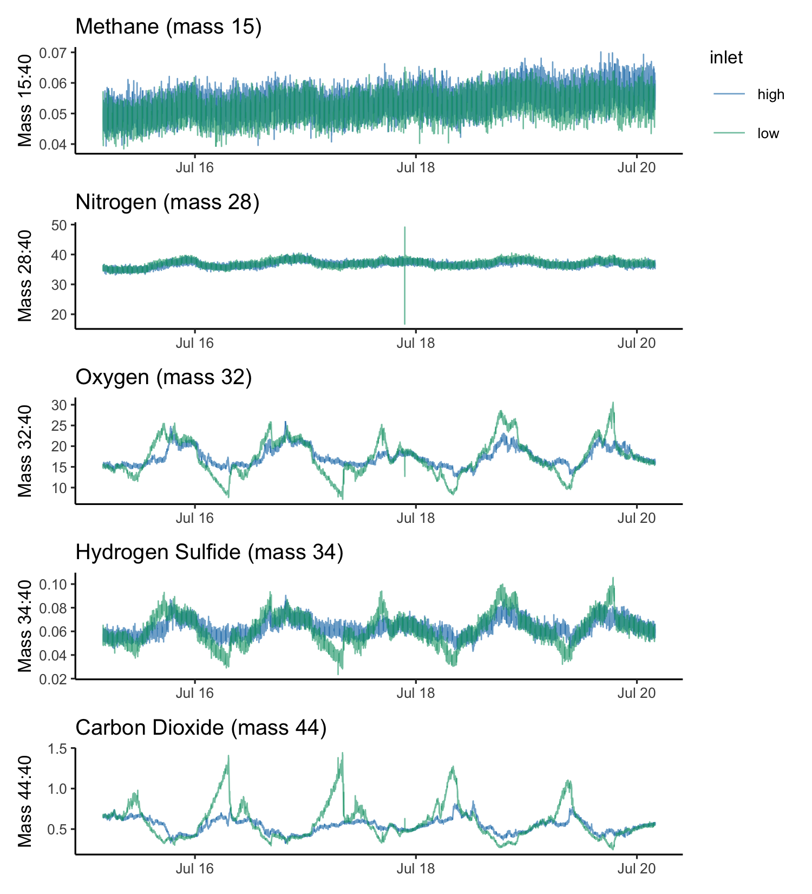
Figure 1: RGA signals for masses of interest. Each mass is measured approximately every 10 s. Mass traces are colored by the selected inlet; blue indicates the upper or “high” inlet, and green indicates the bottom or “low” inlet. A five day period of the deployment was chosen to highlight diel cycles. Each signal is normalized to mass 40 (Argon) to control for effects of temperature, pressure, and biofouling. The mass 34 signal is likely an interference with Oxygen, rather than a true hydrogen sufide signal.

2022-2025 noise comparison
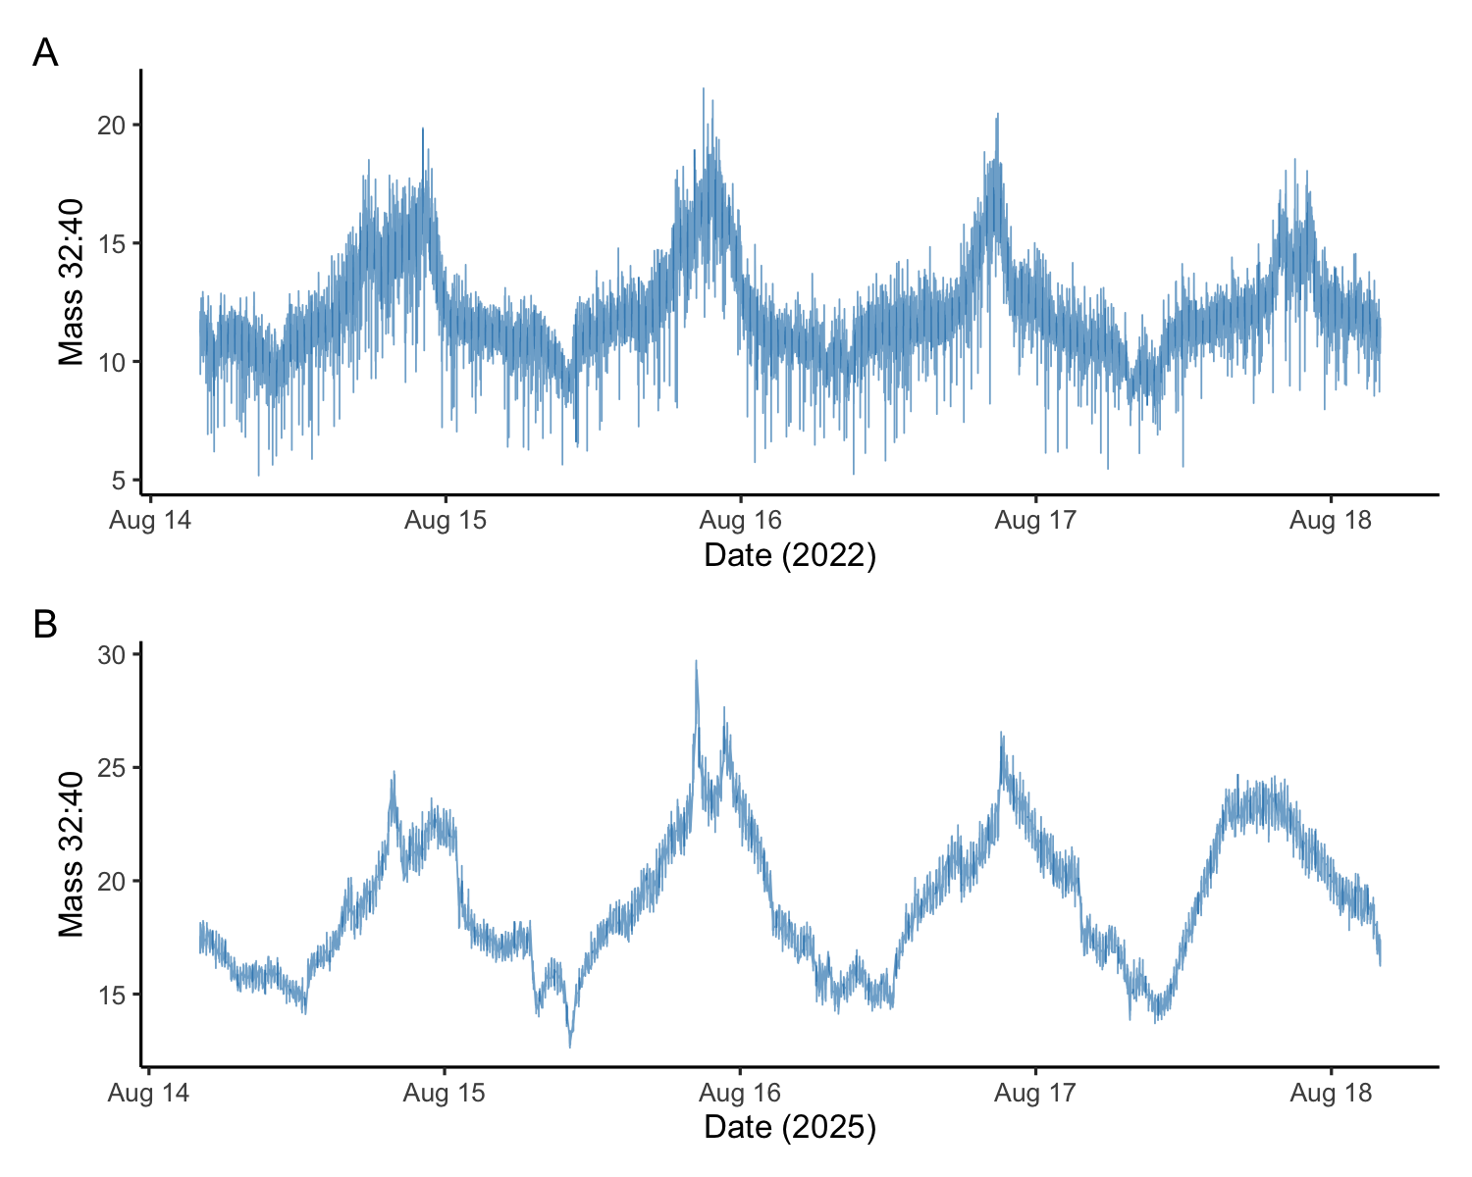
Figure 2: Comparison of QMS signal noise for argon-normalized oxygen at the high inlet between 2022 (A) and 2025 (B) deployments. Signal noise was greatly reduced for the 2025 deployment, improving the accuracy and limit of detection for gradient determination.

Effect of Argon normalization
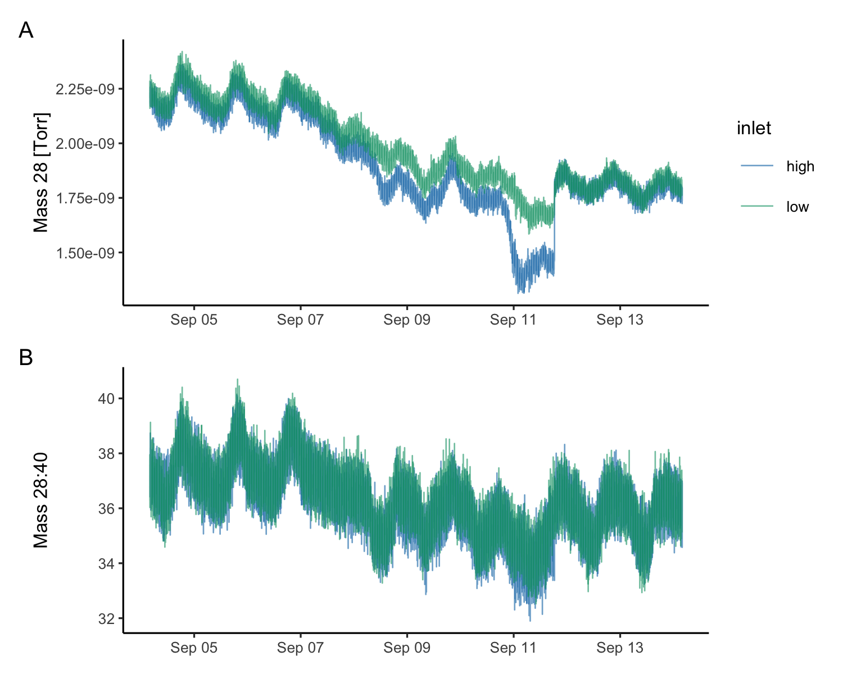
Figure 3: This figure shows Nitrogen (mass 28) un-normalized (A) and normalized (B) using concurrent Argon (mass 40) measurements across a period of increasing biofouling at the high inlet, followed by cleaning the inlets on Sept. 11. Normalizing measured masses to Argon controls for physical effects on gas solubility and membrane transport. Gas transport across the membrane is affected by temperature, pressure and water flow rate.

Oxygen timeseries
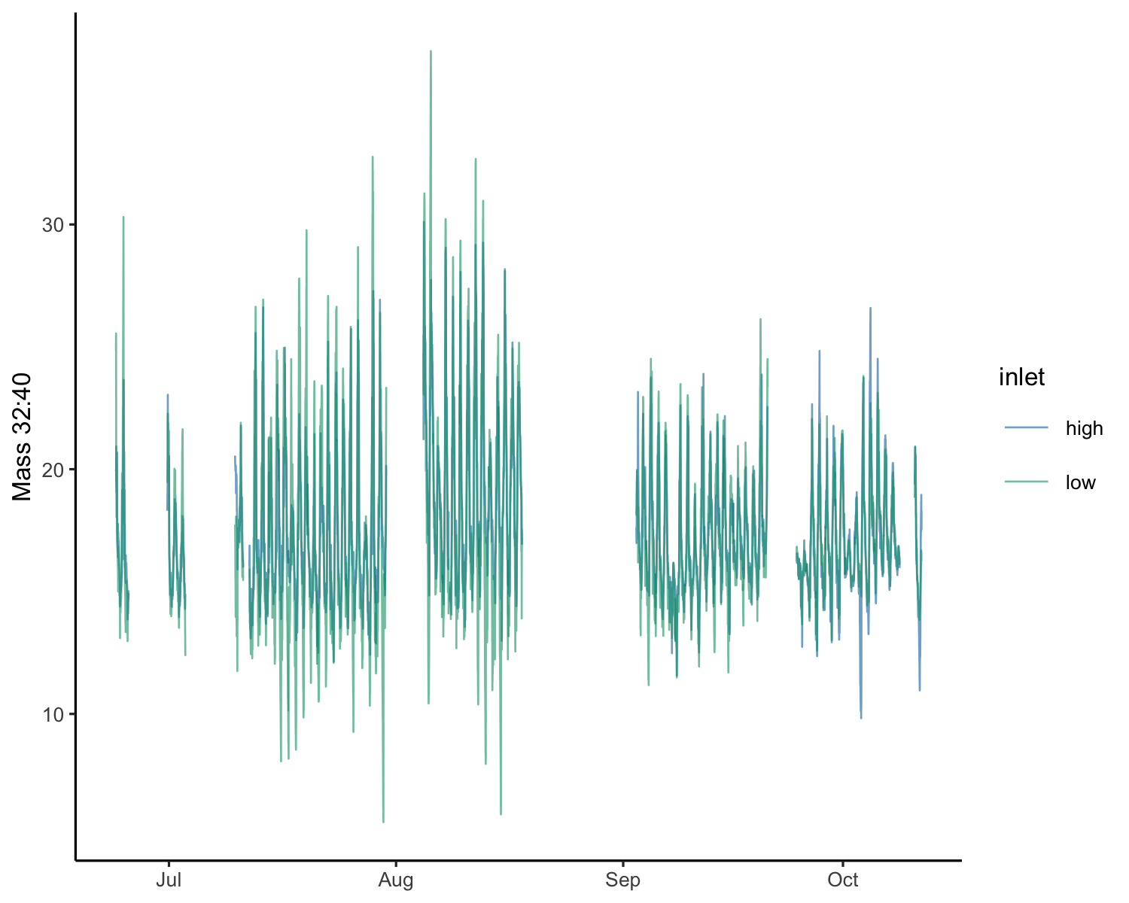
Figure 4: A record of the argon-normalized oxygen signal for the duration of the deployment. Maintenance periods and times when the data were known to be poor due to system issues have been removed.
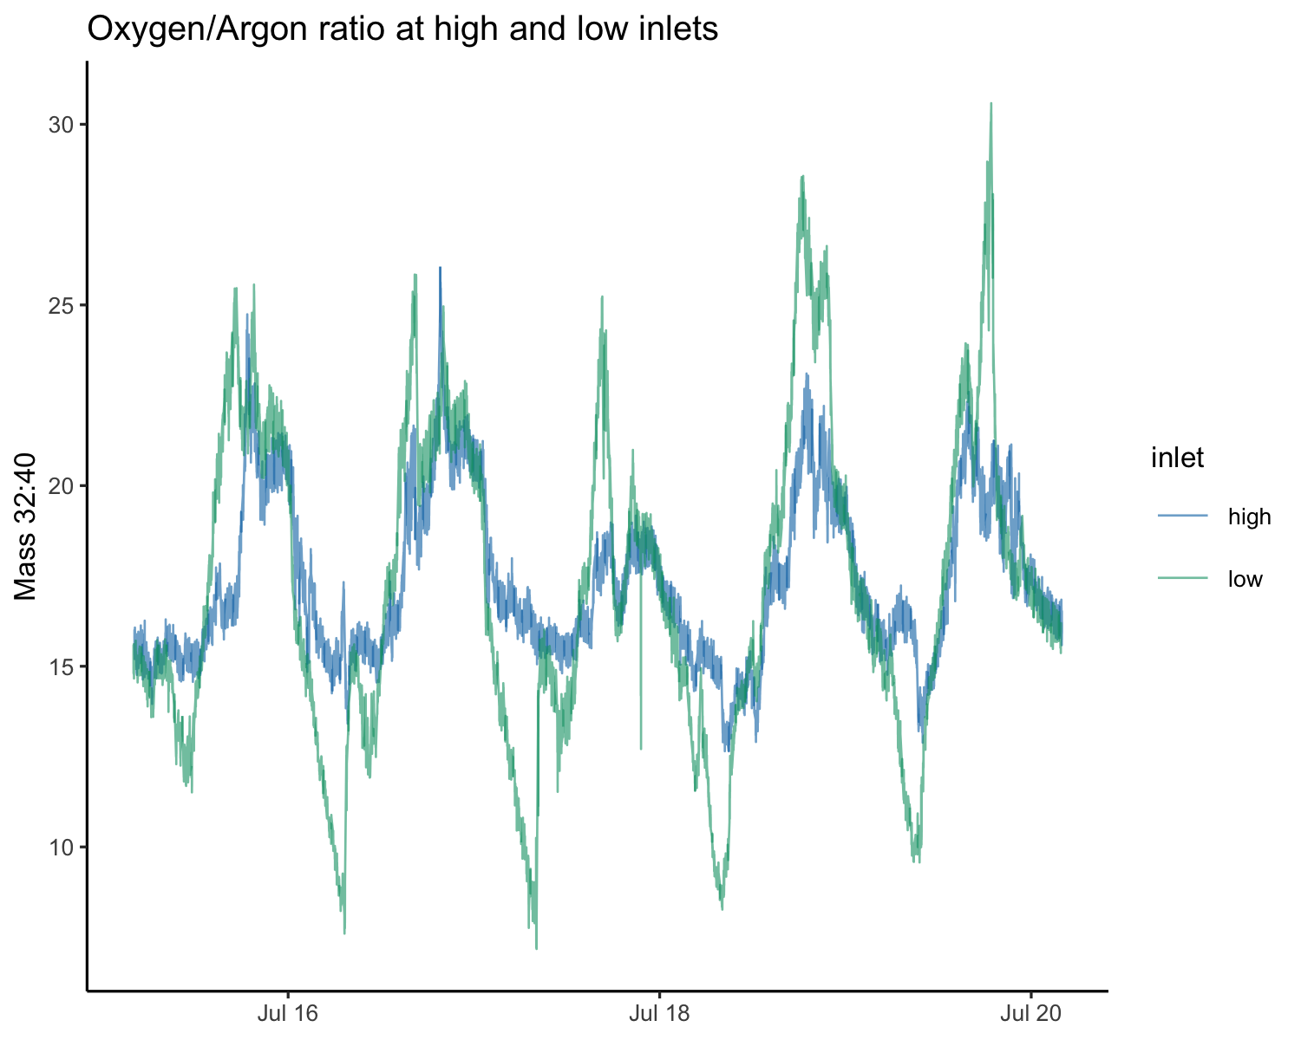
Figure 5: The argon-normalized oxygen signal for July 16-20, showing a clear gradient between the high and low inlets. The diel variability of oxygen at the low inlet is higher due to proximity to the eelgrass and seabed.

Calibration

Optode vs normalized mass 32
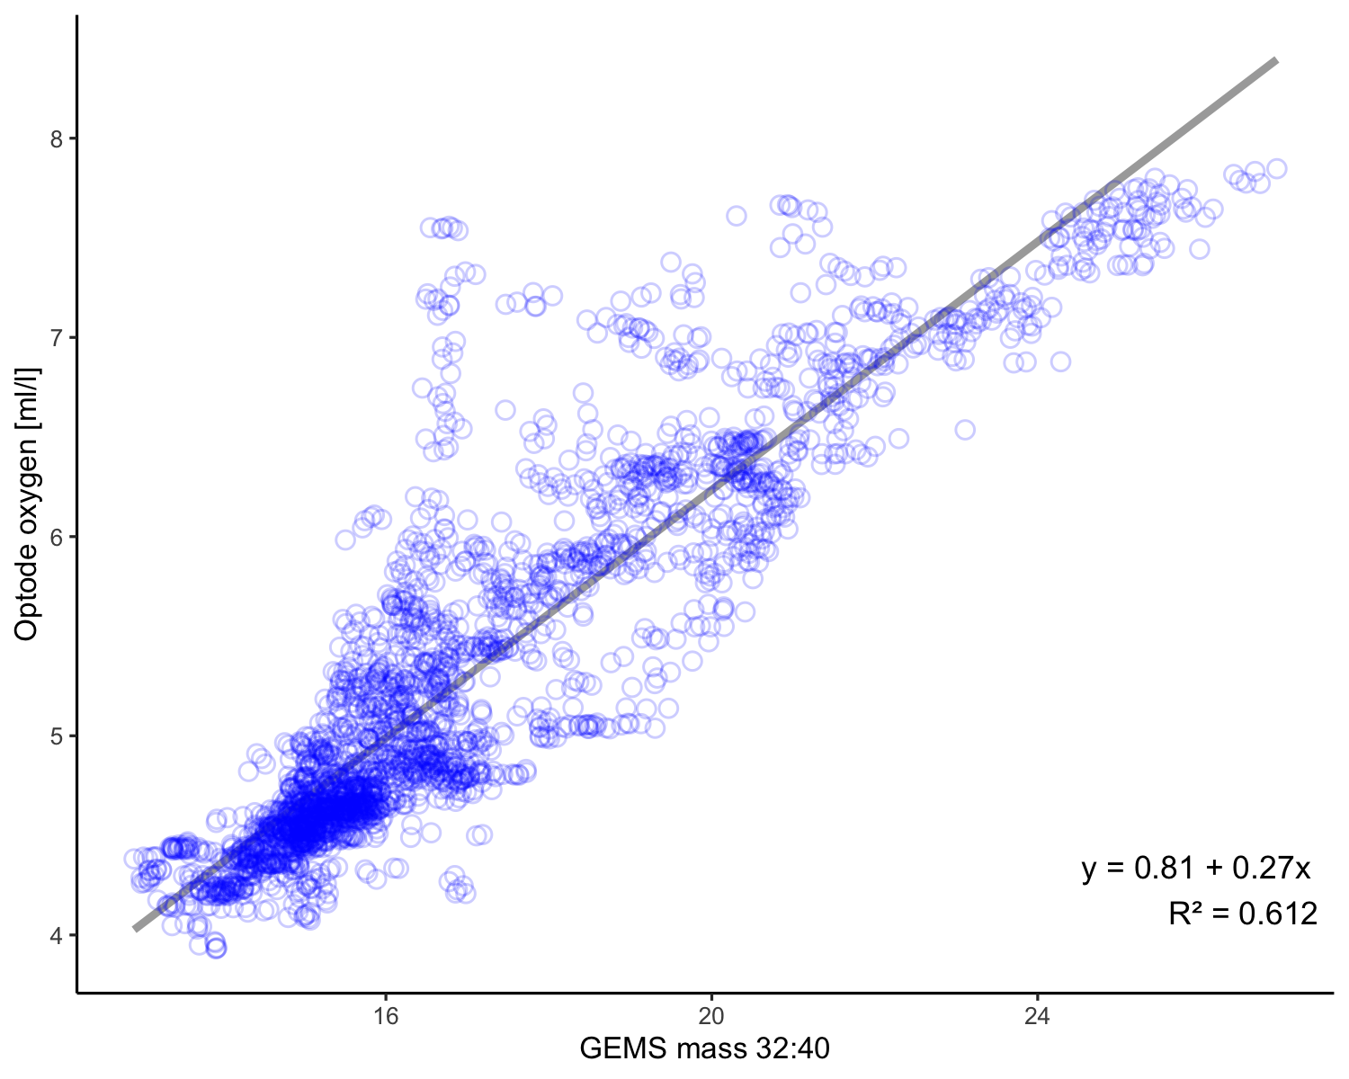
Figure 6: Oxygen calibration data for the SeapHOx codeployment. SeapHOx optode data is compared to GEMS mass 32:40. The line shows linear model fit.

Fitted Oxygen
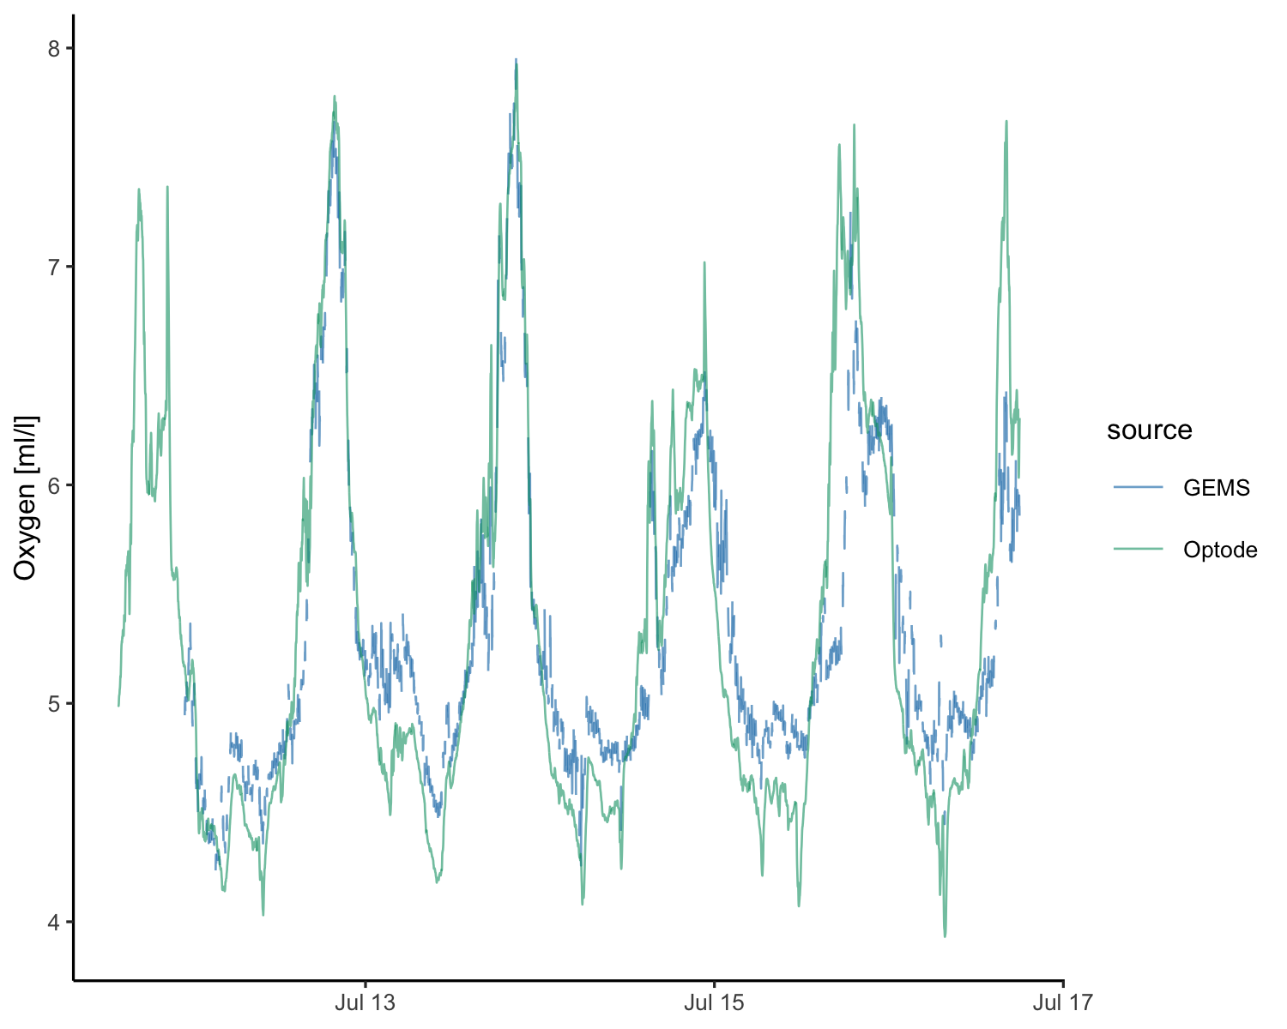
Figure 7: SeapHOx optode (green) and fitted GEMS oxygen (blue) over the codeployment time period. Fitted RGA Oxygen data shows a reasonable match to the SeapHOx optode data for the codeployment period. The peak attenuation in the GEMS signal is likely due to the intermittent signal from inlet switching.

Flux
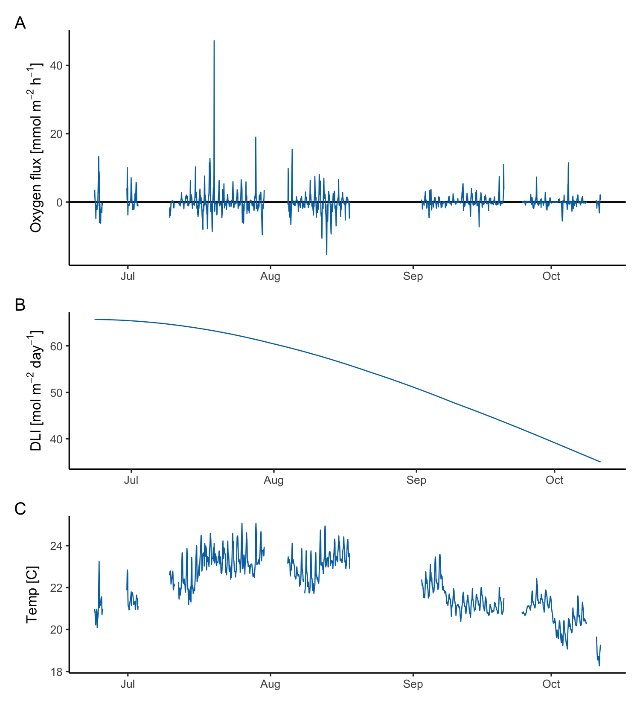
Figure 8: Hourly oxygen flux (A) for the duration of the deployment. estimated daily light integral (DLI, B) and seawater temperature at mid height (C) for comparison. Flux decreases with decreasing light and temperature. No light sensor was codeployed with GEMS, therefore photosynthetically active radiation (PAR) and DLI are estimated from modeled, cloud-free insolation.

Representative daily flux
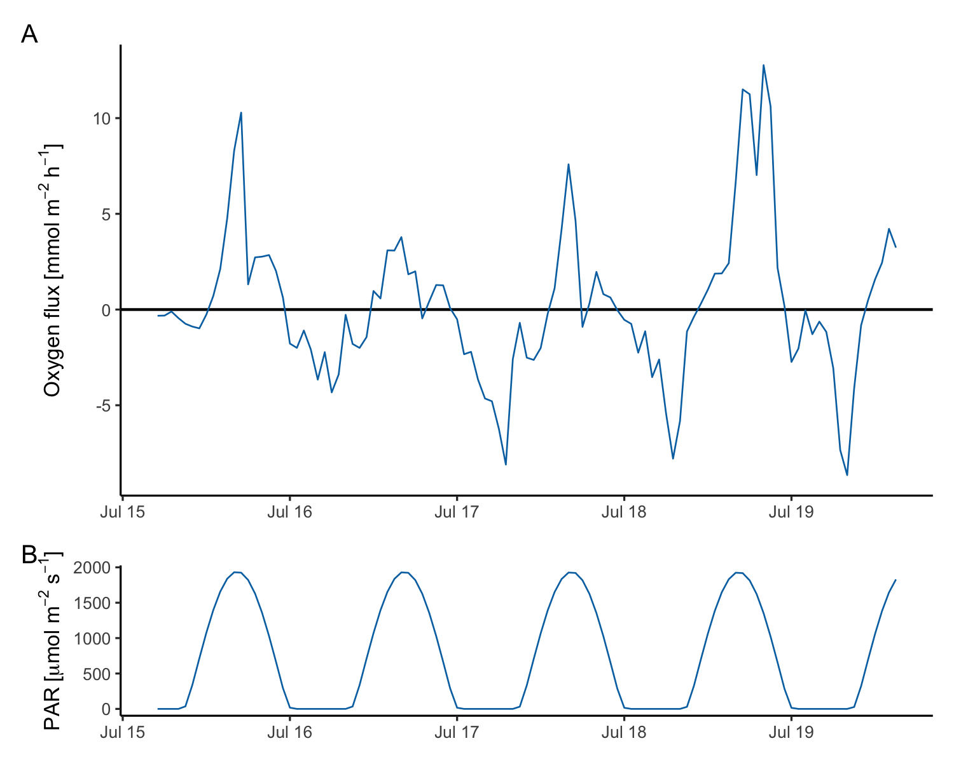
Figure 9: Oxygen flux (A) with predicted PAR (B) for comparison for the period July 15-20. Upward flux aligns with peak daily light. Respiration flux increases through the dark hours. Fluxes have strong daily variability.

Diel Plots

Concentration and gradient
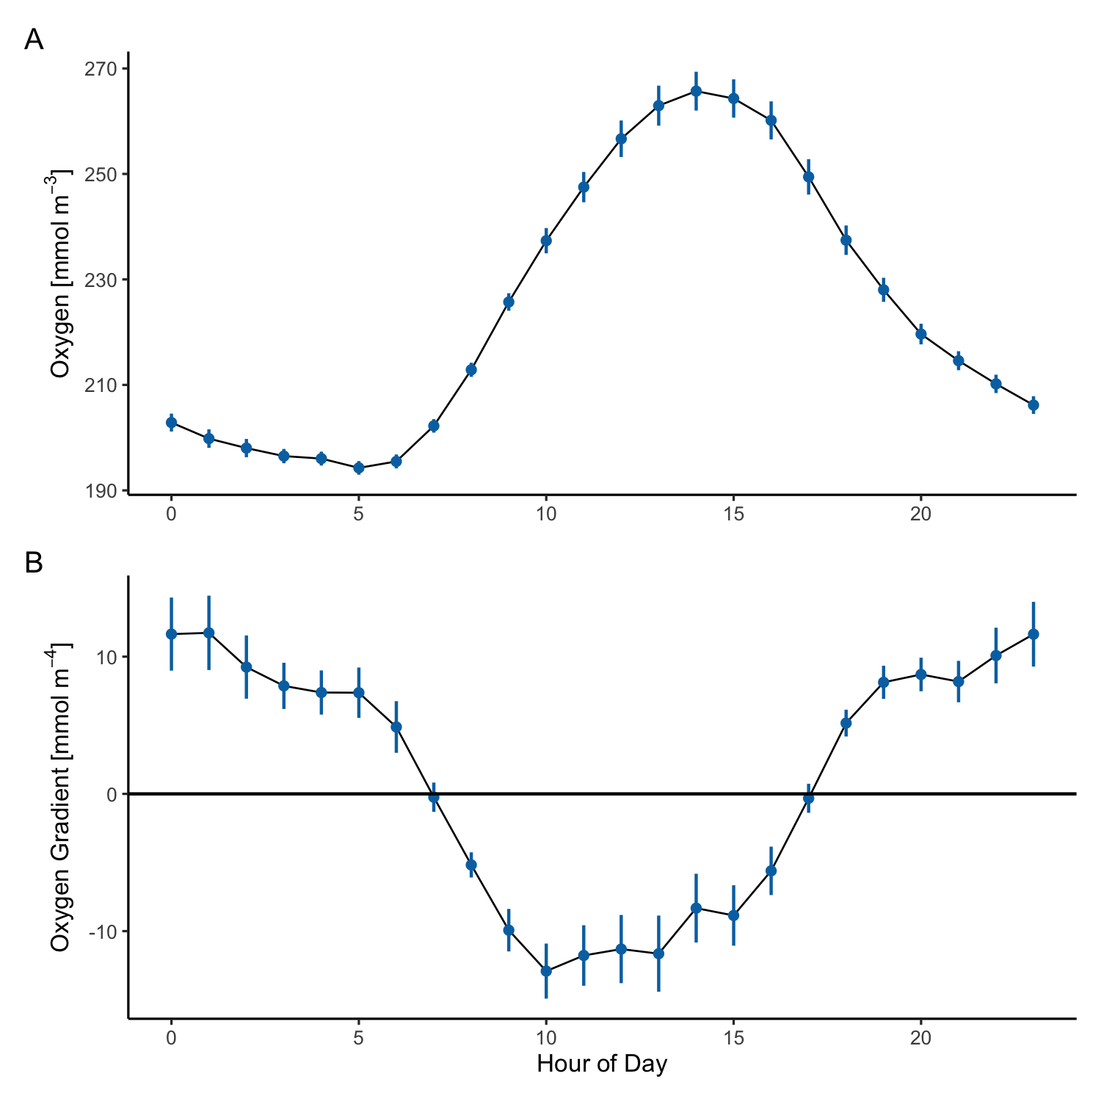
Figure 10: GEMS oxygen concentration (A) and gradient (B) aggregated across the deployment by hour of day. Hour is adjusted to the mean solar noon for the deployment. Oxygen concentration is the mean across both inlets. Gradient is estimated using the difference between high and low inlets over the difference in inlet height.

Oxygen flux and predicted par
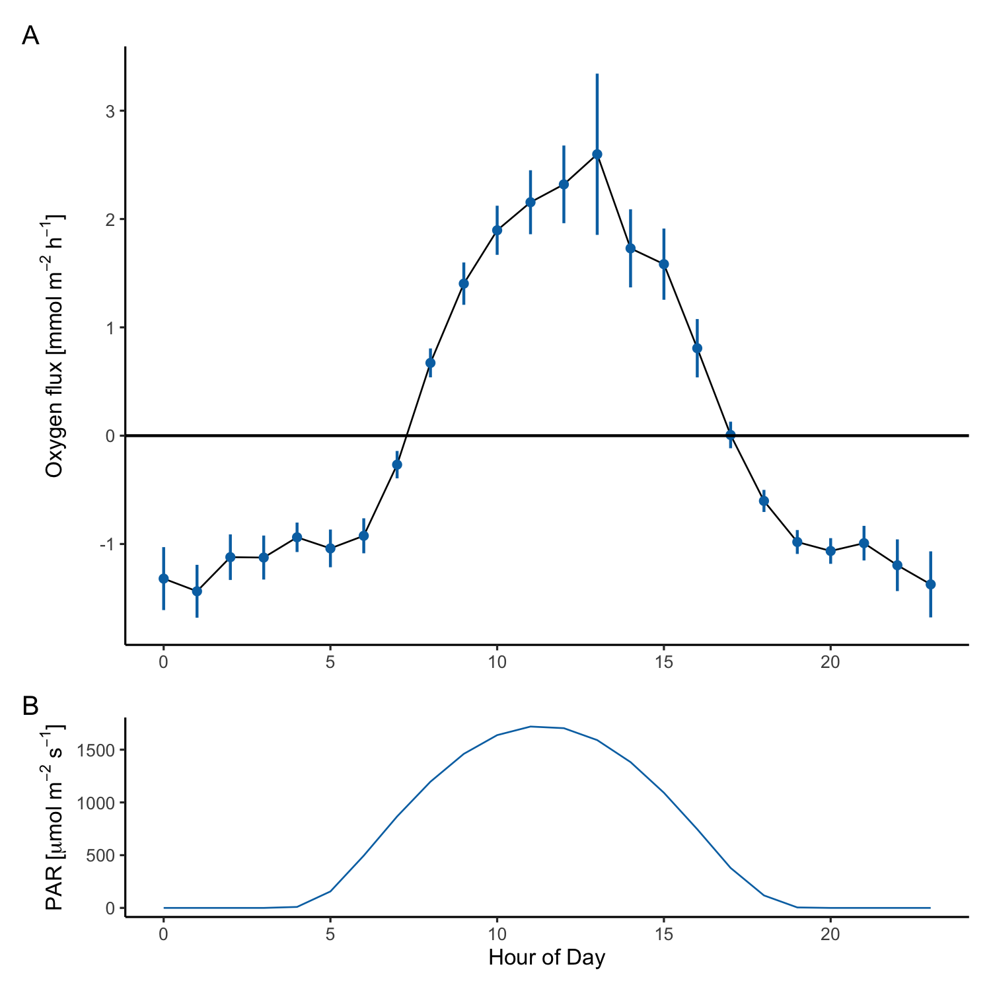
Figure 11: GEMS oxygen flux (A) and predicted PAR (B) aggregated hourly for the duration of the deployment. Hour is adjusted to the mean solar noon for the deployment.

Monthly variability
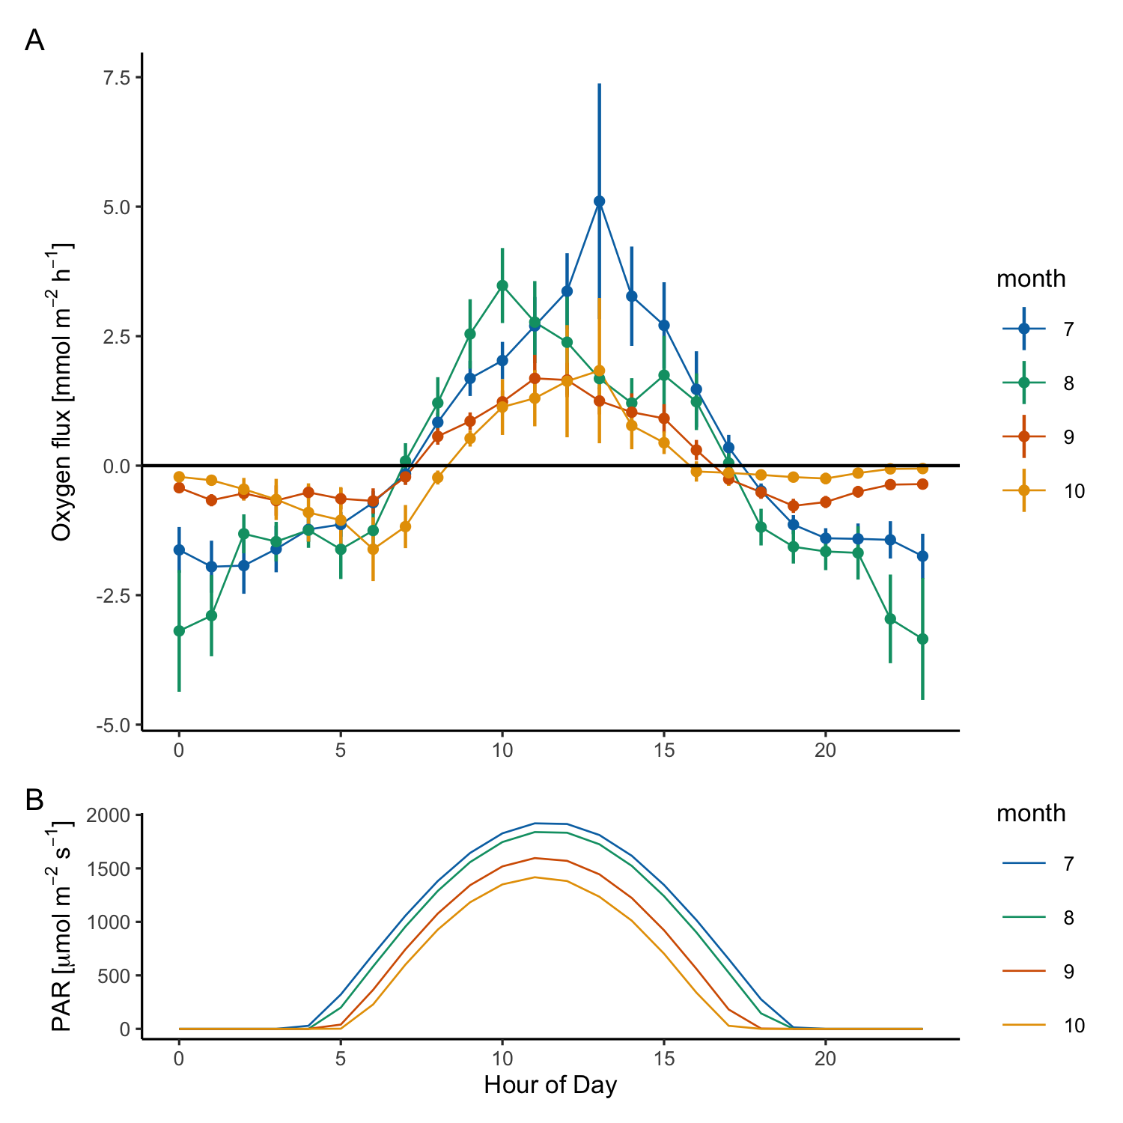
Figure 12: GEMS oxygen flux (A) and predicted PAR (B) aggregated hourly and separated by month. Hour is adjusted to the mean solar noon for the deployment. June data is not shown due to bias from only 3 days of data acquisition.

Net ecosystem metabolism
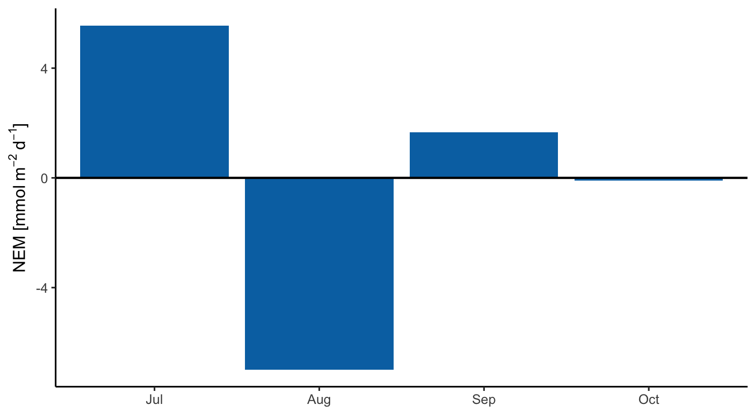
Figure 13: Oxygen flux integrated by month for the deployment period to provide an estimate of net ecosystem metabolism (NEM). The benthic system at Naushon Island is close to net neutral over time.
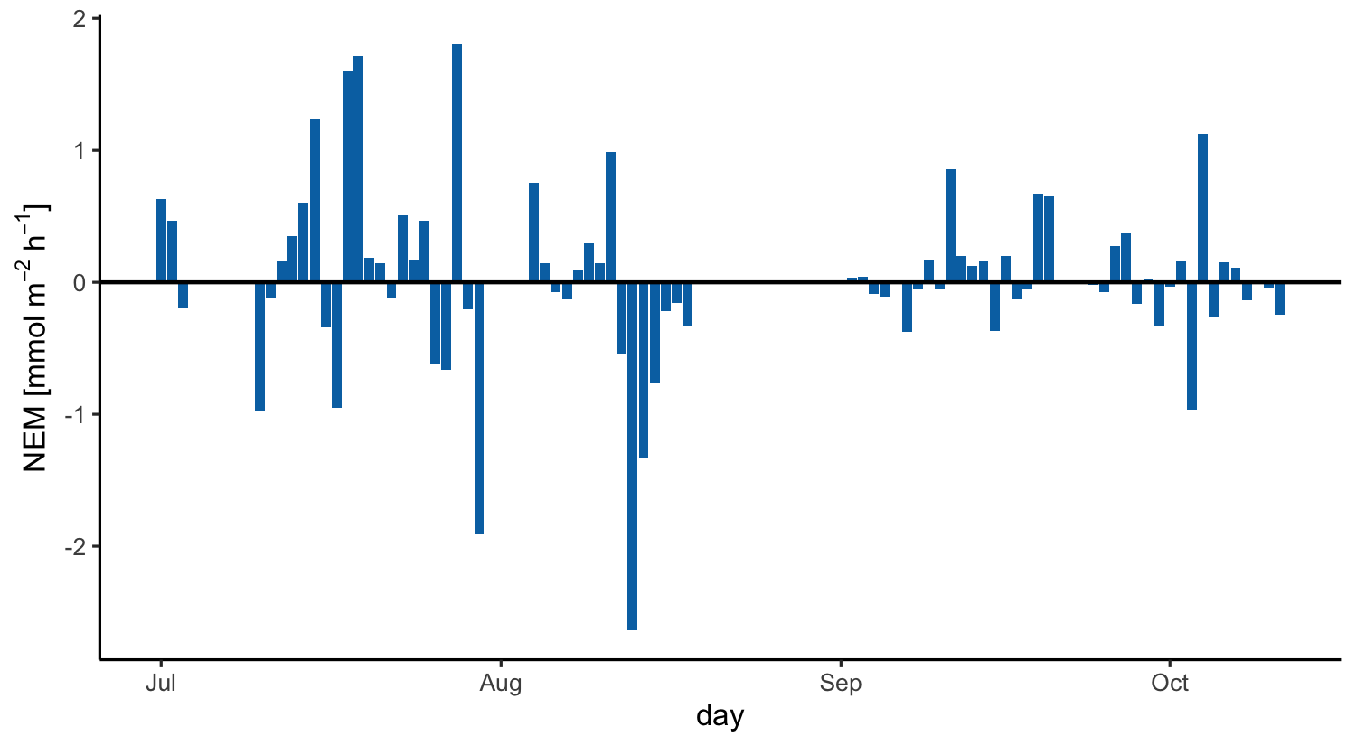
Figure 14: Daily-integrated NEM for the deployment period. Daily NEM is variable, but is close to net-neutral over time.

Eelgrass growth
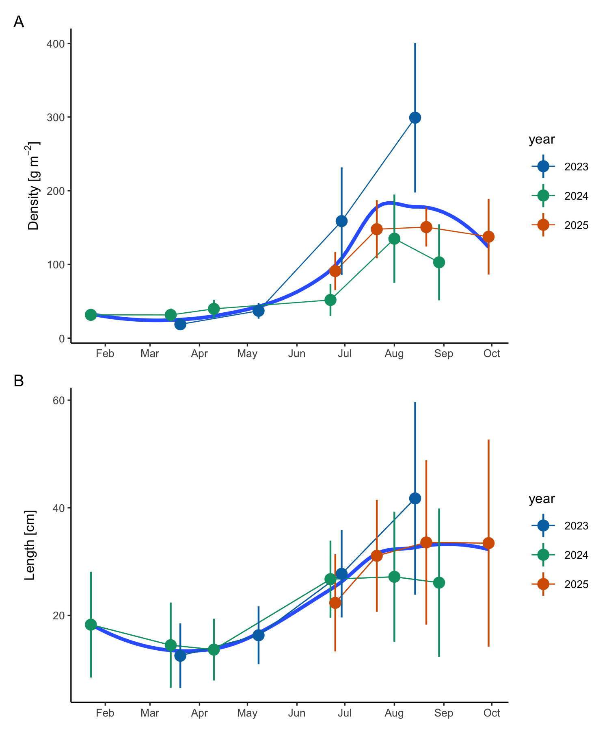
Figure 15: Naushon eelgrass shoot biomass (A) and shoot length (B) data by year. Eelgrass was sampled from 3-5 20 cm² quadrats. Point error bars are the standard deviation of quadrats for mass and count and the standard deviation of all blade lengths for length. The fit line is a loess fit through all data.

