**Final report**

Name: Jia Yi He

Cunyfirst ID: 12152706

Phone: 646 255 3397

Course number: CISC 4900

Semester: Spring 2015

Relationship with Supervisor: None

Address: 1561 Bayridge Ave

Brooklyn, NY 11219

______________________________________________________________________

Name: De Ye Chen

Cunyfirst ID: 15066945

Phone: 917 975 3703

Course: CISC 4900

Semester: Spring 2015

Relationship with Supervisor: Former student of the course: CISC 3630

Address: 405 60th Street Apt 2R

Brooklyn, NY 11220

____________________________________________________________________

**Supervisor: Lawrence Goetz**

Office Phone: 718-951-5000 Extension 2050

Office: 2112 Ingersoll

_____________________________ _________________

Lawrence Goetz Date

Current Progress:

Educational Math App

**Introduction:** The purpose to create this App is that we want to teach and improve the basic calculation skill of children. To summary this App, we can say dragging the operator to create a correct equation.

**Problem or existing system**: The problem is that Brooklyn college student had never learned about how to write an App. Even the project itself is written by java. However, lots of functions in the project would not be tough in our classes. We have to explore the Android Studio by ourselves.

**Solution:** The solution is appearance. Try our best to learn a new language. Since Android Studio is begun to develop in only few years, little information and be found on the Internet. The most useful tutorial which I found is on the YouTube. We spend time to watch YouTube tutorial every week. Also we read some useful functions of Android SDK. For example, the button function, ontouch function, on drag function. The difficulty is not only about the code, it is also about how to design the layout. Using android studio to drag a button can’t get the exactly location you want to. They location, size might be different to what we want. To get the correct location and size of buttons and Textview, we have to handle .xml file. In one work, the two most challenge part in this project are to learn functions in Android SDK and handle the .mxl file.

**Actually performed:** The actually program is similar to our goal. However, we remove some of function in this App. In the proposal, we plan to add multiplication and division in this App. But it is too complex to the player, so we remove it. The original of the time calculate is that we want the player can answer as many as question in sixty seconds. Now, we shorten the timer and modify it base on the difficulty of modes. Once player enters the correct answer, the timer will refresh. Also, we also set the health point for each mode. If the health is zero, the game would be over.

**Detail of the project:**  There are ten classes in this project. DragListener, TouchListener, Variable, NumberRandomGen, EasyMode, MediumMode, HardMode, NormalMode, MemoryMode and Mainactivity. The basic structure of those classes will display below. MainActiveity is the main menu of the project, there is two button on it: Normal and Memory. Each button will tell the player what mode the will select. In the Nomal mode, there are three buttons, they are Easy, Normal, and Hard.

Main Menu: Easy mode:

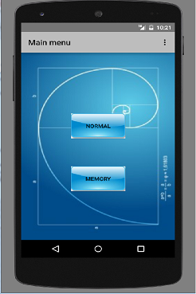 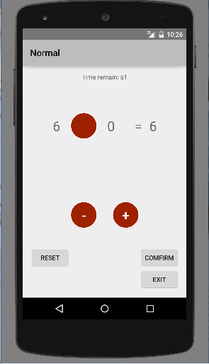

Memorymode

NormalMode

MainActiveity

Varible

DragLis

TouchLis

NumGen

HardModeee

Normal

EasyMode