🦈 Read me.SharkAttack

FinGuard Prosthetics Initiative: Rescue & Rehab
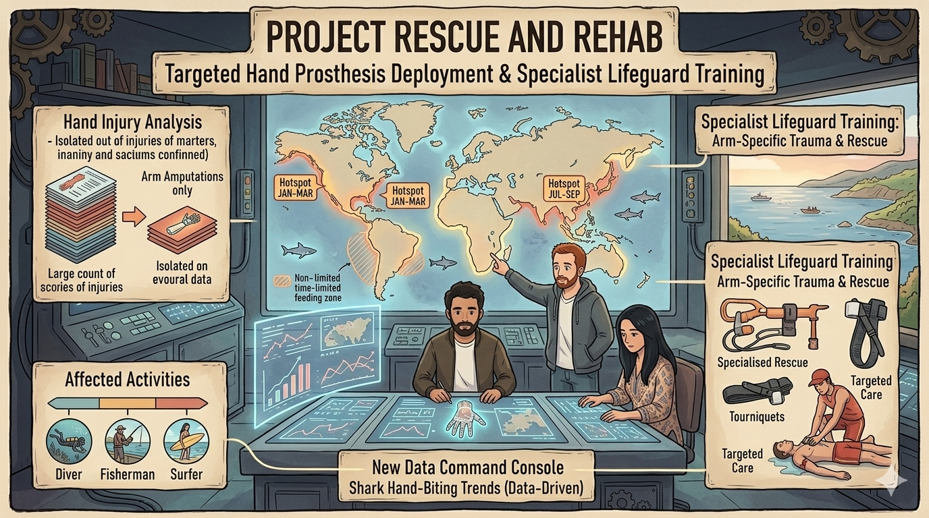

Project name
FinGuard Prosthetics Initiative — Rescue & Rehab

Overview
We assist an inventor of hand prostheses to propose and privately sell prosthetic devices directly at incident locations, while partnering with specially trained lifeguards who provide immediate rescue and medical aid. Using shark-incident data (arm amputations only — complete removals), we identify geographic hotspots and seasonality to guide agent placement, lifeguard staffing, and required rescue equipment.

Data
Source: The International Shark Attack File (incident log)
Link (source used in analysis): https://www.sharkattackfile.net/incidentlog.htm
Notebook: project_SHARKS.ipynb (Google Colab)
Note: This README focuses on incidents classified as "arm amputations (removed)" — injuries where the arm (hand/forearm) was removed, excluding injuries listed as “damaged” only.

