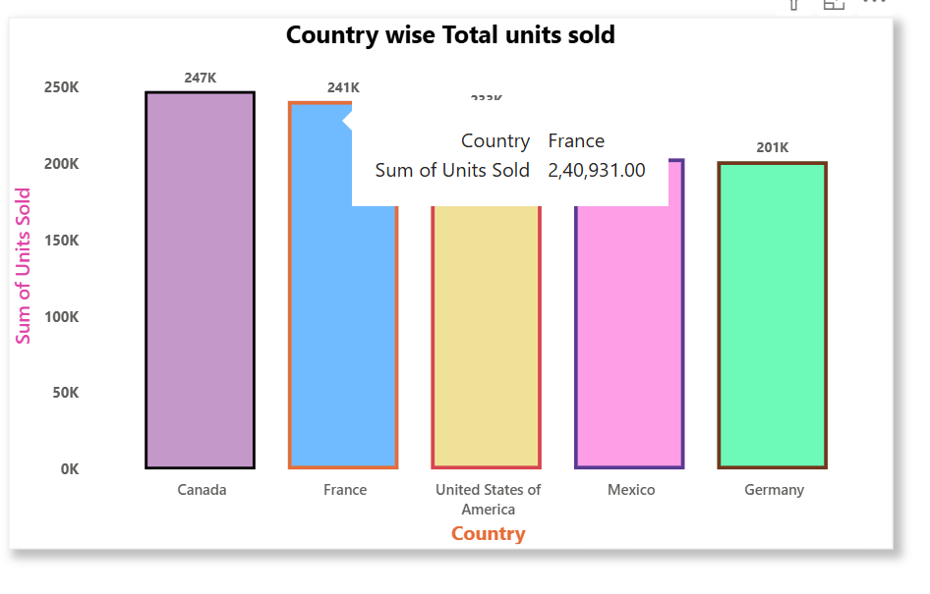**Country wise Total units sold -**

**CT :** Stacked Column chart

**X-Axis :** Country

**Y-Axis :** Sum of Units sold

**Insights :** It shows that Canada as the leading contributor with approximately 250K units sold, and the lower was Germany with 200K units sold.

Coming to regional perspective, North American countries (Canada, USA, Mexico) has the highest share, and strong market demand . On other side, European countries(France, Germany) shows the mixed performance – France aligns closely with North America , while Germany lags behind.

I selected this chart then went to format you visuals for formatting.  
 1) First it is on X-axis in values option we changed the size , font and make bold of x -axis values (Canada to Germany) and X-axis title (Country)

2) Now it is on Y-axis in values option we changed the size , font and make bold of Y -axis values(0K to 250K) and Y-axis title(sum of units Sold).

3) Then I choose columns option for customized each column colour change, I did colour change and border for that then I given Data labels also (it shows exact value on the top of that bar).

4) Then the main title and the shadow part.

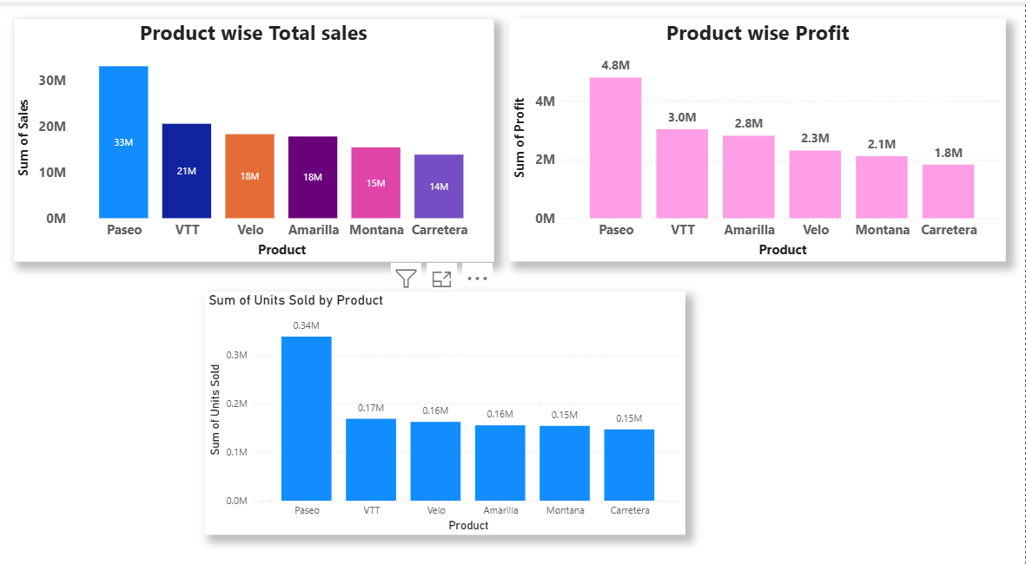

Now we can also give different colours directly by clicking the legends option which is present in the visuals of format visual.

And we can also enable or disable that legends part.

Then I created product wise total sales and product wise profit and product wise unit sold.

**INSIGHTS -**Products like VTT and Amarilla are **high-margin products** with better profitability efficiency, even though their sales volume is moderate. These should be prioritized in sales strategies focused on maximizing profit rather than volume.

Sold =! Sales =! Profit => Sales is not equal to profit as well as sold For ex – ( Android phones has more sales compare to iPhone but the Iphone has more profit.

See we have one numerical value and one categorical value then either we choose stacked column chart or stacked bar chart

Now suppose we have two numerical value and one categorical value now which chart will use stacked column chart or stacked bar chat, clustered column chart or clustered bar chat , 100% stacked chart or 100% stacked bar chart. So know the difference I created like this by considering sales, profit and product.

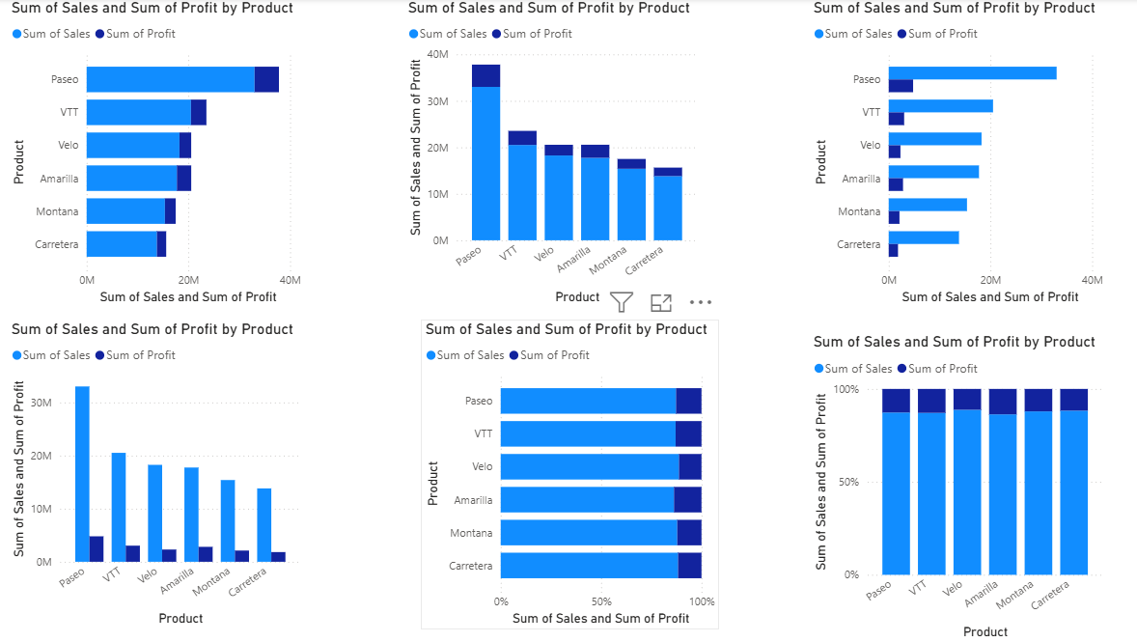By analysing I got to know that clustered column chart is good because it making easy to compare both within the same category. It clearly show the difference and avoids confusion compare to other.