Sum of Profit by Product and Discount Band

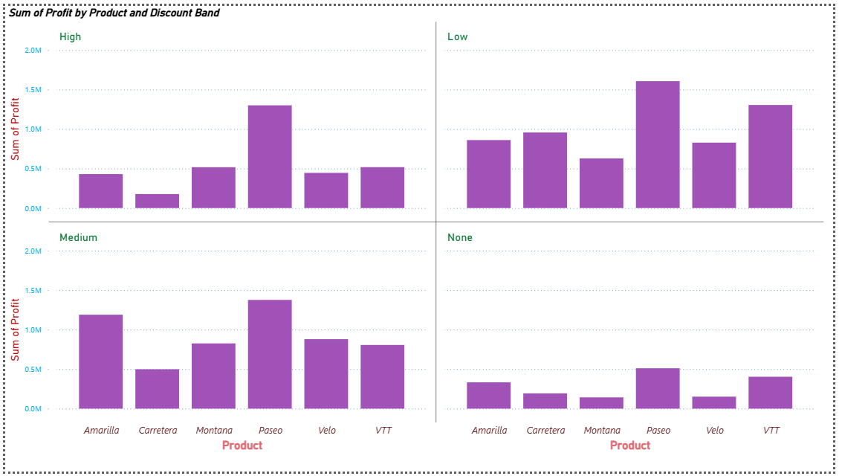

**Small Multiple**:

**CT :** Stacked Column chart

**X-Axis :** Product

**Y-Axis :** Sum of profit

**Insights :**

>.High Discount: Paseo has the highest profit, while Carretera is the weakest.

>.Low Discount: Paseo again leads, followed by VTT; Carretera improves slightly.

>.Medium Discount: Paseo is on top, and Amarilla shows good profit growth; Carretera remains low.

>.No Discount: Profits are very small for all products, though Paseo is still the best.

**Sum of Profit and Sum of Sales by Product**

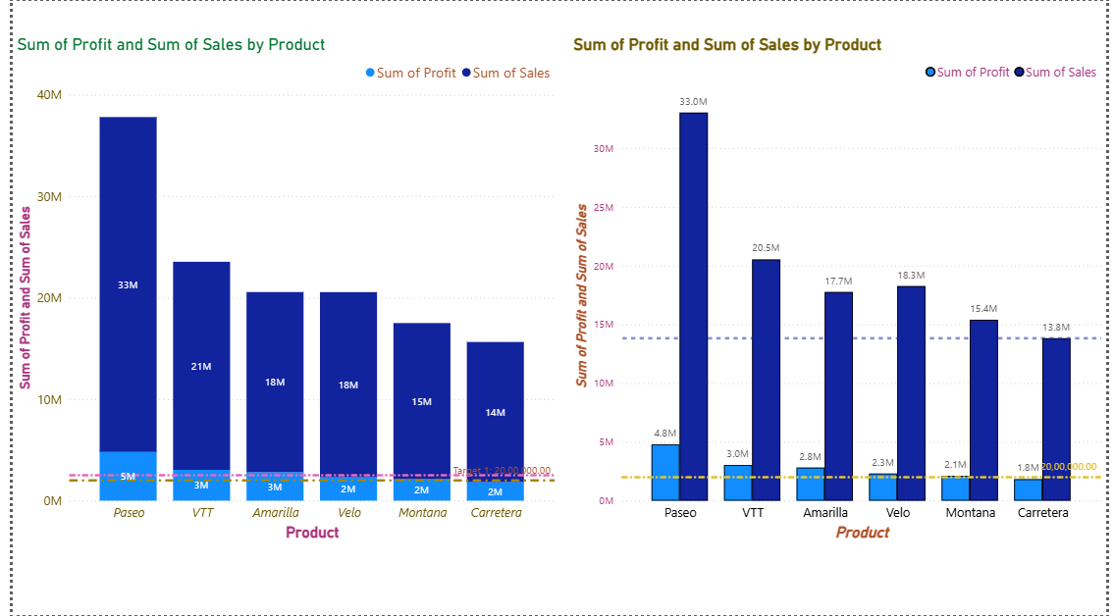

**Target :**

**CT :** Stacked Column chart

**X-Axis :** Product

**Y-Axis :** Sum of profit

**Insights :**

>.Both charts show Sum of Sales (dark blue) and Sum of Profit (light blue) for each product.

>.Paseo is the clear leader with the highest sales (33M) and profit (5M).

> VTT, Amarilla, and Velo form the middle tier, with sales around 18M – 21M and profits between 2.3M – 3M.

>.Montana and Carretera are the lowest performers, with sales below 16M and profits near 2M or less.

>.Profit values are much smaller compared to sales, but Paseo still stands out as the strongest in both metrics.