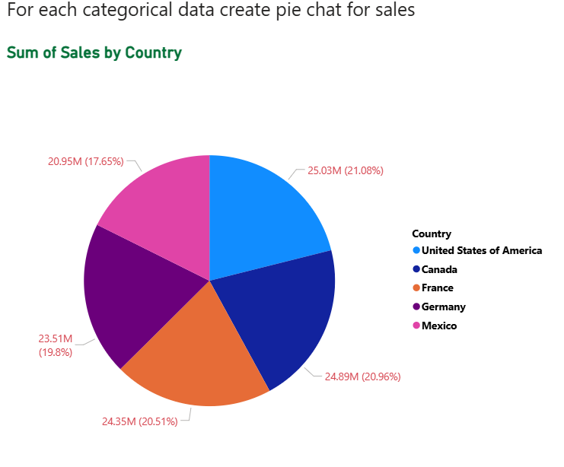

**Sum of Sales by Country**

**CT : Pie chart**

**Insights :**

>United States of America contributes the highest sales with 25.03M (21.08%).

> Canada is very close behind with 24.89M (20.96%), almost equal to the U.S.

>France also performs strongly with 24.35M (20.51%), slightly lower but still competitive.

>Germany records 23.51M (19.8%), a bit lower than France.

>Mexico shows the lowest contribution, with 20.95M (17.65%).

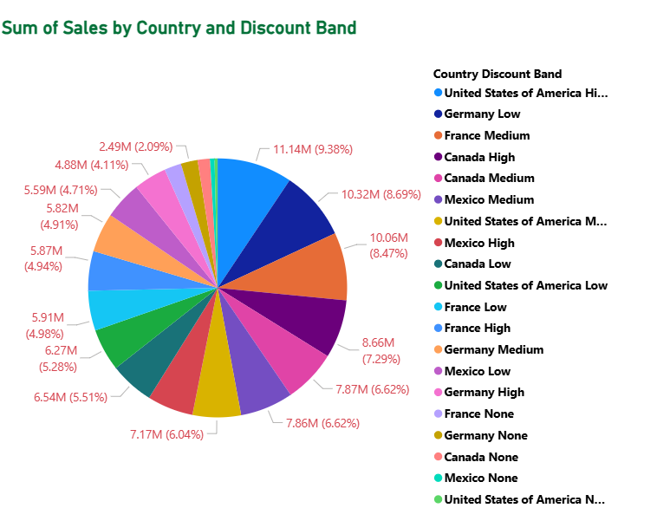

**Sum of Sales by Country and Discount Band**

**CT : Pie chart**

**Insights :**

* Sales are heavily influenced by discounts, with High and Medium bands contributing the most across countries.
* The United States is the largest single contributor, especially under the High discount band.
* Germany and France also make up large portions, primarily through Low and Medium discounts respectively.
* Countries with “None” discount bands contribute the least, showing that discounts drive higher sales.

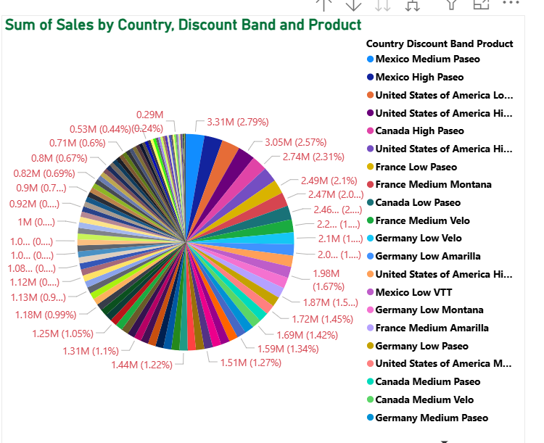

**Sum of Sales by Country ,Discount Band and Product**

**CT : Pie chart**

**Insights :**

Paseo is the star product, leading sales across multiple countries (especially Mexico and the USA).

Discounts (Medium & High) are the biggest sales drivers, with Mexico being the top contributor.

USA contributes steadily across multiple products (Paseo, Velo) with both high and low discounts.

Canada and Germany follow, with strong but slightly smaller contributions.

France contributes mainly through Medium bands for Velo and Montana.

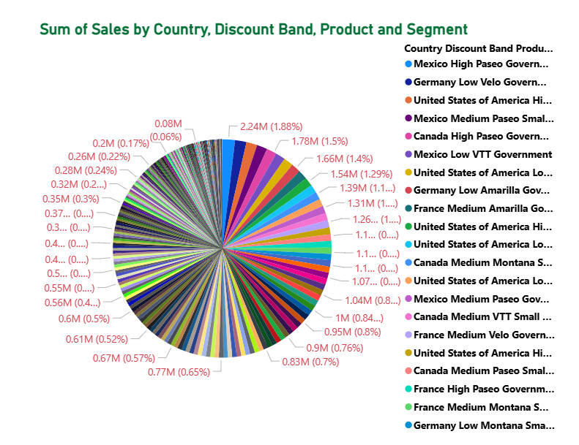

**Sum of Sales by Country ,Discount Band ,Product and Segment**

**CT : Pie chart**

**Insights :**

Sales are highly fragmented, spread across many country-discount-product-segment combinations.

Mexico leads overall, especially in High and Medium discounts for Government and Small Business customers (Paseo & VTT products).

USA and Germany are also strong players, with USA leaning towards High discounts and Germany towards Low discounts.

Canada and France contribute moderately, focusing on Government and Small Business segments.

Government customers + discounts (High/Medium) are the biggest sales drivers across all countries.