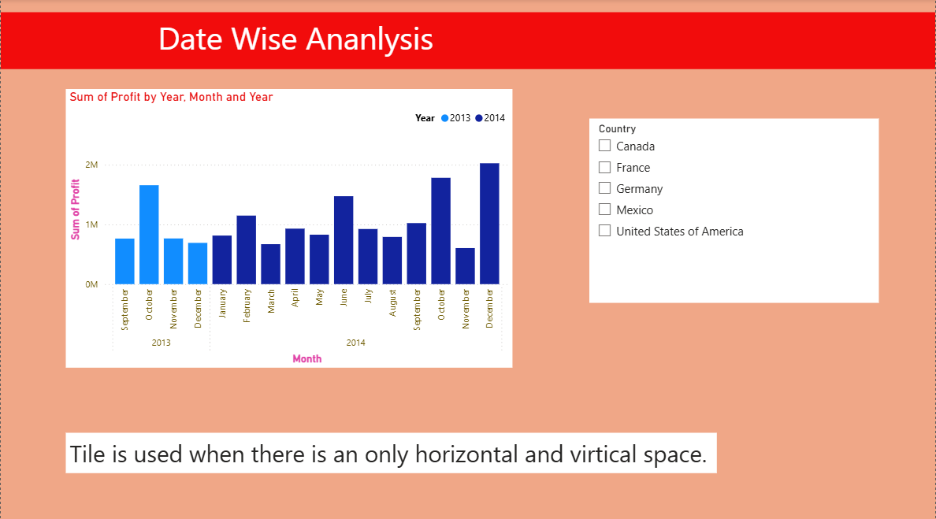

**Date wise Ananlysis**

**CT :** Stacked Column chart

**X-Axis :** Sum of Profit

**Y-Axis :** Month

**Insights :** Years Compared → Data is shown for 2013 (light blue) and 2014 (dark blue).

>2014 shows higher profits than 2013, with steady growth across most months.

>December 2014 recorded the highest profit, followed by strong gains in October.

>End-of-year months (Oct–Dec) consistently perform better, suggesting seasonal profit peaks.

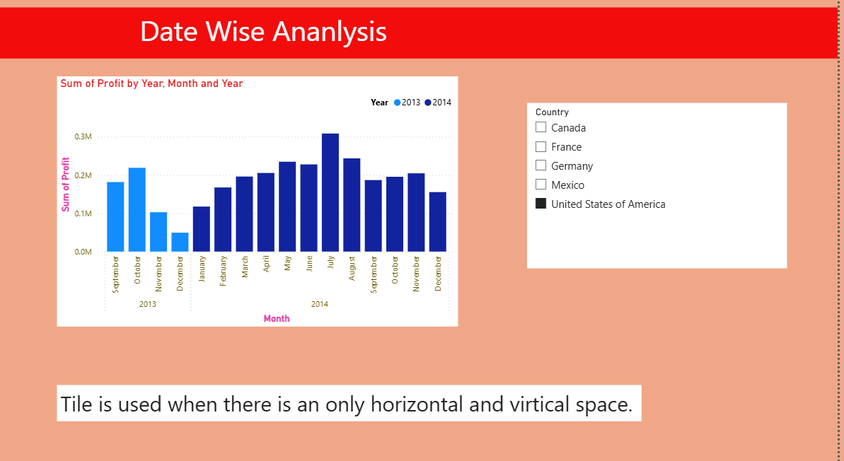

**Ananlysis on United States of America**

**Insights :**

>2014 outperformed 2013 with higher and more stable profits.

>June 2014 recorded the highest profit overall, showing a strong mid-year peak.

>December remained the weakest month in both years, indicating a consistent low-performance period.