Logo of Universität Hamburg.

Universität Hamburg. Der Forschung. Der Lehre. Der Bildung

Logo of Faculty of Mathematics, Informatics and Natural Sciences

Name: Mitulbhai Nandlal Akbari

Homework problem set: 1(week 23 Oct - 29 Oct)

Eulers method to solve first order differential equation.

* Solving time dependent Schrödinger equation i dψ(t)/dt =Hψ(t). for the initial value of the ψ=1, wavefunction energy E0=1.

#### wavefunction evolution

* Energy of a system is in the units of eV
* Total time of iteration is 30 femto seconds.
* Two initialize variables are chosen as…
  + t = 0.0 {in the unit of fs}
  + psi = 1+0j {just a complex number}

* This graph shows the time evolution of our wavefunction computed with time steps ∆t(dt)=0.001(fs), E0=1eV, initial psi= 1+0i.
* Here we started with 1 eV energy and step size is small enough, so that’s why we can’t see how Eulers method loses orthonormality.

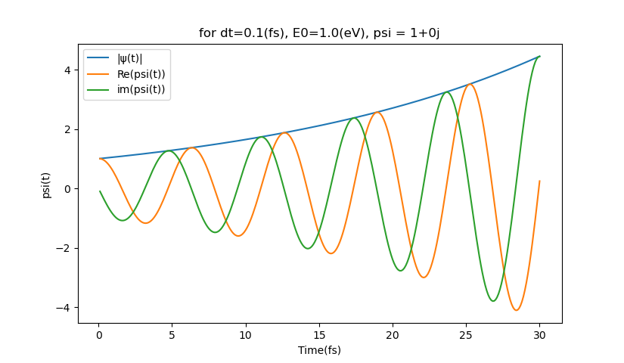

* In above graphs, the time evolution of our wavefunction is computed with two different values of ∆t(dt)=0.1(fs) and E0=1eV at initial psi= 1+0i.

* Comparing results from Euler’s method and from analytical solution we can clearly see that we lose normalization and clearly shows frequency increases as energy is also increased. Normalization is directly affected by step size if step size is larger, then normalization is lost rapidly.