Logo of Universität Hamburg.

Universität Hamburg. Der Forschung. Der Lehre. Der Bildung

Logo of Faculty of Mathematics, Informatics and Natural Sciences

Name: Mitulbhai Nandlal Akbari

Homework problem set: 2

Runge-Kutta method to solve two level system using time dependent schrödinger equation.

* Solving time dependent Schrödinger equation i dψ(t)/dt =Hψ(t). for the initial value of the wavefunction ψ = $\left[\begin{aligned}1 \\ 0\end{aligned}\right]$, and Hamiltonian is given by H = $\left[\begin{matrix}E_{1} & V \\ V & E_{2}\end{matrix}\right]$.

#### wavefunction evolution

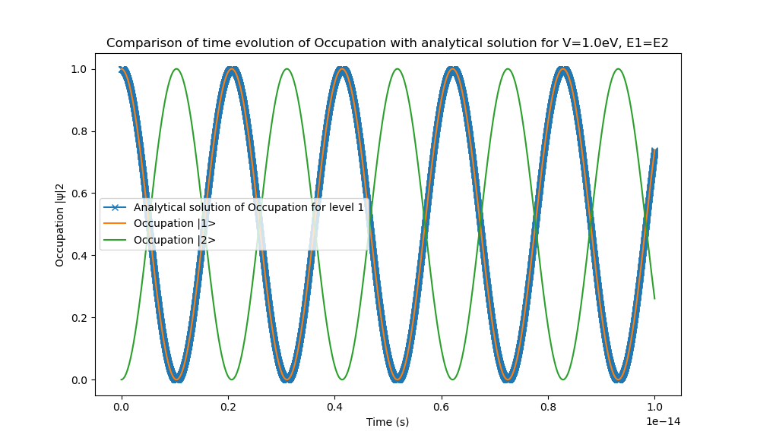

* Above figure shows that computed occupancies for both levels by runge kutta method for ∣E1-E2∣=0 agrees with that of analytical one.

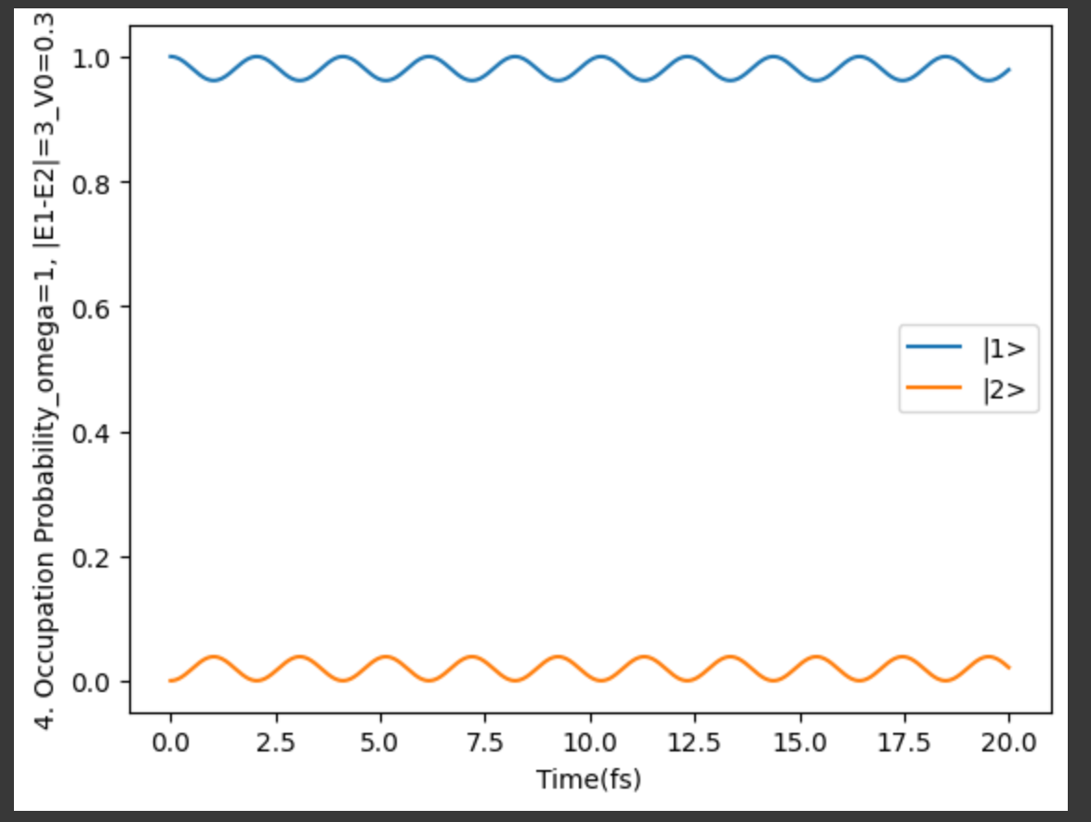

* Above figure shows that computed occupancies at E1= 0 eV, E2= 3eV, V = 0.3eV for both levels by Runge Kutta method for ∣E1-E2∣>>V.
* If we make interaction time dependent by modulating potential (which drives the interaction in this case) with V = V0Cos(wt). Below figure suggests that the occupation will be modulated at angular frequency w.

