We can see many projects in C:\jazzy\build

We should build the necessary projects here manually.

1. image_tools

Please open this cmd file and change the Python path correctly.

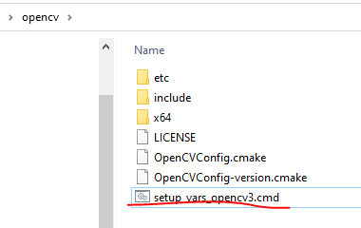

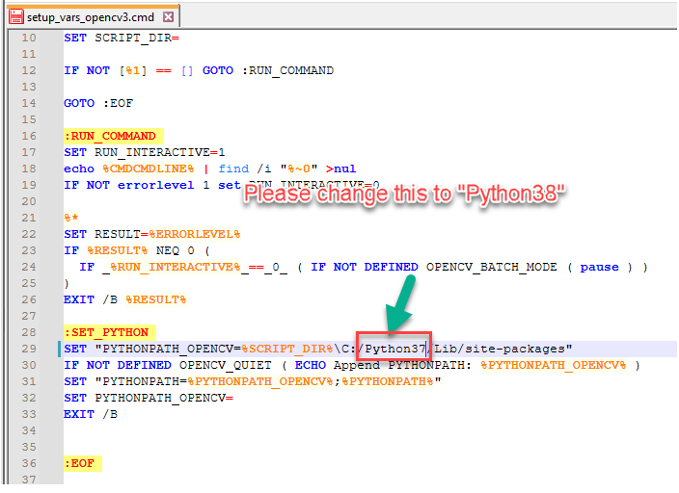

>CMake Error at CMakeLists.txt:16 (find_package):

1> By not providing "Findexample_interfaces.cmake" in CMAKE_MODULE_PATH this

1> project has asked CMake to find a package configuration file provided by

1> "example_interfaces", but CMake did not find one.

1>

1> Could not find a package configuration file provided by

1> "example_interfaces" with any of the following names:

1>

1> example_interfacesConfig.cmake

1> example_interfaces-config.cmake

1>

1> Add the installation prefix of "example_interfaces" to CMAKE_PREFIX_PATH or

1> set "example_interfaces_DIR" to a directory containing one of the above

1> files. If "example_interfaces" provides a separate development package or

1> SDK, be sure it has been installed.

demo_nodes_cpp

done

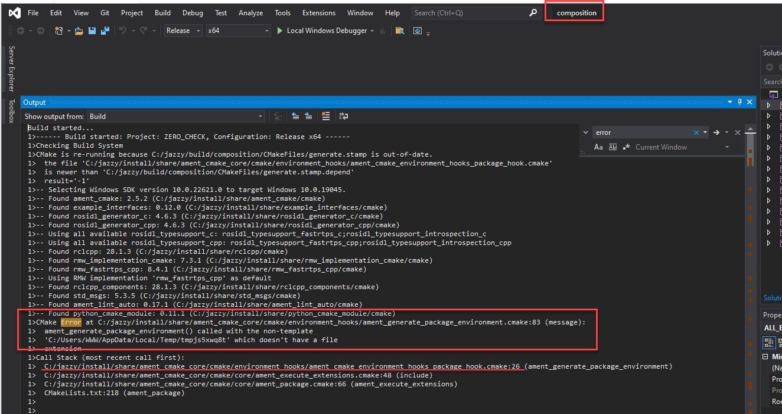

When it is ament_generate_package_environment issue, please open the last file in Call Stack.

(example: C:/jazzy/install/share/ament_cmake_core/cmake/environment_hooks/ament_cmake_environment_hoooks_package_hook.cmake)

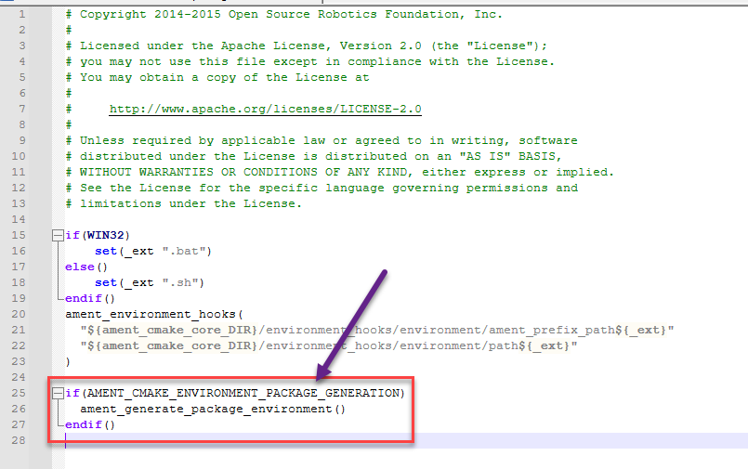

Please delete this part

1. interactive_markers

1>-- Configuring incomplete, errors occurred!

1>CMake Error at C:/jazzy/install/share/ament_cmake_core/cmake/core/assert_file_exists.cmake:20 (message):

1> ament_environment_hooks() the passed hook file

1> 'C:/Users/WWW/AppData/Local/Temp/tmp2o90wg6n' does not exist

1>Call Stack (most recent call first):

1> C:/jazzy/install/share/ament_cmake_core/cmake/environment_hooks/ament_environment_hooks.cmake:35 (assert_file_exists)

1> C:/jazzy/install/share/ament_cmake_python/cmake/ament_cmake_python-extras.cmake:36 (ament_environment_hooks)

1> C:/jazzy/install/share/ament_cmake_python/cmake/ament_python_install_package.cmake:38 (_ament_cmake_python_register_environment_hook)

1> CMakeLists.txt:25 (ament_python_install_package)

1>

1>

1>CMake Configure step failed. Build files cannot be regenerated correctly. Attempting to stop IDE build.

1>The system cannot find the batch label specified - VCEnd

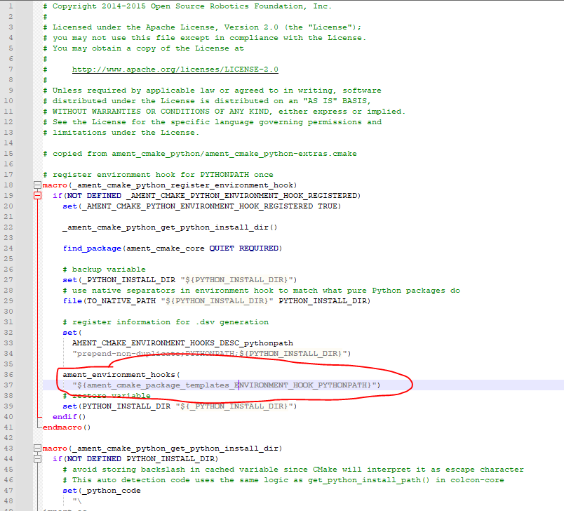

Please delete this in the ament_cmake_python-extras.cmake

We can fix the issues related to the ament package like this.