**CROTON-ON-HUDSON LAUNCHES NEW PHASE**

**OF *SLOW DOWN CROTON* SAFETY CAMPAIGN**

*Village, School District to Offer Educational Programs to Students and Employees;*

*Free Lawn Signs for Public Courtesy of Rotary Club and Croton Police Association*

**FOR IMMEDIATE RELEASE Contact:** Matthew Schuerman

(914) 398-8141 matthew.schuerman@gmail.com

**CROTON-ON-HUDSON, N.Y. –** The Village of Croton-on-Hudson launched its latest “Slow Down Croton” safety campaign on Saturday with a new batch of lawn signs and several educational events over the coming months to encourage drivers, bicyclists, and pedestrians to observe the rules of the road.

The campaign comes five years after the Village launched its first “Slow Down Croton” campaign, and as life—and traffic—begins to return to “normal” as pandemic-related restrictions have eased. In the 2019 Great Croton-on-Hudson Transportation Survey, nearly 40% of respondents said that cars generally do not drive safely in the Village and about 30% said they would walk or bike more if it were not for safety concerns.

The lawn signs, created by Croton resident and graphic designer Tom Smith, once again feature the “Slow Down Croton” slogan with the image of a snail drawn by illustrator Tim Robinson, also a Croton resident. This time, they are printed on a “Croton orange” background. Thanks to generous contributions from the Rotary Club of Croton-on-Hudson and the Croton Police Association, the signs are available for free upon request at the Croton Police Department, at the southern entrance to the Municipal Building, 1 Van Wyck St., Croton-on-Hudson.

Officials and residents kicked off the campaign with a rally in which they showed off their signs to cars driving down South Riverside Avenue at Bungalow Road--one of the most common speeding points in the Village.

“For almost 30 years, we haven’t had a single pedestrian fatality on our Village’s streets. But it only takes one bad day, one moment’s distraction to cause a tragedy,” Croton Mayor Brian Pugh said. “Thank you to our community partners--the Bicycle-Pedestrian Advisory Committee, the Croton-Harmon School District, the Rotary Club, and the Croton Police Association--for helping to remind residents and visitors to slow down and save a life.”

The Croton-Harmon Union Free School District is planning a number of related events, including a walking field trip for elementary schoolers, a bike “rodeo” for middle schoolers, and reminders on safe driving for high schoolers. In addition, the Bike-Ped Committee is collaborating with the Croton chapter of Mothers Out Front to arrange a series of “walking school bus” routes this fall to encourage elementary and middle school students to walk to and from school.

“We look forward to our continued partnership with the Village and the Croton-on-Hudson Bicycle-Pedestrian Advisory Committee,” said District Superintendent Dr. Deborah O’Connell. “Together we will continue to focus on student safety.”

The contributions from the Rotary Club and the Police Association have made it possible for the village to produce the first batch of signs at no cost to taxpayers.

"The Rotary Club of Croton-on-Hudson is proud to be a sponsor of the 'Slow Down Croton' campaign,” said Club President Seaver T. Wang. “It's an effective way to remind all of us to be more sensible and not to take unnecessary risks that could hurt ourselves or others."

"I am proud of the Croton Police Association for donating to this important cause. It shows that the men and women of this department are committed to the bicycle and pedestrian safety in the community they serve," Croton Police Chief John Nikitopoulos said. "With life moving at such a fast pace, we need to realize that if we slow down, we may get to our destination late, but for the safety of those with us and around us we will get there safely. As one of our sergeants loves to say, 'Slow and steady wins the race.'"

The Croton Bike-Ped Committee proposed reviving the “Slow Down Croton” campaign out of concern that the post-pandemic return-to-normal would create a higher level of speeding and recklessness than before. The Committee also wanted to remind pedestrians and bicyclists to do their part to keep roads and sidewalks as safe as possible.

“We have to remember that at some point in our lives every one of us probably has been, or will be, pedestrians, drivers, and bicyclists,” said Bike-Pedestrian Committee Chairman Matthew Schuerman. “Let’s show respect to one another regardless of how we are getting around.”

The Slow Down Croton campaign was started 11 years ago by Tom Smith after he and his daughter were almost hit by a speeding driver on Mount Airy Road South. He distributed “Slow Down Croton” T-shirts and bumper stickers around the community. In 2016, the Village created lawn signs and, along with the School District, staged various events to publicize the message.

In recent years, Croton has shown its commitment to calming traffic by instituting 25-mile-an-hour speed limits on principal streets, and establishing lower school zone speed limits near Pierre Van Cortlandt Middle School and Carrie E. Tompkins Elementary School. The Board of Trustees also recently adopted the Bike-Ped Committee’s Master Plan that outlines safety proposals for the coming years.

- 30 -

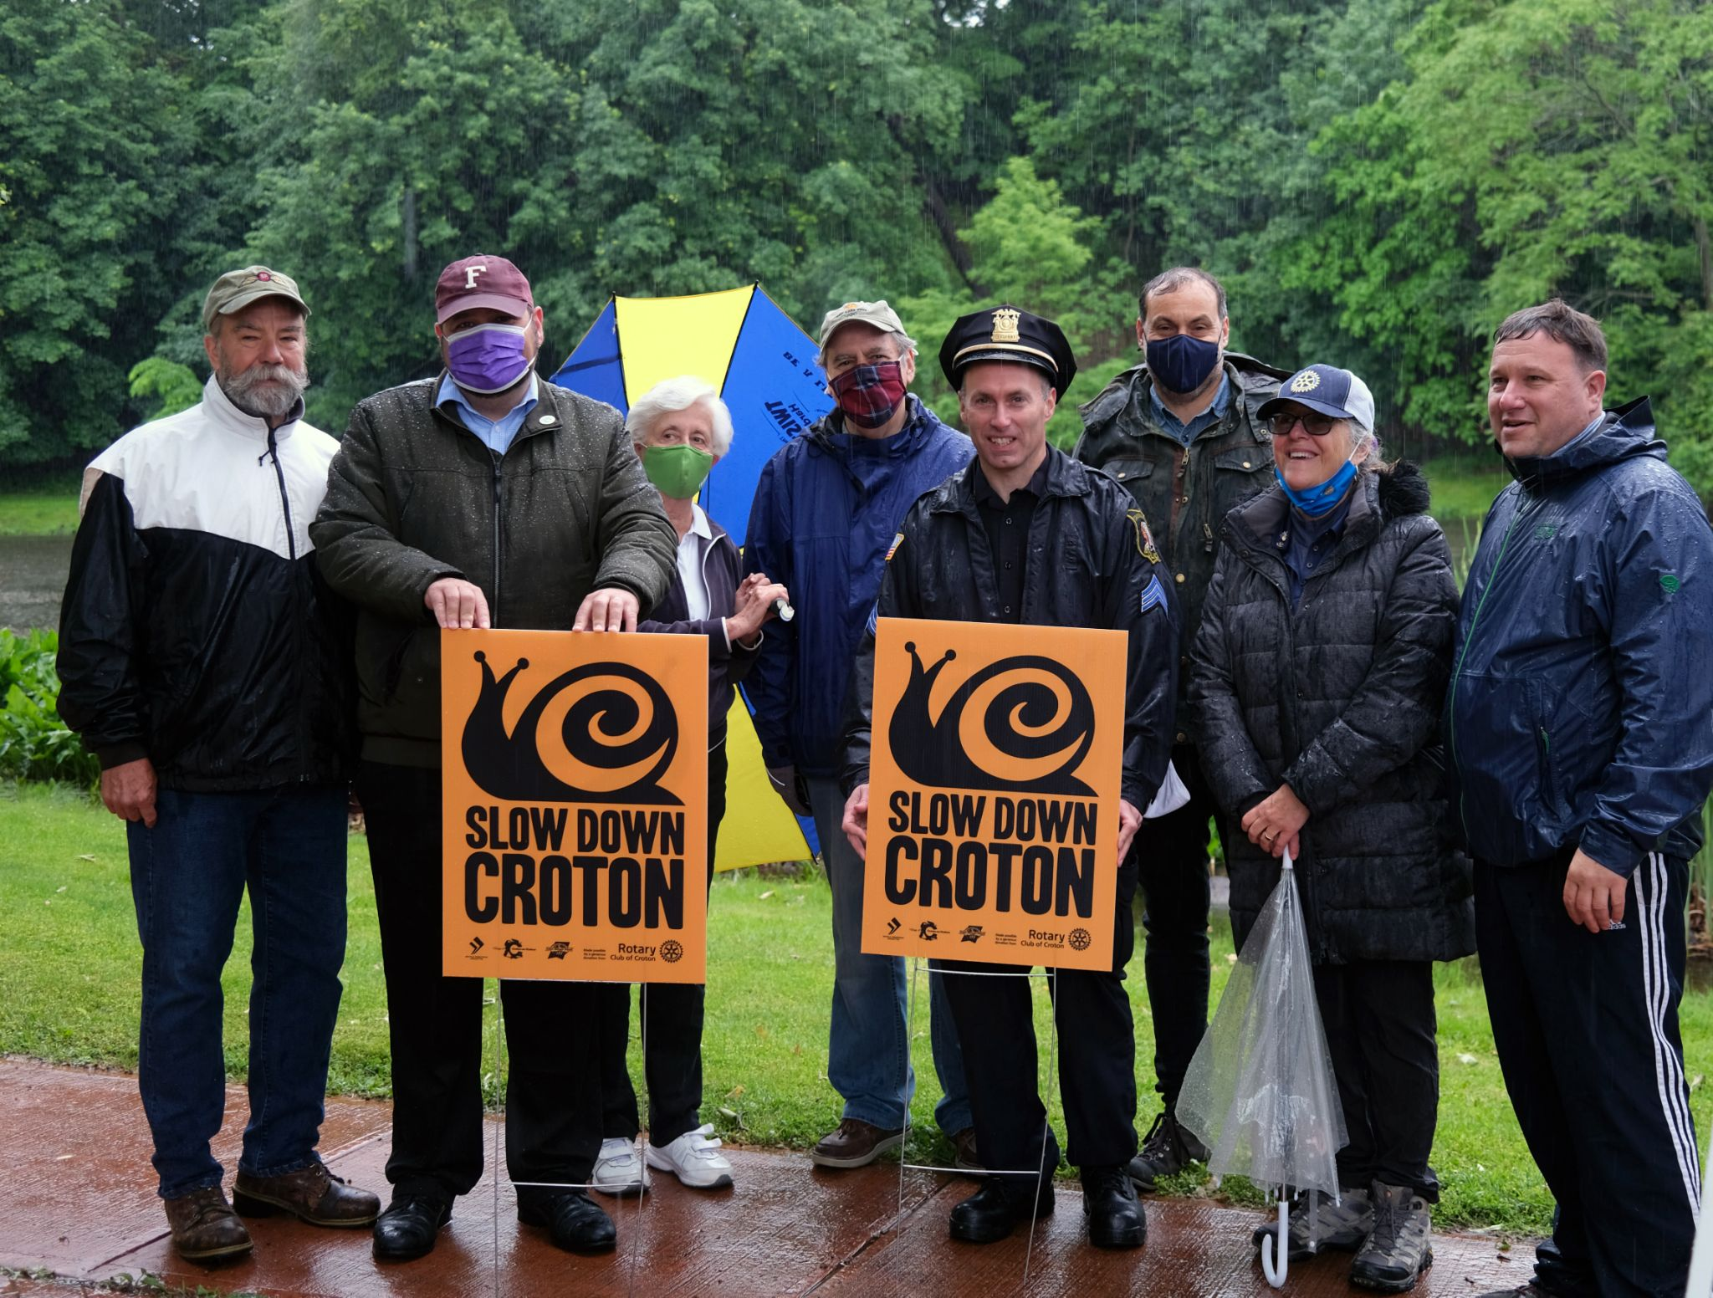

Left-to-right: Trustee Ian Murtaugh, Mayor Brian Pugh, Trustee Ann Gallelli, Trustee Len Simon, Police Sgt. Marc Leuzzi, Bike-Ped Chairman Matthew Schuerman, Rotary Club Executive Director Janeen Violante, Pierre Van Cortlandt Middle School Principal Michael Plotkin