Emergency Response Resources

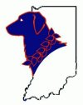
In addition to the law enforcement, fire safety, hazardous material, and health services resources which respond to Central Dispatch, Monroe County benefits from the following government and volunteer emergency response resources:

ARGUS K9 SAR trains and deploys ground search teams and specialty canine units. The team provides Monroe County and surrounding areas with experience in ground search, first aid, map and compass work, amateur radio communications, crime scene preservation, and incident command training.

Bloomington – Monroe County Chapter of the American Red Cross
Chartered by Congress in 1905, the Red Cross provides relief to victims displaced by disaster, from the onset of disaster conditions to the recovery phase. Local ARES Emergency Coordinators work closely with their counterparts in the chapter offices, on missions with Red Cross personnel and providing communications for shelter managers.

Red Cross Disaster Services -- This congressionally-mandated service not only applies to major national tragedies but also to single-family incidents, generally fire, flood or tornadoes. Typically, Red Cross responds by purchasing food, new clothing and providing shelter for families to help meet immediate emergency needs.
Red Cross Armed Forces Emergency -- The congressional mandate of the Red Cross includes providing service to our armed forces, including emergency communication between soldiers and their families, emergency leave and referral services.
Amateur radio operators responding with the Red Cross may do so either as Red Cross volunteers or as ham communicators for agency personnel. [National Statement of Understanding]

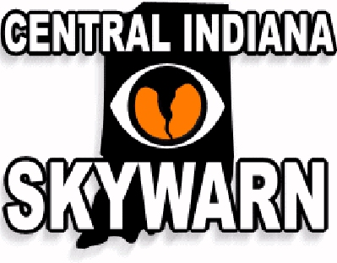
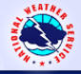
Central Indiana Skywarn -- Amateur Radio is almost synonymous with the Skywarn program, the "eyes and ears" of the National Weather Service during severe weather emergencies. Hams comprise the majority of Skywarn volunteers, who report "ground truths" to local NWS offices, supplementing their sophisticated weather monitoring equipment. Radio operators provide a vital communications link from the 39 counties in the Indianapolis National Weather Service area-of-responsibility in cases of severe weather. It supports the NWS with communications, educational and technical resources, utilizing the services of trained professional volunteers through continuous improvement in the promotion and advancement of the Skywarn program, thereby lessening the burden of government and promoting the social welfare of the citizens of the State of Indiana. The Skywarn program is one of the finest examples of hams providing public service. [National Memorandum of Understanding]

Citizens Corps – The ARRL is an affiliate under the four charter Citizen Corps programs--Neighborhood Watch, Volunteers in Police Service, Community Emergency Response Teams and Medical Reserve Corps. Citizen Corps is an initiative within the Department of Homeland Security to enhance public preparedness and safety. The relationship calls on DHS and ARRL to raise public awareness of Amateur Radio as a safety resource, to cooperate in providing training and accreditation for Amateur Radio emergency communications and towork together to promote the formation of local Citizen Corps councils and assist them with education, training and volunteer service opportunities that support first responders, disaster relief organizations and community safety efforts. [National Memorandum of Understanding]

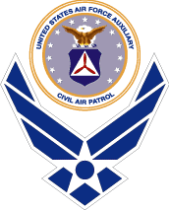
Civil Air Patrol -- The Indiana Wing of CAP is a civilian auxiliary of the US Air Force. CAP is made up of volunteers and among their missions is Emergency Services. These services include air and ground search and rescue operations, disaster relief operations due to tornadoes, floods, or earthquakes, environmental protection operations, State and Regional disaster airlift operations, organ and tissue transportation operations, aerial reconnaissance, transportation of emergency equipment and supplies, and transportation of State Officials and other non-CAP members. The Monroe County Squadron’s communications group is at Monroe County Airport and has ARS operators as members.

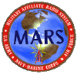
Military Affiliate Radio System -- The MARS mission is to provide the Department of Defense sponsored emergency communications on a local, national, and international basis as an adjunct to normal communications. It also provides as an auxiliary communications for military, civil, and/or disaster officials during periods of emergency. MARS is to assist in effecting normal communications under emergency conditions. In central Indiana, there are representatives for Army, Air Force, and Navy / Marine Corps MARS.

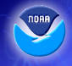
NOAA Weather Radio --The National Weather Service operates more than 670 National Oceanographic and Atmospheric Administration (NOAA) Weather Radio transmission stations across the country. NOAA uses seven frequencies -- 162.400, 162.425, 162.450, 162.475, 162.500, 162.525, and 162.550 MHz to provide overlapping coverage across geographical areas

Indiana Army National Guard – Deployment of the Indiana Army National Guard for general state or local emergency is under the authority of the Governor of the State of Indiana, usually at the request of local authorities under SEMA priorities. Should a large-scale emergency involve Bloomington and Monroe County, it is possible, that units including the local battalion could be assigned to this area. If the President of the United States declares an emergency and with the approval of Congress calls reserve units to active duty, a Guard unit could leave the community for up to a year.

The tactical radio of choice for the Indiana Army National Guard battalion located in Bloomington is SINCGARS, the single channel ground air radio system. It is capable of transmitting between 5 and 10 miles without a retransmission station and also capable of cryptographic encoding for secure communications as well as frequency hopping, allowing communication without being monitored. SINCGARS is thus not available to civilian personnel and organizations. However, in a situation where local authorities and military personnel are co-deployed, the radio is also capable of single channel unencoded operations which can be monitored by anyone who has a scanner tuned to military frequencies.

The unit headquarters for a Mobile Subscriber Equipment (MSE) Signal Battalion, also under control of the Governor, is located in Anderson, IN. The MSE system is analogous to the civilian cell phone system except that it is not capable of long distance communications, is not compatible with civilian cell phones, and is high on overhead requirements of a signal battalion. There is a limited amount of equipment available with the Bloomington Guard unit and it is rarely used.

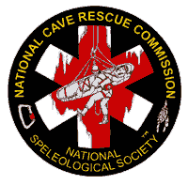
Indiana Karst Conservancy Cave Search-Rescue – The Cave Rescue Team of the Indiana Karst Conservancy is affiliated with the National Cave Rescue Commission. The Central Region Coordinator for NCRC and member of the IKC Cave Rescue Team is an amateur radio operator and headquartered in Bloomington. NCRC coordinates cave rescue training, including rescuer preparedness and safety, cave travel skills, understanding the cave environment, patient care and stabilization, evacuation techniques applicable to cave passage, single rope techniques for personal movement, rope rescue techniques, medical considerations, underground communications, and incident management. The IKC Cave Rescue Team performs the search and rescue operations using both underground telephony and amateur frequencies.

Indiana State Emergency Management Agency -- The Indianapolis SEMA Ham Team provides Amateur Radio communications between the Indiana Government Center SEMA EOC facility and the Indiana SEMA Mobile Command Center (MCC) vehicle, other Indiana County Emergency Operations Centers (EOC) and EMAs and/or other organizations as required to meet the last resort / backup or overflow disaster communications needs of the Indiana SEMA organization http://www.ai.org/sema/. [National Memorandum of Understanding]

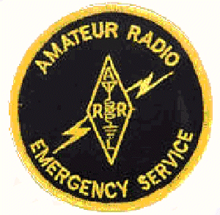
Monroe County Amateur Radio Emergency Services [ARES] operates in accordance with national Memoranda of Understanding between the Amateur Radio Relay League and a number of served agencies. ARES usually cooperates with non-governmental agencies like the American Red Cross and the Salvation Army. Locally, ARES cooperates with the Monroe County Director of Emergency Management. In addition, Monroe County ARES is a member of the National Weather Service (NWS) Skywarn Net and cooperates with contiguous counties in an Amateur Radio Emergency Services Mutual Assistance Team [ARESMAT].

Monroe County ARES-RACES Group is the operational umbrella comprising of ARES, under the direction of the ARRL-appointed Emergency Coordinator, and RACES, directed by the EMA-appointed RACES Officer, which provides Monroe County with a seamless source of volunteer radio amateur communicators ranging from individual, independent operators, through cooperative exercises with non-governmental agencies, to local, state or federal government events and responses.

Monroe County Emergency Management Advisory Council [EMAC] consists of representatives (or appointees) of the president of the county executive, the president of the county fiscal body, the mayor of each city in the county, an individual representing the legislative bodies of towns in the county, representatives private and public agencies or organizations that can assist emergency management as determined by the advisory council, one commander of a local civil air patrol unit.

Monroe County Emergency Management Agency [EMA] prepares for and coordinates all emergency functions other than functions for which military forces or other federal agencies are primarily responsible, to prevent, minimize and repair injury and damage resulting from, disasters. EMA promotes the mitigation of, preparation for, the response to, and the recovery from emergencies and disasters impacting the public, government, and business of the communities in Monroe County. Monroe County has established a non-reverting, Emergency Management Fund for the purpose of receiving donations for emergency management and disaster relief in Monroe County. [National Memorandum of Understanding]

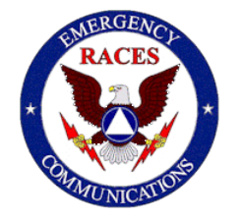
Monroe County Radio Amateur Civil Emergency Services [RACES] operates under the auspices of Monroe County Emergency Management and is authorized by Part 97, Subpart E of the FCC Rules and Regulations. RACES activities are activated by the Monroe County Director of Emergency Management in response to a need for communications support. [Local and National Memoranda of Understanding]

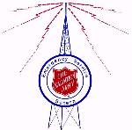
Salvation Army, Bloomington, IN., Corps – The Salvation Army Team Emergency Radio Network [SATERN] is a component of the Salvation Army's emergency disaster response; locally, nationally, and internationally. SATERN provides radio communications between command and remote facilities supporting disaster workers and victims. The Salvation Army is particularly active in the recovery stage of disasters, and has communications needs, often filled by ARRL volunteers. [National Memorandum of Understanding]
Amateur Radio Repeaters

in and contiguous to

Monroe County -- Bloomington, IN
 | WB9TLH |  | 146.640 MHz (-600 kHz) [o,a,e,z,wx, 136.5]
 | former K9OK |  | Monroe County Repeater Association  Auto-dial to Bloomington Post ISP, Monroe Co. Sheriff and Bloomington Police.  Monroe County ARES-RACES, Central Indiana Skywarn, NWS.
 | K9IU |  | 146.940 MHz (-600 kHz) [o,e 136.5]
Indiana University Amateur Radio Club <http://www.indiana.edu/~k9iu/k9iu_repeater.html>
Indiana University, IMU 677, Bloomington, IN 47405
 | WB9HZX |  | 147.180 MHz (+600 kHz) [o, 136.5].
 | KB9SGN |  | 443.755 MHz (+5 MHz) [o,e,x, ARES, 136.5]
 |  |  | Skywarn Network and linked to 145.390 [118.8] (net only) and 145.470 (Greene Co.), 442.250 (Lawrence Co.), 442.425 (Greene Co.), 443.275 (Brown Co.), 444.325 (Marion Co.), and 444.475 (Putnam Co.)[all 136.5].as the W9WIN.org <http://w9win.org/>.
 | W9EAR |  | 442.925 MHz (+5 MHz) [no CTCSS]
EAR Wide Area Network linked to
145.100 [107.2] (Evansville, Ft. Branch, Mt Vernon), 146.925 [107.2] (Vincennes, Paxton, Farmersburg), and 443.925 [no CTCSS] (Vincennes)
East -- Brown County, Nashville, IN
 | KA9SWI |  | 146.300 MHz (+600 kHz) [o,e,x,r,l,w, 88.5]
South Lawrence County, Bedford, IN
 | W9QYQ |  | 146.730 MHz (-600 kHz) [o, 107.2]
Southwest -- Greene County, Bloomfield, IN
 | W9HD |  | 147.240 MHz (+600 kHz) [o,e,z,RACES, 103.5]
 |  |  | ERP: 250w. EPS and auto-dial to ISP (Bloomington), Greene Co. Sheriff and Emergency Management [RACES], affiliated with Indiana Skywarn.
West -- Owen County, Spencer, IN
 | KB9MZZ |  | 146.985 MHz (-600 kHz) [o,e,wx,ARES, RACES 136.5]
Northwest -- Owen County, Gosport, IN
 | KB9SGN | 146.895 MHz (-600 kHz) [o,e,wx, 136.5]
North -- Morgan County, Martinsville, IN
 | N9AJS | 146.060 (+600 kHz) [o,a,e,z]
Indiana Repeater Council |  |  |  | <http://www.ircinc.org/repeaters.htm>

