Initial Action Checklist
The net control station and/or officials on the designated emergency net will provide additional instructions, including information on frequencies used or other resource and tactical nets.
- Check that family and property are safe and secure.
- Be prepared to operate. Check all equipment and connections.
- Be prepared to deploy to an assignment/location with Ready-Kit (see Preparedness).
- Monitor assigned frequency and follow check-in instructions.
- Initiate personal event log of dates and times of various events performed while activated.
- Enter assigned frequency(s) on log sheet. Log all traffic sent or received, and other significant events. The ARES-RACES Asset List included in Appendix can serve as a log.
- Deploy to assignment/location.
- Obtain tactical call sign for location/assignment (if appropriate).
- Use a formal ARRL Message Form (included in Appendix) when a precise record is required.
- If appropriate, use tactical call sign, while observing FCC’s ten-minute ID rule.
- Monitor your assigned frequency at all times. Request permission from NCS before changing frequency. Notify (and/or request permission from) NCS if you have to leave frequency or location.

National Incident Management System

The National Incident Management System [NIMS] is a consistent nationwide approach to work effectively and efficiently together to prepare for, respond to, and recover from domestic incidents, regardless of cause, size or complexity. Incident Command System [ICS] is component tool of NIMS which provides a coordinated system of command, communications, organization and accountability in managing emergency events. NIMS/ICS uses
- Clear text and common terms. No “10” codes.
- Unified command.
- Flexibility
- Concise span of control.

Integral to the NIMS/ICS model is Unified Command – there is one individual responsible for the overall operation, which, no matter the size of the emergency event, will always include planning, logistics, operations, and finance functions. Amateur radio operators are expected to be communicators. Within an ICS event, this is the Logistics Section.

In the event of an emergency, during which any of the communications organizations may be of service to the community, any responsible official of the Monroe County EMA, the Red Cross, NWS, or other agencies may request a number of amateur radio operators regardless of their affiliation with any group. In these cases, the Monroe County ARES EC/RACES Officer may assist in determining what modes of communications are best suited for the emergency.

All jurisdictions will be required to adopt ICS in order to be compliant with NIMS.
Amateur Radio Emergency Operations
All emergencies will initially be treated as ARES events until such time as Monroe County Emergency Management, Indiana EMA, or FEMA declares the incident to be a RACES event. At that point, only RACES-enrolled members will be on the frequencies.

Monroe County ARES-RACES members and other amateur radio service volunteers, upon becoming aware that an emergency exists, shall monitor the following frequencies:
- 146.640 MHz (-) (PL 136.5 unless in net mode) repeater to receive instructions or assignments. This is the primary net frequency and is located on the Indiana University Campus on Eigenmann Hall.
- 146.940 MHz (-) (PL 136.5 unless in net mode) repeater will be used if the above repeater becomes overloaded or inoperative, or as a subnet frequency. It is located in/on the IU Memorial Union Building.
- 147.18 (PL 136.5) becomes the first backup/subnet repeater
- 443.775 MHz (+5 MHz) (PL 136.5 unless in net mode) repeater, if linked, may be used to provide a subnet frequency for liaison between amateur stations monitoring net activity in Greene, Brown, Marion, and Putnam counties. Amateur stations monitoring other sources of information may communicate with ARES liaison on this frequency.
- 146.580 MHz Simplex will be used if all repeaters are overloaded or inoperative, or may be used as a subnet frequency. EC will determine availability of other Simplex frequencies for resource or tactical subnets during an event.
- Monroe County ARES-RACES may utilize other modes on the following, or other, frequencies:
- 144.340 MHz Fast Scan Television (FSTV)
- 144.360 MHz Slow Scan Television (SSTV)
- 144.390 MHz Packet Automatic Position Reporting System
- 145.010 MHz Packet Networking/Keyboard-to-Keyboard
- 145.050 MHz K9IU Packet BBS Primary User Port
- 145.570 MHz K9IU Packet BBS Local User Port

Amateur Radio Traffic
Tactical traffic is the first response communication in an emergency situation. It may be instructions or inquiries: "Send ambulance," "Where are water supplies?" Though tactical traffic is generally unformatted and seldom written, on responses, all traffic should be logged to protect both the radio amateur and the cooperating agency.
Formal traffic is generally long-term communications, often cast in ARRL message format and handled on NTS nets.
Packet – mode is handy for detailed or lengthy messages. The operator may prepare the message ahead of time and edit off-line as text files.
Image communications are live pictures of an area for damage assessment or Welfare traffic. ATV using FSTV requires more expensive equipment than Slow Scan SSTV.
Activation of the Communication Plan
Emergency | Priority | Break
Break -- The normal, polite request for an opportunity to interrupt an ongoing contact is the lowest priority of interruption. Break is also often recognized during an Open Net and may be granted during an Informal Directed Net. The NCS can break back with a higher priority should events warrant a change in net status.
NCS or an operator on any contact will always stop everything and answer the following interruption priority calls immediately.
Priority -- The second highest level of interruption, Priority, means the traffic concerns an immediate safety issue regarding human life or injury, or impending property damage.
Emergency -- The highest level of priority, Emergency, is reserved for only danger-of-death or serious-injury-if-message-is-not-heard-immediately messages
Emergency calls can interrupt Priority, Break, Welfare or normal traffic. Priority calls can interrupt Break, Welfare, or normal traffic, but not Emergency. Break should never be used during a Formal Directed Emergency Net. During nets, rely on NCS to dispatch assistance.
- Monroe County ARES may activate a Declared Formal Emergency Net at the direction of Monroe County Emergency Management Agency. and Formal or Informal Emergency nets at the request of the Red Cross Director of Disaster Services and/or authorities of other agencies. ARES also operates Informal or Formal Declared weather nets based upon observed or potential local events. RACES may activate a Declared Formal Emergency Net only at the direction of Monroe County Emergency Management Agency (or state or federal EMA). Only RACES members should respond.

- Cave Search-Rescue emergencies are activated by the Cave Rescue Team of the Indiana Karst Conservancy from calls to 812-337-7050 or to the Indiana State Police at 812-332-4411. All volunteers, including amateur radio operators, are trained by NCRC. Deployment to an operation is limited to members of the team. Other ARS operators will not generally deploy to a cave rescue operation nor participate in a cave rescue net unless specifically requested to provide communications support by the Cave Rescue Team.

- ARES will activate a Formal Declared Severe Weather or Skywarn Net under the direction of the NWS in Indianapolis. The trigger is an NWS severe weather Watch for Monroe and/or surrounding counties in the path of the event. Skywarn may be requested by NWS prior to severe weather in order to provide communications relays. NWS notifies Monroe County ARES EC, or an assistant, when severe weather threatens any of the 39 reportable counties.

- A local emergency net can also be triggered by EMA when a severe storm/tornado Warning is issued by NWS or if tornado sirens are activated to indicate other emergency events. A steady wail (http://www.co.monroe.in.us/emergencymgt/audio/steadywail.wav) from the Monroe County EMA emergency sirens means that a tornado has been sighted in Monroe County or that NWS has issued a tornado Warning. A fast wail (recorded here:
http://www.co.monroe.in.us/emergencymgt/audio/fastwail.wav) indicates that some type of unusual emergency has occurred, such as a hazardous chemical spill.
Siren locations:
Ellettsville Elementary School (old) | The Pointe
Bean Blossom Twp Fire Dept | Batchelor Middle School
Indiana Dept of Transportation | Century Village WBWB, IN46-IN446
Indian Creek Twp Fire Dept | PYA/Monarch
Harrodsburg Community Center | Van Buren Twp Fire Station
Sabin Corporation, W. Curry Pike | Stanford Baptist Church
Unionville Elementary School | Ransburg Boy Scout Camp
New Unionville Baptist Church | St John’s Catholic Church
Riddle Point Park at Lake Lemon | Justice Building
Sherwood Oaks Christian Church | Old state highway garage on East 10th Street
Smithville ball diamonds | Near IU Cyclotron IN45/46 Bypass
City Service Center, S Henderson | Bloomington Twp Fire Station 5
American Legion, W. Third Street | Ellettsville Elementary School campus
 | Summit Elementary School

- In the event of an emergency event, Monroe County EMA will contact the ARES Emergency Coordinator/RACES Officer, an assistant, or a member of the Emergency Committee. ARES-RACES may activate a telephone tree to alert ARES-RACES volunteers and will begin a declared net on the primary frequency, WB8TLH (146.640/146.040), to secure additional ARES support and other amateur radio volunteers. During a RACES event, only RACES members should respond.

- The Red Cross activates upon receiving a call from Chapter Management. A Telephone Tree Plan is used to activate the membership at large. A Red Cross disaster radio subnet NCS or liaison stations may be assigned by ARES NCS to provide emergency radio communications between the disaster scene, normally at or near the triage location, and the Red Cross Chapter House. Red Cross is involved with sheltering, first-aid, patient tracking, other patient related health and safety activities, and damage assessment.

- SATERN is activated by local Salvation Army authority in the event of a local emergency.

- The SEMA Ham Team in Indianapolis is activated by SEMA when communications assistance is requested by one of the 92 Indiana County Emergency Management Directors.

- Deployment of the Indiana Army National Guard is under the authority of the Governor of the State of Indiana. Should a large-scale emergency/disaster involve Indiana, Guard units could be activated under SEMA priorities. Should a large-scale emergency involve Bloomington and Monroe County, it is possible, but not necessarily a priority, that units could be assigned to this area, at which time SEMA and/or the Governor will notify Monroe County EMA.

- The Civil Air Patrol is an auxiliary of the US Air Force and for utilization of this group, the Duty Officer has to be called by the State and an existing MOU has to be in place. The Duty Officer would assign a mission number (if emergency is warranted) and the group would then be contacted. Monroe County ARES NCS may assign a liaison station or a CAP subnet NCS. This operator, if available, could be an amateur radio licensed member of CAP or another ARS operator.
Principles of Disaster Communication

- Monitor primary or assigned frequency. Stay on assigned frequency.

- Keep the interference level down. All stations should remain silent until called or unless there is necessary traffic to pass.

- Avoid spreading rumors. Report first-hand knowledge. Relay-transmissions should be officially authenticated, authorized and repeated word for word.

- Authenticate all messages. Messages of an official nature should be written and signed (ARRL Message Form). Amateur operators should avoid initiating disaster or emergency traffic. ARS does the communicating; the agency officials supply the content of the communications.

- Strive for efficiency. Instead of trying to operate a station full time at the expense of health and efficiency, volunteer for a shift at one of the better-located, better-equipped stations, manned by relief shifts of the best-qualified operators. This reduces interference and assures well-operated stations.

- Use the selected mode and band. The merits of a particular band or mode in a communications emergency have been evaluated impartially by the authorities and the EC with a view to the appropriate use of bands, modes, equipment and purposes.

- Be courteous of and cooperative with other communications groups responsible for emergency communications support. The primary objective of emergency communications is to save lives and property.

- Use all communications channels intelligently. Under FCC rules and regulations, in the absence of ARS frequencies, other official channels may be used to transmit an Emergency message, but not Priority, Routine or Welfare traffic.

- Operators will not transmit the name of an injured, trapped or deceased subject, but may request that the NCS send the appropriate authorities and assistance to the location using Emergency or Priority traffic protocols. Operators will not transmit the name of a minor lost or separated from responsible adults, but will be prepared to respond to NCS with description and or identifying information established ahead of time. Should this not suffice, have authorities authorize transmission of the name.

- Don’t broadcast. ARS transmissions are not intended to keep the public informed. Emergency Communications are intended to support authorities handling an event.
Repeater Operation

Power -- PL tones will normally be off during emergency events. Use minimum power to avoid keying near-by, same-frequency repeaters and causing unnecessary interference. Low power also conserves batteries.
Pause -- To allow NCS, liaisons, or operators with Emergency or Priority traffic, immediate access, operators with Routine/Welfare traffic should pause after a station finishes a transmission -- count to 2 or 3 before transmitting.
Listen -- Listen much, transmit little.
Think -- Think before transmitting. Stick to facts, control emotions. Write out what is to be transmitted before sending the message. Be succinct -- as short and concise as possible.
Articulate -- Don’t slur. Speak close to the mic, but talk across it, not into it. Keep voice down. Talk slowly, calmly.

Amateur Radio Nets

A Declared Net begins with a statement that a net is being started for a particular purpose. There is an identified Net Control Station [NCS], perhaps identified backup and/or logging stations, and in some instances, liaison(s) between NCS, served agencies and other ARS stations.

Open Net -- A net is declared. Normal use of repeater or frequency continues. Any licensed amateur radio operator can start a net to get assistance with a situation. Usually, such nets involve personal circumstances such as automobile assistance, making travel arrangements, or other non-commercial activity. Sometimes such nets may be a precursor to a Directed Net as operators begin to organize and discuss possible events, such as weather emergencies.
Directed Net -- NCS declares the net and actively controls the frequency. Normal usage of the frequency or repeater is stopped. Specific topic, conditions, and/or instructions for check-in are given.
Informal Directed Net -- Public service nets and practice nets.
Formal Directed Net -- Activation of specific nets for a specific purpose or emergency.
Emergency nets are reserved for danger-of-death or serious-injury situations -- an accident or other crisis where people and/or property are in distress. Emergencies are nearly always recognized and declared by agencies or authorities outside of the Amateur Radio Service, such as the NWS, the local Emergency Manager [EM], and/or the local Red Cross. Amateur radio operators and ARS NCS do not have independent authority to declare an emergency.
Sub-nets – NCS may establish independent sub-nets with or without their own frequencies and NCSs reporting to the main net.

NCS will regularly announce the authority for, and status (Open, Informal, Formal) of, during the course of the nets.
Principles of Net Operation

- Monroe County ARES-RACES Net Control will operate from a location other than that of the Monroe County Emergency Operations Center (EOC) in Monroe County. A liaison may be located at the EOC to pass information to/from the net. Emergency power is available and amateur station equipment is located at the EOC. The EOC amateur station may be shifted to the City-County dispatch/communications center.

- Once a net is declared, NCS will begin to build an Asset List [see Appendix] to match the requirements of the event. ARES-RACES members and other amateur radio volunteers should follow the procedures outlined in instructions from NCS which will depend upon the circumstances of the emergency and may vary throughout the course of the event. For example, NCS may request check-ins by calling for those stations who have been notified by telephone or for RACES members, from only those stations with specific traffic to pass, from stations which are or can be mobile or portable, or from stations with other equipment, modes or operating capabilities, from operators in specific or certain locations in the area, or from all ARS volunteers who are standing by.

- The size of an emergency net will guide and be guided by the National Incident Management System [NIMS/ICS] plan, but it could change very quickly. In a major event that is likely to grow, NCS may request and keep a large Asset List of standby operators who may never be required to activate or give a report.

- As each operator checks in, NCS may request
- Callsign
- Name
- Equipment [type of radio(s), antenna(s), power supply, and transportation]
- Initial Status (mobile, stationary) and Location, and
- an estimate of the length of availability.

- NCS may then ask for a “standby” to organize the available personnel resources to meet the logistics of the event. A local net responding to a large-scale incident may require more functions than can be managed by a single NCS. As the situation develops, NCS may establish a subnet structure to handle some of the traffic. This is a principle of the NIMS/ICS.

- Available operators may then be assigned to function
- as Backup NCS
- as Logging or Liaison stations
- as Resource NCS to direct specific tasks created by the complexity of the event, or
- as an operator or spotter.
Resource NCS, Logging and Liaison stations, and other stations may also be assigned locations. Operators/spotters may be assigned duties on a Resource or other subnet and frequency for which they will be given instructions.

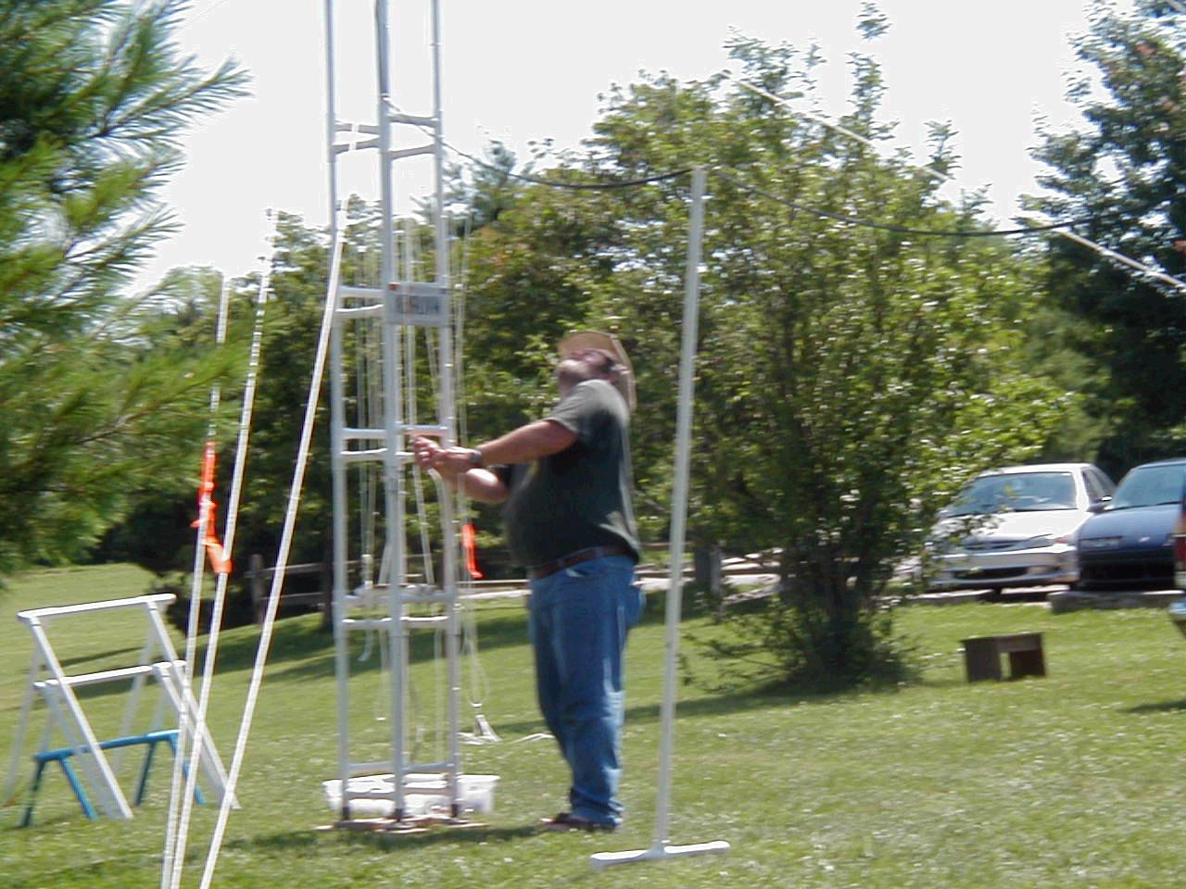
- Mobile and portable units may be dispatched, within the limits of personnel and equipment, as needed to schools, shelters, hospitals, fire stations, or other locations necessary to support emergency communications. ARS operators may be assigned to vehicles operated by EMA, Red Cross, or other cooperating agencies or groups. Mobile and portable units may be contacted by NCS while in route, but will always report in upon arrival at the assigned locations.
Bobby Bristoe (KB9UVW), Assistant ARES EC / RACES Officer [Net Manager] and his portable 30’ PVC VHF-UHF antenna tower.

- Operators will monitor assigned frequency and notify the NCS, if it is necessary to leave or if relief is needed. Transmissions will be made as instructed or at the request of the NCS -- or for Emergency (life and death) or Priority (property damage, threat to human life), or other traffic initiated by the official in charge at that location. All formal traffic shall be handled and formatted in accordance with the individual organizations’ operating procedures. This could be in either plain English text or on the standard ARRL Message Form and using numbered Radiogram messages.

- Information concerning the nature of an emergency event and the extent of ARES involvement will be transmitted to all volunteers as it becomes available and updated when possible. However, ARES-RACES will avoid transmitting identifying addresses of the most severe damage, license or other identification numbers of vehicles, possible reported causes, names of an injured, trapped or deceased subjects, and names of a minors lost or separated from responsible adults – except as outlined and agreed upon by the authorities or agencies in the NIMS/ICS for the event.

- Federal regulations provide that licensed amateurs shall exert direct control over all transmissions on amateur frequencies. This does allow for “third party traffic” where the amateur operator retains control of the transmission and has advised against the use of foul language or the conduct of commercial business. Relays often become incorrectly “translated” by the relay operator, especially if there is a high percentage of special agency terminology, technical terms.

Communications with/by Other Agencies

Amateur radio operators may be assigned as liaison stations to other groups or agencies. Such liaisons may be assigned to physically locate with those groups. Those groups or agencies may have radio service on bands other than those of the Amateur Radio Service. Under FCC rules and regulations, liaison operators will use only assigned amateur frequencies to relay traffic and information.

Liaison Assignments
Liaison contact may be maintained on the following amateur frequencies:
- National Weather reporting repeater: 146.970 MHz (-) or
- National Weather reporting repeater: 442.650 MHz (+5) and/or
- another frequency, repeater or telephone connection as determined
by the authorizing agency and/or ARES-RACES.
- Indiana Traffic Net: 3.910 MHz (If widespread emergency exists)
- Maritime Mobile Net: 7.260 MHz (If widespread emergency exists)
- Maritime Mobile Net: 14.300 MHz (If widespread emergency exists)
ARS operators may be assigned as liaison stations at locations identified by ARES, EMA, the Red Cross, and/or other participating agencies. These may be, but not limited to, the following:
SEMA Regional Staging Areas
- Monroe County Fairgrounds
- Monroe County Highway Garage
- Monroe County Airport (with CAP)
- Monroe County EMA headquarters – 119 W 7th Street
- Monroe County Red Cross Chapter House – 409 E 7th Street
- Bloomington, IN., Corps, Salvation Army (SATERN) – 111 N Rogers Street
- Richland-Bean Blossom (RBB) and/or Monroe County Community School Corporation (MCCSC) buildings being used as shelters or aid stations
Hospitals, Medical Centers and Clinics
- Bloomington Hospital – 601 W 2nd Street
- BHC Meadows Hospital – 3600 N Prow Road
- Indiana University Health Center
- Bloomington Veterans Administration Outpatient Clinic – 200 E Winslow
- Southern Indiana Surgery Center – 2800 Rex Grossman Boulevard
- 1st Healthcare Group – 100 N Curry Pike
- Promptcare East – 888 Auto Mall Road
- Promptcare West – 3443 W Third Street
- The Eye Center of Southern Indiana – 1011 W 2nd Street
- Indiana University Student Health Center
- Indiana Army National Guard – SINCGARS system

Law enforcement headquarters
- Monroe County / Bloomington Dispatch – 220 E 3rd Street
- Monroe County Justice Building – 301 N College Ave
- Bloomington Police – 220 E 3rd Street
- Indiana University Police – 801 N Jordan Avenue
- Indiana State Police – 2135 N Fee Lane
- Town Marshall of Ellettsville
- Bean Blossom Township / Stinesville
- Indiana State Conservation Office (South Region) -- 4850 S IN 446
Fire stations
- Bloomington Headquarters and/or Stations
- Bean Blossom Township
- Benton Township
- Bloomington Township (w/ Hazmat units)
- Ellettsville
- Indian Creek Township
- Perry-Clear Creek District
- Van Buren Township
Other service buildings
- Bloomington Street Department
- Bloomington Utilities Department
- Indiana Department of Transportation Garage
- Indiana University Physical Plant
- Ellettsville Utility Service Building
Other Areas
- Lake Monroe
- Griffey Reservoir
- Lake Lemon
- Bryan Park
- Karst Farm Park

Monitoring Assignments
Operators may be assigned to monitor one or more of these NOAA Weather Radio frequencies depending upon the direction of the weather threat:
Freq MHz | Transmitter | Direction | Watts | Covered Counties
- 162.450 | Bloomington |  | 1000 | Monroe, Owen, Brown, Lawrence
- 162.400 | Putnamville | NW | 1000 | Clay, Owen, Hendricks, Morgan
- 162.425 | Edwardsport | SW - S | 1000 | Knox, Greene, Sullivan, Daviess
- 162.500 | Georgia | S | 1000 | Lawrence, Orange, Martin
- 162.525 | Seymour | E - SE | 1000 | Jennings, Jackson, Bartholomew, Washington, Scott
- 162.550 | Indianapolis | N | 1000 | Marion, Morgan, Johnson, Hendricks, Shelby, Bartholomew

- ARS operators may need to be assigned to monitor radio frequencies of law enforcement, firefighting, and military groups where no liaison operator has been assigned. This will include SINCGARS when there is co-deployment of local authorities and military personnel and the local battalion is operating in unencoded mode. Frequencies and utilization will be assigned during activation instructions.

Unless the event disrupts other normal broadcast and/or data resources, some operators may be assigned to monitor area television channels, cable news and weather services, and Internet resources:
Broadcast and Cable:

- 4 – WTTV Bloomington/Indianapolis
- 6 – WRTV,
- 8 – WISH-TV,
- 13 – WTHR-TV,
- 59 (Cable 11) – WXIN Indianapolis
- 10 (Cable 15) WTHI Terre Haute
- 30 (Cable 5) – WTIU from Indiana University

- Cable 3 -- CATS from Monroe County Public Library
- Cable 12 -- CATS from Monroe County Public Library
and
- Cable 14 -- CATS from Monroe County Public Library

- Cable 38 – Weather Channel
- Cable 94 –Skytrak Weather (13—WTHR-TV)
and
- Cable 95 – Local Weather Service (8--WISH-TV)

Internet sites such as (but not limited to) the following:
- National Weather Service <http://iwin.nws.noaa.gov/iwin/in/in.html>
- NWS Internet Data Source: High Speed Connection <http://iwin.nws.noaa.gov/iwin/graphicsversion/rbigmain.html>;
Mid Speed Connection <http://iwin.nws.noaa.gov/iwin/graphicsversion/bigmain.html;<
Text-based Connection <http://iwin.nws.noaa.gov/iwin/textversion/main.html>

Unless specifically directed by NCS, the ARS operator shall not report information from these sources with the same urgency as direct observations by local operators. Such assignments are supplemental to direct observation.
Communicating with the Media

When involved with an emergency situation, all attempts for interviews from the media should be referred to the designated spokesperson of the convening authority. It is good practice to follow this protocol during practice nets and public service events as well, referring questions to the organizers or directors of the event.

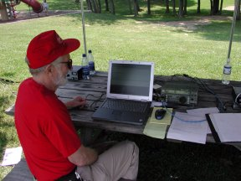
ARS operators will not make any comment to a member of the media regarding information about injuries, deaths, addresses of the most severe damage, license numbers of vehicles, rail car numbers, and possible reported causes which might lead them to a “trail-of-responsibility/blame. “I can’t answer that question,” is always a good response.

Amateur radio operators will not transmit the name of an injured, trapped or deceased subject, but may request that the NCS send the appropriate authorities and assistance to the location using Emergency or Priority traffic protocols. ARS operators will not transmit the name of a minor lost or separated from responsible adults, but will be prepared to respond to NCS with description and or identifying information established ahead of time. Should this not suffice, have authorities authorize transmission of the name.
Dan Miller (KQ9I) operating digital mode at BARC- IUARC Field Day.

In either an emergency or a practice event, operators may discuss the role of the communications volunteers and amateur radio in the overall, but not the specific, situation.
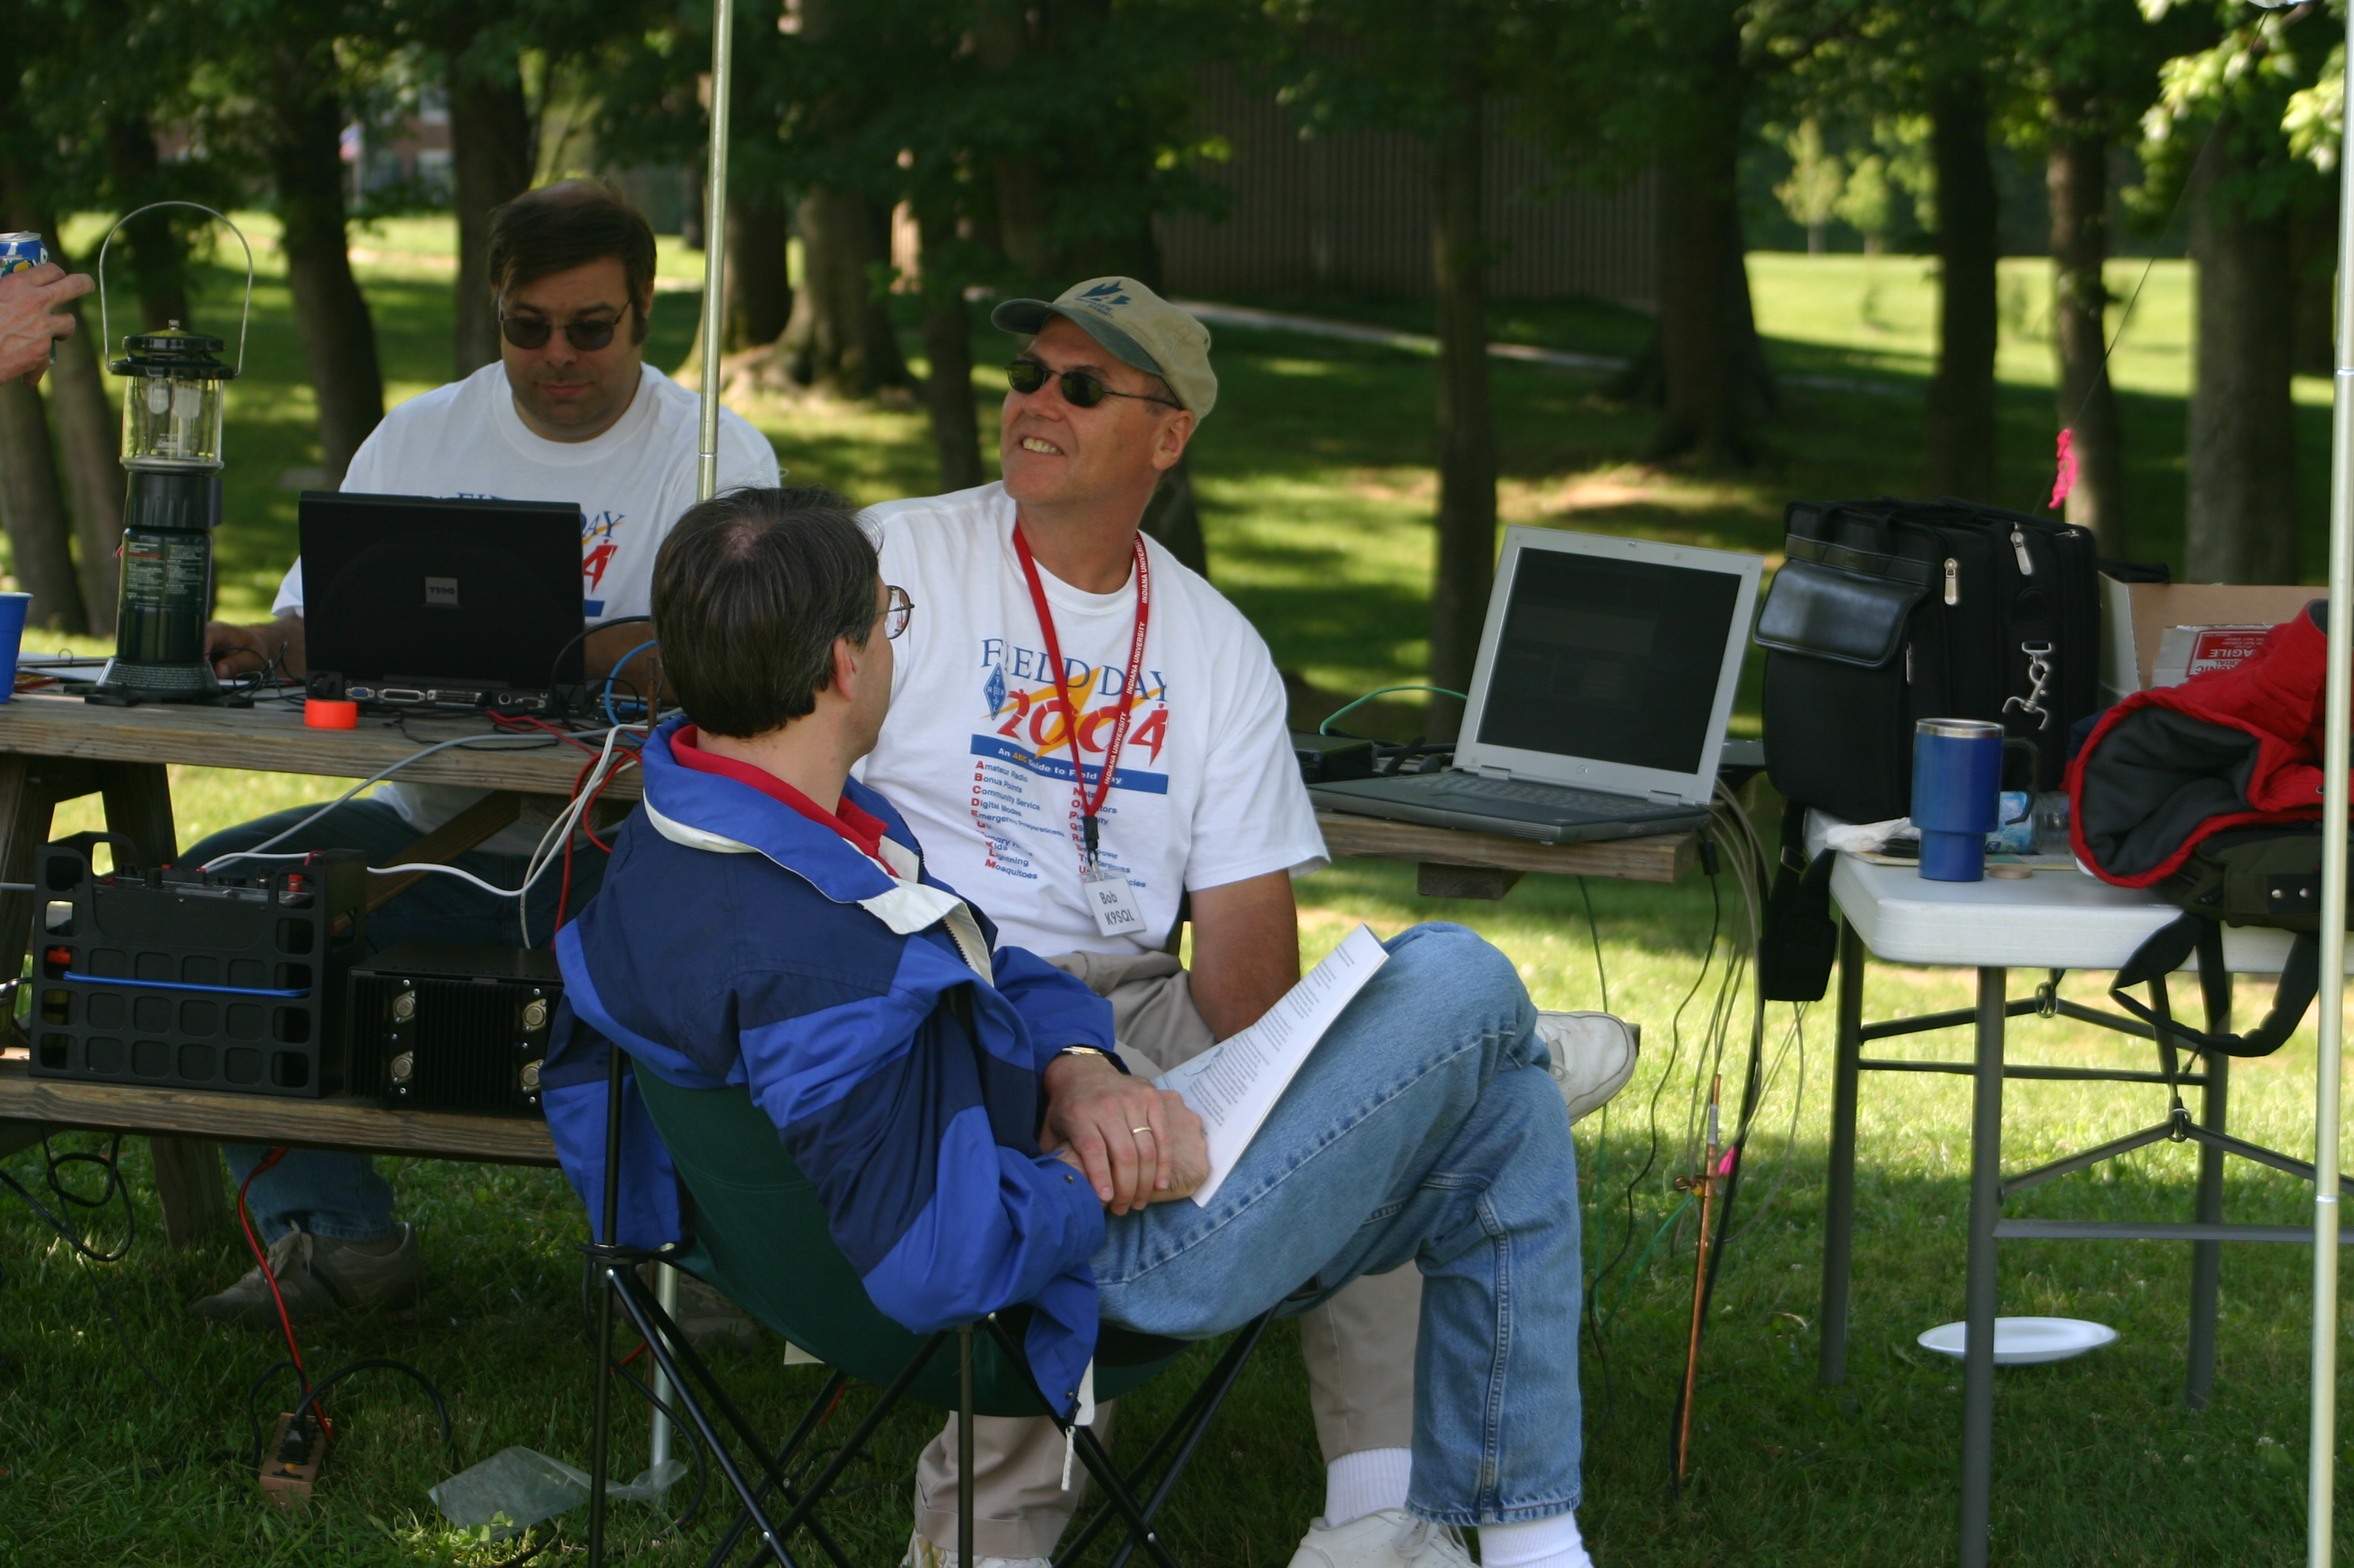
Ray Stevens (KB9LGS), Matt Pierce (N9VKU), Bob Poortinga (K9SQL) on station at BARC- IUARC Field Day.

