Shelter Operations

Amateur Radio operators provide backup for overloaded Red Cross communications systems, staffing Red Cross Shelters, various Red Cross units, and the office of Emergency Management, the Salvation Army and others involved in the aftermath of tragedy. In times of disaster, the nation's ham radio operators are often the first to volunteer their communications expertise. Today, there are nearly 700,000 Amateur Radio operators in the United States and more than 2.5 million worldwide

Shelters are a temporary place of protection where disaster victims can find assistance and supplies. Shelters may operate during an event, Response, such as stranded motorists during a snow storm, or after an event, Recovery, such as individuals and families displaced by a tornado.

In shelters, children may need to be entertained, but adults are worried about what happens next. Repeaters and auto patches allow Welfare communication to inform, advise and reassure friends, families and relatives.

Hams at shelters provide communication support and backup, handle outgoing health-and-welfare traffic, and reassure shelter residents that they are not totally out of touch with the outside world. Hams working in the shelters should maintain a high profile.

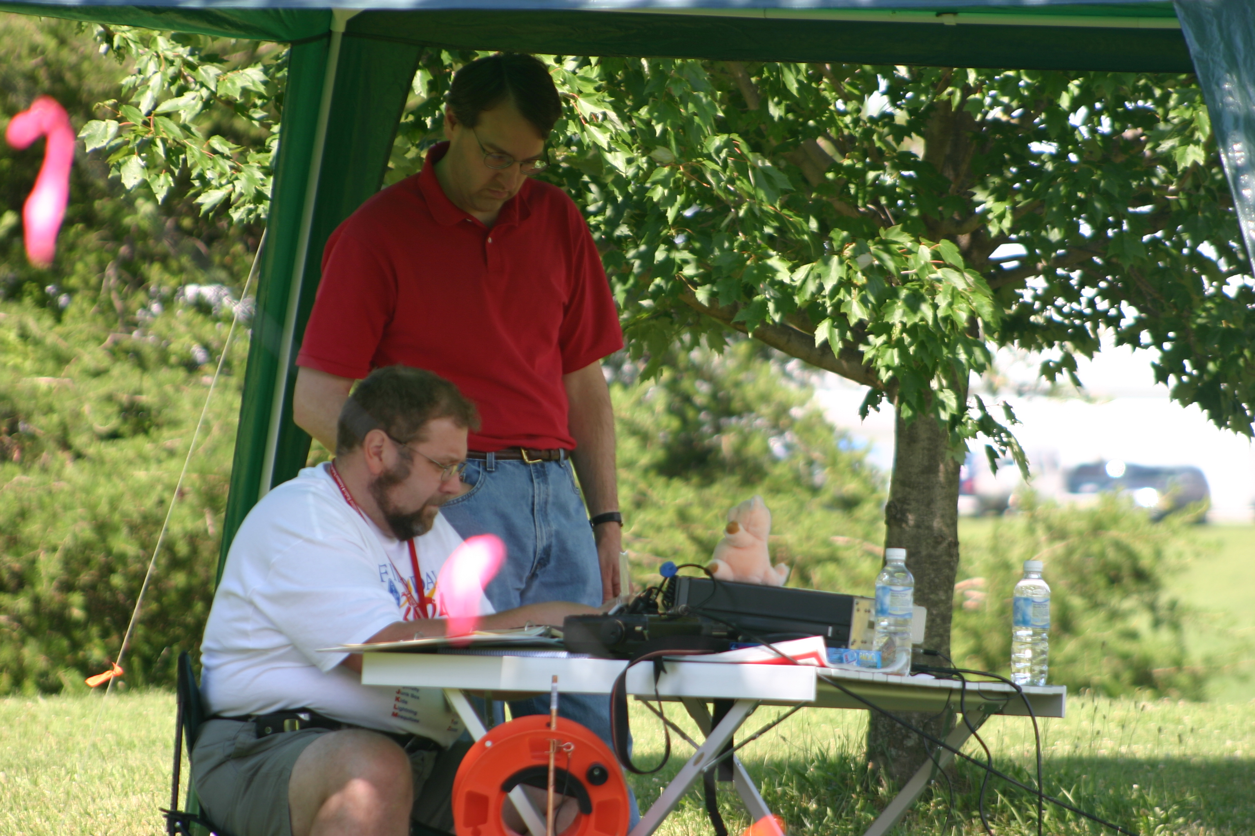
Tom Busch (WB8WOR) and Matt Pierce (N9VKU) at the satelite station at BARC- IUARC Field Day, 2004
Health and Welfare

In the event of a natural or man-made disaster, radio amateurs, including ARRL-certified volunteers will work with community organizations to relay vital information in a structured and accurate manner. They are skilled at composing and relaying messages by voice and through computer based Amateur Radio communications modes. ARS volunteers will join local ARES nets and will support emergency activities ranging from equipment logistics, victim location and identification, emergency shelter, food and water information, medical equipment and materiel distribution, and, sometimes, life-and-death communication.
Emergency | Priority | Break
Break -- The normal, polite request for an opportunity to interrupt an ongoing contact is the lowest priority of interruption. Break is also often recognized during an Open Net and may be granted during an Informal Directed Net. The NCS can break back with a higher priority should events warrant a change in net status.
NCS or an operator on any contact will always stop everything and answer the following interruption priority calls immediately.
Priority -- The second highest level of interruption, Priority, means the traffic concerns an immediate safety issue regarding human life or injury, or impending property damage.
Emergency -- The highest level of priority, Emergency, is reserved for only danger-of-death or serious-injury-if-message-is-not-heard-immediately messages
Emergency calls can interrupt Priority, Break, Welfare or normal traffic. Priority calls can interrupt Break, Welfare, or normal traffic, but not Emergency. Break should never be used during a Formal Directed Emergency Net. During nets, rely on NCS to dispatch assistance.

.Emergency messages within the disaster area often have life-death urgency. Much of the local traffic will be on VHF/UHF. Emergency, Priority and Welfare traffic flowing outside the disaster area may be best handled on HF using the NTS. Incoming Health and Welfare traffic should be handled only after all Emergency and Priority traffic is cleared because it can easily overload an already busy system.

Property Damage Surveys / Assessments
Damage caused by natural disasters can be sudden and extensive. Responsible officials in and near the event may need communications assistance. Such reports and data are used to initiate and coordinate disaster relief and recovery.

Red Cross damage assessment teams survey an area to calculate initial impact estimates. EMA may request surveys to ascertain the amount of outside assistance needed in an area. Using a ride-along ham provides instantaneous contact with the Chapter House or EOC

Definitions
ARES | Amateur Radio Emergency Service
ARRL | Amateur Radio Relay League
ARS | The Amateur Radio Service of the Federal Communications Commission
BARC | Bloomington Amateur Radio Club
CAP | Civil Air Patrol
CW | Continuous wave – Morse code
EC | (ARES) Emergency Coordinator
DHS | Department of Homeland Security
EMA  EMC | Emergency Management  Agency / Center | MCEMA  MCEMC=County | SEMA=State | FEMA=Federal
EOC | Emergency Operations Center | MCEOC = County
FCC | Federal Communications Commission
HAZMAT | Hazardous Materials
HF | High Frequency (1.8 - 30 MHz)
ICS | Incident Command System, component of National Incident Management System [NIMS]
IUARC | Indiana University Amateur Radio Club
MARS | Military Affiliate Radio System
Modes | Various ARS methods of operation: CW, phone, packet, digital, FSTV. SSTV, etc.
MOU / SOU | Memorandum of Understanding / Statement of Understanding
NCS | Net Control Station
Net | A frequency controlled by an NCS for station-to-station traffic
NIMS | National Incident Management System
Phone | Voice mode on the Amateur RadioService
RACES | Radio Amateur Civil Emergency Service
Repeater | A radio which receives signals on one frequency and transmits on a second. Usually has better antenna and location and better power than personal stations.
SATERN | Salvation Army Team Emergency Radio Network
SINCGARS | Single-channel Indiana Army National Guard Radio Service
SOU / MOU | Statement of Understanding / Memorandum of Understanding
UHF | Ultra High Frequency (420-450 MHz)
VHF | Very High Frequency (144-148 MHz)
Conclusion
Amateur radio operators should become familiar with the ARRL Operating Manual, especially the Desktop Reference and the chapters on “Emergency Communications” and “Traffic Handling Procedures,” and the ARES Field Resources Manual, from which much of the operational information for this Plan is derived.

The purpose of this plan is to provide broad written guidelines with a minimum of information needed in an emergency and to define the roles and responsibilities of the licensed amateur radio operators volunteering for Emergency Communications service in Monroe County. Additional, more detailed, information on operating procedures, net control operations and training, Skywarn and local weather events, and cave rescue services is, or will be, available from Monroe County ARES and/or BARC in the form of meeting handouts or brochures.

Monroe County ARES-RACES and the approximately 500 amateur radio operators licensed in this area, and the hundreds in surrounding counties, are proud to offer radio communications support to the community in the hope that such assistance is rarely called for.

ARES – RACES Group
Emergency Management Agency
119 West 7th Street
Bloomington, IN 47401
812.349.2546
Monroe County ARES-RACES Group Emergency Committee
EMA RACES Officer |  | Emergency Management Director
ARRL-ARES Emergency Coordinator |  |  | John Hooker
 | Carl Zager (KB9RVB) | Red Cross Director of Disaster Services
Assistant EMA RACES Officers / ARES ECs: |  |  | Maria Carrasquillo
 | Bobby Bristoe (KB9UVW) Net Manager  Rob Hamros (KB9RNB) Membership  Kevin Pauley (KB9WVI) Community Relations  Maynard Raggio (N9PTG) Simplex Operations | Radio Amateurs
Michael Aronoff (N9YYM)
Tom Busch (WB8WOR)
Allan Gutstadt (KF9RA)
Richard Landgrebe (WB9HXP)
John P Maassen (K9FK)
Murl McRae (WA9CWT)
Dan Miller (KQ9I)
Bob Poortinga (K9SQL)
William Wootton (KC9ACL)
Assistant ARRL Director – Indiana
 | Neil Rapp (WB9VPG)
 | Jay Sissom (KA9OKT)
ARES Emergency Coordinator, Emeritus
 | Millard Qualls (K9DIY)
Owen County Liaison
 | John Sullivan (WD9BKA

Community Contacts
Bloomington Amateur Radio Club |  | Monroe County Emergency Management
 | http:www.bloomingtonradio.com |  | E-Mail: jhooker@co.monroe.in.us  Telephone: 812.349.2546  http://www.co.monroe.in.us/
IndianaUniversity Amateur Radio Club
 | http://www.indiana.edu/~k9iu/
ARRL Indiana Section |  | Emergency Management Advisory  Committee [EMAC]
 | Section Manager: Jim Sellers (K9ZBM)
 | E-Mail: k9zbm@arrl.net Phone: 219.825.5425  http://www.arrl.org/sections/IN.html |  | Herb Kilmer, Monroe County Commissioners  Trent Jones, Monroe County Council  Bob Schmidt, Secretary, Health Department  Steven Sharp, Monroe County Sheriff  Kevin Robling, CoS, City of Bloomington
 | Section Emergency Coordinator:
David L Pifer (N9YNF)
Phone:812.466.1005 E-Mail: n9ynf@arrl.net
 | Section Traffic Manager:  Frank M Dick II (WA9JWL)  Phone:765.642.1237 E-Mail: fmdick@iquest.net |  | Jim Davis, Town of Ellettsville  Randy Carter, Stinesville Town Board  Kim Long, Indiana University
ARGUS K9 SAR [Search and Rescue] |  |  | Don Adams, Local Business Owner  Lt. Col. Robert Young (W9GBJ), CAP Liaison  Maria Carrasquillo, Red Cross Liaison
Contact: John Poehlman (N9TFS)
E-Mail: argusk9@bloomington.in.us
Indiana Karst Conservancy  Cave Rescue Team |  | American Red Cross – Monroe County
 |  |  | E-mail: mcarrasq@monroe-redcross.org
 | Contact Anmar Mirza (N9ISY)  E-Mail: amirza@indiana.edu  Rescue: 812-337-7050  Home: 812-388-6917  http://www.caves.org/io/ncrc-cr/ |  | Telephone: 812.332.7292  http://www.monroe-redcross.org/
 |  | Civil Air Patrol – Monroe County Squadron
 |  |  | Commander: LtC Robert L Young (W9GBJ)
Military Affiliate Radio System [MARS]
Army: Gerald Bailey (KB9XA)
Air Force: Ed Woods (WD9DVA)
Navy / Marine Corps: Paul Schmidt (K9PS)
E-Mail: k9ps@arrl.net

