John Humphreys

LSDS1 Sprint 3 Module 4

2018-11-29

Before editing with hemingwayapp:

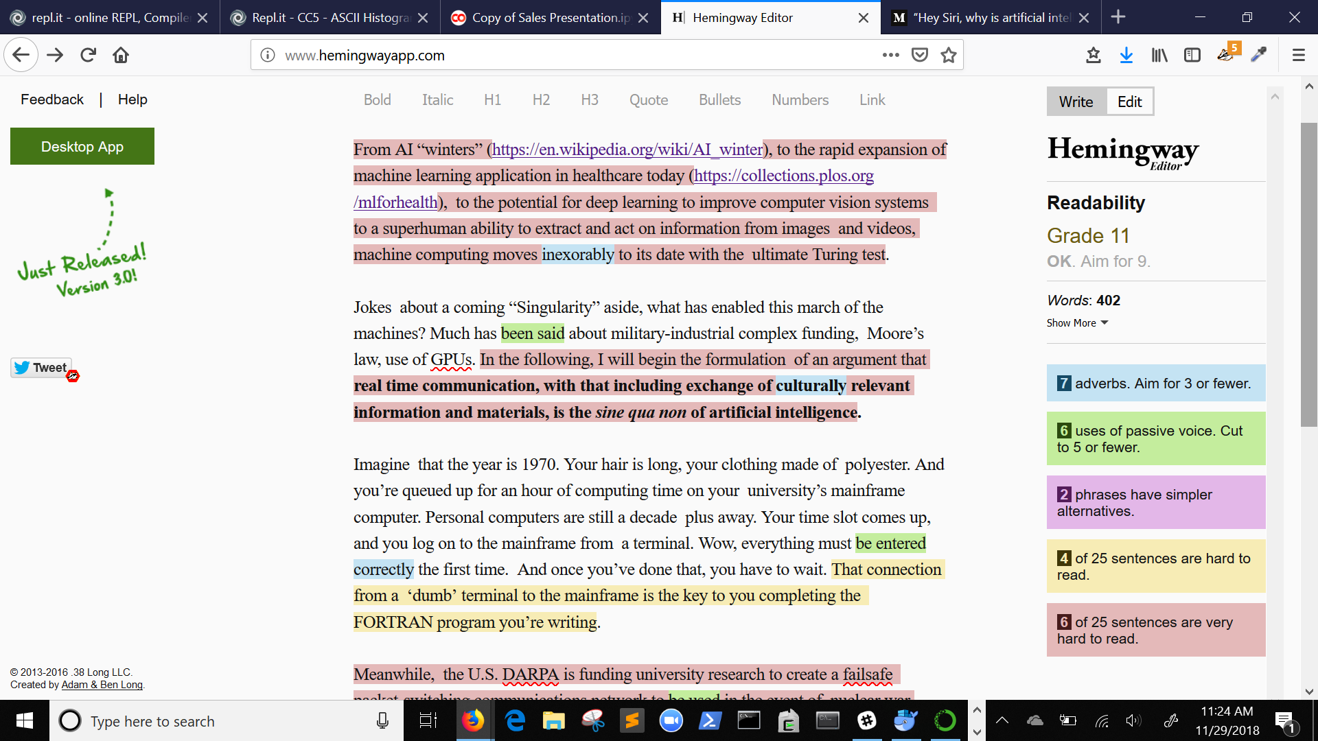

**After** editing with hemingwayapp:

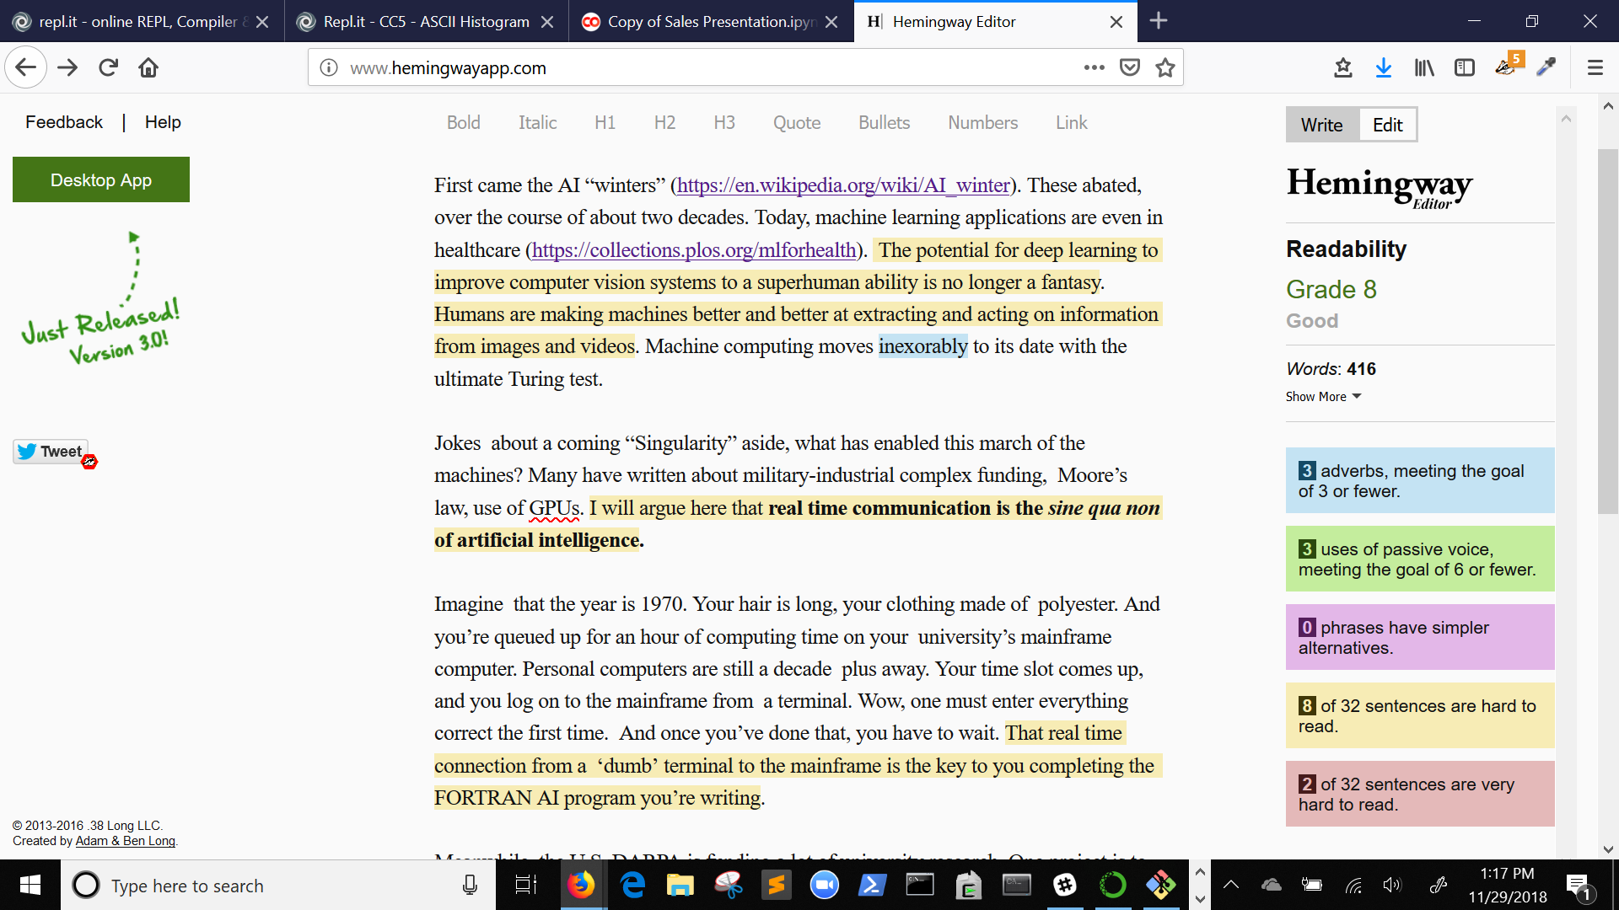

See https://medium.com/@johnhpharmd/hey-siri-why-is-artificial-intelligence-here-to-stay-a361a1d96ecc