1. Rails or Wheels
Rails即导轨版本。由于直线导轨价格较为昂贵，所以，成本约需2200元人民币。
Wheels是滚轮版本。由于价格低廉，所以，成本可以控制在1000元左右。
据说，还有一种方法是使用POM小球，据说更加便宜。
比如：http://www.thingiverse.com/thing:291981
两种类型的3D打印机对比
Rails |  | V-Rollers
Recirculating ball bearings running in a metal carriage running on steel rails | System | Delrin wheels with ball-bearing inside attached to a printed frame running on the OpenBeam beams
$110 for 3 rails and carriages + free china shipping | Cost | Our kit costs $50 incl. bolts,screws and printed parts
No | Adjustable | Yes
No adjustment needed but also none possible | Maintenance | You may need to adjust 1 screw to tighten it over time due to wear of the wheels
When worn, replace completely | Replacement | Separate Delrin wheels (including bearings) can be bought in our store. Undercarriage can be printed yourself.
Excellent | Precision | Excellent
We tried both systems. It’s down to personal preference but we really like the V-rollers. It gives a bit more control because it is adjustable and it’s much cheaper to buy and replace. Plus, since the undercarriage is printable you can print your own replacement, different color or maybe even make enhancements yourself.

2. Bill Of Materials
This page described the Kossel Mini BOM (Bill Of Materials). Also known as “the stuff you need to build an awesome machine”.

Printed Parts
1x End Effector
1x Extruder
1x Z-Probe
3x Bottom Frame
3x Top Frame
3x Carriage
3x Endstop
3x Glass Tabs
3x Rail Carriage

Frame
3x 600mm OpenBeam
9x 240mm OpenBeam
1x Borosilicate glass (170mm round)

Nuts & Bolts
100x M3x8 hex bolt
50x M3x6 hex bolt
15x M3x16 hex bolt
6x M3x20 hex bolt
30x M3x25 hex bolt
6x M3x35 hex bolt
3x M3x40 hex bolt
100x M3 nut
100x M3 nyloc nut
100x M3 washer
7x M2.5×12 hex bolt
2x M2.5×16 hex bolt
12x M4x20 grub screw
1x M5x20 hex bolt
1x M5 nyloc nut
1x M5 washer

Linear Motion
9x Dual 623 V-rollers
3x HiWin MGN12-L 400mm rails
3x HiWin MGN12H Long type carriage
3x 1164mm GT2 belt
6x F623ZZ flanged bearings
3x GT2 Pulley 16 Teeth
3x NEMA17 stepper motor

Diagonal Push Rods
12x Traxxas 5347 rod ends
6x 180mm Carbon/alu tube ID=4mm

Bowden Extruder
1x Clear PFA tubing ID=2mm OD=4mm
2x Pushfit connector ID=4mm M5 thread
1x NEMA17 with 52/11 : 1 ratio gearbox
1x 625 Ball Bearing
1x Spurgear Teeth=22 OD=12mm ID=8mm

Hot End
1x J-Head MKV or similar
1x 12V 40W heater cartridge
1x 100k Thermistor
1x Kapton tape 5mm of 10mm (optional)
1x groovemount

Elecronics
4x Omron SS-5 microswitch
1x Electronics board
4x Stepper controller AD4988 or DRV8825 (if needed)
12x Jumper
1x 12V 6A (or more) power supply
2x 12V 40x40mm fan
1x LCD/SD kit (optional)

Others
Heatshrink tubing (optional)
Dupont connectors
Tie-Wraps
Allen key 1.5mm
Safety pin with 2.5mm loop
Ball point springs
Euro-style terminal block connector
Green items are only for the Rails version
Blue items are only for the Wheels version

We sell everything for our printers in our webshop except electronics and power supply. Mainly because of the immense diversity. Some tips about those can be found below.

Just some thoughts on:

Hotend
The hotend is a personal choice. There are a lot of different hotends so just pick one. We do recommend however to chose a proven model. Any J-Head (or compatible) is fine. We sell the standard J-head hotend and it is a good choice for your first hotend. If you are more familiar with your printer than i recommend an all-metal one. E3d sells great ones.

Electronics
Again, this is a personal choice. There are a lot of options like RAMPS, Azteeg X3 & X5, Minitronics, Megatronics and a lot more. Each with it’s own pro’s and cons. Our personal choices are the RAMPS system and the Minitronics. The latter can be bought from RepRapWorld.com. The RAMPS can be bought at most shops. It’s the oldest type of the bunch but it’s proven to be sturdy, expandable and cheap. Plus, there is a lot of support for it. A cheap source is dealextrem. They sell different sets but you can have a complete set with controllers, SD reader and LCD for $50-$70 incl shipping.

Power Supply
Our best advice is to use a computer power supply. They are silent, safe and reasonable cheap. You can use a cheap supply of go with a more luxurious model. We prefer the modular kind becase you can simply (and safely) remove the cables you don’t need.

LCD & SD
You can certainly do without them. Just connect a laptop to it and run a host program like repetier. But in my opinion you can better shell out the cash for a LCD module. You don’t need to have a computer attached when printing and it makes it a fully stand-alone machine. Also, it seems that printing over an USB connection can be a bit dodgy and printing from an SD card is more reliable. Our advice is to always go for a standalone setup with LCD/SD combo.

Build!

3.1 Lower Frame
需要改成2020的方案。
可以参考的资料有：
Cherry Pi Delta 3D Printer：http://www.thingiverse.com/thing:210028
Wolfstock：http://www.thingiverse.com/thing:124929
Mini Kossel V-Slot 3D Printer：http://www.thingiverse.com/thing:318745

This part describes the assembly of the lower frame.

固定电机：
4个 M3x11mm螺钉
Snap of the print support circles, and you may want to file the edges for a flush fit of the profiles to the corner pieces.
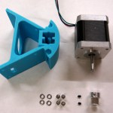

Screw two grub screws in each of the three GT2 pulleys, and then slide the pulley onto the stepper motor shafts. No need to tighten them yet, because they need aligning later on.
Mount the stepper motor on the corner piece, using four M3x8 bolts and M3 washers. The use of a ball head Allen key makes your life easy on this build. Now repeat for all three corners. Aligning the motor to the holes may be easier if you push the screws through the mount first, as they tend to stick in the printed holes.
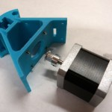

Put four M3x8 bolts with M3 washers into one side of the corner piece, then screw M3 nuts on the top of the bolts.
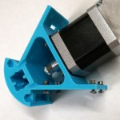

Now slide one of the short OpenBeam pieces over the nuts; rotate the nuts if needed to fit them in the slots. Do the same for the second piece. You may want tighten the nuts slightly to keep the OpenBeam from sliding of.
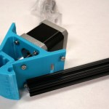

Put four M3x8 bolts with M3 washers into the other side of the corner piece, then screw M3 nuts on the top of the bolts. Repeat for all three corner pieces.
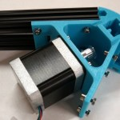

Lay the three parts in a triangle. (IMG_008) And slide all OpenBeam pieces over the first nut, then all pieces over the second nut. (IMG_009) There should be enough play in the beams to do this. If not, slightly loosen the bolts already holding the beams to give more room.
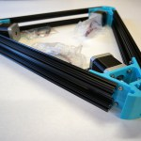

Lay the frame on a flat surface and tighten all 24 bolts with the OpenBeam slid up against the corner pieces. You now have a niece and sturdy triangle.
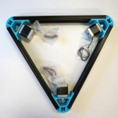

3.2 Upper Frame
需要改为2020的方案
This part describes the assembly of the upper frame.

Snap of the print support circles, and you may want to file the edges for a flush fit of the profiles to the corner pieces.
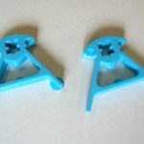

Take an M3x25mm bolt and insert it in the center hole. Screw on an M3 nut, put on two F623ZZ flanged bearings (flanges on the outside) and then put on another M3. This can be fidly, but it will fit. Then screw the bolt all the way in, but make sure the gap between the first nut and the plastic does not get too big, or you risk cracking the frame. The nuts should be tightened, but the bearings must be able to rotate freely.
Repeat for all three corner pieces.
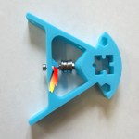

Put two M3x8 bolts with M3 washers into one side of the corner piece, then screw M3 nuts on the top of the bolts. Now slide one of the short openbeam pieces over the nuts; rotate the nuts if needed to fit them in the slots. You may want tighten the nuts sligthly to keep the openbeams from sliding of.
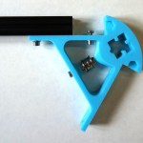

Put two M3x8 bolts with M3 washers into the other side of the corner piece, then screw M3 nuts on the top of the bolts. Repeat for all three corner pieces
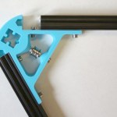

Lay the three parts in a triangle. Slide all openbeam pieces over the first nut, then all pieces over the second nut. There should be enough play in the beams to do this. If not, slightly loosen the bolts already holding the beams to give more room.
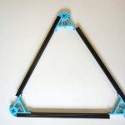

Lay the frame on a flat surface and tighten all 12 bolts with the openbeams slid up against the cornerpieces. You now have another nice triangle.
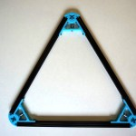

3.3 Carriages
每个carriage用到这些东西：

1个 M5 x 25 螺钉
2个 M5螺母
1个 5mm弹性垫片
1个 打印的零件

考虑采用Mini Kossel V-Slot 3D Printer的方案，见http://www.thingiverse.com/thing:318745

需要研究一下，相关项目可以在这里找到：http://www.thingiverse.com/search/page:1?q=kossel+carriage&sa=

This part is just to build the carriages for our Wheel Conversion Kit. If you want to know if this is something for you check our Rails or Wheels page.
If you are building the rails version then skip this step and continue to the next.

Insert 3 M3 nuts into the holes on the rail carriage. They can be pretty dificult to get in. Be very cautious! The safest way is to drill the holes open with a 3mm drill. That clears the holes for the bolts. Insert a bolt (any M3 sized one), put on a nut and gently pull the nut in it’s hole. Go slow! If you need to use much force then stop and unscrew the bolt.
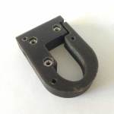

Insert 3 M3x25 bolts in these holes
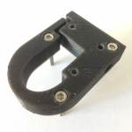

Add a washer and a nuts on the other side. These act as spacers to clear the carriage from the OpenBeam rails. If you need more clearance then just add a washer
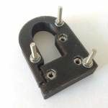

Insert a 623ZZ bearing in each V-roller and place them on the bolts.
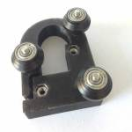

Secure the rollers with a nyloc nut. Tighten them so that there is nu play but the rollers need to be able to move freely and without much friction.
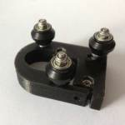

Flip it over and attach the carriage to the rail carriage. There are 2 M3x25 bolts on the top and a M3x16 on the bottom. Slide in the M3x40 bolt in the hole on the side. Add a nyloc nut on the other side. Tighten the bolt only loosely. One carriage is now done. Repeat for the other 2.
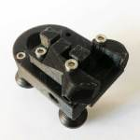

3.4 Diagonal Arms
Cut the carbon or aluminium rods (or buy our carbon rods that are already cut) in 6 pieces of 180 mm. It’s ok if they are 181 mm or 179 mm as long as they are all the same. This is very important! Screw the M4 screws into the Traxxas rod end. About 1 cm should go in. | 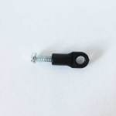
Cut of the heads of the M4 screws with a metal saw. Be careful not to damage or twist the rod ends. You can use pliers or a vise to hold the screw by it’s head. | 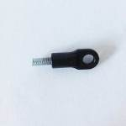
Now you need to glue the rod ends with the screws into the carbon or aluminium rods. As I said, equal length is crucial so a good way is to make a jig. If you bought a kit from us than 2 jig parts are included. Mount these on a piece of wood for instance at 215 mm. Put glue on the bolt threads and insert them in the tube. Make sure there is enough glue to make good contact. Place the assembly in the jig and let it dry. Repeat for the other arms. This ensures they are of equal length and that the rod ends are lined up straight. | 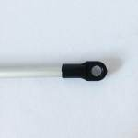
Push the metal ball joints into the rod ends. Be careful not to bend or damage the ends or rod. | 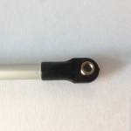
Continue to the next step…

3.5 Bed probe
Cut of the head and the sharp tip (about 1 mm) from the safety pin. | 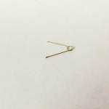
Insert the M2.5×12 bolt through the hole of the safety pin and into the Z-probe. | 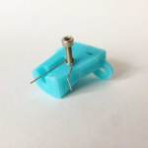
Gently bend the left leg to line up with the hole and push it in. Secure it by tightening the screw. | 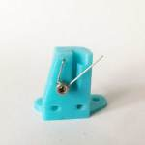
Bend the legs of the micro switch like this and mount it on the z-probe with 2 M2.5×16 srews.  If your microswitch comes with a lever than remove it. Just snap it off with a some pliers by bending it sideways. | 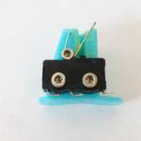
Continue to the next step…

3.6 Effector platform
Gently screw in the push fit connector into the hole. Make sure the hole is the correct size for your connector’s thread. | 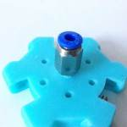
Connect the rod arms to the platform using a M3x25 bolt and a M3 nut. Repeat for all arms. | 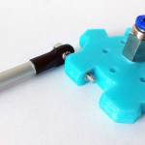
Connect the assembled carriages to the other end of the arms with the M3x20 bolts and nuts. In this picture the actual platform is oriented with the connector facing up (so flat side down). | 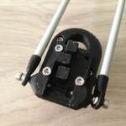
Do this for all 3 sides so you end up with this nice 3-legged spider. | 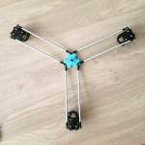

3.7 Extruder

经过测试,将使用Compact Bowden Extruder, direct drive 1.75mm http://www.thingiverse.com/thing:275593 的方案.
测试结果表明，确实很好用。

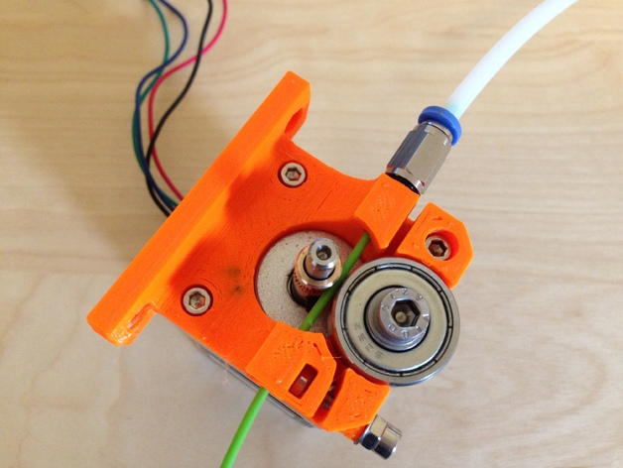
A compact direct drive bowden extruder for 1.75mm and a MK8 style hobbed pulley. The OpenScad is almost completely parametrizable, so it can be adjusted to fit other hobbed pulleys as well. The mounting plate can be removed from OpenScad easily.
I have used a 13x8mm, 5mm bore brass hobbed pulley, because it was easy to acquire here in Germany.
The used MK8 style hobbed pulley can be ordered at the following website:
https://www.reprapsource.com/en/show/6889
Note: I haven't ordered a suitable compression spring, so it's not visible on the images.
UPDATE 2014-06-01: Removed the work-in-progress flag after extensive testing and positive feedback from the community.
UPDATE 2014-04-27: Placed base and idler "printer ready" beneath each other, added compact_direct_drive_extruder.stl with base and idler combined
UPDATE 2014-04-07: Replaced tensioner hole with slot on idler, added funnel on bowden side of base for easier filament insertion
Parts used (BOM):
- 1x base plate (printed)
- 1x idler (printed)
- 1x hobbed pulley 13x8mm, 5mm bore or similar
- 1x 5mm OD push-fit bowden connector
- 1x 608zz bearing
- 1x M5 washer
- 1x M5x10mm allen head screw
- 3x M3x8mm allen head screws
- 1x M3x16mm allen head screw
- 1x M3 nut
- 2x M3 washers
- 1x compression spring 3mm ID
- 1x M3 allen head screw with suitable length for the selected spring
Tools used:
- M5 manual screw tap
- 2mm drill

Instructions
- Important: If you're not using the same 13x8mm drive gear as I do, adjust the drive gear dimensions in the OpenSCAD file and export idler and base as separate STL files.
- Slice model and print base plate and idler separately. I used Slic3r with 0.2mm layer thickness and a 0.5mm J-Head nozzle.
- Use 2mm drill to clean filament path on base plate.
- Use M5 screw tap to cut thread for push-fit bowden connector on base plate and bearing holder on idler.
- Attach 608zz bearing to idler and secure it with a M5 washer and a M5x10mm allen head screw.
- Attach NEMA17-Motor with three M3x8mm allen head screws (use countersunk holes).
- Attach idler to base plate with a M3x16mm allen head screw. Avoid to much tension to allow idler moving freely.
- Fasten hobbed pulley on NEMA17 stepper motor shaft. Adjust its height accordingly.
- Insert Filament into extruder.
- Insert M3 nut into base plate slot.
- Use M3 allen head screw of suitable length with washers and a spring to apply pressure on filament.
- Happy extruding ;-)

Mount the spur gear on the stepper-motor and tighten the little bolt inside. | 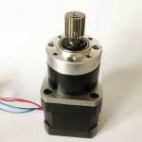
Widen the hole where the connector goes in with a 2 mm drill. Do the same on the other side with that small hole. This is where the plastic will go through. Gently thread in the push fit connector. Make sure the hole is the correct size for your connector thread otherwise the plastic will crack. Also make sure it has gone in straight. | 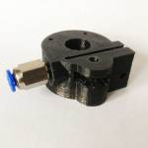
Drop in the M5 nut. | 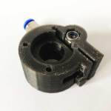
Mount the assembly on the stepper motor using 3 M3x25 bolts. Be careful that the M5 nut doesn’t drop out. | 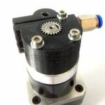
Mount the M3x16 bolt through this hole and place a nyloc nut on the end. | 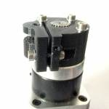
Remove the temporary support and place the 625 bearing in this slot and screw in the M5 bolt to hold in in place. You probably need to cut away some plastic to let the bearing go in and run smoothly. Don’t over-tighten the bolt! | 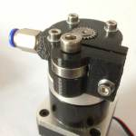
Not a real build step but just to show you how this extruder really bites into the plastic! | 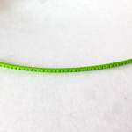

3.8 J Head hot end assembly

目前使用的方案是这个:
http://item.taobao.com/item.htm?spm=a1z09.2.9.209.WJWkYS&id=37929012283&_u=op380hf5d40
考虑目前涨价了: 从78元涨到92,考虑采用更低成本的方案。
也就是传统的喉管+铝块+ 喷头的方案。

This part describes the j head hot end assembly for a standard j head. It is the most used non-metal hot end in the world of 3D printers. Here’s how to assemble one.
These are the parts that you get with a typical hot end kit. Something no kit (ours included) shippes with a a rol of Kapton tape. This should be part of your standard tool kit however, especially when working with J-heads. You can get it in our shop off course.
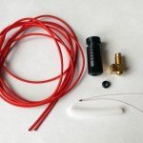

Officially this is an optional step but it’s a best practise to do it. You will need some PTFE tape (also known as plumbers tape for sealing tubes and threads). Wrap some around the brass head. Make it a few layers thick and wrap it tight.
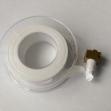

It should look something like this.
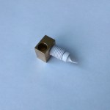

Use a knife to cut of the excess tape. Make sure the threads are covered.
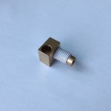

Insert the hotend into the PEEK body. Don’t overturn it near the end. Just make sure it’s secured.
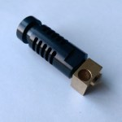

Cut a piece of the PTFE tube approx. 25mm long. Make sure the cuts are as straight as possible.
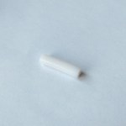

Insert it in the body. It should be just below the inner threads. If it’s too long then shorten it a bit. Don’t make it too short off course.
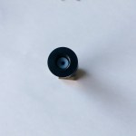

Take the thermistor and make sure the leads are isolated from each other. A simple way to do this is to wrap them in a piece of Kapton tape. You could also use a small silicone tube or heat-resistant sleeves. Just be sure it can take the 200+ degrees of heat.
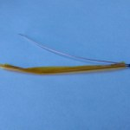

Insert the thermistor in the small hole in the hotend. Place it as deep as you can.
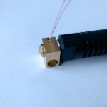

Keep it in place with a small piece of Kapton tape.
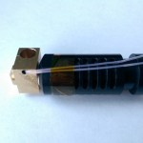

Insert the Heater cartridge into the big hole.
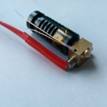

Keep it in place with a small piece of Kapton tape.
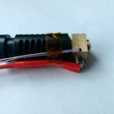

Wrap the head in Kapton tape. The important thing about this is that the thermistor and the heater cartridge won’t be able to move or get loose. If one of them does you can probably throw away the hotend because it will overheat. When you are sure that all is secured well then you’re done. Now solder some wire to the thermistor or better yet, place a Dupont connector on it. Then you can easily remove it if you need to in the future (and you probably will some day).
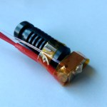

3.9 Electronics

外壳考虑采用这位兄弟的：http://www.thingiverse.com/thing:320117
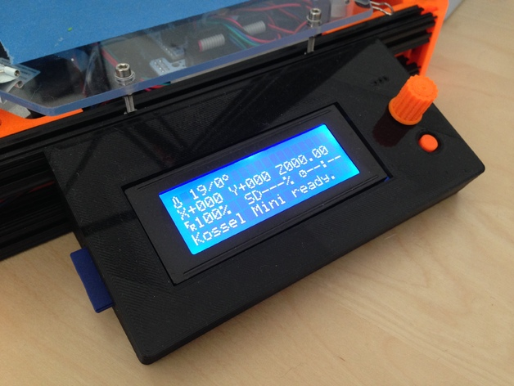
This part is tricky to describe because there are so much personal choices as I mentioned in the sourcing page. There are several ways of doing this. The most commonly used set is the RAMPS system which consists of several boards. Below is description how to join these boards.
You may choose to use another system without penalty just make sure the general connections are the same.
If you have some troubles please refer to the manual of the manufacturer for information or forums on the internet since we can’t support every system out there.
Place the RAMPS board on the Arduino. | 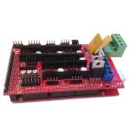
Place the jumpers on the RAMPS board. These set the stepping rate. No jumper means just the hardware steps (200 per rotation). 1 jumper makes 4x the steps, 2 jumpers make 8x steps and 3 jumpers make 16x steps. That means the original 200 steps per revolution are multiplied to 3200 steps. | 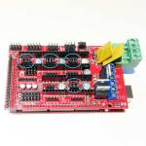
Place the controllers on the print. Mind the orientation! If your controllers looks like mine than place them like in the picture. If not, refer to the manual of you controller and of the RAMPS board to see what the orientation should be. | 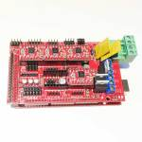
Optionally, you can mount heat-sinks on the stepper controllers and/or a fan but didn’t need to.

3.10 Final Assembly
Insert 2 M3x8 bolts into the holes in the side of the cornerparts. Loosely put on a nut on the inside just like when you’ve put the bottom frame together. Slide the long OpenBeam rods in the bottomframes corner parts. This can be a bit tricky so gently guide the nuts into the OpenBeam cavities. Yes, the use of a rubber hammer is permitted but off course be carefull. Push the OpenBeam through until it’s flush at the bottom. Tighten the bolts to secure the OpenBeam. Repeat for all 3 sides. | 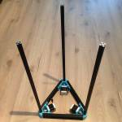
Put a M3x8 through the center hole of the endstop and loosly put a nut on it. Slide the endstops on the inside of each rail.
Rail version only!Mount the rails on the OpenBeam. You don’t need to use all holes but don’t use to few either. We alternate them. | 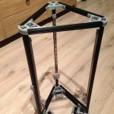
Rail version only!Mount the printed carriages on the metal ones using 2 M3x8 bolt for the 2 bottom holes and M3x16 for the top ones per carriage. | 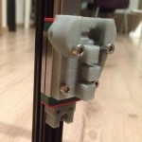
Wheel version only!Slide the wheeled carriages from the assembled spider onto the rails. Be carefull not to overstress the joints. They should just slide on. Adjust the tension with the bolt on the side of each carriage. Just make sure it moves smoothly and without any play. | 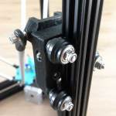
Insert 3 M3x8 bolts and nuts into the extruder frame and loosely put on bolts on the other end. Slide it on the backside of 1 of the long rails. | 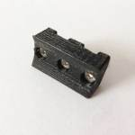
Position it about half-way and tighten the bolts. Use 2 tie-wraps to mount the extruder on the extruder frame. Slide the PTFE tube in the connector. Make sure it is fastened securly. | 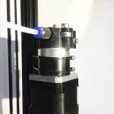
Mount a microswitch to an endstop using 2 M2.5×16 bolts. Put a M3x8 through the center hole of the endstop and loosly put a nut on it. Slide the endstops on the inside of each rail. If you have received a switch with a lever than remove it with some pliers by bending it sideways. It should snap off fairly easy. | 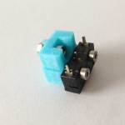
Insert a M3x8 nut into the side hole of the top frame’s cornerpieces. Add a nut on the inside just like the bottom frame. Place the assembled top frame onto the rails. Officially there is a M3x35 bolt used as a tensioner but i just couldn’t get it set up correct so i left it out. In my opinion it is not needed at all. Leave about 1cm of space from the top of the OpenBeam. That way you have some room to slide it up for belt-tensioning. Tighten the bolts to secure it in place for now. | 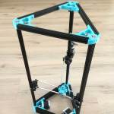
Slide the endstops up until they hit the topframe and tighten the bolt to secure them. Move the platform spider up and down to make sure each carriage hits the endstop. If it doesn’t than you can add some washers between the switch and the endstop. | 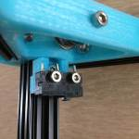
Insert the 1,5mm allen key in the bedprobe. Be sure to apply some grease in there to make it move smoothly. I have attached a couple of cm’s to the bended tip of the allen key to make it easier to catch the belt when it’s calibrating. Insert 2 M3x16 bolts in the mounts of the assembled bed probe. | 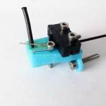
Mount the probe onto the platform and secure with 2 M3 nuts. I suggest doing it facing the rear leg where the extruder is mounted. This way it’s not in the way of the hot end when you need to clean it or something. | 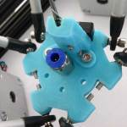
Slide 2 ball point springs over the allen key and lock them in place with the Euro-style terminal block connector. If you’ve bought a kit from me than this printed version is included. Just drop in an M3 nut and secure it with any kind of M3 bolt. The M3x8 bolts are just a bit to short so cut off a larger one or get a M3x10 bolt. | 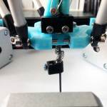
Test the probe. It should drop out of it’s holding place when you turn it a bit and hit the switch. Probe something and make sure that the switch is released and pressed again when the allen key lifts and lowers when probing. Also test if it will go up again into it’s resting position. Adjust the tension on the springs and/or add more grease to make these things happen. It is important this operates smoothly! Check the pictures to see how it should look when deployed and retracted.My allen key is 7cm long. If it is too long just cut or grind it to size. If it’s to short you can lengthen it by adding a piece of another allen key or some other very stiff material (preferably metal) to to probe. You can use the euro-connector to hold both the allen key and the extension.If in a jam, you could also use a larger 2mm allen key. Just widen the holes and shaft to accommodate the larger allen key.Here is a video demonstrating the deployment of the probe. | 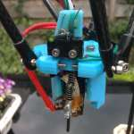  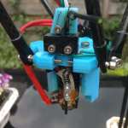  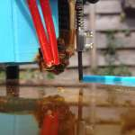  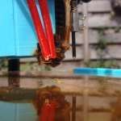
Run the belt around the motorpulley… | 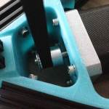
…and over the top idler. | 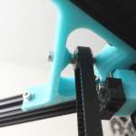
Run the belt through the carriage like on the picture…  (forget that little blue belt coupler, it’s been replaced by a better one. See below) | 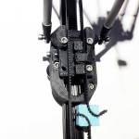
…and secure with the belt coupler. Use 2 small tie-wraps to secure the belt. It will hold without but it will come loose some day. With the tie-wraps it will hold no matter what. | 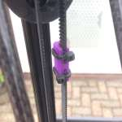
Loosen the bolt that holds the top frame in position and gently slide it up until the belt is tight. Not to tight but certainly not to loose. Tighten the screw again to secure it in place.If you haven’t already tightened the GT2 pulleys then do so now. Place them in a way that the belt is in a straight line as much as possible.
Mount the electronics somewhere on the 3D printer. I chose to mount it inside the bottom frame. That way it’s not in the way of any moving parts, it looks good and it’s away from prying hands. You’re free to place it anywhere else. Just keep the connections the same. I’ve designed and printed a frame to support the electronics but you can use anything you want, even tie-wraps.
Mount the 3 glass plate holders to the frame. Use a M3*8 bolt and a M3 nut. Slide the nut in the rails. There is a small cavity in the printed motormounts to do this. Place the glass plate on the tabs and adjust until the center of the glass is under the hotend. You don’t have to align it to 1000th of millimeter. Just align it roughly. Secure the glass plate by tightening the bolts of the glass tabs. | 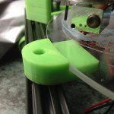
If you bought a heated bed from us than mount it like this. Remove the backing tape and stick it to the glass. Done. The rest is electrical so covered in a different section. | 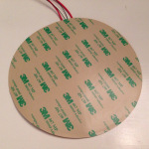  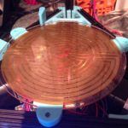
Continue to the next step…

3.11 Wiring
I can’t say it enough, double check your connections! Route the cables neatly and keep them well organised with tie-wraps or cable sleeves.
注意，3个电机应该按照X-Y-Z 逆时针排列。否则会导致一些意外的情况出来。
First here are the schematics so when you route the cables you can can see where you need to go. If you need a bigger version for more detail, you can get it here.  You can plug in the motors, the hotend temperature sensor and connect the heater and fan wires. Orientation for the motors and fan is important, not for the rest. | 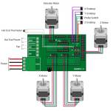
The micro switches all have 3 connections. They are labelled COM, NO and NC. Solder 2 wires to the COM and NO connections (the 2 outer ones) of the endstops. Route the cables through the sides of the OpenBeam plug them into the correct position. It doesn’t matter which way you plug them in as long as they are in the right spot. | 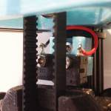
Do the same with the probe switch but now use COM and NC. | 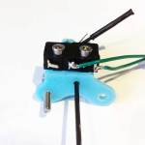
You’re 3D printer is now ready for use. Make a final check that the platform can move in all directions freely but without any play. The frame should be sturdy and the electrical connections safe and double checked. If all is OK than let’s move on to getting this thing up and running!

4. Initial set-up
First download all the programs for controlling and setting up the printer ;
- Arduino IDE - To configure the firmware
- Pronterface - Controls the printer and is used for testing
- KISSlicer – My personal favorite slicer. Download my settings Here
- Firmware – The adapted version of the Marlin firmware which is already modified for the Kossel with the RAMPS electronics. We have firmware for the Kossel Mini (RAMPS), Kossel Mini (Minitronics) and KosselXL (RAMPS).
My firmware is based on Johann’s Deltabot fork and the only modifications are to fit it to the Kossel so some size differences, steps settings and lcd/motherboard settings.
If you use different electronics or use a different LCD (or none) change these values as well. Look through the file, it is pretty self-explanatory. When the basics are set proceed with uploading the firmware.

Upload the firmware
Open the file Marlin.ino with the Arduino software. It will open a lot of files which are displayed in tabs.
A whole list of files, but fortunately we only really need these four :
- Configuration.h – Lists the main settings for the printer. Click the link for more information on the most common settings.
- Configuration_adv.h – Contains some more technical settings. Normally we wouldn’t need them.
- Marlin_main.cpp – Contains the location settings for the auto level function.
- Pins.h – Contains all pin definitions that connects the software to the physical pins on the electronics board.
Always save a working configuration! You can’t extract the firmware from the Arduino, only upload a new one.
Go to the Configuration.h tab. Locate the section “Delta Settings” and the line #define DELTA_DIAGONAL_ROD. Measure the distance of your diagonal rods. It should measure 214 mm between the center of the 2 holes on each end. If it’s not 214 mm then change this value to your measurement. If you’ve build them accurately, which you should have, then they would all be the same length.
Gently move the spider to the very top until it hits the endstops on all 3 legs. Measure the distance between the tip of your hotend and the surface of the bed. Now find the variable #define MANUAL_Z_HOME_POS in configuration.h and change the value to the height of your machine (in mm).
Hook up a standard USB cable to the electronics.
RAMPS electronics only: Select the Arduino MEGA board in Tools => Boards.
Then upload the custom firmware by clicking Upload. The software will check your code for errors, and then upload it to the board. Every time you make a change you need to re-upload the firmware this way. Remember that it’s not real-time so the printer must not be printing when you upload new firmware.
Some led’s will start blinking during the upload if all goes well. When they stop and the software says that the upload is done you’re ready to get it to do something.

Checking basic functionality
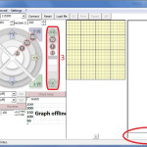

Connect the printer to your computer and start Pronterface. The screen should look similar this picture.
There are 3 main areas/buttons.
- This is where you can do almost everything. It’s basicly a direct communication to and from your printer.
- This is the home button. It’s a quick shortcut to get your printer to it’s start position.
- This is the height control of your printer, known as Z-height or Z-axis.
As I said, number 1 is the place to be. You printer is controlled using Gcode. It’s a semi-universal language for CNC machines and now altered for 3D printers. Gcode is just text and consists of simple 3-4 digit codes to make it do something. For a list of available Gcodes look here.
A typical piece of GCode as sent to a 3D printer might look like this:
G28
G92
G1 X10 Y50 Z0 F3000
Let’s just begin using them and it will become clear what they mean.
Check that the connection speed (top row) is similar the the setting in your configuration.h, normally 250000 and that you have selected the USB port where the printer is attached. Hit Connect and you should see the spiral thing lite up and see some text scroll in the righthand window. You are now connected to your printer. Getting anxious yet?
Go to the console area (at number 1 in the picture). Type M119 and hit enter (all commands are followed by enter). This command returns the status of the endstops. If you printer is not touching any of the endstops then the result should be ‘open’ on all endstops. Now hold down one of the endstops and do a M119 again. One of the results should be ‘TRIGGERED”. Repeat for the other 2 endstops and the Z-probe. The Z-probe switch should behave exactly the opposite.
If the endstops do not respond at all check your wiring and check with a multimeter if the switch is working. Check that it’s plugged in the board correctly. If they do respond but report “open” when triggered and “TRIGGERED” when the’re not, switch the wiring on the switch.
If the endstops work OK enter G28 in the console. This is the command to home the printer and is the same as hitting button no. 2 in the picture. The spider (the moving part of the printer) should now go up, hit the endstops twice and stay there. If it doesn’t stop, kill the power as fast as possible and check your endstops again! If a motor is going down instead of up, check the wiring of that motor and match it to the others.
Wow, that’s the sweat-in-your-hands part. If this works you’re halfway there.
Now, type G1 X0 Y0 Z100 in the console. The spider should now move straight down till about 10 cm from the bed.
Here’s the explanation about this Gcode command. G1 means doing a controlled movement. X0 & Y0 are coordinates on the X and Y plane (in this case dead center) and Z100 is the height from the surface of the bed (Z0 is almost touching the bed).
Now make it move 10 mm down by decreasing the Z height (G1 Xo Y0 Z90). If the difference is indeed 10 mm then you’re doing great. If not, increase or decrease the DEFAULT_AXIS_STEPS_PER_UNIT value and repeat these steps until you get it right. Always start with a G28!
You can play around a bit by giving it some coordinates like G1 X70 Y-50 or G1 X0 Y80.
Now the last thing to set-up is the extruder. Disconnect the bowden tube from the extruder if you already had it on there. Run some filament through it until it comes out the end where the bowden normally is. Now give the command G92 (sets the extruder to 0) followed by G1 E10 F1000. This tells the extruder to put out 10mm of plastic (the F1000 is to set a specific speed, otherwise it is way to slow). Now measure the amount that has actually come out. If it is too short then increase the last value in the line #define DEFAULT_AXIS_STEPS_PER_UNIT {100, 100, 100, 450} in Configuration.h. If you have to much plastic decrease the number. Be very precise here!
If this all works then proceed with the actual calibration.

Configuration.h

需要的参数都是可以自己量出来的
问题只是1604的显屏跟2004的有区别，不知道怎么驱动。
以我整理的固件为例 github.com/zenz/marlin_for_rostock_mini_pro
其中，Configuration.h中跟并联臂打印机相关的各个参数是：
#define DELTA_DIAGONAL_ROD 184.5 <--这个是臂长，量一根吊臂上两个轴心中心到中心的距离。
#define DELTA_SMOOTH_ROD_OFFSET 139.5 <--这个是垂直下来之后，挤出嘴到3跟竖杆的距离（最近处）。
#define DELTA_EFFECTOR_OFFSET 33 <--这个是挤出嘴到同一侧吊臂两个轴芯形成的线之间的距离。
#define DELTA_CARRIAGE_OFFSET 22 <--这个是滑车上的吊臂轴心到竖杆的距离（最近处）。
#define DELTA_PRINTABLE_RADIUS 70.0 <--有效打印半径，记得减掉风扇等影响的距离，否则会打到杆子。
#define XYZ_FULL_STEPS_PER_ROTATION 200 <--步进电机转360度需要走多少步，一般NEMA17的步进电机，每步是1.8度，所以需要200步，这个一般是固定的。
#define XYZ_MICROSTEPS 16 <--A4988插线精度（一般插满就是16分）
#define XYZ_BELT_PITCH 2 <--传送带的齿距（一般都是2mm）
#define XYZ_PULLEY_TEETH 36 <--传动齿轮的齿数，量一下。
#define MANUAL_Z_HOME_POS 180 <--这个是可打印的Z高度，自己通过Pronterface等工具慢慢走来确定可以走动的行程。
还有就是几个限位开关的状态，步进电机转向的定义等。
如果限位判断不正确，就把取值反过来。
const bool X_MIN_ENDSTOP_INVERTING = true; // set to true to invert the logic of the endstop.
const bool Y_MIN_ENDSTOP_INVERTING = true; // set to true to invert the logic of the endstop.
const bool Z_MIN_ENDSTOP_INVERTING = false; // set to true to invert the logic of the endstop.
const bool X_MAX_ENDSTOP_INVERTING = false; // set to true to invert the logic of the endstop.
const bool Y_MAX_ENDSTOP_INVERTING = false; // set to true to invert the logic of the endstop.
const bool Z_MAX_ENDSTOP_INVERTING = false; // set to true to invert the logic of the endstop.
如果步进电机反转了，就把后面的false改为true
#define INVERT_X_DIR false // for Mendel set to false, for Orca set to true
#define INVERT_Y_DIR false // for Mendel set to true, for Orca set to false
#define INVERT_Z_DIR false // for Mendel set to false, for Orca set to true
#define INVERT_E0_DIR false // for direct drive extruder v9 set to true, for geared extruder set to false
基本上就这么些东西了，其他都是编译的时候计算机自己计算的，不需要人干预了。
对于第三个问题，一般情况下，打印PLA的温度要求不高，风扇直接吹铝块也不会影响到加热。如果确实希望保温良好，那么用保温棉纸把铝块包一下，再用耐热胶带缠上，只留出挤出嘴露出来，就可以了。

Here a list of the most common variables that you may need to edit in configuration.h
#define BAUDRATE 250000
Sets the communication speed to the Arduino. 250000 is good but if you have troubles lower it to115200.
#define DELTA
Tells the firmware we’re dealing with a Delta and not a Cartesian model.
#define DELTA_SEGMENTS_PER_SECOND
You can’t make a true circle, all circles are actually segments of small straight lines. This sets how many of these segments can be calculted. Higher is better but an Arduino doesn’t have the processing power to calculate it all so 200 is a good balance.
#define DELTA_DIAGONAL_ROD
Indicates how long the arms are from hole to hole . In my case, 214 mm.

#define DELTA_RADIUS
Displays the curvature correction of the print head. Too large leads to cupping, too small makes the printer think that the printing surface is a mountain peak. This value is made up of DELTA_SMOOTH_ROD_OFFSET , DELTA_EFFECTOR_OFFSET and DELTA_CARRIAGE_OFFSET.
If you want adjust the DELTA_RADIUS then alter DELTA_SMOOTH_ROD_OFFSET. The autoleveler calculates this more accurately.
#define TEMP_SENSOR_1
Sets what type of sensor is in the hot-end. Choose the one that comes with your hotend . Most thermistors will work with option 1. The rest can be set to 0 since we have only one sensor.
#define TEMP_HYSTERESIS
Sets how much the measured temperature value may deviate from the reference value. Default is 3.
#define HEATER_MAXTEMP
Sets the maximum temperature for the hot end. Be careful going over 245 degrees Celsius because
above this the Teflon liner will smoke and it emits toxic fumes.
#define EXTRUDE_MINTEMP
Sets the minimum hotend temperature before the extruder may start supplying plastic. The extruder will not work below this temperature as a safety funtion. You can disable this for testing but be careful.
#define ENDSTOPPULLUPS
Sets the internal pull-up resistor so the firmware can read the switch.
Const bool X_MIN_ENDSTOP_INVERTING
Sets the normal state of a switch. So if it should be reported as triggered if it’s pressed or when it’s not pressed.
#define X_HOME_DIR 1
Sets the location of the endstop. 1 is at the top, -1 at the bottom
#define X_MAX_POS 90
Sets the range of your buildplatform, in this case from 90 to -90 which is 180mm of movement. The printbed is off course 170 mm but this little overhead is needed to be able to print ‘over the edge’ and to reach the probe retract position if this is not a separate raised point.
#define Z_MIN_POS
This tells the printer it can go 30mm under the printbed. This is also for the retract position if this is not a separate raised point.
#define MANUAL_X_HOME_POS
Sets the total height of the printer. Just measure it from the tip of the hotend to the printbed surface. The autolevel feature will adjust this setting somewhat to make the surface flat for the firmware. Be aware, it will not move to a value higher than this so if the autolevel needs to be lower than this it will not work. Better to measure from the tip of the retracted probepoint to the surface and add an extra cm.
#define AUTOLEVEL_GRID
Sets the distance between the measuring points during autoleveling.
#define HOMING_FEEDRATE
Sets how fast the printer returns to the home position , in mm / min.
#define Z_PROBE_OFFSET
This is the setting that you will change the most. This sets how far the tip of the probe is below the tip of the hotend when in it’s extended position.
#define DEFAULT_AXIS_STEPS_PER_UNIT
Sets how many steps the stepper motor must make to move the platform 1 mm. On http://calculator.josefprusa.cz/ # MotorStuffSPMB you can calculate how much it must be for your printer . The suggested motors with 1.8 degrees per step , control with 1/16 microstepping , 16 teeth on the pulley and GT2 belt will give you 100 steps. If you have 20 teeth, then it’s 80 steps etc. You may need to adjust this value so your printer will print the correct size . The extruder is more difficult to calculate but it’s easy to test. In PrintRun give the command to extrude. For example 10mm. Then just measure how much comes out . Be very precise!
#define DEFAULT_MAX_FEEDRATE
Sets the maximum speed at which the plastic can be extruded.
#define DEFAULT_MAX_ACCELERATION
Sets how fast movements may be performed in mm/sec.
#define DEFAULT_RETRACT_ACCELERATION
Sets how fast the filament may be retracted to prevent stringing.

5. Calibration
Before we begin with the calibration
This guide is based on the RAMPS electronics system. It’s very OK to have another system but refer to you documentation when I mention something related to the RAMPS hardware or specific firmware settings.
The steps are the summary of several sources on internet fora, discussion groups and personal experience. A great big thanks goes out to the Let’s make Robots hackerspace for their help.
Get familiar with G-Code
Most 3D printer firmware operates on a standard set of instructions called G-Code, which are sent to the printer via serial connection. There is a code for everything, turning the heater on, going to an end-stop, writting settings to the EEPROM. My recommendation, before you start moving any part of your printer, read through the G-Codes. This will give you an idea how your software talks to the printer.
- G-Code wiki
Check and re-check endstop before testing motors
Now that you’ve read up on G-Code, we know the code to check and see if the endstops are triggered is M119. Check this a few times before you attempt moving anything electronically. If everything is connected correctly it should look like this,
No Buttons Pressed:
- Y_MAX: Open
- X_MAX: Open
- Z_Min: Triggered (This is your probe switch)
- Z_Max: Open
All Buttons Pressed:
- Y_MAX: Triggered
- X_MAX: Triggered
- Z_Min: Open
- Z_Max: Triggered
It is important to have these trigger correctly, otherwise, your hot-end will go crashing into something. For example, if one the end-stops isn’t triggering then the connected carriage will continue trying to pull past the end-stop, which will result in the your belt-link coming apart or worse.

Fans
The Kossel Mini has a small 40x40mm fan that blows directly on the hot-end, all the time.
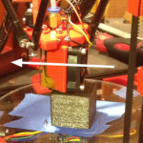
This is required because the hot-end holder is actually a printed part, meaning it is plastic, therefore, if the hot-end exterior isn’t constantly cooled, it will melt the holder and come crashing down on your print plate in a neat heap of defeat.
The fan should operate on 12V. You have several options.You can tie the fan into the PSU itself, which would cause the fan to be on everytime the printer is on. Or, you can tie the fan into the RAMP’s board (connector D9). Whatever you choose is OK.
Ok. Now we have a few things to set in firmware to get the fans to act correctly. First, make sure you are using the correct electronics option under Configuration.h
- #define MOTHERBOARD 33
Again, this is for RAMPS only. This sets the three power channels on the Ramps to function as the following:
- D10 = Extruder Heater (hot-end)
- D9 = Fans
- D8 = Heated Bed
Now that is setup, then everything should work right? Well, kinda.
First, the fan won’t come on automatically, you have to send the G-Code command “M106 SXXX” to get it to turn on, the XXX being a number between 0-255 to set the PWM of the fan (also, the command M107 used to be to turn it off, but now we just send “M106 S0″).
Some fans don’t like to kick on with PWM. Now, for this there is an option under the Configuration_adv.h,
- #define FAN_KICKSTART_TIME 100
The number is the number of milliseconds to drive the fan at full speed before switching to a temperature based PWM. If this still doesn’t help than just connect it to your 12V source.

Physical Print Calibration
“But I bought a Kossel ’cause it’s got an Auto-Probe!” True, but the auto-probe is like many things in electronics, nice to have, but does not replace the ability or the understanding behind it. I’ll go as far as stating, the auto-probe is meant to keep your physical calibration on track, even after heavy use, rather than compensate for poor calibration. As clever as it is, it is not a substitute for good build quality or sloppy fine tuning. A Delta will print best when accurately built and tuned.
The G28 command
One important thing to know is: G28 CANCELS G29 DATA
G28 is the G-Code to home the tower endstops, just know whenever you do this, it will cancel the readings you took from the auto-probe. Some argue that you only need to do a G29 (probe) once every other time and not go to home in between. I disagree strongly. This might work if your steppers never loose their power but, as pointed out earlier, they have an inactivity timer that disables them. After that, they might skip a step or 2 and your home is off. Same goes for powering it off or manually moving the hotend. I advise to do a G28 and G29 before every print. This will tell the printer to set a point zero (home) and probe to detect minor deviations. That way you know for sure that it is setup correctly for each print and adjusts itself if needed. So in short, do a G28 before each calibration adjustment and each print!

Alright, to calibration.
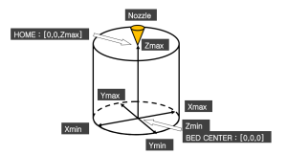
Before we begin calibration, let’s define and agree on what we will be calibrating:

For the sake of brevity, I’m going to define the paper-test once, then simply refer to it as the paper-test.
Paper-test
The idea is eventually you want about a paper’s width space between the hot-end and the printer bed, when the printer is told to go to Z0. First home your printer for a point zero by giving it the G28 command. The paper-test consists of putting a piece of paper on the print bed, then lower your hot-end manually, 10mm steps at first, but as you get closer, 0.1mm steps. At the point the hot-end is putting just enough pressure to create a little drag on the paper, you stop going down. This is the paper-test.

Ok, here we go:

Step #1 — Calibrate ZMax
This takes care. Go to Configuration.h and set,
- #define MANUAL_Z_HOME_POS 270
This is going to tell your printer you have a build volume larger than you do, but we do this so the firmware wont stop us as we try to move the hot-end as close to the bed as possible. Now, perform the paper-test.
Ok. You lower the hot-end carefully until it passes the paper-test. Then, send the G-Code for getting the Z position.
- M114
The printer will respond with the current value for the X, Y, Z, and E (extruder). You only want the Z-value you right now. Take the Z-value and subtract it from the 270, this will be your new MANUAL_Z_HOME_POS.
- MANUAL_Z_HOME_POS = 270 – Z_Value obtained by paper-test.

Step #2 — Calibrate Physical Center
Now, there is a way to set the center of your build plate in your Marlin firmware, but it is better only to tweak it there after you have the physical part set pretty damn close to center. This is what I did.
Print the Kossel_Calibration template to scale on a piece of paper. Cut this paper out and center it on your glass build plate, then tape it down.
Next, lower your hotend until it is near to center.
Firstly, position the glass plate in the center as much as possible. Using the controls, attempt to center the hot-end above the circle the best you can. It helps to change your angle several times before each move. Once it is center we are going to take a measurement, but something important to know before we do. The stepper motors will timeout from their held position, going into an idle position. Be careful not to let them timeout on the next two steps, since you’ll lose a little time by needing to start over. To keep them engaged, simply micro step one direction, then right back.
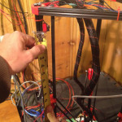
Ok, measure from the top of one of the carriages to the bottom of the plastic on an end-stop, basically, where the end-stop button would be if it was pressed. Also, which end-stop doesn’t matter since our goal is to get them all the same.
Now lower the hot-end to Z0 (remember to do a G28 first!). Then, re-center using the target-template. Now, measure the distance between each end-stop and the top of its respective carriage, being careful not to let the motors go idle. If the end-stop is too high, lower it until it is at the same height. If it’s too low, raise the end-stop. In this manner you are assuring each arm is equidistant from the print bed, while maintaining the hot-end “centeredness”. You can also use a piece of wood or something that you cut to the same length and use that as a reference. Just be sure it is a straight cut.
After this is complete, you must repeat Step 1. This sets “centeredness” and Z-height.
Now, test this by sending the G-Code:
- G1 X0 Y0 Z15
If all worked, the hot-end will magically find its way to the center of the print bed, while staying 15mm above the surface. If that goes well, microstep the hot-end back down to the surface to assure we maintained the correct Z-height (aka, print volume).

Step #3 — Flat Print Surface
Even after all this, we still aren’t done. There is another variable to calibrate on the Kossel, the flatness of the plate.
We have already calibrated the Kossel’s print volume height. This means if we send the command G X0 Y0 Z0 then the hotend-should come to rest at the center of the print bed, about .1mm above the surface. But, delta printers have an additional variable of flatness. Consider the two following images:

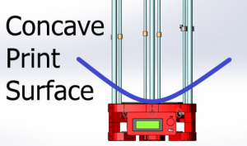
In this image the blue line is the print surface according to the Marlin firmware.
Do you see how this could create a problem? The center Z offset may be correct, but as the hot-end moves towards the edges, it gradually rises until the hot-end is resting 2-10mm away from the print surface.

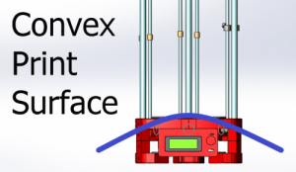
Let’s look at the other, possibly more damaging, scenario.
If the print bed, according to firmware, is convex, then the hot-end might be correct when at center, but as you get to the edges, the machine tries burying your hot-end into the glass plate.
This is why Johann’s auto-probe was such a nifty addition to the Kossel build. But let’s not get ahead of ourselves, physical calibration first.
Well, that’s sort of a lie. To correct for flatness we are going to adjust the firmware. The flatness of a Kossel is reliant on the variable DELTA_RADIUS and it is the sum of several variables. So, to adjust DELTA_RADIUS we focus in on either increasing or decreasing one of the variables. I picked DELTA_SMOOTH_ROD_OFFSET at random.
Ok, the adjustment is pretty straight forward, but requires tinkering to get it right. But before we make an adjustment we need to know what direction to go. We can determine this by visually comparing difference between the distance between the hotend and the print surface when the hotend is at the center, and the distance between the hotend and the print surface when near one of the towers. Let’s go back to pictures.

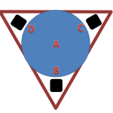
This image is to give you an idea what points we want to compare for flatness. For instance, if Kossel passes the paper-test at point A, then it should at points B, C, and D.
But if the Kossel passes the paper-test at point A, and is too high at B, C, and D then you have a concave print surface.
Likewise, if the Kossel passes the paper-test at point A, and is too low at B, C, and D then you have a convex print surface.
- B Height > A Height = Concave
- B Height < A Height = Convex
One more bit, you maybe asking how to find the spots B, C, and D. Well, I used the following calculations
- Xb = (Build Radius) * COS * (Angle of B tower)
- Yb = (Build Radius) * SIN * (Angle of B Tower)
Also, know your towers should be at angles: 90, 210, 330
If you have the same build radius as me, 170mm, then your points should be.
- Y70, X0
- Y-35, X-60
- Y-35, X60
But remember, we are really looking that all four points pass the paper-test.
Let’s move on to how to make the adjustment. I will not go into the math explaining how adjusting DELTA_RADIUS affects flatness, mainly because I don’t understand it. But secondly, because we don’t need to understand it to adjust it. Just know the following,
- Increasing DELTA_SMOOTH_ROD_OFFSET lowers the hotend.
- Decreasing DELTA_SMOOTH_ROD_OFFSET raises the hotend.
这两条非常重要
Really, it is changing the firmware’s idea of flatness.
Now, make the adjust from the visual information you collected by comparing point A to point B, C, and D. Then, comparing them again, adjust again. Compare, adjust. Ad infinitium.
Please, don’t think your done. Making these last adjustments means you really need to go back and start from Step #1 and work through them a second time, since any adjustment throws the previous adjustments off a little. So, it is true, adjustment is an infinite process of error reduction and perfection will never be achieved. Be happy with pretty damn close
There is one small thing you need to keep in mind. In step 1 we have set the max z-height. The firmware doesn’t allow you to go below that point (for obvious reasons). If your printer is anything like mine and you have a concave form than you need to consider this. At the center you might hit a perfect score on the paper test but your edged are too high (you hotend is above the surface). Increasing DELTA_SMOOTH_ROD_OFFSET will do almost nothing. Why? Because this point above the surface is point zero for the firmware. Since we can’t go below zero you will not get the edges down. You need to increase your z-height to be able to do so. But beware! Since you have a concave surface your hotend will try to go below the surface. Now, increase the DELTA_SMOOTH_ROD_OFFSET until the distance to the surface is about the same in the center as well as the edges. Adjust your z-height again.
It may seem like a difficult proces and it is indeed something you need to do slow and gentle but I calibrated my big Kossel XL in about 45 min and can print across the entire 250mm surface without auto calibration, purely on mechanical calibration! In fact, iI do nog use G29 (auto calibration) on it at all! So take your time, do it right and your printer will be more accurate.

Step #4 – Auto-Probe
Physical calibration is done, now let’s examine what makes us Kossel users, our respective auto-probes.
The auto-probe is meant to keep Kossel Mini printing flat. That is, it is meant to adjust for slight inconsistencies in the print bed or minor mechanical disproportions.
Anyway, on the the next step.

Finding the X, Y, Z Offset of the Z-probe
The Z-probe doesn’t sit directly over the tip of the hot-end, so we have to adjust for this offset. To find this number do the following:
- Place and center the paper-template like before.
- Send the command: G X0 Y0 Z10
- Put the auto-probe in its active position (as if to take readings).
- Using Repetier or Pronterface, move the effector from the hotend being centered, until the tip of the Z-probe is centered.
- Then lower the effector until the Z-probe passes the paper-test.
- After, send G-Code: M114. The output is our auto-probe offset.
Take your readings and put them into the three defines in Marlin
- #define X_PROBE_OFFSET_FROM_EXTRUDER
- #define Y_PROBE_OFFSET_FROM_EXTRUDER
- #define Z_PROBE_OFFSET_FROM_EXTRUDER
As for directionality, I found if my X or Y numbers were negative, I was telling the firmware my auto-probe was offset into the -X or -Y regions. Of course, the Z-probe offset is always negative, or you’d be in trouble.

Extra: Visualizing Auto-Probe readings
What does the auto-probe data mean? Don’t ask me, that’d take math. I’d much rather look at pictures. So, how do we turn the data into a picture? Well, there are several methods, but really, any program that will turn a set of points into a plane.
One of the guys from the Delta Google Group wrote this Python script for MATLAB.
- MATLAB
- Plane Visualizer
Buuut, I don’t have MATLAB. So, here are the steps I took to visualize the data in Excel.
UPDATE: Reggie reports the following: The script uses matplotlib, which is an open-source plotting library similar to MATLAB. Matplotlib is part of the SciPy stack, a collection of Python tools for scientific computing. http://www.scipy.org
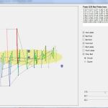
UPDATE 2: Mark wrote a very cool program where you can just paste your probe return values in and be done. The zipped exe-file can be downloaded here: ProbePlotterExe. And an even more impressive Mac version. It looks like this:
1. Run Auto-Probe. Once auto-probe is done, it’ll send back a set of points. Copy them.
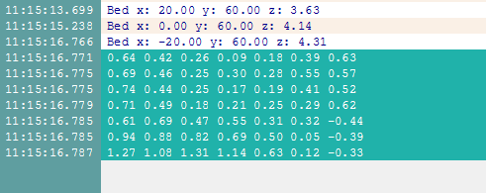

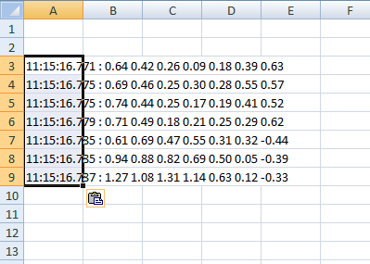
2. Paste the points into Excel. It’ll complain about formatting, press OK.

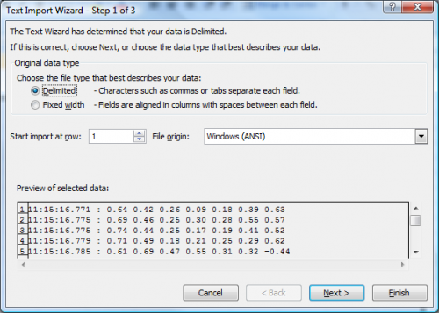
3. If you click on the formatting options and select “Text Import Wizard.” You can then select a “Space Delimited” pasting option. Basically, this will cause Excel to put the numbers in separate cells.

4. Once you have your data in Excel correctly, let’s make a graph. Select your data set then go to the graph type “Surface.”
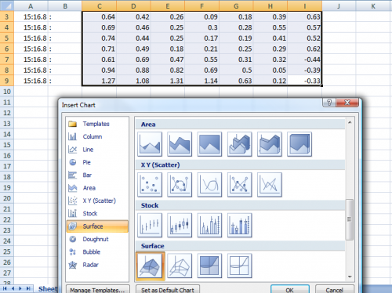
5. There’s the graph.
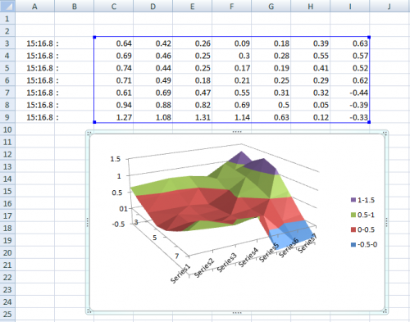

6. There are several things you can do with this data, but only if you have a point of orientation. That is, what area on the graph represent the area on the print surface. To find the auto-probe data orientation, I built a lump on my print surface near one of the towers by putting something on the surface (like a matchbox).
Be careful, if your Z-probe doesn’t retract far enough, it’ll knock your lump into the belt.
You can adjust how far your Z-probe retracts between probing in the Marlin firmware. Under Configuration.h adjust,
- #define Z_RAISE_BETWEEN_PROBING
If all goes well, when you run your auto-probe data you’ll get a nice lump on the graphed surface. This will allow you to make intelligent decisions regarding adjustment.
7. One last bit I’d like to point out. None of this is going to help if your auto-probe is not mechanically reliable. But how do you tell if it is? I just run the auto-probe about 5-10 times and compare each outcome to see if there are big differences. You may do some nice Excel deviations etc on it if you like.

That’s it! This is absolutely the long version and it will take you some time but do it right once and your probe will keep your machine purring and creating high quality prints. Remember though that you have to repeat the calibration (or at least part of it) if you make a mechanical change to your machine (like changing the hotend).

6. First print
Your printer should now be able to move in all directions, auto-level and extrude some plastic. Let’s print something!
The program used to convert a 3D model (in the STL file format) to Gcode is called a slicer. It basically divides your 3D model into thin horizontal slices or layers and calculates the paths the printer should follow. There are several different slicers out there. Try them and see which one you like and/or give the best results. Does it make a difference you ask? Most definitely! The slicer will for the most part determine the quality of your prints. You will be experimenting a lot in there. But let’s just start somewhere.
My favorite slicer is KISSlicer so I will base this part on that. My suggestion is to start with this slicer and when you’re comfortable with it, play with the others. In the Initial Setup page you’ve already downloaded the program and my settings. Extract the settings (4 files) and place them in the same folder as KISSlicer. Overwrite the old ones if needed and open the program.
If you haven’t made any big changes to the printer you should be able to just run it and see what happens. Open a STL file like this testcube and hit slice. After it’s done, save the file and print it. You can use Pronterface for that or just use the SD card.
We are working hard to get the rest of this page ready for you but we’re not ready just yet. Please be patient! In the meantime check the internet forums if you need help with slicing. This is not a specific Kossel thing. Good luck!

7. Troubleshooting
Sometimes things go wrong. It will definitely happen to you. 3D printers are somewhat delicate machines with complex mechanics. Here are some things we’ve encountered and our solutions to solve them. This page will be updated with more common problems as we, or some clients, encounter them.

My print won’t stick to the glass.
Ah, the problem everyone faces. There are several solutions for this and please experiment and try what works best for you. PLA can stick to plain glass especially with the auto-level features of our printers but it isn’t nearly enough to make large prints and will more likely fail than work.
Solution one: Use masking tape or Kapton tape. This seems to be the most used solution. It’s tape normally used by painters to protect parts they do not want to paint. The blue type by 3M are used most. We’ve had mixed results. Yes the plastic does stick to the tape but our tape would stick hard enough to the glass. Kapton tape is also widely used but not yet by us. Try it and let us know!
Solution two: Use hairspray. Just spray some hairspray on the glass, let it dry just a bit so it’s still a bit sticky. It works great! But sometimes to good. Prints can sometimes be hard to get of the glass and the bottom of the prints have a sort of residue. Not all hairsprays are the same so try a few brands. Be aware though, take the glass out of the printer before spraying or you’ll have a sticky printer in no-time.
Solution three: Use window blinding foil. This is our preferred solution for non-heated beds. This is the foil used to matte windowglass. It sticks well to glass off course and has a course structure on top where the PLA will stick to. Prints stay firm in place but will come of very easily. It will last you a couple of prints before it will begin to warp due to the heat of the first layer of plastic. It costs a few bucks for a roll of 2 meters or so. I get about 20 “refills” out of one roll. Good value! There are some who use a matte printing sticker. Apparently it works great. Haven’t tried it yet.
Solution four: Use a heated bed and kapton foil. This is our preferred solution. We heat the bed to about 60-65 degrees for PLA. It will keep it the first layers sticky and we almost never have prints coming loose anymore. Good calibration is off course essential but that’s for all solutions.
Alternative solution: One of our clients reports that a mixture of water and sugar works very well. Spray the saturated mixture on the glass, let it dry and print. He says it sticks so well that you need to use a fair amount of force to remove a part.

The printer makes funny noises
This is normal to some degree. Stepper motors are noisy and the electronics makes humming noises as well. But, if it sounds like hammering or you see strange behavior (ramming into the glass, not stopping at the endstops, trying to move outside the printable area) cut the power immediately! Disconnecting the USB cable is not enough, really disconnect the power supply.

