Projector screens
What the room sees on the projector during each game, and what each screen means. The projector follows the facilitator's console by itself; nobody touches it during the session.

Before the games

Home board
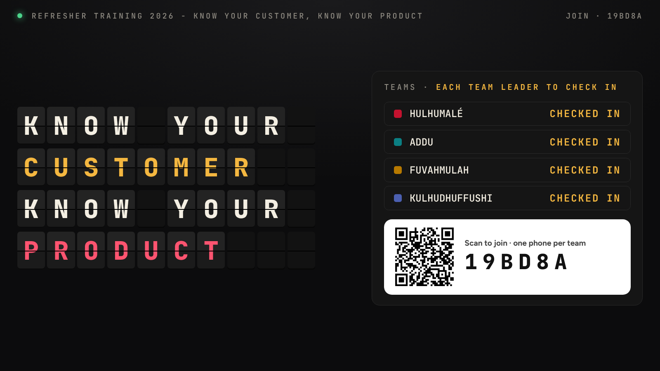
Home board
Shown while staff arrive.
- Left: KNOW YOUR CUSTOMER / KNOW YOUR PRODUCT flips into place letter by letter, like an airport departures board.
- Right: each team appears as CHECKED IN as soon as its team leader joins, with the join QR code and the session code below.
- Top bar: "Refresher Training 2026 – Know your customer, know your product", a green dot when connected, and the join code.
- Bottom: "Did you know?" product facts rotate every 9 seconds.

Join screen
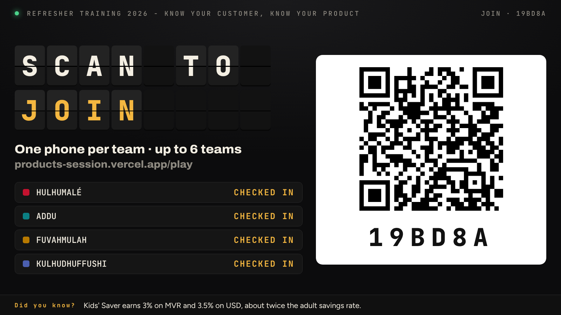
Join screen
Shown when the facilitator presses Show on screen in the session window: a large QR code and code so team leaders can join from across the room. Teams tick over to CHECKED IN as they join.

Round intro
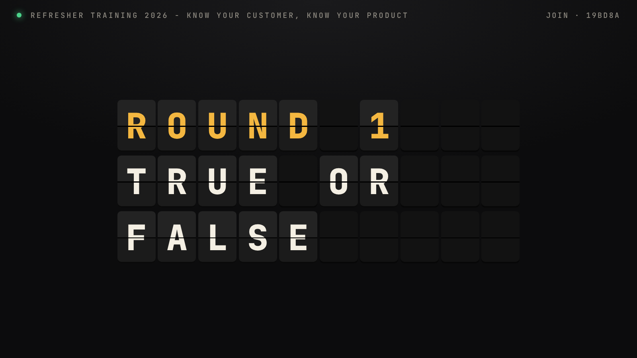
Round intro
Shown for about 4 seconds whenever the facilitator opens a game: the round number and game name flip in with a chime. Rounds run 1 True or False, 2 Product Passport, 3 Product Challenge, 4 Listen for the Clue, 5 Spin & Explain.

Round 1 · True or False

The statement
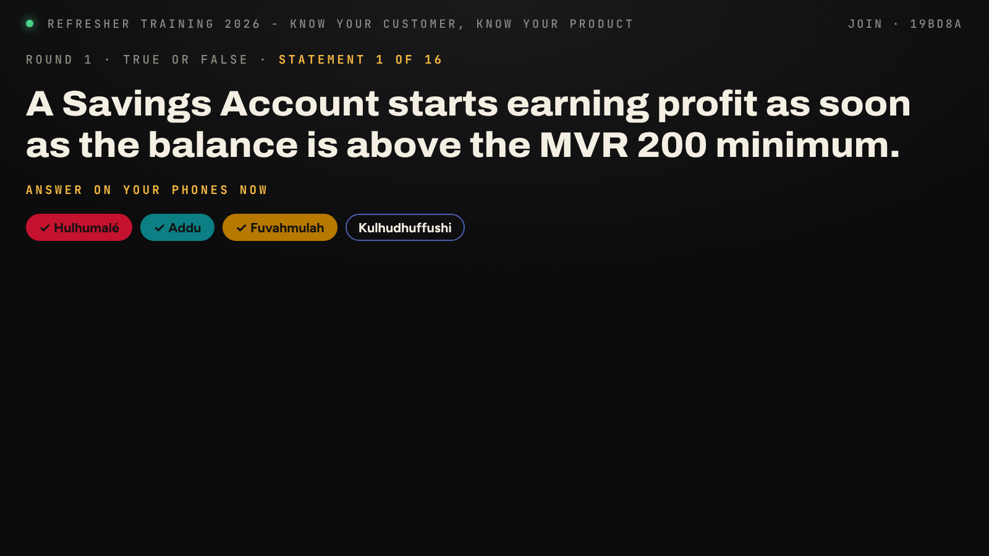
True or False statement
- Top line: round, game and statement number (for example statement 1 of 16).
- Centre: the statement in large type, for the facilitator to read aloud.
- "Answer on your phones now" shows while answers are open.
- Team chips: a team's chip fills with its colour and a tick once it has answered. Nobody can see what a team answered until the reveal.

The reveal
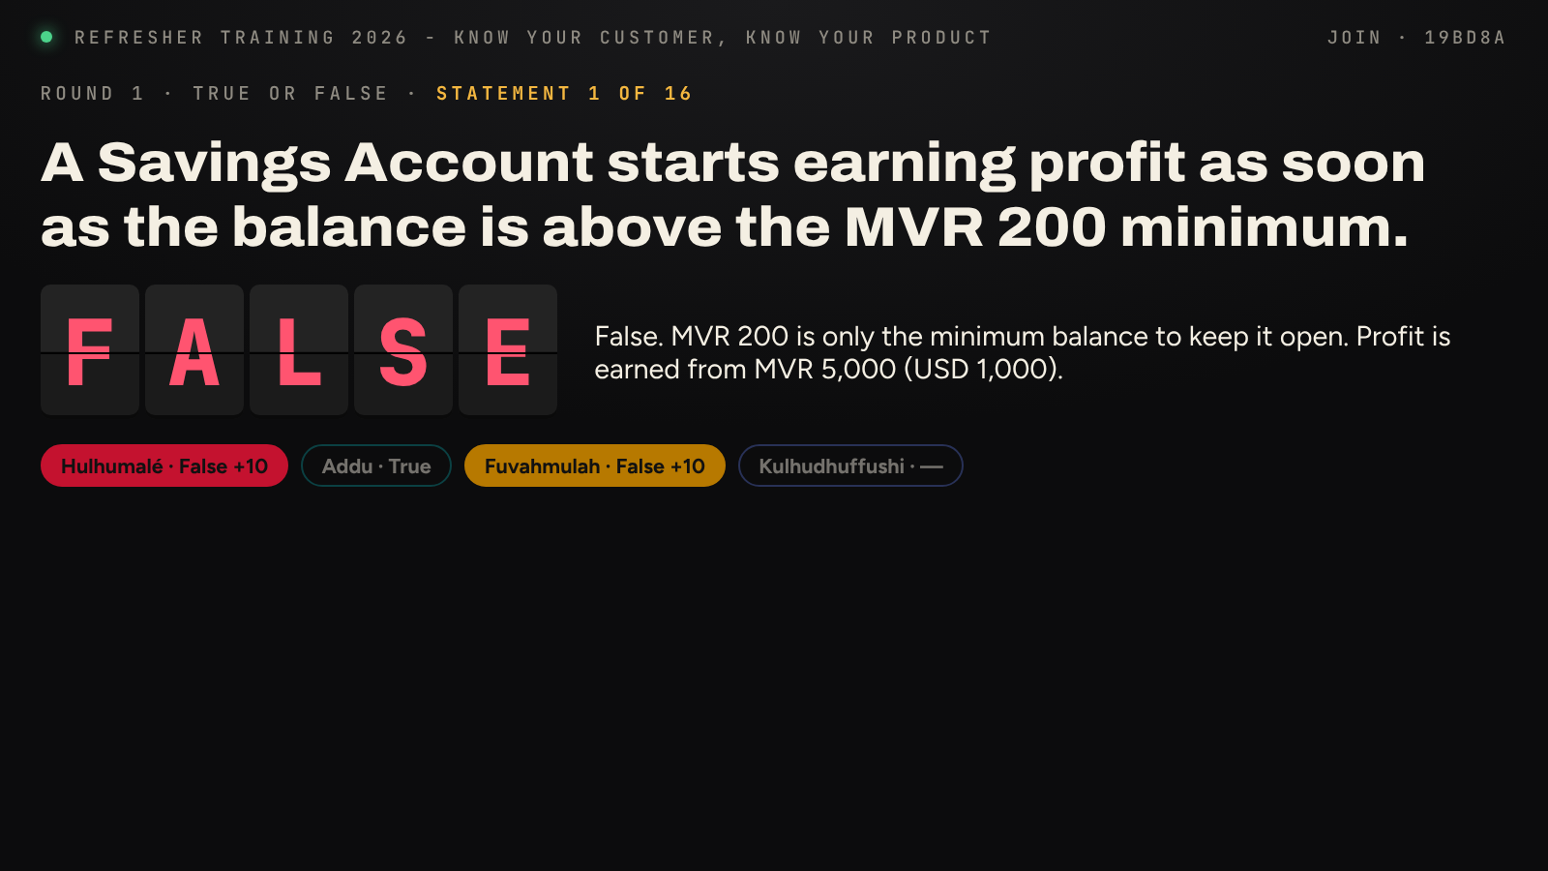
True or False reveal
After Reveal on the console:
- TRUE (green) or FALSE (red) flips in on the board.
- The explanation appears beside it, for the facilitator to expand on.
- Each team's chip shows its answer: coloured with +10 if right, grey if wrong, "—" if it did not answer.
- Confetti falls in the colours of the teams that scored.

Round 2 · Product Passport

Picking products
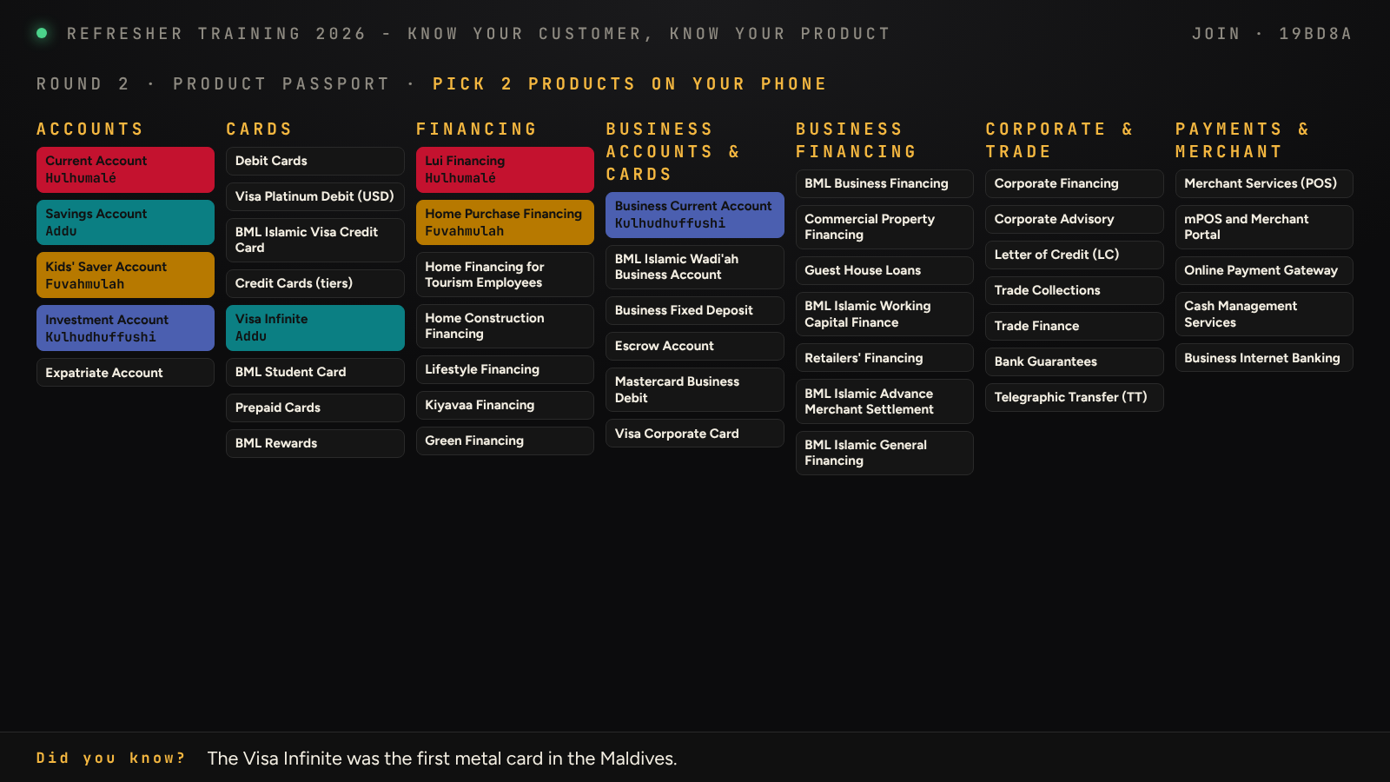
Product picking board
Shown while teams pick their 2 products on their phones.
- Every product is listed by family, individual and business, across the screen.
- A product turns the colour of the team that took it, with the team's name, the moment it is picked. The room can see what is left.

Teach-back in progress
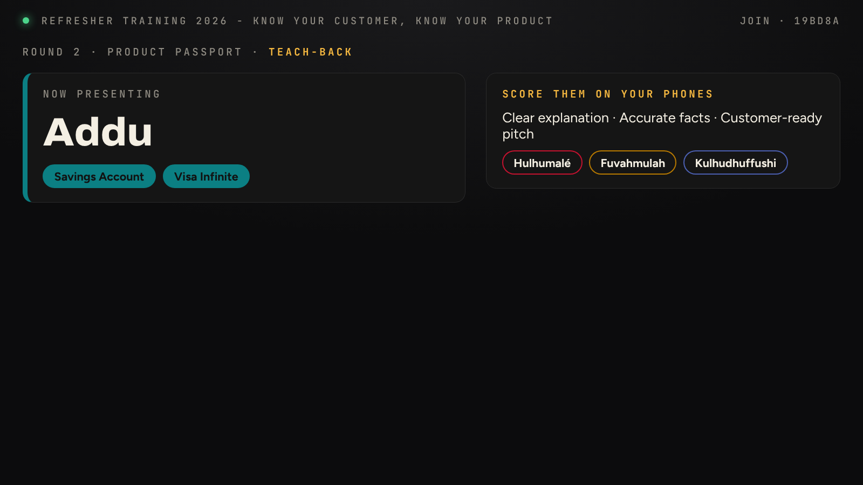
Teach-back in progress
- Now presenting: the team teaching, with its 2 products.
- Score them on your phones: the three points the other teams rate (clear explanation, accurate facts, customer-ready pitch).
- Team chips fill in as each team sends its scores. The presenting team does not vote.

Teach-back result
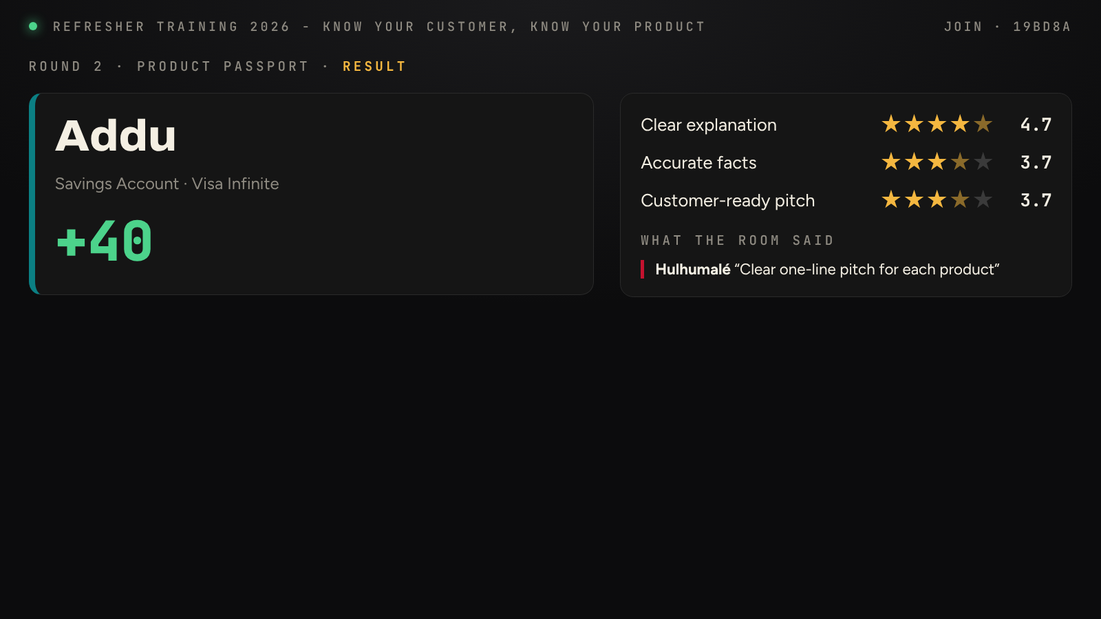
Teach-back result
Shown when the facilitator closes the scoring:
- The team, its products and the points won in large green numbers (up to 50).
- The average star rating for each of the three points.
- What the room said: comments typed by other teams, named by team.

Round 3 · Product Challenge

The board
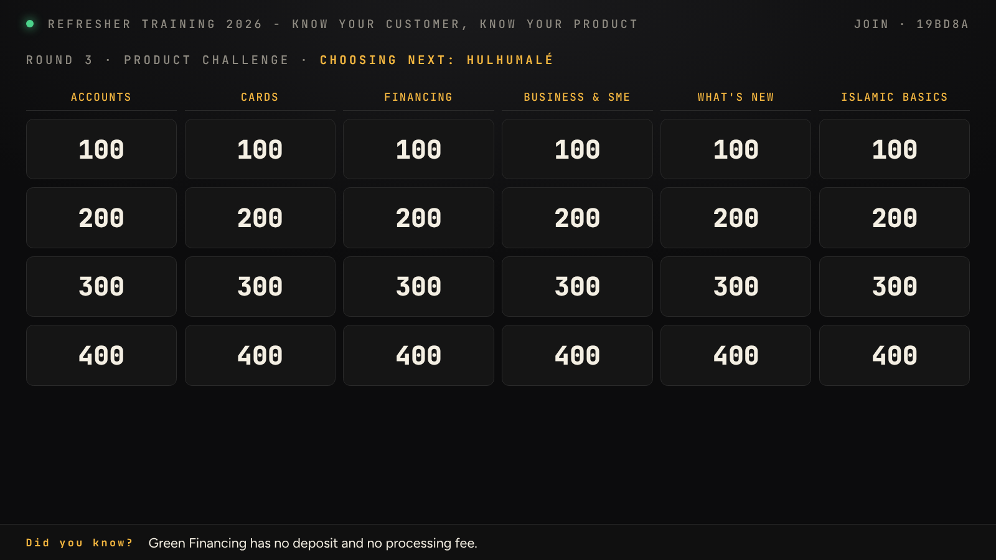
Product Challenge board
- Six categories across the top: Accounts, Cards, Financing, Business & SME, What's new, Islamic basics.
- Four rows of tiles worth 100, 200, 300 and 400 points. Used tiles are greyed out.
- Choosing next names the team whose turn it is to pick a tile.

A question
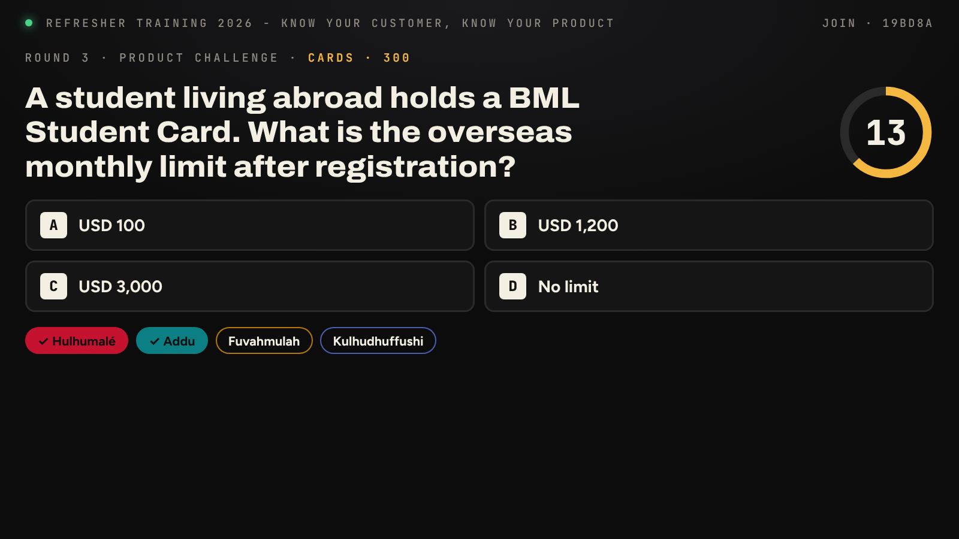
Product Challenge question
- The category and points (for example Cards · 300), and the question in large type.
- Options A to D, matching the buttons on the phones.
- Countdown ring top right; it turns red and ticks in the last 5 seconds.
- Team chips tick as teams answer. Answers lock when the countdown ends or every team has answered.

The reveal
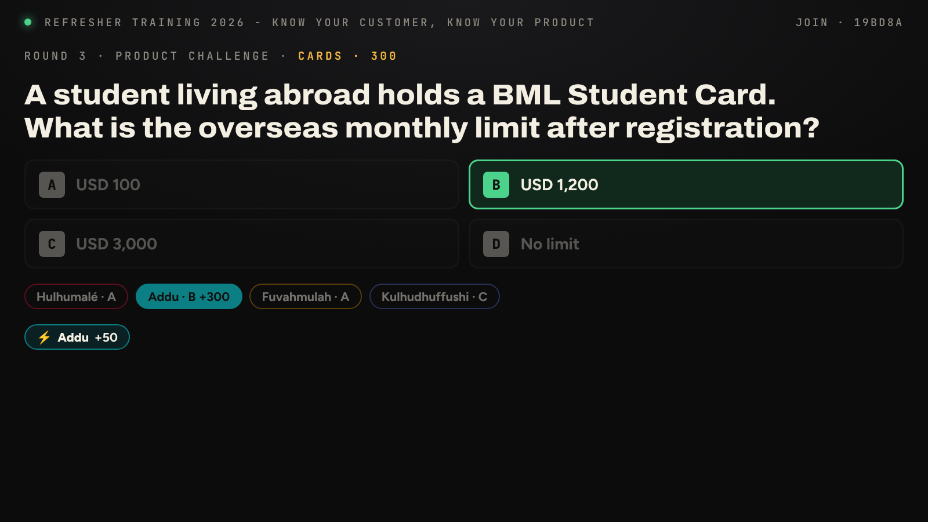
Product Challenge reveal
- The correct option lights up green; the others fade.
- Each team's chip shows its letter, with the points if it was right (for example Addu · B +300).
- The lightning badges show the speed bonus: +50 for the fastest correct team and +25 for the second fastest.
- The screen then returns to the board.

Round 4 · Listen for the Clue
This game runs by itself once the facilitator presses Start. There are 8 customers, each with 3 questions.

The question
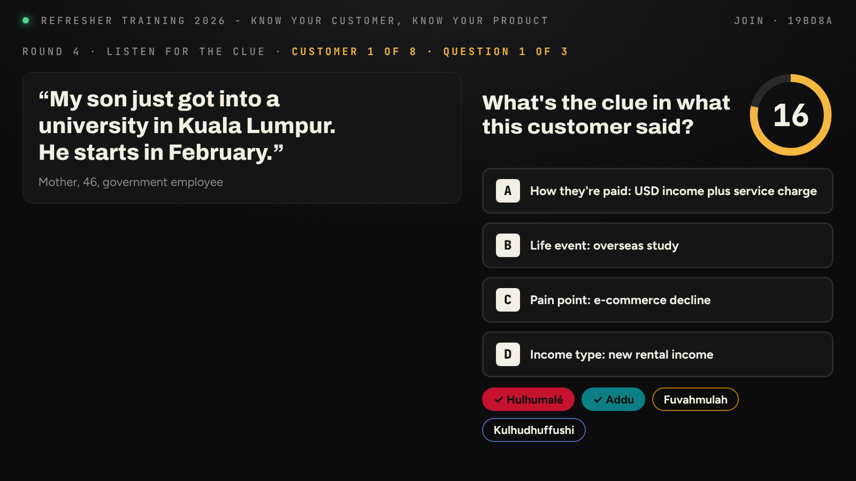
Listen for the Clue question
- Left: the customer's words as a quote, and who they are (for example Mother, 46, government employee).
- Top line: customer number and question number (for example customer 1 of 8, question 1 of 3).
- Right: the question with options A to D and a 20-second countdown ring. The three questions are: what's the clue, which product fits, and what to ask next.
- Team chips tick as teams answer.

The reveal
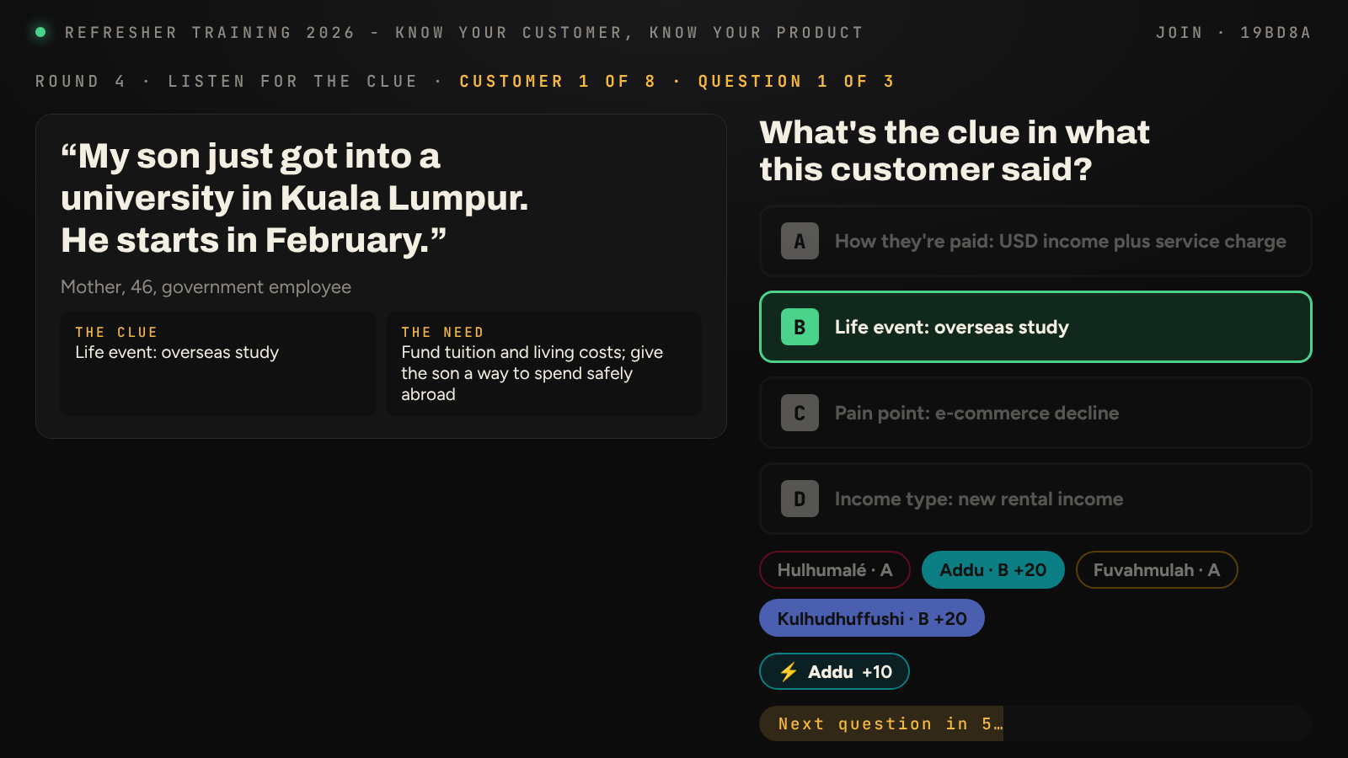
Listen for the Clue reveal
- The right answer lights up green, and each team's letter and points show (+20 if right).
- The lightning badge shows +10 for the fastest correct team.
- Under the quote, the answers so far build up a picture of the customer: the clue, then the need, then the product.
- Next question in … counts down 8 seconds, then the next question starts by itself.

Round 5 · Spin & Explain
The wheel of products stays on the left of every Spin & Explain screen; the right side changes as the turn goes on.

Up next
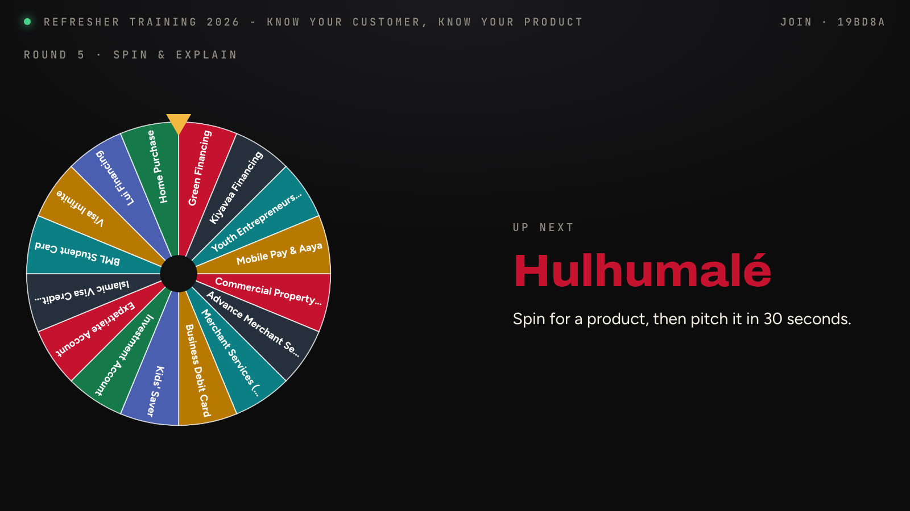
Up next
The team whose turn it is, in its colour, waiting for the facilitator to send SPIN to its phone.

Spinning
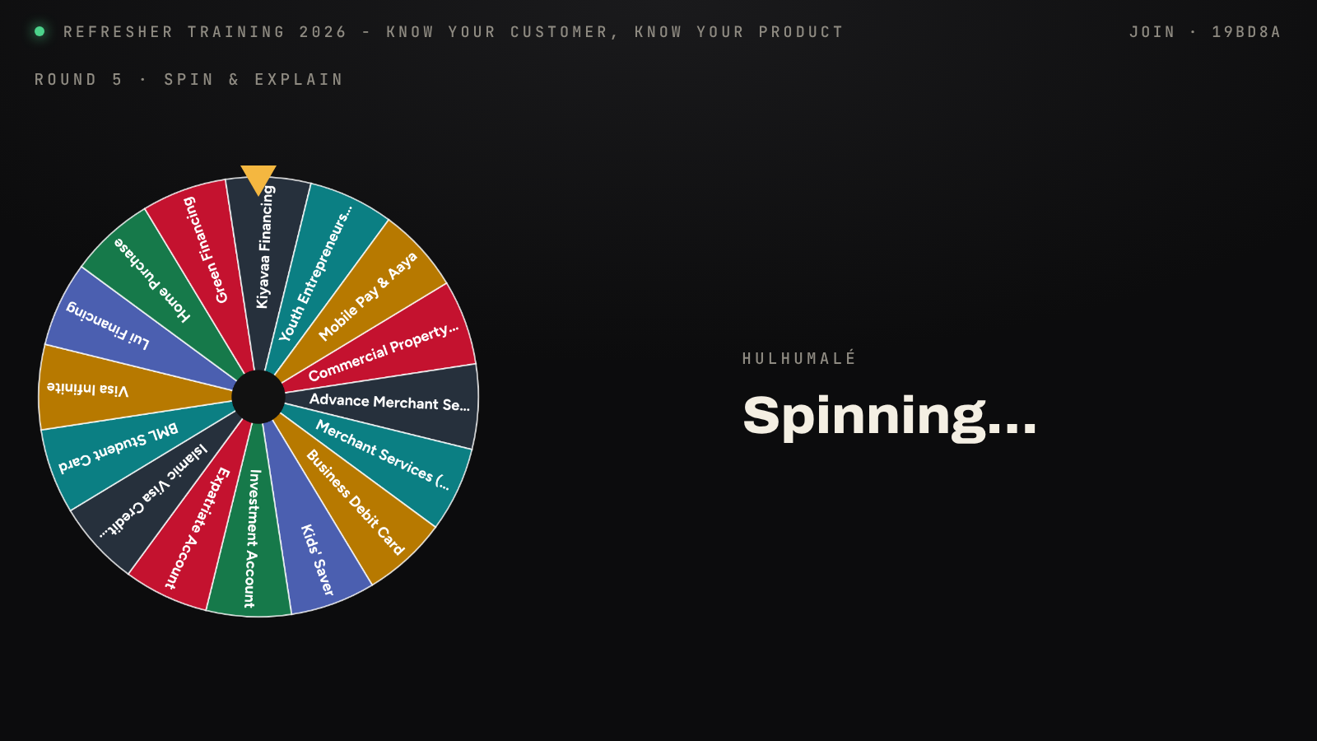
Spinning
The team pressed SPIN on its phone: the wheel spins on the projector with ticking sound and slows to a stop under the pointer.

The product
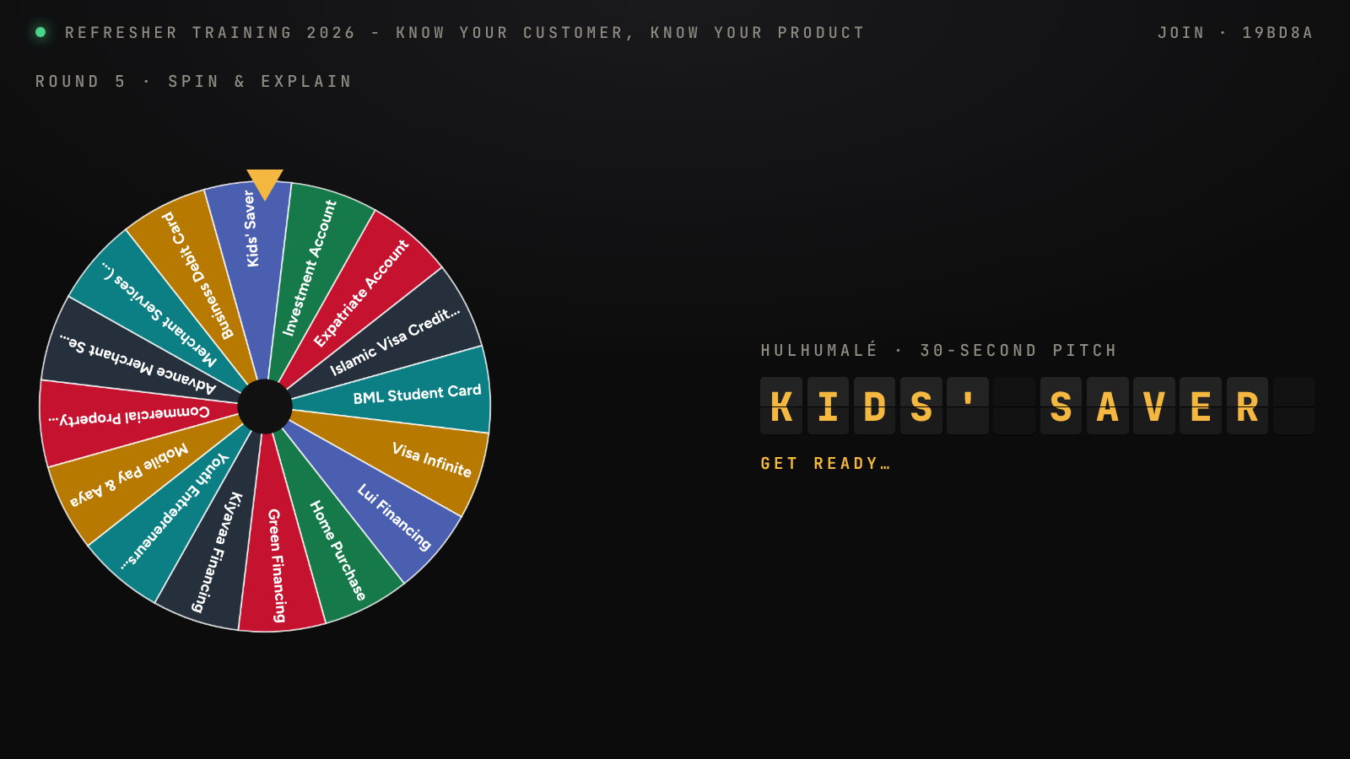
Product chosen
The chosen product flips in (for example KIDS' SAVER), with "Get ready" while the volunteer prepares.

The pitch
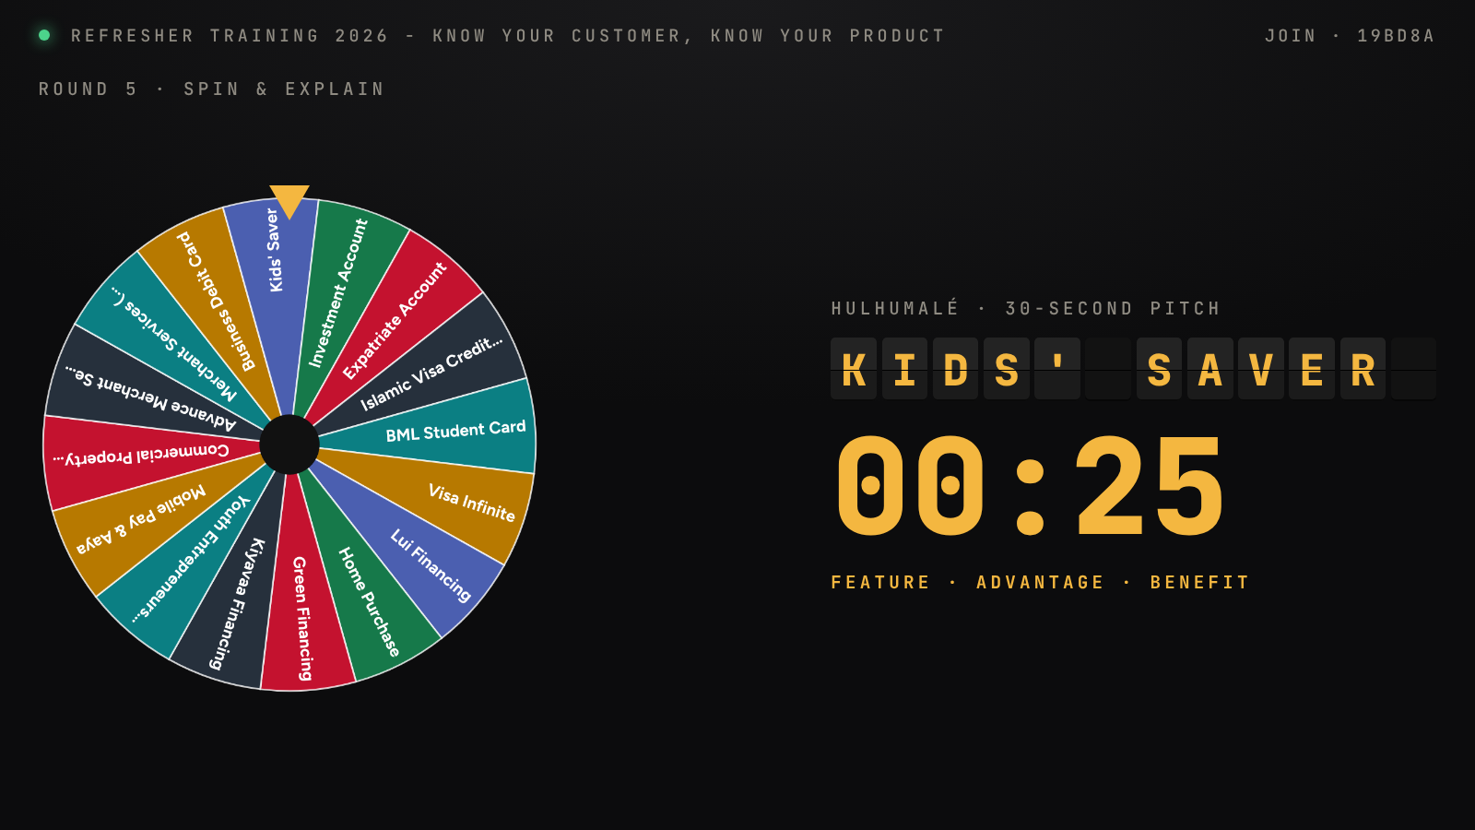
Pitch timer
The 30-second pitch timer counts down in large numbers, with the reminder Feature · Advantage · Benefit. It turns red for the last 5 seconds. During voting, a 20-second voting timer shows here and team chips tick as each team votes.

The result
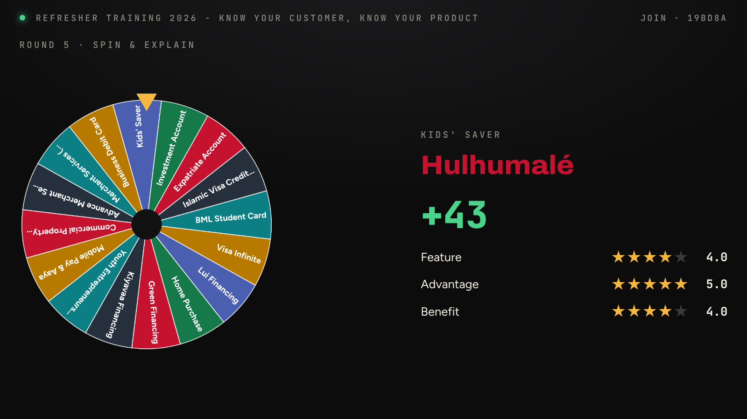
Pitch result
When voting closes: the team, its points (up to 50), and the average stars for Feature, Advantage and Benefit, with confetti in the team's colour.

After each game and at the close

Standings
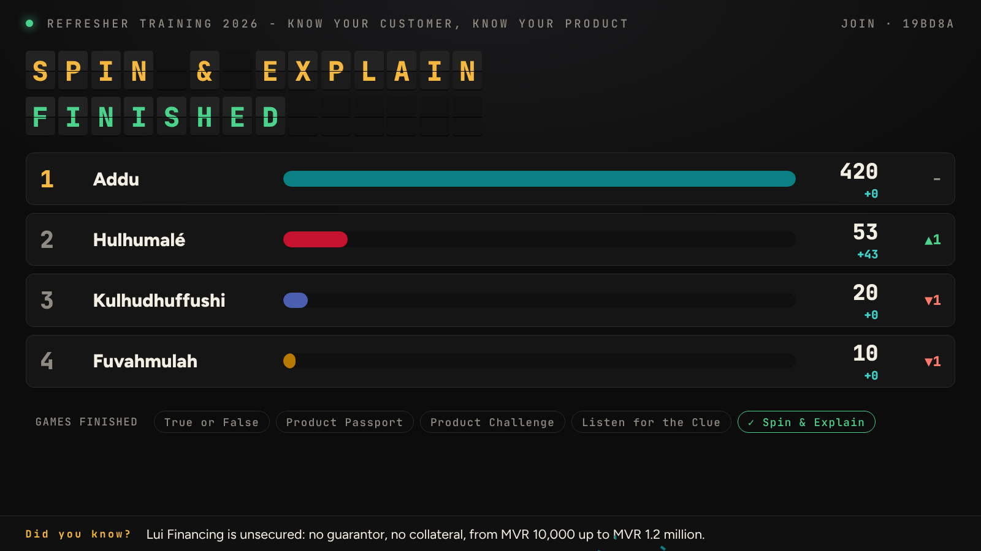
Standings
Shown when the facilitator presses Finish game & show scores, and again from Standings.
- The board names the game just finished.
- Teams in order, with bars that grow to their total. Rows slide to their new places.
- Under each total: the points from this game. The arrows show places gained (▲) or lost (▼).
- Games finished along the bottom ticks off each completed game. Applause plays.

Winner
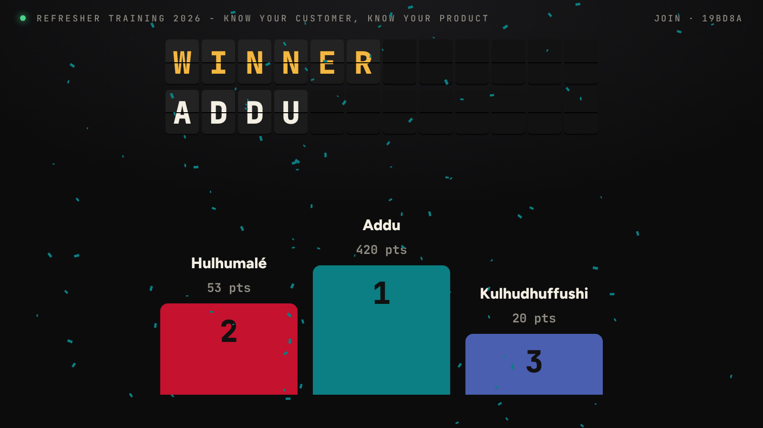
Winner podium
Shown when the facilitator opens Close: WINNER and the team name flip in, the podium rises for the top three with their points, and confetti and applause follow.

Feedback
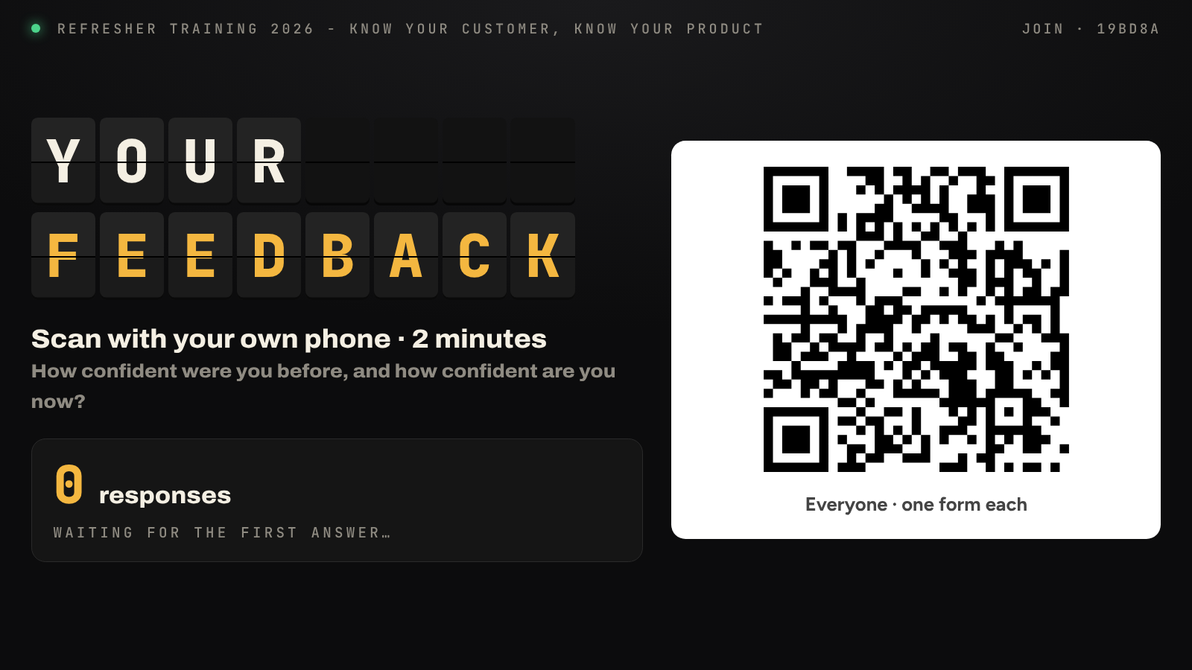
Feedback screen
Shown when the facilitator presses Show feedback QR on the screen:
- A large QR code that every staff member scans with their own phone.
- The live number of responses.
- As answers arrive: average confidence before → after, and the spread of answers from 1 to 5 for each. Names and comments are never shown on the projector.

