**Syntax HW 1 - commented**

인문대학 언어학과 23 장한

**1. p. 101, GPS 8. Ambiguity II**

a) Alvina said Moises went to the store quickly.

a-1) Alvina said that Moises quickly went to the store.

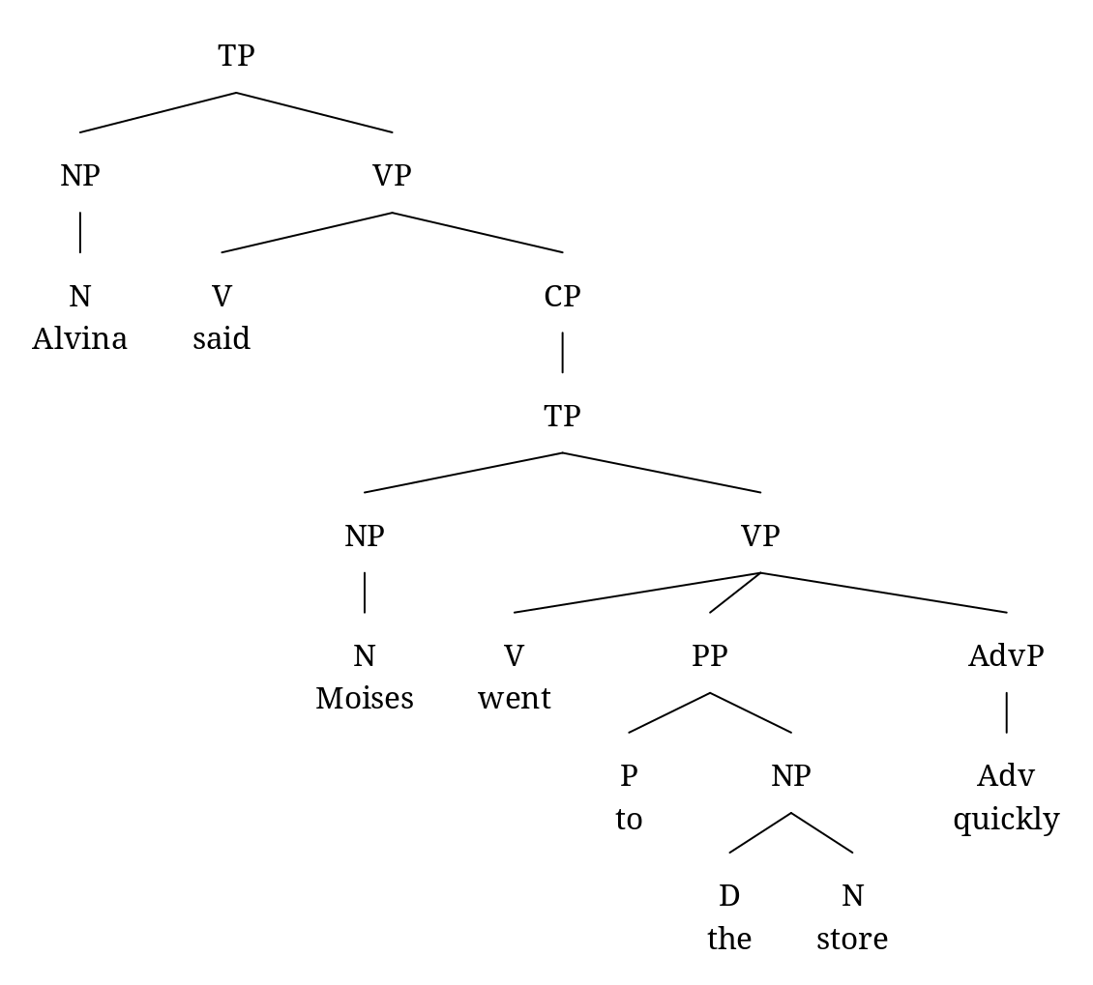

a-2) Alvina quickly said that Moises went to the store.

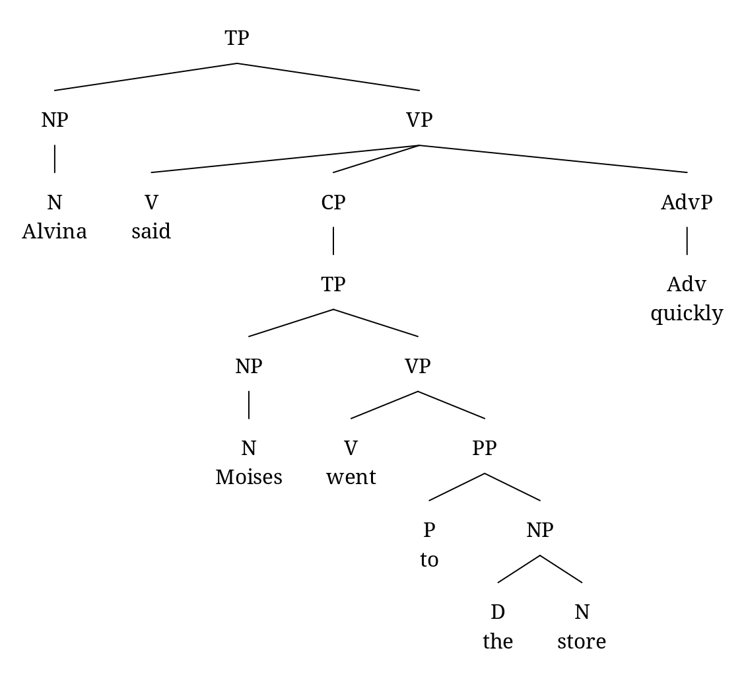

d) Enraged cow injures farmer with ax.

d-1) Enraged cow injures farmer who had an ax.

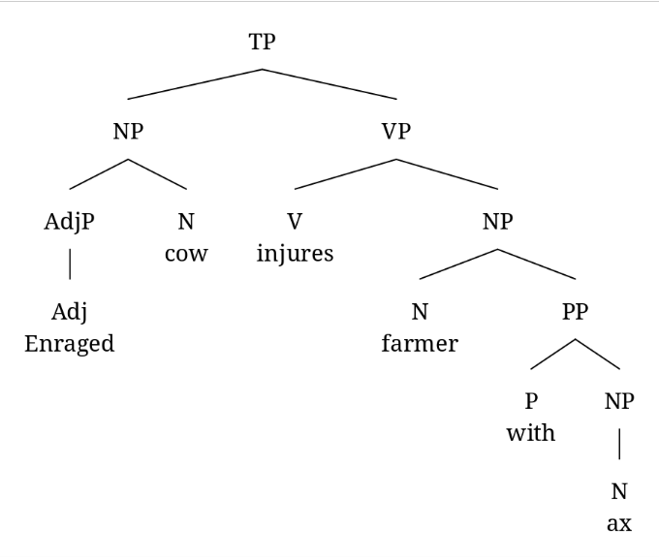

d-2) Enraged cow with using an ax injures farmer.

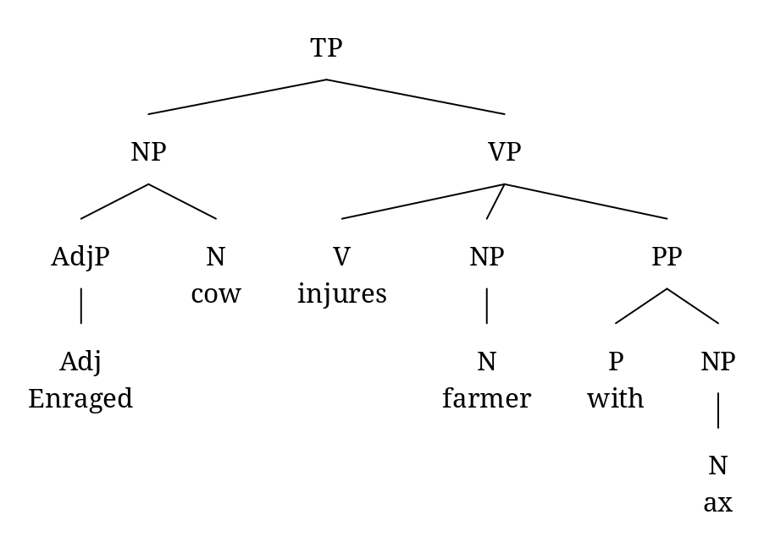

**2. p. 110, CPS 7. Using Constituency Tests**

**part 1:**

a) Juliet says that Romeo lies to his parents a lot.

a-1) Juliet has many sayings that Romeo lies to his parents.

a-2) Juliet says that Romeo tells many lies to his parents.

**part 2:**

a-1) Juliet has many sayings that Romeo lies to his parents.

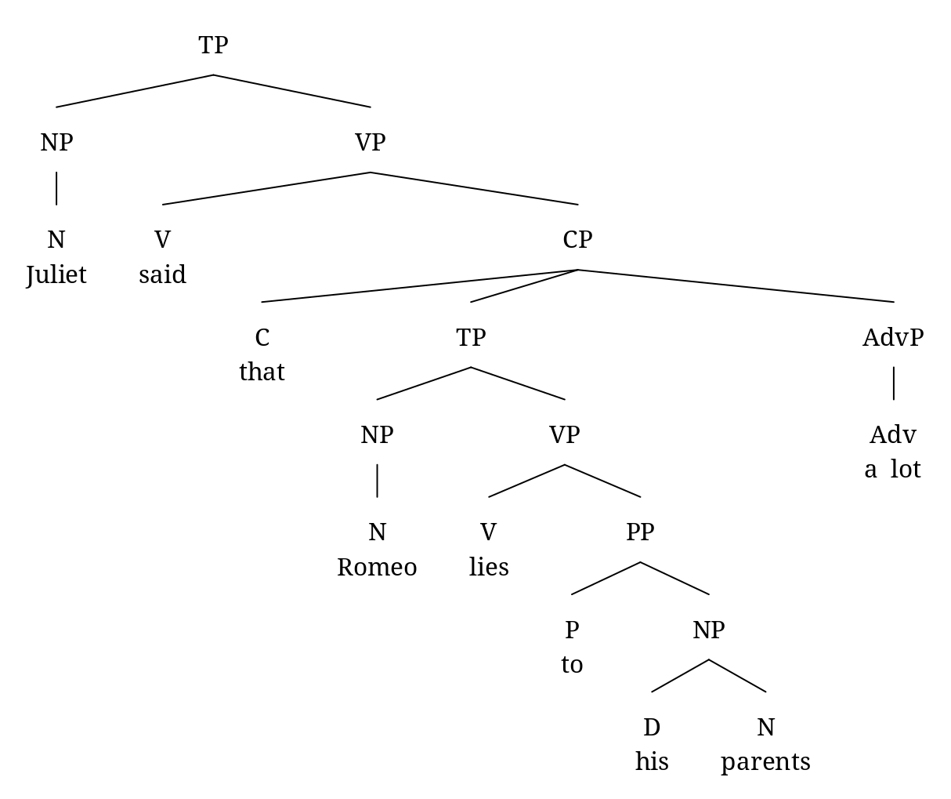

트리 실수 (-1)

=

a-2) Juliet says that Romeo tells many lies to his parents.

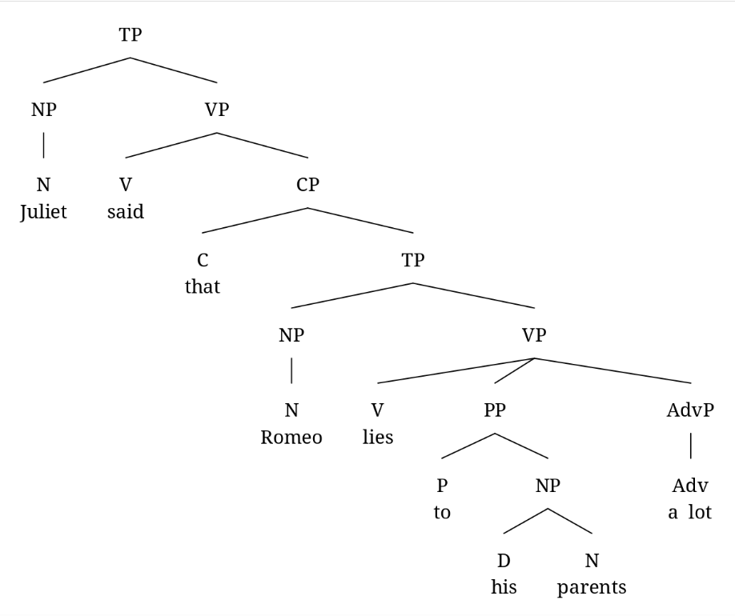

**part 3:** Through VP-preposing in (c), it is established that this sentence has the word sequence “lies to his parents a lot” as a constituent. It indicates that the words are exhaustively dominated by one certain node, VP governed by “that” in (a-2), fixing the meaning of the sentence in (a) as (a-2).

**part 4:** The sentence (d) shows that the sequence “lies to his parents” is a constituent like in (a-1). However, if “a lot” modifies the precedent verb “does” that can be bound with the anteceding preposing VP “lies to his parents”, it is possible to be analyzed as (a-2) too.

**3. p. 110, CPS 8. Leash and Clean up after your pet.**

First, it is impossible to draw a tree where *“your pets”* is an object of both *“leash”* and *“after”* in our theory. This is because we postulated the role of conjunctives as (1) and (2), only possible to coordinate nodes that share the identical category. If we treat *“your pets”* as an object of both, the category of the node dominating the coordination cannot be determined, as in (3). According to our theory, therefore, assuming *“your pets”* as an object only of preposition *“after”* is appropriate. The structure is shown in (4).

1. XP → XP conj XP
2. X → X conj X
3. *? → V conj P
4. Leash and Clean up after your pet.  
   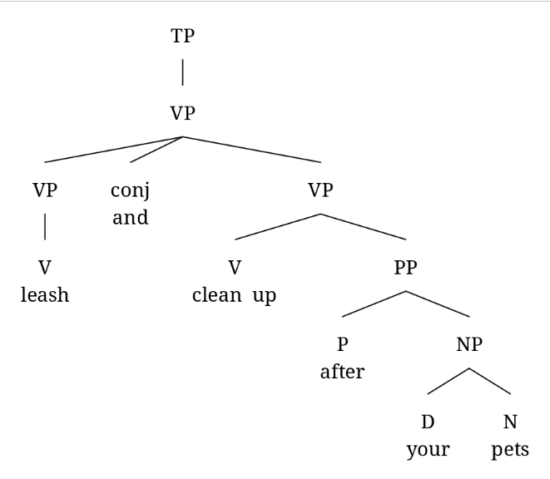

**4. p. 134, GPS 10. Draw a Tree**

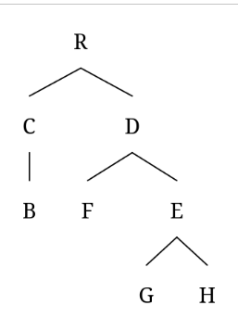

**5. p. 138, CPS 2. Negative Polarity Items**

**part 1:** The sentences in (1~4) demonstrate that the words “any” and “single”, Negative Polarity Items (NPI), must come with a negation marker like “not”. However, as shown in (5) and (6), that is not always allowed even when “not” appears. It indicates the NPI must have a particular relationship with negation markers. Trees in (7) and (8) are illustrates the structures of sentences in (5) and (6).

1. I didn’t have any money.
2. *I had any money.
3. I didn’t read a single book the whole time I was in the library.
4. *I read a single book the whole time I was in the library.
5. I did not have any money.
6. *Any money was not found in the box.
7. I did not have any money.  
   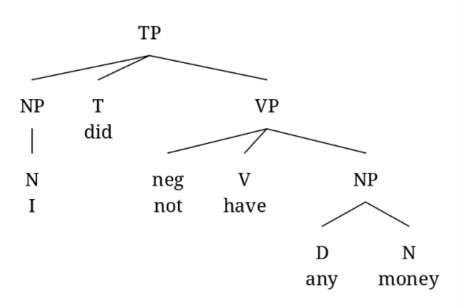
8. *Any money was not found in the box  
   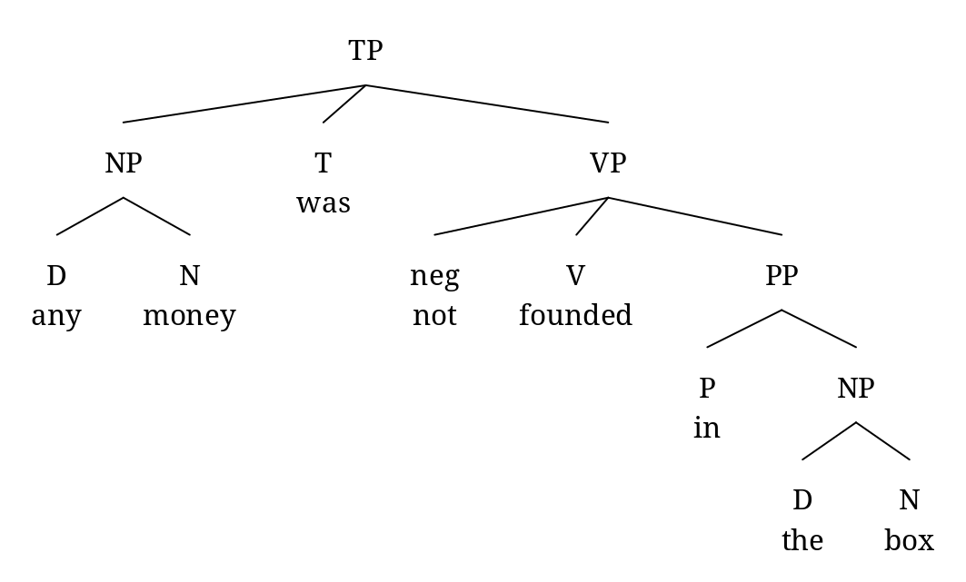

These trees suggest two possibilities for explaining the grammatical restriction of NPI and negation markers. First, the negation marker “not” precedes NPI “any” in (7), but not in (8); also, the negation marker c-commands NPI, but not in (8). More grammatical and ungrammatical sentences are required to establish which one is reasonable.

**part 2:** The sentence in (9), where the negation marker precedes NPI, is ungrammatical, proving that precedence cannot judge grammaticality. Therefore, there is a grammatical restriction that the negation marker must c-command NPI.

1. *The man that Susan didn’t like had any money.  
   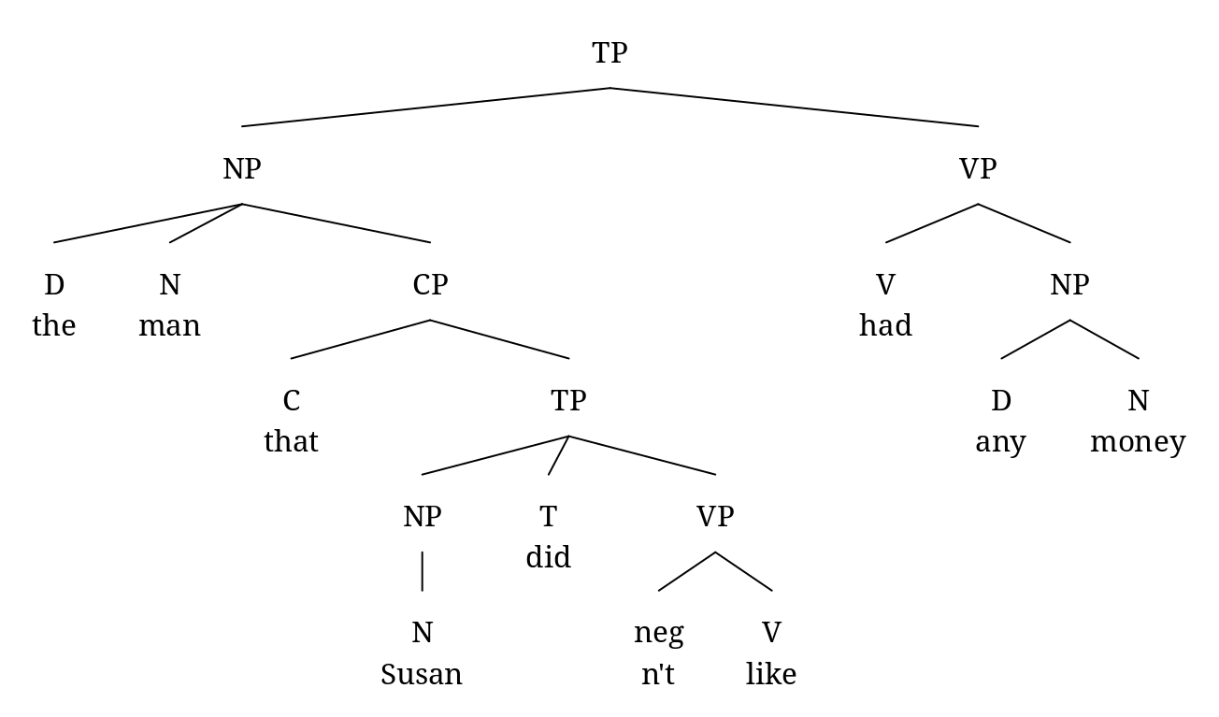

**6. p. 154, CPS 2. Binding Domain**

According to the grammar we have developed, a pronoun must be free in its minimal TP to be coindexed with R-expressions existing in the same sentence. This works for anaphors and pronouns to distribute to solve coindexing complementarily. However, sentences such as (1) suggest that using pronouns within the same binding domain with coindexed R-expression is possible. Therefore, our theory should judge this sentence as ungrammatical and this judgement is a limitation of ours.

1. Andy dismayed his father.  
   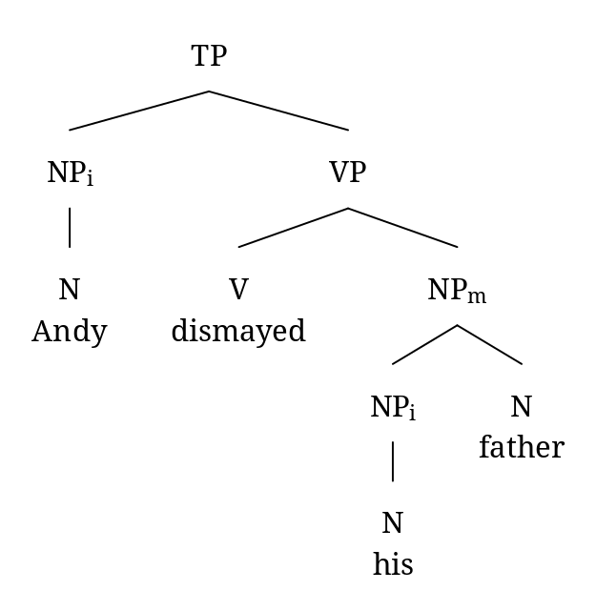

질문) 수업시간에 binding theory가 봉착한 여러 문제를 설명해 주셔서, binding theory 안에서 이 문제를 해결할 수 있을 것이라고는 잘 생각이 들지 않지만 순전히 궁금증 때문에 질문 드립니다! 예전에 여러 언어들을 공부하다가 명사에 붙는 주격 표지와 속격 표지로 동일한 것을 사용하는 야가리아(Yagaria)어나 소유자 표지를 시제 표지와 함께 사용하는 일가르어(Ilgar) 등을 본 적이 있습니다. 추가적으로 조사를 해보니 실제로 일가르어가 속한 이와이자어족(Iwaidjan languages)과 야가리아어가 속한 뉴기니 동부 고원 지대의 언어들은 주어 일치 표지와 소유자 표지가 동일하기도 해서, 개인적으로 소유주는 행위주와 의미적으로 가까이에 있을 수 있겠다는 생각이 듭니다. 위 문장에 제시된 문제를 해결하기 위해, binding theory가 속격 명사를 포함한 명사구에 TP와 같은 보다 복잡한 구조를 제시한 적은 없을까요?

great! 수업시간에 어느 정도 궁금증을 해소했을 것으로 생각합니다.

**7. p. 155, CPS 4. Japanese**

1. Kazukowa Tarooga zibunzisino hihansitato itta.  
   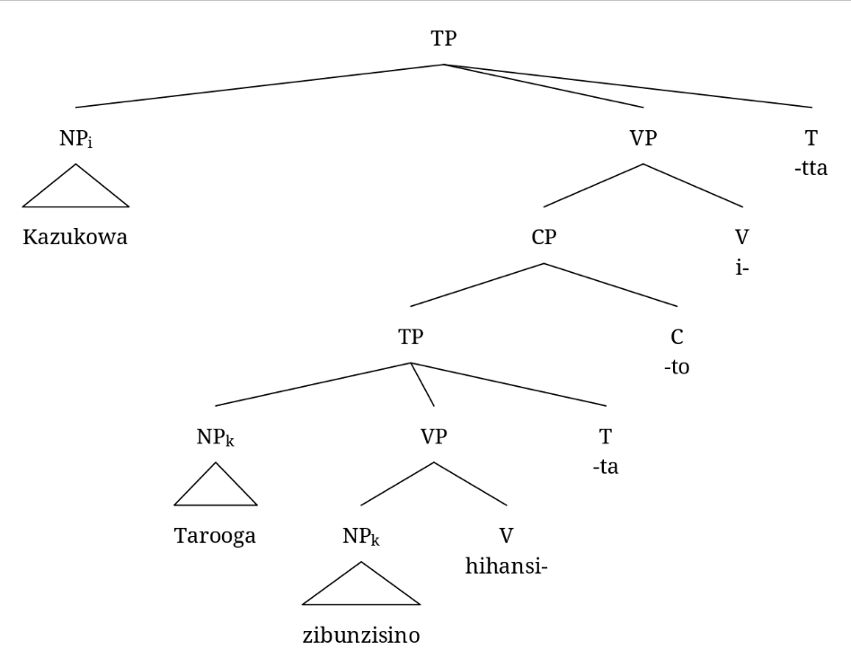

In Japanese, the word *“zibunzisin”* is used like in the sentence (1). If the *“zibunzisin”* indicates *“Kazuko”*, that becomes an ungrammatical sentence. Thus, *“zibunzisin”* seems an anaphor, according to our binding theory, because it is coindexed with the R-expression which c-commands it. However, this analysis could not be maintained in (2).

1. Kazukowa zibunzisinga Tarooo korositato omotteiru.  
   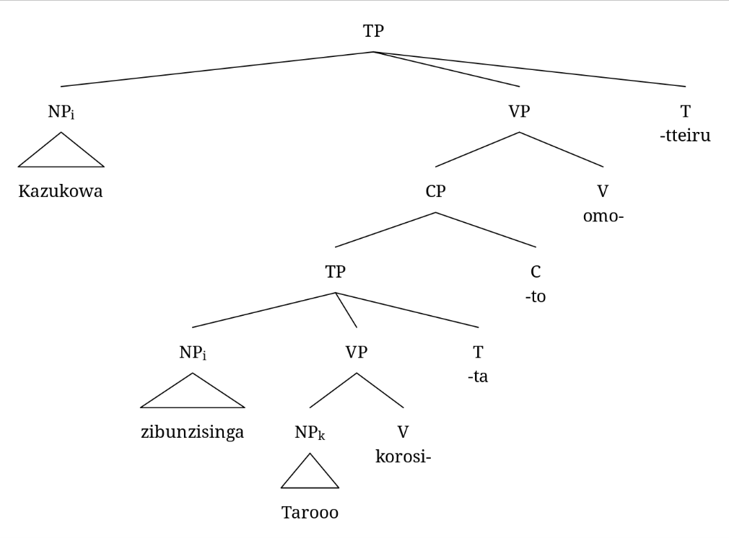

with the domain?

In sentence (2), *“zibunzisin”* is coindexed with *“Kazuko”* which is not in its binding domain. If we considered only the sentences such as (2), it would be possible to judge *“zibunzisin”* as a pronoun. However, we already also confirmed it is ungrammatical in (1) that *“Kazuko”* binds *“zibunzisin”*, when there is another R-expression *“Taroo”* that can bind it. As shown in the structure of (2), *“zibunzisin”* of (2) does not have an appropriate R-expression possible to bind it. Therefore, it seems reasonable that the word abides to become an anaphor or a pronoun by the presence of a potential binding NP.

어느 경우는 anaphor이고 어느 경우는 pronoun?

1. *Kazukowai [CP [TP zibunzisingak [VP Taroook [V korosi-]] [T -ta]] [C -to]] omotteiru.

The ungrammaticality of sentence (3) is caused by the violation of binding principle C, which is “An R-expression must be free.” In this structure, *“zibunzisin”* asymmetrically c-commands *“Taroo”*, which means only *“zibunzisin”* can bind *“Taroo”* structually and not *vice versa*. Because *“Taroo”* is an R-expression, though, the structure where *“zibunzisin”* binds *“Taroo”* like in (3) is ungrammatical.

potential binding NP 없는  
이 문장에서의 zibunzisin은 무엇?  
potential binding NP가 없어서 pronoun?  
그래서 principle A는 위배 아닌 것?