

Deliverable 5.5 – Billing and Payment Service

GitHub with docs (V1)
Grant Agreement Number | 101160678 | Acronym |  | INTELLIGENT
Full Title | INteroperable Tools for nEtwork-aware, Ledger-based Local energy sharIng and flexibility manaGEment leveraging user engagemeNT
Project Start Date | 01/12/2024 | Duration |  |  | 36 months
Type of action | HORIZON Innovation Actions
Project URL | https://intelligent-project.eu/
Deliverable | D5.5 Billing and Payment Service V1
Work Package | WP5 – Peer-to-peer energy and flexibility exchange
Date of Delivery | Contractual | 30/11/2026 (M24) | Actual | Pending submission
Type | OTH Software and documentation
Lead Beneficiary | Blooo
Author(s)/ Organisation(s) | Blooo: Maylis Ametowoglo, Zakaria Farssi, Mickaël Gaborit
Contributor(s) | [TBD]
Abstract | This document presents the INTELLIGENT V1 billing and payment service delivered under T5.6: functions, user journeys, billing rules, architecture and deployment arrangements. It describes the V1 test-mode scope, the service interfaces and their relationship with the functions planned for D5.10 V2.
Document history
Version | Issue Date | Step | Description | Contributor
V0.1 | 24/09/2025 | Draft | Definition of the requirements proposed during the kick-off | Maylis Ametowoglo
V0.2 | 01/10/2025 | Draft | Creation of the template and initial outline | Maylis Ametowoglo
V0.3 | 15/10/2025 | Draft | Statement of the Document  Outline review | Mickaël Gaborit
V0.4 | 29/10/2025 | Draft | Statement & Outline alignment | Maylis Ametowoglo
V0.5 | 12/11/2025 | To review | Analysis of requirement applicability and refinement | Maylis Ametowoglo
V0.6 | 26/11/2025 | To review | Architecture & Hypotheses design | Zakaria Farssi
V0.9 | 08/12/2025 | Reviewed | Requirement & Architecture review  Payment solution fit-gap analysis | Mickaël Gaborit
V1.0 | 17/03/2026 | Reviewed | Integration of INTELLIGENT’s comments:  Iván Pasarín (EWAG) / Tom Čelig (UoC) / Lisa Diamond (AIT)  Revision of H10  Update of §2.6 include crypto-based payments within the scope of D5.10 | Mickaël Gaborit
V1.1 | 02/11/2026 | Draft | Review of comments and preparation of the V1 deliverable. | Maylis Ametowoglo
V1.2 | 09/11/2026 | Draft | Consistency review against the delivered V1 software; preparation for partner review. | Rouslan Nejnov
Dissemination level
PU – Public, fully open, e.g., web | ✓
SEN – Sensitive, limited under the conditions of the Grant Agreement
Classified R-UE/EU-R – EU RESTRICTED under the Commission Decision No2015/444
Classified C-UE/EU-C – EU CONFIDENTIAL under the Commission Decision No2015/444
Classified S-UE/EU-S – EU SECRET under the Commission Decision No2015/444

INTELLIGENT Consortium
Participant No. | Participant organisation name | Short name | Country | Role*
1 | R2M SOLUTION SPAIN SL | R2M | ES | COO
1.1 | R2M SOLUTION SRL | R2M IT | ES | AE
2 | UNIVERSITAT ZU KOLN | UoC | DE | BEN
3 | TECHNISCHE UNIVERSITAET MUENCHEN | TUM | DE | BEN
4 | GRID SINGULARITY GMBH | GSY | DE | BEN
5 | BLOOO | BLOOO | FR | BEN
6 | SMART ENERGY EUROPE | SEN | BE | BEN
7 | GREENVOLT COMUNIDADES SA | GV | PT | BEN
8 | E-REDES – DISTRIBUICAO DE ELECTRIDADE SA | ERE | PT | BEN
9 | UNIVERSITY OF GALWAY | UG | IE | BEN
10 | INOSENS DOO NOVI SAD | INO | RS | BEN
11 | AIT AUSTRIAN INSTITUTE OF TECHNOLOGY GMBH | AIT | AT | BEN
12 | COMHARCHUMANN FORBARTHA ARANN TEORANTA | CFA | IE | BEN
13 | ENERGY WEB AG | EWAG | CH | AP
14 | LUCERNE UNIVERSITY OF APPLIED SCIENCES AND  ARTS / COLLABORATIVE ENERGY PILOT SITE | HSLU | CH | AP
15 | AZIENDA ELETTRICA DI MASSAGNO (AEM) SA | AEM | CH | AP
Role: COO-Coordinator; BEN-Beneficiary; AP-Associated Partner; AE-Associated Entity
QUALITY OF INFORMATION - DISCLAIMER
Funded by the European Union. Views and opinions expressed are however those of the author(s) only and do not necessarily reflect those of the European Union or the European Climate, Infrastructure and Environment Executive Agency (CINEA). Neither the European Union nor the granting authority can be held responsible for them.


© INTELLIGENT Consortium, 2024.
Reproduction is authorised provided the source is acknowledged.

Table of Contents
1 Reference Framework 7
1.1 Position within the INTELLIGENT project 7
1.2 Baseline from the Grant Agreement 7
1.3 General Objectives of T5.6 and D5.5 7
1.4 Documentation and software access 8
2 Service functions and scope 8
2.1 Functional overview 8
2.2 Data protection and GDPR 10
2.3 Payment scope and deferred mechanisms 10
2.4 Billing and payment functions 10
2.4.1 D5.5 Scope 10
2.4.2 D5.10 Scope 11
3 Payment service provider selection 12
3.1 Methodology for Selecting the Payment & KYC Provider 12
3.1.1 Purpose of the Methodology 12
3.1.2 Evaluation Framework Overview 12
3.1.3 Criteria Definition and Rationale 12
3.1.4 Scoring Scale (0–5) 13
3.1.5 Weighting Model 13
3.1.6 Evaluation Procedure 14
3.1.7 “Must-have” filters (eliminate non-viable candidates) 14
3.1.8 Benefits of This Methodology 15
3.2 Detailed Evaluation 15
3.3 “Must-have” filtering 25
3.4 Consolidated Criterion Scores and Weighted Global Score 25
3.5 Resulting short-list 26
3.6 Deep-Dive Analysis of Finalists 26
4 Governance and roles 27
5 Deliverables and milestones 28
6 V1 operating conditions 29
7 Service architecture and delivery 29
7.1 Overview 29
7.2 Payment Flow 30
7.3 Integration Points 32
7.4 Data Handled 32
7.5 Producer verification with Stripe 32
7.6 Integration and delivery 33
7.7 Application components and ownership 34
7.8 Identity and participant access 36
7.9 Interface contracts and publication 37
7.10 Technical implementation choices 38
7.11 Deployment and operations 40
7.12 Documentary references 41
8 Source publication and licensing 42

List of figures
Figure 1 — Functional map
Figure 2 — Service context
Figure 3 — Periodic billing
Figure 4 — Logical blocks
Figure 5 — Application components
Figure 6 — Participant onboarding
Figure 7 — Technical platform
Figure 8 — Deployment topology
List of tables
Table 1 — Criteria definition and rationale
Table 2 — Scoring scale
Table 3 — Weighting Model
Table 4 — Evaluation Procedure
Table 5 — Providers Detailed Evaluation
Table 6 — Consolidated criterion and global scores
Table 7 — Deep-Dive Analysis of Finalists
Table 8 — T5.6 roles

ABBREVIATIONS AND ACRONYMS
3DS | 3-D Secure
AC | Application Component (architecture module identifier, AC-01 to AC-15)
AMM | Automated Market Maker
API | Application Programming Interface (APIs: plural)
BR | Business Rule (BR-01 to BR-13)
CI/CD | Continuous Integration / Continuous Delivery
CNPG | CloudNativePG (PostgreSQL operator for Kubernetes)
D | Deliverable identifier, for example D5.5 and D5.10
DEX | Decentralised Exchange (GSY DEX)
DPO | Data Protection Officer
DSO | Distribution System Operator
ECB | European Central Bank
EWDS | Energy Web Digital Spine
FIAT | Conventional government-issued currency, such as EUR or CHF
GDPR | General Data Protection Regulation
IBAN | International Bank Account Number
ID / IdP | Identifier / Identity Provider (IDs: identifiers)
KYB | Know Your Business
KYC | Know Your Customer
KPI | Key Performance Indicator
mTLS | Mutual Transport Layer Security
NFR | Non-Functional Requirement
OIDC | OpenID Connect
P2P | Peer-to-Peer
PDF | Portable Document Format
PKCE | Proof Key for Code Exchange
PSP | Payment Service Provider
REQ | Functional requirement identifier (REQ-001 to REQ-058)
REST | Representational State Transfer
SEPA | Single Euro Payments Area
SLA | Service-Level Agreement
TLS | Transport Layer Security
UAT | User Acceptance Test
UI | User Interface
UX | User Experience
VAT | Value Added Tax

Reference Framework

Position within the INTELLIGENT project
The INTELLIGENT project aims to develop an open-source, interoperable, and decentralised energy trading platform that enables P2P energy exchange, flexibility management, and active user participation in local energy markets.
Within this framework, Work Package 5 (WP5) - Peer-to-peer energy and flexibility exchange builds upon GSY’s open-source development work to deliver a fully functional blockchain-based P2P energy exchange tool (GSY DEX), integrating trading mechanisms, settlement processes, and grid interactions to ensure interoperability, transparency, and user engagement.
Task 5.6 – Billing and Payment Integration, led by Blooo, represents a key operational layer within WP5. It aims to design, specify, and integrate the billing and payment functionalities that connect energy trading processes with reliable and traceable financial transactions.

Baseline from the Grant Agreement
This section presents the exact extracts from the Grant Agreement that initially define the scope and responsibilities of Task 5.6.
Work package WP5 – Peer-to-peer energy and flexibility exchange
T5.6: Billing and payment integration (Leader: Blooo; Participants: GSY , EWAG, SEN, AEM, ERE; Duration: M7-M30)
T5.6 will focus on developing a billing service by: a) calculating the bill amount based on inputs provided by the exchange by integrating with the GSY DEX Client API (WP4) and Energy Web (EW) data integration service (WP3) to read trades and generate the payment balance; and b) collecting administrative information like an individual’s name and location, provided through GDPR-compliant process and/or integration with the community manager's administrative service. Furthermore to enable a payment service based on conventional payment mechanisms (FIAT) we will integrate applications like STRIPE, PayPal and similar. On the other hand, to enable a payment service based on cryptocurrencies, we will integrate with hard and soft wallets like Ledger, Metamask, Ledger Live, MyEtherWallet or DFNS, while ensuring a simplified user experience. T5.6 will also develop an interface with AMM-based trading mechanism, developed in T5.4, to enable decentralised token swaps and liquidity provision, based on guarantees that the buyer has the collateral to reimburse the seller for any trades performed in the system. INTELLIGENT will also enable payments with stablecoins pegged to Euro (INTELLIGENT-Euro or i-Euro), so that users can convert their funds into the stablecoin to make transactions within the platform.
Deliverables: Billing and payment service, integrating with main FIAT platforms and crypto-based payment methods
D5.5 – Billing & Payment Service (GitHub w/ docs) V1
D5.10 – Billing & Payment Service (GitHub w/ docs) V2
Grant Agreement extract — Section 2.2.2 “Exploitation strategy and measures”:
Blooo - integrates classic payments and a Euro Stable Coin for versatile, high-frequency transactions in energy, transport, logistics, and distribution, promoting decentralisation and local economies with open-source assets.

General Objectives of T5.6 and D5.5
Task 5.6 enables the monetisation and settlement of energy trades through a user-friendly and compliant mechanism that supports traditional currencies. The work performed under this task also ensures interoperability with other WP5 components, such as the GSY DEX, the settlement market, and the EW Digital Spine (EWDS).
The main objectives of Task 5.6 are to:
- Design and document the architecture of the billing and payment module within the INTELLIGENT architecture.
- Ensure interoperability with other INTELLIGENT components such as the DEX, settlement market, and EW Digital Spine (EWDS).
- Ensure compliance with EU regulatory frameworks (financial data protection, GDPR, and security).
- Establish a modular foundation that can support future extensions or integrations with other payment mechanisms.
This deliverable accompanies the billing and payment service software. It presents its functions and architecture, the conditions for using V1 and the interfaces with the other INTELLIGENT services.

Documentation and software access
The service documentation includes the functional and non-functional requirements and the functional, logical, application, technical and physical architecture views. The source code, interface contracts and installation instructions are collected in the repository referenced below.
Service repository: https://github.com/blooo-io/intelligent-eu-billing-and-payment
Delivered version: v1.0.0 (GitHub Release v1.0.0) — Reference commit: [TO BE COMPLETED]
Installation and use: README.md and docs/release/deployment.md in the repository; documentation site https://blooo-io.github.io/intelligent-eu-billing-and-payment/
V1 uses Stripe in test mode. Market data, EWDS publication and exchange rates are simulated behind the service interfaces; the Architecture chapter identifies the components concerned.

Service functions and scope

Functional overview
The functional map below shows how participant onboarding, trade intake, settlement, invoicing, payment and reporting form the Billing and Payment Service. Supporting functions provide notification, audit and data protection across these activities.
The following sections describe the functions available in D5.5 V1 and distinguish them from the crypto functions planned for D5.10 V2.
Functional requirements (REQ) and non-functional requirements (NFR) are documented in docs/requirements/requirements.md, available in the service repository referenced in Section 1.4 and listed among the documentary references in Section 7.12. Their identifiers link the service description to the corresponding requirements. The following sections explain which services are integrated in V1, which external connections are simulated, and which functions are planned for V2. The specification contains 58 functional requirements (45 in D5.5 scope; 13 deferred or out of scope: REQ-004, REQ-019–REQ-027, REQ-034, REQ-037 and REQ-038) and 17 non-functional requirements, traced to 47 user stories, 7 personas and 75 UAT scenarios. At the V1 freeze, 62 UAT scenarios have the status Pass (docs/testing/v1-validation-summary.md).

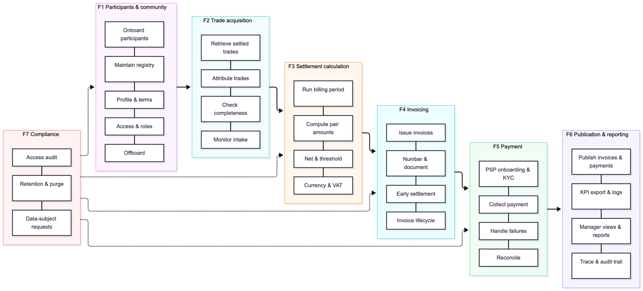
Figure 1 — Functional map

Data protection and GDPR
The service architecture addresses data protection across participant onboarding, billing, payments and the handling of data-subject requests.
The design provides for the following data protection and security measures:
- Roles and data flows: the architecture assigns responsibility for each community’s data to its community operator, with Blooo acting as processor for Billing and the project identity provider. It describes the intended data flows and access controls.
- Data minimisation: participants complete their own billing profile after invitation. Producers complete payment-provider onboarding. Producer KYC information is entered in the reference portal, tokenised in the browser with Stripe.js and sent directly to Stripe. Billing stores the registry, profiles, business calculations, provider references and a rebuildable read cache; raw payment credentials and KYC documents are not a second master copy in the billing database (REQ-008; REQ-010).
- Legal basis and retention: the design distinguishes billing purposes from accounting obligations and provides for retention rules and the expiry or anonymisation of non-essential data.
- Secure API communication and transport security: the design uses authenticated APIs, TLS at public endpoints and for database and messaging connections, HTTPS for payment-provider calls, and signature verification for provider webhooks. A service mesh providing mTLS between internal services is deferred (NFR-001; NFR-015).
- Logging and auditability: the design uses transaction identifiers, access and change audit records, and structured logs that exclude unnecessary personal data. Error handling links failures to the relevant transaction without exposing personal details in logs (REQ-030; NFR-015).
- Data-subject requests are handled through the portal or community manager and propagated to the payment provider and identity provider. The design separates erasure from the retention of invoices and accounting records. Client Gateway messages are purged after ingestion and retained for no more than seven days; in V1 the Client Gateway is packaged but not enrolled, and the billing adapters use mocks (REQ-011; REQ-013; REQ-053).
The payment service provider (Stripe, through its EU entity) processes participant payment, KYC and invoice data as an independent provider; the compatibility of this processing with NFR-002 and the project consent form is subject to confirmation by the project DPO before live operation. The data protection measures are documented in the service architecture files under docs/architecture/ in the repository introduced in Section 1.4; the functional, logical and technical architecture documents are listed in Section 7.12.

Payment scope and deferred mechanisms
D5.5 focuses on fiat payment workflows through Stripe in test mode. Card and SEPA Direct Debit are the specified payment methods (SEPA Direct Debit for EUR communities; CHF communities use cards); Twint, PayPal and virtual-wallet custody are outside this release. Consumer payment-method setup and producer Connect onboarding are distinct processes.
Cryptocurrency payments, connections to crypto wallets and i-Euro functions are within the planned scope of D5.10. D5.5 covers fiat payments through Stripe; this allocation does not remove crypto from the scope of T5.6.
The billing service consumes standardised cleared trades independently of the matching mechanism. It neither executes AMM swaps nor manages tokens or on-chain settlement. An AMM-generated trade can use the same billing path when it satisfies the agreed off-chain trade contract.

Billing and payment functions

D5.5 Scope
D5.5 V1 covers the following billing and payment functions and rules. The descriptions summarise the cited requirements and the architecture decisions documented in Section 7.12. Sections 6 and 7 specify the V1 operating conditions and interface limitations.
- Participants and community managers accept the current Terms and Conditions. Producers also accept a self-billing mandate, with version and timestamp recorded (REQ-050).
- Producer readiness requires payment-provider onboarding and KYC; consumers require a valid payment method before paying. Authentication is provided separately by the project OIDC IdP (REQ-040; REQ-045; REQ-051).
- Only settled, not previously invoiced trades are billed. The final trade price is used without recalculation. Buyer and seller identifiers are resolved through the participant registry, and market completeness is checked against ClearingResult (REQ-001; REQ-003; REQ-041; REQ-058).
- One invoice is issued per consumer and producer pair and period, in the producer’s name. Purchases and sales within the pair are netted, with a configurable minimum threshold of 5 EUR/CHF by default and carry-forward below that threshold (REQ-054; REQ-055; REQ-056).
- A community manager can trigger or schedule billing runs, with a community-specific period from monthly to quarterly (REQ-006); V1 implements monthly periods.
- Invoices have a sequential legal number per producer and a PDF accessible to both parties, with delivery to both parties (REQ-039; REQ-042).
- Payments use Stripe test mode for every community. In V1, each consumer payment is processed as a Stripe destination charge and transferred to the producer’s connected account; the platform keeps no pooled community balance and initiates no separate withdrawal. Moving to direct charges on the producer’s account, so that the platform never holds the funds, is planned before any live operation (REQ-014; REQ-015; REQ-043).
- Each invoice uses the community currency. EUR trades are converted at the ECB reference rate of the last business day of the period, or the settlement date for an early settlement; the rate and date appear on the invoice. VAT is configurable per community, 0 by default. Supplier/DSO grid fees, taxes and levies remain off-platform (REQ-002; REQ-007). V1 uses rate fixtures as described in Section 6.
- A consumer may settle unbilled trades with a producer early. This bypasses the periodic threshold; subsequent runs exclude already invoiced trades. Final settlement is forced at year end or participant exit (REQ-056; REQ-057).
- The service provides idempotent trade intake (REQ-001), an immutable calculation ledger (REQ-005), payment failure detection and notifications (REQ-016; REQ-017), payment-to-trade traceability (REQ-028), failure monitoring (REQ-029) and reconciliation (REQ-041). The architecture also specifies idempotent provider-event handling (see Section 7.12).
- The reference portal, manager console and operator views use documented APIs. Participant profiles, invoices, payments, community settings, history and privacy requests are access-controlled by role and community (REQ-009; REQ-010; REQ-031; REQ-032; REQ-049; REQ-052).
- The Billing and Payment Service is intended for full Apache-2.0 source publication, including its payment and webhook logic. Secrets, personal data and private production configuration are excluded (NFR-005; NFR-012).
Each invoice references the covered trades and shows the energy quantity, amount and VAT; the per-trade breakdown of delivery periods, quantities, final unit prices and amounts is planned for the next release; payments remain attributable to their originating trades and calculations (REQ-007; REQ-028). Exact decimal arithmetic, rounding to the cent per invoice line and a total equal to the sum of those lines are specified in the functional architecture, Section 6, Business rules, rule BR-08 (see Section 7.12).
Invoice lifecycle management includes Draft, Open, PartiallyPaid, Paid, Overdue, Void and Disputed, with a mandatory reason and audit trail for authorised manual status changes (REQ-044). The calculation ledger is immutable and versioned (REQ-005; NFR-003). The logical architecture specifies that corrections to issued invoices use cancellation and a new invoice or a credit note, preserving earlier financial records (see Section 7.12).
Billing exports amounts, energy quantities and billing components for WP6 analytics. It records failure causes and payment timing; project evaluation indicators and comparisons with a reference bill are calculated outside the Billing service (REQ-046; REQ-047).
Trade intake through live GSY/EWDS, publication through a live Client Gateway, ECB retrieval and integration into the R2M UI are target interfaces. V1 exercises their contracts through adapters and mocks. Grid-fee billing, imbalance penalties, bonus/incentive calculation and real-money operation are outside V1 (REQ-001; REQ-048; REQ-052).

D5.10 Scope
D5.10, the second version of the Billing and Payment Service, is planned to extend the fiat payment functions presented in D5.5 with cryptocurrency payments. The planned scope includes connecting participants’ crypto wallets, handling transaction confirmations and failures, and supporting conversion to i-Euro and the recording of i-Euro balance movements (REQ-019–REQ-022; REQ-026; REQ-027). The interface with the T5.4 AMM mechanism (token swaps, collateral check and quoted-price display, REQ-023–REQ-025) is also planned for D5.10, subject to the T5.4 interface baseline. These functions are outside the scope of D5.5 V1.

Payment service provider selection

Methodology for Selecting the Payment & KYC Provider

Purpose of the Methodology
The purpose of this methodology is to provide a transparent, unbiased and reproducible approach for evaluating and selecting the Payment & KYC provider used in Task 5.6 (Billing & Payment Service).
This methodology ensures that:
- the selection is evidence-based,
- alternatives are objectively compared,
- the rationale behind scoring is fully traceable,
- the outcome is defensible in audits and reviews,
- the chosen provider aligns with pilot needs, user expectations, regulatory constraints, and technical constraints of the INTELLIGENT platform.

Evaluation Framework Overview
The evaluation follows a structured multi-criteria decision analysis (MCDA) process, inspired by recognised methodologies such as:
- AHP (Analytical Hierarchy Process),
- Weighted-sum scoring (simple additive weighting),
- EU procurement best practices for supplier selection.
The process includes:
- Defining the evaluation criteria (derived from project deliverables and the Grant Agreement).
- Establishing a scoring scale and scoring rules.
- Defining weights for each criterion.
- Evaluating each candidate provider on each criterion with a justified score.
- Computing weighted scores to obtain a consolidated performance index.
- Identifying a short-list of the most appropriate solutions.
- Conducting a deep-dive analysis of the short-listed providers.
- Recommending the solution best aligned with D5.5 and D5.10 objectives.

Criteria Definition and Rationale
Criteria were derived from:
- D2.1–D2.5 (user needs, UX constraints, behavioural insights),
- D3.1 (EWDS interoperability),
- WP5 dependencies (GSY DEX, T5.3, T5.4),
- WP6 needs (real payments during pilots),
- EU regulatory frameworks (GDPR, PSD2, AMLD, MiCA),
- Financial settlement provisions in the Grant Agreement.
The final evaluation incorporates nine categories, each containing sub-criteria:
Category | Criteria | Why it matters
A — Sovereignty & Compliance | A1. EU Digital Sovereignty / Jurisdiction  A2. GDPR, PSD2, AMLD compliance maturity  A3. Data localisation and storage guarantees (EU region availability) | Trust (WP2), auditability, compliance, and user acceptance
B — KYC & Identity Verification | B1. Automated KYC (documents, biometrics)  B2. Identity verification robustness  B3. KYC auditability and traceability (including future eIDAS2 / EUDI readiness) | Producer onboarding and verification are central to the payment flow.
C — Technical Integration | C1. API quality, completeness, consistency  C2. Webhooks, event reliability, idempotency  C3. Sandbox and developer tools  C4. Compatibility with EWDS and GSY DEX architecture | WP3/WP5 integration challenges, CI/CD pipelines and developer tooling.
D — Marketplace & Multi-Actor Capabilities | D1. Payouts / multi-party settlement / split payments  D2. Wallet / escrow capabilities  D3. Chargebacks, refunds, reversals | INTELLIGENT is not a simple seller→buyer payment flow; it's a multi-actor energy market
E — User Experience & Adoption | E1. Onboarding simplicity  E2. End-user payment UX (including local payment methods such as Bancontact, Twint and iDEAL)  E3. Accessibility for low digital-literacy populations | WP2.3 shows extremely strong expectations for simplicity.
F — Payment Methods & Currency Support | F1. EUR processing and payouts  F2. CHF processing and payouts | EUR/CHF pilots, payout viability.
G — Cost Structure | G1. Setup / integration cost  G2. Monthly fixed cost  G3. Transaction cost (card fees, payout fees, SEPA fees)  G4. KYC verification cost per user | Sustainability over pilots and future exploitation.
H — Reliability & Operational Performance | H1. SLA / uptime guarantees  H2. Approval rate / success rate | Reliability needed for future live pilot operation.
I — Strategic Extensibility | I1. Compatibility with future crypto/stablecoin modules (T5.4)  I2. Replaceability / modular architecture | Long-term flexibility of WP5.
Table 1 — Criteria definition and rationale

Scoring Scale (0–5)
Every score must be justified in writing, referencing project constraints.

Score | Definition | Rule for Assignment
5 – Excellent | Fully satisfies the criterion, no limitations | Strong evidence; no constraints foreseen
4 – Strong | Satisfies with minor limitations | Minor gaps but acceptable
3 – Moderate | Partially satisfies; workarounds required | Usable with adaptations
2 – Weak | Significant limitations | High effort or risk
1 – Very weak | Barely meets the criterion | Major operational risk
0 – Absent | Does not satisfy the criterion at all | Inapplicable or unsupported
Table 2 — Scoring scale

Weighting Model
Relative weights express the importance of the nine criteria. The same integer weights are used in the weighting model, consolidated scores and finalist analysis: A = 15, B = 15, C = 15, D = 10, E = 10, F = 10, G = 10, H = 5 and I = 5. Their sum is 95. These are relative weights, not percentages.
Category | Relative weight | Rationale
A — Sovereignty & Compliance | 15 | High priority for EU-funded project, trust, public acceptance
B — KYC & Identity Verification | 15 | Producer verification and payment-account readiness
C — Technical Integration | 15 | API, webhook and sandbox quality drive integration effort and risk
D — Marketplace & Multi-Actor Capabilities | 10 | Central to the P2P model of INTELLIGENT
E — User Experience & Adoption | 10 | Low digital literacy of pilot participants requires simple onboarding and payment (WP2)
F — Payment Methods & Currency Support | 10 | Mandatory for pilot adoption (WP2 results)
G — Cost Structure | 10 | Sustainability of the solution
H — Reliability & Operational Performance | 5 | Pilot operating needs
I — Strategic Extensibility | 5 | Long-term alignment with WP5 evolution
Table 3 — Weighting Model

Evaluation Procedure
The selection follows these steps:
No. | Step Name | Description
1 | Candidate Identification | A broad set of PSPs and KYC providers is selected, including both EU-sovereign and global providers, regardless of expected score, to avoid bias.
2 | Criterion-by-Criterion Scoring | Each solution is scored independently on all criteria, using the 0–5 scale, with explicit written justification for each score.
3 | “Must-have” filtering | Before even looking at global scores, the method applies hard filters on sub-criteria that are non-negotiable for INTELLIGENT.
4 | Application of Weighting | Weighted scores are computed to obtain a comparable performance index across providers.
5 | Consolidation and Ranking | All solutions are ranked according to their weighted score, creating a full traceable audit trail of the evaluation.
6 | Short-List Definition | The top two or three solutions are selected for deeper analysis, based strictly on quantitative and qualitative evidence.
7 | Deep-Dive Analysis of Finalists | The short-listed solutions undergo additional examination:  - detailed compliance analysis,  - integration effort estimation,  - cost modelling,  - risk assessment,  - alignment with D5.5 and D5.10 timelines,  - compatibility with pilot constraints.
8 | Final decision | A final recommendation is issued, supported by:  - documented evidence,  - analytic scoring,  - partner review,  - project governance validation.
Table 4 — Evaluation Procedure

“Must-have” filters (eliminate non-viable candidates)
Before even looking at global scores, the method applies hard filters on sub-criteria that are non-negotiable for INTELLIGENT:

Hard filter 1 – Marketplace capabilities
- D1 (Marketplace support) ≥ 3
- D2 (Wallet / escrow) ≥ 3
If this is not met, the PSP cannot correctly support prosumers, multiple payees, and platform flows → excluded.

Hard filter 2 – Technical feasibility
- C1 (API completeness) ≥ 3
- C2 (Webhooks quality) ≥ 3
- C3 (Sandbox) ≥ 3
If not, integration cost and risk explode → excluded.

Hard filter 3 – KYC viability
- B1 (Automated KYC level) ≥ 3
If there is no usable KYC model, the burden falls on Blooo/INTELLIGENT → unacceptable for D5.5/D5.10.

Hard filter 4 – Currency support
- F1 (EUR with payouts) ≥ 4
- F2 (CHF with at least basic payouts) ≥ 3
Otherwise, you can’t serve both EU and Swiss pilots properly.

Benefits of This Methodology
This structured evaluation approach ensures:
- objectivity and neutrality,
- traceability of every decision,
- alignment with EU procurement and audit expectations,
- clear justification for rejecting or accepting providers,
- consistent treatment of all candidates,
- evidence that Stripe is not chosen by default,
- long-term flexibility for INTELLIGENT’s evolution.

Detailed Evaluation
Solution | Sub-criterion | Evaluation | Rationale
Adyen | A1 – EU jurisdiction & ownership | 5 | EU-based PSP headquartered in NL.
Adyen | A2 – Regulatory compliance maturity | 5 | Full PSD2/AML/PCI stack for enterprises.
Adyen | A3 – Data localisation guarantees | 5 | EU data centres and regions available.
Adyen | B1 – Automated KYC level | 5 | Strong KYC/KYB for platforms and sub-merchants.
Adyen | B2 – Identity verification robustness | 5 | Bank-grade checks with risk/fraud tooling.
Adyen | B3 – KYC auditability & traceability | 5 | Regulated reporting and detailed KYC records.
Adyen | C1 – API completeness & clarity | 4 | Rich APIs but more complex than Stripe.
Adyen | C2 – Webhooks / eventing quality | 4 | Mature notification system, slightly heavy.
Adyen | C3 – Sandbox & developer tools | 4 | Good sandbox but less dev-centric UX.
Adyen | C4 – Fit with INTELLIGENT (EWDS/DEX) | 4 | Technically fits, but heavier integration effort.
Adyen | D1 – Marketplace support | 5 | “Adyen for Platforms” covers marketplaces.
Adyen | D2 – Wallet / escrow capabilities | 4 | Strong account structures, less “lightweight wallet”.
Adyen | D3 – Refunds / chargebacks handling | 5 | Very strong dispute and chargeback handling.
Adyen | E1 – Merchant onboarding simplicity | 3 | Onboarding OK but more enterprise-oriented.
Adyen | E2 – End-user payment UX | 4 | Solid UX, less “polished” than Stripe checkout.
Adyen | E3 – Low digital literacy accessibility | 3 | Good flows, but more friction than Stripe.
Adyen | F1 – EUR payouts support | 5 | Fully supports EUR processing and payouts.
Adyen | F2 – CHF payouts support | 4 | CHF supported, but conditions may apply.
Adyen | G1 – Integration setup cost | 2 | Entry barrier and contract process heavier.
Adyen | G2 – Monthly fixed cost | 2 | Often includes minimums or commitments.
Adyen | G3 – Transaction & payout cost | 3 | Negotiated, competitive but not “cheap”.
Adyen | G4 – KYC cost per user | 3 | Embedded but reflected in overall pricing.
Adyen | H1 – Reliability / SLA | 5 | Very high reliability and enterprise SLAs.
Adyen | H2 – Approval rate / performance | 4 | Strong performance, sometimes improved by routing.
Adyen | I1 – Crypto/stablecoin compatibility | 3 | Possible via custom integration, not native focus.
Adyen | I2 – Modularity / replaceability | 3 | Strong lock-in once integrated deeply.
Checkout.com | A1 – EU jurisdiction & ownership | 3 | UK-origin with EU entities; mixed jurisdiction.
Checkout.com | A2 – Regulatory compliance maturity | 4 | Licensed PSP with full compliance stack.
Checkout.com | A3 – Data localisation guarantees | 4 | EU data regions available in cloud setup.
Checkout.com | B1 – Automated KYC level | 4 | Good onboarding for merchants and platforms.
Checkout.com | B2 – Identity verification robustness | 4 | Solid merchant due diligence processes.
Checkout.com | B3 – KYC auditability | 4 | Enterprise-grade reporting and audit records.
Checkout.com | C1 – API completeness & clarity | 4 | Modern API, well-structured resources.
Checkout.com | C2 – Webhooks / eventing quality | 4 | Mature webhooks for payments and payouts.
Checkout.com | C3 – Sandbox & developer tools | 4 | Good sandbox and developer tools.
Checkout.com | C4 – Fit with INTELLIGENT | 4 | Compatible with EWDS/DEX patterns, some effort.
Checkout.com | D1 – Marketplace support | 4 | Supports platform/marketplace use cases.
Checkout.com | D2 – Wallet / escrow | 3 | Less wallet-centric than Mangopay/Lemonway.
Checkout.com | D3 – Refunds / chargebacks | 4 | Standard enterprise-grade dispute handling.
Checkout.com | E1 – Merchant onboarding simplicity | 3 | Targeted at mid/large merchants; not plug-and-play.
Checkout.com | E2 – End-user payment UX | 4 | Good UX with customisable checkout.
Checkout.com | E3 – Low digital literacy accessibility | 3 | UX depends on platform implementation.
Checkout.com | F1 – EUR payouts support | 5 | Strong EUR processing and payouts.
Checkout.com | F2 – CHF payouts support | 4 | CHF available in many markets.
Checkout.com | G1 – Integration setup cost | 3 | Requires contractual onboarding and integration.
Checkout.com | G2 – Monthly fixed cost | 3 | Typically enterprise pricing and minima.
Checkout.com | G3 – Transaction & payout cost | 3 | Competitive enterprise pricing, not minimal.
Checkout.com | G4 – KYC cost per user | 3 | Embedded in pricing, not transparent per-check.
Checkout.com | H1 – Reliability / SLA | 4 | Good uptime and resilience track record.
Checkout.com | H2 – Approval rate / performance | 4 | Good routing and performance in EU.
Checkout.com | I1 – Crypto/stablecoin compatibility | 3 | API-first, but no native crypto layer.
Checkout.com | I2 – Modularity / replaceability | 3 | Medium effort to swap out later.
Lemonway | A1 – EU jurisdiction & ownership | 5 | EU PSP headquartered in France.
Lemonway | A2 – Regulatory compliance maturity | 5 | Strong focus on AML/KYC for platforms.
Lemonway | A3 – Data localisation guarantees | 5 | EU-hosted infrastructure for compliance.
Lemonway | B1 – Automated KYC level | 5 | Fully digital KYC/KYB for marketplace actors.
Lemonway | B2 – Identity verification robustness | 5 | Deep checks for borrowers/merchants/investors.
Lemonway | B3 – KYC auditability | 5 | Detailed KYC records and regulatory reporting.
Lemonway | C1 – API completeness & clarity | 3 | Wallet-centric APIs, less polished than Stripe.
Lemonway | C2 – Webhooks / eventing quality | 3 | Notifications available but less developer-oriented.
Lemonway | C3 – Sandbox & developer tools | 3 | Sandbox exists, tooling more limited.
Lemonway | C4 – Fit with INTELLIGENT | 4 | Very relevant for multi-wallet prosumer/producer logic.
Lemonway | D1 – Marketplace support | 5 | Designed specifically for marketplaces and platforms.
Lemonway | D2 – Wallet / escrow capabilities | 5 | Strong wallets and escrow models.
Lemonway | D3 – Refunds / chargebacks | 4 | Well-managed through wallet logic and PSP role.
Lemonway | E1 – Merchant onboarding simplicity | 3 | Good for operators, more friction for small prosumers.
Lemonway | E2 – End-user payment UX | 3 | Depends heavily on front-end of the platform.
Lemonway | E3 – Low digital literacy accessibility | 3 | More complex flows than Stripe/Mollie.
Lemonway | F1 – EUR payouts support | 5 | Very strong EUR and SEPA focus.
Lemonway | F2 – CHF payouts support | 3 | CHF possible but less native.
Lemonway | G1 – Integration setup cost | 2 | Integration and onboarding project-like.
Lemonway | G2 – Monthly fixed cost | 2.5 | Often minimum fees for platforms.
Lemonway | G3 – Transaction & payout cost | 3 | Fair for platforms but not cheapest.
Lemonway | G4 – KYC cost per user | 2 | KYC is strong but not cost-neutral.
Lemonway | H1 – Reliability / SLA | 4 | Stable PSP with EU clients.
Lemonway | H2 – Approval rate / performance | 4 | Good within SEPA and card schemes.
Lemonway | I1 – Crypto/stablecoin compatibility | 3 | Can be layered on top via off-chain logic.
Lemonway | I2 – Modularity / replaceability | 3 | Deep wallet coupling makes swap non-trivial.
Lyra/PayZen | A1 – EU jurisdiction & ownership | 5 | French group with EU focus.
Lyra/PayZen | A2 – Regulatory compliance maturity | 4 | Strong card/PSP heritage, PCI compliant.
Lyra/PayZen | A3 – Data localisation guarantees | 4 | EU hosting options for merchants.
Lyra/PayZen | B1 – Automated KYC level | 3 | Merchant KYC, limited sub-merchant logic.
Lyra/PayZen | B2 – Identity verification robustness | 3 | Standard KYC but not marketplace-oriented.
Lyra/PayZen | B3 – KYC auditability | 3 | PSP-grade logs, not KYC-as-a-service.
Lyra/PayZen | C1 – API completeness & clarity | 3.5 | Solid API for online payments.
Lyra/PayZen | C2 – Webhooks / eventing quality | 3 | Webhooks exist but not best-in-class.
Lyra/PayZen | C3 – Sandbox & developer tools | 3 | Decent, but dev experience is not primary focus.
Lyra/PayZen | C4 – Fit with INTELLIGENT | 3 | Ok for basic payments, limited marketplace logic.
Lyra/PayZen | D1 – Marketplace support | 3 | Marketplace features available but not as advanced.
Lyra/PayZen | D2 – Wallet / escrow capabilities | 2.5 | Possible via PSP logic, not native wallets.
Lyra/PayZen | D3 – Refunds / chargebacks | 4 | Strong card/dispute experience.
Lyra/PayZen | E1 – Merchant onboarding simplicity | 3 | Good for SMEs, less for prosumers.
Lyra/PayZen | E2 – End-user payment UX | 3.5 | Standard hosted/payment page UX.
Lyra/PayZen | E3 – Low digital literacy accessibility | 3 | Acceptable but not optimised for simplicity.
Lyra/PayZen | F1 – EUR payouts support | 5 | Strong presence in Eurozone.
Lyra/PayZen | F2 – CHF payouts support | 4 | CHF supported through acquiring partners.
Lyra/PayZen | G1 – Integration setup cost | 3 | Requires some PSP integration effort.
Lyra/PayZen | G2 – Monthly fixed cost | 3 | Often monthly fees for merchants.
Lyra/PayZen | G3 – Transaction & payout cost | 3 | Competitive but not the lowest.
Lyra/PayZen | G4 – KYC cost per user | 2.5 | KYC included but not granular.
Lyra/PayZen | H1 – Reliability / SLA | 4 | Established PSP with good uptime.
Lyra/PayZen | H2 – Approval rate / performance | 4 | Good performance with European acquirers.
Lyra/PayZen | I1 – Crypto/stablecoin compatibility | 2 | No native path; custom glue required.
Lyra/PayZen | I2 – Modularity / replaceability | 3 | Replaceable but migration costs exist.
Mangopay | A1 – EU jurisdiction & ownership | 5 | EU PSP based in Luxembourg.
Mangopay | A2 – Regulatory compliance maturity | 5 | Strong AML/KYC focus for marketplaces.
Mangopay | A3 – Data localisation guarantees | 5 | EU-hosted infrastructure aligned with regulation.
Mangopay | B1 – Automated KYC level | 4 | Well-integrated KYC/KYB for wallets.
Mangopay | B2 – Identity verification robustness | 4 | Good document checks and KYB flows.
Mangopay | B3 – KYC auditability | 5 | Detailed KYC records and regulatory reporting.
Mangopay | C1 – API completeness & clarity | 4 | Comprehensive wallet/payments API.
Mangopay | C2 – Webhooks / eventing quality | 4 | Webhooks support wallet and transaction events.
Mangopay | C3 – Sandbox & developer tools | 4 | Reasonable sandbox, dev experience improving.
Mangopay | C4 – Fit with INTELLIGENT | 4 | Very close to required multi-wallet architecture.
Mangopay | D1 – Marketplace support | 5 | Core use case is marketplaces & platforms.
Mangopay | D2 – Wallet / escrow capabilities | 5 | Wallets, escrow and complex flows supported.
Mangopay | D3 – Refunds / chargebacks | 4 | Proper refund/dispute handling for platforms.
Mangopay | E1 – Merchant onboarding simplicity | 3 | Needs more structure for small prosumers.
Mangopay | E2 – End-user payment UX | 3 | Depends heavily on integrator’s front-end.
Mangopay | E3 – Low digital literacy accessibility | 3 | More complex than consumer-oriented PSPs.
Mangopay | F1 – EUR payouts support | 4 | Strong EUR wallet and payout capabilities.
Mangopay | F2 – CHF payouts support | 3 | Partial support, may be constrained.
Mangopay | G1 – Integration setup cost | 3 | Requires wallet logic and more dev time.
Mangopay | G2 – Monthly fixed cost | 3 | Platform-oriented pricing; minimum volumes likely.
Mangopay | G3 – Transaction & payout cost | 3 | OK but not optimised for micro-payments.
Mangopay | G4 – KYC cost per user | 2.5 | Embedded KYC, cost relevant for many users.
Mangopay | H1 – Reliability / SLA | 4 | Mature PSP with good stability.
Mangopay | H2 – Approval rate / performance | 4 | Strong in EU card/SEPA flows.
Mangopay | I1 – Crypto/stablecoin compatibility | 4 | Wallet approach facilitates future crypto layer.
Mangopay | I2 – Modularity / replaceability | 3 | Wallet-centric model makes migration non-trivial.
Mollie | A1 – EU jurisdiction & ownership | 5 | Dutch PSP, fully EU-based.
Mollie | A2 – Regulatory compliance maturity | 4 | PSD2, PCI, strong SME compliance.
Mollie | A3 – Data localisation guarantees | 4 | EU hosting for European merchants.
Mollie | B1 – Automated KYC level | 3 | Merchant KYC only, no sub-merchant KYC.
Mollie | B2 – Identity verification robustness | 3 | Standard KYC, not marketplace-centric.
Mollie | B3 – KYC auditability | 3 | Adequate for merchants, limited for platforms.
Mollie | C1 – API completeness & clarity | 5 | Excellent dev-friendly APIs and docs.
Mollie | C2 – Webhooks / eventing quality | 5 | Simple and robust webhook implementation.
Mollie | C3 – Sandbox & developer tools | 5 | Very good sandbox and examples.
Mollie | C4 – Fit with INTELLIGENT | 3 | Good for basic payments, lacks marketplace support.
Mollie | D1 – Marketplace support | 2 | No real Connect-style sub-merchant management.
Mollie | D2 – Wallet / escrow capabilities | 1.5 | No native wallet/escrow layer.
Mollie | D3 – Refunds / chargebacks | 4 | Good refunds; disputes handled via acquirers.
Mollie | E1 – Merchant onboarding simplicity | 5 | Very easy for SMEs to set up.
Mollie | E2 – End-user payment UX | 5 | Strong UX, many local methods supported.
Mollie | E3 – Low digital literacy accessibility | 4 | Flows are simple and recognisable.
Mollie | F1 – EUR payouts support | 5 | Excellent for EUR and SEPA.
Mollie | F2 – CHF payouts support | 3 | Limited or indirect CHF support.
Mollie | G1 – Integration setup cost | 5 | No setup fee, quick integration.
Mollie | G2 – Monthly fixed cost | 4.5 | Low or no minimum monthly fees.
Mollie | G3 – Transaction & payout cost | 4 | Competitive for cards/SEPA in EU.
Mollie | G4 – KYC cost per user | 3 | Only merchant KYC, not per end-user.
Mollie | H1 – Reliability / SLA | 4 | Good track record in EU.
Mollie | H2 – Approval rate / performance | 4 | Good performance on supported methods.
Mollie | I1 – Crypto/stablecoin compatibility | 2.5 | Possible but no marketplace wallets.
Mollie | I2 – Modularity / replaceability | 4 | Easy to replace thanks to simple APIs.
PayPal | A1 – EU jurisdiction & ownership | 2 | US company with EU entities; CLOUD Act risk.
PayPal | A2 – Regulatory compliance maturity | 4 | Very mature AML/KYC and scheme compliance.
PayPal | A3 – Data localisation guarantees | 3 | Data primarily global; limited EU residency control.
PayPal | B1 – Automated KYC level | 4 | Automated account KYC for users.
PayPal | B2 – Identity verification robustness | 4 | Strong internal risk/fraud tooling.
PayPal | B3 – KYC auditability | 3.5 | Logs exist, but less transparent for platforms.
PayPal | C1 – API completeness & clarity | 3.5 | Several APIs; somewhat fragmented historically.
PayPal | C2 – Webhooks / eventing quality | 3 | Webhooks exist but can be noisy/tricky.
PayPal | C3 – Sandbox & developer tools | 3 | Sandbox available but not best-in-class.
PayPal | C4 – Fit with INTELLIGENT | 2.5 | Harder to align with EWDS/DEX flows.
PayPal | D1 – Marketplace support | 2.5 | Limited marketplace tooling vs Stripe/Adyen.
PayPal | D2 – Wallet / escrow capabilities | 3 | Wallet exists but not programmable for platforms.
PayPal | D3 – Refunds / chargebacks | 4 | Very good consumer-oriented dispute handling.
PayPal | E1 – Merchant onboarding simplicity | 4 | Easy to onboard small merchants.
PayPal | E2 – End-user payment UX | 5 | Extremely familiar to many consumers.
PayPal | E3 – Low digital literacy accessibility | 4 | Recognisable button and simple flows.
PayPal | F1 – EUR payouts support | 4 | Good EUR support but payout options limited.
PayPal | F2 – CHF payouts support | 3.5 | CHF supported but with constraints.
PayPal | G1 – Integration setup cost | 4 | Very low friction to start.
PayPal | G2 – Monthly fixed cost | 4.5 | Generally no monthly fees.
PayPal | G3 – Transaction & payout cost | 2.5 | Expensive on card/PayPal wallet transactions.
PayPal | G4 – KYC cost per user | 3 | Embedded in their margin.
PayPal | H1 – Reliability / SLA | 4 | Highly available global infrastructure.
PayPal | H2 – Approval rate / performance | 4 | Good approval rates within PayPal ecosystem.
PayPal | I1 – Crypto/stablecoin compatibility | 3 | Some crypto initiatives, but proprietary.
PayPal | I2 – Modularity / replaceability | 2.5 | Integration tends to be PayPal-centric.
PayPlug | A1 – EU jurisdiction & ownership | 5 | French PSP within BPCE group.
PayPlug | A2 – Regulatory compliance maturity | 4 | Bank-backed, PCI, PSD2 compliant.
PayPlug | A3 – Data localisation guarantees | 4 | EU-hosted services for EU merchants.
PayPlug | B1 – Automated KYC level | 3 | Merchant KYC only, no sub-merchant flows.
PayPlug | B2 – Identity verification robustness | 3 | Standard merchant KYC level.
PayPlug | B3 – KYC auditability | 3 | Adequate for single-merchant setups.
PayPlug | C1 – API completeness & clarity | 3.5 | Adequate API for e-commerce.
PayPlug | C2 – Webhooks / eventing quality | 3 | Eventing sufficient for basic workflows.
PayPlug | C3 – Sandbox & developer tools | 3 | Sandbox present, fewer advanced tools.
PayPlug | C4 – Fit with INTELLIGENT | 2.5 | Good for merchant billing, not for P2P market.
PayPlug | D1 – Marketplace support | 1.5 | No native Connect-style marketplace support.
PayPlug | D2 – Wallet / escrow capabilities | 1 | No programmable wallet layer.
PayPlug | D3 – Refunds / chargebacks | 4 | Standard PSP capabilities.
PayPlug | E1 – Merchant onboarding simplicity | 4 | Simple for e-commerce merchants.
PayPlug | E2 – End-user payment UX | 4 | Clean checkout for CB/SEPA.
PayPlug | E3 – Low digital literacy accessibility | 3.5 | Familiar flows for French users.
PayPlug | F1 – EUR payouts support | 5 | Strong focus on Eurozone.
PayPlug | F2 – CHF payouts support | 2.5 | CHF not core focus.
PayPlug | G1 – Integration setup cost | 4 | Low entry effort for SMEs.
PayPlug | G2 – Monthly fixed cost | 4 | Simple subscription and pricing plans.
PayPlug | G3 – Transaction & payout cost | 4 | Competitive for French and EU SMEs.
PayPlug | G4 – KYC cost per user | 3 | Only merchant-side, not per prosumer.
PayPlug | H1 – Reliability / SLA | 4 | Backed by major banking group.
PayPlug | H2 – Approval rate / performance | 4 | Good for French CB/SEPA transactions.
PayPlug | I1 – Crypto/stablecoin compatibility | 2 | No obvious crypto-friendly path.
PayPlug | I2 – Modularity / replaceability | 4 | Easy to swap as simple PSP.
Radar Payments (BPC) | A1 – EU jurisdiction & ownership | 4 | Multi-region; can deploy EU instances.
Radar Payments (BPC) | A2 – Regulatory compliance maturity | 5 | Bank-grade processing and scheme compliance.
Radar Payments (BPC) | A3 – Data localisation guarantees | 5 | On-prem or EU-hosted options for banks.
Radar Payments (BPC) | B1 – Automated KYC level | 4 | Deep KYC/AML modules aimed at FIs.
Radar Payments (BPC) | B2 – Identity verification robustness | 4 | Strong risk/fraud stack when fully used.
Radar Payments (BPC) | B3 – KYC auditability | 5 | Designed for regulated financial institutions.
Radar Payments (BPC) | C1 – API completeness & clarity | 3 | Rich but oriented to processors, not dev-friendly.
Radar Payments (BPC) | C2 – Webhooks / eventing quality | 3 | Eventing exists but complex to integrate.
Radar Payments (BPC) | C3 – Sandbox & developer tools | 2.5 | Heavy sandbox setup.
Radar Payments (BPC) | C4 – Fit with INTELLIGENT | 2 | Over-kill and too heavy for WP5 timelines.
Radar Payments (BPC) | D1 – Marketplace support | 3 | Can be built, but needs custom project.
Radar Payments (BPC) | D2 – Wallet / escrow capabilities | 3.5 | Possible via card/wallet modules.
Radar Payments (BPC) | D3 – Refunds / chargebacks | 5 | Very strong at scheme-level dispute handling.
Radar Payments (BPC) | E1 – Merchant onboarding simplicity | 1 | Designed for banks, not small platforms.
Radar Payments (BPC) | E2 – End-user payment UX | 2 | Depends entirely on bank front-ends.
Radar Payments (BPC) | E3 – Low digital literacy accessibility | 2 | UX out of scope of core platform.
Radar Payments (BPC) | F1 – EUR payouts support | 5 | Full scheme and SEPA processing.
Radar Payments (BPC) | F2 – CHF payouts support | 5 | Also present in Swiss and non-Euro markets.
Radar Payments (BPC) | G1 – Integration setup cost | 1 | Very high initial integration effort.
Radar Payments (BPC) | G2 – Monthly fixed cost | 1 | Suited for banks, not pilot-scale budgets.
Radar Payments (BPC) | G3 – Transaction & payout cost | 2 | Efficient at scale but high fixed components.
Radar Payments (BPC) | G4 – KYC cost per user | 2 | Heavy processes; unsuitable for small pilots.
Radar Payments (BPC) | H1 – Reliability / SLA | 5 | Tier-1 processing reliability.
Radar Payments (BPC) | H2 – Approval rate / performance | 5 | High-performance core switching.
Radar Payments (BPC) | I1 – Crypto/stablecoin compatibility | 3 | Possible with complex integration.
Radar Payments (BPC) | I2 – Modularity / replaceability | 1.5 | Locks you into a heavy banking stack.
Smile&Pay | A1 – EU jurisdiction & ownership | 5 | French acquirer with EU focus.
Smile&Pay | A2 – Regulatory compliance maturity | 4 | Strong card compliance for TPEs.
Smile&Pay | A3 – Data localisation guarantees | 4 | EU infrastructure oriented to FR market.
Smile&Pay | B1 – Automated KYC level | 3 | Merchant KYC only, simple.
Smile&Pay | B2 – Identity verification robustness | 3 | Enough for small merchants, not platforms.
Smile&Pay | B3 – KYC auditability | 3 | Standard acquirer logs.
Smile&Pay | C1 – API completeness & clarity | 2 | Mainly oriented to terminals and payment links.
Smile&Pay | C2 – Webhooks / eventing quality | 2 | Limited automation hooks.
Smile&Pay | C3 – Sandbox & developer tools | 2 | Minimal dev tooling; POS-first approach.
Smile&Pay | C4 – Fit with INTELLIGENT | 1 | Not designed for P2P energy markets.
Smile&Pay | D1 – Marketplace support | 0.5 | No sub-merchant/marketplace features.
Smile&Pay | D2 – Wallet / escrow capabilities | 0 | No programmatic wallets.
Smile&Pay | D3 – Refunds / chargebacks | 4 | Classic acquirer dispute management.
Smile&Pay | E1 – Merchant onboarding simplicity | 4 | Very easy for small merchants.
Smile&Pay | E2 – End-user payment UX | 4 | Simple terminal and payment link flows.
Smile&Pay | E3 – Low digital literacy accessibility | 4 | Familiar card-present experience.
Smile&Pay | F1 – EUR payouts support | 5 | Focus on France and Eurozone.
Smile&Pay | F2 – CHF payouts support | 1 | No real CHF positioning.
Smile&Pay | G1 – Integration setup cost | 4 | Low barrier, hardware and simple contracts.
Smile&Pay | G2 – Monthly fixed cost | 4 | Plans designed for TPE budgets.
Smile&Pay | G3 – Transaction & payout cost | 3 | OK for small merchants, not optimised.
Smile&Pay | G4 – KYC cost per user | 3 | Only merchant-side.
Smile&Pay | H1 – Reliability / SLA | 4 | Stable for French TPEs.
Smile&Pay | H2 – Approval rate / performance | 4 | Good within domestic card schemes.
Smile&Pay | I1 – Crypto/stablecoin compatibility | 1 | No path beyond card schemes.
Smile&Pay | I2 – Modularity / replaceability | 4 | Easy to stop using if needed.
Square | A1 – EU jurisdiction & ownership | 2 | US-based with EU presence.
Square | A2 – Regulatory compliance maturity | 4 | PSP with full card compliance.
Square | A3 – Data localisation guarantees | 3 | Limited control on EU-only storage.
Square | B1 – Automated KYC level | 3 | Merchant KYC for small businesses.
Square | B2 – Identity verification robustness | 3 | Adequate for micro-merchants.
Square | B3 – KYC auditability | 3 | Standard PSP logs.
Square | C1 – API completeness & clarity | 3 | APIs OK, oriented POS/e-commerce.
Square | C2 – Webhooks / eventing quality | 3 | Eventing is present but simple.
Square | C3 – Sandbox & developer tools | 3 | Sandbox exists, limited advanced tools.
Square | C4 – Fit with INTELLIGENT | 2 | Not aligned with multi-actor P2P logic.
Square | D1 – Marketplace support | 2 | Some payout features; not a full marketplace stack.
Square | D2 – Wallet / escrow capabilities | 1.5 | No real programmable wallets.
Square | D3 – Refunds / chargebacks | 4 | Standard card refunds & disputes.
Square | E1 – Merchant onboarding simplicity | 4 | Very easy for small businesses.
Square | E2 – End-user payment UX | 4 | Good POS and online flows.
Square | E3 – Low digital literacy accessibility | 4 | Simple card flows.
Square | F1 – EUR payouts support | 3.5 | Available in some EU countries.
Square | F2 – CHF payouts support | 1.5 | Not core focus.
Square | G1 – Integration setup cost | 4 | Low barrier for POS + basic online.
Square | G2 – Monthly fixed cost | 4 | Simple plans for merchants.
Square | G3 – Transaction & payout cost | 3.5 | Reasonable for small merchants.
Square | G4 – KYC cost per user | 3 | Merchant-only KYC.
Square | H1 – Reliability / SLA | 4 | Good availability.
Square | H2 – Approval rate / performance | 4 | Similar to other global PSPs.
Square | I1 – Crypto/stablecoin compatibility | 2 | Not aimed at crypto integration.
Square | I2 – Modularity / replaceability | 3.5 | Replaceable, integration relatively contained.
Stripe | A1 – EU jurisdiction & ownership | 2 | US company with EU branches.
Stripe | A2 – Regulatory compliance maturity | 5 | Full PSD2, PCI, AML/KYC tooling.
Stripe | A3 – Data localisation guarantees | 4 | EU regions available; still US governance.
Stripe | B1 – Automated KYC level | 5 | Stripe Connect/Identity handle sub-merchant KYC.
Stripe | B2 – Identity verification robustness | 5 | Document + biometric verification available.
Stripe | B3 – KYC auditability | 5 | Detailed logs, events and reports.
Stripe | C1 – API completeness & clarity | 5 | Industry benchmark for developer-friendly APIs.
Stripe | C2 – Webhooks / eventing quality | 5 | Robust webhooks and idempotency mechanisms.
Stripe | C3 – Sandbox & developer tools | 5 | Extensive sandbox data, CLI, dashboards.
Stripe | C4 – Fit with INTELLIGENT | 5 | Event-driven webhooks fit the billing architecture; EWDS/DEX integration goes through billing adapters.
Stripe | D1 – Marketplace support | 5 | Stripe Connect: full marketplace/sub-account model.
Stripe | D2 – Wallet / escrow capabilities | 5 | Platform balances and controlled payouts.
Stripe | D3 – Refunds / chargebacks | 5 | Very strong dispute and refund handling.
Stripe | E1 – Merchant onboarding simplicity | 5 | Extremely fast for platforms and merchants.
Stripe | E2 – End-user payment UX | 5 | Highly polished checkout & Payment Element.
Stripe | E3 – Low digital literacy accessibility | 4 | Simple flows, but some 3DS friction.
Stripe | F1 – EUR payouts support | 5 | Full EUR and SEPA support.
Stripe | F2 – CHF payouts support | 5 | CHF supported in Switzerland and EU.
Stripe | G1 – Integration setup cost | 5 | No setup fee, quick integration.
Stripe | G2 – Monthly fixed cost | 5 | No mandatory monthly fees.
Stripe | G3 – Transaction & payout cost | 3 | Fees in mid-to-high range.
Stripe | G4 – KYC cost per user | 4 | Usage-based pricing, not the cheapest.
Stripe | H1 – Reliability / SLA | 5 | Very high availability at global scale.
Stripe | H2 – Approval rate / performance | 4 | Strong, but acquirer choice still matters.
Stripe | I1 – Crypto/stablecoin compatibility | 4 | Easy to surround with crypto off-chain logic.
Stripe | I2 – Modularity / replaceability | 4 | Clean APIs make future swap feasible.
SumUp | A1 – EU jurisdiction & ownership | 4 | European-rooted, multi-country presence.
SumUp | A2 – Regulatory compliance maturity | 4 | PSP with card compliance and regulation.
SumUp | A3 – Data localisation guarantees | 3.5 | Some EU hosting, global structure.
SumUp | B1 – Automated KYC level | 3 | Merchant KYC for micro-businesses.
SumUp | B2 – Identity verification robustness | 3 | Adequate but not marketplace-grade.
SumUp | B3 – KYC auditability | 3 | Standard PSP logs, simple.
SumUp | C1 – API completeness & clarity | 3 | APIs exist but narrower in scope.
SumUp | C2 – Webhooks / eventing quality | 3 | Sufficient for basic use cases.
SumUp | C3 – Sandbox & developer tools | 3 | Basic sandbox tools, POS-oriented.
SumUp | C4 – Fit with INTELLIGENT | 2 | Not aligned with complex P2P flows.
SumUp | D1 – Marketplace support | 1.5 | Not marketplace-oriented.
SumUp | D2 – Wallet / escrow capabilities | 1 | No dedicated wallet platform.
SumUp | D3 – Refunds / chargebacks | 4 | Standard card refunds & disputes.
SumUp | E1 – Merchant onboarding simplicity | 4 | Very easy for micro-merchants.
SumUp | E2 – End-user payment UX | 4 | Simple POS/checkouts.
SumUp | E3 – Low digital literacy accessibility | 4 | Card experience is familiar.
SumUp | F1 – EUR payouts support | 4 | Strong in Eurozone markets.
SumUp | F2 – CHF payouts support | 2.5 | Limited CHF focus.
SumUp | G1 – Integration setup cost | 4 | Low barriers for POS + online.
SumUp | G2 – Monthly fixed cost | 4 | Merchant plans designed for affordability.
SumUp | G3 – Transaction & payout cost | 3.5 | OK for small volumes.
SumUp | G4 – KYC cost per user | 3 | Only merchant-side.
SumUp | H1 – Reliability / SLA | 4 | Good reliability for POS.
SumUp | H2 – Approval rate / performance | 4 | Good performance in supported markets.
SumUp | I1 – Crypto/stablecoin compatibility | 2 | No native crypto facilities.
SumUp | I2 – Modularity / replaceability | 4 | Easy to stop using later.
Unzer | A1 – EU jurisdiction & ownership | 5 | German PSP operating under EU regulation.
Unzer | A2 – Regulatory compliance maturity | 4.5 | PCI-DSS, ZAG/GWG compliance.
Unzer | A3 – Data localisation guarantees | 4 | EU infrastructure for EU merchants.
Unzer | B1 – Automated KYC level | 4 | Merchant onboarding and credit checks.
Unzer | B2 – Identity verification robustness | 4 | Strong merchant verification.
Unzer | B3 – KYC auditability | 4 | KYC evidence maintained per EU regulation.
Unzer | C1 – API completeness & clarity | 3.5 | Modern APIs, but less polished.
Unzer | C2 – Webhooks / eventing quality | 3 | Basic eventing capabilities.
Unzer | C3 – Sandbox & developer tools | 3 | Sandbox available, fewer advanced tools.
Unzer | C4 – Fit with INTELLIGENT | 3 | Could support, but not specialised.
Unzer | D1 – Marketplace support | 4 | Marketplace solution with split payments.
Unzer | D2 – Wallet / escrow capabilities | 3.5 | Account structures possible for platforms.
Unzer | D3 – Refunds / chargebacks | 4 | Good dispute processes.
Unzer | E1 – Merchant onboarding simplicity | 3 | More enterprise-like flow.
Unzer | E2 – End-user payment UX | 3.5 | Standard hosted pages and integrations.
Unzer | E3 – Low digital literacy accessibility | 3 | Usable but not specifically optimised.
Unzer | F1 – EUR payouts support | 5 | Strong EUR support.
Unzer | F2 – CHF payouts support | 3.5 | Available via some acquiring routes.
Unzer | G1 – Integration setup cost | 3 | Requires contract and integration effort.
Unzer | G2 – Monthly fixed cost | 3 | Typical mid-market PSP pricing.
Unzer | G3 – Transaction & payout cost | 3 | Not the cheapest.
Unzer | G4 – KYC cost per user | 3 | Embedded in PSP pricing.
Unzer | H1 – Reliability / SLA | 4 | Stable PSP presence in DACH/EU.
Unzer | H2 – Approval rate / performance | 4 | Good within supported schemes.
Unzer | I1 – Crypto/stablecoin compatibility | 3 | Possible via custom integration.
Unzer | I2 – Modularity / replaceability | 3 | Swap possible but non-trivial.
Viva Wallet | A1 – EU jurisdiction & ownership | 5 | Greek-based EU PSP.
Viva Wallet | A2 – Regulatory compliance maturity | 4.5 | Regulated PSP and e-money issuer.
Viva Wallet | A3 – Data localisation guarantees | 4 | EU infrastructure targeting EU merchants.
Viva Wallet | B1 – Automated KYC level | 4 | Account KYC/KYB for businesses.
Viva Wallet | B2 – Identity verification robustness | 4 | Solid KYC and risk controls.
Viva Wallet | B3 – KYC auditability | 4 | Provides regulatory reporting evidence.
Viva Wallet | C1 – API completeness & clarity | 4 | Payment, wallet and marketplace APIs.
Viva Wallet | C2 – Webhooks / eventing quality | 4 | Events for payouts and wallets.
Viva Wallet | C3 – Sandbox & developer tools | 3.5 | Decent sandbox, smaller ecosystem.
Viva Wallet | C4 – Fit with INTELLIGENT | 4 | Wallet/marketplace model can support P2P flows.
Viva Wallet | D1 – Marketplace support | 4 | Marketplace API to manage merchants & payouts.
Viva Wallet | D2 – Wallet / escrow capabilities | 4 | Wallet-based approach for platforms.
Viva Wallet | D3 – Refunds / chargebacks | 4 | Good PSP-style dispute management.
Viva Wallet | E1 – Merchant onboarding simplicity | 3.5 | Suitable for SMEs and platforms.
Viva Wallet | E2 – End-user payment UX | 3.5 | Decent checkout UX.
Viva Wallet | E3 – Low digital literacy accessibility | 3 | Usable but not mainstream yet.
Viva Wallet | F1 – EUR payouts support | 5 | Very strong for Eurozone.
Viva Wallet | F2 – CHF payouts support | 3 | Some coverage, not main focus.
Viva Wallet | G1 – Integration setup cost | 3 | Requires contract and integration.
Viva Wallet | G2 – Monthly fixed cost | 3 | Market-aligned but not “no-strings”.
Viva Wallet | G3 – Transaction & payout cost | 3 | Competitive but needs volume.
Viva Wallet | G4 – KYC cost per user | 3 | Embedded; not exposed granularly.
Viva Wallet | H1 – Reliability / SLA | 4 | Increasingly used in EU.
Viva Wallet | H2 – Approval rate / performance | 4 | Good performance on schemes.
Viva Wallet | I1 – Crypto/stablecoin compatibility | 3 | Wallet style helps, but no native crypto.
Viva Wallet | I2 – Modularity / replaceability | 3 | Integration is deeper than simple PSP.
Worldline (PSP) | A1 – EU jurisdiction & ownership | 5 | European group headquartered in FR.
Worldline (PSP) | A2 – Regulatory compliance maturity | 5 | Long-standing payment/acquiring leader.
Worldline (PSP) | A3 – Data localisation guarantees | 5 | EU data centres and sovereign offerings.
Worldline (PSP) | B1 – Automated KYC level | 4 | Strong merchant KYC, limited as a service.
Worldline (PSP) | B2 – Identity verification robustness | 4 | Bank-grade checks.
Worldline (PSP) | B3 – KYC auditability | 4 | Robust regulatory reporting.
Worldline (PSP) | C1 – API completeness & clarity | 3.5 | Comprehensive but more legacy in style.
Worldline (PSP) | C2 – Webhooks / eventing quality | 3.5 | Available, not dev-first.
Worldline (PSP) | C3 – Sandbox & developer tools | 3 | Sandbox exists; less frictionless than Stripe.
Worldline (PSP) | C4 – Fit with INTELLIGENT | 3.5 | Technically possible but heavier integration.
Worldline (PSP) | D1 – Marketplace support | 4 | Embedded/marketplace solutions via dedicated offers.
Worldline (PSP) | D2 – Wallet / escrow capabilities | 3.5 | Accounts and escrow can be configured.
Worldline (PSP) | D3 – Refunds / chargebacks | 5 | Very strong dispute management at scale.
Worldline (PSP) | E1 – Merchant onboarding simplicity | 3 | More traditional enterprise onboarding.
Worldline (PSP) | E2 – End-user payment UX | 3.5 | Standard hosted pages; can be customised.
Worldline (PSP) | E3 – Low digital literacy accessibility | 3 | Acceptable but not maximally simplified.
Worldline (PSP) | F1 – EUR payouts support | 5 | Excellent EUR/SEPA coverage.
Worldline (PSP) | F2 – CHF payouts support | 5 | Strong Swiss/acquiring capabilities.
Worldline (PSP) | G1 – Integration setup cost | 2.5 | Heavier setup than fintech-style PSPs.
Worldline (PSP) | G2 – Monthly fixed cost | 2.5 | More enterprise-style commercial model.
Worldline (PSP) | G3 – Transaction & payout cost | 3 | Good volume pricing; less good for pilots.
Worldline (PSP) | G4 – KYC cost per user | 3 | Embedded; cost meaningful for many users.
Worldline (PSP) | H1 – Reliability / SLA | 5 | Very high reliability as tier-1 player.
Worldline (PSP) | H2 – Approval rate / performance | 5 | Excellent routing and acquiring performance.
Worldline (PSP) | I1 – Crypto/stablecoin compatibility | 3 | Possible integrations, not native.
Worldline (PSP) | I2 – Modularity / replaceability | 3 | Migration is possible but non-trivial.
Table 5 — Providers Detailed Evaluation

“Must-have” filtering
Applying the filters to the evaluation table:
- Excluded on marketplace / wallets (hard filter 1) or CHF support (hard filter 4)
  - Mollie (D1=2, D2=1.5)
  - PayPlug (D1=1.5, D2=1, F2=2.5)
  - Smile&Pay (D1=0.5, D2=0, C1–C3=2, F2=1)
  - SumUp (D1=1.5, D2=1, F2=2.5)
  - Square (D1=2, D2=1.5, F1=3.5, F2=1.5)
  - PayPal (D1=2.5)
  - Lyra/PayZen (D2=2.5)
- Excluded on technical feasibility (hard filter 2)
  - Radar Payments (BPC) (C3=2.5); it is also over-engineered and economically disproportionate for an R&D pilot platform.
After this hard filtering, the real candidates left for INTELLIGENT are:
- Stripe
- Mangopay
- Lemonway
- Adyen
- Checkout.com
- Viva Wallet
- Unzer
- Worldline (PSP)
The others remain documented as “evaluated but not retained”.

Consolidated Criterion Scores and Weighted Global Score
Solution | A  15 | B  15 | C  15 | D  10 | E  10 | F  10 | G  10 | H  5 | I  5 | Score /5
Stripe | 3.7 | 5.0 | 5.0 | 5.0 | 4.7 | 5.0 | 4.3 | 4.5 | 4.0 | 4.60
Adyen | 5.0 | 5.0 | 4.0 | 4.7 | 3.3 | 4.5 | 2.5 | 4.5 | 3.0 | 4.18
Mangopay | 5.0 | 4.3 | 4.0 | 4.7 | 3.0 | 3.5 | 2.9 | 4.0 | 3.5 | 3.98
Worldline | 5.0 | 4.0 | 3.4 | 4.2 | 3.2 | 5.0 | 2.8 | 5.0 | 3.0 | 3.96
Lemonway | 5.0 | 5.0 | 3.3 | 4.7 | 3.0 | 4.0 | 2.4 | 4.0 | 3.0 | 3.94
Mollie | 4.3 | 3.0 | 4.5 | 2.5 | 4.7 | 4.0 | 4.1 | 4.0 | 3.3 | 3.86
Viva Wallet | 4.5 | 4.0 | 3.9 | 4.0 | 3.3 | 4.0 | 3.0 | 4.0 | 3.0 | 3.83
Checkout.com | 3.7 | 4.0 | 4.0 | 3.7 | 3.3 | 4.5 | 3.0 | 4.0 | 3.0 | 3.74
Unzer | 4.5 | 4.0 | 3.1 | 3.8 | 3.2 | 4.3 | 3.0 | 4.0 | 3.0 | 3.70
Radar Payments (BPC) | 4.7 | 4.3 | 2.6 | 3.8 | 1.7 | 5.0 | 1.5 | 5.0 | 2.3 | 3.48
PayPal | 3.0 | 3.8 | 3.0 | 3.2 | 4.3 | 3.8 | 3.5 | 4.0 | 2.8 | 3.46
Lyra/PayZen | 4.3 | 3.0 | 3.1 | 3.2 | 3.2 | 4.5 | 2.9 | 4.0 | 2.5 | 3.44
PayPlug | 4.3 | 3.0 | 3.0 | 2.2 | 3.8 | 3.8 | 3.8 | 4.0 | 3.0 | 3.42
SumUp | 3.8 | 3.0 | 2.8 | 2.2 | 4.0 | 3.3 | 3.6 | 4.0 | 3.0 | 3.25
Square | 3.0 | 3.0 | 2.8 | 2.5 | 4.0 | 2.5 | 3.6 | 4.0 | 2.8 | 3.07
Smile&Pay | 4.3 | 3.0 | 1.8 | 1.5 | 4.0 | 3.0 | 3.5 | 4.0 | 2.5 | 3.04
Table 6 — Consolidated criterion and global scores

The weighted scores computed from the sub-criterion scores of Table 5 place Stripe first (4.60/5), followed by Adyen (4.18/5), Mangopay (3.98/5), Worldline (3.96/5) and Lemonway (3.94/5). Finalist selection also considers integration effort, pilot scale and implementation constraints, as described in the following sections.

Resulting short-list
Using:
- global weighted score,
- marketplace + KYC filters,
- integration feasibility,
- project constraints (M24 → D5.5),
- pilot scale & sovereignty needs,
the short-list of 3 emerges naturally:
- Stripe — Best technical and functional fit
- Mangopay — Best EU-sovereign alternative
- Lemonway — Strong EU marketplace PSP with full regulatory alignment
Adyen is excellent but penalised by setup cost and enterprise complexity → remains a “reference benchmark” but not a finalist.
Worldline (3.96/5) scores marginally above Lemonway (3.94/5); Lemonway is retained as the third finalist because its marketplace and wallet capabilities (D) and its KYC/KYB coverage (B) are stronger, and these matter most for the multi-actor billing flow.

Deep-Dive Analysis of Finalists
This table compares the three shortlisted PSPs across all 9 criteria, integrating the weighted analysis and the project constraints of INTELLIGENT (WP3, WP5, WP6, pilots, sovereignty, time-to-market).
Criterion (relative weight) | Stripe | Mangopay | Lemonway
A – Sovereignty & Compliance (15) | 3.7  US-headquartered; EU data regions available but subject to CLOUD Act. Fully compliant (PSD2, PCI, AML). | 5.0  EU PSP (Luxembourg); high regulatory alignment; strong AML/KYC posture. | 5.0  EU PSP (France); strong compliance and regulatory reporting; excellent AML/KYC coverage.
B – KYC & Identity (15) | 5.0  Automated KYC/KYB via Connect account verification; excellent verification tooling; strong auditability. | 4.3  Integrated KYC/KYB for platforms; high-quality verification but less automated for small prosumers. | 5.0  Highly robust KYC/KYB oriented to financial platforms; excellent auditability.
C – Technical Integration (15) | 5.0  Best-in-class APIs, webhooks, sandbox, developer tools. Event model fits the event-driven billing architecture. | 4.0  Strong APIs and webhooks; wallet-based logic requires more engineering effort; steeper learning curve. | 3.25  Solid but less developer-friendly; integration often project-driven with heavier onboarding.
D – Marketplace & Multi-Actor (10) | 5.0  Stripe Connect: native sub-accounts, split payments, partner fees, controlled payouts. | 4.7  Excellent multi-party flows; wallet & escrow model closely matches INTELLIGENT needs. | 4.7  Mature marketplace PSP with full wallet/escrow capabilities and compliant settlement flows.
E – User Experience & Adoption (10) | 4.7  Exceptional merchant onboarding + polished end-user checkout; simple flows for users with low digital literacy, with 3-D Secure steps where required. | 3.0  UX depends heavily on integrator; flows more complex for prosumers. | 3.0  Strong operator UX but prosumer/end-user UX must be fully implemented by the platform.
F – Payment Methods & Currencies (10) | 5.0  EUR/CHF full support; wide coverage of EU payment methods. | 3.5  Strong in EUR; CHF more limited and depends on corridors. | 4.0  Excellent EUR support; CHF possible but requires validation.
G – Cost Structure (10) | 4.3  No setup fee, no monthly minimum, pay-as-you-go; card fees mid-range. Very efficient for pilots. | 2.9  Platform-oriented pricing; wallet/KYC costs higher at small scale; requires minimum volumes. | 2.4  Integration and operational costs higher; typical minimum fees for platforms.
H – Reliability & Performance (5) | 4.5  Excellent reliability, global scale, industrial-grade uptime. | 4.0  Very stable EU PSP, strong SEPA/card performance. | 4.0  High reliability; strong support for regulated platforms.
I – Strategic Extensibility (5) | 4.0  Modular API enables future crypto/stablecoin integration off-chain; easy replacement later. | 3.5  Wallet architecture facilitates future tokenisation and AMM-based settlement logic. | 3.0  Wallet model allows extension, but integration is heavier and slower to evolve.
Table 7 — Deep-Dive Analysis of Finalists

Following the evaluation of payment and identity verification solutions, Blooo selected Stripe for the INTELLIGENT billing and payment service. The selection is based on its integration interfaces, developer tools and the Connect and Invoicing services used by the solution. Stripe is the selected provider for V1. Calls to Stripe services are made in test mode.

Governance and roles
The partners' responsibilities cover Billing design and operation, market data, EWDS exchanges and pilot evaluation.
Partner Short name | Role within INTELLIGENT | Contribution to T5.6
Blooo | Leads T5.6  Defines billing and payment architecture  Develops billing and payment solution | Drives functional/technical design  Coordinates data needs  Maintains billing contracts, reference screens, release documentation and operates the billing EWDS Client Gateway; operates the project IdP under the agreed data-governance arrangements.
SEN | Regulatory and legislative analysis for INTELLIGENT | Ensures billing and payment logic aligns with the regulatory and market framework
AEM | Swiss pilot owner  Validates pilot participant onboarding and operational settings; the participant supplies the required billing profile after invitation. | Confirms the Swiss pilot’s operating settings and currency arrangements.
EWAG | Develops EWDS  Ensures secure and interoperable data exchange | Owns EWDS integration arrangements, topics, role grants and schema review; it is not assumed to supply users’ personal or KYC documents to billing.  Creates the agreed billing topics from Blooo proposals and supports Client Gateway integration.
ERE | Develops DSO data exchange  Works on grid fee models | Validates the boundary between P2P energy invoices and existing supplier/DSO bills. Grid charges are not added by billing V1.
GSY | Develops the P2P DEX and exposes settled trades, clearing results and market information for target integration. | Delivers trade/settlement data essential for invoice generation
R2M | Project coordination and quality assurance | Coordinates partner review of the deliverable and agrees the project UI/API boundary. WP6 coordinates pilot evaluation.
Table 8 — T5.6 roles

Deliverables and milestones
Main deliverables:
- D5.5 Billing and Payment Service V1: software repository and documentation, M24, 30 November 2026.
- D5.10 Billing and Payment Service (GitHub w/ docs) V2: software repository and documentation, M30, 31 May 2027.
Software and documentation contents:
- The documentation package includes the functional and non-functional requirements, the five service architecture views, the interface contracts and the installation and operation guides.
- The logical data model, object ownership and ontology mapping are documented with the architecture; Stripe is the authoritative provider system for invoices and payments.
- The delivered release must reference a repository URL, tag/commit, installation instructions and environment configuration.
- The D5.10 roadmap and production-readiness work remain subject to partner coordination and the next release baseline.
Meetings: WP5 coordination sessions; technical follow-ups.
The repository documentation identifies the software version and its installation, configuration, operation and interface information. Build and deployment procedures are documented in docs/release/ (deployment.md, VERSIONING.md, RELEASE-NOTES.md) and form part of the release package identified in Section 1.4.

V1 operating conditions
D5.5 V1 operates in virtual mode with Stripe in test mode. Market intake, EWDS publication and exchange rates use simulated adapters or fixed datasets. The participant portal and manager views use the service APIs. These boundaries distinguish the V1 service from live cross-partner operation and real-money payments.
The community configuration defines its currency, billing period and settlement threshold. The billing flow groups trades by counterparty pair and retains the links between trades, settlements, invoices and payments. Crypto payments, network-fee billing, imbalance penalties and community incentives are outside V1.
V1 implementation limits. In V1, module business state is held in process memory and re-seeded from scenario fixtures at start-up; only the outbox, Stripe account references and the billed-trade index are persisted in PostgreSQL. The per-module database schemas, append-only calculation ledger and audit tables described in Section 7 are the target design; persistent storage is required before any long-running pilot operation.
Consumer payments are processed as Stripe destination charges transferred to the producer’s connected account (Section 7.2). Producer verification relies on Stripe Connect account verification with Stripe test tokens and files; Stripe Identity is not used. Billing runs are monthly; the quarterly period (REQ-006) and the per-trade invoice breakdown (REQ-007) are scheduled for the next release. NFR-008 and NFR-016 remain open at the V1 freeze.

Service architecture and delivery

Overview
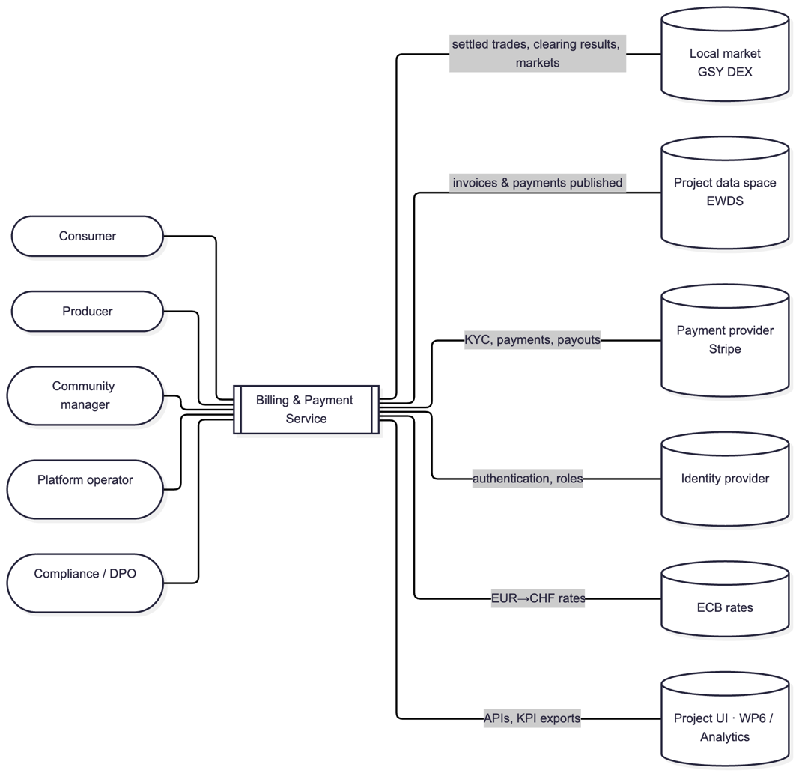
Figure 2 — Service context
The service separates participants and community configuration, trade intake, pair settlement, invoicing, payments, reconciliation and reporting. Supporting modules manage publication, notifications, compliance, reference data and scheduled jobs. Users and the project UI access these functions through a versioned public API.
Stripe Connect (Custom accounts) and Stripe Invoicing are the selected provider services. In V1 they run in test mode. Keycloak provides authentication; it is separate from payment KYC. GSY DEX intake, EWDS publication and ECB rates are simulated behind adapters during the first iteration.

Payment Flow
The revised sequence is based on pair settlement and direct payment to each producer:
- Participant invitation: the manager imports e-mail, marketActorId, meterId and market role. Billing maintains the participant-to-market registry, provisions the IdP account and sends the invitation.
- Authentication and profile: the user signs in through the configured OIDC IdP, completes their billing profile and accepts the current terms. A producer additionally accepts the self-billing mandate.
- Payment readiness: a consumer registers a payment method; a producer completes Stripe Connect onboarding, including identity verification by Stripe and bank-account setup. Invoicing in a producer’s name is held until the required readiness conditions are met.
- Trade intake: the target adapter queries settled trades in windows of at most 24 hours, plus clearing results and markets. V1 uses fixture responses. Trade IDs are deduplicated, delivery dates come from Market, unknown parties are excluded and completeness gaps are flagged.
- Calculation: a scheduled or manual run groups uninvoiced trades by counterparty pair, applies the final trade prices, nets both directions, converts currency where needed and applies VAT. Below-threshold pairs are carried forward, except early and forced final settlement.
- Invoicing: the service creates an invoice on the producer’s connected account through Stripe Invoicing. The legal number, PDF and provider references are retained through the provider integration; calculations and links to trades remain attributable to the billing run.
- Payment: the consumer pays an issued invoice by card or SEPA Direct Debit; in V1 it is processed as a Stripe destination charge transferred to the producer’s Stripe Connect account and reconciled with the producer’s Stripe invoice. The platform does not collect a pooled balance.
  - Provider payout: Stripe pays the connected account out to the producer’s bank under its account configuration. Billing does not offer a separate withdrawal of a net community balance.
- Confirmation: the webhook endpoint verifies the Stripe signature and timestamp tolerance, deduplicates provider events and updates the invoice/payment read models. Failed payments retain a clear cause and corrective action.
  - Publication: invoice and payment changes are mapped to billingInvoice and billingPayment, including billingMode and tradeIds. Billing never changes the GSY trade status; a trade’s paid state is derived from invoice/payment records. Publication is mocked in V1.
- Reconciliation and reporting: invoice/payment discrepancies and market completeness are monitored, participants and managers receive the relevant views, and period exports support WP6/analytics.
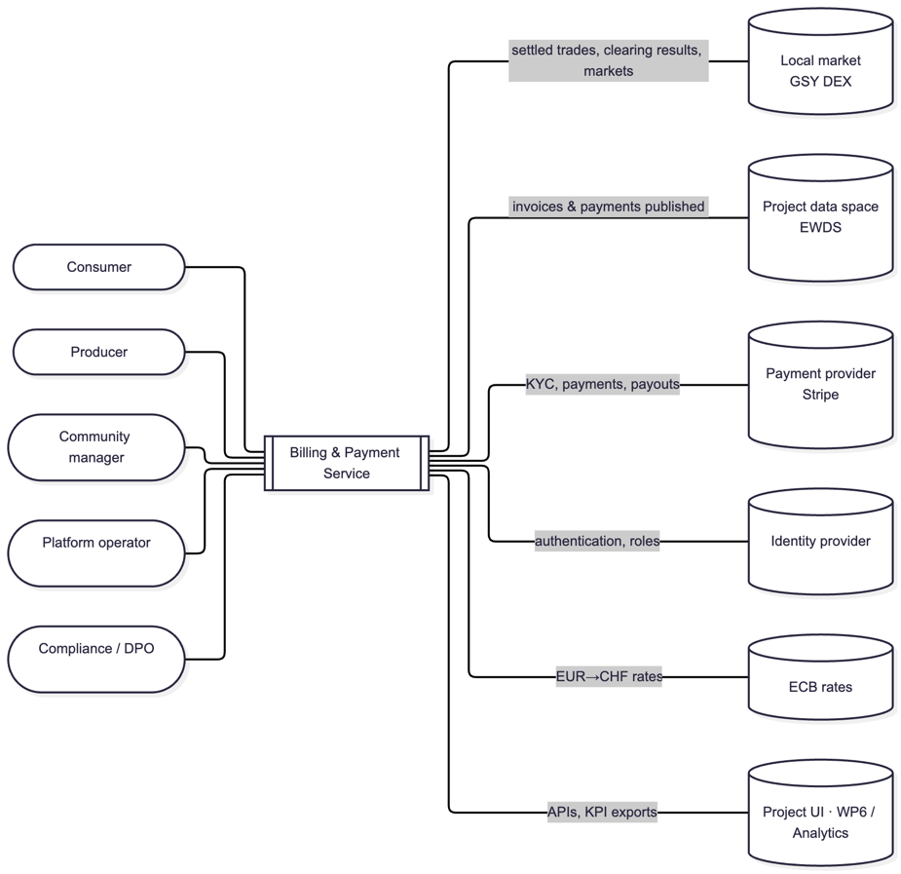
Figure 3 — Periodic billing

Integration Points
- Frontend:
  - Reference participant portal, community-manager console and operator views use the public billing APIs. R2M may connect its own screens to these same contracts.
- Backend:
  - The intake adapter supports the target GSY request/reply contract. The publication adapter maps invoice/payment changes to EWDS schemas. In V1 both use mocks rather than a live GSY/EWDS connection.
- Database:
  - Each module owns its database and exposes its data through APIs/events. Calculation and audit records are append-only. Stripe-mastered invoices, documents and payments are represented locally by references and a rebuildable read cache. In V1, module business state is held in process memory (see Section 6).
- Stripe:
  - Stripe Connect Custom accounts hold producer funds, verification status and payout configuration; Invoicing issues producer invoices. All provider calls use test mode in V1. A provider-agnostic adapter isolates provider-specific operations (REQ-014; REQ-015; REQ-051; NFR-014).

Data Handled
The mapping is maintained in the architecture data model, the ontology mapping and the versioned API/event contracts. It covers:
- Trade, Market and ClearingResult input records, delivery periods and the participant-to-market registry;
- and the internal data structures used by the Billing and Payment module.
In addition to the data exchanges within the INTELLIGENT platform, this mapping also covers the integration with Stripe, including:
- Producer Connect account references and verification status, with consumer payment methods handled separately;
- Pair settlements, invoices, provider documents, payments and webhook events, with invoice issuance delegated to Stripe Invoicing;
- the correspondence between internal identifiers and Stripe customer, account and transaction IDs,
- and the required metadata fields used to ensure traceability, reconciliation and error handling.
The billing database masters community settings, participant mappings, calculation history and audit. Stripe masters provider accounts, invoices and payments; the local read cache can be rebuilt. Invoice PDFs and legal numbers are not transmitted on EWDS.

Producer verification with Stripe
The producer follows the onboarding and verification journey associated with their Stripe Connect account. The information and supporting documents requested depend in particular on the account country, legal entity type and required payment capabilities. Producers are onboarded as Stripe Connect Custom accounts: the reference portal collects the required information, tokenises it in the browser with Stripe.js (account tokens) and submits it to Stripe; identity documents are uploaded to Stripe and verified by Stripe as part of Connect account verification. Stripe Identity (a separate product) is not used in V1; in test mode the journey uses Stripe verification test tokens and files.
The verification information and statuses returned by Stripe guide the onboarding journey and activation of the producer’s capabilities. Billing retains the references and statuses needed for its operation (requirements, charges_enabled), which gate invoicing in the producer’s name (REQ-045); supporting documents are those requested by the applicable Stripe journey.
Provider documentation: https://docs.stripe.com/connect/handling-api-verification, https://docs.stripe.com/connect/custom-accounts and https://docs.stripe.com/connect/account-tokens

Integration and delivery
The delivery design covers build and deployment procedures for the V1 service. It separates local and cloud demonstration environments from full cross-partner integration and production operation.
The engineering and delivery design comprises:
- Local and cloud integration/demo environments, with separate application/data namespaces and environment-specific IdP realms, messaging accounts and secret paths; synthetic data only in V1.
- A stable demo release identified by its tag or commit, environment and resettable scenario data. Production is a later environment with its own readiness decision. In V1 the dev environment is deployed continuously from the develop branch; the demo environment is packaged in GitOps and is to be pinned to the release tag.
- The delivery design uses GitHub Actions for automation, with container packaging and versioned release artefacts.
- Each application module is containerised and has its own Helm chart. helmfile coordinates the charts and Argo CD applies the GitOps configuration to Kubernetes.
- OpenTelemetry, Prometheus, Jaeger, VictoriaLogs and Perses provide telemetry. Alertmanager is deployed; routing actionable alerts to a dedicated Blooo Slack channel is a design target that is not configured in V1.
The following sections present the service's application, technical and physical architecture.

Application components and ownership
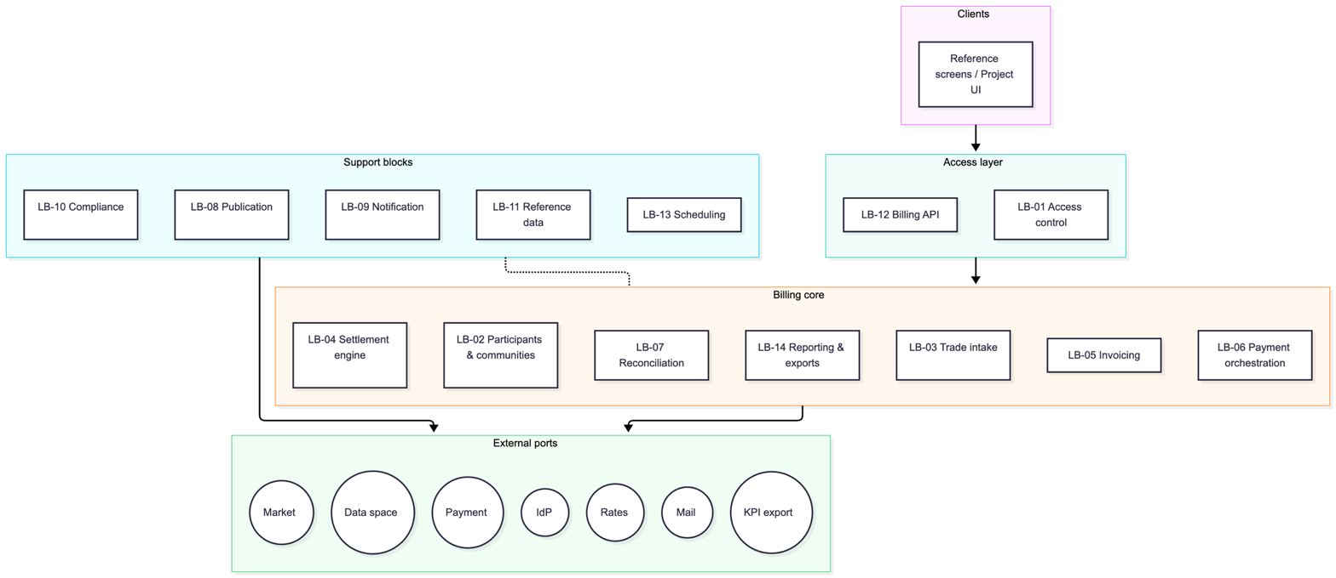
Figure 4 — Logical blocks

The application view defines AC-01 Web app, AC-02 API gateway, AC-03 Participants, AC-04 Trade intake, AC-05 Settlement, AC-06 Invoicing, AC-07 Payments, AC-08 Reconciliation, AC-09 Reporting and exports, AC-10 Publication, AC-11 Notification, AC-12 Compliance, AC-13 Reference data, AC-14 Scheduler and AC-15 Mock suite. AC-02 to AC-14 form the 13 independently deployable backend modules (the APISIX gateway configuration AC-02 and twelve NestJS services AC-03 to AC-14) in the selected application design.
Modules exchange synchronous commands through internal APIs and business facts through an asynchronous transactional outbox. Each module owns its data; no module writes directly into another module’s database. Consumers deduplicate events by eventId. Stripe-owned records are accessed through references and the provider read cache rather than maintained as a second authoritative invoice/payment database.

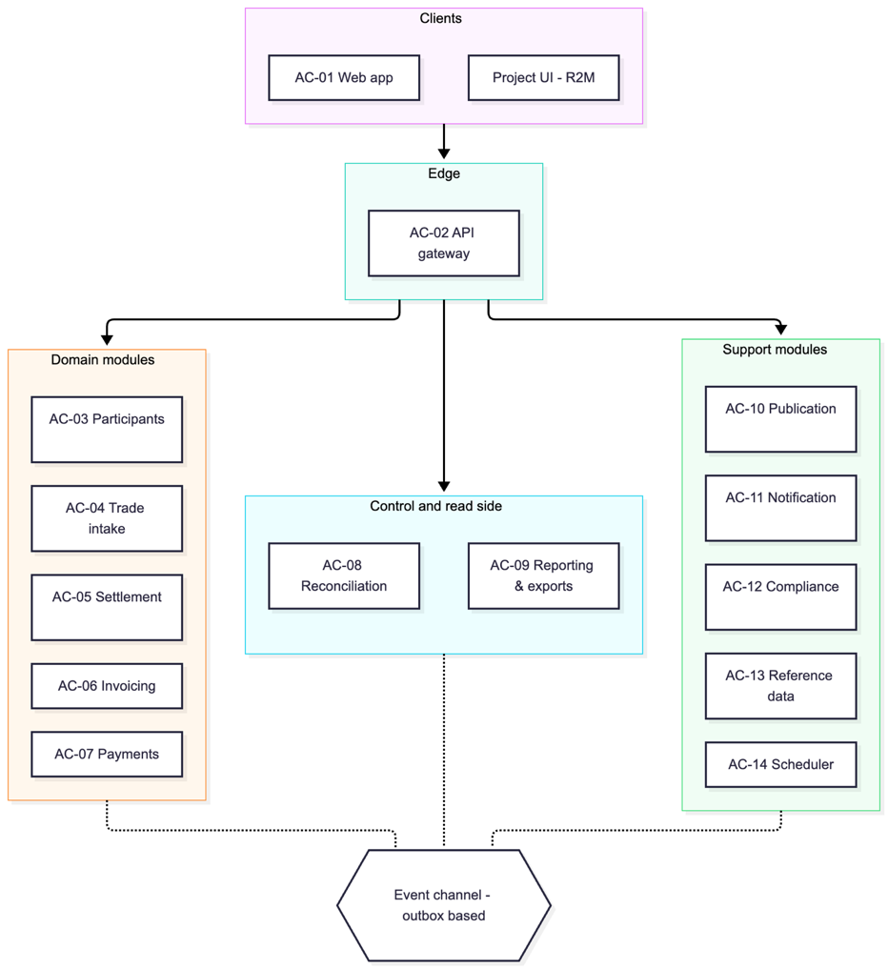
Figure 5 — Application components

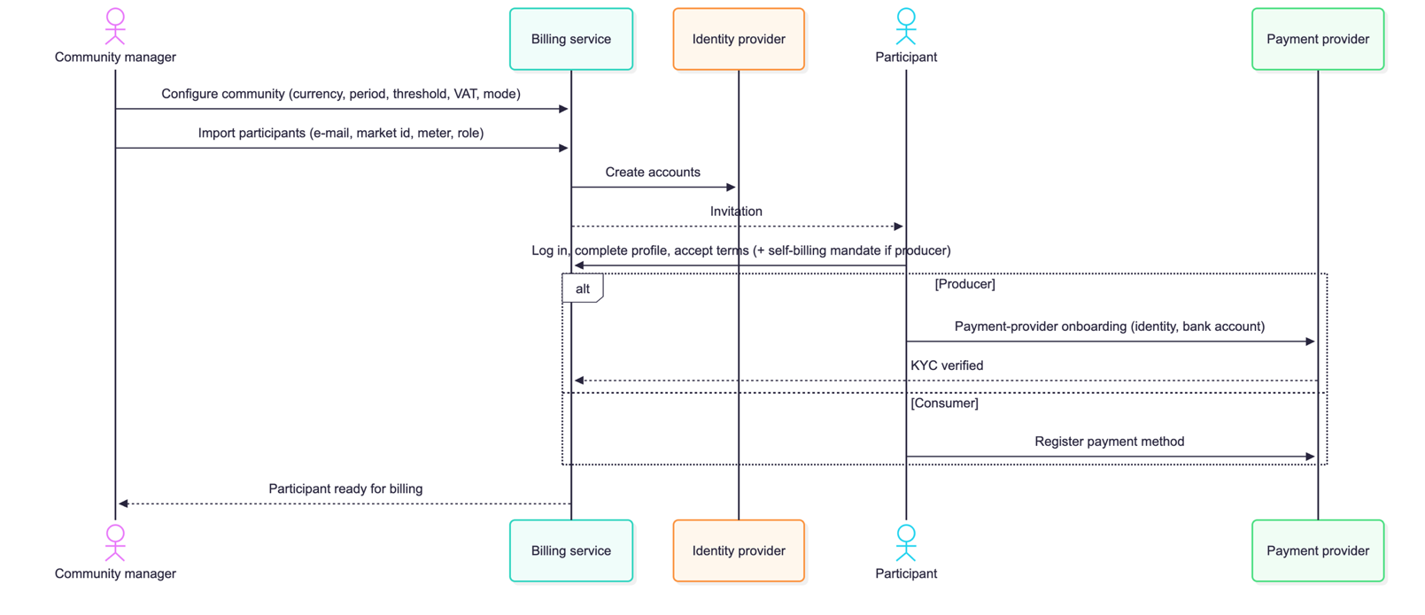
Identity and participant access

Figure 6 — Participant onboarding

Users authenticate through standard OIDC Authorization Code with PKCE. APISIX validates user tokens and propagates the validated claims; module guards enforce role and community scope, and internal APIs require service tokens. Keycloak is the Blooo-operated project IdP and remains an external component. Token-based authentication must be distinguished from the replaceable administrative adapter used to create invitations and manage accounts (REQ-033; REQ-035; REQ-036; REQ-049; NFR-011; NFR-013).
The functional model includes consumer, producer and prosumer participation. A prosumer can buy and sell; the settlement engine nets reciprocal trades between counterparties (REQ-055).

Interface contracts and publication
Public and internal REST APIs are described by versioned OpenAPI 3.1 contracts; events use AsyncAPI 3. The public API covers profile and terms, participant import and registry, balances, invoices/PDF, payment, early settlement, manager settings, billing runs, reporting, privacy requests and operator supervision. Frontends consume the public API only.
The target trade contract uses tradesQuery, clearingResultsQuery and marketsQuery through the EWDS Client Gateway, with REST backfill where access is granted. Query windows do not exceed 24 hours. Recent windows are re-queried to recover late trades, and the delivery window is taken from Market. A GSY trade marked settled is not thereby proven paid by the billing service (REQ-001; REQ-041).
The billingInvoice and billingPayment proposals reuse the INTELLIGENT Invoice and Payment models with billingMode, community/party identifiers and trade attribution. No names, addresses, e-mail, IBAN, StripePayment record, provider identifiers or legal invoice numbers are published. Actor identifiers are pseudonymous and remain subject to appropriate access controls. V1 publication uses simulated adapters rather than live delivery through EWDS (REQ-048; NFR-004).

Technical implementation choices
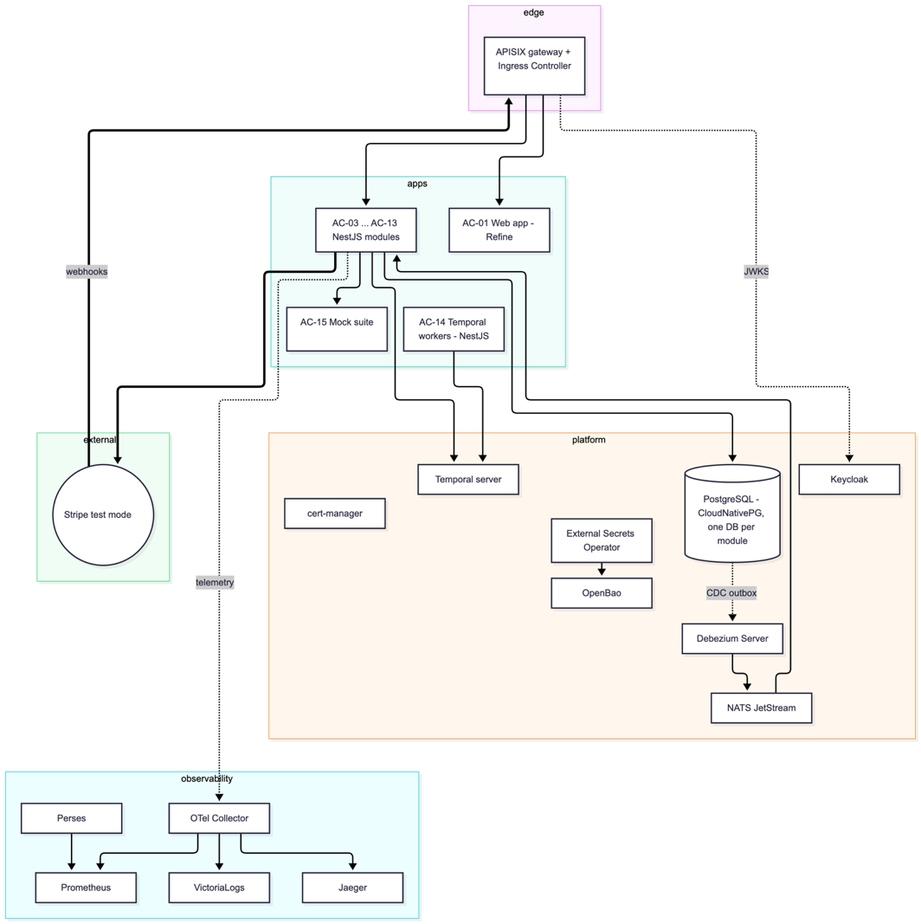
Figure 7 — Technical platform
The selected stack is TypeScript/NestJS for backend modules, React/Refine for reference screens, Apache APISIX at the edge and PostgreSQL managed by CloudNativePG with one database/user per module (provisioned; V1 business-state persistence is described in Section 6). Temporal provides durable workflows and timers. Debezium Server relays transactional outbox records to NATS JetStream; idempotent consumers handle at-least-once delivery.
Stripe Invoicing creates invoices on each producer’s connected account and provides their numbering and PDF documents. The billing service retains provider references and a rebuildable read cache. Self-billing details and the applicable country-specific arrangements are reviewed with the responsible team. In V1 the consumer payment is a destination charge reconciled with that invoice (see Section 6).
External Secrets Operator retrieves secrets from OpenBao; cert-manager provides certificates. Public endpoints use TLS, provider webhooks require signature verification, and modules use service tokens and restrictive NetworkPolicies. The current design defers a service mesh; it does not claim mTLS on every internal hop. Logs and events exclude unnecessary personal attributes, while the access audit remains attributable.

Deployment and operations
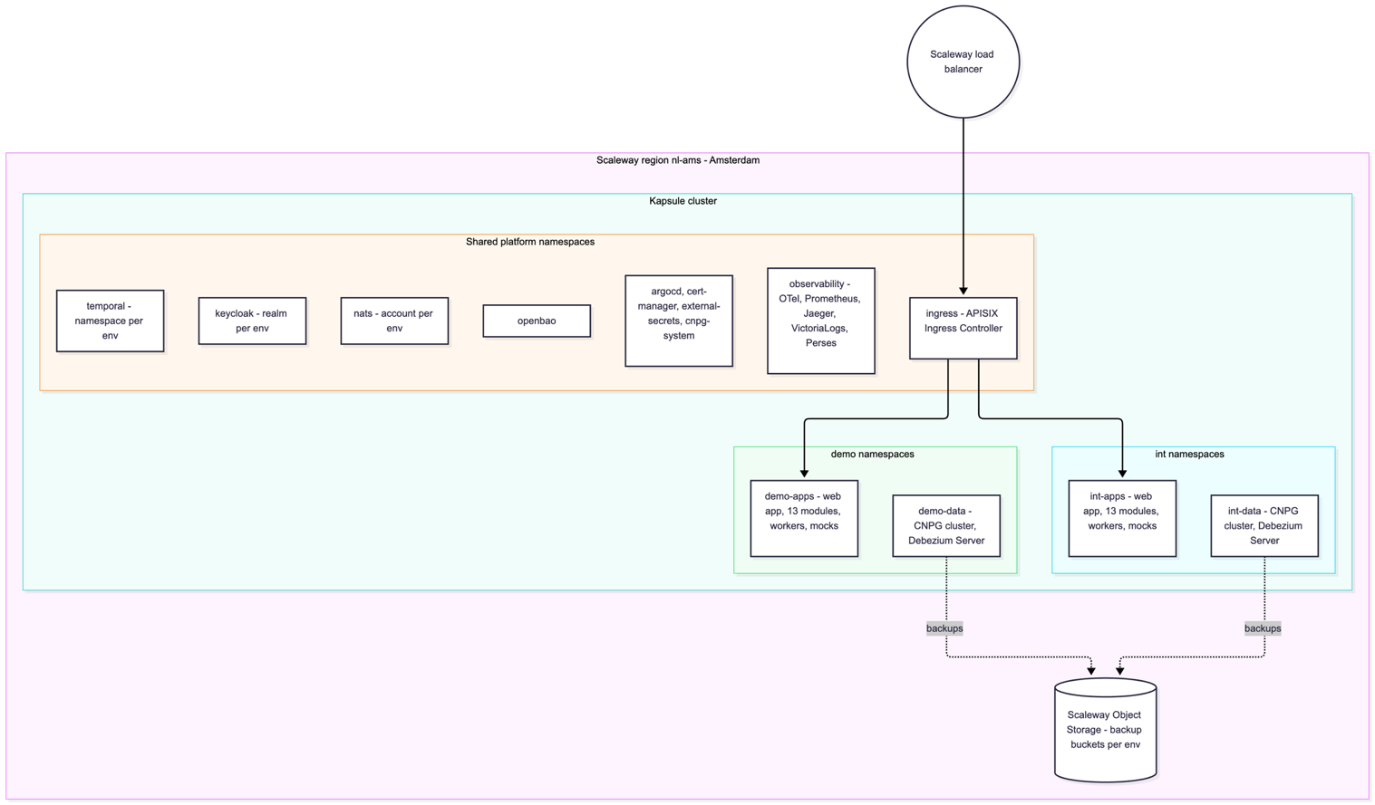
Figure 8 — Deployment topology

The documented hosting design uses a Scaleway Kapsule cluster and storage in nl-ams. Local development uses k3d/Tilt. The V1 release runs the cloud environment dev (namespaces int-apps and int-data, deployed continuously from the develop branch); the demo environment (demo-apps and demo-data) is packaged for the release tag. Each environment has separate application/data namespaces and environment-specific platform isolation. Actual release hostnames and environment naming are recorded in the deployment manifest.
Only the frontend, public API, IdP login and controlled operational endpoints are exposed through the ingress layer. Databases, internal modules, messaging and secrets remain private. V1 mail is captured in Mailpit, exchange rates use fixtures, and EWDS/GSY access is mocked.
CloudNativePG backups with WAL archiving, base backups and point-in-time recovery are a design target and are not configured in V1. The non-production design retains seven days for int and thirty days for demo, in the same region; production requires a separate resilience decision. Recovery objectives and sizing estimates remain design targets.

Documentary references
Service specification and user context: docs/requirements/requirements.md, docs/requirements/user-stories.md and docs/requirements/personas.md; detailed records are available under docs/requirements/items/. These documents are part of the repository referenced in Section 1.4. The requirements file defines the REQ and NFR identifiers cited in this deliverable.
Architecture: docs/architecture/01-functional-architecture.md, 02-logical-architecture.md, 03-application-architecture.md, 04-technical-architecture.md and 05-physical-architecture.md. EWDS message schemas and examples: docs/architecture/ewds-topics/. These files accompany the code and contracts of the delivered version.

Source publication and licensing
The service source code is intended to be published under Apache-2.0 with LICENSE and NOTICE. This includes billing calculations, provider adapters, webhook signature validation, payment routing, KYC orchestration and reconciliation logic. Security relies on access controls, correct implementation and protected secrets rather than withholding these algorithms (NFR-005; NFR-012).
Credentials, API tokens, cryptographic keys, personal data, KYC evidence and private production configuration are excluded from the public repository. Example configuration and reproducible non-production deployment instructions must use placeholders and synthetic data. Publication review must remove sensitive content from comments, tracked deletions and document metadata as well as from the visible accepted text.
The PSP abstraction layer remains part of the open design. It separates provider-specific operations from billing logic and supports mocks for CI and future provider replacement. It is not a boundary between a public interface and a mandatory closed-source payment implementation.
Dependency licences must be checked for the exact released versions. The selected design favours MIT/Apache-2.0 components and records three accepted exceptions, each a separately deployed, unmodified third-party service: OpenBao (MPL-2.0), SonarQube Community Build (LGPL-3.0, CI quality tooling only) and the EWDS/DDHub Client Gateway (GPL-3.0, run from upstream images). None of them is linked into the billing code (NFR-012). Billing exchanges messages with GSY DEX rather than incorporating its GPL code; the legal/licence boundary and reused EWAG schema licences require confirmation before release.
The release package is organised to include source code, versioned contracts and schemas, installation and operation guides, example configuration and mock datasets. The accompanying release guide is intended to document the build and deployment procedures.



