How TTJ Can Help  techtonicjustice.org  Questions / request a briefing  Clarence Okoh | Susan Garcia Nofi | Kevin De Liban |   THIS ISN'T  (JUST) ABOUT AI.  It's about your constituents' healthcare, Medicaid, food assistance, education, housing, jobs and basic rights.  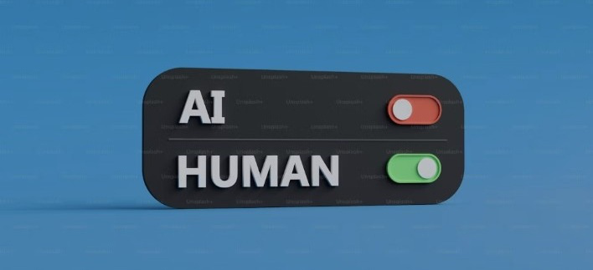  REAL PEOPLE. REAL HARMS. REAL SOLUTIONS. | At a Glance  The issue. The framework. The political opening.  Concrete harms cross party lines.  TTJ + Data for Progress testing found voters respond most strongly to specific harms - denied care, lost benefits, rent, jobs - rather than abstract governance language.
  1 | Request a briefing  Get up to speed on a bill, system or emerging risk.
  2 | Stress-test draft legislation  Identify what a proposal prevents, protects and repairs - and where it is thin.
  3 | Connect with impacted communities  Ground policy in the experiences of people affected by automated systems.
  4 | Access policy language and research  Use TTJ evidence, model concepts and sector-specific resources.
  HUMAN JUDGMENT SHOULD STAY ON.
  Prevent. Protect. Repair.
  A Practical AI Policy Guide for
  Legislative Staff
  1 | Prevent  Stop the most harmful uses before they cause harm.
  2 | Protect  Require testing, disclosure, human oversight and power to shut systems down.
  3 | Repair  Make accountability real with liability, redress, compensation and funded enforcement.
  92 million | people with low incomes are exposed to automated systems in services meant to serve them.
  The PPR test: Could this harm have been prevented? Was the person protected? Can their life be repaired?
The Problem in  Three States  These aren't hypothetical risks. They've already happened.  Sources: TTJ Prevent, Protect, Repair; Inescapable AI. | Prevent, Protect, Repair  Three verbs. Three policy functions. One practical standard. | Stress-Test Your Bill  A quick read before markup, negotiation or amendment.
  1 | ARKANSAS  Medicaid home care  An algorithm cut home-care benefits for roughly 4,000 people with disabilities. TTJ staff secured the legal victory that ended its use.
  2 | INDIANA  SNAP / TANF / Medicaid  An automated eligibility system denied more than one million applications for food assistance, cash assistance and healthcare in two years.
  3 | FLORIDA  Predictive policing in schools  Pasco County used school and policing data to track 18,000 children and label at least 420 as likely future criminals. TTJ's team won a first-of-its-kind DOJ settlement.
  These are not isolated incidents. They reveal the same pattern: high-stakes decisions become automated, people are harmed, and accountability becomes harder.
  1  PREVENT  Ban the most harmful uses.  • No final AI denial of essential benefits or doctor-recommended care.  • No automated discipline or punitive surveillance of students. | 2  PROTECT  Require real oversight.  • Test before deployment, evaluate after launch, and disclose when AI is used.  • Give people an explanation they can contest and clear power to pause harmful systems. | 3  REPAIR  Make accountability real.  • Give harmed people a route to challenge and seek redress; hold vendors liable.  • Fund enforcement and compensate people for losses caused by system errors.
  THE SHIFT
  Move responsibility upstream - from the person harmed to the institutions that deploy and profit from the system.
  □ | Does it ban AI from denying, reducing or terminating essential public benefits?
  □ | Does it stop AI from making the final denial of doctor-recommended healthcare?
  □ | Does it require meaningful testing before deployment?
  □ | Must people be told when AI materially affects them and receive an explanation they can contest?
  □ | Is there independent evaluation and clear authority to pause or shut down a harmful system?
  □ | Are vendors liable, enforcement funded, and losses caused by system errors compensable?
  FIVE RED FLAGS
  1 Can a human reverse the decision?
  2 Can the system be shut down quickly?
  3 Can the person find out AI was used?
  4 Can the vendor be held responsible?
  5 Is somebody actually funded to enforce the law?
  Don't just look at the total. Look for the gap. The weakest PPR pillar often tells you where the next amendment belongs.

