SUMMARY

of the License Thesis entitled:

FINANCIAL EFFICIENCY BOOSTING SYSTEM

FOR CONSUMER-GRADE PRODUCTS

|  |  |
| --- | --- |
| Author: | **Péter-Tibor ZAVACZKI** |
| Advisor: | **Assoc. Prof. Dr. Eng. Delia Alexandrina MITREA** |

1. **Requirements**:

The aim of my project is to create an easily accessible, easy to use product price tracker. The application must make the user’s web shopping experiences easier by offering them the lowest price for a product they chose at a distance of a few clicks.

1. **Proposed solutions**:

The diagram in Figure 1 represents the conceptual architecture of the proposed system. The system is composed of multiple modules: MySQL based database server, which deploys the database which stores the data necessary for the functioning of the application; a RESTful web server, which deploys the RESTful web service build with Spring and Java 8 that forms a connection point between the database the other components; and a web page server, which deploys the web app that was created using AngularJS so that this can be accessed by the client’s browser. We can consider that the crawling system, created with Scrapy and Python3, is part of the server side, but this is not entirely necessary, as it could be distributed on a different machine due to it connecting with the system via the uniform interface offered by the RESTful web service. The client side of the application is composed of a Google Chrome web browser, which uses the browser extension and renders the web page of the application.

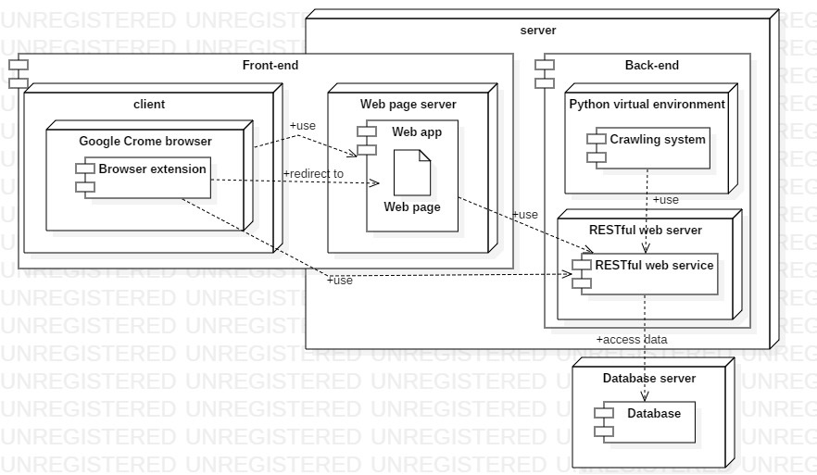  
Figure 1: The conceptual architecture of the project

1. **Results obtained**:

The application takes the data retrieved during the crawling process to feed any kind of user useful and concise data in the Google Chrome extension about the product they are looking at. Using the Chrome extension is the key use case of the application. It be seen in Figure 2. The application has a web site to give another way for users to find products they want, or for admins to manage the stored products.

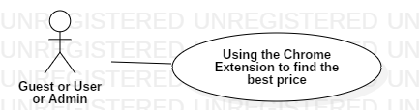  
Figure 2: The most representative use case of the project

1. **Tests and verifications**:

The application has been tested manually throughout the development cycle. This meant using the actual application and using the logs outputted or using apps, such as Postman to check if the application functioned accordingly to expectations.

1. **Personal contributions**:

* Implementing a RESTful web service for uniformly using the data in the system
* Using Scrapy to develop crawlers for the emag.ro and pcgarage.ro domains to extract necessary product data
* Implementing a minimalist Google Chrome browser extension for ease of use and a web site with AngluarJS to form the front-end of the application

1. **Documentation sources**:

* D. Kouzis-Loukas, Learning Scrapy, 1st ed. Packt Publishing, 2016.
* P. Mehta, Creating Google Chrome Extensions, 1st ed. Apress, 2016.

|  |  |  |
| --- | --- | --- |
| Date: ________________ | Author | _____________________________ |
|  |  |  |
|  | Coordonator | _____________________________ |