SUMMARY

of the License Thesis entitled:

FINANCIAL EFFICIENCY BOOSTING SYSTEM

FOR CONSUMER-GRADE PRODUCTS

|  |  |
| --- | --- |
| Author: | **Péter-Tibor ZAVACZKI** |
| Advisor: | **Assoc. Prof. Dr. Eng. Delia Alexandrina MITREA** |

1. **Requirements**:

The aim of my project is to create an easily accessible, easy to use product price tracker. The application must make the user’s web shopping experiences easier by offering them the lowest price for a product they chose at a distance of a few clicks.

1. **Proposed solutions**:

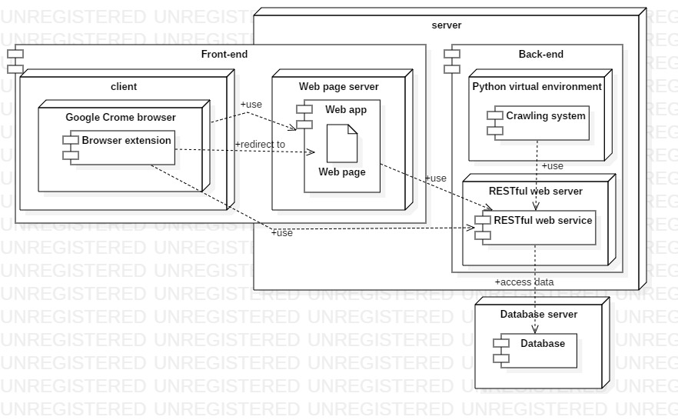  
Figure 1: Conceptual architecture of the proposed system

The shown diagram represents the conceptual architecture of the proposed system. The system is composed of multiple modules: a database server, which deploys the database which stores the data necessary for the functioning of the application; a RESTful web server, which deploys the RESTful web service which forms a connection point between the database the other components; and a web page server, which deploys the web app so that this can be accessed by the client’s browser. We can consider that the crawling system is part of the server side, but this is not entirely necessary, as it could be distributed on a different machine due to it connecting with the system via the uniform interface offered by the RESTful web service. The client side of the application is composed of a Google Chrome web browser, which uses the browser extension and renders the web page of the application.

1. **Results obtained**:

The application takes advantage of the data retrieved during the crawling process to feed the user useful and concise data in the Google Chrome extension about the product they are looking at. The application is feature complete, including a web site to offer another way for users to find the products they want to buy, or for admins to manage the products in the system.

1. **Tests and verifications**:

The application has been tested manually throughout the development cycle. This meant using the actual application or third party apps, such as Postman, and taking advantage of the logs outputted to check if the application functioned accordingly to expectations.

1. **Personal contributions**:

* Implementing a RESTful web service for uniformly handling the data through the system
* Using Scrapy to develop crawlers for the emag.ro and pcgarage.ro domains to extract necessary product data
* Implementing a minimalist Google Chrome browser extension for ease of use and a web site with AngluarJS to form the front-end of the application

1. **Documentation sources**:

* D. Kouzis-Loukas, Learning Scrapy, 1st ed. Packt Publishing, 2016.
* P. Mehta, Creating Google Chrome Extensions, 1st ed. Apress, 2016.

|  |  |  |
| --- | --- | --- |
| Date: ________________ | Author | _____________________________ |
|  |  |  |
|  | Coordonator | _____________________________ |