Super market simulation
Name: Zavaczki Péter-Tibor
Group: 30423
Coordinating professor: Cristina Bianca Pop

Objective of the project
The presented project simulates the evolution of a super market in real life, having several threads started, which represent the queues at the cashiers.

Analysis of the problem
The simulation revolving around a super market, which, in turn has several queues, we have to implement these. We have a thread started for each queue in the super market and an additional thread for the representation of the super market. We add and remove ‘customers’ to and from the queues. A Graphical User Interface, also called GUI, is implemented as well, for ease of access.

Modeling
I have split the problem into several parts: creating the data structures to represent the customers and queues, and the operations we can do with these, creating the Graphical User Interface and processing the inputs from the Graphical User Interface, to be able to start the simulation with the data received.

Scenarios
There are several scenarios of use of the given project. These scenarios differ with regard to several input factors: the number of open queues, the interval of minimum and maximum serve time each customer may have compared to the maximum ‘open time’ of the super market.
The implementation dictates that each customer that has once arrived, shall be served before the super market fully closes.

Use cases
In my point of view, there are two main components of the project’s running mechanism: the user and the program itself, which access several functions of the project to reach a result from the user’s input data.
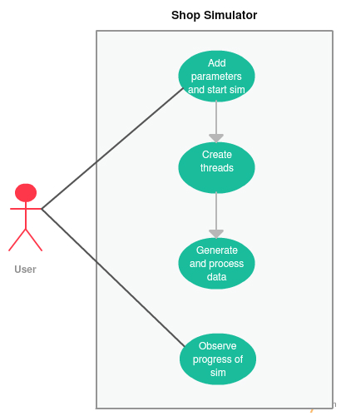
As we can see on the previous diagram, the user has access to several project elements, namely adding parameters for the simulation to run with, starting the simulation with said operands and viewing the result of the requested operation, all possible via the Graphical User Interface. In contrast, the program has access to the elements which give us the result to the requested operation relative to the input operands. Besides the previously mentioned project element, the program can edit the result seen by the user through the Graphical User Interface.

Program Design

Design Decisions
For my main structure I used objects of the class type Cashier composed of several Customer objects ordered in a vector, among others (to be specified under the Data strucutres branch). The Customer objects are composed of a long cID field, an integer arrivalTime field as well as an integer serveTime field. Considering the format of a Customer, we can affirm that a Cashier is a composition of its Customer elements, that by having a thread assigned to it, which would represent a queue of Customers waiting to be served by the Cashier.
The way the program processes customers is based on the run() methods in the Shop and Cashier classes, which override the run() method in the Thread class, which they extend. The Shop class adds customers to the queues of cashiers while the Cashier class removes them after they have been served.

UML Class Diagram
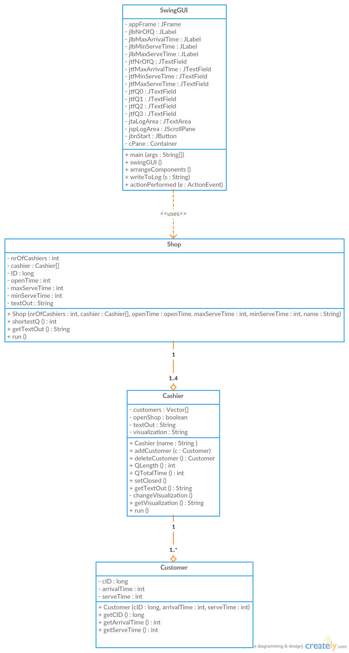

Data Structures
The Customer class is an abstraction of a real life customer, it having data assigned to it that actually matters for the Shop’s point of view, like a serial number represented by cID, the time he or she arrived into the queue represented by arrivalTime which stores int values which represent the milliseconds from the beginning of the simulation up to the time the object got created or “the customer entered the shop”. The Customer class also has an attribute called serveTime which represents the amount of time the Cashier of who’s queue it standing in has to spend to serve him or her, after which the Customer is elminated from the Vector or “the customer exits the shop”.
The Cashier class is a representation of a cashier working at a shop, taking customers and serving them. It has a Customer type Vector which represents the queue in which the customers are listed, them waiting to be served by the cashier. Another attribute it has is the openShop boolean which represents the shop’s status, it being able to be open or closed (true or false); if the shop is closed the cashier does not receive any more customers, it finishes serving the ones in the queue, thus modeling real life, in which customers standing in a queue at a shop don’t get thrown out when the shop closes, instead the shop waits to actually close until every customer is served. It also has a field called textOut which contains a line of String representing a status change in the cashier’s queue’s evolution, more explicitly, the cashier served a customer, so the queue being reduced by one customer. This can somewhat be equal to the cashier printing a bill, which signals a customer being served. The also is an attribute called visualization, which basically represents the queue in a String as follows: “<the name of the cashier>: <as many O’s as there are customers in the queue>”, which can in turn be written to the Graphical User Interface, thus represeneting a way to monitor the shop.
The Shop class is a representation of an actual real life shop. This representation has multiple cashiers in an array cashiers of type Cashier, every element in this array has the structure described above. We require this attribute to realistically model the shop, since without cashiers, the customers wouldn’t be able to be served, thus there wouldn’t be any customers and without customers, the shop can’t produce profit. And since I am absolutely certain that this documentation’s purpose is pretty much for us to get used to documenting our work, so others can know what it is about, thus nobody will read through this I will add a pancake recipe somewhere in here, it is really good, I tried it and I recommend it. It is of absolute importance that this part is taken with a humorous attitude, since it was meant to create a lighter mood in the reader from all the monotonous lines of text which just really repeat themselves to fill words because let’s be honest, nobody should write a three thousand word documentation for a project that teaches the student how to work with threads. The basic elements that should be focused on, in my opinion are the correct creation of diagrams, which are, truly, important to master, since for an advanced programmer, they can offer a lot of information, opposed to this, we are supposed to write a long bit of text as if we were at a literature faculty, i am not saying those universities are bad or anything, I am only saying we should be axed on more practical things, as I said above, like creation of diagrams. On that note I absolutely agree with these projects, as in us being pretty much on our own in doing them and discovering the topic and now going back to the same ol. The Cashier type array couldn’t exist without having a length, which is stored in nrOfCashiers, which represents, as the name says, the number of the cashiers in work at the shop. There also is a field called ID, which numbers the cashiers, giving them names such as “Cashier 1” based on the increasing ID using the formula “Cashier ”+ID. The openTime attribute represents the maximum point in time after the start of the simulation at which new customers can enter the open queues. The maxServeTime attribute represents the maximal amount of time a certain customer can request to be served for, while the minServeTime attribute represents the minimal amount of time which a customer can request to be served for. The textOut attribute represents a line from the log to be displayed on the Graphical User Interface.

Class Design

Customer
The class Customer is stands at the base of the whole project, since the whole project simulates the management of customers in a super market, the Shop class creating them and adding them to the cashier’s queues while the Cashier type threads manage them by taking their serveTime attributes and “serving them” which actually is a sleep for that time after which the Cashier removes the customer from the queue and takes the next one.
This class, being an abstraction of a real life customer, it has data assigned to it that actually matters for the Shop’s point of view, like a serial number represented by cID, the time he or she arrived into the queue represented by arrivalTime which stores int values which represent the milliseconds from the beginning of the simulation up to the time the object got created or “the customer entered the shop”. The Customer class also has an attribute called serveTime which represents the amount of time the Cashier of who’s queue it standing in has to spend to serve him or her, after which the Customer is elminated from the Vector or “the customer exits the shop”.
The class has several methods implemented to be worked with. The constructor for this class, called has the abstract public Customer(lont cID, int arrivalTime, int serveTime); from which we can tell that is takes three parameters and sets the object’s attributes to them, namely the cID parameter sets the cID attribute, which represents the cartographic number of the customer, so it can be observable in the logs. The arrivalTime parameter sets the attribute with the same name, arrivalTime, which represents the time in which the customer got generated and appeneded to one of the queues. The next parameter is called serveTime which sets the likely named attribute, called serveTime to be its value, thus representing the time it will take to serve this customer when he comes next in line at the queue. The remaining methods are for extracting data from the object, they are getCID, getArrivalTime and getServeTime. The getCID method has the following abstract public long getCID(); from which we can see that it returns a long type value, which will be equal to the cID field of the Customer type object. The getArrivalTime method has the following abstract public int getArrivalTime(); which show that it returns an int type value that will be equal to the arrivalTime field of the Customer type object. The getServeTime method has the following abstract public int getServeTime(); which show that it returns an int type value that will be equal to the serveTime field of the Customer type object.

Cashier
The class Cashier is one of the two working bits of the whole big project, as in, it is the part which processes the customers in the queue. Every single Cashier type object has a thread for itself started when the program starts. The Customer type objects are added to the Cashier objects’ customers’ field which is a Vector of Customer type objects, which is then taken by the class and processed by serving each customer and removing them from the queue.
The class has a few attributes: a Customer Vector customers, a boolean openShop, a String textOut, and another String visualization. The Customer type Vector customers is the backbone of the Cashier class since it represents the queue of the Cashier in which there are the actual customers to be served, which were put there to be served by the Shop class. The boolean openShop represents a constraint to keep the thread open, as in it is a signal coming from the higher thread, that of the Shop class, which signals the Cashier that the shop is closed, which means that there will be no more customers coming in to stand in the queues. When the openShop is true, it means that the shop is still open and running, when it is false, it means that the shop is closed and it is waiting for all the customers to be served to finalize its day, which symbolizes that all the Customer Vectors are of length zero and the threads finish their work and shut down. The textOut attribute is a representation of a bill printed by the cashier when a customer is served, which symbolizes a customer having been served, thus a log line is generated with the more important details, like when was the customer served, which customer was served and who served him or her. The visualization attribute is a String type representation of the current state of the queue which shows how many customers are in it, by representing each one with an O these being appended to the name of the cashier followed by a colon and a space character.
The methods this class has are public Cashier(String name); public synchronized void addCustomer(Customer c); public synchronized Customer deleteCustomer() throws InterruptedException; public synchronized long Qlength(); public synchronized int QtotalTime(); public synchronized void setClosed(); public String getTextOut(); private synchronized void changeVisualization(); public String getVisualization(); and public void run(). The constructor for the class Cashier, has the abstract public Cashier(String name); it has a String type parameter called name which sets the name of the Cashier object, to be later used by the output logs in this class and the Shop class. The first method in the class is called addCustomer, it has the abstract public synchronized void addCustomer(Customer c); from which we can see that its use is adding a customer into the queue of the Cashier, which is a ccomplished using the method addElement of the Vector class parameterized with the Customer type. The deleteCustomer() method has the abstract public synchronized Customer deleteCustomer() throws InterruptedException; is a method to remove an element from the Customer Vector customers of the Cashier object. It does this by having a while loop making the whole process wait until the Customer Vector has at least one element, which, then proceeds to save in a local variable, remove from the Vector and the return as value to the calling method so that it can be used to output it to the log area later. The QLength method has the abstract public synchronized long Qlength(); is a method that returns the size of the queue of the cashier’s CustomerVector using the size() method of the Vector class to get the length and store it in a local variable and return it as a value. The QTotalTime method has the abstract public synchronized int QtotalTime(); which is a method for calculating the total time the last customer at the end of the queue would have to wait to be the first in the queue and to start to be served by the cashier, the calculated time is returned as an int value to the calling method. The setClosed method has the abstract public synchronized void setClosed(); and it is a method to help other classes where the cashier is instantiated to access the openShop attribute and set it to false, thus signaling that there will no longer be an influx of customers and the total closing of the program depends on when the queues empty. The method getTextOut has the abstract public String getTextOut(); its purpose is reurning the textOut field of the cashier, to provide a line of log to the logger. The changeVisualization method has the abstract private synchronized void changeVisualization(); from which we can observe that it is set to private, since the visualization, which represents the queue at the cashier so it shouldn’t be changeable only by the Cashier object itself. The method builds the visualization attribute by starting with the cashier’s name, a colon and a space character, after which it appends as many ‘O’ characters as there are customers in the vector. The run method is an overriden methonf from the Thread class, which the Cashier method extends. It has an abstract as follows: public void run(); and it serves as the core of the thread of the Cashier objects. The running mechanism behind the method is as follows: the method changes the current visualization based on the current status of the queue, displays the visualization into the according field, noting that there are only four fields to display the queue status in, though we can have up to 2.147.483.647 queues, which is the maximum value of int. After displaying the current status of the queue, it works on the first element on Customer Vector by serving the first one in the Vector and removing it from the Vector, not quite in that order but that is the basics of it so there is no need for questioning it. It creates a log text line by adding up the arrival time of the customer with its serve time, thus creating a leave time which in turn gets put into the log line as follows: first there is the word at, a space character the leave time, a space character, the word Customer, a space character, the ID of the Customer, the string “ was served by “ and the name of the cashier. After building the log line, it is outputted into the log area, the visualization is changed ad outputted again, since a customer was removed.

Shop
The class Shop extends the Thread class. This class is the second of the two working bits of the whole big project, as in, it is the part which adds the customers into the queues. The instantiated Shop type object has a thread for itself started when the program starts. The Customer type objects are added to the Cashier objects’ customers’ field which is a Vector of Customer type objects by a certain algorithm which looks for the shortest queue by their total wait time and putting the Customer into it.
The Shop class has the attributes nrOfCashiers, cashier[], ID, openTime, maxServeTime, minServeTime, textOut. The nrOfCashiers and cashier[] attribute are closely related, since the nrOfCashiers defines the number of elements in the cashier[] array. As its name says nrOfCashiers defines the number of cashiers in the shop. This attribute is set at the beginning of the run time from the implemented Graphical User Interface. The cashier array is of type Cashier and it represents the cashiers in the shop, respectively, the queues at them. Using this array’s elements we can access the attributes and methods of the Cashier objects. The ID attribute is a counter for the Customers, since we generate the customers to be in the cashiers’ queues and this ID generates a distinction between the Customers, so we can have a clear view of the status of the shop at the logger. The openTime is an int type attribute that stores the maximum time the shop is open, thus customers can come. From a literal point of view, the openTime represents a criteria which is taken into consideration when we generate customers for the shop. If the current simulation time, which starts from 0 at the birth of the thread for the Shop object, is equal or larger than the openTime the customer generation process ends and every cashier linked to the shop gets notified of this by calling their setClosed() methods. The maxServeTime attribute is set at the beginning of the run time from the implemented Graphical User Interface. It represents the maximum amount of time a customer can request to be served for. Practically, it is the upper bound of the generation of the serveTime attributes for the customers who are generated into the simulation. Now for the pancake recipe I promised, I need to remind you to take this absolutely with a light heart, since it is supposed to be cheerful escape from the monotone. So, as ingredients, we need one and a half cups of all purpose flour, three and a half teaspoons of baking powder, a teaspoon of salt, a tablespoon of white sugar, one and a quarter cups of milk, one egg and three tablespoons of butter in melted state. The preparation is as follows: in a large bowl, sift together the flour, baking powder, salt and sugar. Make a well in the center and pour in the milk, egg and melted butter; mix until smooth. Heat a lightly oiled griddle or frying pan over medium high heat. Pour or scoop the batter onto the griddle, using approximately a quarter cup for each pancake. Brown on both sides and serve hot. This should take bout twenty minutes in total and produce an absolutely delicious result. The minServeTime attribute is of type int, and as with the maxServeTime, it is the lower bound of the generation of serveTime attributes for the generated customers. Finally, the textOut atribute is a String which represents a log line in which we can document the data about the most recent arrival of a customer.
The constructor for the object has the abstract public Shop(int nrOfCashiers, Cashier cashier[], int openTime, int maxServeTime, int minServeTime, String name); which sets the object’s attributes according to the input data taken from the implemented Graphical User Interface. The shortestQ method returns an int value equal to the ID of the shortest queue from the total wait time that is until the last customer in the queue is served point of view. The getTextOut returns the textOut attribute which can be used by the logger. The run method is the overridden method of the Thread. The run method is the backbone of the thread in which the thread’s program runs. During its uptime the Shop’s thread generates customers at random based on the given parameters and the current time. It takes these things as follows: the maxServeTime and minServeTime are the upper and lower limits of the serveTime the program generates for the next customer, the ID is given to the customer at generation and increased instantly, and the currentTime is given to it as arrival time. Then the generated customer is put into the shortest queue based on the value returned by the shortestQ method. After this step the program generates a log line by the current time, the customer’s name and the cashier’s name, representing the arrival time of said customer into the said cashier’s queue. The program then waits for a random amount of time between the current time and the maximum amount of time until the shop is open. If the shop’s open time limit is reached the influx of customers is stopped, and the cashiers are notified that the shop is supposed to close. The program waits for the cashiers’ customer management termination to fully stop its run.

SwingGUI
The class SwingGUI contains the main components to the Graphical User Interface, it creates the window, the text boxes and the buttons among others.
This class has the following attributes: private JFrame appFrame; private JLabel jlbNrOfQ, jlbMaxArrivalTime, jlbMinServeTime, jlbMaxServeTime; private JTextField jtfNrOfQ, jtfMaxArrivalTime, jtfMinServeTime, jtfMaxServeTime; static JTextField jtfQ0, jtfQ1, jtfQ2, jtfQ3; static JTextArea jtaLogArea; private JScrollPane jspLogArea; private JButton jbnStart; private Container cPane. The appFrame attribute represents the frame of the window we will receive when we create this Graphical User Interface, it is initialized with the name of the window passed as a String type parameter to the constructor. The jlbNrOfQ, jlbMaxArrivalTime, jlbMinServeTime, jlbMaxServeTime attributes represent non-modifiable text fields. The jlbNrOfQ represents the label put next to the input box of the text field of the number of queues. The jlbMaxArrivalTime represents the label put next to the input box of the text field of the upper limit of the arrival times of customers. The jlbMinServeTime represents the label put next to the text field of the lower limit of the serve times of customers. The jlbMaxServeTime represents the label put next to the text field of the upper limit of the serve times of customers. The jtfNrOfQ represents the text box in which the user inputs the number of queues. The jtfMaxArrivalTime represents the text box in which the user inputs the upper limit of the arrival times of customers. The jtfMinServeTime represents the text box in which the user inputs the upper limit of the serve times of customers. The jtfMaxServeTime represents the text box in which the user inputs the upper limit of the serve times of customers. The text fields jtfQ0, jtfQ1, jtfQ2, jtfQ3 are uneditable text fields in which the first four queues states are outputted. The jtaLogArea represents the text area in which all the generated log lines are outputted. The jspLogArea is a scroll pane into which the jtaLogArea is put into. The jbnStart represents the button which, when pressed takes in the parameters inputted at the Graphical User Interface.
The methods in this class are its constructor, SwingGUI(), an initializer createGUI(), a layout modifier arrangeComponents(), and the method that makes the connection between elements from input to output, actionPerformed(ActionEvent e). The constructor SwingGUI() basically only helps at the instantiation of the Graphical User Interface. The createGUI() method creates the frame of the Graphical User Interface and sets the layout of the elements that will be in it. The arrangeComponents() method sets the position of the specific elements on the Graphical User Interface, sets some of the labels’ values and adds action listeners to the buttons so that we know when one is pressed. The actionPerformed(ActionEvent e) method creates threads for the number of queues that are inputted and the shop.

Relations
As we can see in the UML class diagram aswell, there is a composition between Customer and Cashier and between Cashier and Shop and a dependency between SwingGUI and Shop.

Graphical User Interface
The Graphical User Interface is composed of labels, editable text boxes, and buttons.
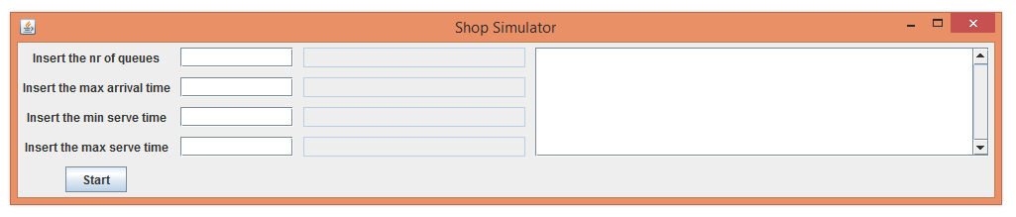
The Graphical User Interface changes its look dynamically during execution, having new lines inserted into the logger and changing the representation of the first four queues.
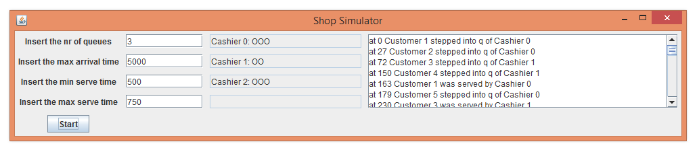

Implementation and testing
Almost every sepparate .java implementation file has another file associated to it, usually having the same name as the file it tests, with Test appended to its name. In these files every method is tested from the source file.

Results
Creating this project, among others, resulted for me in experience with working in Object Oriented Programming environments, and getting used to developing Object Oriented programs and managing threads.

Conclusions
As a conclusion, I can say that there is still space for my personal improvement in the field, having poor preparation from the past.

Possible future development
Adding a text area instead of sepparate text fields to output the states of the queues, thus being able to output the states of at most 2.147.483.647 queues, making the outputs classier and better incapsulation can all be part of a future development.

Bibliography
- https://creately.com/
- https://en.wikipedia.org/wiki/Class_diagram
- https://docs.oracle.com/javase/tutorial/uiswing/
- https://www.tutorialspoint.com/java/lang/index.htm

