InfoTraffic Application

Use-Case Model

Version 1.0

Revision History

|  |  |  |  |
| --- | --- | --- | --- |
| **Date** | **Version** | **Description** | **Author** |
| 19/Mar/18 | 1.0 | Beginning document | Zavaczki Péter - Tibor |
| 19/Mar/18 | 1.1 | Revision 1 | Zavaczki Péter - Tibor |
|  |  |  |  |
|  |  |  |  |

Table of Contents

1. Use-Cases Identification 4

2. UML Use-Case Diagrams 4

# Use-Case Identification

The application revolves mainly around one actor, the actual users submitting and receiving the traffic alerts, but there can be a second actor, the admin, who can have access to the data on the servers and interact with it, such as edit the users’ accounts.

**Use case: Create account**

Level: user-goal level

Primary actor: User

Main success scenario: The users inputs his desired username and password, thus creating an account with which he can then access the application’s features.

Extensions: Optionally, a user can input an email address, being identifiable by that as well, and additionally receiving a confirmation email.

# UML Diagrams

* 1. **Use-Case diagram**

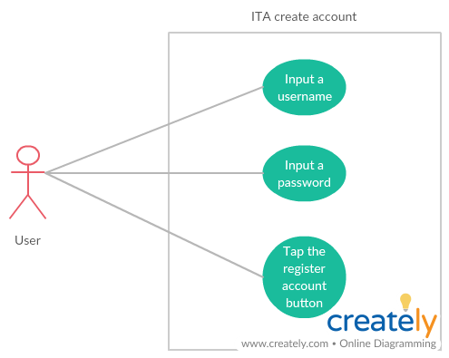

* 1. **Sequence diagram**

