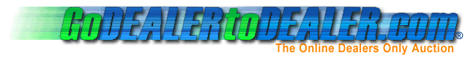

Amendment

Participation / User Agreement and Application

Go Dealer To Dealer hereby waives the first Annual (twelve months) Participation Fee. (See 2.1 Annual Participation Fee) starting from the date of this Amendment form for:
Company Name: __________________________________
This one time annual participation fee wavier is given in consideration of your agreement to become a Charter Member of Go Dealer to Dealer and your pledge to:
List a minimum of _________ items on an active auction every month
or
Have _________ transactions (buy / sell) per month
within two (2) weeks from the date of membership activation, on the Go Dealer to Dealer web site duration of the first year.
Company Owner / Authorized Agent

I have read and fully accept the terms and conditions contained within the Go Dealer To Dealer Participation / User Agreement and this Application Amendment.

Signature: _________________________________________________________________

Printed Name: _____________________________________________________________

Title:_________________________________________ Date: ____________________

