GameDude Plus

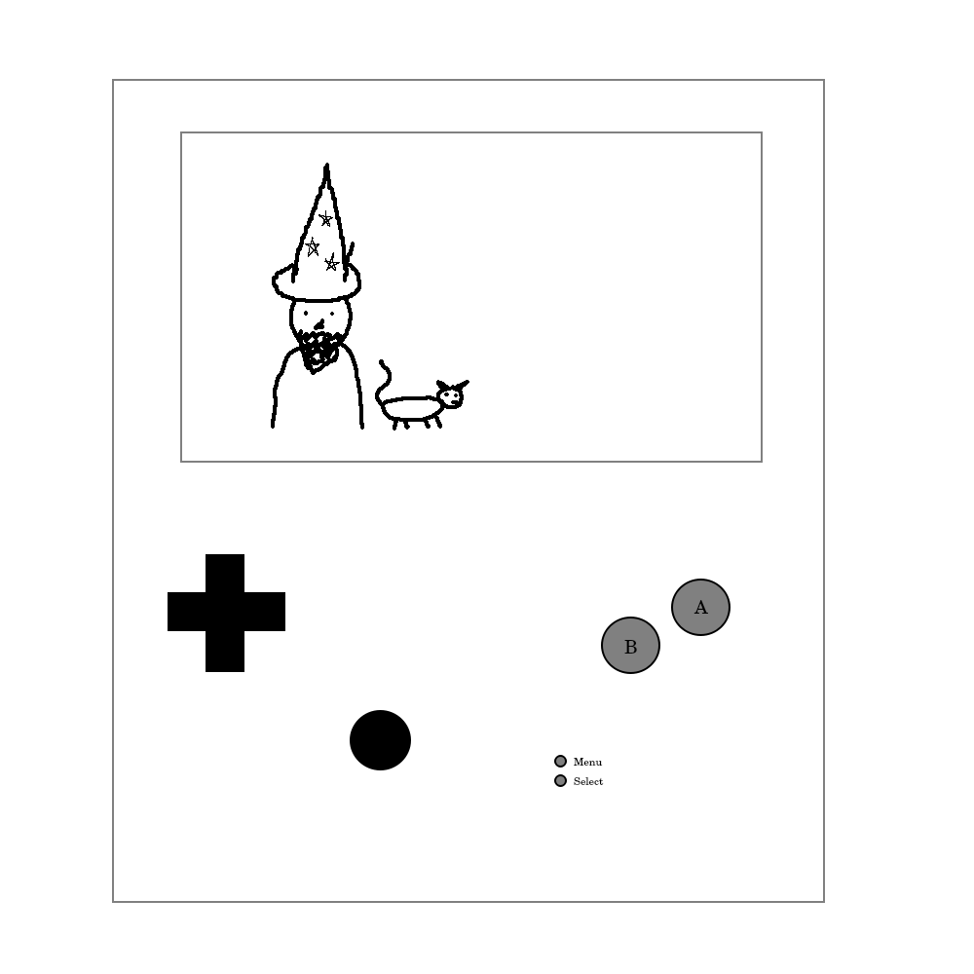

Table of Contents
Hardware 2
Input 2
D-Pad 2
Display 3
Battery and Charging 3
WiFi 3
Storage 3
Processor 3
Software 3

Hardware

Input

D-Pad
Buttons
Analog

Display

Battery and Charging

WiFi

Storage

Processor

Software

